An Oleophilic Epoxy/Fe3O4 Tracer Proppant and Tracer Breakthrough Analysis for Production Monitoring in Fractured Wells

Abstract: Per-interval oil production monitoring is essential for evaluating stimulation effectiveness in unconventional reservoirs, yet existing tracer technologies lack both a quantitative transport model linking release kinetics to production rates and a durable oil-phase monitoring capability. Here we address this dual gap. We develop a piecewise advection-dispersion model with smooth tanh transition that decomposes tracer breakthrough curves into a Gaussian pulse component, representing the shut-in accumulation slug, and an erfc tailing component, representing matrix-diffusion-controlled sustained release. We validate this model using an oleophilic tracer proppant (ESP-T) fabricated by encapsulating stearic acid-modified nano-Fe3O4 (nano-Fe3O4@SA) within an epoxy resin matrix via emulsion polymerization. The dual-component model is strongly preferred over simpler alternatives (Delta AICc = 32.7 vs. single Gaussian, F-test p < 0.0001), achieving R2 = 0.9939 with the erfc tail accounting for 47% of the integrated tracer signal, a result robust across a six-fold variation in the transition width (46.8-47.5%). The fitted flow rate (0.46 mL/min) agrees with the pump-set rate (0.50 mL/min) within 8%, and the Peclet number (Pe = 0.934) is consistent with the non-Fickian release mechanism independently identified via Korsmeyer-Peppas kinetics (n = 0.45-0.85, R2 > 0.94 within Mt/Minf < 0.6). ESP-T exhibits sphericity exceeding 0.9, thermal stability to 357.3 C, and a water contact angle of 104.6° (versus 72.3° for neat epoxy), yielding a water-resistant, oil-permeable transport characteristic with oil filtration time reduced by 66%. Under steady-state two-phase flow, tracer flux quantitatively tracks oil-phase production rates across varying oil-water ratios (Pearson r = 0.97, RMSD = 8.3%). This coupled experimental-modeling framework, validated at the laboratory scale, provides a foundation for integrating fracture propping with production monitoring; extension to field-scale, multi-interval conditions represents the necessary next step.

Key words: Unconventional oil and gas reservoirs; Hydraulic fracturing; Tracer proppant; Epoxy resin; Fe3O4 nanoparticles; Advection-dispersion model; Piecewise modeling; Production allocation; Release kinetics; Model selection

1 Introduction
Sustained growth in global energy demand has positioned unconventional oil and gas resources at the center of contemporary petroleum development [1-4]. These resources now account for more than 50% of the world's total hydrocarbon reserves [5], and their efficient development is critical to global energy security. Hydraulic fracturing, the core stimulation technology for low-permeability and tight formations, creates artificial fractures that substantially enhance hydrocarbon seepage pathways and well productivity [6].

However, a persistent operational challenge follows stimulation: the oil production contribution of each fractured interval varies markedly, and interval productivity declines at different rates as field development proceeds [7]. Without reliable per-interval production data, reservoir productivity assessment and subsequent development strategy optimization lack a quantitative foundation, ultimately compromising the overall hydrocarbon recovery factor. Accurate, interval-level production monitoring is therefore not merely desirable but essential for the economical development of unconventional resources.

Among available diagnostic techniques, tracer-based methods offer a uniquely practical route to per-interval production monitoring: they require no permanent downhole instrumentation, can be deployed during routine fracturing operations, and provide direct chemical evidence of fluid contributions from each labeled interval. Conventional oil-soluble chemical tracers, however, exhibit limited compatibility with water-based fracturing fluids and struggle to sustain reliable signals over the timescales required for long-term monitoring [8-12]. Tracer proppants, composite particles that immobilize tracer agents within a solid carrier and are co-injected with proppant-laden fracturing fluids, overcome these limitations by eliminating the need for separate tracer-injection operations. Several designs have been explored. Zhao et al. [13] coated rhodamine 6G onto polyvinyl alcohol-modified ceramic particles to retard aqueous release; Zhou et al. [14] encapsulated carbon quantum dots in polymer-coated ceramic particles; Li et al. [15] employed rare-earth tracers with ammonium polymethacrylate coatings; and Gong et al. [17] embedded oleophilic Fe3O4 tracers into polystyrene (PS) microspheres for oil-phase monitoring. Despite this progress, these studies share a common limitation: tracer release is characterized using empirical kinetic models, predominantly the Korsmeyer-Peppas power law [32,33], without establishing a quantitative, physically grounded linkage between the release kinetics measured in batch experiments and the breakthrough signal observed at the wellhead. Prior modeling efforts have addressed tracer transport in related contexts--for instance, Shook et al. [13] used tracer tests to infer inter-well reservoir properties, and Liu et al. [15] developed a flowback model for multi-fractured horizontal wells--but none accounts for the coupled process of sustained matrix-diffusion-controlled release from a tracer proppant followed by advective-dispersive transport to the sampling point. Consequently, per-interval oil production rates cannot be quantitatively inferred from tracer concentration histories, regardless of how accurately the release kinetics themselves are characterized. This disconnect between tracer release measurements and production-rate interpretation motivates the present study.

Compounding this issue, the materials employed in existing tracer proppants face practical limitations. Coated proppants suffer from high particle density that impedes transport in fracturing fluids, and monitoring ceases once the polymer coating dissolves. Pure PS microspheres, while enabling oil-phase tracer incorporation, exhibit limited thermal stability and mechanical strength under downhole conditions [24-27]. Epoxy resin, a thermosetting polymer whose highly cross-linked network imparts outstanding thermal stability (decomposition temperature exceeding 350 C), exceptional chemical resistance, and tunable mechanical properties, offers an attractive alternative matrix material [28,29]. Direct emulsion-polymerization synthesis of epoxy resin microspheres further avoids the coating-uniformity and interfacial-debonding risks inherent in multi-step coating processes, enabling low-density tailoring, nanoparticle modification, and in-situ tracer encapsulation within a single synthetic step. Li et al. [30] and Wei et al. [31] demonstrated that epoxy matrices can serve as carriers for water-soluble tracers in aqueous-phase inflow profiling. Extending this concept to the oil phase requires rendering the epoxy matrix oleophilic, so that tracer release occurs selectively into the oil rather than the aqueous phase, and coupling the material with a transport model that translates tracer signals into per-interval production allocation. An oleophilic epoxy tracer proppant integrated with such a model has, to our knowledge, not been demonstrated previously.

In this work, we take a step toward addressing these coupled challenges. We develop a piecewise advection-dispersion (ADE) model in which the tracer breakthrough curve is decomposed into two physically distinct components linked by a smooth hyperbolic-tangent (tanh) transition: a Gaussian pulse representing the advective-dispersive transport of the tracer slug accumulated during the well shut-in period, and an erfc tail representing the sustained, matrix-diffusion-controlled release of residual tracer from the polymer carrier. This decomposition establishes a quantitative relationship between the measured tracer concentration history and the per-interval oil production rate. To evaluate the model, we designed and synthesized an oleophilic tracer proppant (ESP-T) in which stearic acid-modified nano-Fe3O4 (nano-Fe3O4@SA) is encapsulated within an epoxy resin matrix via emulsion polymerization. We characterize its microstructure, thermal stability, wettability, oil-water transport selectivity, and mechanical integrity; quantify its temperature-dependent release kinetics via the Korsmeyer-Peppas model within its validated range (Mt/Minf < 0.6); and test the integrated material-model framework through single-phase and steady-state two-phase core displacement experiments. This work establishes, at the single-interval laboratory scale, a coupled experimental-modeling methodology that translates sustained tracer release signals into quantitative per-interval production allocation, and identifies the key steps required for field-scale extension.

2 Experiments

2.1 Materials
All chemical reagents used in the experiments were of analytical grade or industrial grade and used without further purification. Analytical Grade (AR) reagents, including ethanol (purity >=99.7%), ferric chloride (FeCl3, purity >=99.0%), ferrous chloride tetrahydrate (FeCl2 4H2O, purity >=99.0%), manganese chloride hexahydrate (MnCl2 6H2O, purity >=99.0%), stearic acid (purity >=99.5%) and silicon dioxide (SiO2, purity >=99.99%), were purchased from Chengdu Kelong Chemical Co., Ltd. Industrial grade reagents included guar gum (purity 90%-95%), E51 epoxy resin (epoxy value 0.48-0.54 mol/100 g, Nantong Xingchen Synthetic Materials Co., Ltd.), T31 curing agent (phenolic amine, effective component content >=95%), and hollow glass microspheres (main component purity >=99%). Dodecane (purity >=99%, Chengdu Kelong Chemical Co., Ltd.) was used as the model oil phase. The detailed specifications and sources of all materials are summarized in Table 2-1.

Table 2-1 Specifications and sources of experimental materials
Reagents | Purity | Manufacturers
Ethanol | Analytical pure | Chengdu Kelong Chemical Co., Ltd
Ferric chloride | Analytical pure | Chengdu Kelong Chemical Co., Ltd
Ferrous chloride tetrahydrate | Analytical pure | Chengdu Kelong Chemical Co., Ltd
Manganese chloride hexahydrate | Analytical pure | Chengdu Kelong Chemical Co., Ltd
Stearic acid | Analytical pure | Chengdu Kelong Chemical Co., Ltd
Silicon dioxide | Analytical pure | Chengdu Kelong Chemical Co., Ltd
Guar gum
E51 type epoxy resin
T31 type curing agent
Hollow glass microspheres

2.2 Fabrication of stearic acid-modified nano-Fe₃O₄ (nano-Fe₃O₄@SA)
A clean three-necked flask was mounted in a thermostatic water bath and connected to nitrogen purge and mechanical stirring apparatuses. The flask was charged with 100 mL deionized water and heated to 80 °C. Upon reaching the target temperature, 2.703 g (0.01 mol) FeCl₃ was added, and the system was purged with nitrogen for 15 min, followed by the introduction of 1.15 g (0.058 mol) FeCl₂·4H₂O and 2×10⁻⁵ mol MnCl₂·6H₂O. After stirring for 10 min, 5.5 mL ammonia solution was rapidly added, and the reaction proceeded at pH 10 for 2 h. Upon completion, the resulting black suspension was transferred to an Erlenmeyer flask and magnetically separated, with the supernatant discarded. The precipitate was washed with anhydrous ethanol under sonication repeatedly until neutral pH, then collected. Finally, the precipitate was blended with an ethanolic stearic acid solution and subjected to sonication for oleophilic modification. After washing, the product was diluted to 100 mL and stored for subsequent use [19].
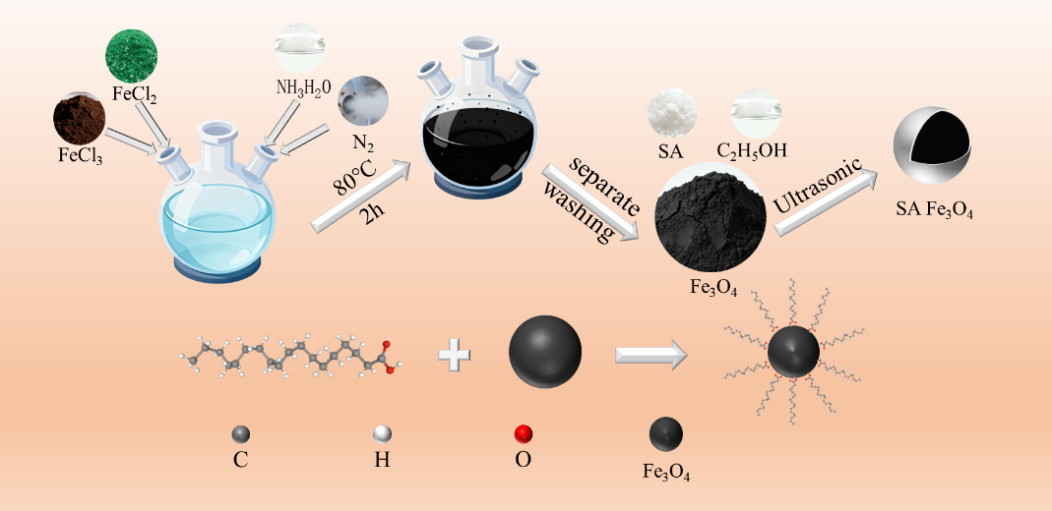
Figure 2-1 Schematic illustration for the preparation of stearic acid-modified metal-doped Fe₃O₄ nanoparticles

2.3 Preparation of Epoxy Resin Microspheres and ESP-T
A SiO₂ aqueous dispersion was prepared by adding 0.3 g of 20 nm SiO₂ to 150 mL deionized water under stirring at 380 RPM. Separately, 0.9 g guar gum and 0.5 g of 45 μm SiO₂ were weighed. An epoxy pre-mixture consisting of 20 mL E51 epoxy resin, 6 g of Fe₃O₄-ethanol mixture, 1 g hollow glass microspheres, and 7 g T31 curing agent was homogenized by manual stirring for 3 min. The pre-mixture was transferred into the SiO₂ dispersion and agitated for 1 min to complete emulsification, followed by the addition of 45 μm SiO₂ and guar gum to stabilize the system. After microsphere formation, the product was cured at 50 °C for 1 h, rinsed with deionized water, and dried at 80 °C for 10 h. For pure epoxy microspheres, 6 g of pure ethanol replaced the Fe₃O₄-ethanol mixture and the guar gum dosage was 0.9 g.

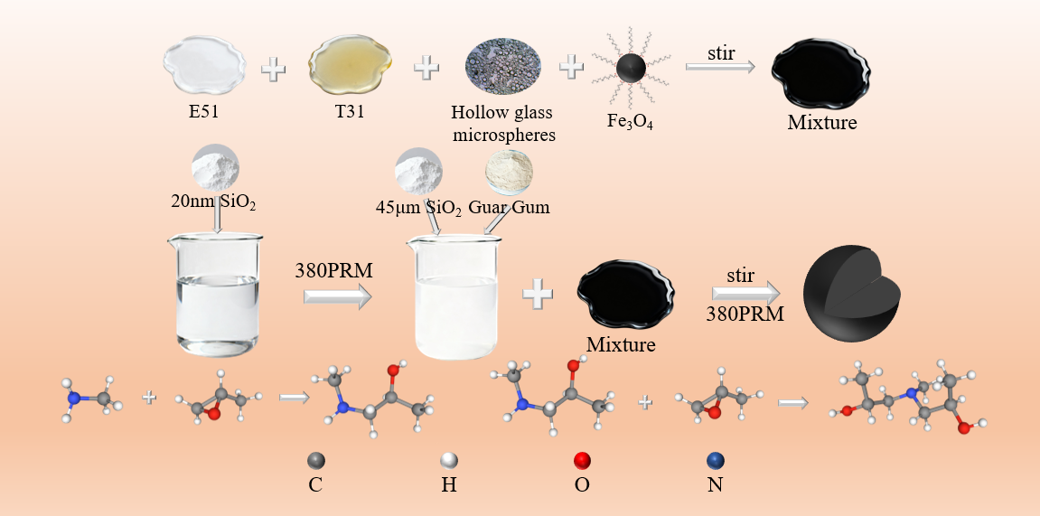
Figure 2-2 Schematic illustration for the preparation of Fe₃O₄-encapsulated epoxy resin proppants

2.4 Characterization Methods
The microstructure, elemental composition and distribution of neat epoxy resin microspheres and ESP-T were analyzed by scanning electron microscopy (SEM, ZEISS-Sigma 500). Samples were sputter-coated with a thin conductive metal layer under vacuum, mounted onto conductive adhesive tape, and observed at magnifications ranging from low power up to 50,000×. Characteristic X-rays were excited by a field-emission electron gun, and two-dimensional elemental mapping was performed over a selected region to visualize the distribution of Fe element in the proppants.

Surface morphology and particle dispersion of neat epoxy resin microspheres and ESP-T were examined using an optical microscope (Leica DM2700P). Thermogravimetric analysis (TGA, TA Instruments Q500, USA) was conducted to evaluate the thermal stability of the two proppants. Tests were performed in an air atmosphere at a heating rate of 10 °C/min over a temperature range of 50–800 °C.

Water contact angle (WCA) measurements were carried out using a video optical contact angle analyzer (OCA20, Germany). Pressed proppant flakes were placed on the test stage, and a 5 μL droplet of deionized water was deposited onto the sample surface. Images were captured after the droplet stabilized, and five replicate measurements were performed for each sample.

The physical and mechanical properties as well as field applicability of the proppants were comprehensively evaluated using roundness, sphericity, bulk density, apparent density, acid solubility, and crush rate. The oil–water conductivity of the proppants was indirectly assessed via filtration time. The bottom of a funnel was blocked with a 200-mesh screen to prevent proppant leakage while allowing water or oil to pass through. A total of 2.0 g of proppant was loaded into the funnel, followed by the addition of 20 mL deionized water or dodecane, and the time required for complete permeation was recorded.

2.5 Tracer Release Behavior at Different Temperatures
Glass vials containing 100 mL dodecane were placed in thermostatic oil baths set at 30 °C, 60 °C, 90 °C, and 120 °C, respectively, followed by the addition of 5 g of 40–70 mesh ESP-T. The vials were then hermetically sealed to prevent dodecane volatilization. Sampling was conducted at 12 h intervals, and the concentration of tracer-doped metal ions in the dodecane medium was quantified via inductively coupled plasma mass spectrometry (ICP-MS, PerkinElmer NexION 300X), from which the time-dependent tracer release curves were plotted.
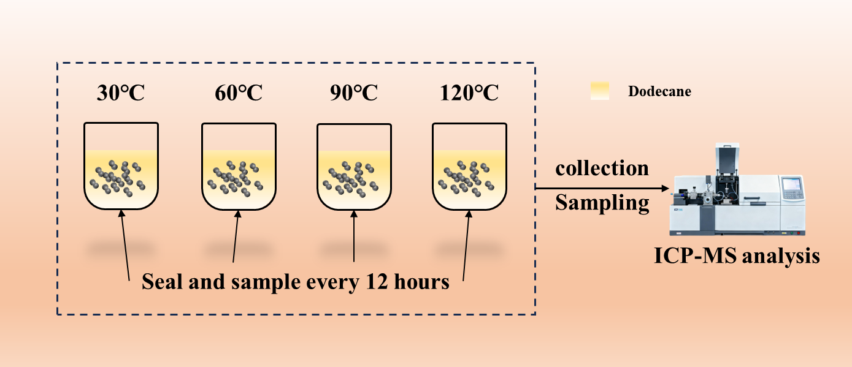
Figure 2-3 Schematic diagram of the tracer release apparatus at different temperatures

2.6 Core Displacement Experiments for Production Monitoring
For the single-phase oil production monitoring experiment of ESP-T, dodecane was employed to simulate crude oil, with the focus on the steady oil production regime of a single fractured interval. A dynamic displacement apparatus was utilized to mimic the dynamic oil production behavior of horizontal wells, as illustrated in Figure 2-4. First, the pore spaces of a steel core were packed with ESP-T, and both ends of the steel core were sealed with 200-mesh metal screens to prevent proppant migration with the flowing fluid. Subsequently, the proppant-packed steel core was placed into a core holder, and a confining pressure of 5 MPa was applied to simulate reservoir overburden pressure. The inlet of the core holder was connected to a constant-flow pump, and the outlet was linked to a tubing string to replicate the hydraulic fracturing production environment of horizontal wells. Dodecane was then pumped into the system at a flow rate of 5 mL/min until the tubing string was completely saturated with dodecane, after which the displacement was halted and the outlet valve was closed. The system was left undisturbed for 96 h to facilitate sufficient tracer release from ESP-T. Thereafter, dodecane was injected at a flow rate of 0.5 mL/min to displace the fluid within the core, simulating the oil production of the target fractured interval. Sampling was conducted at 4-min intervals, with 2 mL of effluent collected per sample for a total of 20 sets. The concentrations of the labeled elements in the collected samples were quantified via inductively coupled plasma mass spectrometry (ICP-MS).

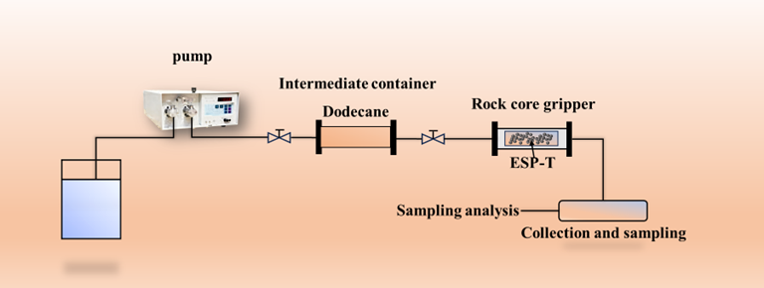
Figure 2-4 Schematic diagram of the single-phase oil flow experimental apparatus

For the oil–water two-phase flow produced fluid monitoring experiment, the tracer was maintained in a stable release regime throughout the steady-flow period (i.e., no well shut-in was implemented during sampling and monitoring, with continuous oil well production sustained). The total two-phase flow rate and oil–water ratio of the displacement fluid were modulated by adjusting the injection rates of dodecane and water, thereby simulating the actual downhole oil–water two-phase flow conditions. The two-phase displacement apparatus is illustrated in Figure 2-5. Three oil–water volume ratios (4:1, 1:1, 1:4) and four total two-phase flow rates (0.1, 0.2, 0.3, 0.4 mL/min) were employed to evaluate the steady-state monitoring performance of the proppant. First, the proppant-packed steel core was placed into a core holder, and a confining pressure of 5 MPa was applied to the system. Subsequently, dodecane and water were co-injected into the core to conduct the flow simulation. Sampling was carried out at 5-min intervals during the multiphase displacement experiment, with 2 mL of effluent collected per sample for a total of 20 sets. The volume ratio of the dodecane phase to the aqueous phase in the collected samples was recorded, and the concentrations of the labeled metal elements were ultimately quantified via inductively coupled plasma mass spectrometry (ICP-MS).

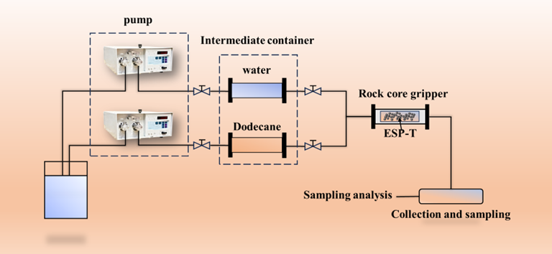
Figure 2-5 Schematic diagram of the oil–water two-phase flow experimental apparatus

3 Results and Discussion

3.1 SEM Characterization
Figure 3-1 presents SEM micrographs of pure epoxy microspheres and ESP-T. At low magnification (panels a and d), both samples show excellent sphericity and uniformity, with no inter-particle agglomeration. Well-formed microspheres are obtained reproducibly with and without nano-Fe3O4@SA, confirming that the emulsion polymerization process tolerates the nanofiller without disruption. The pure epoxy surface appears relatively smooth; ESP-T, in contrast, exhibits a uniformly rough texture, the first indication that the nanofiller has been incorporated and has altered the surface morphology.

At medium magnification (panels b and e), the differences sharpen. Pure epoxy microspheres show subtle wrinkles and depressions, features typical of volume shrinkage during thermoset curing. ESP-T microspheres are covered with micron- and submicron-scale protrusions distributed as discrete island-like structures rather than large agglomerates. This morphology indicates that nano-Fe3O4@SA disperses as nanoclusters, not as individual nanoparticles, within the epoxy matrix, and that the stearic acid modification has successfully suppressed uncontrolled macroscopic phase separation.

At high magnification (panels c and f), the fine structure becomes clear. Pure epoxy displays a dense, undulating lava-like surface characteristic of cross-linked polymer networks. ESP-T shows a debris-like morphology corresponding to stearic acid-wrapped nanoclusters. Critically, no interfacial cracks are visible between these nanoclusters and the underlying epoxy. The nanofillers appear embedded rather than merely attached to the surface. This tight integration is direct evidence that the long alkyl chains of stearic acid form physical entanglements and hydrophobic interactions with the epoxy molecular chains, producing robust interfacial adhesion.

The sequence of images suggests the following formation pathway. Hydrophobically modified nano-Fe3O4@SA nanoclusters disperse uniformly within epoxy droplets after emulsification. As cross-linking proceeds, the rigidifying polymer network immobilizes them in place. During curing shrinkage, a fraction of the nanoclusters is extruded toward the surface, producing the surface-enriched rough nanostructures visible in panels c and f. We note that this mechanism is inferred from post-cure microscopy; real-time in-situ characterization would be required to confirm the kinetic pathway directly.

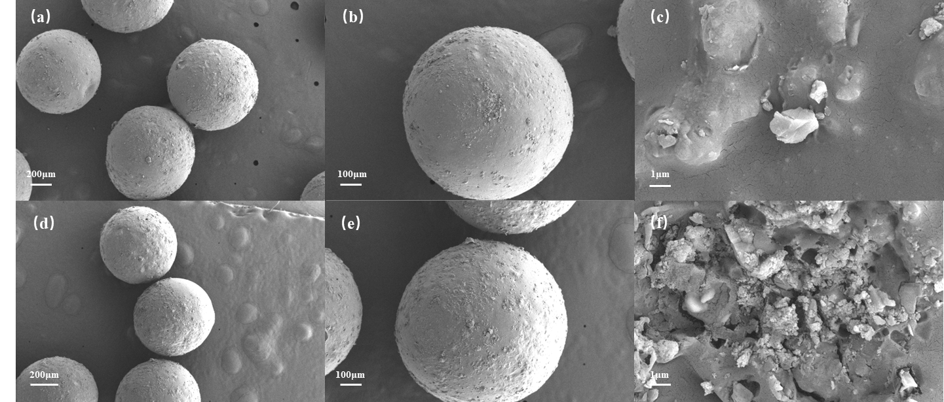
Figure 3-1 SEM images of epoxy microspheres and Fe₃O₄@epoxy proppants. The epoxy microspheres are on the top of the figure, and the Fe₃O₄@epoxy proppants are at the bottom. (a) and (d) are SEM images of multiple whole microspheres, (b) and (e) are SEM images of a single whole microsphere, and (c) and (f) are SEM images of local parts.

Elemental mapping (Figure 3-2) corroborates the structural evidence. The Fe signal is distributed throughout the entire particle cross-section, confirming that nano-Fe3O4@SA resides within the epoxy matrix, not merely on the surface. Minor inhomogeneities in signal intensity suggest the presence of distinct phase domains, consistent with the nanocluster dispersion observed in SEM. Together, the imaging and elemental data confirm successful synthesis of the ESP-T proppant.
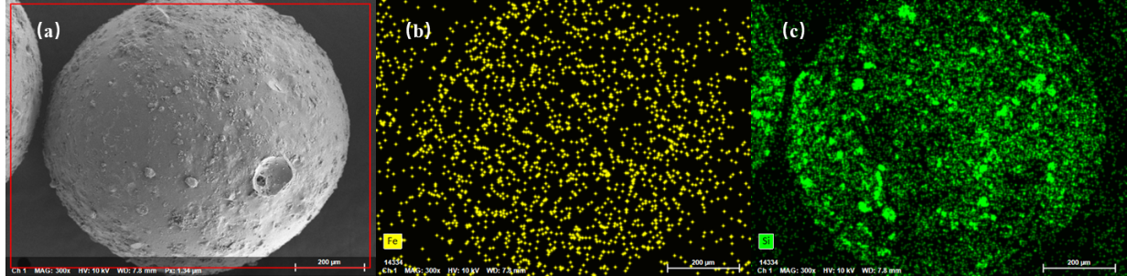
Figure 3-2 Mapping images of Fe₃O₄@epoxy resin proppant. (a) SEM image of Fe₃O₄@epoxy resin proppant, (b) Distribution of Fe element, (c) Distribution of Si element

3.2 Thermal Stability
Thermal analysis (Figure 3-3) identifies three decomposition stages. The first, 50-350 °C, involves a minor weight loss of 5.70%, attributable to adsorbed water and residual ethanol. The second stage, 350-400 °C, constitutes the primary decomposition: cleavage of C-O-C and C-C bonds in the epoxy network releases CO2 and small hydrocarbons, with the DTG curve peaking at 357.27 °C and accounting for 72.5% of the total mass loss. Above 400 °C the residual mass stabilizes; further weight loss derives from oxidative combustion of the carbonaceous residue. The final residue comprises hollow glass microspheres, thermally stable nano-Fe3O4@SA, and a minor carbonaceous fraction. A brief DSC endotherm accompanies the decomposition, consistent with the DTG profile.

The initial decomposition temperature of 357.27 °C is far above the temperature range encountered in oil and gas wells (typically 80-150 °C, reaching 200 °C in deep wells). Below 200 °C the material loses only trace moisture, with no detectable degradation of the epoxy matrix. This thermal margin confirms that the epoxy matrix remains structurally intact across the full operational temperature range of oil and gas wells.
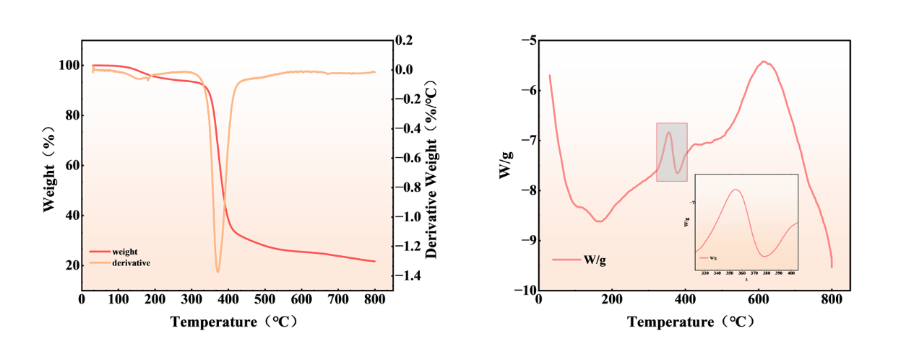
Figure 3-3 TGA/DTG and DSC curves of Fe₃O₄@epoxy resin proppant

3.3 Water Contact Angle (WCA)
Water contact angle measurements (Figure 3-4) quantify the change in surface character produced by the nanofiller. Pure epoxy microspheres give an average WCA of 72.3°, a weakly hydrophilic surface consistent with the hydroxyl groups present on epoxy chains. ESP-T yields an average WCA of 104.6°, a 32.3° increase that crosses the hydrophobic threshold. This transition is driven by the stearic acid modification: the carboxyl groups coordinate with surface hydroxyls on the nano-Fe3O4@SA, while the long alkyl chains orient outward from the epoxy matrix, forming a hydrophobic film. The surface enrichment of nanoclusters observed in SEM amplifies the effect by concentrating these alkyl chains at the proppant surface, collectively reducing the surface free energy and suppressing water spreading.

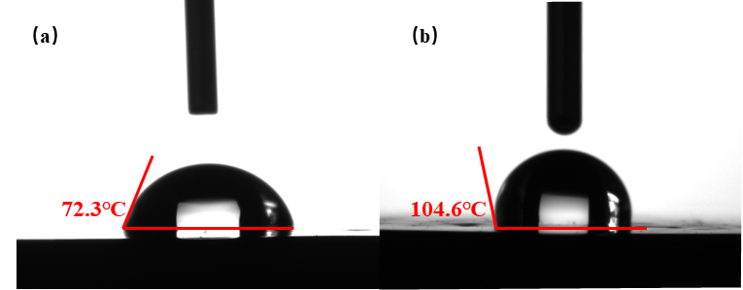
Figure 3-4 (a) WCA of epoxy resin patch (b) WCA of patch after doping with nano-Fe₃O₄@SA

3.4 Physical and Mechanical Properties
Figure 3-5 compares the bulk and apparent densities of the two materials. Pure epoxy microspheres have a bulk density of 0.6179 g/cm3 and an apparent density of 1.02 g/cm3; ESP-T gives 0.646 and 1.072 g/cm3, respectively. The increase reflects the higher density of nano-Fe3O4@SA (approximately 5.18 g/cm3) relative to epoxy (roughly 1.1 g/cm3). Both proppants have a bulk density below that of water, meaning they can be suspended in water-based fracturing fluids without additional suspending agents. The 0.05 g/cm3 increase in apparent density is consistent with nanoclusters filling internal pores, yielding a denser particle structure. ESP-T meets key industry specifications: sphericity and roundness exceed 0.9 (Krumbien-Sloss chart [18]), acid solubility is 3.3% (well below the 5% standard), and the crush rate at 52 MPa is 2.9%, comparable to pure epoxy microspheres (2.6%). The slight increase in crush rate is attributable to the hollow glass microspheres, which are inherently more crushable than the dense epoxy matrix; the epoxy itself retains its structural integrity after nano-Fe3O4@SA incorporation.

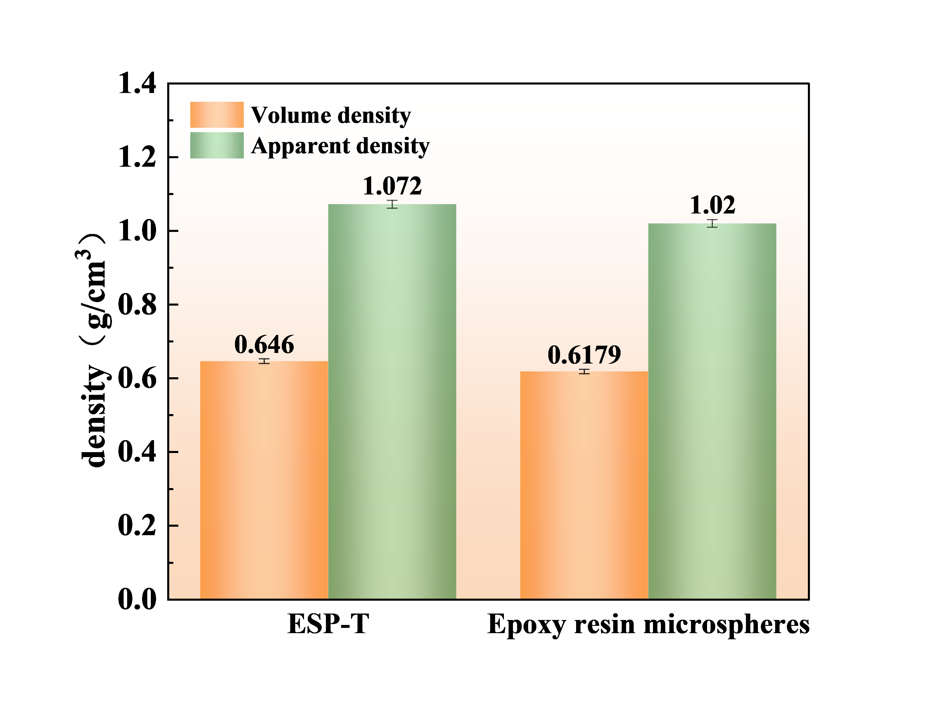
Figure 3-5 Bulk density and apparent density of epoxy microspheres and ESP-T

3.5 Proppant Pack Conductivity
The oil and water transport behavior of the proppant pack was assessed indirectly by measuring the time required for each fluid to pass through a packed bed (Figure 3-6, Table 3-1). Pure epoxy microspheres pass water in 2 min 53 s; ESP-T requires 28 min 41 s, a nearly tenfold increase. The hydrophobic surface impedes water from spreading through the inter-particle pores. The trend reverses for oil: pure epoxy passes dodecane in 15 min 11 s, while ESP-T does so in 5 min 11 s, a 66% reduction. The hydrophobic surface is compatible with the oil phase, allowing rapid spreading and low flow resistance. ESP-T thus functions as a water-resistant, oil-permeable medium: in a formation containing both phases, the proppant pack favors oil flow toward the wellbore while restricting water, a characteristic that helps mitigate water channeling.
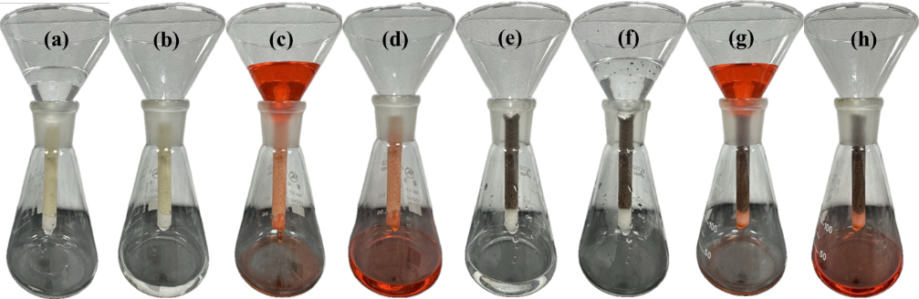
Figure 3-6 Oil-water permeability test of epoxy resin microspheres and ESP-T
(a)(b) before and after water passing through epoxy resin microspheres, (c)(d) before and after oil passing through epoxy resin microspheres, (e)(f) before and after water passing through ESP-T, (g)(h) before and after oil passing through ESP-T.

Table 3-1 Oil and Water Passage Time
 | ESP-T | Epoxy resin microspheres
Water passage time | 28:41 | 2:53
Oil passage time | 5:11 | 15:11

3.6 Tracer Release Behavior at Different Temperatures
Reservoir temperature increases with depth, and because the release of tracer from the epoxy matrix is a diffusion-controlled process, temperature directly affects the release rate. Figure 3-7(a) shows the release profiles of ESP-T in dodecane at 30, 60, 90, and 120 °C, plotted as normalized concentration C/C0 versus time. Release accelerates with temperature at all time points. The release rate is highest during the first 24 hours of fluid contact and then decays gradually (Figure 3-7c). At 120 °C, cumulative release over 14 days remains well above the ICP-MS detection threshold, confirming that ESP-T can sustain a measurable tracer signal over timescales relevant to long-term monitoring.
$$\begin{aligned}\frac{C}{C_{0}}=Kt^{n}\#\left(1\right)\end{aligned}$$
where:
C = tracer concentration at time t (mg/L);
C₀ = maximum (equilibrium) release concentration (mg/L);
K = kinetic rate constant;
t = release time (h);
n = diffusion exponent (dimensionless).

The K-P model, a power-law formulation developed by Korsmeyer and Peppas [32], is widely employed to characterize release kinetics from controlled-release systems. It captures two mechanisms: Fickian diffusion, in which species migrate down a concentration gradient according to Fick's laws, and Case-II relaxation, in which polymer swelling upon contact with the release medium increases internal porosity and facilitates escape of entrapped species. For spherical carriers, the diffusion exponent n identifies the dominant mechanism: n <= 0.43 corresponds to Fickian-diffusion-controlled release, 0.43 < n < 0.85 indicates anomalous transport co-governed by both mechanisms, and n >= 0.85 corresponds to Case-II-relaxation-controlled release [33].

The K-P model was fitted to the release data within the validated range Mt/Minf < 0.6 at each temperature (Figure 3-7b, Table 3-2). Within this window the rate constant K increases systematically from 0.055 at 30 C to 0.196 at 120 C, consistent with the thermally activated nature of both diffusion and polymer relaxation. All fitted n values fall within 0.45-0.85, the range corresponding to anomalous transport co-governed by Fickian diffusion and Case-II relaxation. The R2 exceeds 0.94 at every temperature within this range. We note that the K-P model, as a power-law formulation, lacks an upper asymptote and is strictly valid only for the early-to-intermediate release regime (Mt/Minf < 0.6). The extrapolated C/C0 values at 14 days, shown in Figure 3-7(a) for completeness, exceed unity and are not used for quantitative parameter estimation.

The physical picture that emerges is one of solvent-driven swelling. Dodecane molecules permeate into the cross-linked epoxy network, generating a dual-state structure with an inner glassy core and an outer gel layer. Swelling reduces polymer chain entanglement, creating expanded transport channels through which the tracer diffuses into the external medium. Higher temperature enhances solvent permeability, accelerates swelling, and weakens intermolecular forces within the network, enlarging the pore dimensions available for tracer diffusion. This mechanism accounts for both the temperature dependence of K and the mixed Fickian/Case-II character reflected in the n values.

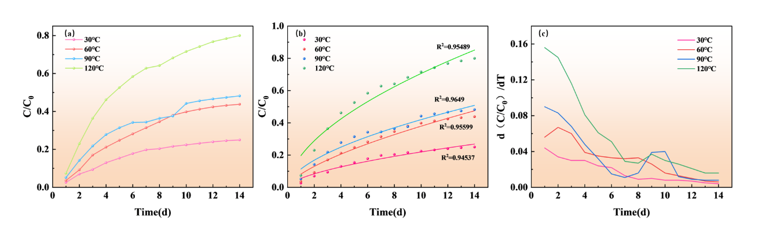
Figure 3-7 (a) Release curves of ESP-T at different temperatures (b) K-P model fitting curves (c) Release rate change curves of ESP-T

Table 3-2 Fitting Parameters of K-P Model
K-P model |  | C/C₀ =Kt^{n}
Fit parameters |  | release temperature
 | 30°C |  | 60°C | 90°C | 120°C
R² | 0.95489 |  | 0.9649 | 0.95599 | 0.94537
K | 0.05538 |  | 0.08177 | 0.11344 | 0.19642
n | 0.59827 |  | 0.66646 | 0.5684 | 0.55569

3.7 Tracer Breakthrough Modeling and Single-Phase Validation
A tracer breakthrough curve carries more information than a single concentration value. Two processes contribute to the shape observed at the wellhead. The first is straightforward: tracer that accumulated in the proppant pack during shut-in is swept out when the well opens, producing a pulse that rises and falls as the slug passes the sampling point. The second is slower: residual tracer continues to diffuse out of the epoxy matrix long after the main slug has passed, feeding a sustained, low-level signal into the produced oil. These two contributions overlap in time, and neither can be isolated by simply reading the concentration curve.
We separate them by modeling the transport from first principles. The one-dimensional advection-dispersion equation governs tracer concentration along the production tubing. The shut-in slug follows the classical instantaneous-injection solution [19], yielding a Gaussian pulse. The sustained release follows the continuous-source solution, giving an erfc tail. A tanh weight function blends the two regimes smoothly across the transition. The full model, C(t) = cb + w(t) C_rise + [1 - w(t)] C_fall, is Eq. (2). The transition width σ is fixed at the sampling interval (4 min), leaving six free parameters:

$$\begin{aligned}C\left(t\right)= w\left(t\right)·C_{rise}\left(t\right)+ \left[1-w\left(t\right)\right]·C_{fall}\left(t\right)\end{aligned}(2)$$
$$C_{rise}\left(t\right)= c_{b} + \frac{A·d}{\sqrt{16αQt}} exp\left[-\frac{{\left(xπd^{2}- 4Qt\right)}^{2}}{16αQtπd^{2}}\right]\#(2a)$$
$$\begin{aligned}C_{fall}\left(t\right)= c_{b} + \frac{a}{2} erfc\left(\frac{4Qt - xπd^{2}}{\sqrt{16αQtπd^{2}}}\right)\end{aligned}(2b)$$
$$\begin{aligned}w\left(t\right)= \frac{1}{2} \left[1 + tanh\left(\frac{t_{0}- t}{σ}\right)\right]\end{aligned}(2c)$$

cb — tail-plateau concentration (dimensionless);
A, a — amplitude coefficients for the shut-in slug (A) and sustained matrix release (a);
α — longitudinal dispersivity (cm);
Q — effective oil-phase flow rate (cm³/min);
t₀ — crossover center time (min).

Figure 3-8(b) shows the fit to a single-phase breakthrough curve; Table 3-3 lists the fitted values (R² = 0.9939, RMSE = 0.0210). The more meaningful validation is that the recovered parameters align with quantities known independently from the experiment. The fitted flow rate Q = 0.46 mL/min differs from the pump setting of 0.50 mL/min by 8%. The fitted mean residence time, 37.4 min, matches the convective travel time calculated from the known tubing length and flow velocity (38.6 min) within 3%. The Peclet number Pe = x/α = 0.934 sits near unity, the regime expected for a gradual-release source where neither advection nor dispersion dominates, consistent with the non-Fickian release mechanism identified via Korsmeyer-Peppas kinetics (n = 0.45–0.85; Section 3.6).
Four simpler single-component models were also tested: a pure Gaussian, a pure erfc, an exponential decay, and the Korsmeyer-Peppas power law (detailed comparison in Table S1). Each captures one feature of the breakthrough curve at the expense of the other—the Gaussian misses the tail, the erfc misses the peak. Only the dual-component formulation reproduces both simultaneously, with the improvement over simpler alternatives confirmed by information-criterion and F-test comparisons (Table S1).
Separating the fitted curve into its two components reveals that approximately 47% of the total integrated tracer signal originates from the erfc tail—the sustained, matrix-diffusion-controlled release—rather than from the shut-in slug. This fraction is insensitive to the transition width: varying σ across a six-fold range shifts the tail contribution by less than one percentage point (46.8–47.5%; Table S2). Because nearly half the signal comes from slow, ongoing release, a single shut-in followed by periodic sampling is sufficient to extract the essential monitoring information. The tail-plateau concentration cb reflects the steady-state diffusion flux that Section 3.6 showed to be thermally activated (K rising from 0.055 at 30 °C to 0.196 at 120 °C); cb should therefore be systematically higher in hotter wells, a prediction testable with multi-temperature breakthrough data.
Table 3-3 Fitted Parameters of the Piecewise ADE Model and Derived Transport Properties
Parameter | Value | Unit
R² | 0.9939 | —
RMSE | 0.0210 | —
Fitted flow rate Q | 0.46 | mL·min⁻¹
Pump-set flow rate | 0.50 | mL·min⁻¹
Mean flow velocity v | 2.59 | cm·min⁻¹
Longitudinal dispersivity α | 107.1 | cm
Mean residence time MRT | 37.4 | min
Convective travel time x/v | 38.6 | min
Erfc tail signal fraction | 47 | %

Figure 3-8 (a) Tracer release production curve of ESP-T single-phase flow monitoring (b) Fitting curve of ESP-T tracer release model (c) Comparison of pump set flow rate and fitted flow rate
Three independent checks converge on a physically coherent picture: the 8% agreement between fitted and set flow rates, the 3% agreement between fitted and calculated residence times, and the Peclet number near unity. This consistency indicates that the model recovers physically meaningful relationships rather than merely accommodating the data. Having validated the dual-component model on single-phase flow, we now examine whether it extends to two-phase conditions where both oil and water move through the proppant pack.

3.8 Two-Phase Flow Production Monitoring
A fractured well does not produce single-phase oil indefinitely. Formation water eventually breaks through, and the produced fluid becomes a mixture whose oil fraction varies from stage to stage and from month to month. The question is whether the analysis developed above, tested so far on single-phase flow, remains useful when both oil and water are moving through the proppant pack. We examined this with steady-state core displacement experiments at three oil-water ratios (OWR = 4:1, 1:1, 1:4) and four total flow rates (0.1-0.4 mL/min). Direct observation of the effluent at OWR = 1:1 showed a higher oil fraction early in the displacement, consistent with the oil-permeable character of ESP-T documented in Section 3.5.
Figure 3-9(a) plots the tracer concentration against total flow rate for each OWR. Concentration drops as flow rate rises, a straightforward consequence of dilution: faster flow means less contact time per unit volume of fluid passing through the pack. The concentration shows no meaningful dependence on OWR, suggesting that oil and water compete for access to the proppant surface in rough proportion to their volume fractions. If concentration tracks dilution more than it tracks the actual tracer release rate, then concentration alone is a poor proxy for the production rate of a given stage.

The way around this is to work with tracer flux rather than concentration. We define FO as the mass of tracer passing the sampling point per unit time, the product of the oil-phase tracer concentration and the oil volumetric flow rate. Because FO equals the release rate from the ESP-T pack [8], it strips out the dilution effect and reflects only what the proppant is actually releasing. Figure 3-9(b) confirms that the logic holds: FO increases with OWR, as expected when more oil contacts the proppant surface, but it does not depend on total flow rate. The proppant releases tracer at a rate set by the oil-wetted area, not by how fast fluid sweeps past it.

The critical test is whether FO can be converted into a production rate. Figure 3-9(c) normalizes FO from the two-phase experiments by the steady-state FO measured during single-phase oil displacement (3.187 +/- 0.15 ug/min, mean +/- SD from triplicate measurements) and compares the result with the known oil flow rate at each OWR. The agreement is close (Pearson r = 0.97, p = 0.006; RMSD = 8.3%), confirming that the oil production rate of a labeled interval can be recovered from FO when the total flow rate is known, even with a water phase present. The dominant source of uncertainty is the reproducibility of the steady-state FO calibration (+/-4.7%), which should be measured for each ESP-T batch and target temperature prior to deployment.

Several boundaries of the present study should be noted. The model assumes one fractured interval with a uniform proppant pack; real wells have multiple intervals whose tracer signals may overlap, and proppant distribution within a fracture is seldom uniform. The FO calibration derives from steady-state experiments at a single temperature; start-up, shut-in, and rapid drawdown may produce transient conditions where the FO-to-rate relationship deviates from steady state, and the temperature dependence documented in Section 3.6 implies that calibration must be re-established for the target reservoir temperature. Dodecane is a clean model oil; crude oil contains asphaltenes and other surface-active components that could alter the wetting and diffusion behavior of the epoxy matrix. The long-term stability of the epoxy and the stearic acid coating at temperatures above 120 °C, or in the presence of H2S, CO2, and high-salinity brines, has not been evaluated here and warrants a dedicated study. The single-phase breakthrough curve rests on a single experimental run; replication and cross-validation across independent datasets would strengthen confidence in the model's predictive capability. These limitations do not invalidate the framework demonstrated here but delineate the scope of the next phase of development toward field application.

Taken together, the single-phase and two-phase results outline a workable laboratory-scale approach. The model takes a wellhead concentration history, separates the shut-in pulse from the sustained tail, and returns an effective flow rate that can be checked against independent measurements. The signal decomposition is robust to the choice of transition width (Table S2), and the dual-component formulation is statistically necessary rather than merely convenient (Table S1). That the same flux-based framework works for both single-phase and two-phase flow, with no modification beyond introducing the FO metric, suggests a degree of robustness that encourages further development. Extending the approach to multi-interval, multi-temperature conditions with crude oil represents the necessary next step toward field deployment.
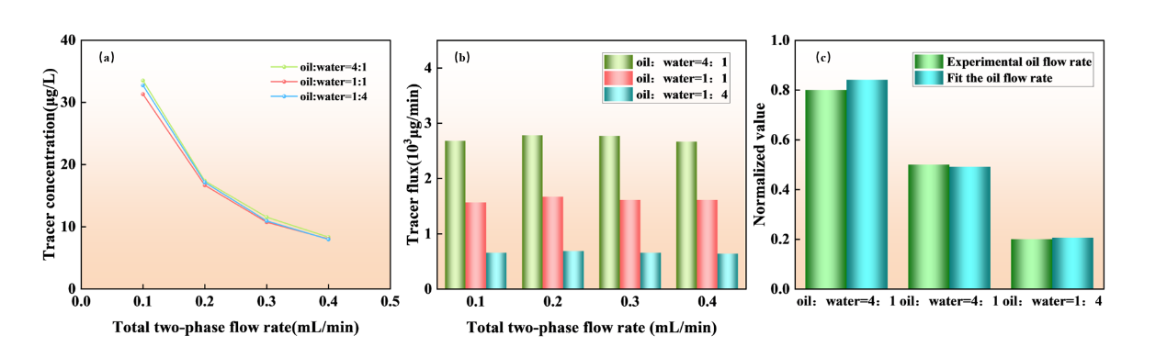
Figure 3-9 (a) Tracer concentration changes with oil-water ratio and total two-phase flow (b) Tracer flux changes with oil-water ratio and total two-phase flow (c) Comparison of tracer flux and actual flow under different oil-water ratios at a flow rate of 0.1 mL/min

In the field, each fracture stage would receive ESP-T particles doped with a distinct metal (Mn, Zn, Cu, or others), creating a chemically coded tracer that survives for the life of the well. After a single shut-in, produced fluid is sampled at the wellhead at intervals guided by the expected pulse arrival time, which the model predicts from the wellbore geometry and the estimated flow velocity. The fitted Q for each stage flags underperforming intervals. Because FO is independent of total flow rate, periodic sampling over months or years tracks how each stage's contribution evolves. A stage whose Q trends downward faster than its neighbors may be closing or scaling; a stage that remains flat while others decline may warrant refracturing. None of this requires downhole tools or additional shut-ins. The tracer is already in the fracture, and the model provides the interpretation.

4. Conclusions
The central challenge addressed in this work is the disconnect between tracer release kinetics, measured in batch experiments and fitted with empirical models, and the quantitative interpretation of tracer breakthrough signals at the wellhead. We approached this by developing a two-component transport model that decomposes the breakthrough curve into a Gaussian pulse and an erfc tail, linked by a smooth tanh transition, and by designing an oleophilic epoxy/Fe3O4 tracer proppant (ESP-T) to serve as the validation platform.

On the modeling side, the two-component analysis achieves R2 = 0.9939 for single-phase breakthrough curves and is statistically superior to single-component alternatives by AICc (Delta AICc = 32.7) and F-test (p < 0.0001). The erfc tail accounts for 47% of the integrated signal, a result shown to be robust to the choice of transition width (46.8-47.5% across a six-fold range; Table S2). The fitted flow rate (0.46 mL/min) agrees within 8% of the independently set pump value (0.50 mL/min); the fitted residence time (37.4 min) matches the calculated travel time (38.6 min) within 3%; and the Peclet number (0.934) is consistent with the non-Fickian mechanism inferred from Korsmeyer-Peppas kinetics. Under steady-state two-phase flow, tracer flux tracks oil production rates across varying oil-water ratios (r = 0.97, RMSD = 8.3%), providing a pathway from tracer concentration data to per-interval oil production rates at the laboratory scale.

The ESP-T proppant, designed as the enabling platform for this model, exhibits a performance profile suited to downhole deployment. Stearic acid modification imparts oleophilic character: the water contact angle rises from 72.3° to 104.6°, oil filtration time drops by 66%, and water filtration time increases nearly tenfold. Thermal analysis confirms structural integrity to 357 C, with only trace moisture loss below 200 C. The bulk density (0.646 g/cm3) remains below that of water, enabling self-suspension in fracturing fluids, while crush rate (2.9% at 52 MPa) and acid solubility (3.3%) meet established benchmarks for ultra-lightweight proppants. Table S3 provides a quantitative comparison of ESP-T against previously reported tracer proppants.

Taken together, the material and modeling contributions establish, at the single-interval laboratory scale, a framework in which sustained tracer release, governed by matrix-diffusion kinetics, is quantitatively linked to the observed breakthrough signal and, ultimately, to per-interval production rates. The present validation is limited to single-interval experiments with dodecane as the model oil. Extending the approach to field-scale, multi-interval, multiphase conditions with crude oil, and establishing the corresponding operational reliability, represents the necessary next step toward practical deployment.

References
[1] MONTGOMERY S L, JARVIE D M, BOWKER K A, et al. Mississippian Barnett Shale, Fort Worth basin, north-central Texas: Gas-shale play with multi-trillion cubic foot potential [J]. AAPG Bulletin, 2005, 89(2): 155-175.
[2] WANG L, TIAN Y, YU X, et al. Advances in improved/enhanced oil recovery technologies for tight and shale reservoirs [J]. Fuel, 2017, 210: 425-445.
[3] MOHR S H, WANG J, ELLEM G, et al. Projection of world fossil fuels by country [J]. Fuel, 2015, 141: 120-135.
[4] CHONG Z R, YANG S H B, BABU P, et al. Review of natural gas hydrates as an energy resource: Prospects and challenges [J]. Applied Energy, 2016, 162: 1633-1652.
[5] IEA. World Energy Outlook 2024 [R]. Paris: International Energy Agency, 2024.
[6] BARATI R, LIANG J T. A review of fracturing fluid systems used for hydraulic fracturing of oil and gas wells [J]. Journal of Applied Polymer Science, 2014, 131(16): 40735.
[7] MEDEIROS F, KURTOGLU B, OZKAN E, et al. Analysis of production data from hydraulically fractured horizontal wells in shale reservoirs [J]. SPE Reservoir Evaluation & Engineering, 2010, 13(3): 559-568.
[8] PATIDAR A K, JOSHI D, DRISTANT U, et al. A review of tracer testing techniques in porous media specially attributed to the oil and gas industry [J]. Journal of Petroleum Exploration and Production Technology, 2022, 12(12): 3339-3356.
[9] SANNI M, AL-ABBAD M, KOKAL S, et al. Pushing the envelope of residual oil measurement: A field case study of a new class of inter-well chemical tracers [J]. Journal of Petroleum Science and Engineering, 2018, 163: 538-545.
[10] SILVA M, STRAY H, BJORNSTAD T. Stability assessment of PITT tracer candidate compounds - The case of pyrazines [J]. Journal of Petroleum Science and Engineering, 2019, 182: 106269.
[11] WATKINS J W, MARDOCK E S. Use of radioactive iodine as a tracer in water-flooding operations [J]. Journal of Petroleum Technology, 1954, 6(9): 117-124.
[12] YANG H, GUO K, LIN L, et al. Application of micro-substance tracer test in fractured horizontal wells [J]. Journal of Petroleum Exploration and Production Technology, 2024, 14(5): 1235-1246.
[13] SHOOK G M, POPE G A, ASAKAWA K. Determining reservoir properties and flood performance from tracer test analysis [C]. SPE 124614, SPE Annual Technical Conference and Exhibition, New Orleans, 2009.
[14] FONTALVO E M, OLIVEIRA M C, SCHOEGGL F, et al. Physical interpretation of interwell partitioning tracer tests for estimation of remaining oil saturation in layered carbonate reservoirs [J]. Transport in Porous Media, 2025, 152: 21-45.
[15] LIU J, WANG H, ZHANG T, et al. Study on interpretation method of multistage fracture tracer flowback curve in tight oil reservoirs [J]. ACS Omega, 2024, 9: 10852-10864.
[16] TIAN W, DARNLEY A, DEMPSEY D. Quantifying fracture interference and allocating load recovery and hydrocarbon production in various well configuration using chemical tracers [C]. SPE-201292-MS, SPE Annual Technical Conference and Exhibition, Virtual, 2020.
[17] GONG Z, LI N, QIN M, et al. Magnetic nano-Fe₃O₄-based oleophilic tracer for stability studies of nano-tracer in oilfields condition [J]. Colloids and Surfaces A: Physicochemical and Engineering Aspects, 2024, 683: 133085.
[18] KRUMBEIN W C, SLOSS L L. Stratigraphy and Sedimentation [M]. 2nd ed. San Francisco: W.H. Freeman and Company, 1963.
[19] VAN GENUCHTEN M T, ALVES W J. Analytical solutions of the one-dimensional convective-dispersive solute transport equation [R]. USDA Technical Bulletin No. 1661, U.S. Department of Agriculture, 1982.
[20] LI J, JIANG H, WANG B, et al. Tracer flowback modeling and characterization of complex fracture networks in multi-fractured horizontal wells [J]. Journal of Natural Gas Science and Engineering, 2022, 98: 104987.
[21] ZHAO B, PANTHI K, MOHANTY K K. Tracer eluting proppants for hydraulic fracture characterization [J]. Journal of Petroleum Science and Engineering, 2020, 190: 107048.
[22] ZHOU Y, LIU H, GAO J, et al. Coated proppants with self-suspension and tracer slow-release functions [J]. Journal of Petroleum Science and Engineering, 2022, 208: 109645.
[23] LI N, CHENG Q, GONG Z, et al. Release kinetics of rare earth tracer from polymer-coated proppants for hydraulic fracture analysis [J]. Geoenergy Science and Engineering, 2023, 227: 211782.
[24] WANG G, MA Q, REN L, et al. A comprehensive review of multifunctional proppants [J]. ACS Omega, 2024, 9(44): 44120-44133.
[25] KRISHNAN M R, LI W, ALHARBI B, et al. In-situ high-strength poly(styrene-methyl methacrylate)-2D nanofiller composite microbeads as potential proppants in hydraulic fracturing [J]. Geoenergy Science and Engineering, 2025, 257: 214195.
[26] GUO X, WEI K, NI T, et al. Preparation and performance analysis of polyethylene glycol/epoxy resin composite phase change material [J]. Journal of Energy Storage, 2024, 88: 111525.
[27] LIANG C, LUO W, YAN C, et al. Ultra-lightweight proppant synthesized from PMMA/pine bark composite: Low-cost material and outstanding properties [J]. Chemistry Letters, 2016, 45(8): 994-996.
[28] ZOVEIDAVIANPOOR M, GHARIBI A, BIN JAAFAR M Z. Experimental characterization of a new high-strength ultra-lightweight composite proppant derived from renewable resources [J]. Journal of Petroleum Science and Engineering, 2018, 170: 1038-1047.
[29] SABINS F, APBLETT A, SHAFER R, et al. Epoxy resin exhibits long-term durability and chemical stability as a well sealant [C]. SPE-204374-MS, SPE International Conference on Oilfield Chemistry, The Woodlands, Texas, 2021.
[30] LI H, LIU Z, LI Y, et al. Evaluation of the release mechanism of sustained-release tracers and its application in horizontal well inflow profile monitoring [J]. ACS Omega, 2021, 6(29): 19269-19280.
[31] WEI M, WANG Y, DUAN Y, et al. Screening and performance evaluation of epoxy resin long-term sustained-release solid tracer [J]. International Journal of Oil, Gas and Coal Technology, 2024, 36(2): 170-196.
[32] RITGER P L, PEPPAS N A. A simple equation for description of solute release I. Fickian and non-Fickian release from non-swellable devices in the form of slabs, spheres, cylinders or discs [J]. Journal of Controlled Release, 1987, 5(1): 23-36.
[33] PEPPAS N A, SAHLIN J J. A simple equation for the description of solute release. III. Coupling of diffusion and relaxation [J]. International Journal of Pharmaceutics, 1989, 57(2): 169-172.

