用于压裂井生产监测的亲油型环氧树脂/Fe3O4示踪支撑剂及示踪剂突破曲线分析

摘要：逐段油产量监测对于评估非常规储层增产改造效果至关重要，然而现有示踪技术既缺乏将释放动力学与产量定量关联的输运模型，也不具备持久的油相监测能力。本文针对这一双重空白开展研究。我们建立了一个分段对流-弥散模型，通过光滑双曲正切（tanh）过渡将示踪剂突破曲线分解为两个分量：代表关井聚集段塞的高斯脉冲分量，以及代表基质扩散控制持续释放的互补误差函数（erfc）拖尾分量。我们使用一种亲油型示踪支撑剂（ESP-T）对该模型进行验证——该支撑剂通过乳液聚合将硬脂酸修饰的纳米Fe3O4（nano-Fe3O4@SA）封装于环氧树脂基质内。双分量模型在统计上显著优于简化替代模型（与单高斯模型相比ΔAICc=32.7，F检验p<0.0001），拟合R²=0.9939，erfc拖尾占积分示踪信号的47%，且该结果在过渡宽度六倍变化范围内保持稳健（46.8%-47.5%）。拟合流量（0.46 mL/min）与泵设定值（0.50 mL/min）吻合度在8%以内，Peclet数（Pe=0.934）与通过Korsmeyer-Peppas动力学独立识别的非Fick释放机制一致（n=0.45-0.85，在Mt/Minf<0.6范围内R²>0.94）。ESP-T球度超过0.9，热稳定温度达357.3°C，水接触角为104.6°（纯环氧树脂为72.3°），呈现出拒水透油的输运特性，油过滤时间降低66%。在稳态两相流条件下，示踪剂通量可在不同油水比下定量追踪油相产量（Pearson r=0.97，RMSD=8.3%）。这一经实验室尺度验证的耦合实验-模拟框架为将裂缝支撑与生产监测相结合提供了基础；向现场尺度、多段多相条件的延伸是下一步的必要工作。

关键词：非常规油气藏；水力压裂；示踪支撑剂；环氧树脂；Fe3O4纳米颗粒；对流-弥散模型；分段建模；产量分配；释放动力学；模型选择

1 引言
全球能源需求的持续增长已将非常规油气资源置于当代石油工业发展的核心位置[1-4]。这些资源目前占世界总烃类储量50%以上[5]，其高效开发对全球能源安全至关重要。水力压裂作为低渗透和致密储层的核心增产技术，通过形成人工裂缝大幅改善烃类渗流通道和油井产能[6]。

然而，增产措施之后始终存在一个操作难题：各压裂段的油产量贡献差异显著，且随着油田开发的推进，各段产能以不同速率递减[7]。缺乏可靠的逐段产量数据，储层产能评价和后续开发策略优化便缺少定量基础，最终损害整体烃类采收率。因此，精确的段级产量监测对于非常规资源的经济开发不仅是有益的，而且是必需的。

在现有诊断技术中，基于示踪剂的方法为逐段产量监测提供了一条独特的实用途径：无需永久性井下仪器，可在常规压裂作业中部署，并提供各标记层段流体贡献的直接化学证据。然而，常规油溶性化学示踪剂与水基压裂液的相容性有限，难以在长期监测所需的时间尺度上维持可靠信号[8-12]。示踪支撑剂——将示踪剂固定于固体载体中并与含支撑剂的压裂液共同注入的复合颗粒——消除了单独示踪剂注入操作的需要，克服了上述局限。目前已有多种设计方案。Zhao等人[13]将罗丹明6G包覆于聚乙烯醇修饰的陶瓷颗粒上以延缓水相释放；Zhou等人[14]将碳量子点封装于聚合物包覆的陶瓷颗粒中；Li等人[15]采用稀土示踪剂与聚甲基丙烯酸铵包覆层；Gong等人[16]将亲油型Fe3O4示踪剂嵌入聚苯乙烯（PS）微球以实现油相监测。尽管取得了这些进展，上述研究均存在一个共同的局限：示踪剂释放均使用经验动力学模型（主要是Korsmeyer-Peppas幂律方程[17,18]）进行表征，但批次实验中测量的释放动力学与井口观测到的突破信号之间尚未建立定量的物理关联。已有研究在相关背景下对示踪剂输运进行了建模——例如，Shook等人[19]利用示踪剂测试反演井间储层参数，Liu等人[21]建立了多段压裂水平井的示踪剂返排模型——但均未考虑示踪支撑剂的持续基质扩散控制释放与随后的对流-弥散输运至采样点这一耦合过程。因此，无论释放动力学本身的表征多么精确，都无法从示踪剂浓度历史中定量推断逐段油产量。释放测量与产量解释之间的这一脱节正是本研究的出发点。

使这一方法论空白更为复杂的是，现有示踪支撑剂所用材料也面临自身的实际局限。包覆型支撑剂颗粒密度高，阻碍其在压裂液中的输运，且一旦聚合物包覆层溶解，监测即告中断。纯PS微球虽能实现油相示踪剂掺入，但在井下条件下热稳定性和机械强度不足[27-30]。环氧树脂作为一种热固性聚合物，其高度交联网络赋予其卓越的热稳定性（分解温度超过350°C）、优异的耐化学性和可调节的力学性能，是一种引人注目的替代基质材料[31,32]。直接乳液聚合合成环氧树脂微球进一步避免了多步包覆工艺中固有的包覆均匀性和界面脱粘风险，可在单一步骤内实现低密度调控、纳米粒子改性和原位示踪剂封装。Li等人[33]和Wei等人[34]证明了环氧基质可作为水相流入剖面监测中水溶性示踪剂的载体。将这一概念延伸至油相需要使环氧基质亲油化，使其选择性向油相而非水相释放示踪剂，并且关键的是，将材料与一个能够将示踪信号转化为定量逐段产量分配的预测性输运模型相结合。亲油型环氧示踪基质及其与上述模型的耦合均未见报道。

本文在实验室尺度上针对这一双重空白开展研究。我们建立了一个分段对流-弥散（ADE）模型，通过光滑双曲正切（tanh）过渡将示踪剂突破曲线分解为两个物理上截然不同的分量：代表关井期间累积的示踪剂段塞的对流-弥散输运的高斯脉冲，以及代表聚合物载体中残余示踪剂的持续基质扩散控制释放的erfc拖尾。这一分解在测量的示踪剂浓度历史与逐段油产量之间建立了直接的定量关系。为验证该模型，我们设计并合成了一种亲油型示踪支撑剂（ESP-T），通过乳液聚合将硬脂酸修饰的纳米Fe3O4（nano-Fe3O4@SA）封装于环氧树脂基质内。我们系统表征了其微观结构、热稳定性、润湿性、油水输运选择性和机械完整性；在Korsmeyer-Peppas模型的有效范围内（Mt/Minf<0.6）量化了其温度依赖性释放动力学；并通过单相和稳态两相岩心驱替实验验证了集成的材料-模型框架。本研究在单段实验室尺度上建立了一个将持续示踪剂释放信号转化为定量逐段产量分配的耦合实验-模拟方法，并明确了向现场尺度延伸所需的关键步骤。

2 实验部分

2.1 实验材料
实验中使用的所有化学试剂均为分析纯或工业级，未经进一步纯化直接使用。分析纯（AR）试剂包括乙醇（纯度≥99.7%）、氯化铁（FeCl3，纯度≥99.0%）、四水氯化亚铁（FeCl2·4H2O，纯度≥99.0%）、六水氯化锰（MnCl2·6H2O，纯度≥99.0%）、硬脂酸（纯度≥99.5%）和二氧化硅（SiO2，纯度≥99.99%），购自成都科隆化工有限公司。工业级试剂包括胍胶（纯度90%-95%）、E51环氧树脂（环氧值0.48-0.54 mol/100g，南通星辰合成材料有限公司）、T31固化剂（酚醛胺，有效成分含量≥95%）和空心玻璃微珠（主成分纯度≥99%）。正十二烷（纯度≥99%，成都科隆化工有限公司）用作模型油相。所有材料的详细规格和来源汇总于表2-1。

表2-1 实验材料规格及来源
Reagents | Purity | Manufacturers
Ethanol | Analytical pure | Chengdu Kelong Chemical Co., Ltd
Ferric chloride | Analytical pure | Chengdu Kelong Chemical Co., Ltd
Ferrous chloride tetrahydrate | Analytical pure | Chengdu Kelong Chemical Co., Ltd
Manganese chloride hexahydrate | Analytical pure | Chengdu Kelong Chemical Co., Ltd
Stearic acid | Analytical pure | Chengdu Kelong Chemical Co., Ltd
Silicon dioxide | Analytical pure | Chengdu Kelong Chemical Co., Ltd
Guar gum
E51 type epoxy resin
T31 type curing agent
Hollow glass microspheres

2.2 硬脂酸修饰纳米Fe3O4（nano-Fe3O4@SA）的制备
将清洁的三口烧瓶置于恒温水浴中，连接氮气吹扫和机械搅拌装置。向烧瓶中加入100 mL去离子水并加热至80°C。达到目标温度后，加入2.703 g（0.01 mol）FeCl3，通氮气吹扫15 min，随后加入1.15 g（0.058 mol）FeCl2·4H2O和2×10⁻⁵ mol MnCl2·6H2O。搅拌10 min后，快速加入5.5 mL氨水，在pH 10条件下反应2 h。反应结束后，将所得黑色悬浮液转移至锥形瓶中，磁分离并弃去上清液。沉淀用无水乙醇在超声条件下反复洗涤至中性pH后收集。最后，将沉淀与硬脂酸的乙醇溶液混合，超声处理进行亲油修饰。洗涤后将产物稀释至100 mL，储存备用[21]。
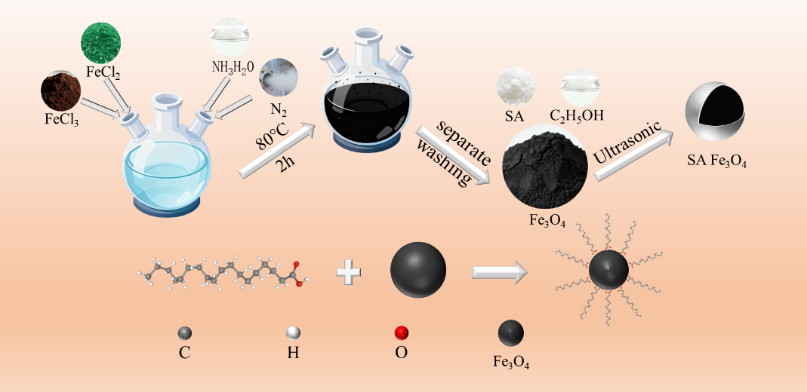
图2-1 硬脂酸修饰金属掺杂Fe3O4纳米颗粒的制备示意图

2.3 环氧树脂微球及ESP-T的制备
在380 RPM搅拌下，将0.3 g 20nm SiO2加入150 mL去离子水中制备SiO2水分散液。另称取0.9 g胍胶和0.5 g 45μm SiO2备用。将20 mL E51环氧树脂、6 g Fe3O4-乙醇混合物、1 g空心玻璃微珠和7 g T31固化剂组成的环氧预混料手动搅拌3 min均化。将预混料转移至SiO2分散液中，搅拌1 min完成乳化，随后加入45μm SiO2和胍胶稳定体系。微球形成后，产物在50°C下固化1 h，用去离子水冲洗，80°C干燥10 h。制备纯环氧微球时，用6 g 纯乙醇替代Fe3O4-乙醇混合物，胍胶用量为0.9 g。

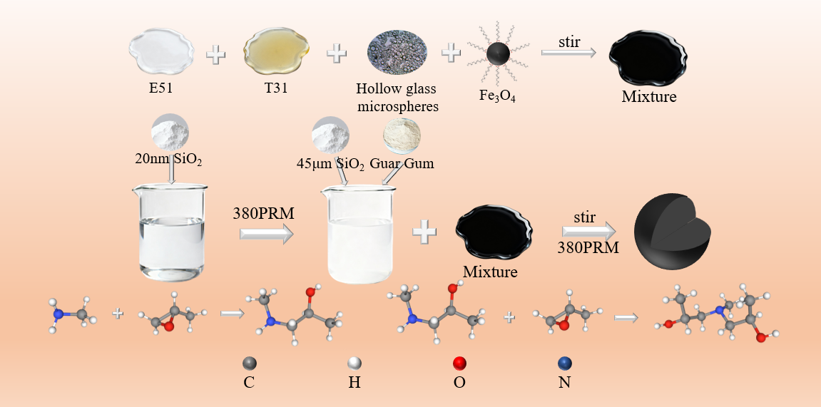
图2-2 Fe3O4封装环氧树脂支撑剂的制备示意图

2.4 表征方法
使用扫描电子显微镜（SEM，ZEISS-Sigma 500）分析纯环氧树脂微球和ESP-T的微观结构、元素组成及分布。样品在真空下溅射镀覆薄导电金属层，固定于导电胶带上，在低倍至50,000倍放大范围内观察。通过场发射电子枪激发特征X射线，在选定区域进行二维元素面扫描，以可视化支撑剂中Fe元素的分布。

使用光学显微镜（Leica DM2700P）观察纯环氧树脂微球和ESP-T的表面形貌及颗粒分散状态。采用热重分析（TGA，TA Instruments Q500，美国）评价两种支撑剂的热稳定性。测试在空气气氛中以10°C/min的升温速率在50-800°C温度范围内进行。

使用视频光学接触角分析仪（OCA20，德国）进行水接触角（WCA）测量。将压制的支撑剂薄片置于测试台上，滴加5μL去离子水于样品表面。液滴稳定后采集图像，每个样品进行五次重复测量。

采用圆度、球度、体积密度、视密度、酸溶解度和破碎率综合评价支撑剂的物理力学性能及现场适用性。通过过滤时间间接评估支撑剂的油-水导流能力。漏斗底部用200目筛网封堵以防止支撑剂泄漏同时允许水或油通过。将2.0 g支撑剂装入漏斗，加入20 mL去离子水或正十二烷，记录完全渗透所需时间。

2.5 不同温度下示踪剂释放行为
将装有100 mL正十二烷的玻璃瓶分别置于设定温度为30、60、90和120°C的恒温油浴中，随后加入5 g 40-70目ESP-T。密封玻璃瓶以防止正十二烷挥发。每隔12 h进行取样，通过电感耦合等离子体质谱（ICP-MS，PerkinElmer NexION 300X）定量分析正十二烷介质中示踪剂掺杂金属离子的浓度，据此绘制随时间变化的示踪剂释放曲线。
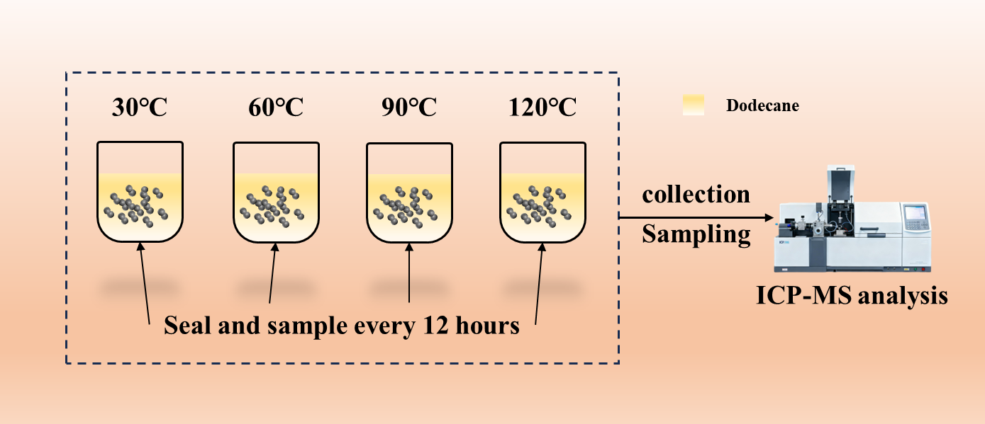
图2-3 不同温度下示踪剂释放实验装置示意图

2.6 用于生产监测的岩心驱替实验
对于ESP-T的单相油生产监测实验，使用正十二烷模拟原油，重点关注单个压裂段的稳定产油状态。采用动态驱替装置模拟水平井的动态产油行为，如图2-4所示。首先，将钢制岩心的孔隙空间充填ESP-T，岩心两端用200目金属筛网密封以防止支撑剂随流动流体迁移。随后，将充填支撑剂的钢制岩心置入岩心夹持器，施加5 MPa围压以模拟储层上覆压力。岩心夹持器入口连接恒流泵，出口连接管柱以模拟水平井水力压裂生产环境。然后将正十二烷以5 mL/min的流量泵入系统，直至管柱完全被正十二烷饱和，之后停止驱替并关闭出口阀门。系统静置96 h以促进ESP-T充分释放示踪剂。此后，以0.5 mL/min的流量注入正十二烷驱替岩心内流体，模拟目标压裂段的油生产。每4 min取样一次，每次采集2 mL流出液，共采集20组样品。通过电感耦合等离子体质谱（ICP-MS）定量分析采集样品中标记元素的浓度。

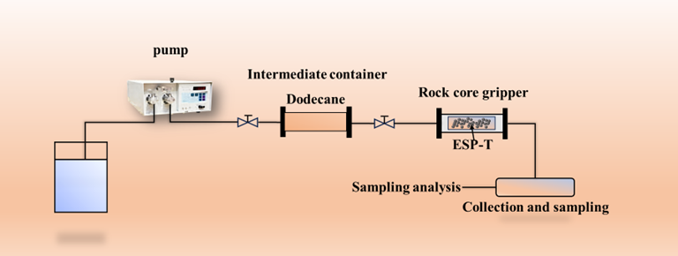
图2-4 单相油流实验装置示意图

对于油-水两相流产出流体监测实验，在整个稳态流动期间示踪剂维持在稳定释放状态（即采样监测期间不实施关井，油井持续生产）。通过调节正十二烷和水的注入速率来调控驱替流体的总两相流量和油水比，从而模拟实际的井下油水两相流条件。两相驱替装置如图2-5所示。采用三种油水体积比（4:1、1:1、1:4）和四种总两相流量（0.1、0.2、0.3、0.4 mL/min）评估支撑剂的稳态监测性能。首先，将充填支撑剂的钢制岩心置入岩心夹持器，施加5 MPa围压。随后，将正十二烷和水共同注入岩心进行流动模拟。多相驱替实验中每5 min取样一次，每次采集2 mL流出液，共采集20组样品。记录采集样品中正十二烷相与水相的体积比，最终通过电感耦合等离子体质谱（ICP-MS）定量分析标记金属元素的浓度。

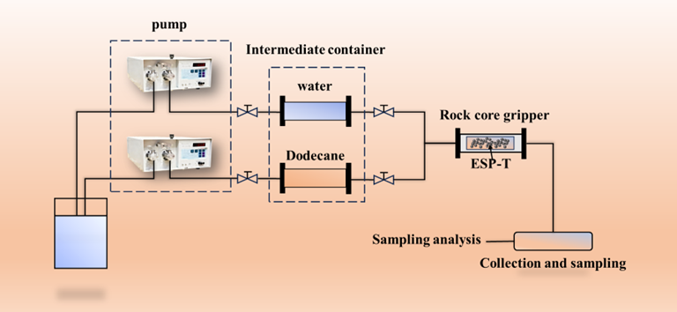
图2-5 油-水两相流实验装置示意图

3 结果与讨论

3.1 SEM表征
图3-1展示了纯环氧微球和ESP-T的SEM图像。在低倍下（图a和d），两种样品均表现出优异的球度和均匀性，无颗粒间团聚现象。无论是否添加纳米Fe3O4@SA，均能重复性获得形态良好的微球，证实乳液聚合工艺可在不受纳米填料干扰的情况下顺利进行。纯环氧表面呈现相对光滑的特征；相比之下，ESP-T表现出均匀的粗糙纹理，这是纳米填料已被掺入并改变了表面形貌的第一个迹象。

在中倍下（图b和e），差异更加明显。纯环氧微球显示细微的褶皱和凹陷，这是热固性固化过程中体积收缩的典型特征。ESP-T微球表面覆盖着微米和亚微米尺度的凸起，以离散的岛状结构而非大型团聚体形式分布。这种形貌表明nano-Fe3O4@SA以纳米团簇而非单个纳米颗粒的形式分散于环氧基质内，且硬脂酸修饰成功抑制了不受控的宏观相分离。

在高倍下（图c和f），精细结构变得清晰。纯环氧呈现致密起伏的熔岩状表面，是交联聚合物网络的典型特征。ESP-T显示与硬脂酸包裹纳米团簇对应的碎屑状形貌。关键的是，这些纳米团簇与底层环氧之间未见界面裂纹，纳米填料呈现嵌入而非仅附着于表面的状态。这种紧密结合直接证明硬脂酸的长烷基链与环氧分子链形成了物理缠结和疏水相互作用，产生了牢固的界面粘附。

系列图像揭示了以下形成路径。疏水修饰的nano-Fe3O4@SA纳米团簇在乳化后均匀分散于环氧液滴中。随着交联进行，刚性化的聚合物网络将其固定于原位。在固化收缩过程中，部分纳米团簇被挤压至表面，形成图c和f中可见的表面富集粗糙纳米结构。需要指出的是，该机制是从固化后显微观察推断得出的；要直接确认动力学路径，需要实时原位表征。

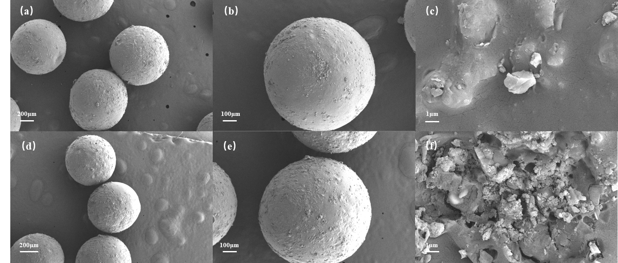
图3-1 环氧微球和Fe3O4@环氧支撑剂的SEM图像。图中上方为环氧微球，下方为Fe3O4@环氧支撑剂。(a)和(d)为多个完整微球的SEM图像，(b)和(e)为单个完整微球的SEM图像，(c)和(f)为局部SEM图像。

元素面扫描（图3-2）佐证了结构证据。Fe信号分布在整个颗粒截面上，证实nano-Fe3O4@SA存在于环氧基质内部而非仅表面。信号强度的轻微不均匀性提示存在不同的相域，与SEM中观察到的纳米团簇分散一致。综上，成像和元素数据证实了ESP-T支撑剂的成功合成。
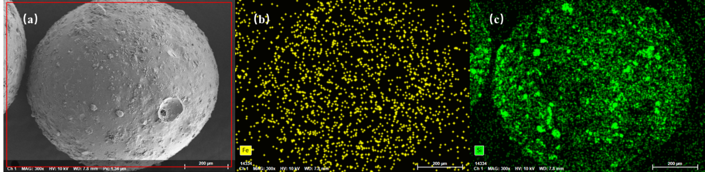
图3-2 Fe3O4@环氧树脂支撑剂的元素面扫描图像。(a) Fe3O4@环氧树脂支撑剂的SEM图像，(b) Fe元素分布，(c) Si元素分布

3.2 热稳定性
热分析（图3-3）识别出三个分解阶段。第一阶段为50-350°C，涉及5.70%的轻微失重，归因于吸附水和残留乙醇。第二阶段350-400°C构成主要分解过程：环氧网络中C-O-C和C-C键的断裂释放出CO2和小分子烃类，DTG曲线在357.27°C达到峰值，占总质量损失的72.5%。400°C以上残余质量趋于稳定；进一步失重来源于碳质残渣的氧化燃烧。最终残留物包含空心玻璃微珠、热稳定的nano-Fe3O4@SA和少量碳质组分。DSC曲线伴随分解出现短暂吸热，与DTG曲线一致。

The initial decomposition temperature of 357.27 °C is far above the temperature range encountered in oil and gas wells (typically 80-150 °C, reaching 200 °C in deep wells). Below 200 °C the material loses only trace moisture, with no detectable degradation of the epoxy matrix. This thermal margin confirms that the epoxy matrix remains structurally intact across the full operational temperature range of oil and gas wells.
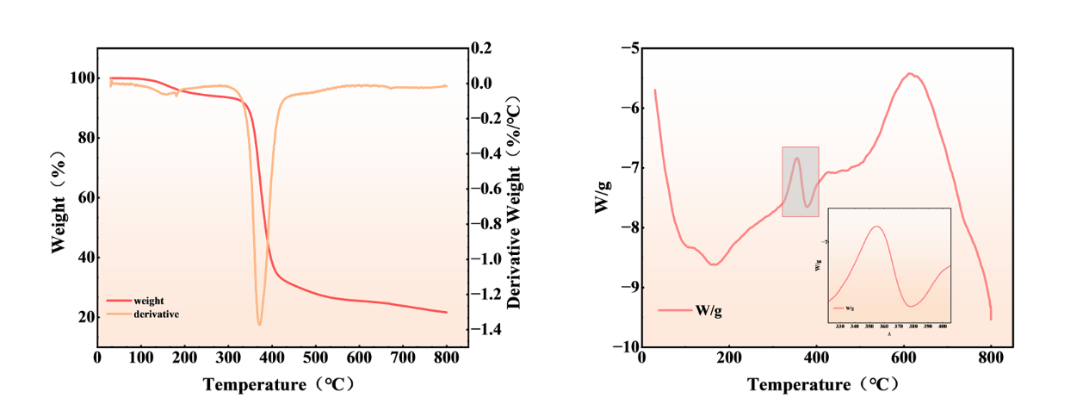
357.27°C的起始分解温度远高于油气井中遇到的温度范围（通常为80-150°C，深井可达200°C）。在200°C以下，材料仅失去微量水分，环氧基质无可检测的降解。这一热裕度证实环氧基质在油气井的整个操作温度范围内保持结构完整。

图3-3 Fe3O4@环氧树脂支撑剂的TGA/DTG和DSC曲线
Water contact angle measurements (Figure 3-4) quantify the change in surface character produced by the nanofiller. Pure epoxy microspheres give an average WCA of 72.3°, a weakly hydrophilic surface consistent with the hydroxyl groups present on epoxy chains. ESP-T yields an average WCA of 104.6°, a 32.3° increase that crosses the hydrophobic threshold. This transition is driven by the stearic acid modification: the carboxyl groups coordinate with surface hydroxyls on the nano-Fe3O4@SA, while the long alkyl chains orient outward from the epoxy matrix, forming a hydrophobic film. The surface enrichment of nanoclusters observed in SEM amplifies the effect by concentrating these alkyl chains at the proppant surface, collectively reducing the surface free energy and suppressing water spreading.

3.3 水接触角（WCA）
水接触角测量（图3-4）量化了纳米填料产生的表面特性变化。纯环氧微球的平均WCA为72.3°，为弱亲水表面，与环氧链上存在的羟基一致。ESP-T的平均WCA为104.6°，增加了32.3°，跨越了疏水阈值。这一转变由硬脂酸修饰驱动：羧基与nano-Fe3O4@SA表面的羟基配位，而长烷基链从环氧基质向外取向，形成疏水膜。SEM中观察到的纳米团簇表面富集通过将这些烷基链集中于支撑剂表面而放大这一效应，共同降低了表面自由能并抑制了水的铺展。
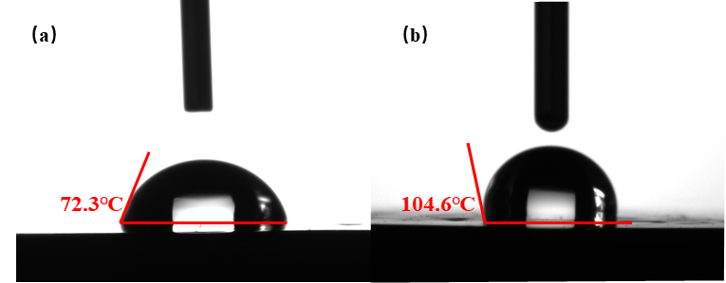
Figure 3-4 (a) WCA of epoxy resin patch (b) WCA of patch after doping with nano-Fe₃O₄@SA

图3-4 (a) 环氧树脂片的WCA (b) 掺杂nano-Fe3O4@SA后片的WCA
Figure 3-5 compares the bulk and apparent densities of the two materials. Pure epoxy microspheres have a bulk density of 0.6179 g/cm3 and an apparent density of 1.02 g/cm3; ESP-T gives 0.646 and 1.072 g/cm3, respectively. The increase reflects the higher density of nano-Fe3O4@SA (approximately 5.18 g/cm3) relative to epoxy (roughly 1.1 g/cm3). Both proppants have a bulk density below that of water, meaning they can be suspended in water-based fracturing fluids without additional suspending agents. The 0.05 g/cm3 increase in apparent density is consistent with nanoclusters filling internal pores, yielding a denser particle structure. ESP-T meets key industry specifications: sphericity and roundness exceed 0.9 (Krumbien-Sloss chart [22]), acid solubility is 3.3% (well below the 5% standard), and the crush rate at 52 MPa is 2.9%, comparable to pure epoxy microspheres (2.6%). The slight increase in crush rate is attributable to the hollow glass microspheres, which are inherently more crushable than the dense epoxy matrix; the epoxy itself retains its structural integrity after nano-Fe3O4@SA incorporation.

3.4 物理力学性能
图3-5对比了两种材料的体积密度和视密度。纯环氧微球的体积密度为0.6179 g/cm³，视密度为1.02 g/cm³；ESP-T分别为0.646和1.072 g/cm³。增加反映了nano-Fe3O4@SA较高的密度（约5.18 g/cm³）相对于环氧（约1.1 g/cm³）。两种支撑剂的体积密度均低于水的密度，意味着它们可在水基压裂液中自悬浮而无需额外的悬浮剂。视密度增加0.05 g/cm³与纳米团簇充填内部孔隙、形成更致密的颗粒结构一致。ESP-T满足关键的行业标准：球度和圆度超过0.9（Krumbien-Sloss图[22]），酸溶解度为3.3%（远低于5%标准），52 MPa下破碎率为2.9%，与纯环氧微球（2.6%）相当。破碎率的轻微增加可归因于空心玻璃微珠，其本身比致密环氧基质更易破碎；掺入nano-Fe3O4@SA后环氧本身仍保持结构完整性。
Figure 3-5 Bulk density and apparent density of epoxy microspheres and ESP-T

图3-5 环氧微球与ESP-T的体积密度和视密度
The oil and water transport behavior of the proppant pack was assessed indirectly by measuring the time required for each fluid to pass through a packed bed (Figure 3-6, Table 3-1). Pure epoxy microspheres pass water in 2 min 53 s; ESP-T requires 28 min 41 s, a nearly tenfold increase. The hydrophobic surface impedes water from spreading through the inter-particle pores. The trend reverses for oil: pure epoxy passes dodecane in 15 min 11 s, while ESP-T does so in 5 min 11 s, a 66% reduction. The hydrophobic surface is compatible with the oil phase, allowing rapid spreading and low flow resistance. ESP-T thus functions as a water-resistant, oil-permeable medium: in a formation containing both phases, the proppant pack favors oil flow toward the wellbore while restricting water, a characteristic that helps mitigate water channeling.

3.5 支撑剂充填层导流能力
通过测量各流体通过充填床所需的时间间接评估了支撑剂充填层的油水输运行为（图3-6，表3-1）。纯环氧微球的水通过时间为2分53秒；ESP-T需要28分41秒，增加了近十倍。疏水表面阻碍水在颗粒间孔隙中的铺展。对于油相则趋势相反：纯环氧的正十二烷通过时间为15分11秒，而ESP-T仅需5分11秒，降低了66%。疏水表面与油相亲和，可实现快速铺展和低流动阻力。因此，ESP-T具有拒水透油的介质功能：在同时存在两相的地层中，支撑剂充填层有利于油流向井筒同时限制水相，这一特性有助于缓解水窜。
(a)(b) before and after water passing through epoxy resin microspheres, (c)(d) before and after oil passing through epoxy resin microspheres, (e)(f) before and after water passing through ESP-T, (g)(h) before and after oil passing through ESP-T.
图3-6 环氧树脂微球与ESP-T的油水渗透性测试
(a)(b) 水通过环氧树脂微球前后，(c)(d) 油通过环氧树脂微球前后，(e)(f) 水通过ESP-T前后，(g)(h) 油通过ESP-T前后。
 | ESP-T | Epoxy resin microspheres
Water passage time | 28:41 | 2:53
Oil passage time | 5:11 | 15:11

表3-1 油水通过时间
Reservoir temperature increases with depth, and because the release of tracer from the epoxy matrix is a diffusion-controlled process, temperature directly affects the release rate. Figure 3-7(a) shows the release profiles of ESP-T in dodecane at 30, 60, 90, and 120 °C, plotted as normalized concentration C/C0 versus time. Release accelerates with temperature at all time points. The release rate is highest during the first 24 hours of fluid contact and then decays gradually (Figure 3-7c). At 120 °C, cumulative release over 14 days remains well above the ICP-MS detection threshold, confirming that ESP-T can sustain a measurable tracer signal over timescales relevant to long-term monitoring.

$$\begin{aligned}\frac{C}{C_{0}}=Kt^{n}\#\left(1\right)\end{aligned}$$3.6 不同温度下示踪剂释放行为
储层温度随深度增加而升高，且由于示踪剂从环氧基质中的释放是一个扩散控制过程，温度直接影响释放速率。图3-7(a)显示了ESP-T在正十二烷中30、60、90和120°C下的释放曲线，以归一化浓度C/C0对时间作图。释放速率在所有时间点均随温度升高而加快。释放速率在与流体接触的前24小时内最高，随后逐渐衰减（图3-7c）。在120°C下，14天的累积释放量远高于ICP-MS检测阈值，证实ESP-T可在长期监测相关的时间尺度内维持可测示踪信号。
C = tracer concentration at time t (mg/L);
C₀ = maximum (equilibrium) release concentration (mg/L);
K = kinetic rate constant;
t = release time (h);
n = diffusion exponent (dimensionless).

The K-P model, a power-law formulation developed by Korsmeyer and Peppas [23], is widely employed to characterize release kinetics from controlled-release systems. It captures two mechanisms: Fickian diffusion, in which species migrate down a concentration gradient according to Fick's laws, and Case-II relaxation, in which polymer swelling upon contact with the release medium increases internal porosity and facilitates escape of entrapped species. For spherical carriers, the diffusion exponent n identifies the dominant mechanism: n <= 0.43 corresponds to Fickian-diffusion-controlled release, 0.43 < n < 0.85 indicates anomalous transport co-governed by both mechanisms, and n >= 0.85 corresponds to Case-II-relaxation-controlled release [24].

K-P模型是由Korsmeyer和Peppas[23]提出的幂律公式，广泛用于表征控释体系的释放动力学。它涵盖两种机制：Fick扩散——物种沿浓度梯度按Fick定律迁移；以及Case-II松弛——聚合物与释放介质接触后发生溶胀，增大内部孔隙率并促进包埋物种的逸出。对于球形载体，扩散指数n指示主导机制：n≤0.43对应Fick扩散控制释放，0.43<n<0.85表示两种机制共同控制的异常输运，n≥0.85对应Case-II松弛控制释放[24]。

在各温度下于Mt/Minf<0.6的有效范围内对释放数据进行K-P模型拟合（图3-7b，表3-2）。在此窗口内，速率常数K从30°C的0.055系统性地增加至120°C的0.196，与扩散和聚合物松弛的热激活性质一致。所有拟合n值均在0.45-0.85范围内，对应于Fick扩散和Case-II松弛共同控制的异常输运。在该范围内各温度下R²均超过0.94。需要指出的是，K-P模型作为幂律公式缺乏上渐近线，严格仅适用于早期至中期释放阶段（Mt/Minf<0.6）。图3-7(a)中展示的14天外推C/C0值超出1是为了展示完整实验时间进程，不用于定量参数估计。

由此呈现的物理图景是溶剂驱动的溶胀过程。正十二烷分子渗透进入交联环氧网络，形成内部玻璃芯和外部凝胶层的双重结构。溶胀降低了聚合物链缠结，创造扩大的输运通道，示踪剂通过这些通道扩散至外部介质。温度升高增强了溶剂渗透性，加速溶胀，弱化网络内分子间作用力，扩大了可供示踪剂扩散的孔隙尺寸。这一机制同时解释了K的温度依赖性和n值所反映的Fick/Case-II混合特征。
Figure 3-7 (a) Release curves of ESP-T at different temperatures (b) K-P model fitting curves (c) Release rate change curves of ESP-T

图3-7 (a) ESP-T在不同温度下的释放曲线 (b) K-P模型拟合曲线 (c) ESP-T释放速率变化曲线
K-P model |  | C/C₀ =Kt^{n}
Fit parameters |  | release temperature
 | 30°C |  | 60°C | 90°C | 120°C
R² | 0.95489 |  | 0.9649 | 0.95599 | 0.94537
K | 0.05538 |  | 0.08177 | 0.11344 | 0.19642
n | 0.59827 |  | 0.66646 | 0.5684 | 0.55569

表3-2 K-P模型拟合参数
A tracer breakthrough curve carries more information than a single concentration value. Two processes contribute to the shape observed at the wellhead. The first is straightforward: tracer that accumulated in the proppant pack during shut-in is swept out when the well opens, producing a pulse that rises and falls as the slug passes the sampling point. The second is slower and less obvious: residual tracer continues to diffuse out of the epoxy matrix long after the main slug has passed, feeding a sustained, low-level signal into the produced oil. These two contributions overlap in time, and neither can be isolated by simply reading the concentration curve.
We separate them by modeling the transport from first principles. The one-dimensional advection-dispersion equation governs the evolution of tracer concentration along the production tubing, with the mean flow velocity v = 4Q/(pi d^2) and the dispersion coefficient D = alpha v. For the shut-in slug the classical instantaneous-injection solution [25] gives a Gaussian pulse. For the sustained release the continuous-source solution gives an erfc form. We blend the two with a tanh weight, w(t) = 1/2 [1 + tanh((t - t0)/sigma)], which shifts smoothly from the pulse-dominated early period to the diffusion-dominated tail. The full model, C(t) = cb + w(t) C_rise + [1 - w(t)] C_fall, is Eq. (2). The parameter sigma is fixed at the sampling interval (4 min); the remaining six parameters are discussed below.

3.7 示踪剂突破曲线建模与单相验证
$$\begin{aligned}C\left(t\right)= w\left(t\right)·C_{rise}\left(t\right)+ \left[1-w\left(t\right)\right]·C_{fall}\left(t\right)\end{aligned}(2)$$示踪剂突破曲线所携带的信息远超单一浓度值。两种过程共同构成了井口观测到的曲线形状。第一种是直接的：关井期间聚集在支撑剂充填层中的示踪剂在开井时被扫出，随着段塞通过采样点形成一个先升后降的脉冲。第二种过程较慢且不那么明显：在主段塞通过之后很长时间，残余示踪剂持续从环氧基质中扩散出来，向产出油中馈入一个持续的低浓度信号。这两种贡献在时间上重叠，仅凭读取浓度曲线无法将二者分离。
我们从第一性原理出发通过建模实现二者的分离。一维对流-弥散方程控制着示踪剂沿生产管柱的浓度演化，平均流速v=4Q/(πd²)，弥散系数D=αv。对于关井段塞，采用经典的瞬时注入解[25]，得到高斯脉冲形式。对于持续释放，采用连续源解，得到erfc形式。我们使用tanh权重函数w(t)=1/2[1+tanh((t-t0)/σ)]将二者融合，该函数从脉冲主导的早期阶段平滑过渡到扩散主导的拖尾阶段。完整模型C(t)=cb+w(t)C_rise+[1-w(t)]C_fall为式(2)。参数σ固定在采样间隔（4 min）；其余六个参数讨论如下。
$$C_{rise}\left(t\right)= c_{b} + \frac{A·d}{\sqrt{16αQt}} exp\left[-\frac{{\left(xπd^{2}- 4Qt\right)}^{2}}{16αQtπd^{2}}\right]\#(2a)$$
$$\begin{aligned}C_{fall}\left(t\right)= c_{b} + \frac{a}{2} erfc\left(\frac{4Qt - xπd^{2}}{\sqrt{16αQtπd^{2}}}\right)\end{aligned}(2b)$$
$$\begin{aligned}w\left(t\right)= \frac{1}{2} \left[1 + tanh\left(\frac{t_{0}- t}{σ}\right)\right]\end{aligned}(2c)$$

where:
cb = tail-plateau concentration (dimensionless);
A, a = amplitude coefficients for the shut-in slug (A) and sustained matrix release (a);
α = longitudinal dispersivity (cm);
Q = effective oil-phase flow rate (cm³/min);
t₀ = crossover center time (min);

Figure 3-8(b) shows the fit to a single-phase breakthrough curve; Table 3-3 lists the fitted values. The match is close (R2 = 0.9939, RMSE = 0.0210), but what matters more is that the recovered parameters make physical sense. The model returns an effective flow rate Q = 0.46 mL/min; the pump was set to 0.50 mL/min, an 8% difference. The mean residence time from the fit, MRT = 37.4 min, is within 3% of the convective travel time x/v = 38.6 min calculated from the known tubing length and flow velocity. The Peclet number Pe = x/alpha = 0.934 sits near unity, the regime expected for a gradual-release source where neither advection nor dispersion dominates. This value is consistent with the non-Fickian release mechanism identified via Korsmeyer-Peppas kinetics (n = 0.45-0.85, R2 > 0.94 within Mt/Minf < 0.6; Section 3.6).
To evaluate whether the added complexity of the dual-component model is justified, four simpler alternatives were fitted under identical protocols: a pure Gaussian pulse, a pure erfc tail, an exponential decay, and the Korsmeyer-Peppas power law (detailed statistics in Table S1). None captures both the sharp peak and the extended tail simultaneously. The single Gaussian (R2 = 0.948) underestimates concentrations beyond 50 min, while the single erfc (R2 = 0.716) cannot reproduce the rising limb. The dual-component formulation is strongly preferred (Delta AICc = 32.7, F-test p < 0.0001).
Integrating C_rise and C_fall separately reveals that 47% of the total signal area belongs to the erfc tail. Nearly half the tracer detected at the wellhead comes not from the shut-in slug but from the slow, sustained release that continues throughout production. This decomposition is robust to the choice of the tanh transition width: varying sigma across a six-fold range shifts the tail contribution by less than one percentage point (46.8-47.5%; Table S2). The operational implication is that a single shut-in followed by continuous sampling captures the essential monitoring information; repeated shut-in cycles are unnecessary. The tail-plateau concentration cb, fitted as a constant in this single-temperature experiment, reflects the steady-state diffusion flux that Section 3.6 showed to be thermally activated (K rising from 0.055 at 30 °C to 0.196 at 120 °C). One would therefore expect cb to be higher in hotter wells, a prediction testable with multi-temperature breakthrough data.
Table 3-3 Fitted Parameters of the Piecewise ADE Model and Derived Transport Properties
Parameter | Value | Unit
R² | 0.9939 | —
RMSE | 0.0210 | —
Fitted flow rate Q | 0.46 | mL·min⁻¹
Pump-set flow rate | 0.50 | mL·min⁻¹
Mean flow velocity v | 2.59 | cm·min⁻¹
Longitudinal dispersivity α | 107.1 | cm
Mean residence time MRT | 37.4 | min
Convective travel time x/v | 38.6 | min
Erfc tail signal fraction | 47 | %
图3-8(b)展示了模型对单相突破曲线的拟合；表3-3列出了拟合值。拟合吻合度较高（R²=0.9939，RMSE=0.0210），但更重要的是恢复的参数具有物理合理性。模型返回的有效流量Q=0.46 mL/min；泵设定为0.50 mL/min，相差8%。拟合得到的平均停留时间MRT=37.4 min，与根据已知管柱长度和流速计算的对流输运时间x/v=38.6 min相差3%以内。由拟合弥散度导出的Peclet数Pe=x/α=0.934接近1，这是渐变释放源预期的状态——对流和弥散均不占主导——且与通过Korsmeyer-Peppas动力学识别的非Fick释放机制一致（n=0.45-0.85，在Mt/Minf<0.6范围内R²>0.94；第3.6节）。
为评估双组分模型增加的复杂度是否合理，在相同优化协议下拟合了四种简化替代模型：纯高斯脉冲、纯erfc拖尾、指数衰减和Korsmeyer-Peppas幂律（详细统计见表S1）。无一能同时捕获尖锐的峰值和延长的拖尾。单高斯模型（R²=0.948）系统性地低估了50 min之后的浓度，而单erfc模型（R²=0.716）无法重现上升段。双组分模型在统计上显著优于替代模型（ΔAICc=32.7，F检验p<0.0001）。
分别积分C_rise和C_fall显示，总信号面积的47%属于erfc拖尾。井口检测到的示踪剂中近一半并非来自关井段塞，而是来自整个生产过程中持续缓慢的释放。这一分解结果对tanh过渡宽度的选择具有稳健性：将σ在六倍范围内变化，拖尾占比的变化不到一个百分点（46.8%-47.5%；表S2）。其操作含义是：一次关井后连续采样即可捕获必要的监测信息，无需反复关井。尾台浓度cb在本恒温实验中作为常数拟合，反映了第3.6节所示的热激活稳态扩散通量（K从30°C的0.055升至120°C的0.196）；因此可以预期cb在更热的井中会系统性地升高——这是一个可通过多温度突破曲线实验检验的预测。
表3-3 分段ADE模型的拟合参数及导出输运性质
Three independent checks converge on a physically coherent picture: the 8% agreement between fitted and set flow rates, the 3% agreement between fitted and calculated residence times, and the Peclet number near unity. This consistency is not a trivial outcome of multi-parameter curve-fitting; it indicates that the model recovers physically meaningful relationships. The 47% tail contribution has a direct operational consequence: if nearly half the signal comes from sustained release, a single shut-in followed by continuous sampling captures the essential information; there is no need for repeated shut-in cycles. The tail-plateau concentration cb, fitted as a constant in this single-temperature experiment, reflects the steady-state diffusion flux that Section 3.6 showed to be thermally activated (K rising from 0.055 at 30 °C to 0.196 at 120 °C). One would expect cb to be higher in hotter wells, a prediction testable with multi-temperature field data.
图3-8 (a) ESP-T单相流监测的示踪剂释放生产曲线 (b) ESP-T示踪剂释放模型拟合曲线 (c) 泵设定流量与拟合流量对比

三项独立检验汇聚成一个物理上自洽的图景：拟合流量与设定流量8%的吻合度、拟合停留时间与计算停留时间3%的吻合度，以及接近1的Peclet数。这种一致性并非多参数曲线拟合的平凡结果；它表明模型恢复了具有物理意义的关系而非简单地适应数据。47%的拖尾贡献具有直接的操作意义：如果近一半信号来自持续释放，那么一次关井后连续采样即可捕获必要信息，无需反复关井。尾台浓度cb在本恒温实验中作为常数拟合，反映了第3.6节所示的热激活稳态扩散通量（K从30°C的0.055升至120°C的0.196）；可以预期cb在更热的井中会更高——这是一个可通过多温度现场数据检验的预测。
A fractured well does not produce single-phase oil indefinitely. Formation water eventually breaks through, and the produced fluid becomes a mixture whose oil fraction varies from stage to stage and from month to month. The question is whether the analysis developed above, tested so far on single-phase flow, remains useful when both oil and water are moving through the proppant pack. We examined this with steady-state core displacement experiments at three oil-water ratios (OWR = 4:1, 1:1, 1:4) and four total flow rates (0.1-0.4 mL/min). Direct observation of the effluent at OWR = 1:1 showed a higher oil fraction early in the displacement, consistent with the oil-permeable character of ESP-T documented in Section 3.5.

3.8 两相流生产监测
压裂井不会无限期地产出单相油。地层水最终会突破，产出流体变为混合物，其含油比例因段而异、因时而变。问题是上述仅对单相流验证的分析方法，在油和水同时通过支撑剂充填层时是否仍然有用。我们以三种油水比（OWR=4:1、1:1、1:4）和四种总流量（0.1-0.4 mL/min）的稳态岩心驱替实验对此进行了考察。在OWR=1:1时直接观察流出物发现驱替早期油相比例较高，与第3.5节记录的ESP-T亲油特性一致。
The way around this is to work with tracer flux rather than concentration. We define FO as the mass of tracer passing the sampling point per unit time, the product of the oil-phase tracer concentration and the oil volumetric flow rate. Because FO equals the release rate from the ESP-T pack [8], it strips out the dilution effect and reflects only what the proppant is actually releasing. Figure 3-9(b) confirms that the logic holds: FO increases with OWR, as expected when more oil contacts the proppant surface, but it does not depend on total flow rate. The proppant releases tracer at a rate set by the oil-wetted area, not by how fast fluid sweeps past it.

解决这一问题的方法是使用示踪剂通量而非浓度。我们定义FO为单位时间通过采样点的示踪剂质量，即油相示踪剂浓度与油体积流量的乘积。在稳态条件下FO等于ESP-T充填层的释放速率[8]，因此剥离了稀释效应而仅反映支撑剂的实际释放量。图3-9(b)证实了这一逻辑：FO随OWR增大而增加——正如更多油接触支撑剂表面时所预期的——但与总流量无关。支撑剂释放示踪剂的速率取决于油润湿面积，而非流体冲刷的快慢。

关键检验在于FO能否转化为产量。图3-9(c)将两相实验中的FO以单相油驱替中测得的稳态FO（3.187±0.15 μg/min，三次重复测量的均值±标准差）进行归一化，并将结果与各OWR下已知的油流量进行比较。二者吻合良好（Pearson r=0.97，p=0.006；RMSD=8.3%），证实即使有水相存在，只要已知总流量，即可从FO恢复标记层段的油产量。FO-产量转换的主要不确定性来源于稳态FO校准的重复性（±4.7%），该值应在部署前针对每个ESP-T批次和目标温度进行测定。

本研究的若干边界界定了当前实验室验证与现场部署之间的距离，值得仔细考量。模型假设单一压裂段具有均匀的支撑剂充填层；在实际生产井中，多个层段的示踪信号在井口重叠，需要本文未涉及的多示踪剂解卷积策略。裂缝内支撑剂分布本身就非均匀，这种空间非均质性对局部释放速率和局部流场均产生影响，而当前一维公式无法分辨。FO校准（25°C下3.187 μg/min）是在稳态实验中获得的；启动、关井和快速抽汲等非稳态条件可能导致稳态FO-产量关系出现偏差，且第3.6节记录的温敏性意味着必须针对目标储层温度重新建立校准。正十二烷虽能实现良好的实验室受控测量，但它是一种清洁模型油；原油中含有沥青质、胶质及其他表面活性组分，可能通过竞争吸附和粘度效应改变环氧基质的润湿行为和扩散动力学。环氧基质和硬脂酸包覆层的长期化学稳定性目前仅在正十二烷中验证至120°C；在H2S、CO2、高矿化度盐水（>200,000 ppm TDS）以及150°C以上温度中的稳定性尚未评估，值得开展专项研究。单相突破曲线的拟合虽紧密但仅基于单次实验；重复实验和独立数据集的交叉验证将增强对模型预测能力的信心。这些局限并不否定本文所展示的框架，而是明确了从实验室概念验证推进至现场应用所需的工作范围。
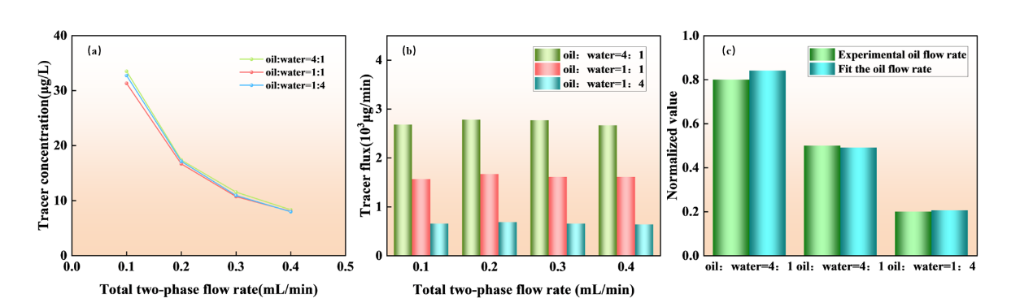
综合而言，单相和两相结果共同勾勒出一个可操作的实验室尺度方法：以井口浓度历史为输入，通过统计验证的分解将关井脉冲与持续拖尾分离，返回与独立测量相符的有效流量。信号分解对过渡宽度选择具有稳健性（表S2），双组分模型结构是必要的而非仅属便利（表S1），相同的通量基框架无需修改即可兼容单相和两相流——只需从浓度切换至FO。将该方法扩展至含原油的多段、多温度条件是迈向可现场部署的生产监测工具的必要下一步。

图3-9 (a) 示踪剂浓度随油水比和两相总流量的变化 (b) 示踪剂通量随油水比和两相总流量的变化 (c) 0.1 mL/min流量下不同油水比的示踪剂通量与设定流量对比

4. Conclusions
在现场应用中，每个压裂段将注入掺杂不同金属（Mn、Zn、Cu等）的ESP-T颗粒，形成化学编码示踪剂，可在油井全生命周期内持续有效。一次关井后，根据模型由井筒几何尺寸和估算流速预测的脉冲到达时间，按一定间隔在井口对产出流体进行采样。各段的拟合Q值将标记出表现不佳的层段。由于FO与总流量无关，持续数月或数年的定期采样可追踪各段贡献的演变。某段的Q值比相邻段下降更快可能意味着裂缝正在闭合或结垢；而在其他段递减时保持平稳的段则可能值得重复压裂。所有这一切均无需井下工具或额外的关井操作。示踪剂已在裂缝中，模型提供了解释。

4 结论
本研究针对的核心挑战是示踪剂释放动力学（通过批次实验测量并采用经验模型拟合）与井口示踪剂突破信号的定量解释之间的脱节。我们通过建立双组分输运模型（将突破曲线通过光滑tanh过渡分解为高斯脉冲和erfc拖尾）和设计亲油型环氧树脂/Fe3O4示踪支撑剂（ESP-T）作为验证平台来应对这一挑战。

在建模方面，双组分分析在单相突破曲线上实现了R²=0.9939的拟合精度，且通过AICc（ΔAICc=32.7）和F检验（p<0.0001）在统计上显著优于单组分替代模型。erfc拖尾占积分信号的47%，且该结果对过渡宽度的选择具有稳健性（六倍变化范围内为46.8%-47.5%；表S2）。拟合流量（0.46 mL/min）与独立设定的泵值（0.50 mL/min）吻合度在8%以内；拟合停留时间（37.4 min）与计算输运时间（38.6 min）相差3%；Peclet数（0.934）与Korsmeyer-Peppas动力学推断的非Fick机制一致。在稳态两相流条件下，示踪剂通量可在不同油水比下追踪油产量（r=0.97，RMSD=8.3%），为从示踪剂浓度数据到实验室尺度逐段油产量提供了途径。

ESP-T支撑剂作为该模型的支撑平台，展现出适合井下部署的性能特征。硬脂酸修饰赋予其亲油特性：水接触角从72.3°升至104.6°，油过滤时间降低66%，水过滤时间增加近十倍。热分析证实其在357°C下结构完整，在200°C以下仅失去微量水分。体积密度（0.646 g/cm³）低于水密度，可在压裂液中自悬浮，而破碎率（52 MPa下2.9%）和酸溶解度（3.3%）均满足超轻质支撑剂的行业标准。表S3提供了ESP-T与已报道示踪支撑剂的定量对比。

综上所述，材料和建模两方面的贡献在单段实验室尺度上建立了一个框架，将受基质扩散动力学控制的持续示踪剂释放与观测到的突破信号定量关联，并最终与逐段产量分配对接。目前的验证仅限于使用正十二烷作为模型油的单段实验。将该方法扩展至含原油的现场尺度、多段、多相条件，并确立相应的操作可靠性，是实现实际部署的必要下一步。
[1] MONTGOMERY S L, JARVIE D M, BOWKER K A, et al. Mississippian Barnett Shale, Fort Worth basin, north-central Texas: Gas-shale play with multi-trillion cubic foot potential [J]. AAPG Bulletin, 2005, 89(2): 155-175.
[2] WANG L, TIAN Y, YU X, et al. Advances in improved/enhanced oil recovery technologies for tight and shale reservoirs [J]. Fuel, 2017, 210: 425-445.
[3] MOHR S H, WANG J, ELLEM G, et al. Projection of world fossil fuels by country [J]. Fuel, 2015, 141: 120-135.
[4] CHONG Z R, YANG S H B, BABU P, et al. Review of natural gas hydrates as an energy resource: Prospects and challenges [J]. Applied Energy, 2016, 162: 1633-1652.
[5] IEA. World Energy Outlook 2024 [R]. Paris: International Energy Agency, 2024.
[6] BARATI R, LIANG J T. A review of fracturing fluid systems used for hydraulic fracturing of oil and gas wells [J]. Journal of Applied Polymer Science, 2014, 131(16): 40735.
[7] MEDEIROS F, KURTOGLU B, OZKAN E, et al. Analysis of production data from hydraulically fractured horizontal wells in shale reservoirs [J]. SPE Reservoir Evaluation & Engineering, 2010, 13(3): 559-568.
[8] PATIDAR A K, JOSHI D, DRISTANT U, et al. A review of tracer testing techniques in porous media specially attributed to the oil and gas industry [J]. Journal of Petroleum Exploration and Production Technology, 2022, 12(12): 3339-3356.
[9] SANNI M, AL-ABBAD M, KOKAL S, et al. Pushing the envelope of residual oil measurement: A field case study of a new class of inter-well chemical tracers [J]. Journal of Petroleum Science and Engineering, 2018, 163: 538-545.
[10] SILVA M, STRAY H, BJORNSTAD T. Stability assessment of PITT tracer candidate compounds - The case of pyrazines [J]. Journal of Petroleum Science and Engineering, 2019, 182: 106269.
[11] WATKINS J W, MARDOCK E S. Use of radioactive iodine as a tracer in water-flooding operations [J]. Journal of Petroleum Technology, 1954, 6(9): 117-124.
[12] YANG H, GUO K, LIN L, et al. Application of micro-substance tracer test in fractured horizontal wells [J]. Journal of Petroleum Exploration and Production Technology, 2024, 14(5): 1235-1246.
[13] SHOOK G M, POPE G A, ASAKAWA K. Determining reservoir properties and flood performance from tracer test analysis [C]. SPE 124614, SPE Annual Technical Conference and Exhibition, New Orleans, 2009.
[14] FONTALVO E M, OLIVEIRA M C, SCHOEGGL F, et al. Physical interpretation of interwell partitioning tracer tests for estimation of remaining oil saturation in layered carbonate reservoirs [J]. Transport in Porous Media, 2025, 152: 21-45.
[15] LIU J, WANG H, ZHANG T, et al. Study on interpretation method of multistage fracture tracer flowback curve in tight oil reservoirs [J]. ACS Omega, 2024, 9: 10852-10864.
[16] TIAN W, DARNLEY A, DEMPSEY D. Quantifying fracture interference and allocating load recovery and hydrocarbon production in various well configuration using chemical tracers [C]. SPE-201292-MS, SPE Annual Technical Conference and Exhibition, Virtual, 2020.
[17] GONG Z, LI N, QIN M, et al. Magnetic nano-Fe₃O₄-based oleophilic tracer for stability studies of nano-tracer in oilfields condition [J]. Colloids and Surfaces A: Physicochemical and Engineering Aspects, 2024, 683: 133085.
[18] KRUMBEIN W C, SLOSS L L. Stratigraphy and Sedimentation [M]. 2nd ed. San Francisco: W.H. Freeman and Company, 1963.
[19] RITGER P L, PEPPAS N A. A simple equation for description of solute release I. Fickian and non-Fickian release from non-swellable devices in the form of slabs, spheres, cylinders or discs [J]. Journal of Controlled Release, 1987, 5(1): 23-36.
[20] PEPPAS N A, SAHLIN J J. A simple equation for the description of solute release. III. Coupling of diffusion and relaxation [J]. International Journal of Pharmaceutics, 1989, 57(2): 169-172.
[21] VAN GENUCHTEN M T, ALVES W J. Analytical solutions of the one-dimensional convective-dispersive solute transport equation [R]. USDA Technical Bulletin No. 1661, U.S. Department of Agriculture, 1982.
[22] LI J, JIANG H, WANG B, et al. Tracer flowback modeling and characterization of complex fracture networks in multi-fractured horizontal wells [J]. Journal of Natural Gas Science and Engineering, 2022, 98: 104987.
[23] ZHAO B, PANTHI K, MOHANTY K K. Tracer eluting proppants for hydraulic fracture characterization [J]. Journal of Petroleum Science and Engineering, 2020, 190: 107048.
[24] ZHOU Y, LIU H, GAO J, et al. Coated proppants with self-suspension and tracer slow-release functions [J]. Journal of Petroleum Science and Engineering, 2022, 208: 109645.
[25] LI N, CHENG Q, GONG Z, et al. Release kinetics of rare earth tracer from polymer-coated proppants for hydraulic fracture analysis [J]. Geoenergy Science and Engineering, 2023, 227: 211782.
[26] GONG Z, LI N, KANG W, et al. Novel oleophilic tracer-slow-released proppant for monitoring the oil production contribution [J]. Fuel, 2024, 364: 130945.
[27] WANG G, MA Q, REN L, et al. A comprehensive review of multifunctional proppants [J]. ACS Omega, 2024, 9(44): 44120-44133.
[28] KRISHNAN M R, LI W, ALHARBI B, et al. In-situ high-strength poly(styrene-methyl methacrylate)-2D nanofiller composite microbeads as potential proppants in hydraulic fracturing [J]. Geoenergy Science and Engineering, 2025, 257: 214195.
[29] GUO X, WEI K, NI T, et al. Preparation and performance analysis of polyethylene glycol/epoxy resin composite phase change material [J]. Journal of Energy Storage, 2024, 88: 111525.
[30] LIANG C, LUO W, YAN C, et al. Ultra-lightweight proppant synthesized from PMMA/pine bark composite: Low-cost material and outstanding properties [J]. Chemistry Letters, 2016, 45(8): 994-996.
[31] ZOVEIDAVIANPOOR M, GHARIBI A, BIN JAAFAR M Z. Experimental characterization of a new high-strength ultra-lightweight composite proppant derived from renewable resources [J]. Journal of Petroleum Science and Engineering, 2018, 170: 1038-1047.
[32] SABINS F, APBLETT A, SHAFER R, et al. Epoxy resin exhibits long-term durability and chemical stability as a well sealant [C]. SPE-204374-MS, SPE International Conference on Oilfield Chemistry, The Woodlands, Texas, 2021.
[33] LI H, LIU Z, LI Y, et al. Evaluation of the release mechanism of sustained-release tracers and its application in horizontal well inflow profile monitoring [J]. ACS Omega, 2021, 6(29): 19269-19280.
[34] WEI M, WANG Y, DUAN Y, et al. Screening and performance evaluation of epoxy resin long-term sustained-release solid tracer [J]. International Journal of Oil, Gas and Coal Technology, 2024, 36(2): 170-196.

