CITY UNIVERSITY OF SCIENCE AND INFORMATION TECHNOLOGY, PESHAWAR
Department of Software Engineering
SOFTWARE REQUIREMENTS SPECIFICATION

KhyberSole E-Commerce Platform
with AI-Powered Foot Size Measurement System
Project Type: Final Year Project (FYP)
Version: 1.0
Date: October 2026
Status: Final Submission
Prepared By:
Mudassir Munir -- 14879
Muhammad Danyal -- 14998
Supervised By:
Kashif Tufail

Revision History
Version | Date | Author(s) | Description of Change
0.1 | September 2026 | Development Team | Initial draft: scope, stakeholder, and system overview
0.5 | September 2026 | Development Team | Added functional requirements, use-case diagrams, and ERD
1.0 | October 2026 | Development Team | Final: complete SRS with all diagrams, NFRs, and appendices
1.1 | October 2026 | Development Team | Updated AI Foot Size Finder model specifications: custom-trained YOLOv8 instance segmentation model (best.pt), PCA anatomical landmark extraction (calcaneus heel to longest toe apex), reference homography calibration, and high-resolution photo upload pipeline.
Table 1 - Document Revision History

Table of Contents
1. Introduction
1.1 Purpose
1.2 Document Conventions
1.3 Intended Audience
1.4 Project Scope
1.5 References
2. Overall Description
2.1 Product Perspective
2.2 Product Features Summary
2.3 User Classes
2.4 Operating Environment
2.5 Design and Implementation Constraints
2.6 Assumptions and Dependencies
3. System Features (Functional Requirements)
3.1 Customer-Facing Features
3.2 Admin Panel Features
3.3 AI Foot Size Finder
3.4 Outfit Matcher
3.5 Payment and Promo Code Management
4. External Interface Requirements
4.1 User Interfaces
4.2 Hardware Interfaces
4.3 Software Interfaces
4.4 Communication Interfaces
5. Non-Functional Requirements
5.1 Performance
5.2 Security
5.3 Reliability and Availability
5.4 Scalability
5.5 Maintainability
5.6 Usability
6. System Models and Diagrams
6.1 Context Diagram (Level-0 DFD)
6.2 Level-1 DFD - Customer Subsystem
6.3 Use Case Diagram
6.4 Entity-Relationship Diagram
6.5 System Architecture Diagram
6.6 Sequence Diagram
6.7 Deployment Diagram
7. Other Requirements
Appendix A Glossary
Appendix B Technology Stack

Chapter 1: Introduction
1.1 Purpose
This Software Requirements Specification (SRS) document defines the complete functional and non-functional requirements for the KhyberSole E-Commerce Platform, a full-stack web application that digitalises the marketing, sales, and order-management operations of a traditional KhyberSole business. This document follows the IEEE Std 830-1998 structure and serves as the definitive contract between the development team and all project stakeholders throughout the Final Year Project (FYP) lifecycle at the City University of Science and Information Technology, Peshawar.
1.2 Document Conventions
The following typographic conventions apply throughout this document:
- Body text: Times New Roman 12 pt, Justified, 1.5 line spacing.
- Chapter headings: 16 pt Bold; Main headings: 14 pt Bold; Sub-headings: 12 pt Bold.
- SHALL denotes a mandatory requirement; SHOULD is strongly recommended; MAY is optional.
- Requirement identifiers: FR-XX for functional requirements; NFR-XX for non-functional requirements.
- All figures are captioned below the diagram; all tables are captioned below the table.
1.3 Intended Audience and Reading Suggestions
This document is intended for the following stakeholders:
Audience | Recommended Sections
Project Supervisor / FYP Examiner | 1, 2, 6, 7
Development Team | 1 - 7 (all)
UI/UX Designer | 2.3, 3.1, 4.1, 5.6
Backend / AI Developer | 3.3, 4, 5.1, 5.2, 6
QA / Testing Team | 3, 5
Table 2 - Intended Audience Reading Guide
1.4 Project Scope
The KhyberSole E-Commerce Platform is a web-based system enabling customers across Pakistan to discover and purchase handcrafted Peshawari sandals online. The system combines a React single-page application (SPA), a RESTful Node.js backend, and a Python FastAPI microservice for computer-vision-based foot size measurement. The platform encompasses:
- A public-facing storefront with product catalogue, filtering, search, and detail pages.
- A shopping cart, and multi-step checkout supporting Cash-on-Delivery (COD) and Easypaisa
- An AI Foot Size Finder utilizing a custom-trained YOLOv8 neural instance segmentation model (best.pt), PCA anatomical landmark extraction, and reference metric homography calibration to convert a foot photograph into accurate Pakistani/UK, EU, and US size recommendations.
- An Outfit Matcher that recommends KhyberSole models based on outfit style attributes or uploaded photos.
- An admin panel for product management, order processing, customer CRM, promo codes, investment ledger, and real-time analytics.
- An order tracking feature that lets customers follow their shipment status through Leopards Courier tracking.
- A Heritage Club subscription option for customers who wish to join.
- OUT OF SCOPE: Native mobile application, real-time payment webhooks, and any 3D product viewer or customizer.
1.5 References
[1] K. E. Wiegers and J. Beatty, Software Requirements, 3rd ed. Redmond, WA: Microsoft Press, 2013.
[2] IEEE Std 830-1998, IEEE Recommended Practice for Software Requirements Specifications, New York: IEEE, 1998.
[3] React Documentation. (2024). react.dev.
[4] Express.js Documentation. (2024). expressjs.com.
[5] FastAPI Documentation. (2024). fastapi.tiangolo.com.
[6] MongoDB Documentation. (2024). mongodb.com/docs.
[7] OpenCV Documentation. (2024). docs.opencv.org.
[8] Ultralytics YOLOv8 & rembg Neural Vision Libraries. (2024). docs.ultralytics.com; github.com/danielgatis/rembg.
[9] Vite Build Tool. (2024). vitejs.dev.

Chapter 2: Overall Description
2.1 Product Perspective
The KhyberSole E-Commerce Platform is a new standalone web system replacing informal social-media and in-person selling channels for the artisan business. The system comprises three independently deployable services communicating over HTTP/REST: (1) a React 18 SPA frontend served by Vite, (2) a Node.js 20 Express backend on Port 5000, and (3) a Python FastAPI AI microservice on Port 8000. Data persists in MongoDB Atlas (cloud). All uploaded product media are stored in a local /uploads/ directory served as static files by the Express server.
2.2 Product Features Summary
Feature | Module | Priority
Product catalogue with search, filter, and sort | Frontend / Backend | High
Product detail page with size selector and reviews | Frontend / Backend | High
Shopping cart with quantity management | Frontend (React Context) | High
Multi-step checkout (COD / Easypaisa | Frontend / Backend | High
Promo code validation at checkout | Frontend / Backend | Medium
Order tracking via Leopards Courier tracking number | Frontend / Backend | High
Customer review and star rating submission | Frontend / Backend | Medium
AI Foot Size Finder (YOLOv8 + CV pipeline) | Frontend / FastAPI AI Service | High
Outfit Matcher (style recommendation engine) | Frontend / FastAPI | Medium
Admin dashboard with KPI charts | Admin Frontend | High
Product and category CRUD management | Admin Frontend / Backend | High
Order processing and status management | Admin Frontend / Backend | High
Customer CRM view | Admin Frontend / Backend | Medium
Investment and expense ledger | Admin Frontend / Backend | Medium
Analytics and revenue charts | Admin Frontend / Backend | Medium
Promo code management | Admin Frontend / Backend | Medium
Multi-admin RBAC (superadmin / manager) | Backend | Medium
Table 3 - Product Feature Priority Matrix
2.3 User Classes and Characteristics
2.3.1 Customer
The primary end user who browses the catalogue, places orders, and uses AI features. Customers may be of any age with basic browser literacy. Customers do not hold accounts: all core shopping functions, including checkout and reviews, are available as a guest. Customers may optionally subscribe to the Heritage Club.
2.3.2 Administrator (Superadmin)
A privileged user with full access to every section of the admin panel including credential management, product CRUD, order updates, analytics, investment tracking, and store configuration. Only one superadmin account exists by default; the superadmin may promote other users to the Manager role.
2.3.3 Manager
A limited-privilege admin who can manage products, process orders, and view analytics, but cannot modify admin credentials, store settings, or the investment ledger. Manager accounts are created and revoked exclusively by the Superadmin.
2.4 Operating Environment
Component | Specification
Frontend Browsers | Chrome 110+, Firefox 110+, Edge 110+, Safari 16+
Mobile Browsers | Android Chrome 110+, iOS Safari 16+
Frontend Runtime | React 18, TypeScript 5.5, Vite 5, TailwindCSS 3
Backend Runtime | Node.js 20 LTS, Express 4, TypeScript 5.5
AI Service Runtime | Python 3.10+, FastAPI 0.111, Uvicorn 0.30
Database | MongoDB Atlas (M0+); Mongoose 8 ODM
Server OS | Windows 10/11 (development); Linux (production)
Network | HTTPS in production; HTTP in local LAN development
Camera / Imaging | High-resolution device camera capture or photo gallery upload via standard file input
Table 4 - Operating Environment
2.5 Design and Implementation Constraints
- CON-01: The system MUST support Cash-on-Delivery (COD) as the primary payment method due to limited credit-card penetration in Pakistan.
- CON-02: The AI foot-sizing service MUST operate fully locally with no third-party cloud vision API calls, preserving user privacy and eliminating per-call costs.
- CON-03: All product images MUST be served from /uploads/ directory via Express static middleware.
- CON-04: All application data MUST be persisted in MongoDB Atlas through the Mongoose ODM.
- CON-05: The frontend MUST be a single-page application (React Router v6) for fast navigation.
- CON-06: The admin panel MUST be protected by JWT authentication; unauthenticated users are redirected to /admin/login.
- CON-07: No 3D product viewer or customizer is included in this project scope.
2.6 Assumptions and Dependencies
- ASS-01: Customers have access to a device camera or gallery to upload high-resolution foot photographs for the AI Foot Size Finder.
- ASS-02: Standard calibration reference objects (credit/debit card, ID card, or planar reference) are available during foot measurement, with optional manual fine-tuning for extreme precision.
- ASS-03: The production server has stable internet access for MongoDB Atlas connectivity.
- ASS-04: Orders are shipped through Leopards Courier, and the Leopards tracking number is recorded against each order by the admin.
- DEP-01: The frontend depends on the Recharts library for all dashboard analytics charts.

Chapter 3: System Features (Functional Requirements)
3.1 Customer-Facing Features
3.1.1 Product Catalogue (FR-01 to FR-06)
Req. ID | Requirement
FR-01 | The system SHALL display all active products in a responsive grid with image, name, price, and available sizes.
FR-02 | The system SHALL support text-based search across product names and descriptions.
FR-03 | The system SHALL support filtering by category, leather type, price range, and size availability.
FR-04 | The system SHALL support sorting by price (ascending/descending), newest, and popularity.
FR-05 | The system SHALL display a product detail page with multiple images, description, size chart, leather type, and customer reviews.
FR-06 | The system SHALL display a low-stock warning badge on products below the configured threshold (default: 5 units).
Table 5 - Catalogue Requirements
3.1.2 Shopping Cart (FR-07 to FR-09)
Req. ID | Requirement
FR-07 | The system SHALL allow customers to add products to a persistent cart (localStorage).
FR-08 | The system SHALL allow quantity adjustment and item removal from the cart.
FR-09 | The system SHALL display an order summary with subtotal, shipping fee, and total.
Table 6 - Cart Requirements
3.1.3 Checkout and Payment (FR-10 to FR-16)
Req. ID | Requirement
FR-10 | The system SHALL collect: full name, email, phone, address, city, postal code, and country.
FR-11 | The system SHALL offer Standard Shipping and Express Shipping with configurable fees.
FR-12 | The system SHALL offer Cash on Delivery (COD),and Easypaisa payment methods.
FR-13 | The system SHALL apply free shipping when order subtotal >= configured threshold (default: PKR 4,500).
FR-14 | The system SHALL validate and apply promo codes, deducting the discount from the total.
FR-15 | The system SHALL create an order record on successful submission.
FR-16 | The system SHALL clear the cart and show a confirmation screen after successful placement.
Table 7 - Checkout and Payment Requirements
3.1.4 Order Tracking (FR-17 to FR-19)
Req. ID | Requirement
FR-17 | The system SHALL allow customers to look up shipment status by entering the Leopards Courier tracking number issued for their order.
FR-18 | The system SHALL display the current shipment status retrieved from Leopards Courier tracking.
FR-19 | The system SHALL display shipping address, ordered items, and total amount on the tracking page.
Table 8 - Order Tracking Requirements
3.1.5 Customer Reviews (FR-20 to FR-22)
Req. ID | Requirement
FR-20 | The system SHALL allow customers to submit a 1-5 star rating and a text review.
FR-21 | The system SHALL display average rating and total review count on the product detail page.
FR-22 | The system SHALL allow the admin to approve or delete customer reviews.
Table 9 - Review Requirements
3.2 Admin Panel Features
3.2.1 Authentication and RBAC (FR-23 to FR-26)
Req. ID | Requirement
FR-23 | The system SHALL authenticate admin users via username/password.
FR-24 | The system SHALL enforce RBAC: Superadmin has full access; Manager is restricted from Settings, Investments, and Credential changes.
FR-25 | The system SHALL apply a sliding-window IP rate limiter: maximum 100 requests per 15-minute window.
FR-26 | The system SHALL allow the Superadmin to create, update, and delete Manager accounts.
Table 10 - Authentication Requirements
3.2.2 Product and Category Management (FR-27 to FR-33)
Req. ID | Requirement
FR-27 | Admin SHALL create products with name, slug, description, price, category, leather type, sizes, images, and stock quantity.
FR-28 | Admin SHALL update any product attribute including active/inactive status toggle.
FR-29 | Admin SHALL delete products; associated order items SHALL NOT be deleted.
FR-30 | Admin SHALL create, update, and delete product categories with name, slug, and cover image.
FR-31 | The system SHALL provide a bulk image-upload endpoint accepting JPEG/PNG/WebP up to 50 MB.
FR-32 | The system SHALL persist all product, category, and order writes to MongoDB Atlas.
FR-33 | The system SHALL provide a low-stock dashboard report listing products below the configured threshold.
Table 11 - Product and Category Requirements
3.2.3 Order Management (FR-34 to FR-39)
Req. ID | Requirement
FR-34 | The system SHALL list all orders with ID, date, customer name, status, payment method, and total.
FR-35 | Admin SHALL advance order status: Pending -> Confirmed -> Shipped -> Delivered, and SHALL record the Leopards Courier tracking number when an order is marked as Shipped.
FR-36 | Admin SHALL cancel any order that has not yet been shipped.
FR-37 | The system SHALL support filtering orders by status, payment method, and date range.
FR-38 | Admin SHALL generate a printable invoice for any order.
FR-39 | The system SHALL display revenue and order count KPIs segmented by day, week, month, or year.
Table 12 - Order Management Requirements
3.2.4 Investment and Expense Ledger (FR-40 to FR-44)
Req. ID | Requirement
FR-40 | Admin SHALL log expenses under: Packaging, Monetization, Marketing, Logistics, Equipment, Other.
FR-41 | The system SHALL track a configurable Supplier Material Budget (spent vs. remaining).
FR-42 | The system SHALL provide a product-cost breakdown table (purchase cost, markup, margin).
FR-43 | The system SHALL display cumulative profit and loss across all investment categories.
FR-44 | The system SHALL maintain a date-stamped audit log of all budget changes.
Table 13 - Investment Ledger Requirements
3.2.5 Analytics (FR-45 to FR-48)
Req. ID | Requirement
FR-45 | The system SHALL display area charts showing revenue over time (daily/weekly/monthly/yearly).
FR-46 | The system SHALL display a pie chart showing order distribution by payment method.
FR-47 | The system SHALL identify top-selling products by revenue and units sold.
FR-48 | The system SHALL display customer acquisition KPIs: new, repeat, and total customers per period.
Table 14 - Analytics Requirements
3.3 AI Foot Size Finder (FR-49 to FR-58)
The AI Foot Size Finder is a step-by-step guided wizard allowing customers to upload a top-down photograph of their foot alongside a standard reference object (or use calibrated measurement). The computer-vision pipeline utilizes a custom-trained YOLOv8 instance segmentation model (best.pt) with U2-Net/morphological fallback, computes anatomical landmark endpoints via Principal Component Analysis (PCA) along the true longitudinal axis (heel calcaneus to longest toe apex), and applies metric calibration to output precise millimeter foot length and width. Sizing is classified against the official KhyberSole size chart, recommending matching handcrafted models. The pipeline executes 100% locally and in-memory on the Python AI microservice; no customer foot images are stored permanently on disk.
Req. ID | Requirement
FR-49 | The system SHALL support metric calibration using a standard reference object (ISO/IEC 7810 ID-1 standard: credit/debit card or ID card: 85.60 mm x 53.98 mm) or planar dimensional reference, with manual fine-tuning capabilities.
FR-50 | The system SHALL accept high-resolution foot images via direct camera photo capture or image file upload (JPEG, PNG, WebP) from device storage.
FR-51 | The system SHALL detect the reference object contour and compute perspective homography mapping into metric millimeter coordinates (px/mm scale factor), with optional interactive coordinate adjustment.
FR-52 | The system SHALL segment the foot contour and binary mask using a custom-trained YOLOv8 neural instance segmentation model (best.pt), with U2-Net / morphological thresholding fallback.
FR-53 | The system SHALL extract anatomical landmarks using Principal Component Analysis (PCA) to measure the true longitudinal foot length (heel calcaneus center to longest toe apex) and ball girth width.
FR-54 | The system SHALL map foot measurements (mm) to Pakistani/UK (6-13), EU (39-47), and US sizes via the configurable KhyberSole size chart (size_chart.json) with fit allowance recommendations.
FR-55 | The system SHALL evaluate image quality (motion blur variance, lighting contrast, bounding box clipping) and return a confidence level: High / Medium / Uncertain - Retake Photo.
FR-56 | The system SHALL generate an annotated visual overlay illustrating the segmented foot contour, reference homography, and measured heel-to-toe longitudinal axis.
FR-57 | The system SHALL display real-time diagnostics: detected reference object, metric px/mm ratio, length/width in millimeters, and image validation alerts.
FR-58 | The system SHALL recommend matching KhyberSole handcrafted chappal models (Kaptaan Signature, Zalmi Royal, Quetta Sovereign, etc.) in the calculated size with direct add-to-bag action.
Table 15 - AI Foot Size Finder Requirements
3.4 Outfit Matcher (FR-59 to FR-62)
Req. ID | Requirement
FR-59 | The system SHALL allow outfit photo upload OR manual selection of outfit type (Shalwar Kameez, Waistcoat, Sherwani, Suit) and primary color.
FR-60 | The system SHALL analyze outfit input and return a ranked list of matching KhyberSole products.
FR-61 | The system SHALL display a match score (0-100%) and a styling advisory note per recommended product.
FR-62 | The system SHALL provide direct links to product detail and Add-to-Cart from the Outfit Matcher results.
Table 16 - Outfit Matcher Requirements
3.5 Payment and Promo Code Management (FR-63 to FR-66)
Req. ID | Requirement
FR-63 | Admin SHALL create promo codes with discount type (flat amount or percentage), minimum order value, and expiry date.
FR-64 | The system SHALL validate promo codes at checkout and reject expired or exhausted codes.
FR-65 | The system SHALL track usage count for every promo code in the admin panel.
FR-66 | The system SHALL allow enabling/disabling individual payment methods from store settings.
Table 17 - Payment and Promo Requirements

Chapter 4: External Interface Requirements
4.1 User Interfaces
The UI is a fully responsive SPA built with React 18 and TailwindCSS 3. The following interface conventions SHALL apply across all pages:
- UI-01: All pages SHALL render correctly on viewport widths from 320 px (mobile) to 2560 px (ultrawide desktop).
- UI-02: A persistent navigation bar SHALL link to Catalogue, Cart (with item count badge), AI Foot Size Finder, and Outfit Matcher.
- UI-03: All interactive elements SHALL have unique, descriptive HTML id attributes for automated browser testing.
- UI-04: Form validation errors SHALL be displayed inline without a full page reload.
- UI-05: Loading states SHALL be indicated via skeleton loaders or spinner animations.
- UI-06: The admin panel SHALL be accessible only at /admin and SHALL redirect unauthenticated users to /admin/login.
4.2 Hardware Interfaces
- HW-01: The AI Foot Size Finder SHALL support direct device camera shutter capture and photo file uploads (JPEG, PNG, WebP) without requiring continuous video stream degradation.
- HW-02: File upload inputs SHALL accept JPEG, PNG, and WebP files from any connected storage device.
4.3 Software Interfaces
Interface | Protocol | Purpose
React Frontend <-> Node.js Backend | HTTP/HTTPS + JSON | All CRUD operations and authentication
Node.js Backend <-> Python AI Service | HTTP + JSON / Base64 | YOLOv8 neural foot segmentation, PCA landmark measurement, and metric calibration
Node.js Backend <-> MongoDB Atlas | MongoDB Wire Protocol (TLS) | Primary data persistence
Admin Frontend <-> Backend (JWT) | HTTP/HTTPS + JSON | Admin CRUD, analytics, and settings
Table 18 - Software Interfaces
4.4 Communication Interfaces
- COM-01: All client-server communication SHALL use JSON (Content-Type: application/json).
- COM-02: In production, all communication SHALL be encrypted with TLS 1.2 or higher (HTTPS).
- COM-03: The backend SHALL send security headers on every response: X-Content-Type-Options, X-Frame-Options, X-XSS-Protection, and Referrer-Policy.
- COM-04: The Express server SHALL accept JSON bodies up to 50 MB to accommodate Base64-encoded image uploads.
- COM-05: CORS SHALL be unrestricted in development mode to enable cross-device LAN testing on the same Wi-Fi network.

Chapter 5: Non-Functional Requirements
5.1 Performance
NFR ID | Requirement
NFR-01 | Product listing pages SHALL load within 2 seconds on a 10 Mbps connection under normal server load.
NFR-02 | The AI Foot Size Finder SHALL return a measurement result within 8 seconds of image submission.
NFR-03 | The backend REST API SHALL respond to standard CRUD requests within 500 ms under 50 concurrent users.
NFR-04 | The frontend SPA compressed bundle size SHALL NOT exceed 2 MB for mobile network performance.
Table 19 - Performance Requirements
5.2 Security
NFR ID | Requirement
NFR-05 | Admin passwords SHALL be hashed using bcrypt with a minimum cost factor of 10 before storage.
NFR-06 | JWT tokens SHALL be signed with a secret of at least 32 characters and SHALL expire after 7 days.
NFR-07 | The IP rate limiter SHALL block any IP sending more than 100 requests in any 15-minute window.
NFR-08 | All admin API routes SHALL require a valid JWT bearer token; unauthenticated requests return HTTP 401.
NFR-09 | Customer foot images SHALL NOT be stored on disk or in any database; they are processed in-memory and discarded immediately after the response is sent.
NFR-10 | File uploads SHALL be validated for MIME type (JPEG/PNG/WebP) and size (max 50 MB) before processing.
Table 20 - Security Requirements
5.3 Reliability and Availability
NFR ID | Requirement
NFR-11 | The system SHALL achieve a target uptime of 99% excluding planned maintenance windows.
NFR-12 | If MongoDB Atlas connectivity is lost, the backend SHALL return a clear error response to the client and SHALL automatically retry the connection.
NFR-13 | If the FastAPI AI microservice is unavailable, the frontend SHALL display an informative error message and allow continued shopping without the AI features.
Table 21 - Reliability Requirements
5.4 Scalability
NFR ID | Requirement
NFR-14 | The backend API architecture SHALL be stateless, enabling horizontal scaling via a load balancer without session-affinity requirements.
NFR-15 | MongoDB collections SHALL use indexed fields (productId, orderId, customerId, slug) to maintain query performance as data grows.
NFR-16 | The admin dashboard auto-refresh polling interval SHALL be configurable and SHALL default to 9 seconds.
Table 22 - Scalability Requirements
5.5 Maintainability
NFR ID | Requirement
NFR-17 | The backend SHALL be implemented in TypeScript with strict mode enabled to facilitate type-safe refactoring.
NFR-18 | Frontend component files SHALL NOT exceed 500 lines each to maintain readability and modularity.
NFR-19 | All API route handlers SHALL have explicit TypeScript request and response type annotations.
NFR-20 | The AI microservice SHALL expose a FastAPI Swagger UI at /docs in development mode.
Table 23 - Maintainability Requirements
5.6 Usability
NFR ID | Requirement
NFR-21 | The AI Foot Size Finder wizard SHALL guide the customer through the process in no more than 4 clearly labelled steps.
NFR-22 | All error messages displayed to the customer SHALL use plain language, clearly stating the problem and the corrective action.
NFR-23 | The checkout form SHALL pre-populate the country field with "Pakistan" and SHALL validate phone format in real time.
NFR-24 | The admin panel SHALL display contextual empty-state messages with a call-to-action when any list (products, orders, customers) is empty.
Table 24 - Usability Requirements

Chapter 6: System Models and Diagrams
This chapter presents seven formal models describing the structure, behaviour, and deployment of the KhyberSole E-Commerce Platform. All diagrams use black-and-white rendering with formal academic notation: Gane-Sarson DFD (Figures 1-2), Use Case (Figure 3), Crow's Foot ERD (Figure 4), four-tier architecture (Figure 5), UML Sequence (Figure 6), and UML Deployment (Figure 7).
6.1 Context Diagram (Level-0 DFD)
The Level-0 DFD (Gane-Sarson notation) represents the entire platform as a single central process surrounded by five external entities. Data flows crossing the system boundary are labelled with the category of information exchanged.
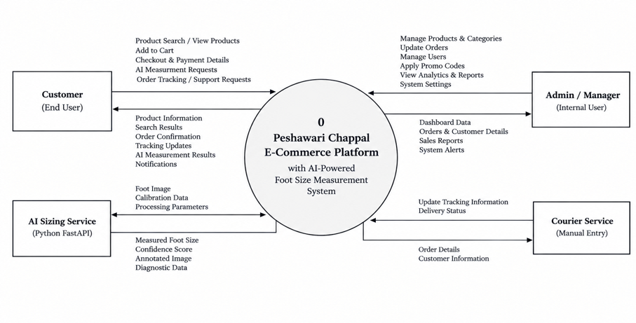
Figure 1 - Level-0 Context DFD

6.2 Level-1 DFD
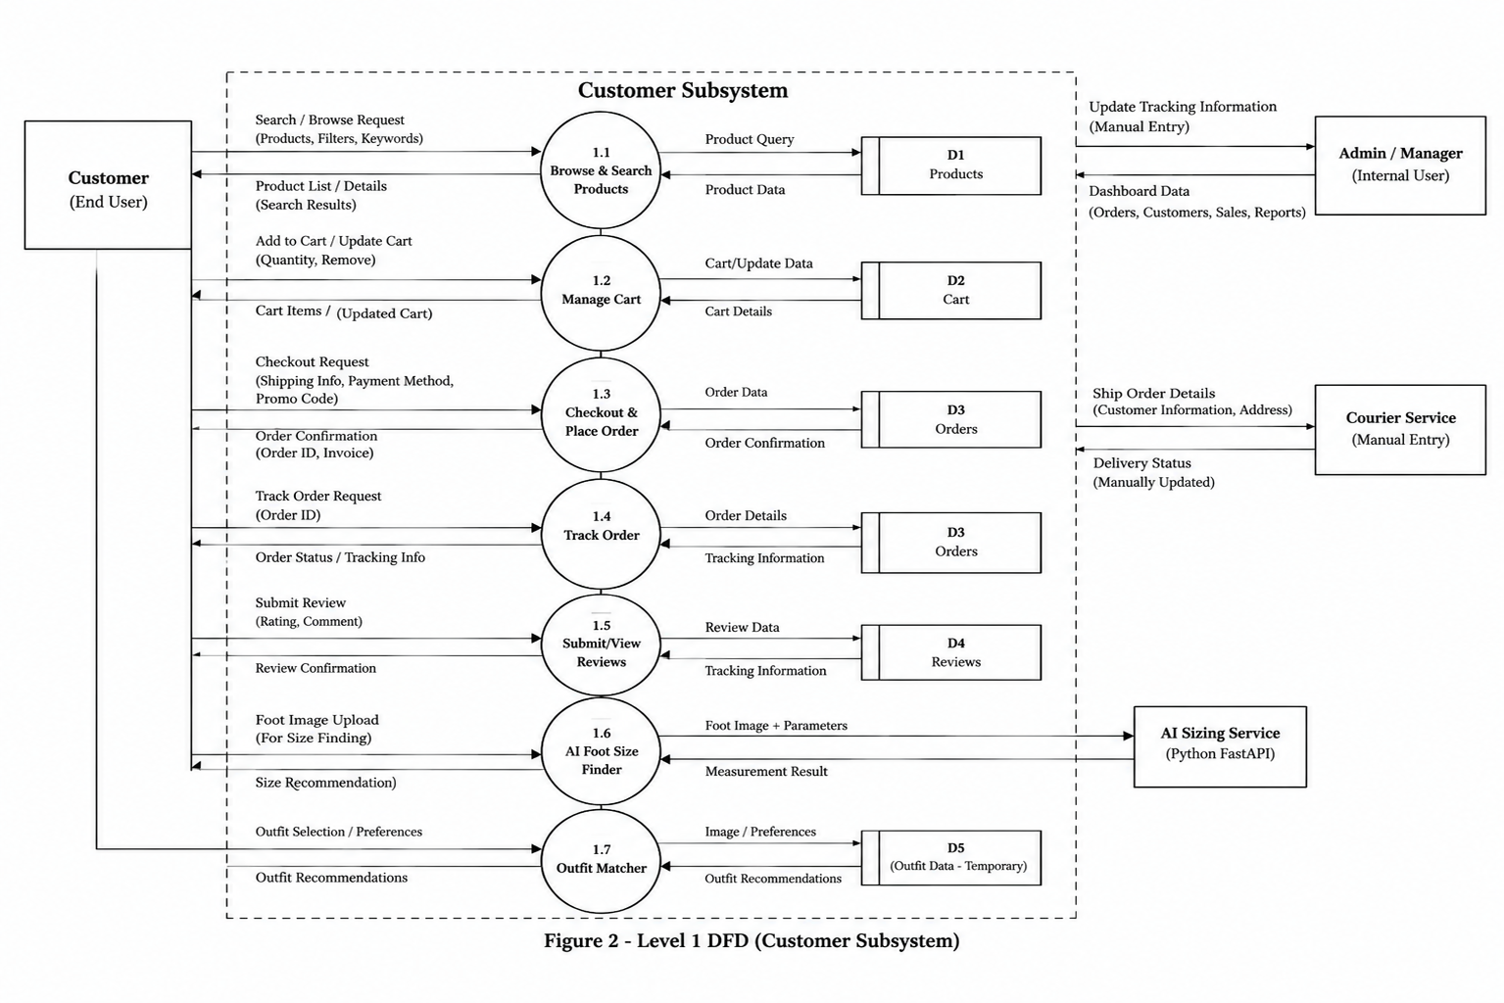
Figure 2 - Level-1 DFD

6.3 Use Case Diagram
The Use Case Diagram identifies all actors (Customer, Admin/Manager, AI Sizing Service, and Courier Service) and their interactions with system use cases. Stick-figure notation is used for actors, and all use cases are enclosed within the system boundary rectangle. Generalization and include relationships are shown on the diagram.
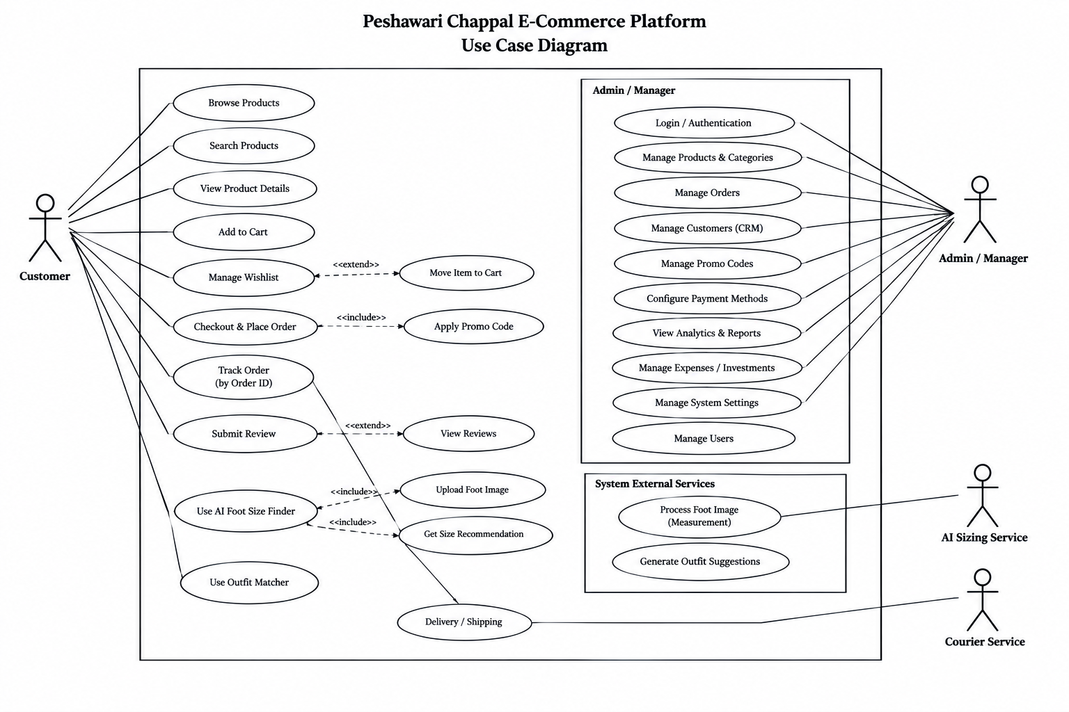
Figure 3 - Use Case Diagram

6.4 Entity-Relationship Diagram
The ERD models six primary entities: PRODUCT, ORDER, ORDER_ITEM, CUSTOMER,CATEGORY and REVIEW. Primary keys (PK) and foreign keys (FK) are identified in each entity box. Crow's Foot cardinality labels (1:M, M:1) are placed on all relationship lines.
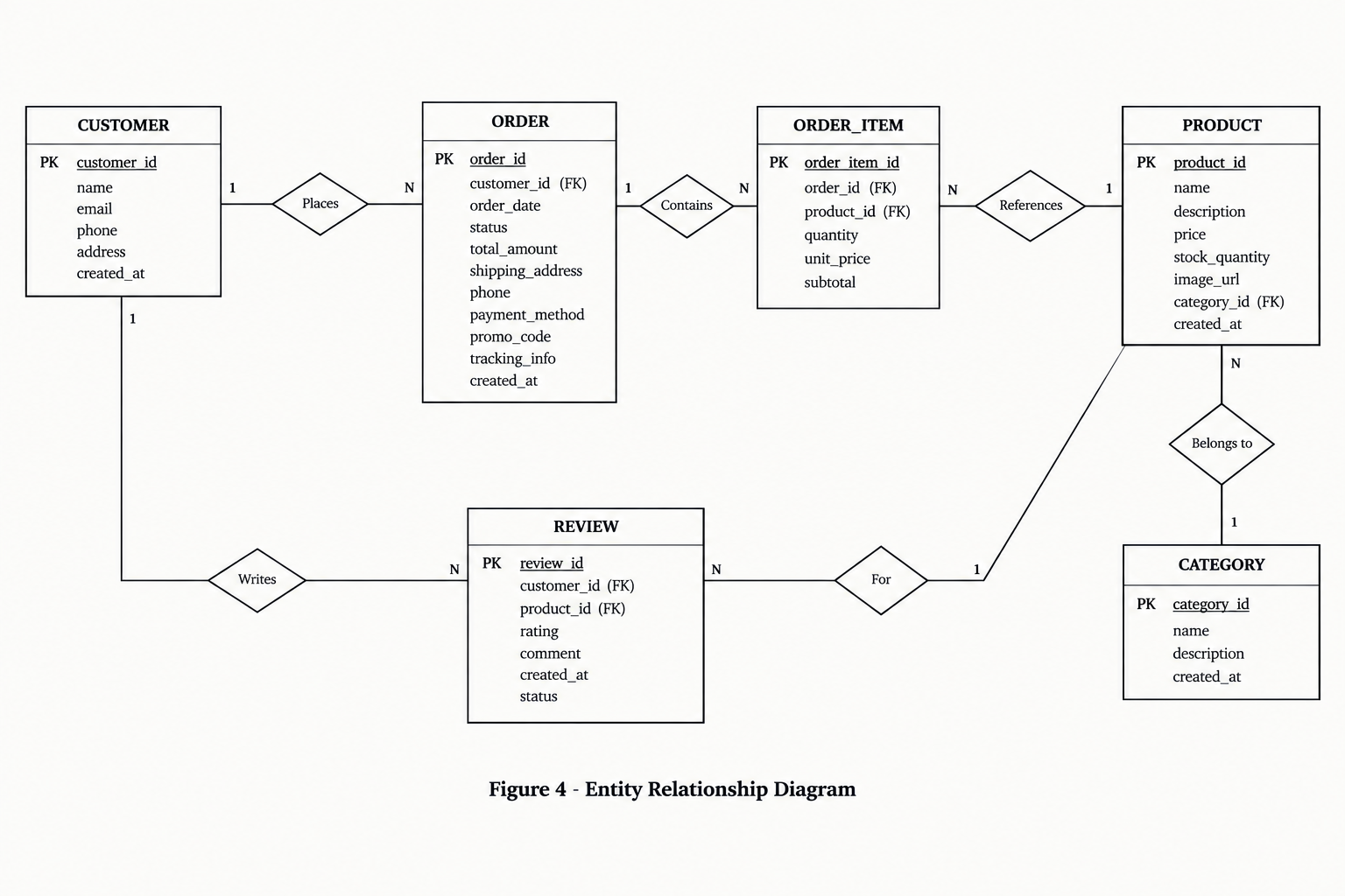
Figure 4 - Entity-Relationship Diagram (Crow's Foot Notation)

6.5 Four-Tier System Architecture
The four-tier architecture diagram illustrates the layered structure of the platform: Tier 1 (React SPA frontend), Tier 2 (Node.js Express backend), Tier 3 (Python FastAPI AI microservice), and Tier 4 (MongoDB Atlas). Internal components within each tier are shown as sub-boxes. Bidirectional arrows between tiers represent HTTP/REST communication.
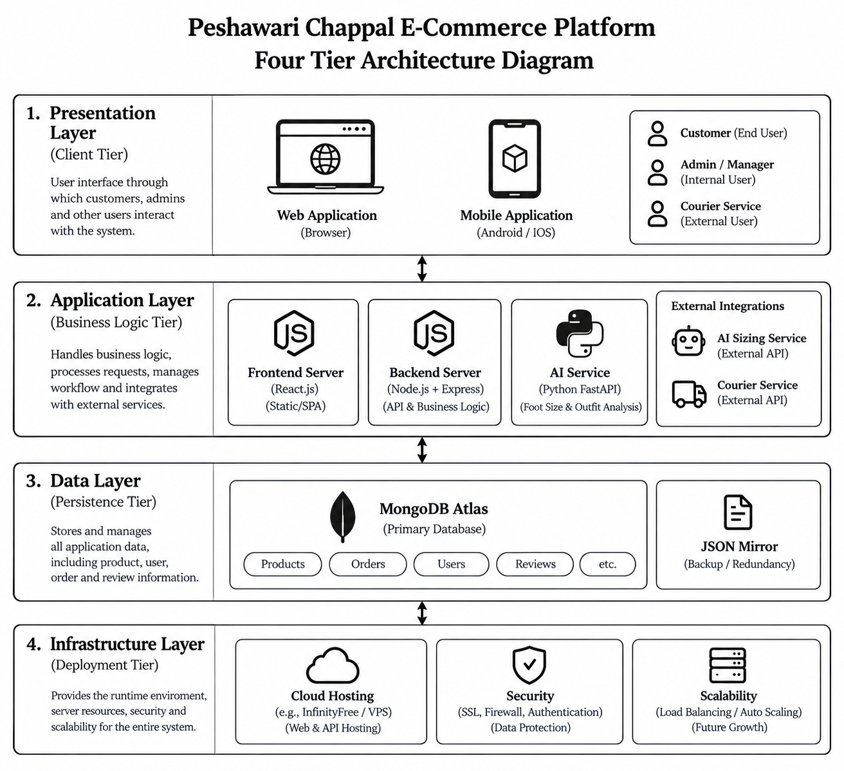
Figure 5 - Four-Tier System Architecture Diagram

6.6 Sequence Diagram
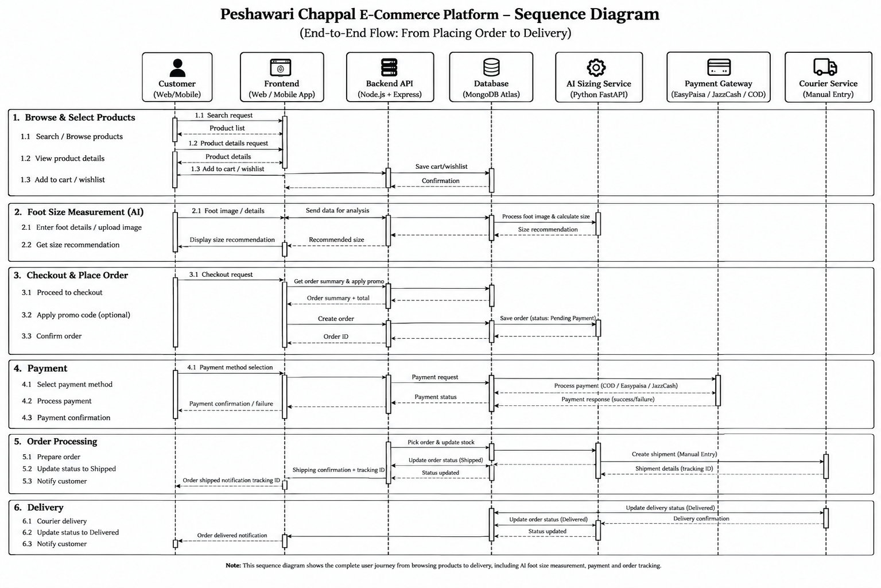
Figure 6 - Sequence Diagram

6.7 Deployment Diagram
The UML Deployment Diagram distributes software artefacts across four execution environments: Client Browser (React SPA), Application Server (Node.js/Express Port 5000), AI Microservice (FastAPI/Python Port 8000), and the Persistence tier (MongoDB Atlas + local file system). Node stereotype boxes with "ear" decorations follow UML 2.5 deployment notation. Communication paths are labelled with protocol and data format.
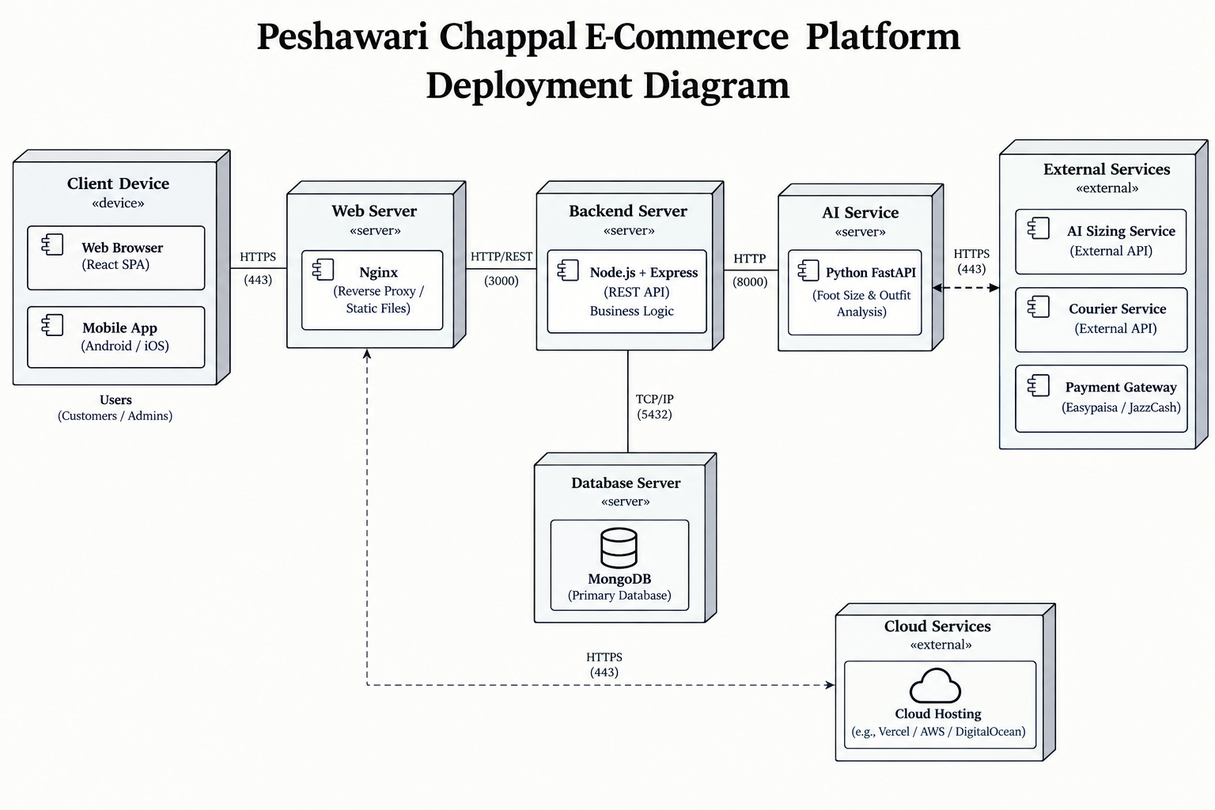
Figure 7 - UML Deployment Diagram

Chapter 7: Other Requirements
7.1 Localization and Internationalization
The platform initially targets Pakistani consumers. The following localization requirements SHALL apply:
- The default currency SHALL be Pakistani Rupee (PKR), displayed with the "Rs." prefix, configurable from admin store settings.
- Product prices SHALL be displayed without decimal places in the PKR context (e.g., Rs. 4,500).
- The checkout form SHALL pre-select "Pakistan" as the default country.
- Phone number validation SHALL accept standard Pakistani formats (+92 XXX XXXXXXX or 0XXX-XXXXXXX).
7.2 Legal and Compliance Requirements
- The platform SHALL include a Privacy Policy page and a Terms of Service page, both accessible from the footer navigation.
- Customer foot images SHALL be processed entirely in-memory and SHALL NOT be stored on any disk or database, in compliance with data minimization principles.
- A cookie consent notice SHALL be displayed if any tracking cookies are introduced in future versions.
7.3 Accessibility Requirements
- All images SHALL include descriptive alt attributes for screen-reader compatibility.
- All interactive elements SHALL be keyboard-navigable (Tab for focus cycling; Enter/Space for activation).
- Color contrast ratios SHALL meet WCAG 2.1 Level AA standards for all text content.

Appendix A - Glossary
Term | Definition
API | Application Programming Interface.
COD | Cash on Delivery - payment collected at point of delivery.
CRUD | Create, Read, Update, Delete - the four fundamental data operations.
CV | Computer Vision - AI enabling computers to interpret digital images.
DFD | Data Flow Diagram - graphical representation of data flows (Gane-Sarson notation).
ERD | Entity-Relationship Diagram - data model using Crow's Foot notation.
EU Size | European shoe-size standard (Paris Points = 2/3 cm increments).
FastAPI | High-performance Python web framework for APIs with OpenAPI support.
FR | Functional Requirement - a statement of what the system shall do.
FYP | Final Year Project - undergraduate capstone project.
JWT | JSON Web Token - signed, compact token for authentication claims.
Mongoose | Object Document Mapper (ODM) for MongoDB in Node.js.
NFR | Non-Functional Requirement - quality attribute (performance, security, etc.).
OpenCV | Open Source Computer Vision Library for image processing.
Planar Homography | Mathematical transformation mapping one plane to another, used for real-world calibration from a photograph.
RBAC | Role-Based Access Control - access rights assigned by role.
React SPA | React Single-Page Application - all navigation handled by the browser without full page reloads.
YOLOv8 / U2-Net | Custom-trained YOLOv8 instance segmentation neural model (best.pt) with U2-Net fallback for precision foot mask isolation.
SRS | Software Requirements Specification - this document.
UK Size | United Kingdom shoe-size standard (EU size minus 33).
Vite | Fast modern frontend build tool and development server.
PCA | Principal Component Analysis - eigenvector statistical method used to determine the true longitudinal heel-to-toe foot axis.
Table A1 - Glossary

Appendix B - Technology Stack Summary
Layer | Technology | Version | Licence
Frontend Framework | React | 18.x | MIT
Frontend Language | TypeScript | 5.5 | Apache 2.0
Frontend Build Tool | Vite | 5.x | MIT
Frontend Styling | TailwindCSS | 3.x | MIT
Frontend Icons | Lucide React | Latest | ISC
Frontend Charts | Recharts | Latest | MIT
Backend Runtime | Node.js | 20 LTS | MIT
Backend Framework | Express | 4.x | MIT
Backend Language | TypeScript | 5.5 | Apache 2.0
Backend Auth Tokens | jsonwebtoken (JWT) | 9.x | MIT
Backend Password Hashing | bcryptjs | 3.x | MIT
Database ODM | Mongoose | 8.x | MIT
Database | MongoDB Atlas | 7.x | SSPL
AI Framework | FastAPI | 0.111 / Python 3.10+ | MIT
AI ASGI Server | Uvicorn | 0.30 | BSD
AI Language | Python | 3.10+ | PSF
Computer Vision Library | OpenCV (opencv-python-headless) | 4.9+ | Apache 2.0
Neural Foot Segmentation | YOLOv8 (Ultralytics) & U2-Net (best.pt) | 8.2+ / Latest | AGPL-3.0 / MIT
Numerical Computing | NumPy | 1.26 | BSD
Image Processing | Pillow | 10.3 | HPND
Table B1 - Technology Stack

