
Article
SCFusion: Spatial-Channel Cross Frequency Guided Fusion
Network for Infrared-Visible Image Object Detection
Guoxia Xu ¹, Yulong Sun ¹, Kang Chen ¹, Yufeng Yu ², Lizhen Deng ¹ and Hu Zhu ^{1,}*
1
School of Communications and Information Engineering, Nanjing University of Posts and
Telecommunications, Nanjing 210003, China
2
Department of Statistics, Guangzhou University, Guangzhou 510006, China
Correspondence: peter.hu.zhu@gmail.com
*
Abstract
1
While Infrared-Visible image object detection exhibits advantages in complex scenarios,
existing methods still suffer from issues such as static frequency-domain modeling, severe
cross-modal interference, and insufﬁcient local detail perception. To address these problems,
this paper proposes an infrared and visible image object detection based on spatial-channel
cross frequency guided fusion network. First, we construct frequency residual selective
transformer to realize local inductive bias and global receptive ﬁeld for infrared and visible
image feature extraction. Furthermore, the spatial-channel frequency fusion mechanism
based on homogeneous frequency reﬁned block and heterogeneous spatial-channel fre-
quency fusion block is proposed to achieve modality-consistent feature fusion. Finally, the
frequency reconstruction guided decoder performs to select high-frequency components
to sharpen object boundaries. SCFusion shows superior performance on four benchmark
datasets (VT821, VT1000, VT5000, and VI-RGBT1500). On VI-RGBT1500, it achieves an
E-measure of 0.926, a weighted F-measure of 0.874, and an MAE of 0.020, reducing MAE
by about 9.1% compared to the second-best method. On VT5000, SCFusion maintains high
efﬁciency with 36.04M parameters and 5.78 GFLOPs.
2
3
4
5
6
7
8
9
10
11
12
13
14
15
16
Keywords: Infrared-Visible Image; Object Detection; Spatial-Channel Frequency Fusion
17
1. Introduction
18
Infrared-visible image object detection has emerged as a pivotal technology in com-
puter vision, serving as the cornerstone for safety-critical applications such as remote
sensing [1], autonomous driving, and search-and-rescue missions [2,3]. In real-world
environments, single-modal sensors often face insurmountable physical limitations. For
instance, Visible sensors are easily compromised by low illumination, severe weather
(e.g., fog, haze), or lens ﬂare, while thermal sensors, despite their robustness to lighting
changes, lack textural details and color information, making them indistinguishable in
thermal crossover scenarios [4]. By integrating the rich appearance details from the visible
spectrum with the thermal radiation signatures from the infrared spectrum, infrared and
visible systems can achieve robust perception across all-weather and all-time conditions.
Despite signiﬁcant advancements, constructing a high-performance infrared and visible
detector remains challenging due to inherent spectral discrepancies and the complexity of
feature interactions. Existing methods still face critical challenges regarding static frequency
modeling, modal interference, and detail preservation.
19
20
21
22
23
24
25
26
27
28
29
30
31
32
33
34
Received:
Revised:
Accepted:
Published:
Copyright: © 2026 by the authors.
Submitted to Journal Not Speciﬁed for
possible open access publication under
the terms and conditions of the
Creative Commons Attribution
(CC BY) license.
Traditional infrared and visible image object detection rely on deep feature extraction
paradigms, primarily dominated by Convolutional Neural Networks (CNNs) and Vision
Version February 10, 2026 submitted to Journal Not Speciﬁed
https://doi.org/10.3390/1010000

Version February 10, 2026 submitted to Journal Not Speciﬁed
2 of 25
Transformers. Early approaches typically employed two-stream CNN architectures to
extract modality-speciﬁc features, which were subsequently integrated via feature concate-
nation or element-wise summation strategies [5,6]. While these CNN-based methods excel
at capturing local patterns, their limited receptive ﬁelds hinder the modeling of global
context. To address this, Transformer-based architectures have emerged as a powerful alter-
native, leveraging self-attention mechanisms to capture long-range dependencies across the
entire image [7]. For instance, Cross-Modality Fusion Transformers [8]utilize inter-modal
cross-attention to dynamically model the interactions between visible and thermal features.
However, most of these dominant backbones operate exclusively in the spatial domain,
often overlooking the distinct spectral characteristics inherent in the frequency domain [9].
A critical problem in current methods is their reliance on static frequency model-
ing. While frequency analysis excels at capturing global context [10], traditional ap-
proaches—and even learnable ones like GFNet [11]—apply the same spectral ﬁlter across
the entire image. This content-agnostic strategy is fundamentally ﬂawed for fusion tasks,
where scenes are complex and non-stationary. For instance, a single ﬁxed kernel cannot
simultaneously preserve the smooth thermal background (low frequency) and sharpen the
edges of a small target (high frequency). This inevitably leads to a trade-off: either blur-
ring ﬁne details or amplifying noise. Furthermore, while dynamic weight adaptation has
revolutionized spatial convolution [12], its potential for frequency-domain fusion remains
untapped, leaving a signiﬁcant gap in capturing ﬁne-grained spectral dependencies.
A more serious problem lies in the severe cross-modal interference stemming from
the fundamental disparity between visible and infrared imaging mechanisms. Since these
sensors capture distinct physical attributes—reﬂectance versus thermal emissivity—their
feature distributions are inherently inconsistent. Standard fusion methods (e.g., simple
concatenation or AFF [13,14]) often overlook this incompatibility, treating both modalities
as equally informative at all times. This indiscriminate integration is perilous, especially in
challenging scenarios [15]. For instance, when the visible stream is swamped by noise in
low-light conditions, rigid fusion mechanisms act as a conduit, blindly propagating this
corruption into the fused representation. Instead of leveraging the complementary thermal
data, the model allows the degraded modality to pollute the ﬁnal features, drowning out
critical target signals and severely compromising detection reliability.
Furthermore, we confront the challenge of detail preservation. Deep networks inher-
ently trade spatial precision for semantic abstraction, often eroding the ﬁne edges needed
for accurate bounding box regression [16]. Existing frequency-based methods often worsen
this by applying blanket ﬁlters that smooth out high-frequency phase signals—the very
components responsible for deﬁning object boundaries. In challenging scenarios like partial
occlusion or low contrast, this leads to ’blurry’ feature representations: the model detects
the object category but fails to pinpoint its exact limits. Addressing this requires aban-
doning uniform spectral ﬁltering and instead adopting a strategy that surgically enhances
high-frequency details.
To address the above issues, this paper proposes a novel infrared and visible image
object detection algorithm based on spatial-channel cross frequency guided fusion network
shown in Figure 1. Our approach fundamentally shifts the modeling paradigm from static
global ﬁltering to learnable selective ﬁlter generation. Speciﬁcally, we introduce a infrared
and visible frequency residual selective transformer that constructs learnable selective ﬁlter
generation enabling the network to perceive diverse frequency responses tailored to spatial
feature. To mitigate modal interference, we propose the homogeneous frequency reﬁned
block and heterogeneous spatial-channel frequency fusion block, which leverages a dual-
branch mechanism to dynamically re-weight features based on their spatial and channel
contexts. Finally, an frequency reconstruction guided module for decoder is designed to
35
36
37
38
39
40
41
42
43
44
45
46
47
48
49
50
51
52
53
54
55
56
57
58
59
60
61
62
63
64
65
66
67
68
69
70
71
72
73
74
75
76
77
78
79
80
81
82
83
84
https://doi.org/10.3390/1010000

Version February 10, 2026 submitted to Journal Not Speciﬁed
3 of 25
select high-frequency components to sharpen object boundaries. Extensive experiments on
four benchmark datasets (VT821, VT1000, VT5000, VI-RGBT1500) demonstrate that our
method signiﬁcantly outperforms state-of-the-art comparison methods.
85
86
87
88
The main contributions of this work are summarized as follows:
•
•
•
•
We propose the Frequency Residual Selective Transformer (FREFormer), which fun-
damentally shifts the frequency modeling paradigm from static global ﬁltering to
adaptive selective ﬁlter generation. By dynamically re-weighting frequency compo-
nents conditioned on spatial features, FREFormer effectively captures non-stationary
visual patterns that traditional FFT-based token mixers often overlook.
We devise a dual-branch fusion strategy to resolve cross-modal conﬂicts. The Homoge-
neous Frequency Reﬁned Block (HFRB) employs a global-local calibration mechanism
to preserve intra-modal textures, while the Heterogeneous Spatial-Channel Frequency
Fusion Block (HSFB) leverages decoupled amplitude and phase processing in the
frequency domain to suppress modal interference and align heterogeneous features.
To address the issue of blurred boundaries in infrared-visible detection, we propose
a Frequency Reconstruction Guided Module (FRGM). Integrated into the decoder, it
acts as a multi-scale frequency ﬁlter to recover high-frequency edge details. This is
further supervised by a novel Frequency Fidelity Loss, ensuring precise boundary
regression.
89
90
91
92
93
94
95
96
97
98
99
100
101
102
103
104
105
106
Extensive evaluations on the VT821, VT1000, VT5000, and VI-RGBT1500 datasets
validate the effectiveness of our proposed method. On the challenging VI-RGBT1500
dataset, speciﬁcally, we reduced the Mean Absolute Error (MAE) by 9.1% (from 0.022
to 0.020), maintaining good boundary accuracy and stability in complex scenarios. 107
Furthermore, our method consistently maintains state-of-the-art performance, im- 108
proving the E-measure by 0.5% on VT821 and the F score by 1.5% on the large-scale
VT5000 dataset. Compared with leading methods, our approach achieves an optimal
balance between parameter efﬁciency and detection performance.
109
110
111
β
The remainder of this paper is organized as follows. Section 2 reviews relevant
literature. Section 3 presents the details of proposed network architecture. Section 4
presents the experimental evaluation and analysis. Section 5 concludes the paper.
112
113
114
2. Related Work
115
116
2.1. CNN/Transformer based Infrared and Visible Image Object Detection
CNN-based methods have been extensively studied in infrared and visible image
object detection due to their strong capability in local feature extraction and computational
efﬁciency. Early works mainly focus on designing effective fusion strategies to integrate
visible and infrared information. Kang et al. [17] proposed a global-local feature fusion
117
118
119
120
framework based on recurrent structures to iteratively aggregate cross-modal features, 121
which improves modal complementarity but struggles to model long-range dependencies
due to the inherent locality of convolution operations. To enhance feature discrimination, 123
Yang et al. [18] introduced a cascaded information enhancement module that reﬁnes fused
features in the channel dimension. Although this approach improves inter-channel rep- 125
resentation, it implicitly assumes similar spectral characteristics across modalities and
ignores the intrinsic frequency distribution differences between visible and infrared data. 127
122
124
126
Huo et al. [19] developed a context-guided stacked reﬁnement network to progressively
optimize salient target representations. However, its reliance on static convolution kernels
128
129
limits adaptability to complex scenes with heterogeneous frequency components, espe- 130
cially in scenarios involving small targets, low contrast, or cluttered backgrounds. To
capture broader contextual information, Cai et al. [20] utilized feature correlations to model
131
132
https://doi.org/10.3390/1010000

Version February 10, 2026 submitted to Journal Not Speciﬁed
4 of 25
long-range dependencies. However, this process often involves downsampling to reduce
computational cost, inevitably sacriﬁcing ﬁne-grained details. Addressing the rigidity of
ﬁxed kernels, Huang et al. [21] proposed a dynamic receptive ﬁeld attention module to
adaptively adjust feature extraction. Yet, its effective ﬁeld of view remains constrained by
the local nature of convolutional operations, limiting true global modeling. Overall, while
CNN-based approaches are effective in capturing local structures and ﬁne details, their
limited receptive ﬁeld and static kernel design restrict their ability to adaptively model
global context and frequency-varying characteristics across modalities, motivating the
exploration of more ﬂexible modeling paradigms.
Transformer-based methods have recently attracted increasing attention in infrared
and visible image object detection due to their powerful global context modeling ability
enabled by self-attention mechanisms. By establishing long-range dependencies among
feature tokens, Transformers can effectively enhance global semantic consistency across
133
134
135
136
137
138
139
140
141
142
143
144
145
modalities. Liu et al. [22] proposed SwinNet, which introduces a hierarchical Swin Trans- 146
former to capture edge-aware representations in RGB-T data. Although effective, its high
147
computational complexity and memory overhead pose challenges for real-time deploy- 148
ment. To explicitly model cross-modal interactions, Shen et al. [23] proposed ICAFusion, 149
which adopts iterative cross-attention to facilitate information exchange between visible
and infrared features. While this strategy improves modal interaction, it operates purely
in the spatial domain and lacks ﬁne-grained frequency-aware modulation, making it less
effective in preserving local details. Xiao et al. [24] introduced GM-DETR, a generalized
multispectral detection transformer that enhances fusion efﬁciency through attention-based
mechanisms.
Despite their strong global modeling capability, most Transformer-based methods
suffer from three common limitations in infrared and visible scenarios: high computational
cost, insufﬁcient sensitivity to local high-frequency details, and the absence of explicit
frequency-domain modeling. These issues limit their effectiveness in complex scenes where
accurate target boundary localization and frequency-selective fusion are crucial. These
limitations motivate the exploration of alternative fusion strategies that operate at the
frequency domain, rather than relying solely on attention-based feature interaction.
150
151
152
153
154
155
156
157
158
159
160
161
162
2.2. Frequency-domain Modeling for Infrared and Visible Image Detection
163
Frequency-domain modeling provides an alternative and complementary perspec- 164
tive for infrared and visible feature representation and fusion. By transforming features
into the frequency domain, such methods can effectively expand the receptive ﬁeld and
decouple structural information across different frequency bands. Tatsunami et al.[10]
leveraged FFT-based token mixing to enhance global context modeling. However, their
frequency modeling strategy is global and static, lacking spatial adaptivity and the ability
to selectively emphasize task-relevant frequency components. Lyu et al.[25] introduced
a deep Fourier-embedded network to strengthen frequency feature representation for
infrared-visible object detection, while [26] proposed a frequency-aware attention module
for redundancy removal. Collectively, these frequency-driven methods have explored
expansive feature extraction and complementary information mining for multimodal object
detection. Furthermore, uniﬁed spatial-frequency information processing has been recently
introduced into infrared-visible object detection [27].
Recently, Wu et al. [28] proposed a frequency-driven transformer for infrared and
visible image object detection via frequency decomposition and aggregation. Similarly, both
abundant high-frequency details and valuable low-frequency components are considered
in [29]. The central motivation of these frequency-driven methods lies in selective feature
extraction between single-modal and cross-modal cases. However, these existing methods
165
166
167
168
169
170
171
172
173
174
175
176
177
178
179
180
181
https://doi.org/10.3390/1010000

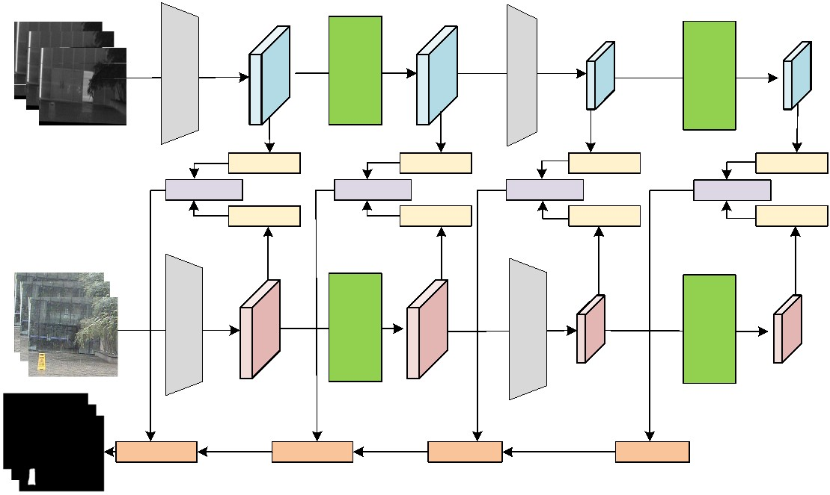



Version February 10, 2026 submitted to Journal Not Speciﬁed
5 of 25
often neglect the spatial-channel feature redundancy inherent in both single-modal and
cross-modal scenarios. To address this, our method introduces learnable selective ﬁlter
generation to complement local inductive biases and avoid high complexity in feature
extraction. To enable the enhancement of modality-consistent frequency components
while suppressing interference, we design the Homogeneous Frequency Reﬁned Block
(HFRB) and the Heterogeneous Spatial-Channel Frequency Fusion Block (HSFB). Our work
further advances frequency-domain modeling by introducing these two modules, enabling
spatially adaptive and modality-consistent fusion of cross-modal features.
182
183
184
185
186
187
188
189
3. SCFusion Method
190
This section presents the details of overall architecture and key modules of the pro- 191
posed infrared and visible image object detection framework, which focuses on accurate
192
localization and boundary-aware prediction of salient objects. As illustrated in Figure. 1, 193
the proposed framework mainly consists of following core modules: Frequency Resid- 194
ual Selective Transformer (FREFormer), Homogeneous Frequency Reﬁned Block (HFRB), 195
Heterogeneous Spatial-Channel Frequency Fusion Block (HSRB), and Frequency Recon- 196
struction Guided Module (FRGM), along with a joint loss function for optimization.
197
3.1. Overall Network Architecture
198
HFRB
HFRB
HFRB
HFRB
HFRB
HFRB
HFRB
HFRB
HSFB
HSFB
HSFB
HSFB
FRGM
FRGM
FRGM
FRGM
Homogeneous Frequency
Refined Block
Heterogeneous Spatial-Channel
Frequency Fusion Block
Frequency Reconstruction
Guided Module
HFRB
HSFB
FRGM
Figure 1. Overall architecture of the proposed infrared and visible image object detection algorithm.
The framework primarily comprises three core components: the FREFormer Block for feature extrac-
tion, the Homogeneous Frequency Reﬁned Block (HFRB) for frequency-domain enhancement, and
the Heterogeneous Spatial-Channel Frequency Fusion for frequency-domain selection, Reconstruction
Guided Module (FRGM) for multi-modal feature fusion and reconstruction.
First, visible and infrared images are input into two parallel weight-sharing encoders
to extract hierarchical features through a series of Downsampling layers and FREFormer
Blocks. Within each encoder level, Homogeneous Frequency Reﬁned Blocks (HFRB) are
employed to capture intra-modal frequency details, while Heterogeneous Spatial-Channel
199
200
201
202
Frequency Fusion Blocks (HSFB) bridge the two branches to integrate cross-modal com- 203
plementary information. These fused features are then progressively fed into a four-stage
decoder consisting of Frequency Reconstruction Guided Module (FRGM). Each FRGM
layer adaptively reconstructs target-related frequency components from the fused features
204
205
206
https://doi.org/10.3390/1010000

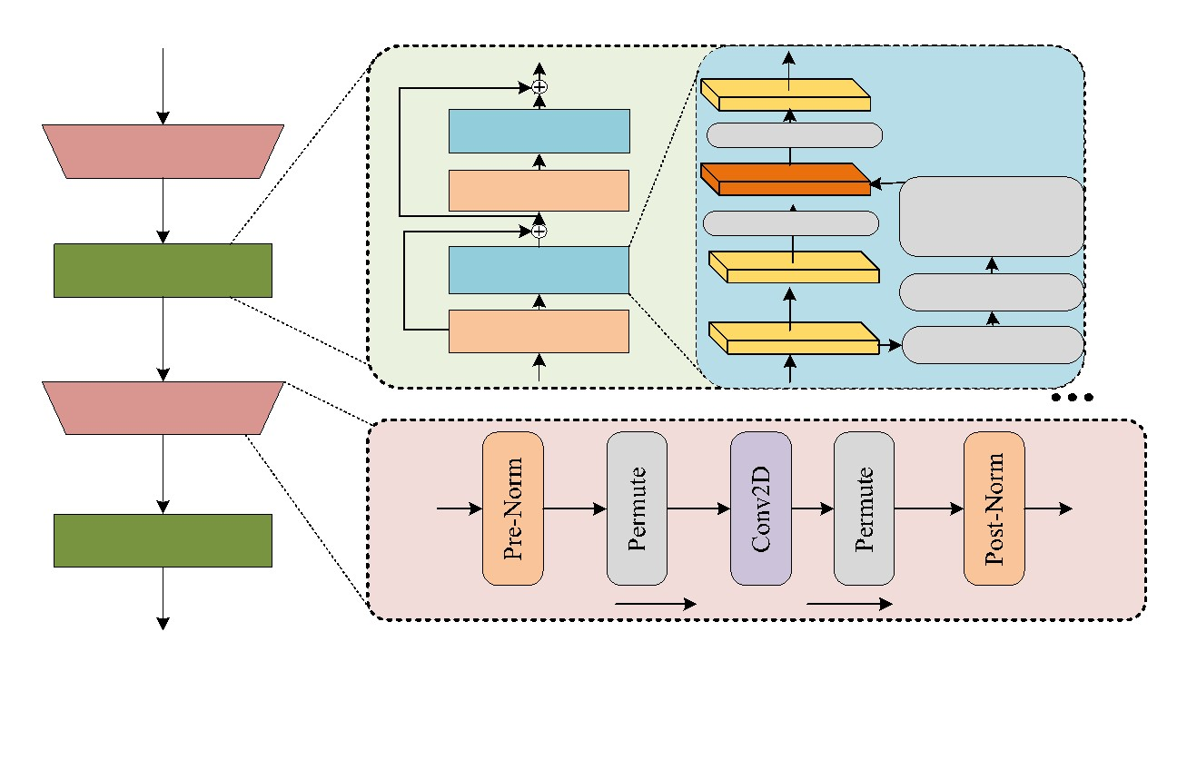
Version February 10, 2026 submitted to Journal Not Speciﬁed
6 of 25
to provide ﬁne-grained spatial guidance, ultimately facilitating precise target detection and
segmentation through multi-scale frequency-domain reﬁnement.
207
208
3.2. The FREFormer Encoder of Infrared and Visible Image
209
In the proposed method, the extensive use of Fast Fourier Transform (FFT) and Inverse
Fast Fourier Transform (IFFT) is essential. Theoretically, point-wise multiplication in the
210
211
frequency domain is equivalent to circular convolution in the spatial domain. Since convo- 212
lution operations inherently exhibit translational equivariance, this theoretical property
holds between the frequency and spatial domains. However, in practical applications, FFT
assumes signal periodicity, which does not hold for images, leading to the introduction
213
214
215
of boundary artifacts. Speciﬁcally, due to the ﬁnite nature of images, the periodicity as- 216
sumption of FFT causes discontinuities at the boundaries, generating artifacts that affect
analysis. To address this issue, SCFusion adopts a hybrid design. Speciﬁcally, SCFusion
integrates frequency-domain modules with MetaFormer-style blocks [30] and alternates
217
218
219
them with standard convolutional layers (e.g., in the downsampling and encoder stages). 220
These convolutional layers introduce strong local inductive biases, effectively mitigating the
impact of boundary artifacts. The local convolutional layers perform smoothing operations
in local regions of the image, alleviating artifacts caused by boundary discontinuities. At
the same time, this design enhances the network’s ability to capture local details, further
improving the precision of image processing.
221
222
223
224
225
FREFormer
Input
Channel MLP
2D IFFT
2D FFT
DownSampling
Learnable
Selective Filter
Generation
Norm
Learnable
Selective Filter
FREFormer Blocks
SoftMax
MLP
Norm
Input
Input
✖ 4
DownSampling
Input
FREFormer Blocks
Output
[B,H,W,C]
[B,C,H,W]
[B,H,W,C]
Figure 2. Structural details of the FREFormer Encoder. This architecture adopts a hierarchical design
consisting of stacked FREFormer Blocks with downsampling layers for multi-stage feature extraction.
The central component in FREFormer is the Learnable Selective Filter Generator, which transforms
input features into the frequency domain via 2D FFT. The processed frequency-domain features
are then mapped back to the spatial domain through a 2D IFFT , followed by a Channel MLP for
inter-channel feature mixing.
Based on this MetaFormer-style block structure, we designed the entire Encoder mod- 226
ule, which is the FREFormer Encoder. As illustrated in Figure 2, FREFormer Encoder adopts
a two-stage hierarchical structure, with each stage containing two layers: Downsampling
Layer and FREFormer Block. This hybrid approach leverages the local inductive bias of
227
228
229
convolutions in early stages and the global receptive ﬁeld of FFT-based ﬁlters in later stages. 230
Downsampling Layer reduce spatial resolution while increasing channel capacity. Given
231
232
233
input feature X , the module of Downsampling layer can be expressed as the following
i
equation:
https://doi.org/10.3390/1010000

Version February 10, 2026 submitted to Journal Not Speciﬁed
7 of 25
Y = LN(Conv2d(LN(X )))
(1) 234
i
i
where LN(∗) denotes as the Layer Normalization.
Following downsampling, the network retains signiﬁcant frequency information, 236
235
comprising both target-related details essential for detection and irrelevant background
noise. The ampliﬁcation or suppression of these frequency signals is critical for detection
performance, creating a pressing need for an effective frequency-processing ﬁlter.
Conventional spectral ﬁltering approaches typically learn a static, global complex
ﬁlter. Once trained, this ﬁlter remains ﬁxed and is applied indiscriminately to all input
images. This "content-agnostic" paradigm assumes that a single spectral modulation
237
238
239
240
241
242
strategy can generalize across all scenarios. However, real-world scenes are non-stationary; 243
the frequency distribution of a cluttered scene differs signiﬁcantly from that of a clean, 244
simple object. A static ﬁlter lacks the ﬂexibility to adapt to these varying semantic contents, 245
often leading to suboptimal feature extraction where noise is ampliﬁed or edges are blurred. 246
To address these limitations, we propose a dynamic ﬁltering architecture: the Learnable
Selective Filter. The Learnable Selective Filter serves as the overarching architectural unit
designed to replace the multi-head self-attention mechanism in the Transformer, deﬁning
the complete pipeline for frequency domain modulation. Embedded within the Learnable
Selective Filter is its core functional module, the Learnable Selective Filter Generation
(LSFG), which acts as the brain of the ﬁlter.
247
248
249
250
251
252
253
254
255
256
The primary motivation behind LSFG is to introduce adaptability into frequency
domain processing. Unlike static approaches that use a ﬁxed weight matrix, LSFG functions
as a dynamic parameter generator, synthesizing a unique ﬁlter weight F(Y ) tailored to
i
each input instance Y . The mathematical formulation of LSFG is deﬁned in Equ. 2:
i
∑ X
HW
i,j i,j
E(X) =
!
(2) 257
N
X
i,j
∑ E(X)
E( )
i,j
∑
G(E(X)) =
i,j
i=1
∑i,j
X
HW
Speciﬁcally, the module initiates by capturing global semantics through E(X) =
^{i,j} ,
258
259
260
261
which functions as a global average pooling operator to compress spatial information
into a concise global descriptor representing the image’s overall "energy." Building on this
statistical proﬁle, the generator G synthesizes the dynamic ﬁlter weights via a normalization

N
E(X)i,j
i,j
process, expressed as G(E(X)) = ∑
. By explicitly conditioning the ﬁlter
262
i=1
X
)
i,j
∑
E(
generation on these input-speciﬁc characteristics derived from E(X), the model achieves
263
"instance-aware" processing. This ensures that the ﬁlter evolves adaptively with the data, 264
dynamically distinguishing informative frequency components from noise for each speciﬁc
instance.
With the dynamic weights generated by LSFG, the overall Learnable Selective Filter
operates as described in Equ. 3:
265
266
267
268
F(Y ) = G(MLP(Softmax(Y )))
i
i
(3) 269
L(Y ) = F− (F(Y ) ⊙ F(Y ))
1
i
i
i
The process involves two key steps: ﬁrst, ﬁlter synthesis, where input features are
270
271
272
273
274
processed via MLP and Softmax layers to generate instance-speciﬁc weights F(Y ); and
i
second, dynamic modulation, where the synthesized ﬁlter F(Y ) modulates the input
i
spectrum F(Y ) via element-wise multiplication, followed by feature reconstruction using
i
the Inverse FFT (F−¹).
https://doi.org/10.3390/1010000

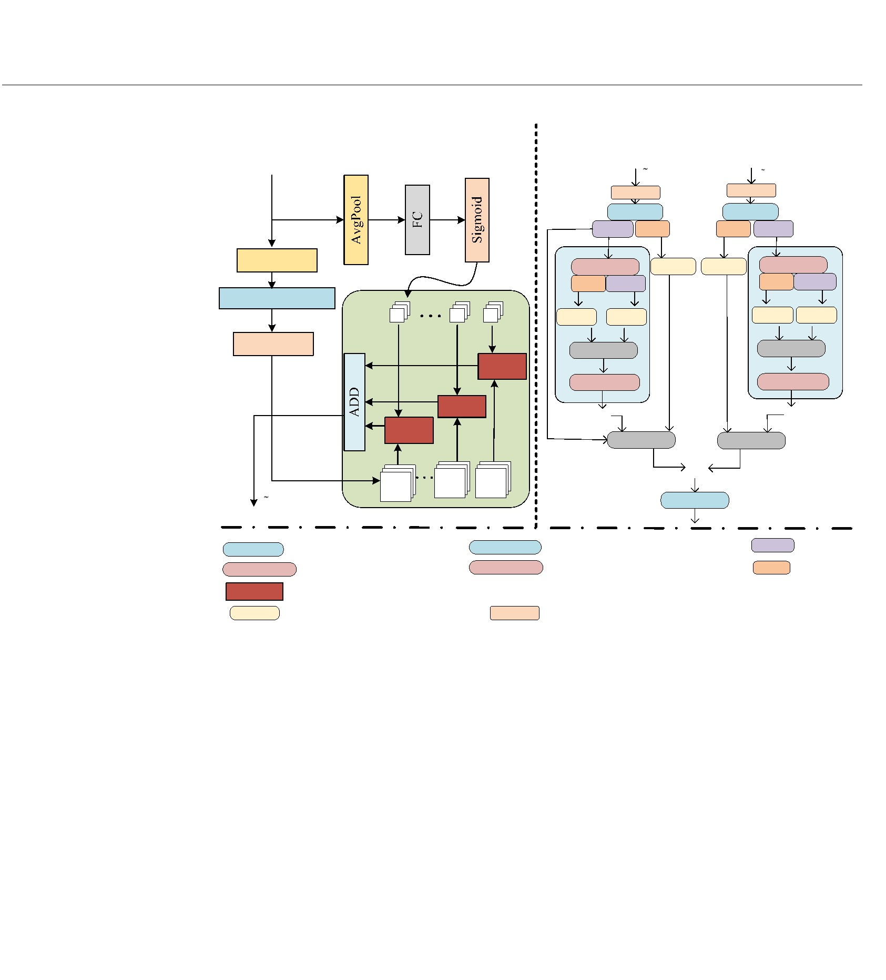
Version February 10, 2026 submitted to Journal Not Speciﬁed
8 of 25
Homogeneous Frequency
Heterogeneous Spatial-Channel Frequency
Fusion Block
Refined Block


T
2
T
1
CBS
T₀
CBS
2D FFT
2D FFT
Amp Pha
Pha Amp
AvgPool
2D CFFT
Pha Amp
CLC
CLC
2D CFFT
^{w}global
Pha Amp
CLC CLC
Complex
FC&Conv1D
CLC
CLC
c
Sigmoid
Complex
HAD
2D ICFFT
2D ICFFT
HAD


HAD
Complex
Complex

^{F}k

T
1
2D IFFT
F
i
Amp Amplitude
Phase
2D FFT
Spatial Fourier Transform
2D IFFT Spatial Fourier Inverse Transform
2D CFFT Channel Fourier Transform 2D ICFFT Channel Fourier Inverse Transform Pha


Element-wise Addition
HAD
CLC
Hadamard Product
Element-wise Multiplication
CBS Conv1×1+BatchNorm+CStarReLU
Conv1×1+LeakyRelu+Conv1×1
Figure 3. Architecture of the CFGIM. The left panel illustrates the Homogeneous Frequency Reﬁned
Block (HFRB), which extracts multi-scale features via global weights w_{global} and Hadamard products
(HAD). The right panel displays the Heterogeneous Spatial-Channel Frequency Fusion Block (HSFB),
designed to fuse frequency domain features across spatial and channel dimensions using 2D FFT,
Channel Fourier Transform (CFFT), and complex operations.
This design establishes a coherent mechanism where the spatial content (captured by E) 275
explicitly governs the spectral bias F. By adapting to the input, the model can intelligently
preserve high-frequency components to maintain sharpness in textured regions or suppress
speciﬁc bands to reduce noise in smooth backgrounds. Consequently, by synthesizing
the global receptive ﬁeld of FFT with adaptive, instance-speciﬁc weights, LSF offers a
compelling alternative to multi-head self-attention.
276
277
278
279
280
281
282
Finally, integrating this mechanism into the network, the overall FREFormer block is
formulated as:
F = X + LSF(LN(X))
A
(4) 283
F = F + ChannelMLP(LN(F ))
B
A
A
3.3. Cross Frequency Guided Interaction Module (CFGIM)
284
Building upon the frequency-enhanced representations extracted by the FREFormer, 285
we introduce the Cross Frequency Guided Interaction Module (CFGIM), as illustrated
in Figure 3, to resolve inherent conﬂicts between infrared and visible modalities. Unlike
traditional fusion methods that implicitly assume strict pixel-to-pixel alignment in the
spatial domain, CFGIM reframes multi-modal interaction as a spectral decoupling and
recombination process.
Our design is grounded in a fundamental property of Fourier analysis: Phase encodes
spatial structural information, while Amplitude represents signal intensity. Motivated by
this physical interpretability, CFGIM employs a two-stage interaction mechanism:
286
287
288
289
290
291
292
293
https://doi.org/10.3390/1010000

Version February 10, 2026 submitted to Journal Not Speciﬁed
9 of 25
1)Homogeneous Frequency Reﬁned Block (HFRB): This module serves as a content- 294
aware active ﬁlter. Prior to fusion, it adaptively suppresses modality-speciﬁc noise (e.g., 295
thermal grain or background clutter) within each branch, effectively preventing noise
ampliﬁcation during the interaction process.
296
297
2)Heterogeneous Spatial-Channel Frequency Fusion Block (HSFB): This module per- 298
forms the core structure-content decoupling. It explicitly aligns the structural edges of
the two modalities via phase calibration—thereby addressing the spatial misalignment
issue—while simultaneously fusing their salient intensities via amplitude interaction.
This divide-and-conquer strategy in the frequency domain provides a transparent
mechanism for cross-modal integration, ensuring that the fused features inherit both the
sharpest structures and the most salient semantics from the respective inputs.
299
300
301
302
303
304
3.3.1. Homogeneous Frequency Reﬁned Block (HFRB)
305
306
We design a Homogeneous Frequency Reﬁned Block (HFRB) from a dual-branch
mechanism to predict two dense reﬁned weight T and T_{vis} for element-wise adjustment. 307
ir
Let deﬁne uniformly as T as input of this block, T ∈ R^{C}×H×^{W}. In this module, features
308
309
310
311
0
0
will be processed through two branches: a global grouped aggregation branch and a local
frequency calibration branch.
The upper branch is primarily responsible for capturing global context information and
performing grouped weighted fusion, in which this strategy is similar with Split-Attention. 312
First, the input feature T ∈ R^{C}×H×^{W} is spatially compressed via Global Average Pooling
313
314
315
316
317
318
319
320
0
(AvgPool), which is then passed through a Fully Connected (FC) layer and a Sigmoid
activation function to generate global channel weight w_{global}. This global channel weight
would be used for weighting the frequency domain feature.
Furthermore, the frequency-guided mechanism that aimed at enhancing frequency
feature expression by capturing local dependencies between channels and performing
the ﬁnal feature calibration. This branch also utilizes Average Pooling layer with 1D
Convolution (Conv1D) and fully connected (FC) layer. It can be formulated as :
F = Sigmoid(Conv1D(FC(AvgPool(T ))))
(5) 321
k
0
This design effectively captures interaction information between adjacent frequency com- 322
ponents (i.e., adjacent channels) in the frequency domain, avoiding the destruction of local
frequency correlations caused by fully connected layers.
323
324
325
Simultaneously, the input feature w_{global} is split along the channel dimension into K
groups. These groups are individually weighted using the generated weights via element- 326
wise multiplication (Hadamard Product). Finally, these weighted grouped features are
327
˜
aggregated through element-wise addition (ADD) to obtain the intermediate feature T . 328
1
This process can be formulated as :
329
T = (F ⊙ w^{k}
˜
∑
)
global
(6) 330
1
k
k
It aims to adaptively retain salient global features from either infrared or visible
modalities through a gating mechanism. Through this dual-attention mechanism (global
grouped aggregation + local frequency calibration), the model effectively preserve both
texture details and target features.
331
332
333
334
3.3.2. Heterogeneous Spatial-Channel Frequency Fusion Block (HSFB)
335
The detailed execution ﬂow of HSFB is summarized in Algorithm 1. Unlike standard
CNN modules that operate on entangled features, HSFB is designed to explicitly decouple
the “where” (spatial structure) from the “what” (semantic intensity).
336
337
338
https://doi.org/10.3390/1010000

Version February 10, 2026 submitted to Journal Not Speciﬁed
10 of 25
Algorithm 1 Heterogeneous Spatial-Channel Frequency Fusion Block (HSFB)
Require: Input features T , T ∈ R ×^{H}×^{W} (IR & Visible);
˜
˜
C
1
2
Require: Learnable blocks CBS(·), CLC(·).
Ensure: Fused feature map F_{out}
.
1: for k ∈ {1, 2} do
▷ Parallel processing for each modality
▷ Projection to latent space
˜
2:
X ← CBS(T )
k
k
// Step 1: Spatial Decomposition
3:
4:
S ← F
(X )
k
spatial k
sp sp
▷ Save P^{sp} for ﬁnal reconstruction
A , P ← |S |, ∠S
k
k
k
k
k
// Step 2: Channel Frequency Interaction
sp
k
5:
6:
7:
C ← F
(A )
▷ FFT along channel dimension
▷ Learnable modulation
k
channel
A
^{ch}, P^{ch}
← |
C , ∠C
|
k
k
k
k
ˆ ch
ch
ˆ ch
ch
A
← CLC(A );
P
← CLC(P )
k
k
k
k
// Step 3: Dual-Domain Reconstruction
ˆ
ˆ ^{sp}
ˆ ch
j Pˆ ch
C ← A · e
k
·
8:
9:
k
k
k
−1
ˆ
A
← F
(C )
▷ Obtain reﬁned intensity
k
channel
// Step 4: Structure-Content Recombination
ˆ ^{sp}
·
j P
sp
k
ˆ
10:
11:
S ← A · e
▷
Inject reﬁned intensity into original skeleton
k
k
branch
−1
(^{Sˆ} _{k}
F
← F
)
k
spatial
12: end for
13: F_{out} ← F₁
branch
+
F^{branch}
▷
Element-wise Fusion
2
14: return F
out
˜
˜
Given the frequency-reﬁned features T (Infrared) and T (Visible) generated by the
339
340
341
342
343
1
2
preceding HFRB module, these features are ﬁrst processed by a CBS block to project them
into a shared embedding space. To initiate the decoupling, we transform the features
into the spatial frequency domain via a 2D FFT. This step extracts two distinct physical
components: the Spatial Phase (P^{sp}), which represents the “skeleton” of the image by
encoding structural edges, and the Spatial Amplitude (A^{sp}), which represents the “muscle” 344
or signal intensity. This decomposition is formulated as:
345
346
347
10

sp sp
˜
A , P = F_{spatial} CBS(T ) , k ∈ {1, 2}
(7)
k
k
k
where F
denotes the Spatial FFT. By isolating P^{sp}, we preserve the precise location of
spatial
objects, effectively preventing the boundary blurring often caused by spatial misalignment. 348
While the spatial phase is preserved to maintain structure, the amplitude (intensity) 349
requires cross-channel calibration to highlight salient targets. We map the spatial ampli- 350
tude A^{sp} into the channel-frequency domain using Channel-wise FFT (CFFT), treating the
channel dimension as a temporal sequence to capture inter-channel dependencies:
351
352
ch ch
sp
k
A , P = F_{channel}(A )
(8) 353
k
k
In this domain, the CLC module (comprising 1 × 1 convolutions) acts as a learnable
frequency ﬁlter. It dynamically modulates the channel spectrum to suppress background
noise and enhance target-related responses:
354
355
356
ˆ ch
ch
ˆ ch
ch
A
= CLC(A ),
P
= CLC(P )
(9)
k
k
k
k
357
https://doi.org/10.3390/1010000

Version February 10, 2026 submitted to Journal Not Speciﬁed
11 of 25
Structure-Preserving Reconstruction is the most critical step for addressing cross- 358
modal interference. We ﬁrst reconstruct the reﬁned spatial amplitude using the inverse
359
360
channel FFT (F−¹
):
channel

ˆ ^{sp}
−1
ˆ ch
A · e
k
j·Pˆ ch
A
= F
(10) 361
k
k
channel
Then, strictly following the logic in Algorithm 1, we perform a Structure-Content
362
363
364
365
ˆ ^{sp}
Recombination. We combine the calibrated intensity (A ) with the original spatial phase
k
sp
k
(P ). This ensures that the enhanced semantic features are perfectly aligned with the
original object boundaries, effectively solving the spatial misalignment issue:

ˆ ^{sp}
· e^{j·P}
sp
k
branch
−1
F
= F
A
k
(11) 366
k
spatial
Finally, the features from both branches are fused via element-wise addition to integrate
the complementary information:
367
368
branch
F_{out} = F₁
branch
+ F₂
(12) 369
Through this mechanism, HSFB achieves a physically interpretable fusion: it “transplants” 370
the robust, noise-free semantic intensities onto the precise structural skeletons of the source
images.
371
372
3.4. Frequency Reconstruction Guided Module (FRGM) for Decoder
373
Transitioning from deep semantic features back to high-resolution detection masks
presents a critical challenge: the "Information Attenuation" dilemma. Standard decoders
374
375
typically rely on spatial upsampling, which tends to smooth out high-frequency details, 376
resulting in the common "blurred boundary" problem where object edges become am- 377
biguous. To overcome this limitation, we design the Frequency Reconstruction Guided
Module (FRGM). As illustrated in the decoder architecture, FRGM operates on the rigorous
principle of Multi-resolution Analysis (MRA), fundamentally transforming the decoding
process from simple interpolation into a spectral-aware reconstruction.
378
379
380
381
Speciﬁcally, FRGM decomposes the fused features into distinct frequency bands, 382
assigning explicit physical roles to each component: Low-frequency bands serve as the Se- 383
mantic Anchor. They guide the coarse localization of salient objects, ensuring that the global
shape and category information remain consistent during upsampling. High-frequency
bands serve as the Boundary Sharpener. They are explicitly isolated and enhanced to
regress sharp contours and ﬁne-grained textures, which are typically the ﬁrst to be lost in
deep networks.
384
385
386
387
388
This coarse-to-ﬁne reconstruction strategy physically guarantees that the model pro- 389
duces detection masks with precise edges. By mathematically enforcing the recovery of
high-frequency components to sharpen target boundaries.
390
391
392
393
394
The FRGM module decomposes the fused feature O into multi-frequency bands
f
to enhance target edge localization in decoder. First, the weight M of F is designed for
i
frequency selection into four frequency bands with different thresholds:


1,
F
b
_{≤ ∥(i, j)∥F}b
i
i−1
M (i, j) =
(13) 395
b
0, otherwise
https://doi.org/10.3390/1010000

Version February 10, 2026 submitted to Journal Not Speciﬁed
12 of 25
where M is the binary mask of the b-th frequency band, and f is the frequency threshold. 396
b
b
The frequency band feature is obtained by multiplying the Fourier transform of O with
397
398
f
M and inverse Fourier transform:
b

F = F−¹ F(O ) ⊙ M_{b}
(14) 399
b
f
A convolution layer + Sigmoid activation is used to generate a modulation map
400
401
A ∈ R^{H}×W×^{C} for the b-th frequency band:
b
A = Sigmoid(Conv(F ))
(15) 402
b
b
The ﬁnal enhanced feature is:
403
4
∑
b
F
=
F ⊙ A^{b}
(16) 404
f inal
b=1
Indeed, FRGM is embedded into decoder for object detection. The decoder block
405
406
consists of a 3 × 3 convolution layer, batch normalization, and GELU activation. The
decoder consists of four progressive stages, where the FRGM serves as the core enhance- 407
ment module at each level. Let D denote the output feature of the l-th decoder stage
408
l
(l ∈ {1, 2, 3, 4}). To effectively leverage the multi-frequency information, the fused feature
409
O from the fusion bottleneck is downsampled or upsampled to match the spatial resolu- 410
f
tion of each decoder layer, denoted as O^{l} . The FRGM then processes O^{l} to generate the
411
f
f
frequency-enhanced guidance feature F^{l}_{f inal}
.
412
413
414
Speciﬁcally, the l-th decoder block integrates the upsampled feature from the previous
layer D_{l−1} and the frequency-guided feature F^{l}_{f inal} as follows:

l
Dl = GELU BN Conv3 × 3([Up(Dl − 1); F f inal ])
(17) 415
The FRGM acts as a multi-scale frequency ﬁlter across all four stages, ensuring that
both high-frequency edge details and low-frequency semantic consistency are adaptively
injected into the reconstruction process. This hierarchical integration allows the decoder
to precisely localise targets by reconstructing sharp boundaries from the multi-frequency
components.
416
417
418
419
420
3.5. Loss Function
421
To enhance the model’s ability to capture target edges and structure, a joint loss
422
423
424
function is designed, including Frequency Fidelity Loss (L ), Dice (L_{dice}) and Cross Entropy
f f
loss (L ).
ce
3.5.1. Frequency Fidelity Loss
425
The edge detection map E_{pred} and ground truth E_{gt} (obtained by Canny algorithm
[31]) are transformed by 2D FFT:
426
427
F_{pred} = F(E_{pred}), F_{gt} = F(E )
(18) 428
gt
The frequency ﬁdelity error of the b-th frequency band is:
429
1
HW
b
∥F_{pred} − F ∥²
L
=
(19) 430
gt
2
f f
https://doi.org/10.3390/1010000

Version February 10, 2026 submitted to Journal Not Speciﬁed
13 of 25
The multi-band frequency ﬁdelity error loss is:
431
4
∑
b
b
L_{spec}
=
w L
(20) 432
f f
b=1
where w is a learnable weight coefﬁcient.
433
434
b
The ﬁnal joint loss function is:
L_{total} = λ L + λ L
+ λ L
3 ce
(21) 435
1
f f
2
dice
where λ , λ and λ are balance coefﬁcients (set to 0.6 and 0.4 in experiments).
436
437
1
2
3
4. Experiments
To verify the effectiveness of the proposed algorithm, extensive experiments are
conducted on four public infrared and visible image object detection datasets. This section
details the experimental settings, results analysis, robustness analysis in hazy and complex
scenarios and ablation studies.
438
439
440
441
4.1. Experimental Settings
442
All experiments are conducted on Python framework under Ubuntu 18.04 LTS with
NVIDIA GeForce RTX 4060 (8GB) The proposed method is trained by batch size 8 and
number of epochs 300. Initial learning rate is set 3 × 10−⁵ (decayed by 0.1 every 100
epochs) and we apply Adam optimizer (betas=(0.9, 0.999), weight decay=1e-4)The random
cropping (384×384), horizontal ﬂipping (p=0.5), rotation (±15°) data augmentations are
applied for training. In order to fair evaluation, we select four public infrared and visible
443
444
445
446
447
448
object detection datasets with a split ratio of 70% (training), 20% (validation), and 10% 449
(testing). VT821 [32] contains 821 pairs of visible-infrared images, with manual registration
and partial missing infrared regions. VT1000 [33] includes 1000 pairs of high-precision
aligned images with ﬁne pixel-level annotations. VT5000 [13] is with 5000 pairs of images
covering complex scenarios such as occlusion and low illumination. VI-RGBT1500 [34]
has 1500 pairs of images with diverse scenes (indoor/outdoor, day/night) and accurate
450
451
452
453
454
annotations. 9 state-of-the-art methods, including CSRNet [19], MIDD [35], OSRNet [18], 455
SwinNet [22], TNet [23], LSNet [24], IFFNet [25], DFENet [36], LAFB [2] are used in standard
evaluation. Finally, 5 common metrics for object detection. E-measure (Em), Measures
456
457
global and local alignment [37], S-measure (Sm), Measures structural similarity [38], F- 458
measure (F ), Weighted harmonic mean of precision and recall [39], Weighted F-measure
β
459
(ωF ), Emphasizes spatial structure [40], MAE, Mean absolute error (lower is better) [41]. 460
β
In addition, we selected the M3FD [42] dataset, which includes a large number of target
images captured under challenging conditions such as haze and dense fog. The dataset
consists of high-resolution images with varying sizes, ranging from 800x600 to 1920x1080
pixels, ensuring a broad representation of real-world environmental conditions. These
images provide valuable data for evaluating object detection performance under degraded
visibility conditions.
461
462
463
464
465
466
4.1.1. Enhanced-alignment Measure
467
The E-measure comprehensively considers global statistical information at the image
level and local pixel alignment to measure the overall consistency between the predicted
map P and the ground truth G. Its deﬁnition is:
468
469
470
W
H
1
∑ ∑
Q =
ϕ(P(x, y), G(x, y))
(22) 471
W × H
x=1 y=1
https://doi.org/10.3390/1010000

Version February 10, 2026 submitted to Journal Not Speciﬁed
14 of 25
where W and H represent the width and height of the image respectively, and ϕ(·) repre- 472
sents the enhanced alignment function, which aims to simultaneously evaluate local pixel
consistency and overall structural alignment capabilities. They represent the values of the
473
474
predicted image and the corresponding ground truth image at the pixel point respectively. 475
4.1.2. Structure-measure
476
477
The S-measure evaluates the similarity between the predicted map and the ground
truth from a structural perspective, combining two aspects: object-aware and region-aware. 478
It is deﬁned as:
479
S = α × S + (1 − α) × S
(23) 480
α
o
r
where S represents the structural similarity at the object level, S represents the structural
481
o
r
similarity at the region level, and α ∈ [0, 1] is a weighting coefﬁcient, typically set to α = 0.5. 482
4.1.3. F-measure
The F-measure is the weighted harmonic mean of Precision and Recall, used to com- 484
483
prehensively evaluate model performance:
485
(24) 486
487
(1 + β ) ×
F =
2
Precision Recall
×
β
2
+
Precision Recall
β ×
4.1.4. Weighted F-measure
To overcome the deﬁciencies of the traditional F-measure regarding interpolation
defects and spatial dependencies, the Weighted F-measure was introduced. This metric
incorporates pixel-level weights into the calculation, placing greater emphasis on the
inﬂuence of spatial structural information and error distribution, thereby improving the
robustness of the model performance evaluation.
488
489
490
491
492
4.1.5. Mean Absolute Error
493
MAE measures the average difference between the predicted map and the ground
truth at the pixel level; a smaller value indicates that the predicted map is closer to the real
image, signifying better model performance. Its formula is:
494
495
496
W
H
1
∑ ∑
MAE =
|P(x, y) − G(x, y)|
(25) 497
W × H
x=1 y=1
4.2. Experimental Results and Analysis
4.2.1. Results on VT821 Dataset
498
499
Table 1. Quantitative Results on the VT821 Dataset (Best Results in Bold).
Algorithm
E-measure ↑
S-measure ↑
F ↑
ωF ↑
MAE ↓
β
β
CSRNet [19]
MIDD [35]
OSRNet [18]
SwinNet [22]
TNet [23]
LSNet [24]
IFFNet [25]
DFENet [36]
LAFB [2]
0.864
0.892
0.869
0.900
0.895
0.879
0.901
0.913
0.891
0.860
0.874
0.866
0.893
0.879
0.874
0.882
0.904
0.889
0.830
0.819
0.822
0.844
0.832
0.825
0.849
0.866
0.861
0.826
0.806
0.801
0.847
0.842
0.813
0.848
0.862
0.863
0.036
0.046
0.042
0.030
0.031
0.034
0.029
0.023
0.026
Ours
0.918
0.904
0.870
0.869
0.024
https://doi.org/10.3390/1010000

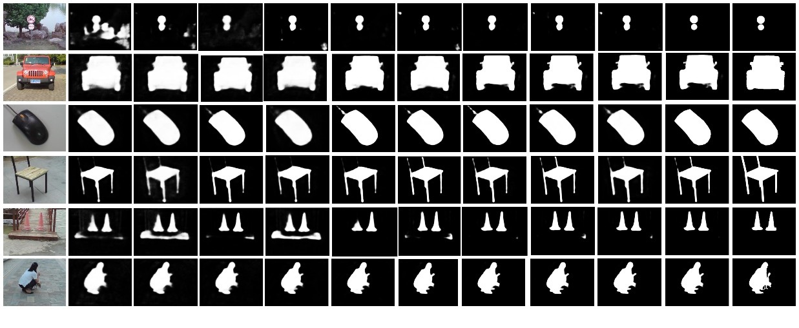
Version February 10, 2026 submitted to Journal Not Speciﬁed
15 of 25
RGB
CSRNet
MIDD
OSRNet
SwinNet
Tnet
LSNet
IFFNet
DFENet
LAFB
Our
GT
Figure 4. Qualitative comparison results on the VT821 dataset. The proposed algorithm outputs
clearer target edges and fewer background interferences compared with other methods.
To intuitively display the differences in algorithm performance, Figure 4 presents
the visual comparison results of the method in this chapter against mainstream RGB-T
saliency detection algorithms such as CSRNet, MIDD, and OSRNet in typical multi-modal
500
501
502
scenarios. Among them, GT (Ground Truth) serves as the true saliency annotation map, 503
providing a standard for objectively assessing the accuracy of each algorithm in object
boundary restoration and salient region identiﬁcation. Experimental results show that
traditional models like CSRNet, MIDD, and OSRNet can achieve basic object highlighting
when dealing with scenarios involving simple structures and high contrast between the
target and background. However, once faced with complex scenarios involving complex
background interference or multi-object overlapping occlusion, the limitations of these
models are fully exposed: salient regions appear severely fragmented, object boundaries
504
505
506
507
508
509
510
are blurred, and it even leads to missed detections of key targets. In contrast, while new- 511
generation models like SwinNet, Tnet, and LSNet have made certain progress in object
contour extraction, they still exhibit obvious shortcomings in ﬁne detail depiction and
overall object coherence expression. For example, when processing objects with complex
textures or irregular shapes, these models struggle to fully capture all detail features of the
targets, resulting in fractures or omissions in the saliency prediction results. Conversely, the
method proposed in this chapter demonstrates excellent detection performance in all test
scenarios. Whether facing small-sized targets or low-contrast weak targets, the model can
output clear and complete salient region prediction maps. It not only accurately outlines
512
513
514
515
516
517
518
519
object edges but also effectively suppresses background noise interference, achieving high- 520
resolution detail expression and strong robustness in object coherence representation.
The quantitative evaluation results on the VT821 dataset are shown in Table 1. The
comparison of key metrics between the method in this chapter and mainstream RGB-T
saliency detection models highlights signiﬁcant advantages. Looking at the E-measure
521
522
523
524
(Enhanced-alignment measure), the method in this chapter ranks ﬁrst with a value of 0.918, 525
a 0.5% improvement over the runner-up model DFENet (0.913), indicating that the model
526
achieves a better balance between global structural alignment and local detail consistency. 527
The S-measure (Structure measure) ties with DFENet for the highest value at 0.904, indi- 528
cating that both are at the same leading level in characterizing object structural integrity, 529
but combining this with other metrics further reﬂects the comprehensive advantage of this
530
531
532
533
chapter’s method. In the F and ωF metrics, this method achieves optimal values of 0.870
β
β
and 0.869 respectively. Especially compared to methods like SwinNet (0.844/0.847) and
IFFNet (0.849/0.848), the dual representation capability for high-frequency details (such as
small target textures) and low-frequency semantics (such as large target contours) is signiﬁ- 534
cantly enhanced. It is worth noting that for MAE (Mean Absolute Error), a core indicator
535
https://doi.org/10.3390/1010000

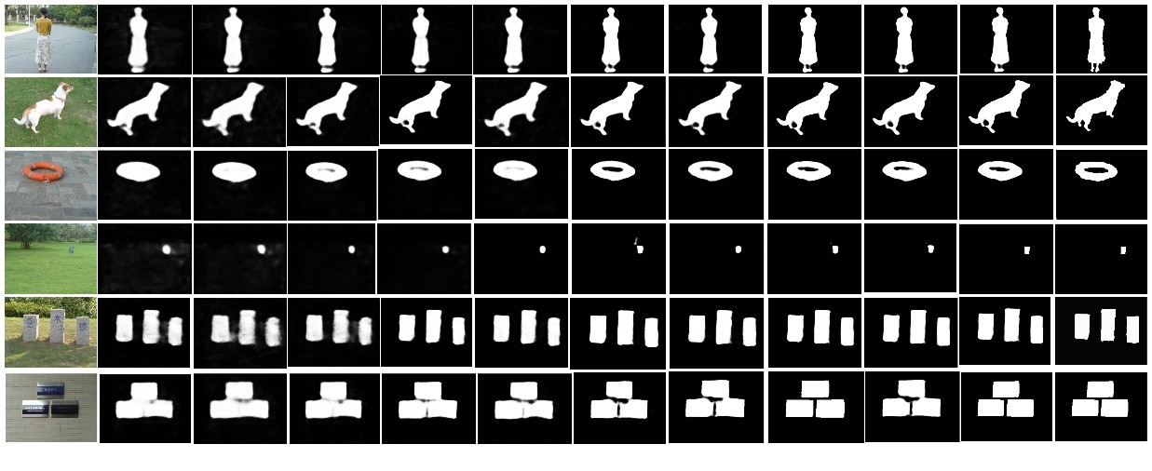
Version February 10, 2026 submitted to Journal Not Speciﬁed
16 of 25
reﬂecting overall prediction error, this method ranks second with a low value of 0.024, only
slightly higher than DFENet (0.023). However, combined with the comprehensive lead in
536
537
the ﬁrst four metrics, this indicates that the model achieves more precise salient region lo- 538
calization while reducing background false detections. Integrating the performance across
ﬁve metrics, the method in this chapter achieves a better balance in saliency detection
integrity, structural consistency, detail resolution, and error control through cross-modal
feature fusion and reﬁned frequency domain modeling, validating the effectiveness and
robustness of the algorithm in this chapter.
539
540
541
542
543
4.2.2. Results on VT1000 Dataset
544
RGB
CSRNet
MIDD
OSRNet
SwinNet
Tnet
LSNet
IFFNet
DFENet
LAFB
Our
GT
Figure 5. Qualitative comparison results on the VT1000 dataset. The proposed algorithm maintains
complete target structure in occluded and irregular target scenes.
Table 2. Quantitative Results on the VT1000 Dataset (Best Results in Bold).
Algorithm
E-measure ↑
S-measure ↑
F ↑
ωF ↑
MAE ↓
β
β
CSRNet [19]
MIDD [35]
OSRNet [18]
SwinNet [22]
TNet [23]
LSNet [24]
IFFNet [25]
DFENet [36]
LAFB [2]
0.877
0.894
0.885
0.900
0.903
0.896
0.911
0.921
0.914
0.873
0.890
0.874
0.898
0.895
0.892
0.906
0.912
0.913
0.841
0.843
0.851
0.848
0.862
0.854
0.869
0.882
0.878
0.850
0.849
0.841
0.838
0.860
0.852
0.872
0.881
0.876
0.036
0.042
0.037
0.028
0.028
0.031
0.025
0.019
0.021
Ours
0.924
0.915
0.885
0.881
0.018
Figure 5 displays visual comparison results in typical scenarios of the VT1000 dataset, 545
covering diverse saliency detection tasks such as a single person standing, animal contours, 546
circular lifebuoys, distant weak targets, inscription structures, and box arrangements. By
comparing with the ground truth saliency annotations (GT), differences in the capabili- 548
547
ties of different methods regarding salient region localization, boundary depiction, and
background suppression can be clearly observed. In the "person standing" scenario in
the ﬁrst row, methods like CSRNet, MIDD, and OSRNet can roughly outline the target
area, but edges generally suffer from blurring and expansion phenomena. The "circular
lifebuoy" in the third row represents a medium target with a closed shape, suitable for
examining the model’s edge closure. LSNet and TNet show signiﬁcant fractures in the
inner circle area; while LAFB and DFENet are integral in form, their edges are thick and
exhibit fusion redundancy. The "multi-inscription structure" in the ﬁfth row belongs to
549
550
551
552
553
554
555
556
a multi-target arrangement scenario, posing challenges to saliency consistency and seg- 557
https://doi.org/10.3390/1010000

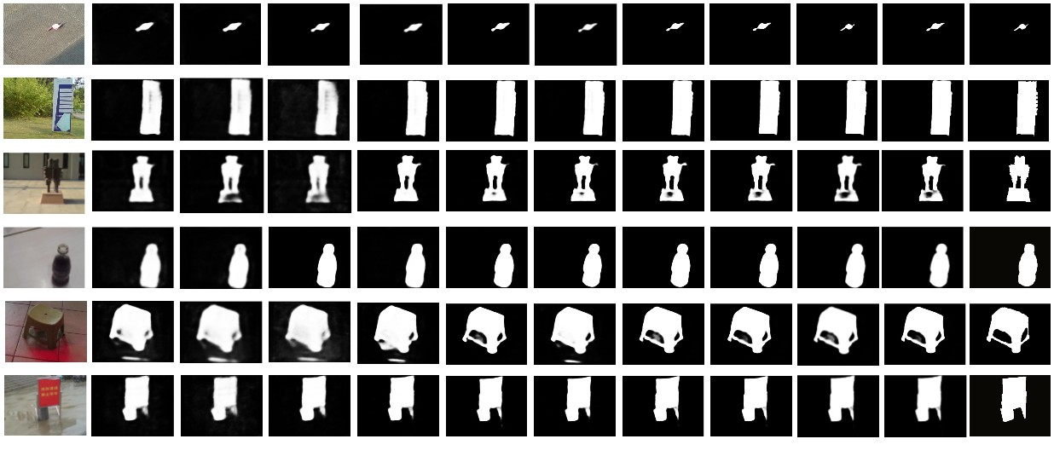
Version February 10, 2026 submitted to Journal Not Speciﬁed
17 of 25
mentation precision. Apart from CSRNet and MIDD, most methods predict the overall
structure relatively well but suffer from partial target fusion or blurred edge issues. The
method in this paper maintains clear boundaries between all sub-targets, demonstrating
good saliency separation capability. The method in this paper performs best in edge details
and shape recovery. The model proposed in this chapter demonstrates superior salient
558
559
560
561
562
region consistency, edge clarity, and target coherence across multiple typical scenarios, 563
capable of more stably handling interference and compensation relationships between
multi-modal data.
564
565
From the quantitative results in Table 2, it is evident that early methods like CSRNet, 566
MIDD and OSRNet lag relatively behind in multi-metric performance. Taking MIDD as
an example, its MAE metric is as high as 0.042, reﬂecting signiﬁcant defects in the fusion
processing of the infrared modality, which easily leads to blurring of salient regions or
false activation of the background. Although OSRNet shows slight improvements in some
567
568
569
570
metrics, the fragmentation of salient regions in complex structure scenarios is obvious, 571
resulting in lower S-measure (0.874) and ωF (0.841) metrics, exposing its deﬁciency in
integrating multi-modal spatial structural information. SwinNet and Tnet enhanced global
modeling capabilities by introducing Transformer architectures, improving the coherence of
572
573
574
575
576
β
salient regions, with F metrics rising to 0.848 and 0.862 respectively. However, due to the
β
lack of collaborative regulation mechanisms for inter-modal frequency domain features and
spatial structures, their performance stability in complex scenarios still needs improvement. 577
In contrast, the algorithm in this chapter performs best across all metrics: E-measure (0.924), 578
S-measure (0.915), and MAE is as low as 0.018, achieving signiﬁcant optimization over the
runner-up method. This result indicates that through deep collaborative modeling of inter- 580
579
modal frequency and spatial features, the algorithm effectively improves salient region
integrity, structural consistency, and background suppression capabilities, with overall
performance comprehensively surpassing current mainstream methods, highlighting its
leading advantage in cross-modal saliency detection.
581
582
583
584
4.2.3. Results on VI-RGBT1500 Dataset
585
RGB
CSRNet
MIDD
OSRNet
SwinNet
Tnet
LSNet
IFFNet
DFENet
LAFB
Our
GT
Figure 6. Qualitative comparison results on the VI-RGBT1500 dataset. The proposed algorithm
adapts to diverse illumination scenes and maintains high detection accuracy.
Figure 6 displays the visual detection results on the VI-RGBT1500 dataset, covering
586
multiple typical and challenging scenarios such as small object detection, complex back- 587
ground interference, irregularly shaped objects, occlusion interference, and low-contrast
environments. By comparing with the Ground Truth (GT), the performance differences
of various methods in salient region localization, boundary depiction, object integrity
maintenance, and background information suppression can be intuitively observed. In the
588
589
590
591
https://doi.org/10.3390/1010000

Version February 10, 2026 submitted to Journal Not Speciﬁed
18 of 25
Table 3. Quantitative Results on the VI-RGBT1500 Dataset (Best Results in Bold) [34].
Algorithm
E-measure ↑
S-measure ↑
F ↑
ωF ↑
MAE ↓
β
β
CSRNet [19]
MIDD [35]
OSRNet [18]
SwinNet [22]
TNet [23]
LSNet [24]
IFFNet [25]
DFENet [36]
LAFB [2]
0.857
0.834
0.891
0.873
0.900
0.911
0.909
0.922
0.917
0.842
0.838
0.855
0.824
0.862
0.894
0.896
0.912
0.911
0.804
0.811
0.807
0.821
0.835
0.826
0.843
0.877
0.864
0.820
0.819
0.829
0.832
0.857
0.857
0.863
0.870
0.862
0.039
0.037
0.031
0.038
0.034
0.031
0.028
0.022
0.025
Ours
0.926
0.912
0.876
0.874
0.020
small object detection scenario in the ﬁrst row, although methods like CSRNet, MIDD, and
OSRNet can detect the target in the rough area, the object edges in their prediction maps are
blurred, the forms are unclear, and obvious pseudo-responses exist, demonstrating weak
perception capabilities for small-scale targets, especially signiﬁcant defects in boundary
preservation. TNet and LSNet show improvements in boundary expression, but issues with
inconsistency between target contours and actual annotations remain, and the ﬁneness and
stability of prediction results are insufﬁcient. In the irregular object detection task in the
592
593
594
595
596
597
598
ﬁfth row, many comparison methods struggle to maintain the integrity of the overall struc- 599
ture when facing objects with complex shapes and irregular contours, often resulting in
edge distortion, absence, or over-smoothing, which affects the model’s accurate expression
of object morphology. Especially in areas with strong background interference or unclear
saliency edges, traditional methods are more prone to salient region overﬂow or loss of
internal target details. In contrast, the method proposed in this chapter exhibits superior
visual performance in all scenarios. Whether for ﬁne localization of small objects, effective
separation under complex backgrounds, or in edge depiction and shape restoration, this
method can generate clear, compact, and structurally complete prediction maps.
The quantitative experimental results on the VI-RGBT1500 dataset are shown in Table
3. The method proposed in this chapter performs best overall across ﬁve mainstream
600
601
602
603
604
605
606
607
608
609
evaluation metrics, fully validating its superior performance in multi-modal saliency de- 610
tection tasks. Among them, it achieved the highest scores of 0.926, 0.876, and 0.874 in
611
612
613
614
615
616
617
618
E-measure, F , and ωF metrics respectively, signiﬁcantly outperforming existing advanced
β
β
methods like DFENet and IFFNet. This indicates that the method has obvious advantages
in maintaining the overall structure of salient regions and target detection accuracy. At
the same time, it reached 0.912 on the structural similarity metric S-measure, performing
on par with the current best method, further explaining its strong expression capability in
global and local structural perception, enabling effective perception of the spatial layout
and morphological features of salient targets in images. Furthermore, this chapter’s method
achieved the lowest value of 0.020 on the MAE metric, signiﬁcantly superior to all com- 619
parison algorithms, indicating smaller errors in saliency map prediction and more reﬁned
boundary depiction. Combining all metrics, the method in this chapter demonstrates
620
621
stronger robustness and detection precision in scenarios involving complex backgrounds, 622
small targets, and signiﬁcant modal differences, verifying the model’s broad adaptability
and promotion value in practical applications.
623
624
4.2.4. Results on VT5000 Dataset
625
Figure 7 shows six sets of comparison examples from the VT5000 dataset. From
the complex background interference in the second row and the extremely low light
conditions in the sixth row, it is visible that methods like CSRNet and SwinNet generally
626
627
628
https://doi.org/10.3390/1010000

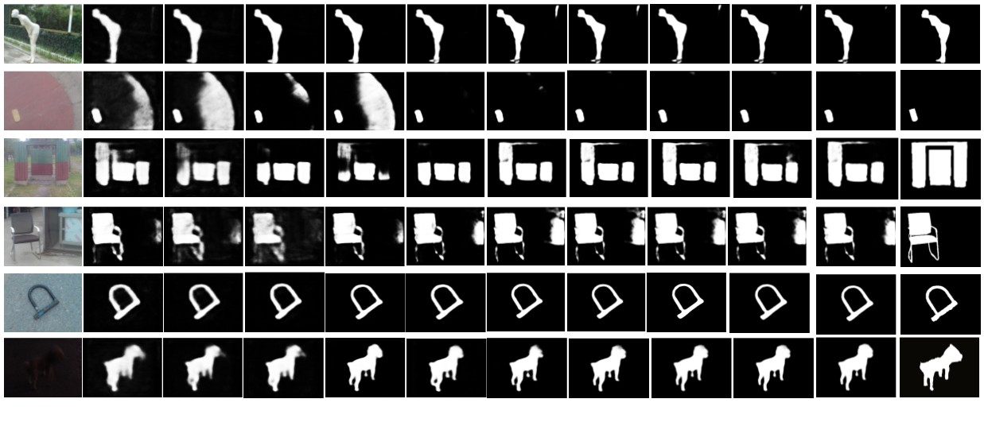
Version February 10, 2026 submitted to Journal Not Speciﬁed
19 of 25
GT
RGB
CSRNet
MIDD
OSRNet
SwinNet
Tnet
LSNet
IFFNet
DFENet
LAFB
Our
GT
Figure 7. Qualitative comparison results on the VT5000 dataset. The proposed algorithm accurately
detects small and occluded targets in large-scale complex scenes.
Table 4. Quantitative Results on the VT5000 Dataset (Best Results in Bold).
Algorithm
E-measure ↑
S-measure ↑
F ↑
ωF ↑
MAE ↓
β
β
CSRNet [19]
MIDD [35]
OSRNet [18]
SwinNet [22]
TNet [23]
LSNet [24]
IFFNet [25]
DFENet [36]
LAFB [2]
0.872
0.876
0.882
0.871
0.894
0.898
0.904
0.918
0.912
0.861
0.866
0.854
0.876
0.881
0.884
0.899
0.905
0.906
0.819
0.826
0.822
0.821
0.834
0.843
0.842
0.861
0.854
0.820
0.819
0.828
0.830
0.824
0.841
0.842
0.864
0.878
0.032
0.033
0.029
0.035
0.030
0.036
0.028
0.024
0.024
Ours
0.920
0.909
0.867
0.869
0.023
suffer from background confusion and incomplete object detection. In scenarios where
chair structures exist within strong interfering background textures, except for DFENet and
LAFB which perform relatively better, most methods exhibit salient region omission or edge
drift phenomena. In contrast, the method in this paper demonstrates excellent structural
perception capabilities in detail areas like chair backs and legs; it not only positions edges
accurately but also effectively recovers occluded areas, demonstrating stronger robustness
and perception precision.
629
630
631
632
633
634
635
The quantitative experimental results on the VT5000 dataset are shown in Table 4. 636
This dataset covers various challenging scenarios such as complex background interference
and low light, posing high demands on the robustness and detail perception capabilities
of saliency detection algorithms. From the table, it can be observed that CSRNet and
MIDD have signiﬁcant bottlenecks in core performance, reﬂecting the dual defects of such
637
638
639
640
methods in target structure maintenance and edge positioning precision, especially in low- 641
contrast scenarios where salient region blurring easily occurs. Although improved models
642
like Tnet and LSNet have made some progress by optimizing feature extraction paths, 643
limited by the local perception characteristics of traditional convolutional architectures, 644
they have shortcomings in cross-modal global semantic correlation modeling, and their
comprehensive performance still lags behind new-generation fusion schemes. DFENet
and LAFB demonstrate stronger multi-modal feature fusion capabilities by introducing
attention mechanisms and multi-scale feature interaction, approaching advanced levels in
F and ωF metrics, indicating the effectiveness of dynamic feature selection mechanisms
645
646
647
648
649
650
β
β
for performance improvement. However, the method proposed in this chapter achieves
the best results in all ﬁve metrics: E-measure, S-measure, F , ωF , and MAE. Speciﬁcally, 651
β
β
https://doi.org/10.3390/1010000

Version February 10, 2026 submitted to Journal Not Speciﬁed
20 of 25
compared to DFENet, E-measure improved by 0.2%, S-measure by 0.4%; compared to
652
653
654
655
LAFB, F improved by 1.5%. It performs particularly well in edge preservation and
β
regional consistency, validating its stronger perception capability and stability in complex
scenarios.
4.2.5. Computational Efﬁciency Analysis
656
Table 5. Complexity Analysis on the VT5000 Dataset(best results in bold).
Algorithm
Backbone
Params (M)↓
FLOPs (G)↓
FPS↑
E-measure↑
CSRNet [19]
MIDD [35]
OSRNet [18]
SwinNet [22]
TNet [23]
LSNet [24]
IFFNet [25]
DFENet [36]
LAFB [2]
ESPNetV2
VGG16
ResNet50
256.74
200.00
59.67
88.5
256.74
17.41
123.77
398.05
223.45
326.04
216.72
51.27
45.25
326.04
3.04
241.2
552.1
235.66
178
33
142
22
178
314
74
0.872
0.876
0.882
0.871
0.894
0.898
0.904
0.918
0.912
SwinTransformer
ResNet50
MobileNetV2
ResNet50
VGG16
ResNet50
37
87
Ours
FREFormer
36.04
5.78
277
0.920
To comprehensively evaluate the practical applicability of the proposed method, we
compare its computational complexity and inference speed with state-of-the-art methods
on the VT5000 dataset. As presented in Table 5, our SCFusion achieves the best performance
with an E-measure of 0.920, while maintaining a highly efﬁcient design.
657
658
659
660
Speciﬁcally, compared to the top-performing competitors such as DFENet and LAFB, 661
our method demonstrates a signiﬁcant advantage in efﬁciency. DFENet, despite achieving a
high E-measure of 0.918, suffers from an excessively heavy computational burden (398.05M
Params and 552.1G FLOPs) and a low inference speed of 37 FPS. In sharp contrast, our
method reduces the parameter count by approximately 11× (36.04M) and FLOPs by nearly
95× (5.78G), while boosting the inference speed to 277 FPS, which is roughly 7.5× faster
than DFENet.
662
663
664
665
666
667
668
Furthermore, compared to Transformer-based SwinNet (22 FPS), our SCFusion
achieves real-time speeds, validating the efﬁciency of our frequency-domain token mix- 669
ing strategy over quadratic self-attention mechanisms. Although the lightweight LSNet
achieves slightly higher FPS (314 FPS), it comes at the cost of detection accuracy (E-measure
of 0.898). Our method strikes an optimal trade-off, delivering state-of-the-art accuracy with
computational costs suitable for real-time deployment.
670
671
672
673
4.3. Robustness Analysis in Hazy and Complex Scenarios
674
To evaluate the model’s performance under adverse weather conditions (e.g., haze, 675
fog) and sudden visual changes (e.g., occlusion, illumination ﬂare), we visualized the
intermediate feature maps of the proposed network. As shown in Figure 8, we selected
four representative challenging scenes from the M3FD.
676
677
678
In scenarios with heavy fog, the visible images lose most textural details and contrast. 679
However, the infrared modality remains unaffected. The visualization of the FREFormer
output shows that the encoder successfully extracts initial global contexts. Subsequently, 681
the HFRB module signiﬁcantly suppresses the background noise (fog) by recalibrating the
frequency components, effectively highlighting the target areas (e.g., cars and pedestrians) 683
680
682
by leveraging the thermal signature. Row 3 depicts a night scene with strong glare (sudden
visual change), and Row 4 shows targets occluded by smoke and trees. The FRGM in the
684
685
decoder stage plays a crucial role here. By reconstructing high-frequency edge details, 686
it sharpens the target boundaries that are otherwise blurred in the RGB image. The
687
https://doi.org/10.3390/1010000

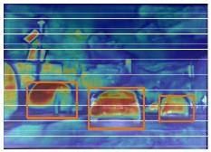
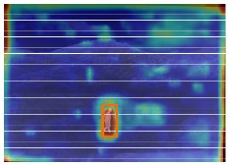
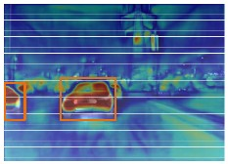
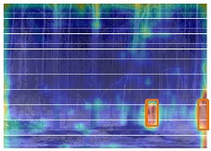
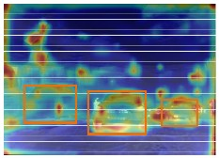
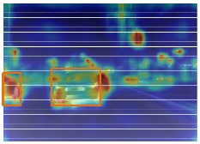
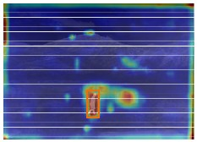
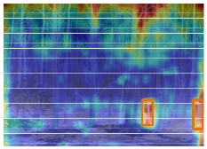
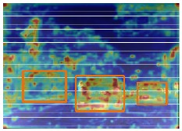
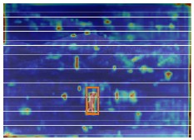
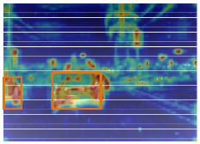
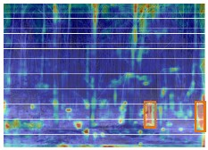
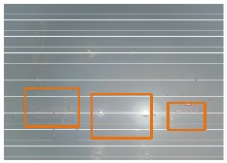
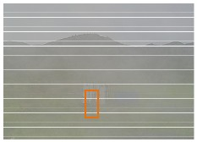
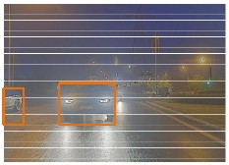
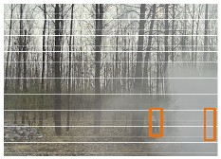
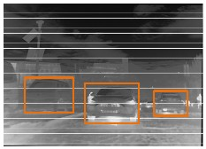
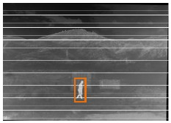
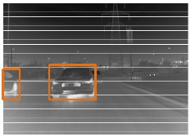
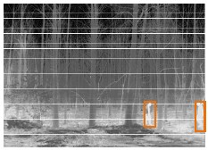
Version February 10, 2026 submitted to Journal Not Speciﬁed
21 of 25
After FREFormer
for Encoder
After FRGM
for Decoder
Input Image(RGB)
Input Image(IR)
After HFRB
Figure 8. Visualization of feature evolution under challenging scenarios (e.g., heavy fog, haze,
strong glare, and smoke occlusion). The columns from left to right display: Input RGB Image,
Input Infrared Image, Feature after Encoder (FREFormer), Feature after HFRB, and Feature after
Decoder (FRGM). It can be observed that even when the visible spectrum is severely degraded, the
proposed modules effectively integrate infrared information to highlight salient targets and suppress
background interference.
ﬁnal feature maps demonstrate that our method maintains robust perception and precise
localization even when one modality is severely corrupted.
688
689
4.4. Ablation Study
690
Table 6. Ablation study results on the VT821 dataset. (Best results in bold).
Components
HSFB
Metrics
HFRB
FRGM
E ↑
0.911
0.910
0.912
0.918
S ↑
0.898
0.896
0.901
0.904
F ↑
ωF ↑
0.860
0.859
0.862
0.869
MAE ↓
0.029
0.032
0.027
0.024
ξ
α
β
β
×
✓
✓
✓
✓
×
✓
✓
✓
✓
×
✓
0.862
0.861
0.865
0.870
To comprehensively verify the effectiveness of the proposed algorithm, a systematic
ablation study was conducted on the VT821 and VT5000 datasets, evaluating the Homoge- 692
691
neous Frequency Reﬁned Block (HFRB), Heterogeneous Spatial-Channel Frequency Fusion
Block (HSFB), and Frequency Reconstruction Guided Module (FRGM). The quantitative
results in Tables 6 and 7 demonstrate that the complete conﬁguration achieves optimal
performance across all metrics. Speciﬁcally, on the VT5000 dataset, the full model reached
an E-measure of 0.920, an S-measure of 0.909, and the lowest MAE of 0.023. These results
693
694
695
696
697
conﬁrm that the absence of any module causes varying degrees of performance degrada- 698
tion, validating the rationality and complementarity of the module designs in improving
target boundary restoration and suppressing background interference.
The HFRB module plays a pivotal role in adaptively extracting salient features within
the frequency domain, particularly in complex scenarios. Experimental results demonstrate
699
700
701
702
https://doi.org/10.3390/1010000

Version February 10, 2026 submitted to Journal Not Speciﬁed
22 of 25
Table 7. Ablation study results on the VT5000 dataset (best results in bold).
Components
Metrics
HFRB
HSFB
FRGM
E ↑
0.912
0.911
0.914
0.920
S ↑
0.897
0.895
0.903
0.909
F ↑
0.862
0.861
0.865
0.867
ωF ↑
0.862
0.860
0.862
0.869
MAE ↓
0.030
0.034
0.028
0.023
ξ
α
β
β
×
✓
✓
✓
✓
×
✓
✓
✓
✓
×
✓
that removing the HFRB module (refer to Row 1 in the tables) leads to a substantial
deterioration in precision metrics. For instance, on the VT821 dataset, the exclusion of
703
704
705
706
707
708
HFRB results in a decrease of the F score from 0.870 (full model) to 0.862, while the MAE
β
signiﬁcantly increases from 0.024 to 0.029. This quantitative decline conﬁrms that without
HFRB, the model struggles to effectively distinguish high-response regions, especially
when the spectral characteristics of salient objects are similar to those of the background.
The HSFB is indispensable for integrating cross-modal frequency-domain information. 709
As shown in Row 2, the absence of this module severely compromises the model’s fusion
capability, which is reﬂected in the notable decline of structural and enhancement metrics. 711
710
On the VT821 dataset, removing HSFB results in the lowest S-measure of 0.896 (compared
to 0.904 for the full model) and a reduction in the E-measure to 0.910. Similarly, on the
VT5000 dataset, the MAE escalates to 0.034, the highest value among all variants. These
statistics underscore the necessity of HSFB for maintaining structural integrity and ensuring
effective cross-modal fusion.
712
713
714
715
716
The FRGM is designed to ensure inter-modal coordination and prevent saliency shift. 717
Ablation results indicate that eliminating the FRGM (Row 3 in the tables) impairs this
coordination capability. Speciﬁcally, on the VT5000 dataset, the absence of FRGM leads to a
drop in the E-measure from 0.920 to 0.914, accompanied by an increase in MAE from 0.023
to 0.028. Although the performance degradation is slightly less severe compared to the
removal of the primary fusion blocks, the consistent decline across both datasets validates
that FRGM plays an essential role in maintaining salient region consistency and reﬁning
boundary details.
718
719
720
721
722
723
724
Table 8. Component-wise ablation study on VT5000. LSF: Learnable Selective Filter. S-Freq: Spatial
Frequency Branch. C-Freq: Channel Frequency Branch.
Components
S-Freq
Metrics
LSF
C-Freq
E ↑
0.833
0.891
0.865
0.920
S ↑
F ↑
MAE ↓
0.046
0.039
0.037
0.023
ξ
α
β
×
✓
✓
✓
✓
×
✓
✓
✓
✓
×
✓
0.802
0.878
0.863
0.909
0.819
0.835
0.831
0.867
To pinpoint the speciﬁc factors driving our performance gains, we conducted a
component-wise ablation ablation study on the internal mechanisms of LSFG and HSFB, as
detailed in Table 8.
We ﬁrst investigate the Learnable Selective Filter (LSF) within the LSFG module, which
is designed to replace traditional static ﬁlters. By substituting our dynamic generator with a
ﬁxed ’Static Filter’, we observed a sharp performance decline, with the E-measure dropping
from 0.920 to 0.833. This substantial gap conﬁrms that the improvement stems not merely
from operating in the frequency domain, but speciﬁcally from the input-adaptive nature
of our design. Unlike static ﬁlters, which struggle with non-stationary scenes containing
725
726
727
728
729
730
731
732
733
https://doi.org/10.3390/1010000

Version February 10, 2026 submitted to Journal Not Speciﬁed
23 of 25
varying object scales and clutter, our selective mechanism dynamically adjusts spectral
weights. This allows the model to surgically sharpen boundaries or suppress noise tailored
to each speciﬁc image instance.
734
735
736
737
Subsequently, we dissect the Heterogeneous Spatial-Channel Frequency Fusion
Block (HSFB) to verify the contribution of its dual-branch design. Removing the Spa- 738
tial Branch—which processes phase information via 2D FFT—leads to a signiﬁcant drop in
739
S-measure (from 0.909 to 0.891). This result underscores the branch’s critical role in struc- 740
tural alignment, effectively correcting spatial shifts between infrared and visible modalities. 741
Conversely, excluding the Channel Branch—which handles amplitude via CFFT—causes
742
743
744
745
746
747
a notable decrease in F (from 0.867 to 0.831), indicating that channel-wise interaction is
β
indispensable for feature selection and saliency enhancement. Ultimately, the full model
achieves the best performance, demonstrating that the spatial and channel operations are
mutually complementary: one guarantees structural precision, while the other ensures
semantic strength.
5. Conclusions
748
749
In this paper, we propose a novel infrared and visible image object detection algorithm
grounded in a frequency-domain multi-scale reﬁnement framework. We introduce the FRE- 750
Former as a hierarchical encoder, which efﬁciently captures global spatial dependencies via
751
an Adaptive Selective Filter in the frequency domain. To mitigate cross-modal interference, 752
we design the Cross Frequency Guided Interaction Module (CFGIM), integrating the Ho- 753
mogeneous Frequency Reﬁned Block (HFRB) for dual-branch channel calibration and the
Heterogeneous Spatial-Channel Frequency Fusion Block (HSFB) for robust spatial-channel
754
755
fusion. Furthermore, we embed the Frequency Reconstruction Guided Module (FRGM) 756
into a four-stage decoder, enabling the progressive injection of multi-band frequency com- 757
ponents to enhance target edge localization. Finally, a joint loss function incorporating
Frequency Fidelity Loss ensures the precise reconstruction of sharp boundaries and struc- 759
758
tural integrity. Experimental results demonstrate that our method effectively coordinates
complementary information from dual modalities, achieving superior performance in
complex environmental conditions.
In future work, we aim to further optimize the computational efﬁciency of the
frequency-domain modules to facilitate real-time detection scenarios and explore the
integration of temporal features for handling dynamic video sequences.
760
761
762
763
764
765
Author Contributions: Conceptualization, G.X. and Y.S.; methodology, G.X. and Y.S.; software,
G.X. and Y.S.; validation, Y.S. and K.C..; formal analysis, G.X. and Y.S.; investigation, Y.S. and K.C.;
resources, Y.Y. and L.D.; data curation, Y.S. and Y.Y.; writing—original draft preparation, G.X. and
Y.S.; writing—review and editing, G.X., Y.S. and H.Z.; visualization, Y.S.; supervision, G.X. and H.Z.;
project administration, G.X., G.X. and H.Z.; funding acquisition, H.Z. All authors have read and
agreed to the published version of the manuscript.
766
767
768
769
770
771
Funding: This work was supported by the National Natural Science Foundation of China under Grant:
62401292 and 62476140, Postdoctoral Fellowship Program of China Postdoctoral Science Foundation
under Grant Number: GZC20240745 and Jiangsu Funding Program for Excellent Postdoctoral Talent
under Grant Number: 2024ZB682. Natural Science Research Start-up Foundation of Recruiting
Talents of Nanjing University of Posts and Telecommunications (Grant No. NY225048)
772
773
774
775
776
Institutional Review Board Statement: Not applicable.
Informed Consent Statement: Not applicable.
777
778
Data Availability Statement: The data presented in this study are available in [VT821] at https:// 779
www.researchgate.net/ﬁgure/Examples-of-RGB-T-images-in-the-VT821-dataset-RGB-T-and-GT-represent-
780
visual-image_ﬁg3_376647770, [VT1000] at https://www.kaggle.com/datasets/cindystoila/vt1000-
781
https://doi.org/10.3390/1010000

Version February 10, 2026 submitted to Journal Not Speciﬁed
24 of 25
aug, [VI-RGBT1500] at https://github.com/huanglm-me/VI-RGBT1500, [VT5000] at https://www. 782
kaggle.com/datasets/stoilacindy/vt5000-new, [M3FD] at https://www.kaggle.com/datasets/nus1
998/m3fd-dataset
783
784
Conﬂicts of Interest: The authors declare no conﬂicts of interest.
785
References
786
1.
Sun, H.; Liu, Q.; Wang, J.; Ren, J.; Wu, Y. ; Zhao, H.; Li, H. Fusion of infrared and visible images for remote detection of low-altitude
slow-speed small targets. IEEE Journal of Selected Topics in Applied Earth Observations and Remote Sensing 2021, 14, 2971–2983.
Wang, G.; Li, C.; Ma, Y.; et al. RGB-T Saliency Detection Benchmark: Dataset, Baselines, Analysis and a Novel Approach. In
Proceedings of the Image and Graphics Technologies and Applications: 13th Conference on Image and Graphics Technologies
787
788
789
790
2.
and Applications, IGTA 2018, Beijing, China, April 8–10, 2018, Revised Selected Papers. Springer Singapore, 2018, Vol. 13, pp. 791
359–369.
792
793
794
795
796
797
798
799
800
3.
4.
5.
6.
Hwang, S.; Park, J.; Kim, N.; Choi, Y.; So Kweon, I. Multispectral pedestrian detection: Benchmark dataset and baseline. In
Proceedings of the Proceedings of the IEEE conference on computer vision and pattern recognition, 2015, pp. 1037–1045.
Qingyun, F.; Dapeng, H.; Zhaokui, W. Cross-modality fusion transformer for multispectral object detection. arXiv preprint
arXiv:2111.00273 2021.
Wagner, J.; Fischer, V. ; Herman, M.; Behnke, S.; et al. Multispectral pedestrian detection using deep fusion convolutional neural
Networks. In Proceedings of the ESANN, 2016, Vol. 587, pp. 509–514.
Li, C.; Song, D.; Tong, R.; Tang, M. Illumination-aware faster R-CNN for robust multispectral pedestrian detection. Pattern
Recognition 2019, 85, 161–171.
7.
8.
Dosovitskiy, A. An image is worth 16x16 words: Transformers for image recognition at scale. arXiv preprint arXiv:2010.11929 2020. 801
Lee, W.Y.; Jovanov, L.; Philips, W. Cross-modality attention and multimodal fusion transformer for pedestrian detection. In
Proceedings of the European conference on computer vision. Springer, 2022, pp. 608–623.
802
803
804
805
806
807
808
9.
Xiang, X.; Zhou, G.; Niu, B.; Pan, Z.; Huang, L.; Li, W.; Wen, Z.; Qi, J.; Gao, W. Infrared-Visible Image Fusion Meets Object
Detection: Towards Uniﬁed Optimization for Multimodal Perception. Remote Sensing 2025, 17, 3637.
10. Tatsunami, Y. ; Taki, M. FFT-based Dynamic Token Mixer for Vision. In Proceedings of the Proceedings of the AAAI Conference
on Artiﬁcial Intelligence, 2024, Vol. 38, pp. 15328–15336.
11. Yu, A.; Ye, V. ; Tancik, M.; Kanazawa, A. Proceedings of the IEEE/CVF conference on computer vision and pattern recognition. In
Proceedings of the Proceedings of the IEEE/CVF Conference on Computer Vision and Pattern Recognition, 2020, pp. 5295–5305. 809
12. Lyu, H.; Sha, N.; Qin, S.; Yan, M.; Xie, Y.; Wang, R. Advances in neural information processing systems. Advances in neural
information processing systems 2019, 32.
13. Tu, Z.; Ma, Y.; Li, Z.; et al. RGBT Salient Object Detection: A Large-Scale Dataset and Benchmark. IEEE Transactions on Multimedia
2022, 25, 4163–4176.
14. Dai, Y.; Gieseke, F.; Oehmcke, S.; Wu, Y.; Barnard, K. Attentional feature fusion. In Proceedings of the Proceedings of the
IEEE/CVF winter conference on applications of computer vision, 2021, pp. 3560–3569.
810
811
812
813
814
815
15. Zhang, L.; Zhu, X.; Chen, X.; Yang, X.; Lei, Z.; Liu, Z. Weakly aligned cross-modal learning for multispectral pedestrian detection. 816
In Proceedings of the Proceedings of the IEEE/CVF international conference on computer vision, 2019, pp. 5127–5137.
16. Ma, J.; Tang, L.; Fan, F.; Huang, J.; Mei, X.; Ma, Y. SwinFusion: Cross-domain long-range learning for general image fusion via
swin transformer. IEEE/CAA Journal of Automatica Sinica 2022, 9, 1200–1217.
817
818
819
17. Huo, F.; Zhu, X.; Zhang, L.; et al. Efﬁcient Context-Guided Stacked Reﬁnement Network for RGB-T Salient Object Detection. 820
IEEE Transactions on Circuits and Systems for Video Technology 2022, 32, 3111–3124.
18. Liu, Z.; Tan, Y. ; He, Q.; et al. SwinNet: Swin Transformer Drives Edge-Aware RGB-D and RGB-T Salient Object Detection. IEEE
Transactions on Circuits and Systems for Video Technology 2021, 32, 4486–4497.
19. Tu, Z.; Li, Z.; Li, C.; et al. Multi-Interactive Dual-Decoder for RGB-Thermal Salient Object Detection. IEEE Transactions on Image
Processing 2021, 30, 5678–5691.
20. Huang, Y.; Li, H.; Wang, G.; Xu, D.; Yang, J.; Yue, G.; Liu, X. DPSNET: A Dual-path Lightweight Network with Semantic-guided
Cross-modal Feature Fusion for Multi-modal Object Detection. IEEE Transactions on Instrumentation and Measurement 2025.
21. Cai, Z.; Ma, Y.; Huang, J.; Mei, X.; Fan, F. Correlation-guided discriminative cross-modality features network for infrared and
visible image fusion. IEEE Transactions on Instrumentation and Measurement 2023, 73, 1–18.
22. Cong, R.; Zhang, K.; Zhang, C.; et al. Does Thermal Really Always Matter for RGB-T Salient Object Detection? IEEE Transactions
on Multimedia 2023, 25, 6971–6982.
23. Zhou, W.; Zhu, Y.; Lei, J.; et al. LSNet: Lightweight Spatial Boosting Network for Detecting Salient Objects in RGB-Thermal
Images. IEEE Transactions on Image Processing 2023, 32, 1329–1340.
821
822
823
824
825
826
827
828
829
830
831
832
833
https://doi.org/10.3390/1010000

Version February 10, 2026 submitted to Journal Not Speciﬁed
25 of 25
24. Song, K.; Bao, Y.; Wang, H.; et al. A Potential Vision-Based Measurements Technology: Information Flow Fusion Detection
Method Using RGB-Thermal Infrared Images. IEEE Transactions on Instrumentation and Measurement 2023, 72, 1–13.
25. Lyu, P. ; Yu, X.; Wu, C.; et al. Deep Fourier-Embedded Network for Bi-Modal Salient Object Detection. arXiv Preprint
arXiv:2411.18409 2024. arXiv:2411.18409 [cs.CV].
26. Zhang, Y.; Gao, H.; Sohel, F.; Wu, F.; Muzahid, A.A.M.; Zhao, J.; Du, Z.; Zhang, L. Multimodal Stream Focusing Salient Object
Detection Based on Visible–Infrared Complementary Fusion. IEEE Transactions on Instrumentation and Measurement 2025, 74, 1–14.
27. Zhou, H.; Hong, W.; Zhang, Z.; Liu, X.; Wu, X.J. Lightweight Spatial-Channel-Frequency Network for RGB-Thermal Salient
Object Detection. IEEE Signal Processing Letters 2025, 32, 4009–4013.
28. Wu, W.; Zhang, X.; Yin, H.; Dai, S.; Zhang, H.; Zhang, Y. FreDFT: Frequency Domain Fusion Transformer for Visible-Infrared
Object Detection. arXiv preprint arXiv:2511.10046 2025.
29. Li, K.; Wang, D.; Hu, Z.; Li, S.; Ni, W.; Zhao, L.; Wang, Q. Fd2-net: Frequency-driven feature decomposition network for
infrared-visible object detection. In Proceedings of the Proceedings of the AAAI Conference on Artiﬁcial Intelligence, 2025,
Vol. 39, pp. 4797–4805.
834
835
836
837
838
839
840
841
842
843
844
845
846
847
848
30. Yu, W.; Luo, M.; Zhou, P. ; Si, C.; Zhou, Y.; Wang, X.; Feng, J.; Yan, S. Metaformer is actually what you need for vision. In
Proceedings of the Proceedings of the IEEE/CVF conference on computer vision and pattern recognition, 2022, pp. 10819–10829.
31. Canny, J. A Computational Approach to Edge Detection. IEEE Transactions on Pattern Analysis and Machine Intelligence 1986, pp. 849
679–698.
32. Tang, J.; Fan, D.; Wang, X.; Tu, Z.; Li, C. RGBT salient object detection: Benchmark and a novel cooperative ranking approach. 851
850
IEEE Transactions on Circuits and Systems for Video Technology 2019, 30, 4421–4433.
33. Tu, Z.; Xia, T.; Li, C.; et al. RGB-T Image Saliency Detection via Collaborative Graph Learning. IEEE Transactions on Multimedia
2019, 22, 160–173.
34. Song, K.; Huang, L.; Gong, A.; et al. Multiple Graph Afﬁnity Interactive Network and a Variable Illumination Dataset for RGBT
Image Salient Object Detection. IEEE Transactions on Circuits and Systems for Video Technology 2022, 33, 3104–3118.
35. Huo, F.; Zhu, X.; Zhang, Q.; et al. Real-Time One-Stream Semantic-Guided Reﬁnement Network for RGB-Thermal Salient Object
Detection. IEEE Transactions on Instrumentation and Measurement 2022, 71, 1–12.
36. Wang, K.; Tu, Z.; Li, C.; et al. Learning Adaptive Fusion Bank for Multi-Modal Salient Object Detection. IEEE Transactions on
Circuits and Systems for Video Technology 2024. Accepted for Publication.
37. Fan, D.P.; Gong, C.; Cao, Y.; et al. Enhanced-Alignment Measure for Binary Foreground Map Evaluation. arXiv Preprint
arXiv:1805.10421 2018. arXiv:1805.10421 [cs.CV].
38. Fan, D.P.; Cheng, M.M.; Liu, Y.; et al. Structure-Measure: A New Way to Evaluate Foreground Maps. In Proceedings of the
Proceedings of the IEEE International Conference on Computer Vision, 2017, pp. 4548–4557.
39. Achanta, R.; Hemami, S.; Estrada, F.; et al. Frequency-Tuned Salient Region Detection. In Proceedings of the 2009 IEEE Conference
on Computer Vision and Pattern Recognition. IEEE, 2009, pp. 1597–1604.
40. Margolin, R.; Zelnik-Manor, L.; Tal, A. How to Evaluate Foreground Maps? In Proceedings of the Proceedings of the IEEE
Conference on Computer Vision and Pattern Recognition. IEEE, 2014, pp. 248–255.
852
853
854
855
856
857
858
859
860
861
862
863
864
865
866
867
868
869
870
871
872
873
41. Perazzi, F.; Krähenbühl, P. ; Pritch, Y.; et al. Saliency Filters: Contrast Based Filtering for Salient Region Detection. In Proceedings
of the 2012 IEEE Conference on Computer Vision and Pattern Recognition. IEEE, 2012, pp. 733–740.
42. Liu, J.; Fan, X.; Huang, Z.; Wu, G.; Liu, R.; Zhong, W.; Luo, Z. Target-aware dual adversarial learning and a multi-scenario
multi-modality benchmark to fuse infrared and visible for object detection. In Proceedings of the Proceedings of the IEEE/CVF
conference on computer vision and pattern recognition, 2022, pp. 5802–5811.
https://doi.org/10.3390/1010000

