

ASSIGNMENT-1

**SMARTBRIDGE EXTERNSHIP**

**Modern Application Development (Java Spring Boot)**



NAME-ARYAN AGRAWAL REGISTERATION NO.-20BCE2876

1. **Make a form using HTML and CSS.**

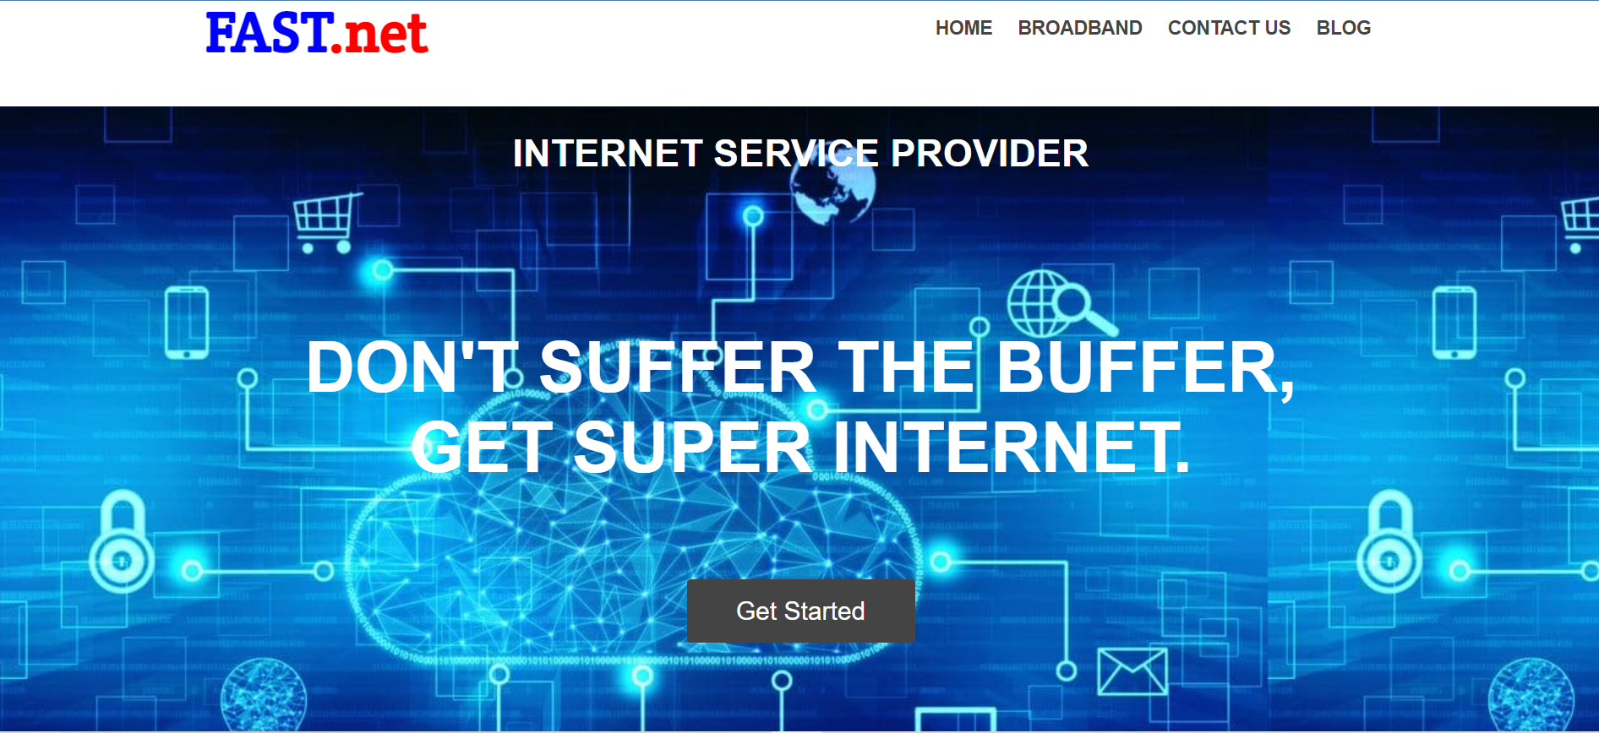

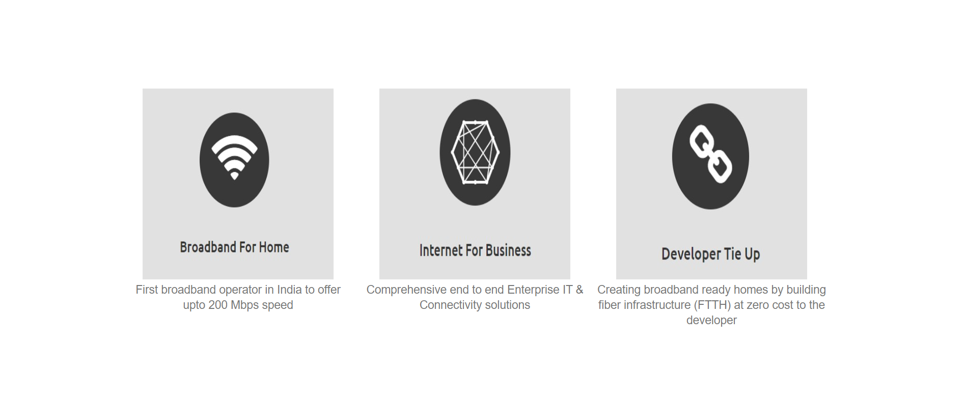

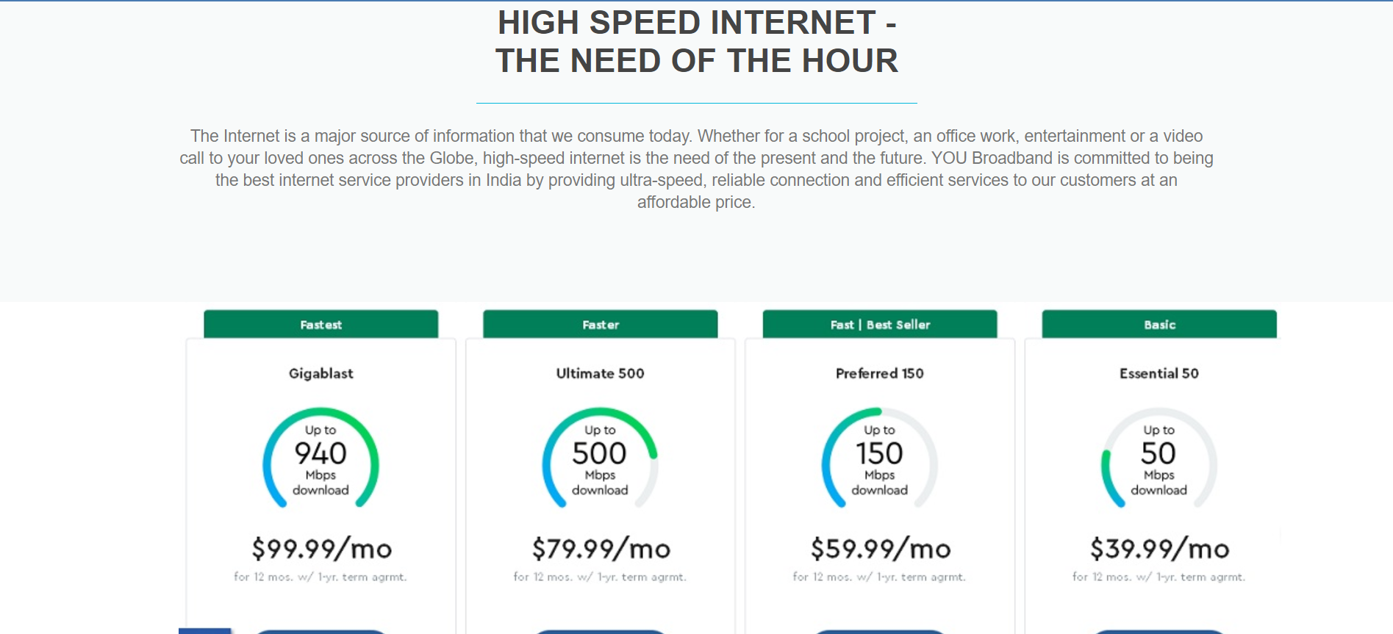

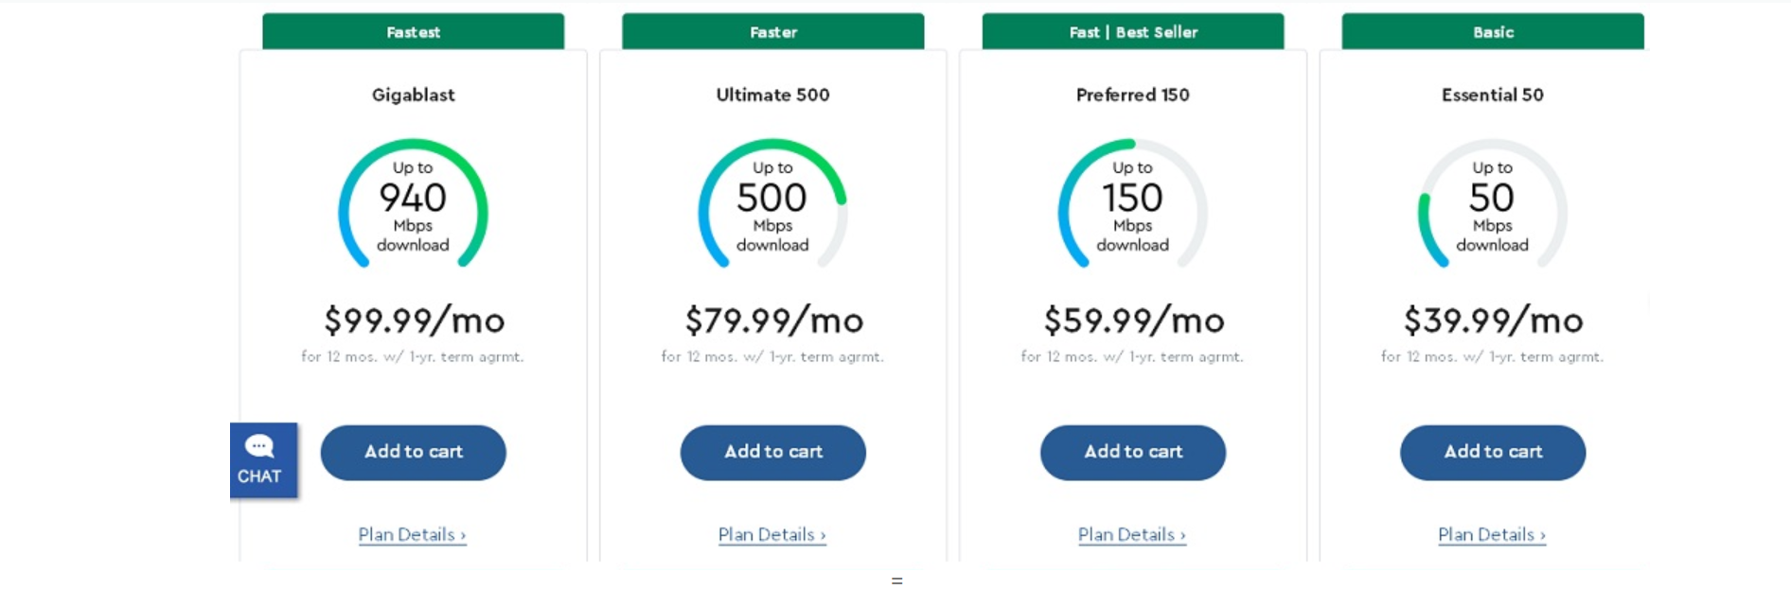

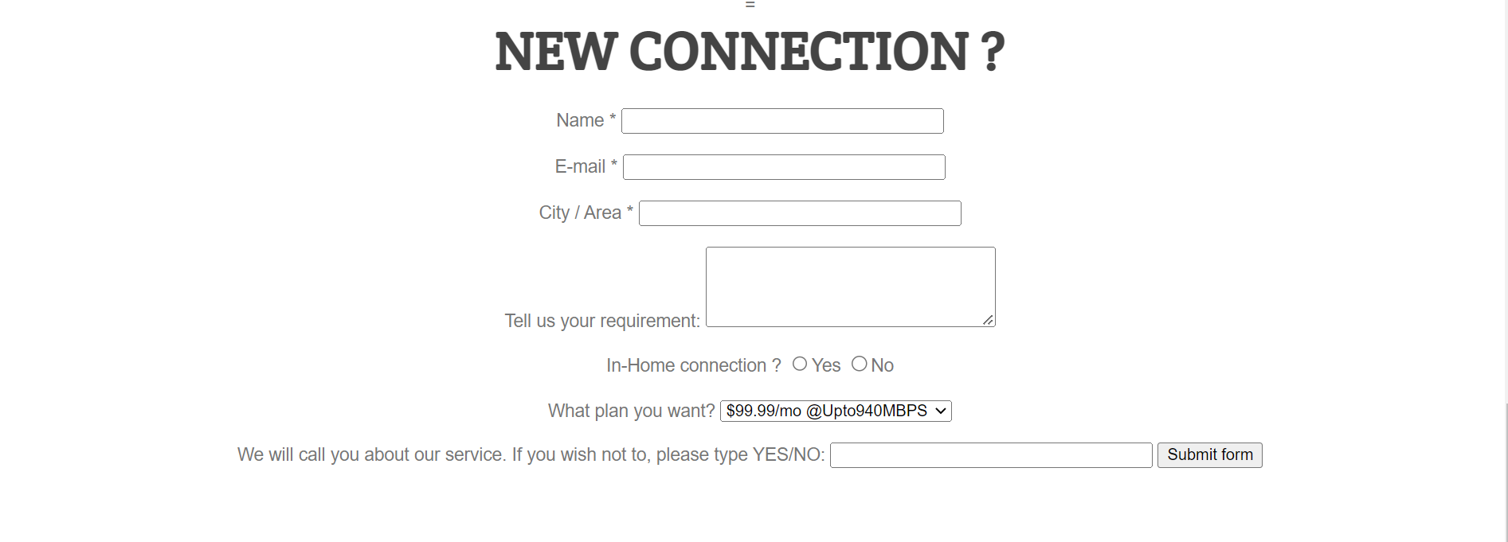



**Code for the Webpage:**

1. index.html

<!DOCTYPE HTML>

<html>

<head>

  <meta http-equiv="Content-Type" content="text/html; charset=utf-8">

  <title>ISP</title>

</head>

<link rel="stylesheet" type="text/css" href="style.css">

<link href='http://fonts.googleapis.com/css?family=Crete+Round' rel='stylesheet' type='text/css'>

<body>

  <header>

    <div class="wrapper">

      <h1 align="center" style="color: blue;">FAST<span style="color: red;">.net</span></h1>

      <nav>

        <ul>

          <li><a href="#">Home</a></li>

          <li><a href="#">Broadband</a></li>

          <li><a href="#">Contact Us</a></li>

          <li><a href="#">Blog</a></li>

        </ul>

      </nav>

    </div>

  </header>

  <div id="bgimage">

    <h3 style="padding-top: 20px; color: white;">Internet Service Provider</h3>

    <h2 style="color: white; padding-top: 100px;"><strong>Don't suffer the buffer,<br>get supper internet.</strong></h2>

    <br><br><br>

    <a href="#" class="button-1">Get Started</a>

  </div>

  <div id="features">

    <div class="wrapper">

      <ul>

        <li class="feature-1">

            <img src="1.jpeg" alt="" height="250px" width="250px">

          <p>First broadband operator in India to offer

            upto 200 Mbps speed</p>

        </li>

        <li class="feature-2">

            <img src="2.jpeg" alt="" height="250px" width="250px">

          <p>Comprehensive end to end Enterprise IT & Connectivity solutions</p>

        </li>

        <li class="feature-3">

            <img src="3.jpeg" alt="" height="250px" width="250px">

          <p>Creating broadband ready homes by building fiber infrastructure (FTTH) at zero cost to the developer</p>

        </li>

        <div class="clear"></div>

      </ul>

    </div>

  </div>

  <div id="primary-content">

    <div class="wrapper">

      <article>

        <h3>High Speed Internet - The need of the hour</h3>

        <p>The Internet is a major source of information that we consume today. Whether for a school project, an office work, entertainment or a video call to your loved ones across the Globe, high-speed internet is the need of the present and the future. YOU Broadband is committed to being the best internet service providers in India by providing ultra-speed, reliable connection and efficient services to our customers at an affordable price.

        </p>

      </article>

    </div>

  </div>

  <div class="wrapper">

    <article class="plan">

    </article>

  </div>

  <form action="http://google.co.in">

    <div align="center">

      =

      <h1>NEW CONNECTION ?</h1>

      Name *

      <input type="text" name="UserName" size=35 maxlength=35 value="">

      <br><br>

      E-mail *

      <input type="text" name="email" size=35 maxlength=35 value="">

      </br></br>

      City / Area *

      <input type="text" name="Deptt" size=35 maxlength=35 value=""> </br> </br>

      Tell us your requirement:

      <textarea name="Comments" cols=30 rows=4></textarea> </br> </br>

      In-Home connection ?

      <input type="radio" name="exe" value=1>Yes

      <input type="radio" name="exe" value=2>No

      </p>

      What plan you want?

      <select name="moviepref">

        <option>

        <option value=1 selected="true">Rs499 @Upto40MBPS

        <option value=2>Rs999 @Upto200MBPS

        <option value=3>Rs1499 @Upto300MBPS

        <option value=4>Rs3999 @Upto1GBPS

        <option value=5>Rs6999 @Upto2GBPS

        <option value=6>Rs7999 @Upto3GBPS

      </select>

      </br></br>

      We will call you about our service. If you wish not to, please type YES/NO:

      <input type="text" name="email" size=35 maxlength=35 value="">

      <input type=submit value="Submit form">

    </div>

  </form>

  <br>

  <div id="cta">

    <div class="wrapper">

      <h3>Heard Enough?</h3>

 <p>VIPUL MANGUKYA;

    Surat.

    For me speed matters a lot as I run a computer education institute. With YOU I got the speed that I was looking for. There is no doubt that YOU is better than my previous service provider.

      </p>

      <a href="#" class="button-2">Get Started</a>

    </div>

  </div>

</body>

</html>

1. style.css

html, body, div, span, applet, object, iframe,

h1, h2, h3, h4, h5, h6, p, blockquote, pre,

a, abbr, acronym, address, big, cite, code,

del, dfn, em, img, ins, kbd, q, s, samp,

small, strike, strong, sub, sup, tt, var,

b, u, i, center,

dl, dt, dd, ol, ul, li,

fieldset, form, label, legend,

table, caption, tbody, tfoot, thead, tr, th, td,

article, aside, canvas, details, embed,

figure, figcaption, footer, header, hgroup,

menu, nav, output, ruby, section, summary,

time, mark, audio, video {

    margin: 0;

    padding: 0;

    border: 0;

    font-size: 100%;

    font: inherit;

    vertical-align: baseline;

}

#bgimage{

    background-image: url('bgimage.jpg');

    height: 500px;

    width: auto;

}

article, aside, details, figcaption, figure,

footer, header, hgroup, menu, nav, section {

    display: block;

}

body {

    line-height: 1;

}

ol, ul {

    list-style: none;

}

table {

    border-collapse: collapse;

    border-spacing: 0;

}

body {

    background-color: #fff;

    color: #777;

    font: normal 15px "Helvetica Neue", Arial, Helvetica, Geneva, sans-serif;

}

p {

    line-height: 20px;

    margin-bottom: 20px;

}

h1 {

    font-family: 'Crete Round', serif;

    font-weight: bold;

    color: #444;

    font-size: 45px;

    margin-bottom: 20px;

}

h2 {

    font-weight: 300;

    color: #444;

    font-size: 55px;

    text-transform: uppercase;

    text-align: center;

    margin-bottom: 20px;

}

h3 {

    font-size: 30px;

    color: #444;

    font-weight: bold;

    text-transform: uppercase;

    text-align: center;

    margin-bottom: 20px;

}

h4 {

    font-size: 24px;

    color: #444;

    font-weight: bold;

    text-transform: uppercase;

    margin-bottom: 20px;

}

h5 {

    font-size: 15px;

    color: #444;

    font-weight: bold;

    text-transform: uppercase;

}

a {

    text-decoration: none;

    color: #444;

}

a:hover {

    color: #02b8dd;

}

strong {

    font-weight: bold;

}

small {

    font-size: 13px;

    color: #777;

    font-style: italic;

}

.clear {

    clear: both;

}

.wrapper {

    margin: 0 auto;

    padding: 0 10px;

    width: 940px;

}

header {

    height: 120px;

}

header h1 {

    float: left;

    margin-top: 32px;

}

header h1 .color {

    color: #02b8dd;

}

header nav {

    float: right;

}

header nav ul li {

    float: left;

    display: inline-block;

    margin-top: 50px;

}

header nav ul li a {

    color: #444;

    text-transform: uppercase;

    font-weight: bold;

    display: block;

    margin-right: 20px;

}

#hero-image {

    height: 580px;

    padding-top: 1px;

    background: #e8eced url('../images/hero.jpg') no-repeat center;

}

#hero-image h2 {

    margin: 180px 0 40px 0;

}

.button-1 {

        margin-top: 100px;

    display: block;

    text-align: center;

    background: #444;

    border-radius: 3px;

    color: #fff;

    width: 180px;

    height: 50px;

    font-size: 20px;

    line-height: 50px;

    margin: 0 auto;

}

.button-1:hover {

    background-color: #02b8dd;

    color: #fff;

}

#features ul {

    margin: 80px 0;

}

#features ul li {

    width: 300px;

    padding-top: 140px;

    float: left;

    margin-right: 10px;

    text-align: center;

}

#features ul li.feature-1 {

    background: url('../images/features-icon-1.png') no-repeat top center;

}

#features ul li.feature-2 {

    background: url('../images/features-icon-2.png') no-repeat top center;

}

#features ul li.feature-3 {

    background: url('../images/features-icon-3.png') no-repeat top center;

}

#primary-content {

    background-color: #f8fafa;

    padding: 60px 0;

    text-align: center;

}

#primary-content h3 {

    display: block;

    margin: 0 auto 20px auto;

    width: 400px;

    border-bottom: 1px solid #02b8dd;

    padding: 0 0 20px 0;

}

#primary-content a img {

    margin: 20px 0;

}

#secondary-content {

    padding: 60px 0;

    text-align: center;

}

#secondary-content article {

    width: 460px;

    height: 270px;

    float: left;

    background-color: #f5f5f5;

}

#secondary-content article:first-child {

    margin-right: 20px;

}

#secondary-content article .overlay {

    background: rgba(255, 255, 255, .95);

    height: 230px;

    width: 190px;

    padding: 20px;

}

.plan{

    background-image: url('plan.jpg');

    height: 400px;

    width: 1000px;

}

article h4 {

    border-bottom: 1px solid #02b8dd;

    padding-bottom: 20px;

}

.more-link {

    border: 1px solid #02b8dd;

    color: #02b8dd;

    padding: 6px 20px;

    border-radius: 3px;

}

.more-link:hover {

    background-color: #02b8dd;

    color: #fff;

}

#cta {

    padding: 60px 0;

    text-align: center;

}

#cta h3 {

    display: block;

    margin: 0 auto 20px auto;

    width: 400px;

    border-bottom: 1px solid #02b8dd;

    padding: 0 0 20px 0;

}

.button-2 {

    display: block;

    margin: 0 auto;

    border: 2px solid #02b8dd;

    color: #02b8dd;

    border-radius: 3px;

    width: 180px;

    height: 50px;

    font-size: 20px;

    line-height: 50px;

}

.button-2:hover {

    background-color: #02b8dd;

    color: #fff;

}

footer {

    padding: 60px 0;

    background-color: #f8fafa;

}

#footer-info {

    width: 380px;

    float: left;

    margin-top: 10px;

}

#footer-links {

    width: 520px;

    float: right;

}

#footer-links ul {

    width: 150px;

    float: left;

    margin-left: 20px;

}

#footer-links ul li {

    margin: 10px 0;

}