

ASSIGNMENT-2

**SMARTBRIDGE EXTERNSHIP**

**Modern Application Development (Java Spring Boot)**



NAME-ARYAN AGRAWAL REGISTERATION NO.-20BCE2876

1. **Create table, update, delete, commands, perform joins in mysql.  
   Create update delete commands in mongo**

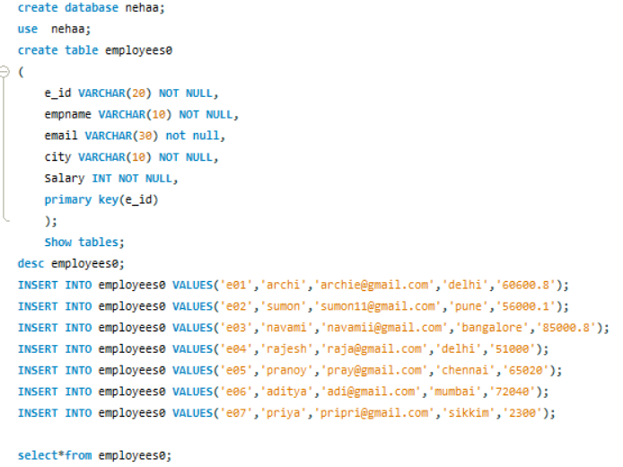

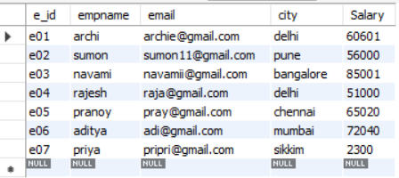

**DELETE:**

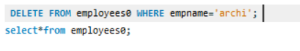

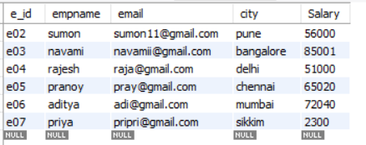

**UPDATE:**

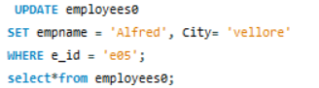

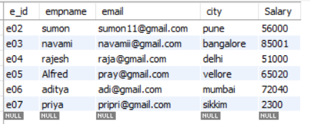

**MONGO DB:**  
  
