

ASSIGNMENT-3

**SMARTBRIDGE EXTERNSHIP**

**Modern Application Development (Java Spring Boot)**



NAME-ARYAN AGRAWAL REGISTERATION NO.-20BCE2876

**Ques) Implement Java JDBC using Java:**

**JDBC CONNECTIVITY:**

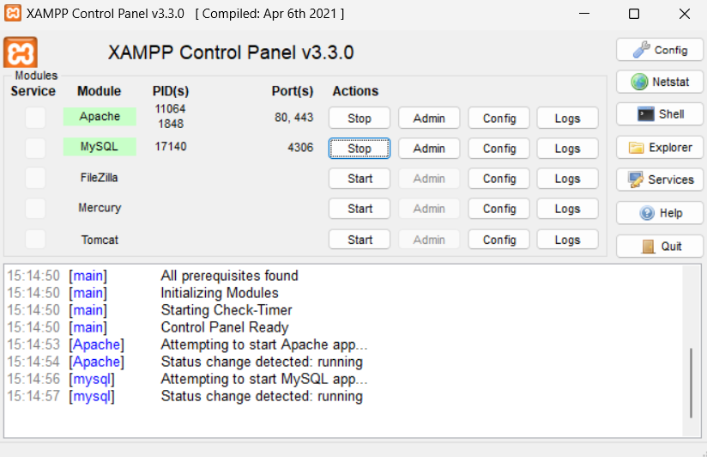import java.sql.Connection;  
import java.sql.DriverManager;  
import java.sql.ResultSet;  
import java.sql.Statement;  
  
public class JDBC {  
 public static void main(String[] args) {  
 try {  
 Class.*forName*("com.mysql.cj.jdbc.Driver");  
 Connection connection = DriverManager.*getConnection*(  
 "jdbc:mysql://localhost:4306/jdbcdemoo", "root", ""  
 );  
 Statement statement = connection.createStatement();  
 ResultSet resultSet = statement.executeQuery("select * from students");  
 while (resultSet.next()) {  
 System.*out*.println(resultSet.getInt(1) + " " + resultSet.getString(2) + " " + resultSet.getString(3));  
 ;  
  
 }  
 connection.close();  
 } catch (Exception e) {  
 System.*out*.println(e);  
 }}}

**Table Information:**

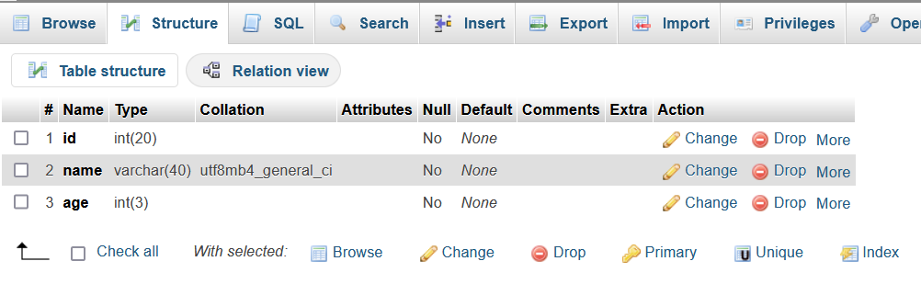

**Table after inserting values :**

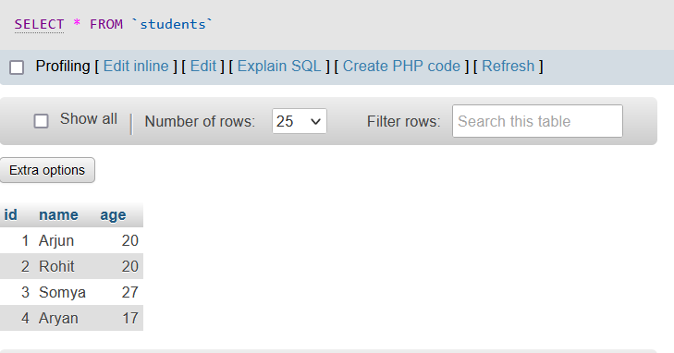

**Queries :**

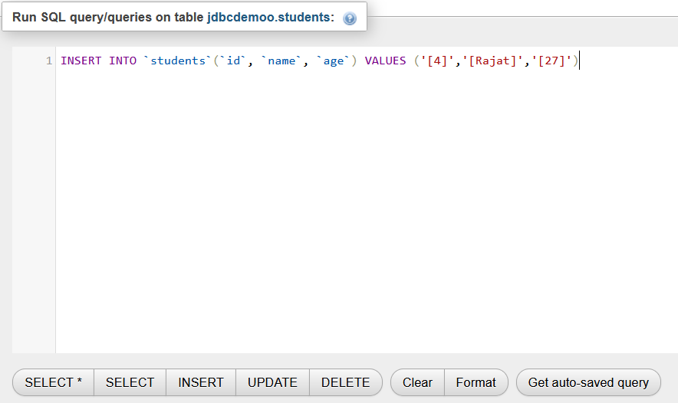

**OUTPUT:**

