**MongoDB -Aggregation Exercises**

Import the zips.json file into your MongoDB. Database name is "population" and collection name is "zipcodes".

**mongoimport --db population --collection zipcodes --file zip.json**

**Database imported successfully:**

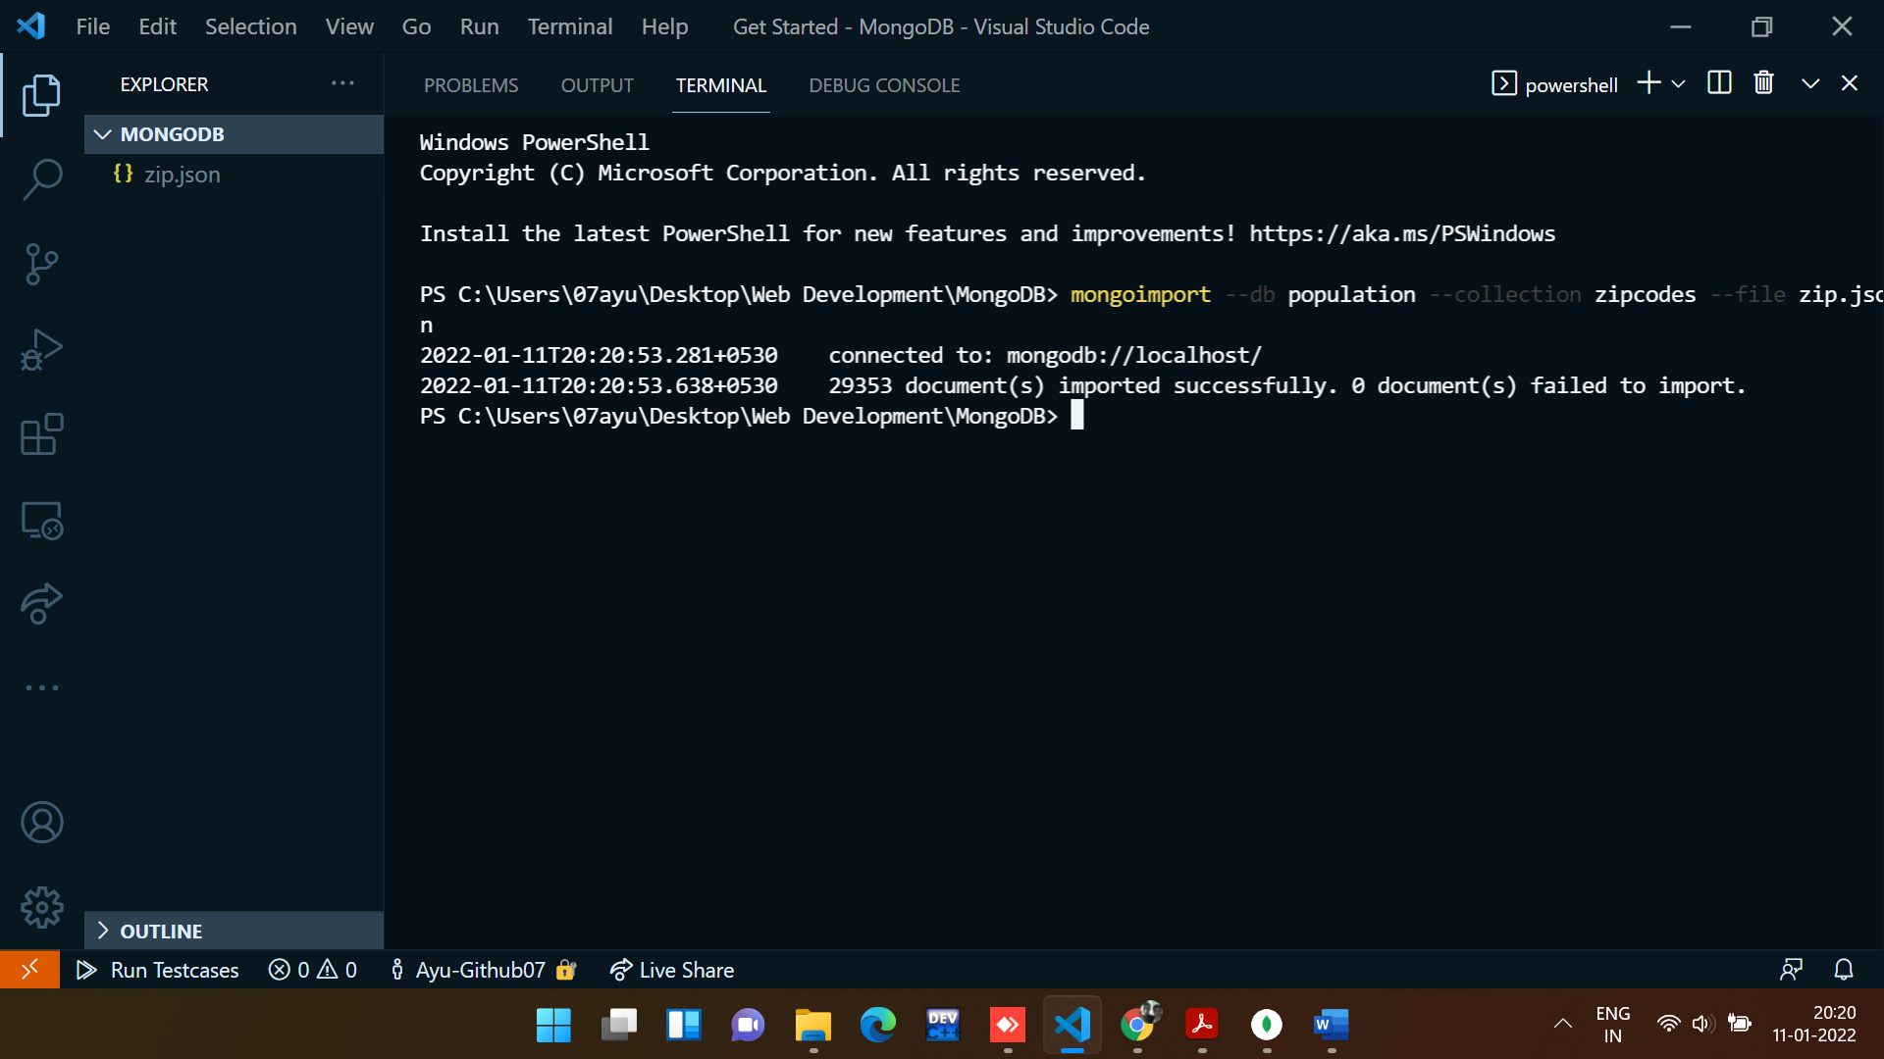

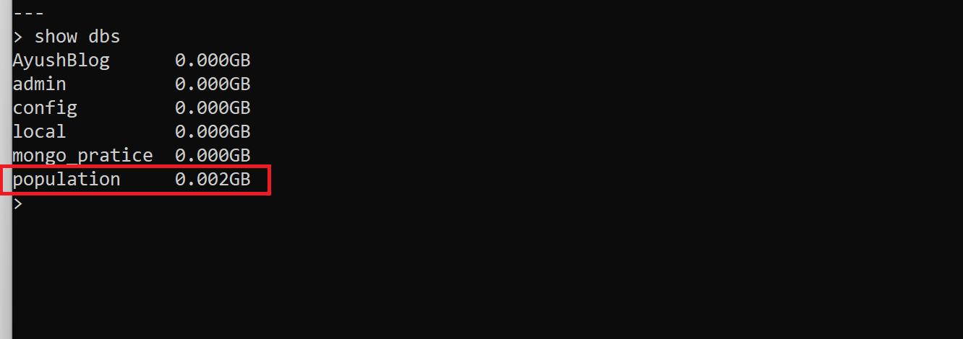

**Section-1: -** **Atlanta Population**

1. use db.zipcodes.find() to filter results to only the results where city is ATLANTA and state is GA.

**Command:**

*// 1. use db.zipcodes.find() to filter results to only the results where city is ATLANTA and state is GA.*

db.zipcodes.find({ $and: [{ city: "ATLANTA" }, { state: "GA" }] });

**Output:**

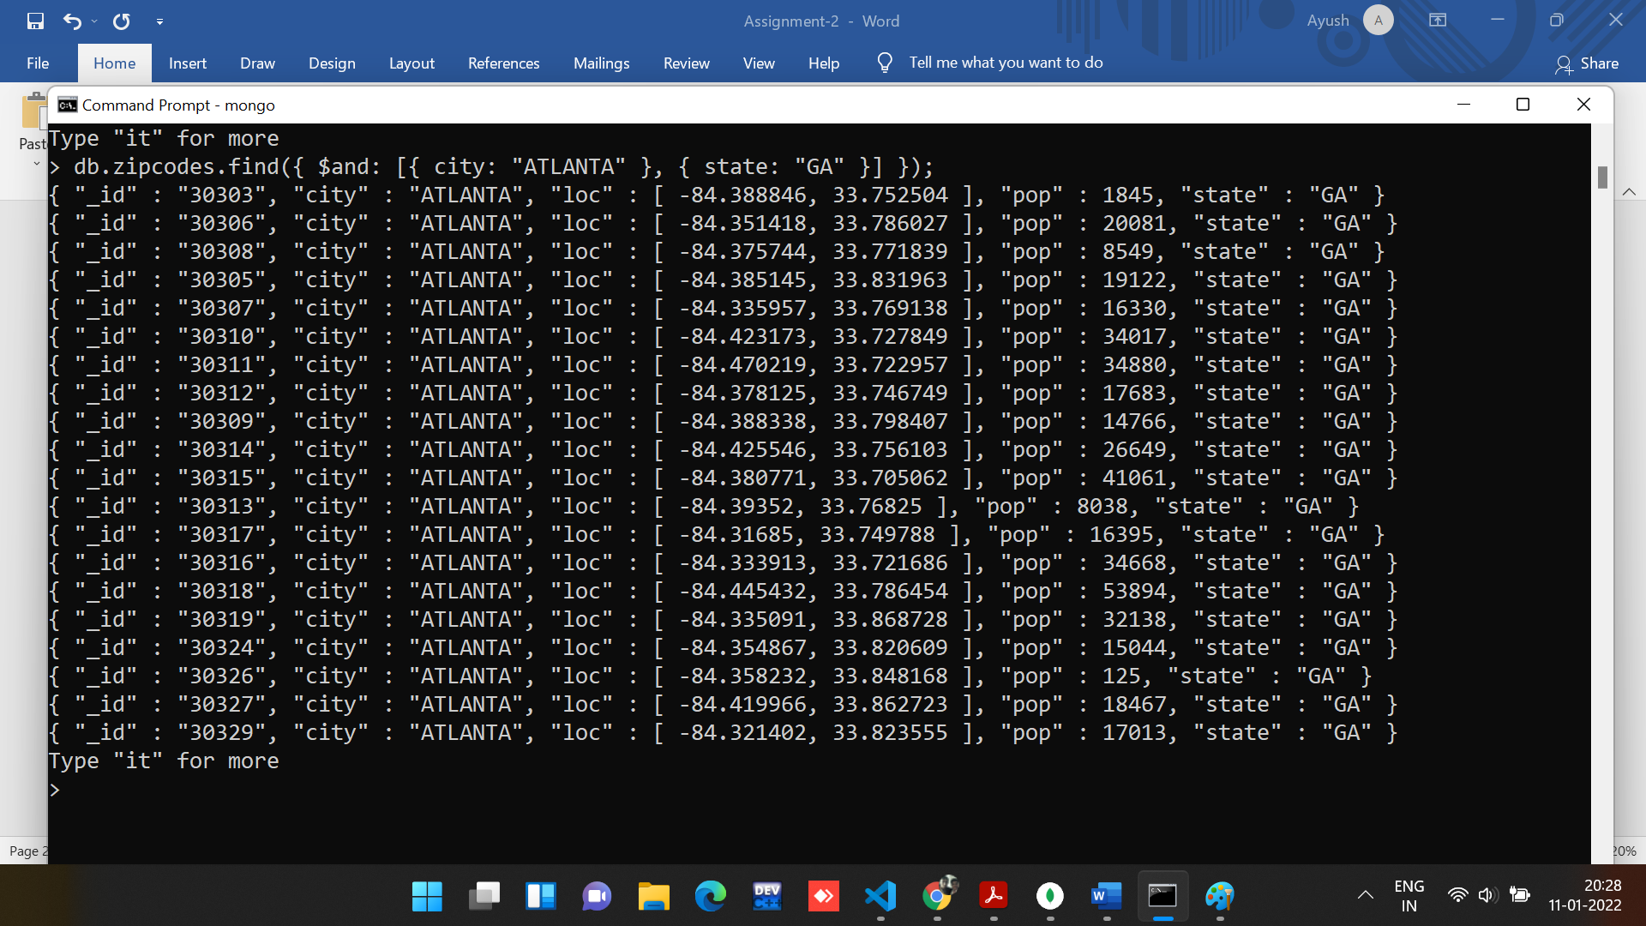

2. use db.zipcodes.aggregate with $match to do the same as above.

**Command:**

*// use db.zipcodes.aggregate with $match to do the same as above.*

db.zipcodes.aggregate([

  {

    $match: {

      $and: [

        {

          city: "ATLANTA",

        },

        {

          state: "GA",

        },

      ],

    },

  },

]);

**Output:**

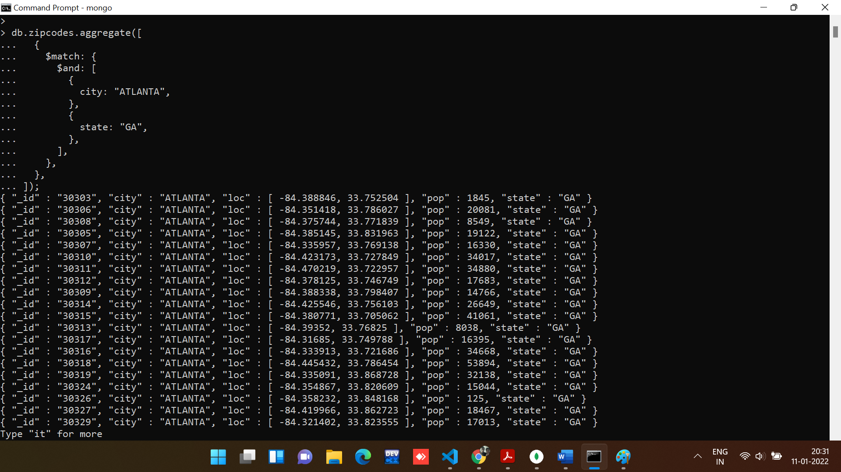

3. use $group to count the number of zip codes in Atlanta.

**Command:**

*// Use $group to count the number of zip codes in Atlanta.*

db.zipcodes.aggregate([

  {

    $match: {

      city: "ATLANTA",

    },

  },

  {

    $group: {

      _id: "$city",

      count: { $sum: 1 },

    },

  },

]);

**Output:**

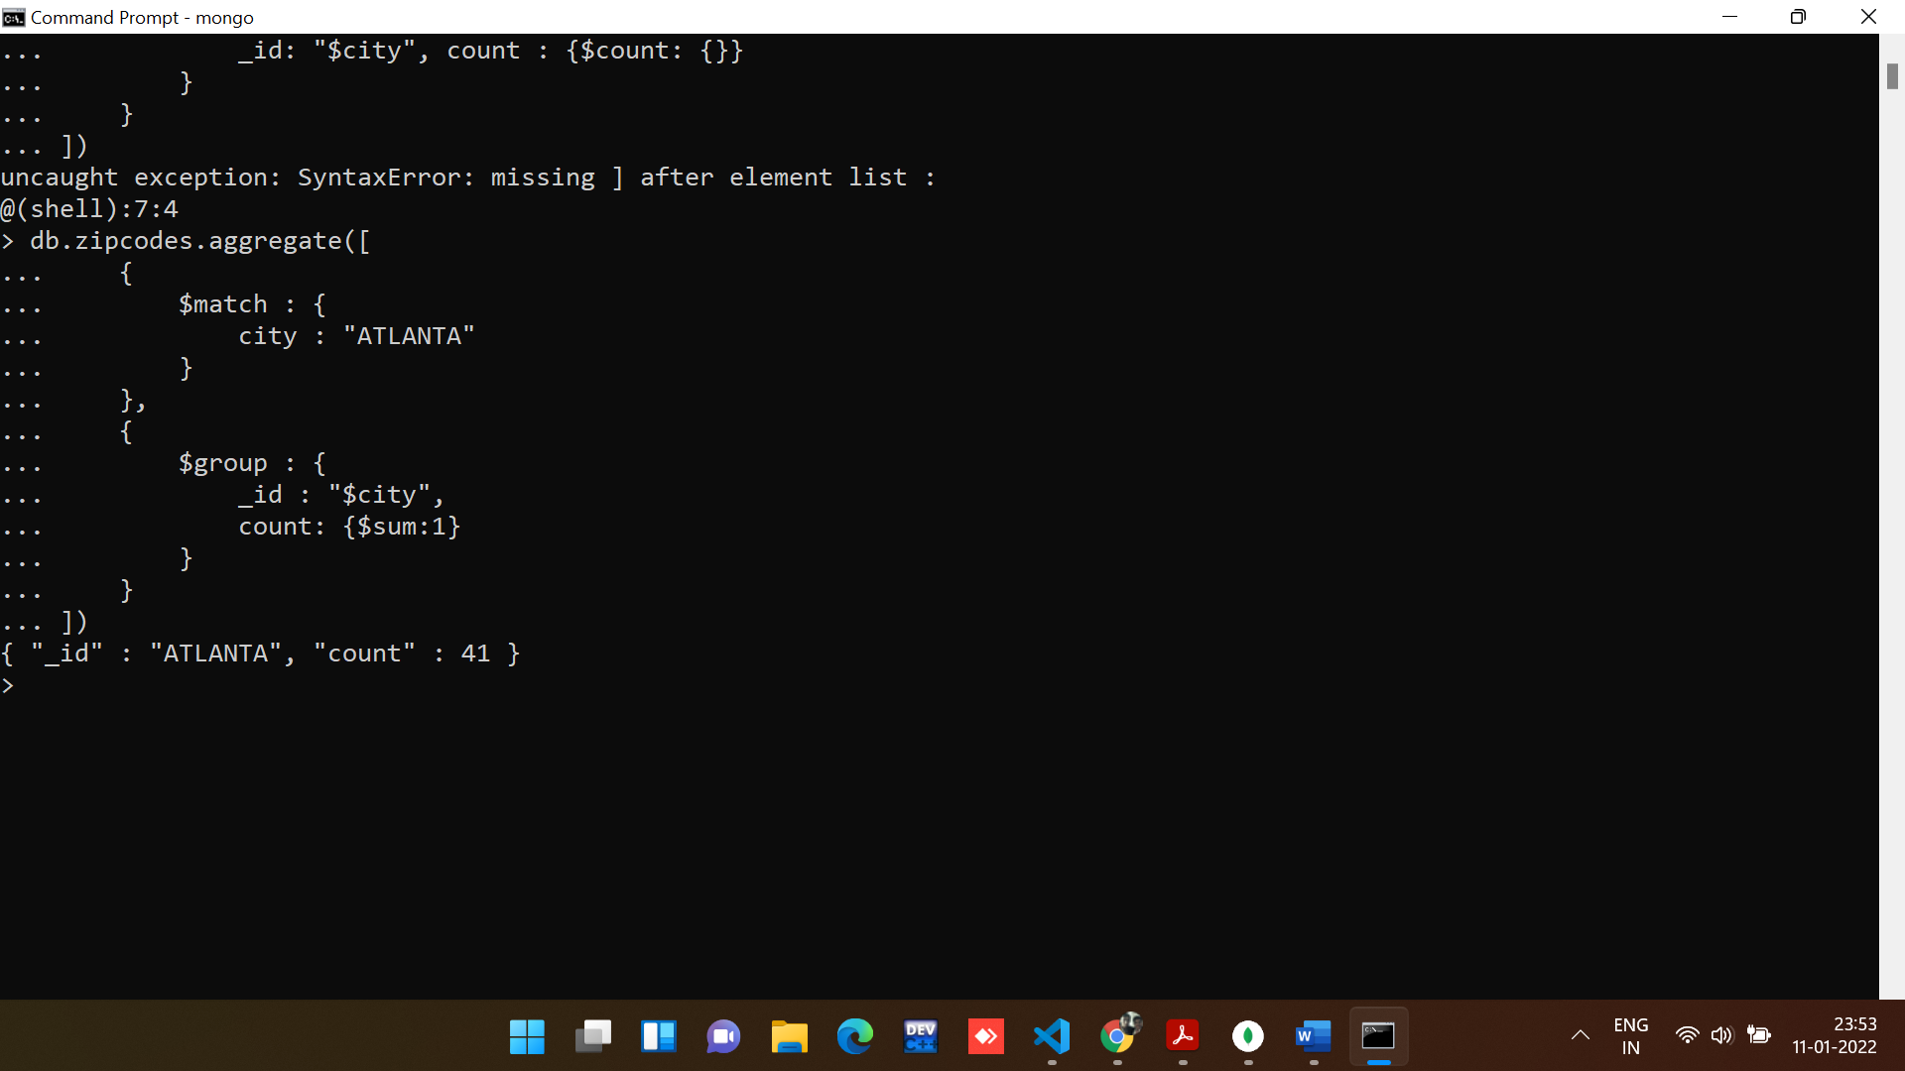

4. use $group to find the total population in Atlanta.

**Command:**

*//Use $group to count the total population in ATLANTA.*

db.zipcodes.aggregate([

  {

    $match: {

      city: "ATLANTA",

    },

  },

  {

    $group: {

      _id: "$city",

      "Total Population": { $sum: "$pop" },

    },

  },

]);

**Output:**

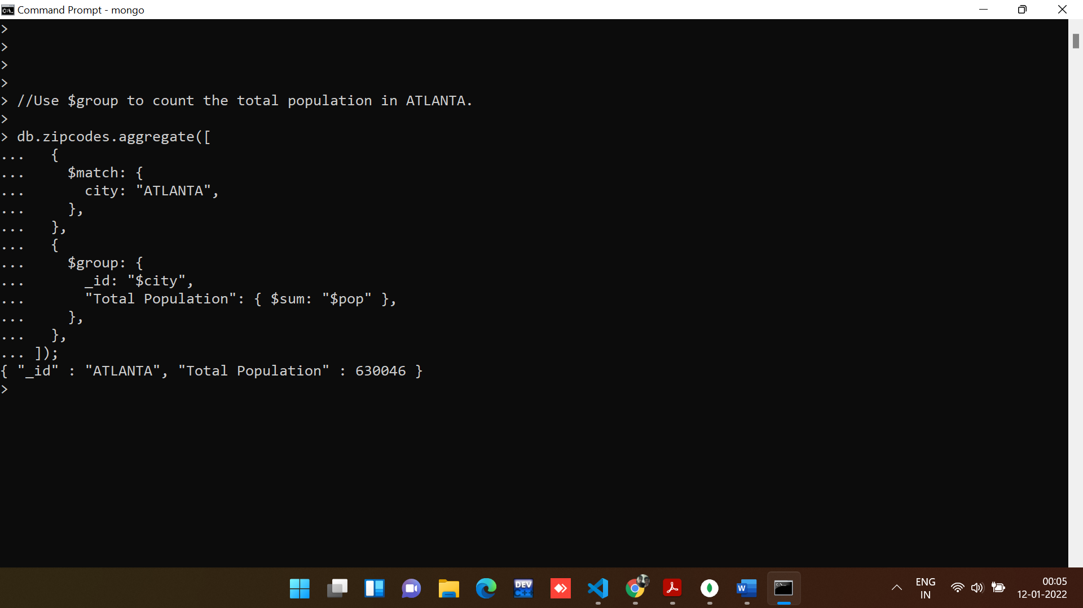

**Section-2: -** **Populations by State**

1. use aggregate to calculate the total population for each state.

**Command:**

*//Use aggregate to calculate total population of each state.*

db.zipcodes.aggregate([

  {

    $group: {

      _id: "$state",

      "Total Population": { $sum: "$pop" },

    },

  },

]);

**Output:**

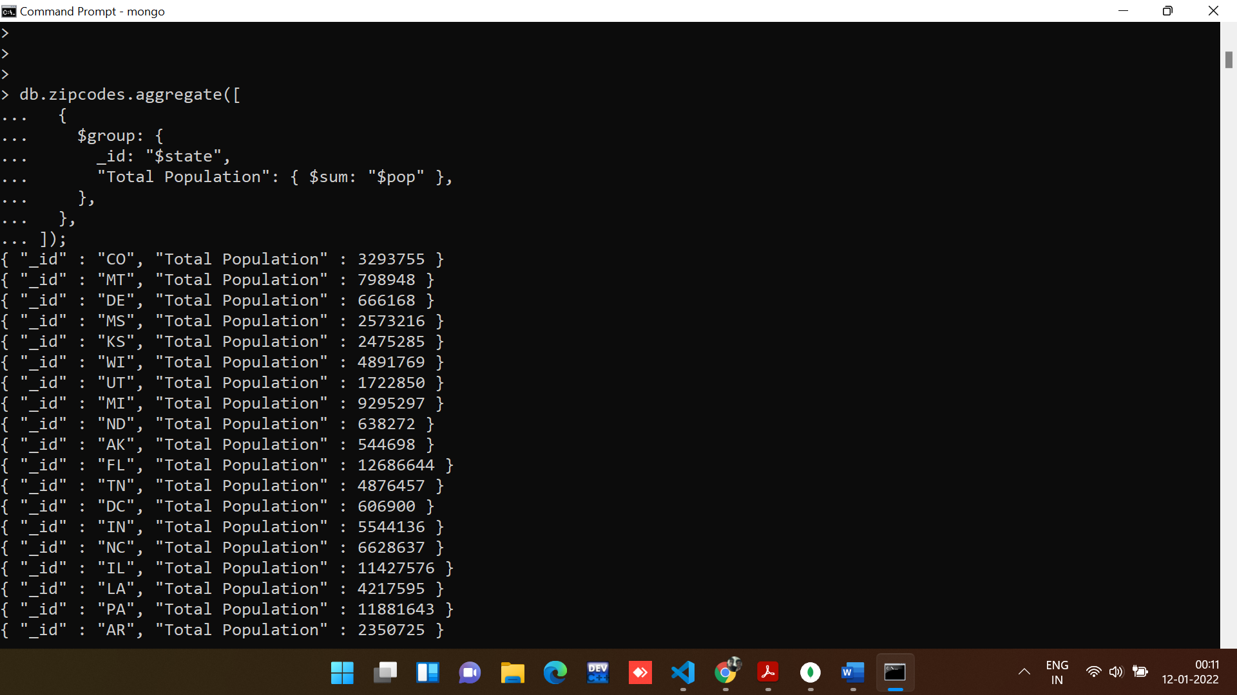

2. sort the results by population, highest first.

**Command:**

*//Use aggregate to calculate total population of each state.*

db.zipcodes.aggregate([

  {

    $group: {

      _id: "$state",

      "Total Population": { $sum: "$pop" },

    },

  },

  {

    $sort: {

      "Total Population": -1,

    },

  },

]);

**Output:**

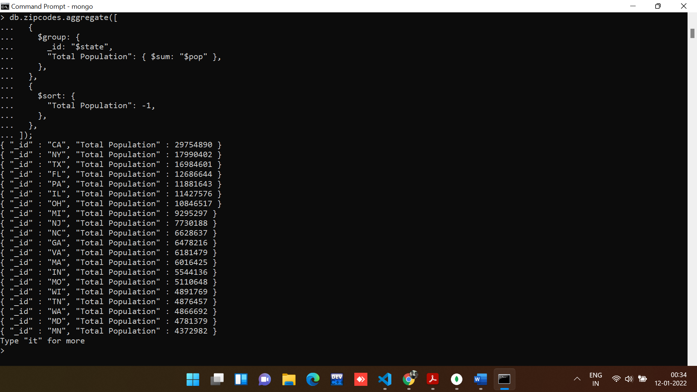

3. limit the results to just the first 3 results. What are the top 3 states in population?

**Command:**

db.zipcodes.aggregate([

  {

    $group: {

      _id: "$state",

      "Total Population": { $sum: "$pop" },

    },

  },

  {

    $sort: {

      "Total Population": -1,

    },

  },

  {

    $limit: 3,

  },

]);

**Output:**

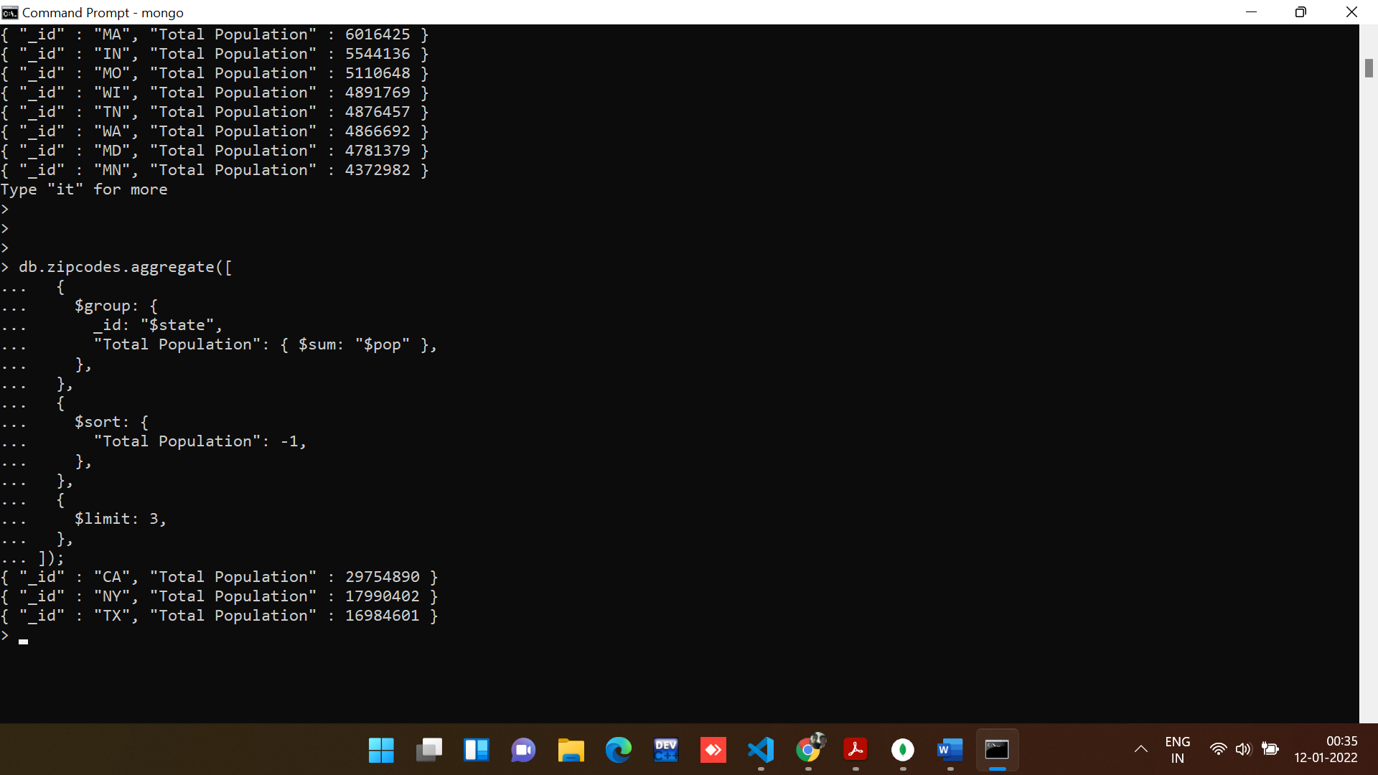

**Section-3: -Populations by City**

1. use aggregate to calculate the total population for each city (you have to use city/state combination). You can use a combination for the _id of the $group: { city: '$city', state: '$state' }

**Command:**

db.zipcodes.aggregate([

  {

    $group: {

      _id: { State: "$state", City: "$city" },

      "Total Population": { $sum: "$pop" },

    },

  },

]);

**Output:**

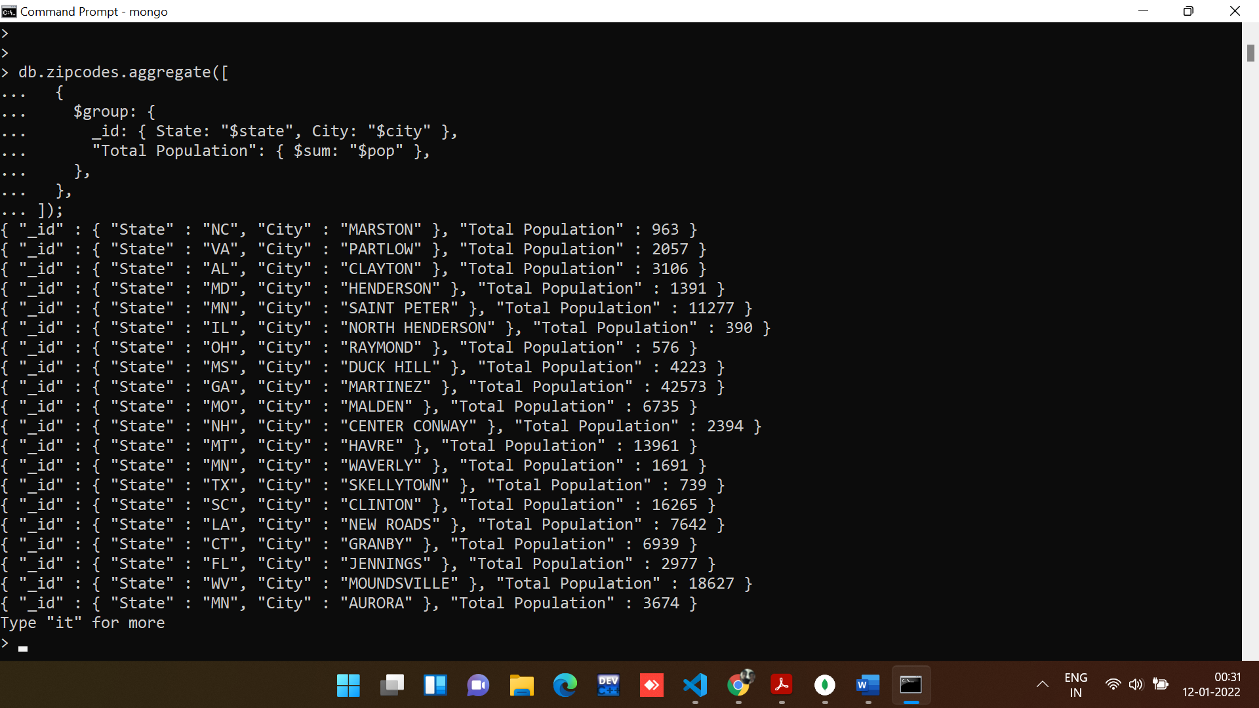

2. sort the results by population, highest first .

**Command:**

db.zipcodes.aggregate([

  {

    $group: {

      _id: { State: "$state", City: "$city" },

      "Total Population": { $sum: "$pop" },

    },

  },

  {

    $sort: {

      "Total Population": -1,

    },

  },

]);

**Output:**

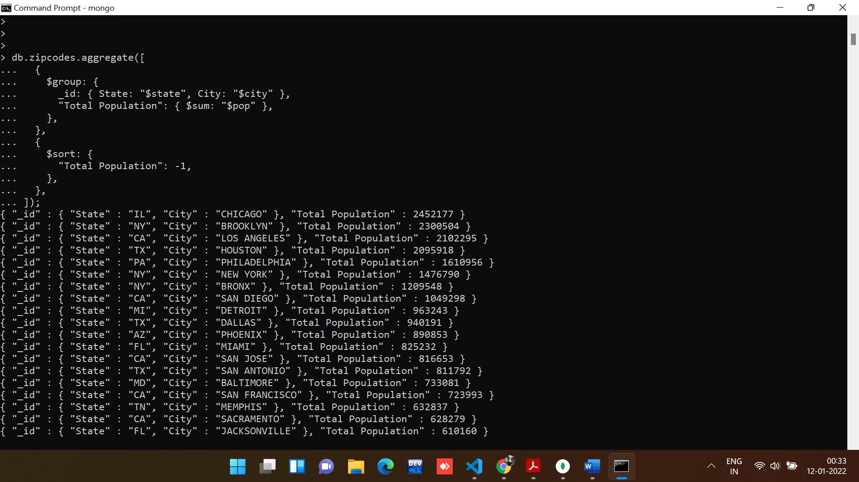

3. limit the results to just the first 3 results. What are the top 3 cities in population?

**Command:**

db.zipcodes.aggregate([

  {

    $group: {

      _id: { State: "$state", City: "$city" },

      "Total Population": { $sum: "$pop" },

    },

  },

  {

    $sort: {

      "Total Population": -1,

    },

  },

  {

    $limit: 3,

  },

]);

**Output:**

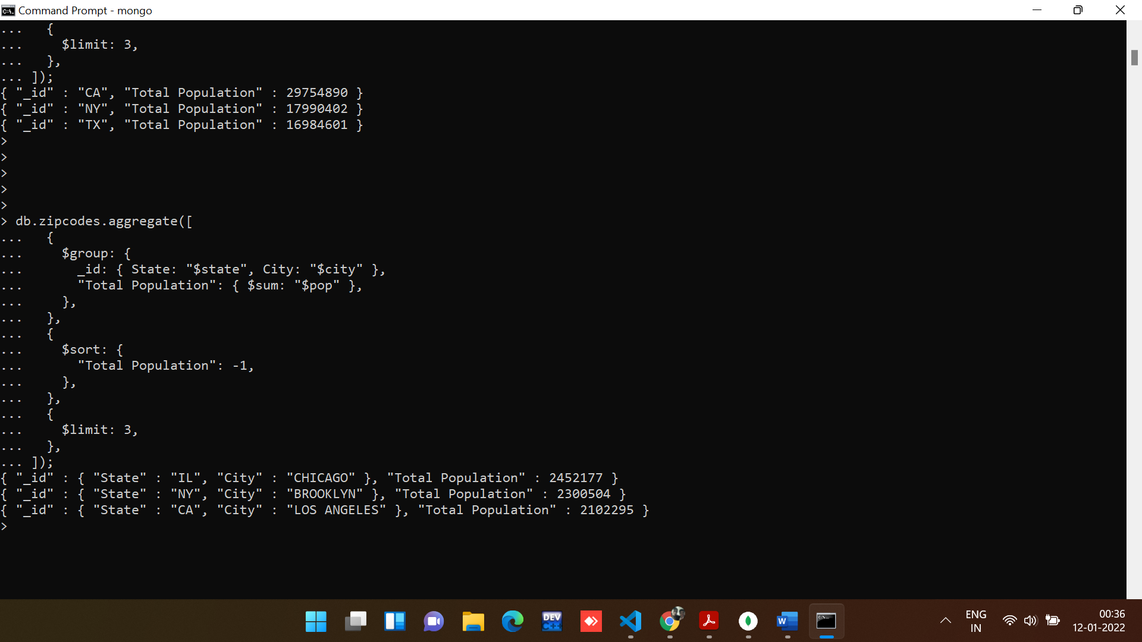

4. What are the top 3 cities in population in Texas?

**Command:**

db.zipcodes.aggregate([

  {

    $match: {

      state: "TX",

    },

  },

  {

    $group: {

      _id: { State: "$state", City: "$city" },

      "Total Population": { $sum: "$pop" },

    },

  },

  {

    $sort: {

      "Total Population": -1,

    },

  },

  {

    $limit: 3,

  },

]);

**Output:**

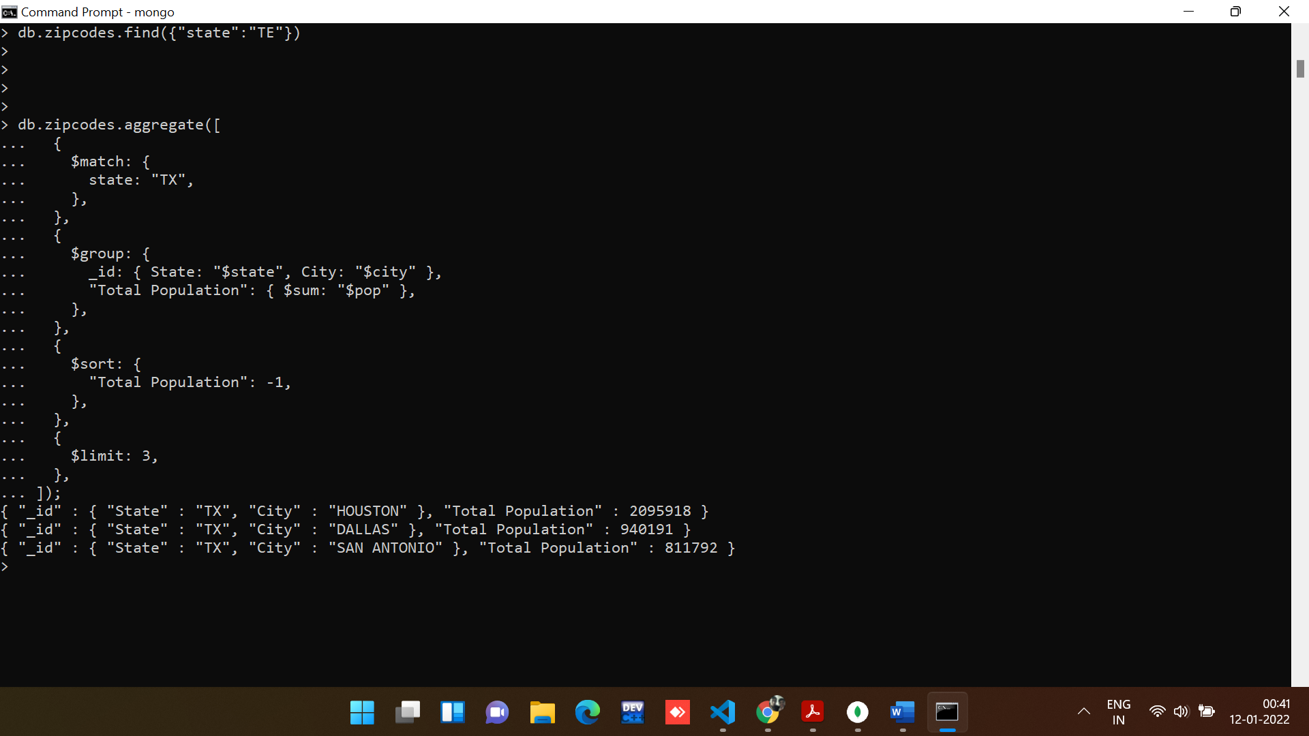

**Section-4: - Bonus**

1. Write a query to get the average city population for each state.

**Command:**

db.zipcodes.aggregate([

  {

    $group: {

      _id: "$state",

      "Average Population": {

        $avg: "$pop",

      },

    },

  },

]);

**Output:**

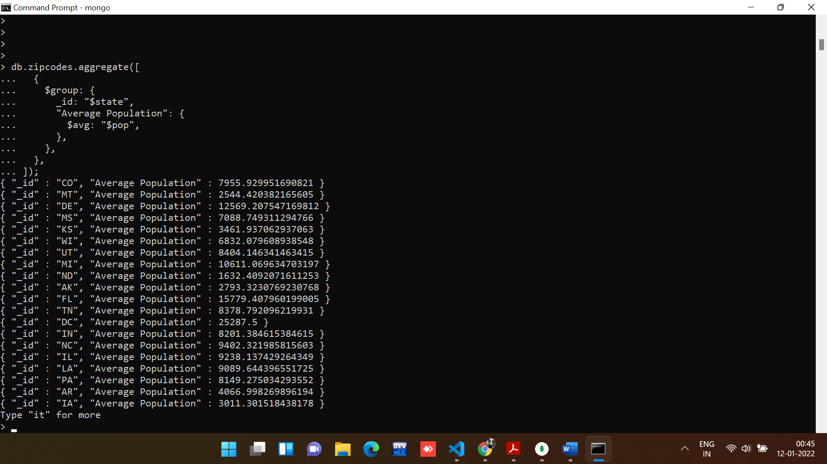

2. What are the top 3 states in terms of average city population?

**Command:**

db.zipcodes.aggregate([

  {

    $group: {

      _id: "$state",

      "Average Population": {

        $avg: "$pop",

      },

    },

  },

  {

    $sort: {

      "Average Population": -1,

    },

  },

  {

    $limit: 3,

  },

]);

**Output:**

