Main 1
SNRs for FIRST COEFFICIENTS 1
SNRs for DOMINANT COEFFICIENTS 2

Main
[audio,fs] = audioread('sample.wav');
N = size(audio);
F = [64 128 256 512]; %N
P = [0.10 0.25 0.50 0.75]; %DCT Coefficients
ssnrs=[]; %snrs for First Coefficients
ssnrs2=[]; %snrs for Dominant Coefficients
for j = 1 : length(P)
p = P(j); %Iterate over DCT Coefficient values
snrs = [];
snrs2 = [];
for i = 1 : length(F)
f = F(i); %Iterate over N values
y = FirstS(audio,f,p); %Reconstructed sound for First Coefficients
snrs = [snrs SSNR(audio',y)];
y2 = Dominant(audio,f,p);
snrs2 = [snrs2 SSNR(audio',y2)]; %Reconstructed sound for Dominant Coefficients
end
ssnrs = [ssnrs;snrs];
ssnrs2 = [ssnrs2;snrs2];
end

SNRs for FIRST COEFFICIENTS
figure(1)
subplot(2,2,1);
stem(F, ssnrs(1,:));
title('p=10%');
subplot(2,2,2);
stem(F, ssnrs(2,:));
title('p=25%');
subplot(2,2,3);
stem(F, ssnrs(3,:));
title('p=50%');
subplot(2,2,4);
stem(F, ssnrs(4,:));
title('p=75%')
ssnrs
ssnrs =
1.5339 1.7849 1.8476 1.8124
5.7876 6.0266 6.0721 6.0958
8.4965 8.9257 9.0255 9.0560
14.7707 16.2100 16.6362 16.7951
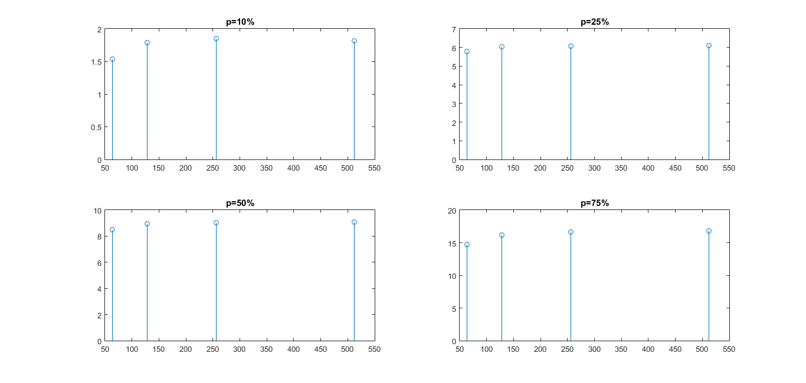

SNRs for DOMINANT COEFFICIENTS
figure(2)
title('Dominant p Samples')
subplot(2,2,1);
stem(F, ssnrs2(1,:));
title('p=10%');
subplot(2,2,2);
stem(F, ssnrs2(2,:));
title('p=25%');
subplot(2,2,3);
stem(F, ssnrs2(3,:));
title('p=50%');
subplot(2,2,4);
stem(F, ssnrs2(4,:));
title('p=75%');
ssnrs2
ssnrs2 =
0.9427 0.9230 0.9278 0.8757
0.6756 0.6784 0.6763 0.6758
0.6131 0.6257 0.6131 0.6079
0.5143 0.5137 0.5133 0.5134
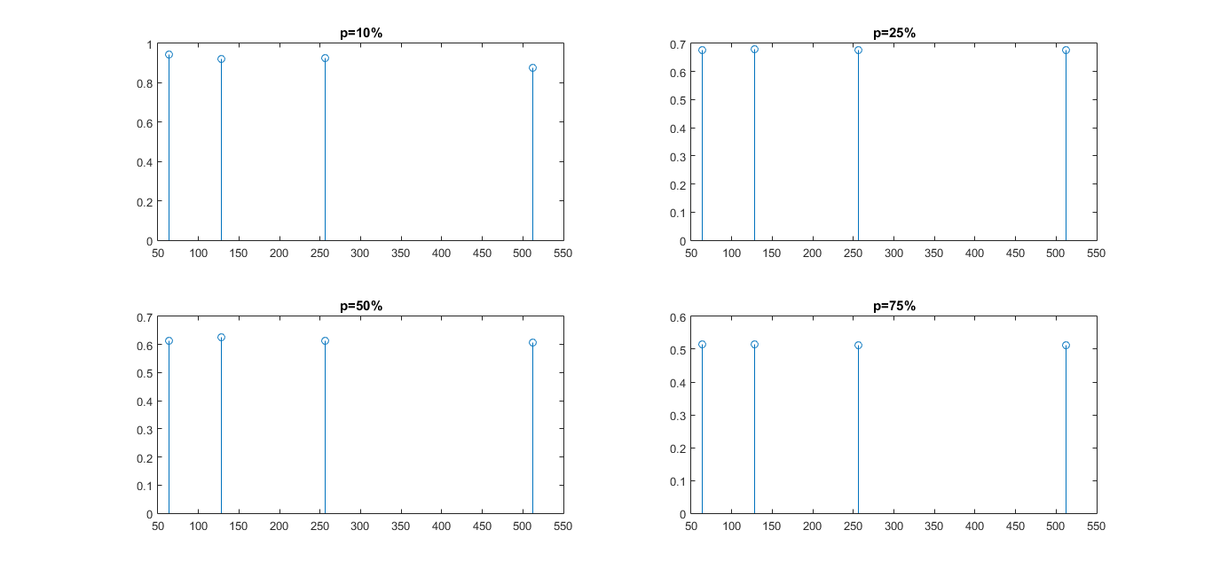
Published with MATLAB® R2015a

