Mohammad Saad

***Question 1*** : What is the effect of using the wrong sign when filtering with the contra harmonic

mean filter?

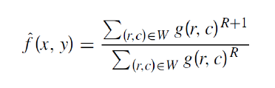

The formula for Conta Harmonic mean is given. In this case for removing pepper noise, R is chosen to be positive and incase of salt noise, R is chosen to be negative.

If for removing pepper noise R is chosen negative instead of positive, the numerator value will become smaller than 1 and the overall result move towards zero. In this way the black parts i.e the pepper noise will increase instead of decreasing. Similarly, in case of salt noise, if the opposite is chosen the salt noise will increase.

***Question 2:*** Why do you think the median filter works on salt and pepper noise but not Gaussian

noise?

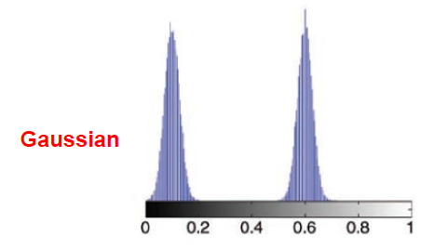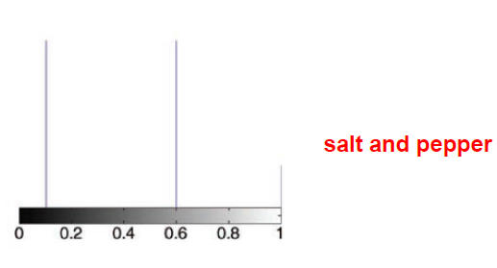

Median filter selects middle pixel value from the ordered set. It is unable to work on Gaussian noise as the noise is distributed by a uniform PDF. It can be seen in the figure above. Select the middle pixel does not remove the noise. Whereas in case of salt of pepper noise, the noise is not evenly distributed rather it is in the form of peaks. In this case the middle pixel removes the noise.

Copy the output image of each filter to the MS WORD file and give explanation of the

effect of filter application as visible in respective output images.

After adding Noises:

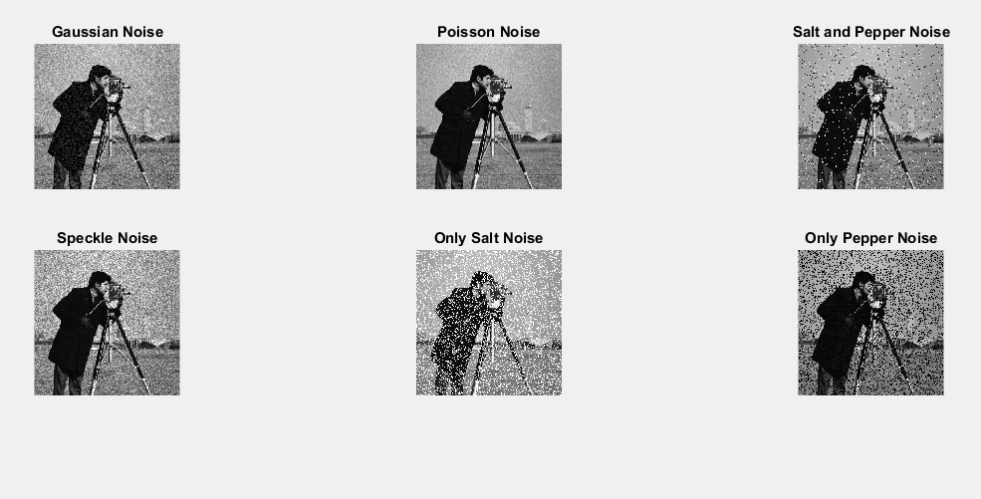

Applying Arithmetic Mean:

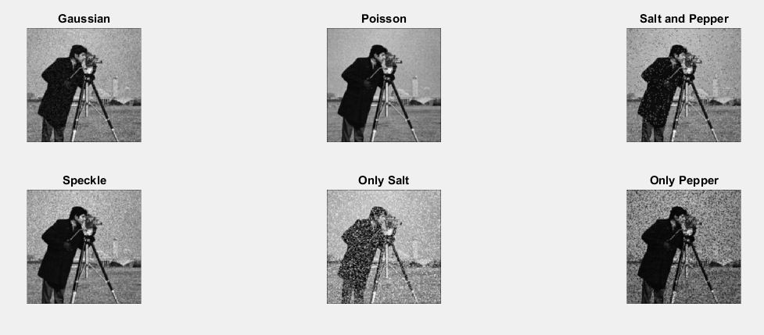

Mean filter has made the image a little blur and hence has removed the noise. It can be seen that it has worked best in case of Gaussian. It is because Gaussian has a uniform PDF and there are no irregularities. It has taken the average of pixels and assigned them the mean value.

Applying Geometric Mean:

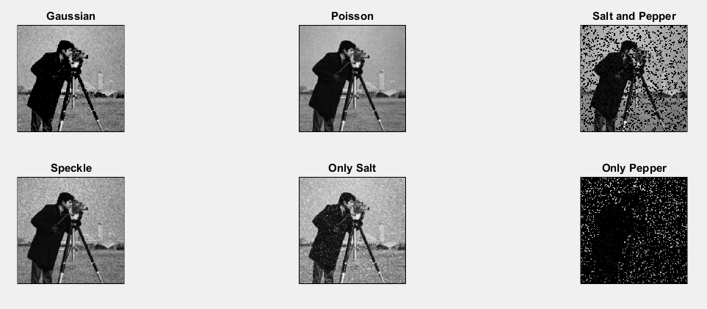

The effect of Geometric filter is almost the same as that of Arithmetic filter. But in this case the details are retained. It can be seen that it has worked the best for Gaussian noise. The reason is the same. In case of salt and pepper noise it has made the image worse by increasing the noise.

Applying Min Filter:

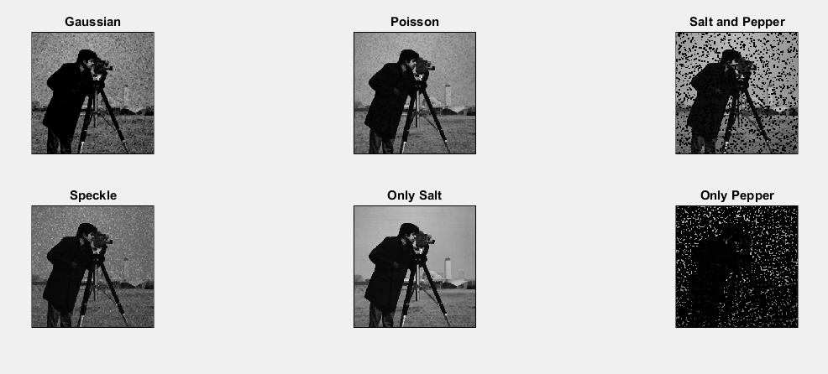

Min filter works by selecting the lowest pixel value from the ordered set. It can be seen that as it chooses the lowest pixel value it has made the images darker. It has worked very well for removing salt type noise. In case of pepper it has increased the pepper type noise.

Applying Max Filter:

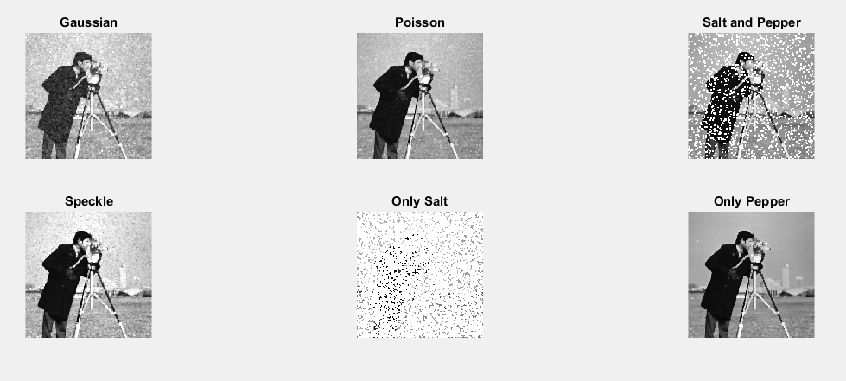

It works as the opposite of minimum filter. It chooses the maximum pixel of the ordered set. It has made the images brighter. And as pepper noises are a bunch of low pixels, the maximum filter has removed the pepper noise very beautifully by selecting the high pixels only. In case of salt, the noise is increased.

Applying Harmonic Mean

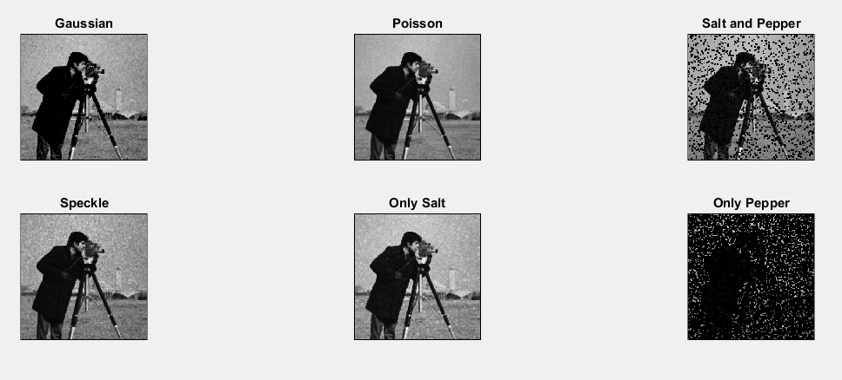

It works similar to mean filter. As it can be seen from the image that it has worked well for the Gaussian noise and for salt noise. But in case of pepper noise, the noise is increased.

Applying Conta Harmonic Mean:

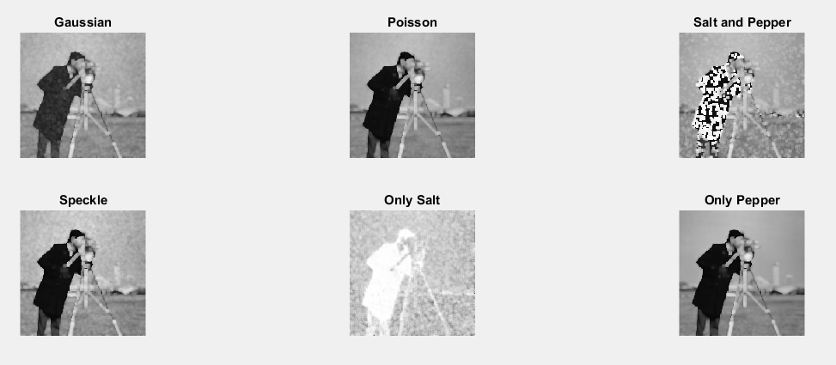

Conta Harmonic Filter is used to remove only salt or pepper noise. As it can be seen that in the above case the value of R was kept greater than zero and hence pepper noise is eliminated while salt noise has increased.

Applying Median Filter:

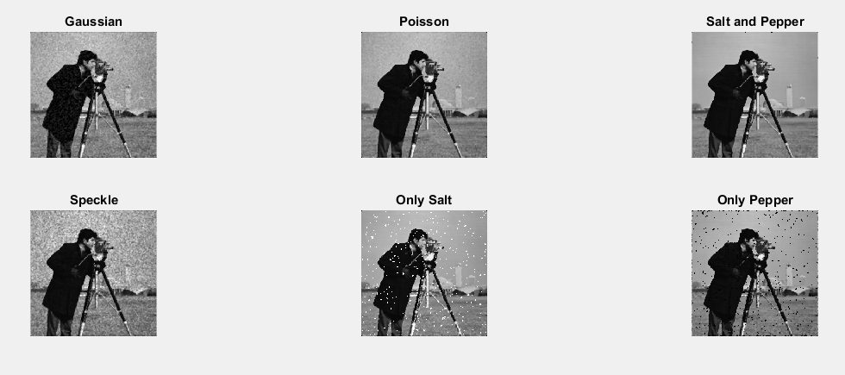

The median filter is the most famous of the rank filters. It selects the middle value of the ordered values. It works very well. As it can be seen it has worked very well in case of salt and pepper noise. The middle values are selected and the outcasts (i.e salt and pepper noises) are removed.