# Rawan Alsaadi 10081442
# Omar Toutounji 10169506
# Beltan Michel 10169162

First Screenshot:
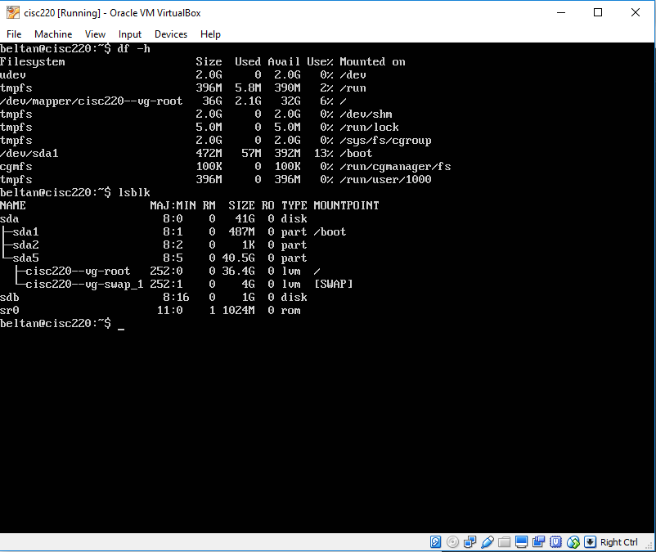
Question: The command lsblk shows the new disk of size 1GB whose name is sdb.
Second Screenshot:
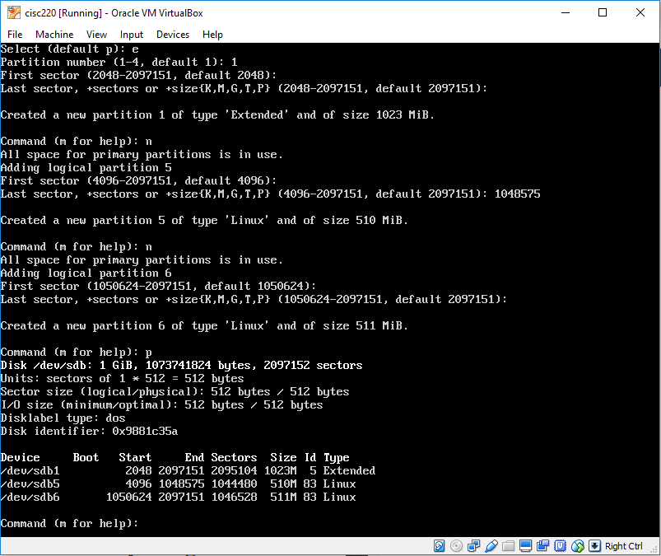

Third Screenshot:
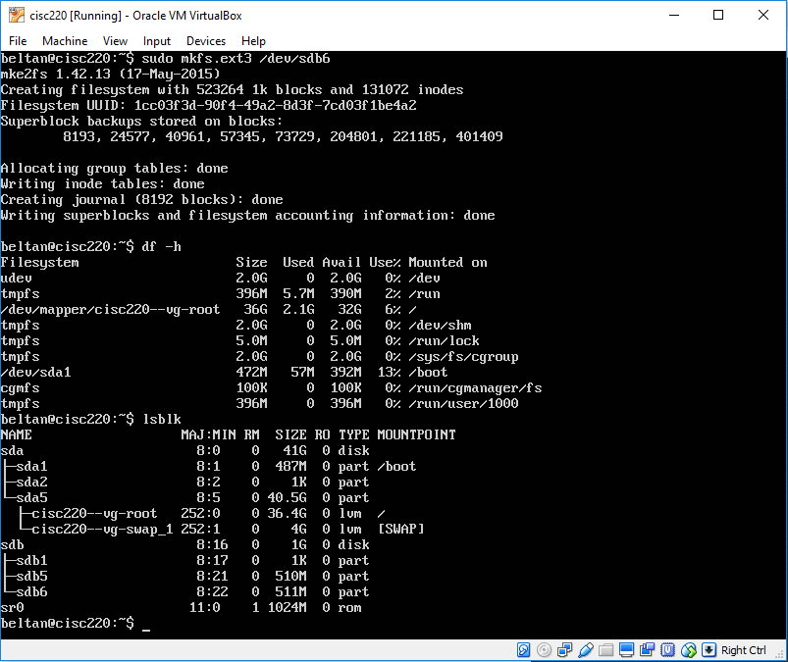
Question: The command lsblk shows the new hard disk.

Fourth Screenshot:
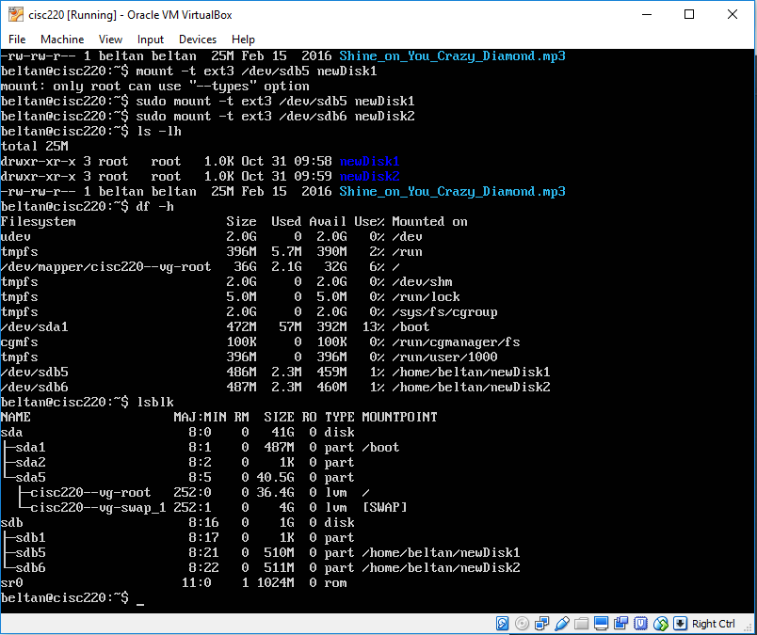
Question: lsblk is still the command that shows the new hard disk. df -h shows the mounted partitions (/dev/sdb5 and /dev/sdb6) but not the disk itself.

Bonus: Fifth Screenshot:
