**Name Imran Mohammed**

**Subject: Advance Database Concepts**

**Topic: Hospital Management System**

This document contains all the required information about the database implementation for the Hospital Management System. Starting with UML Diagram, so we can see what tables and fields we need, and we can configure the relationship between the database tables. We can see below the

**1) Hospital Management System Database UML Class Diagrams:**

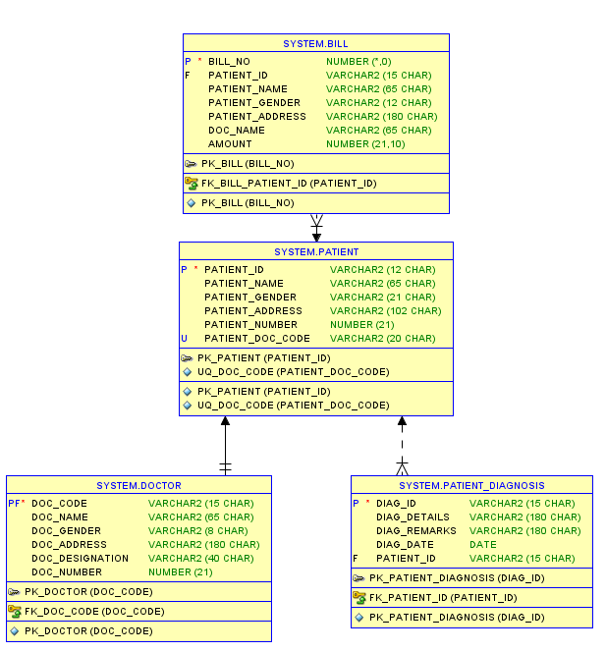

The tables that we will need to build this database system:

i)Patients

ii)Diagnosis

iii)Bill

iv)Doctor

Example code for creating patients table

create table patient (

patient_id varchar2(12 CHAR),

patient_name varchar2(65 CHAR),

patient_gender varchar2(21 CHAR),

patient_address varchar2(102 CHAR),

patient_number number(21,0),

patient_doc_code varchar2(20 CHAR),

constraint pk_patient primary key (patient_id),

constraint uq_doc_code unique (patient_doc_code)

);

**2) Designed tables, performed functional dependency analysis on the original tables, and then created all tables in Third Normal Form.**

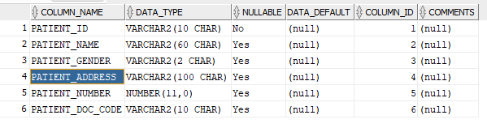

**The Patient & Doctor relation:**

| **PATIENT_ID** | PATIENT_NAME | PATIENT_GENDER | PATIENT_ADDRESS | PATIENT_NUMBER |  |
| --- | --- | --- | --- | --- | --- |
| **DOC_CODE** | DOC_NAME | DOC_GENDER | DOC_ADDRESS | DOC_DESIGNATION | DOC_NUMBER |

Doctor Relation

| **DOC_CODE** | DOC_NAME | DOC_GENDER | DOC_ADDRESS | DOC_DESIGNATION | DOC_NUMBER |
| --- | --- | --- | --- | --- | --- |

New Normalized Patient Relation looks like this

| **PATIENT_ID** | PATIENT_NAME | PATIENT_GENDER | PATIENT_ADDRESS | PATIENT_NUMBER | **PATIENT_ DOC_CODE** |
| --- | --- | --- | --- | --- | --- |

**The Diagnosis & Patient relation:**

| **PATIENT_ID** | PATIENT_NAME | PATIENT_GENDER | PATIENT_ADDRESS | PATIENT_NUMBER |
| --- | --- | --- | --- | --- |
| **DIAG_ID** | DIAG_DETAILS | DIAG_REMARKS | DIAG_DATE |  |

Patient Relation

| **PATIENT_ID** | PATIENT_NAME | PATIENT_GENDER | PATIENT_ADDRESS | PATIENT_NUMBER |
| --- | --- | --- | --- | --- |

New Normalized Diagnosis Relation looks like this

| **DIAG_ID** | DIAG_DETAILS | DIAG_REMARKS | DIAG_DATE | **PATIENT_ID** |
| --- | --- | --- | --- | --- |

**3) Implemented key constraint, entity integrity constraint, and referential integrity constraint on tables, such as primary keys, foreign keys, check constraints, and not null constraints. Added foreign key constraints.**

Patient table constraints and available columns

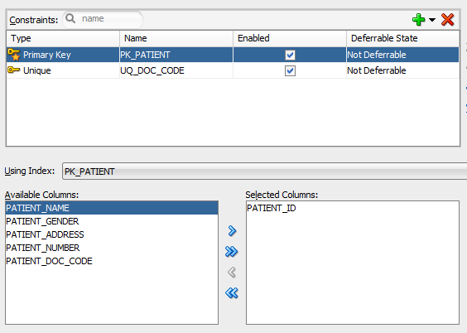

Patient_Diagnosis table constraints and available columns

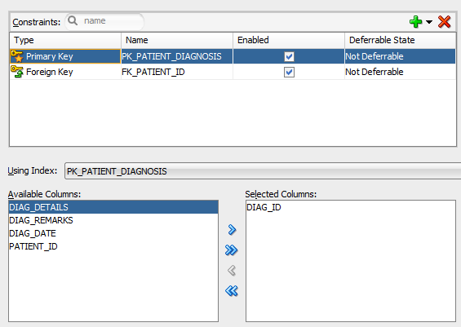

Bill table constraints and available columns

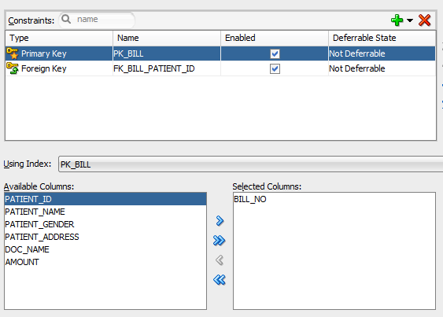

Doctor table constraints and available columns

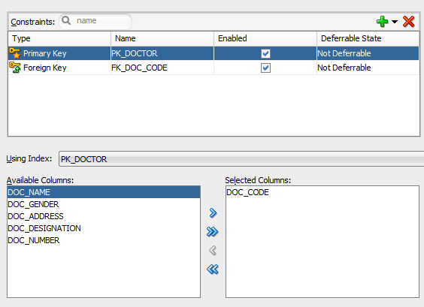

**4) Creation of PL/SQL Objects**

i) Creating Bill table with objects, primary key, and foreign key constraints

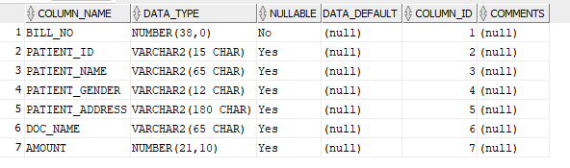

**Creating Indexes for Bill**

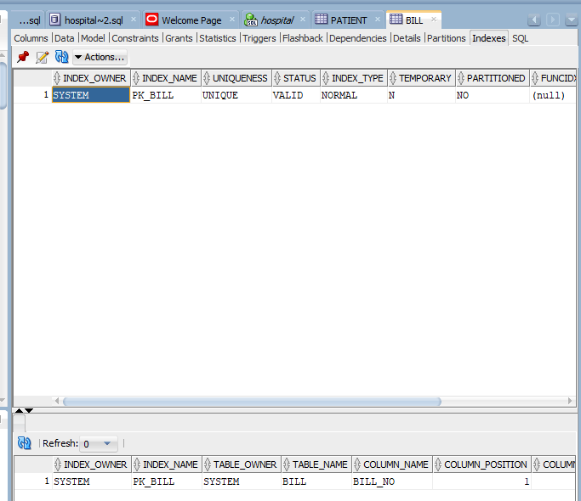

**5)Created triggers for Bill Table and active elements to maintain the integrity of the database and to perform appropriate actions on database updates.**

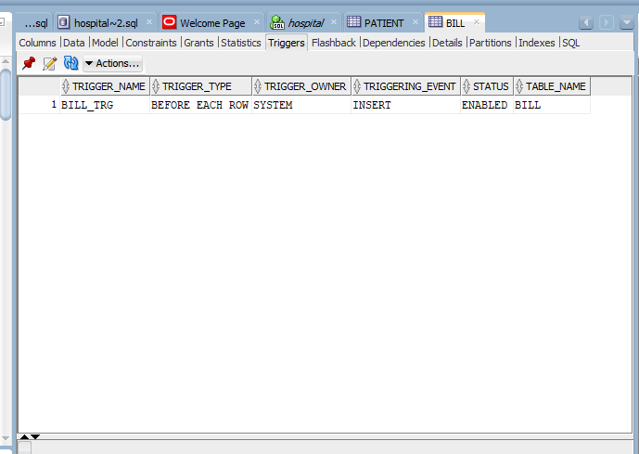

**Model Bill Table**

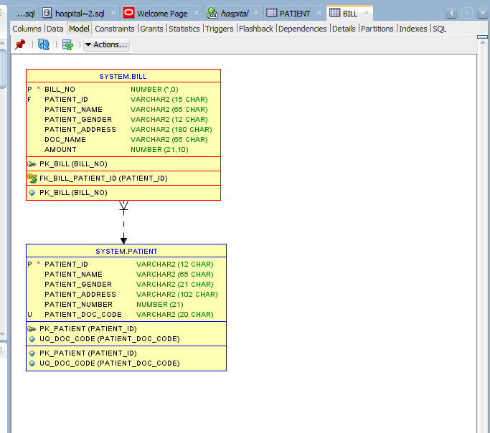

**Creating a Sequence for Bill**

CREATE SEQUENCE BILL_NO_SEQ

MINVALUE 1

MAXVALUE 100000

START WITH 1

INCREMENT BY 1;

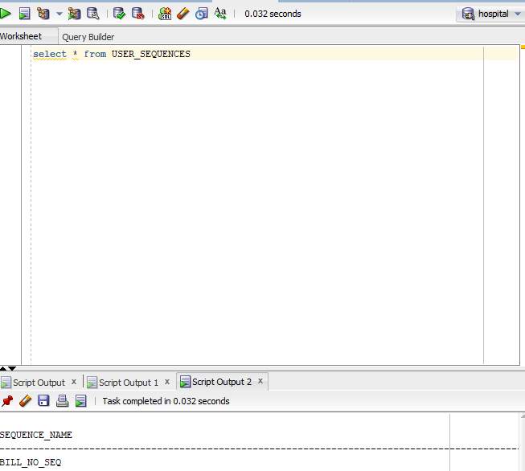

**6) Populate the database using SQL insert statements**

**Insert data in Patient Table**

INSERT INTO PATIENT_DIAGNOSIS VALUES ('DIAG031','Suffering from Covid19','Need to use oxygen',sysdate,'P031');

INSERT INTO PATIENT_DIAGNOSIS VALUES ('DIAG032','Suffering from lung disease','Treatments surgery.',sysdate,'P032');

INSERT INTO PATIENT_DIAGNOSIS VALUES ('DIAG033','Suffering from monkeypox diseases','Use vaccine',sysdate,'P033');

INSERT INTO PATIENT_DIAGNOSIS VALUES ('DIAG034','Suffering from mouth cancer','Need to use pain killers',sysdate,'P034');

INSERT INTO PATIENT_DIAGNOSIS VALUES ('DIAG035','Suffering from migrane','Avoid stress, sleep well',sysdate,'P035');

INSERT INTO PATIENT_DIAGNOSIS VALUES ('DIAG035','Suffering from stomach cancer','have a balanced diet',sysdate,'P036');

**Insert Data into Diagnosis table**

INSERT INTO PATIENT_DIAGNOSIS VALUES ('DIAG031','Suffering from Covid19','Need to use oxygen',sysdate,'P031');

INSERT INTO PATIENT_DIAGNOSIS VALUES ('DIAG032','Suffering from lung disease','Treatments surgery.',sysdate,'P032');

INSERT INTO PATIENT_DIAGNOSIS VALUES ('DIAG033','Suffering from monkeypox diseases','Use vaccine',sysdate,'P033');

INSERT INTO PATIENT_DIAGNOSIS VALUES ('DIAG034','Suffering from mouth cancer','Need to use pain killers',sysdate,'P034');

INSERT INTO PATIENT_DIAGNOSIS VALUES ('DIAG035','Suffering from migrane','Avoid stress, sleep well',sysdate,'P035');

INSERT INTO PATIENT_DIAGNOSIS VALUES ('DIAG035','Suffering from stomach cancer','have a balanced diet',sysdate,'P036');

**Insert Data into Doctor Table**

INSERT INTO DOCTOR VALUES ('D031','Dr Sarah Abelson','M','125, Mayo Clinic, Illinois','General Surgeon',10506571);

INSERT INTO DOCTOR VALUES ('D032','Dr Geri Aitken','M','452, Cleveland Clinic, California','Cardiologist',100188336);

INSERT INTO DOCTOR VALUES ('D033','Dr Jacqueline Pongracic','F','764,UCLA Medical, Los Angeles','Dermatologist',142795770);

INSERT INTO DOCTOR VALUES ('D034','Dr Brian Cole','M','714, Massachusetts General Hospital, Boston','Oral Surgeon',170188336);

INSERT INTO DOCTOR VALUES ('D035','Dr Joanne Smith','M','354,Cedars-Sinai, Manhattan','Neurologist',120766036);

INSERT INTO DOCTOR VALUES ('D036','Dr Santiago Horgan','M','232,NewYork-Presbyterian, NewYork','Neurologist',160766036);

**Insert Data into Bill Table**

INSERT INTO BILL (PATIENT_ID,AMOUNT) values ('P031',16000.0);

INSERT INTO BILL (PATIENT_ID,AMOUNT) values ('P032',780000.5);

INSERT INTO BILL (PATIENT_ID,AMOUNT) values ('P033',145500.8);

INSERT INTO BILL (PATIENT_ID,AMOUNT) values ('P034',12000);

INSERT INTO BILL (PATIENT_ID,AMOUNT) values ('P035',186000.8);

INSERT INTO BILL (PATIENT_ID,AMOUNT) values ('P035',250000.0);

7)

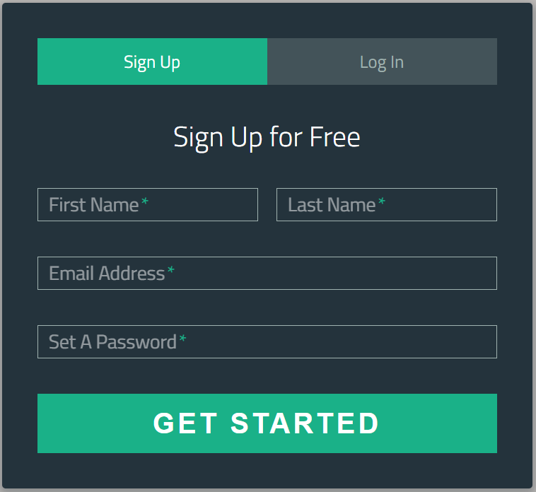

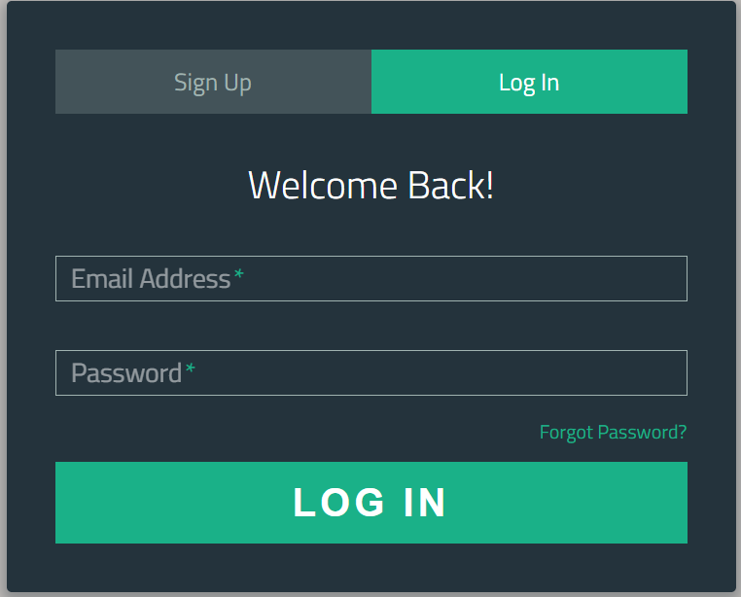

**Home Page**

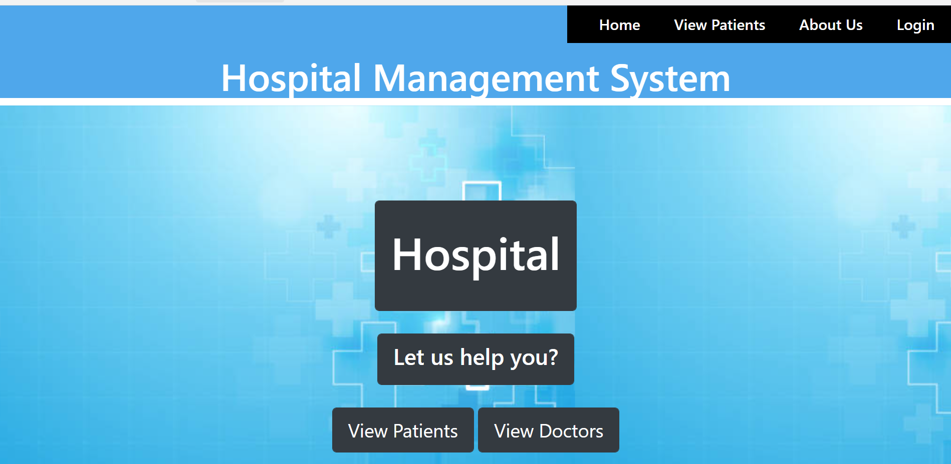



**View Patients**

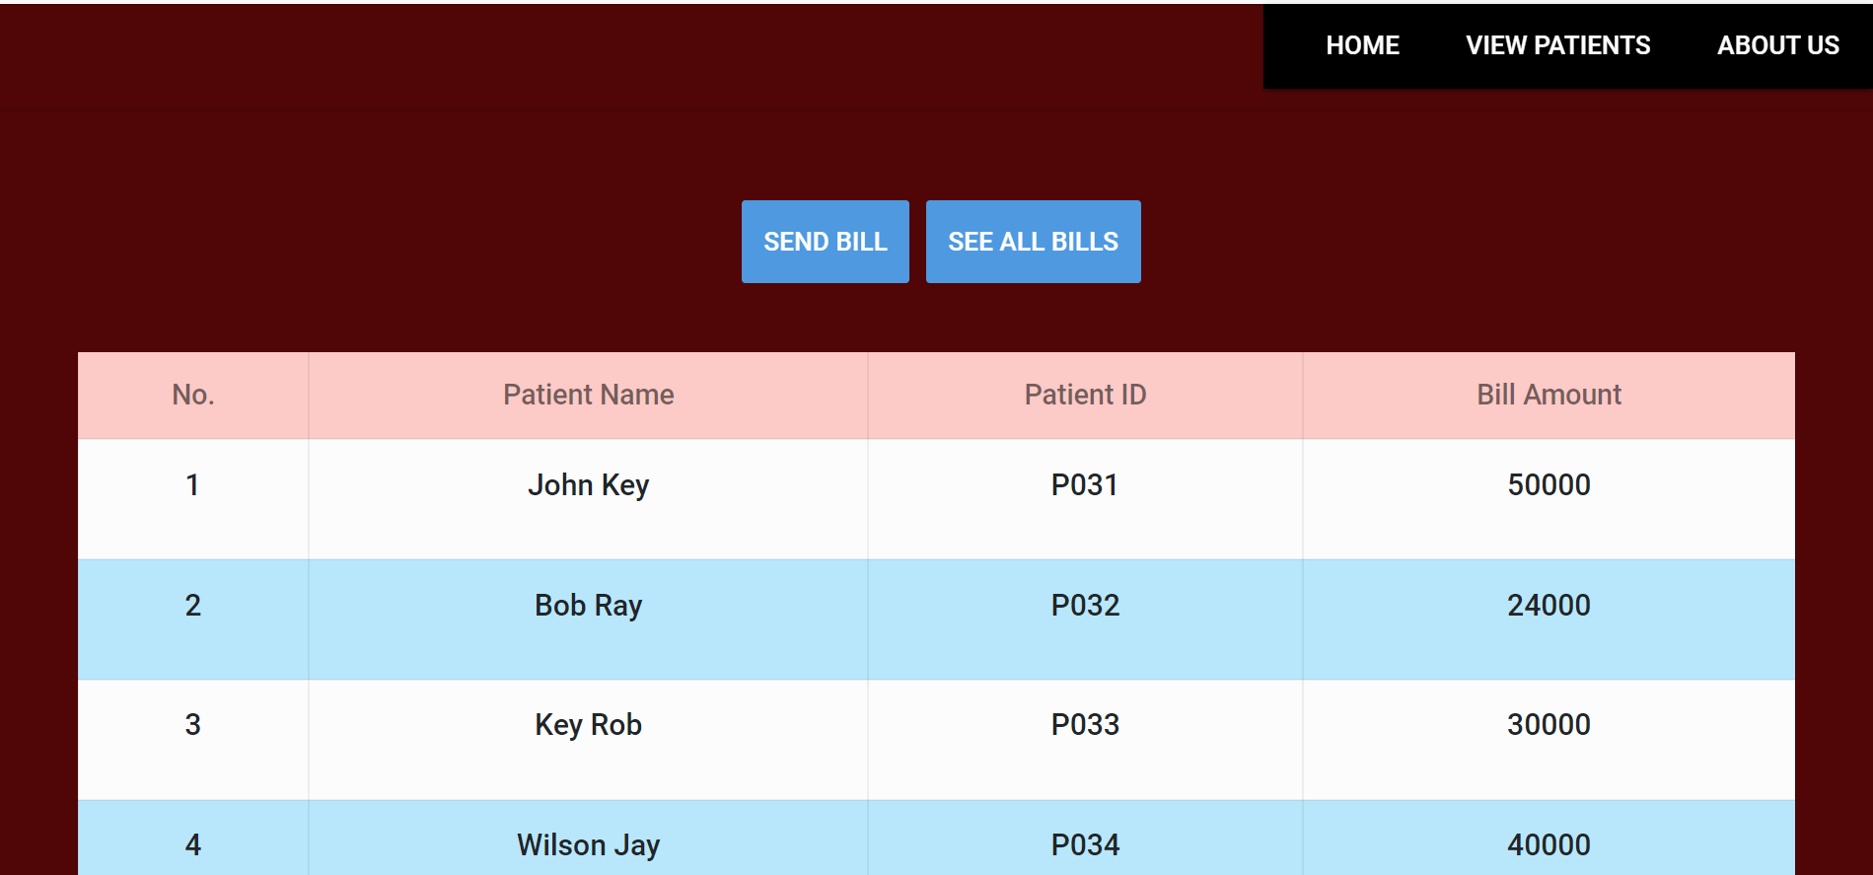

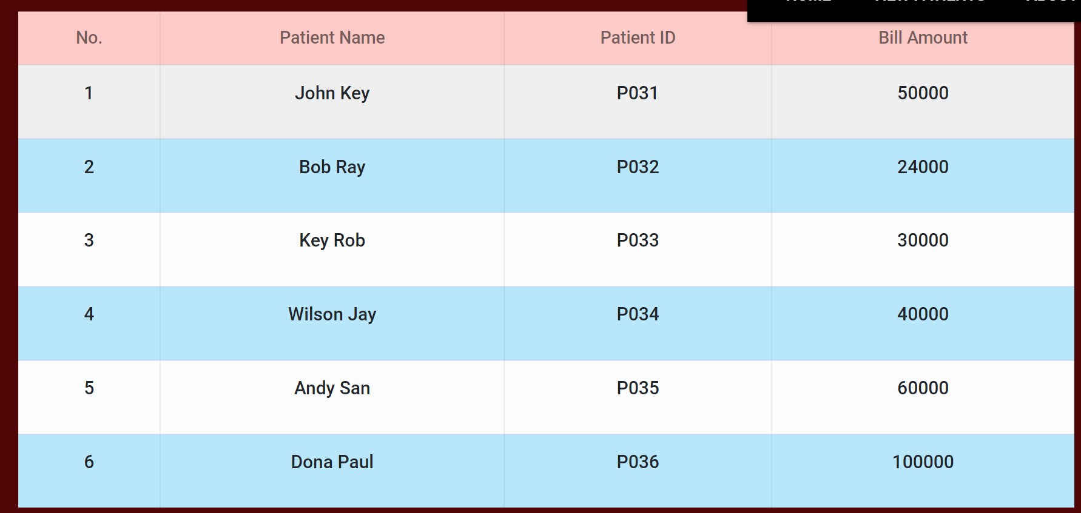

**Billing**

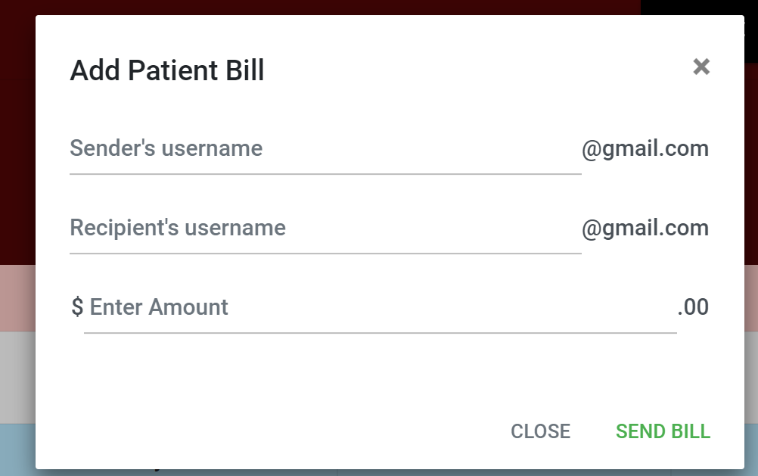

**About Us**

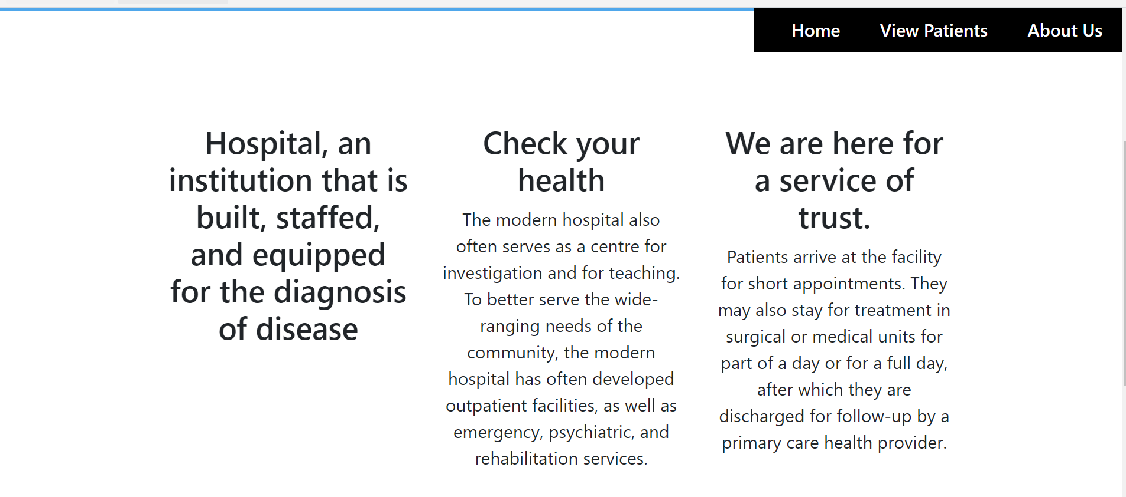

**Doctors**

