Personal Finance Tracker
A Python application for tracking, analysing and visualising personal finances

DATA 333 – Data Management & Analysis
Bellevue College — Prior Learning Assessment (PLA)
Project Report

Student Name: ______________________
September 30, 2026

1. Project Overview and Objectives
The Personal Finance Tracker is a Python application that records income and expenses, organises them into categories, and turns them into summaries, trends, budget alerts and charts. It offers three ways to work with the same data: an interactive console menu, a Tkinter desktop window and an interactive Streamlit web dashboard, plus a non-interactive demo mode that runs every feature on a realistic sample dataset (311 fictional transactions over six months).
Requires Python 3.11+ (pandas 3, matplotlib 3.11). Dependencies are pinned in requirements.txt.
The objectives, taken from the DATA 333 project brief, were to:
- track income and expenses and assign each transaction to a category;
- display spending summaries and analyse spending trends over time;
- set savings goals and follow their progress;
- save and load data from files (both JSON and CSV);
- visualise the results, and demonstrate every core course concept: input/output, decisions and loops, functions, files and exceptions, lists/dictionaries/sets, object-oriented programming and pandas;
- implement all four enhancements: a Tkinter GUI, JSON + CSV storage, budget alerts and a Streamlit dashboard.

2. Key Features
- Transactions — add, edit, delete, search (text) and filter (kind, category, date range, amount). Every value is validated; bad input is explained, never fatal.
- Summaries & analysis — monthly income/expenses/net and savings rate, category shares, 3-month rolling average, month-over-month change and top expenses (pandas).
- Budgets & alerts — a monthly limit per category; WARNING at 80 %, EXCEEDED at 100 %. The CLI and GUI warn immediately when a new expense crosses a threshold.
- Savings goals — target, deadline, contributions, milestones at 25/50/75/100 %.
- Files — full state in JSON, transactions in CSV (import/export). Writes are atomic; a corrupted JSON file is backed up and the app starts cleanly.
- Charts — category donut, monthly income vs. expenses, spending trend and goal progress, saved as PNG and embedded in the GUI; interactive Plotly charts online.
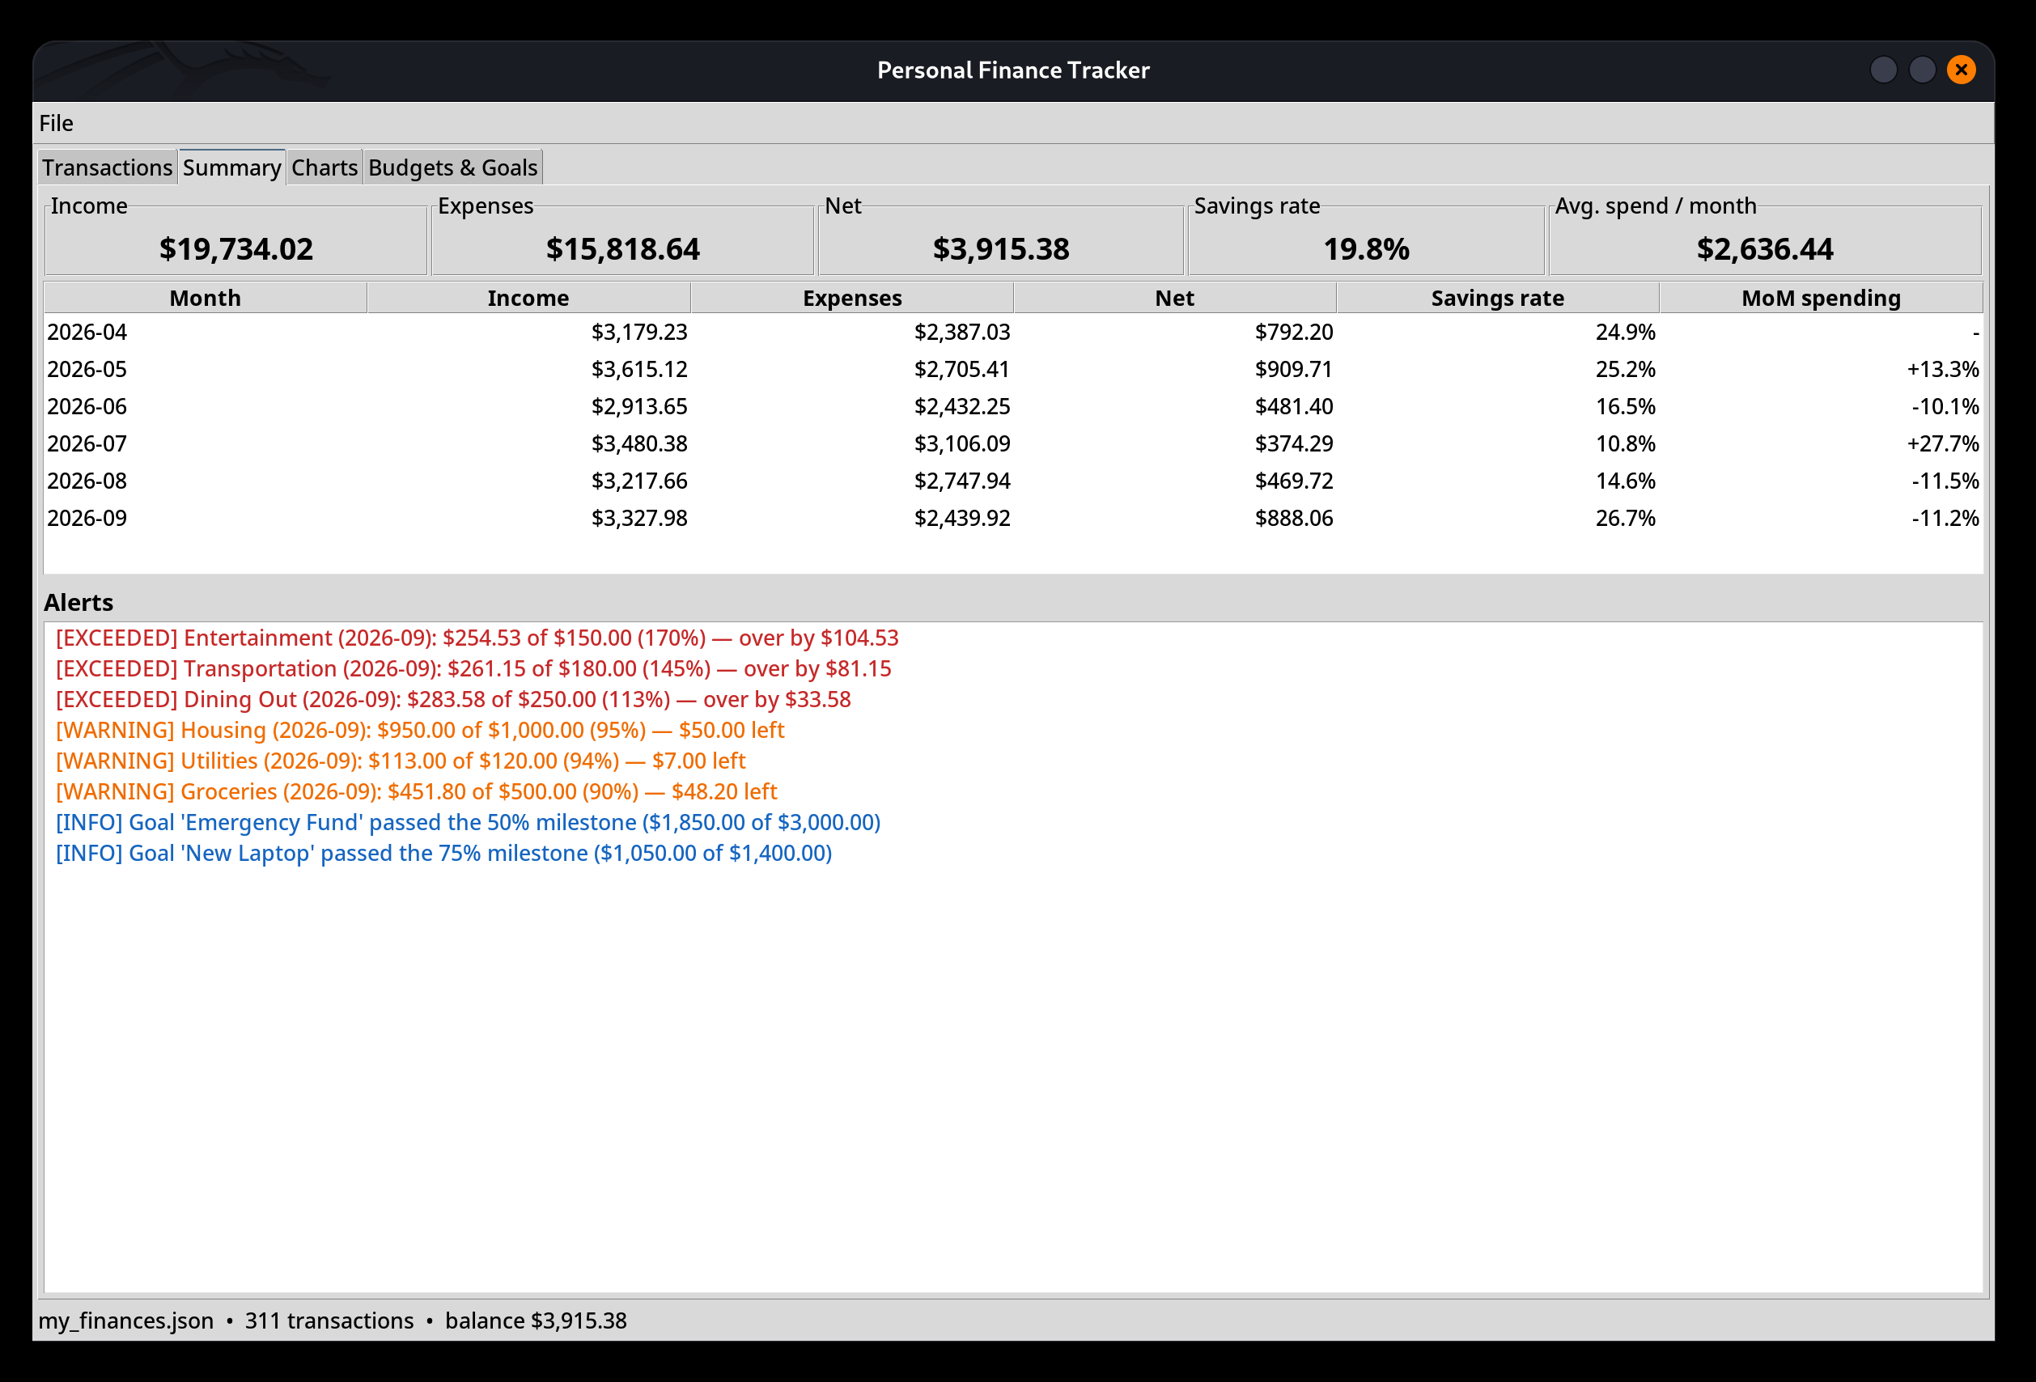
Figure 1 — Tkinter GUI, Summary tab: KPIs, monthly table and colour-coded alerts.
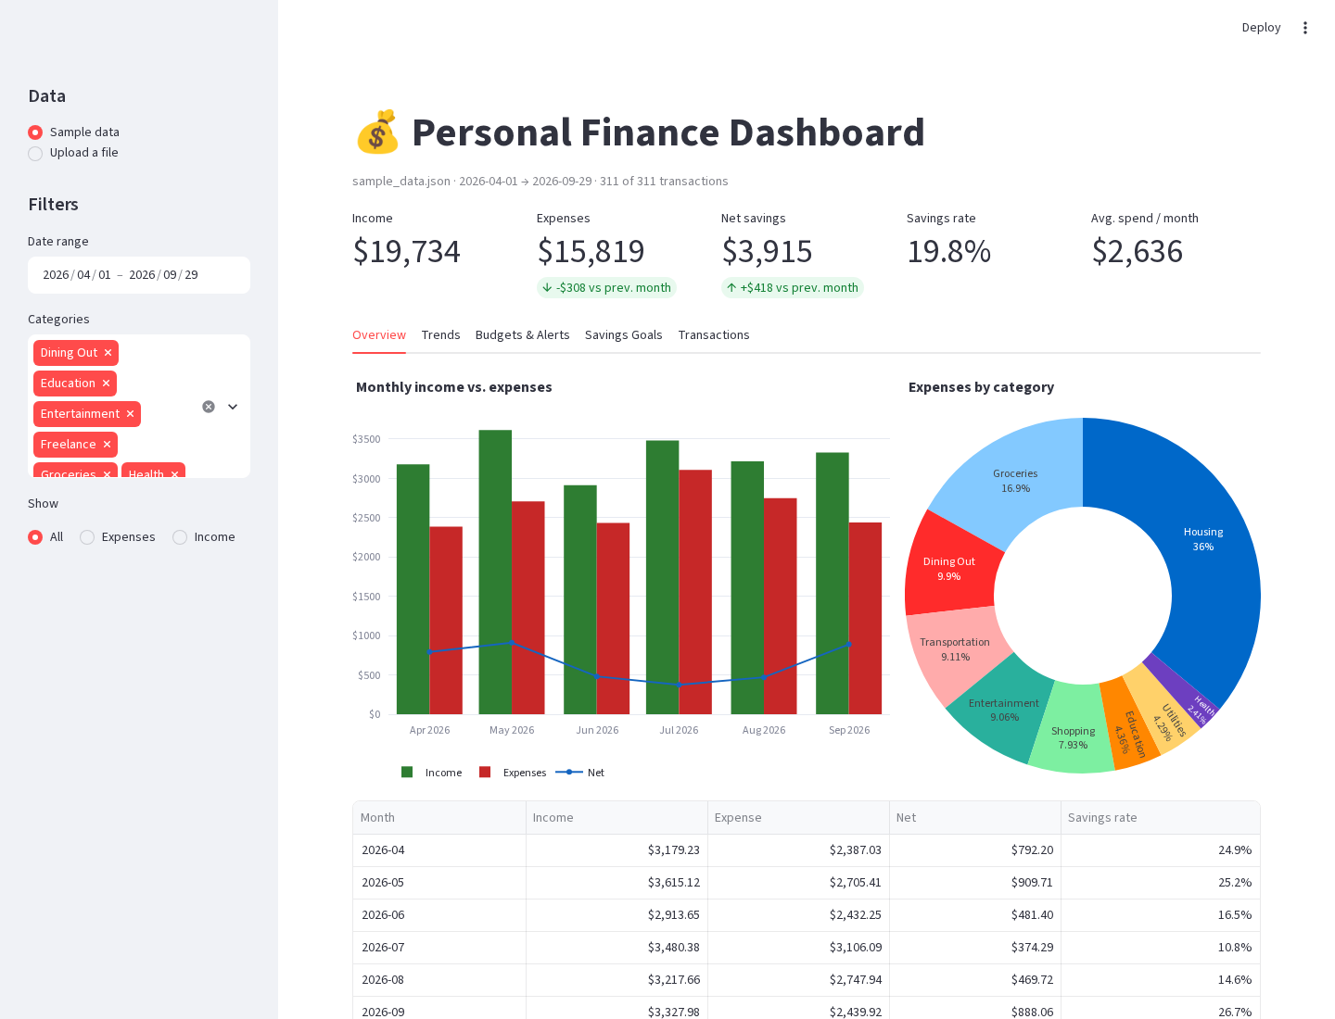
Figure 2 — Streamlit dashboard (captured with Playwright): filters, KPIs, Plotly charts.
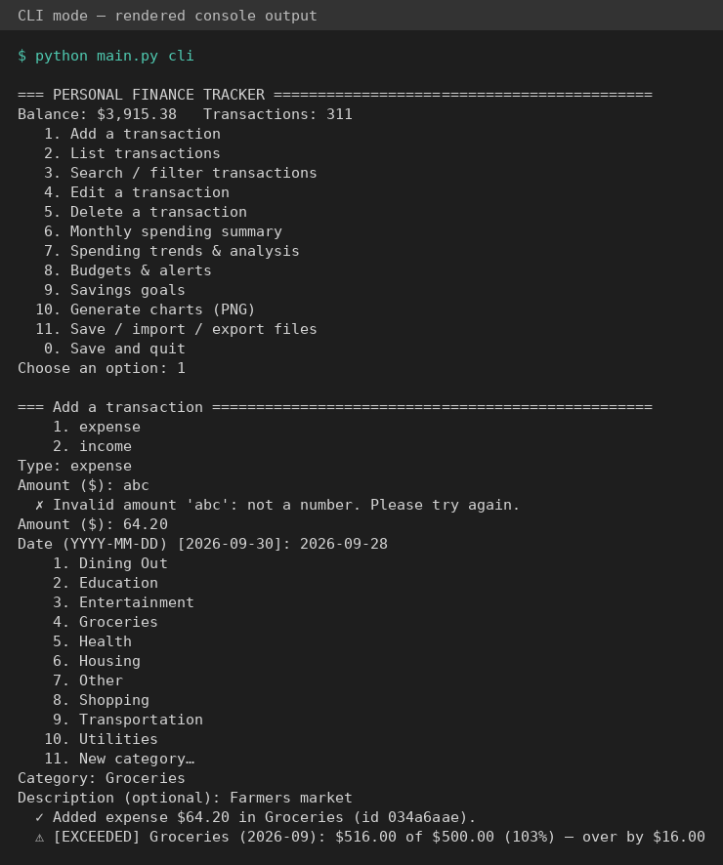
Figure 3 — CLI mode (rendered console output): an invalid amount is re-prompted, then a budget alert is raised.

3. Application of Course Concepts
Every concept is labelled in the source code with a # Concept: comment at the exact line where it is applied. The table maps each concept to where it is used.
Concept | File / function | How it is applied
User input / output | cli.py → ConsoleApp.ask, prompt_*, show_summary | All keyboard input goes through one method; results are printed as aligned f-string tables.
Decision structures | alerts.budget_level, main.main, ConsoleApp.run | if/elif/else classifies budget usage (OK / WARNING / EXCEEDED) and dispatches the modes.
Loops | ConsoleApp.run, prompt_amount, FinanceTracker.filter | while menu loop, re-prompt loops for invalid input, for loops with continue filters.
Functions | models.parse_amount, analytics.*, visualize.* | Small, documented, type-hinted functions reused by the CLI, GUI and dashboard.
File handling | storage.save_json/load_json/save_csv/load_csv, config.py | pathlib, with open(...), json and csv modules, atomic writes via a temp file.
Exceptions | exceptions.py, storage.load_json, models.parse_date | Custom hierarchy; try/except/else in load_json, try/except/finally in _atomic_write; corrupted JSON is backed up and recovered.
Lists | FinanceTracker.transactions, list comprehensions | Ordered collection of transactions; comprehensions build filtered views.
Dictionaries | FinanceTracker.budgets/goals, ConsoleApp.menu, to_dict() | O(1) lookup by name, menu dispatch table, JSON serialization.
Sets | FinanceTracker.categories, models.VALID_KINDS, storage.load_csv | Unique category names, O(1) membership tests, set difference for missing CSV columns.
OOP (classes) | Transaction, SavingsGoal, Budget, FinanceTracker, FinanceApp | Dataclasses validated in __post_init__, properties, class methods, inheritance.
pandas | analytics.monthly_summary, category_breakdown, spending_trend | pivot_table, groupby().agg(), rolling().mean(), pct_change(), boolean masks.

4. Architecture
The code is organised in layers. The interfaces contain no business rules: they call FinanceTracker and the analytics, alerts and visualize modules, and only format the results (the dashboard also applies its sidebar filters with pandas). Validation lives in the model classes and every file format lives in storage.py. Because the logic does not depend on the interface, the same functions power the CLI, the GUI, the dashboard and the demo — and can be unit tested without a screen.
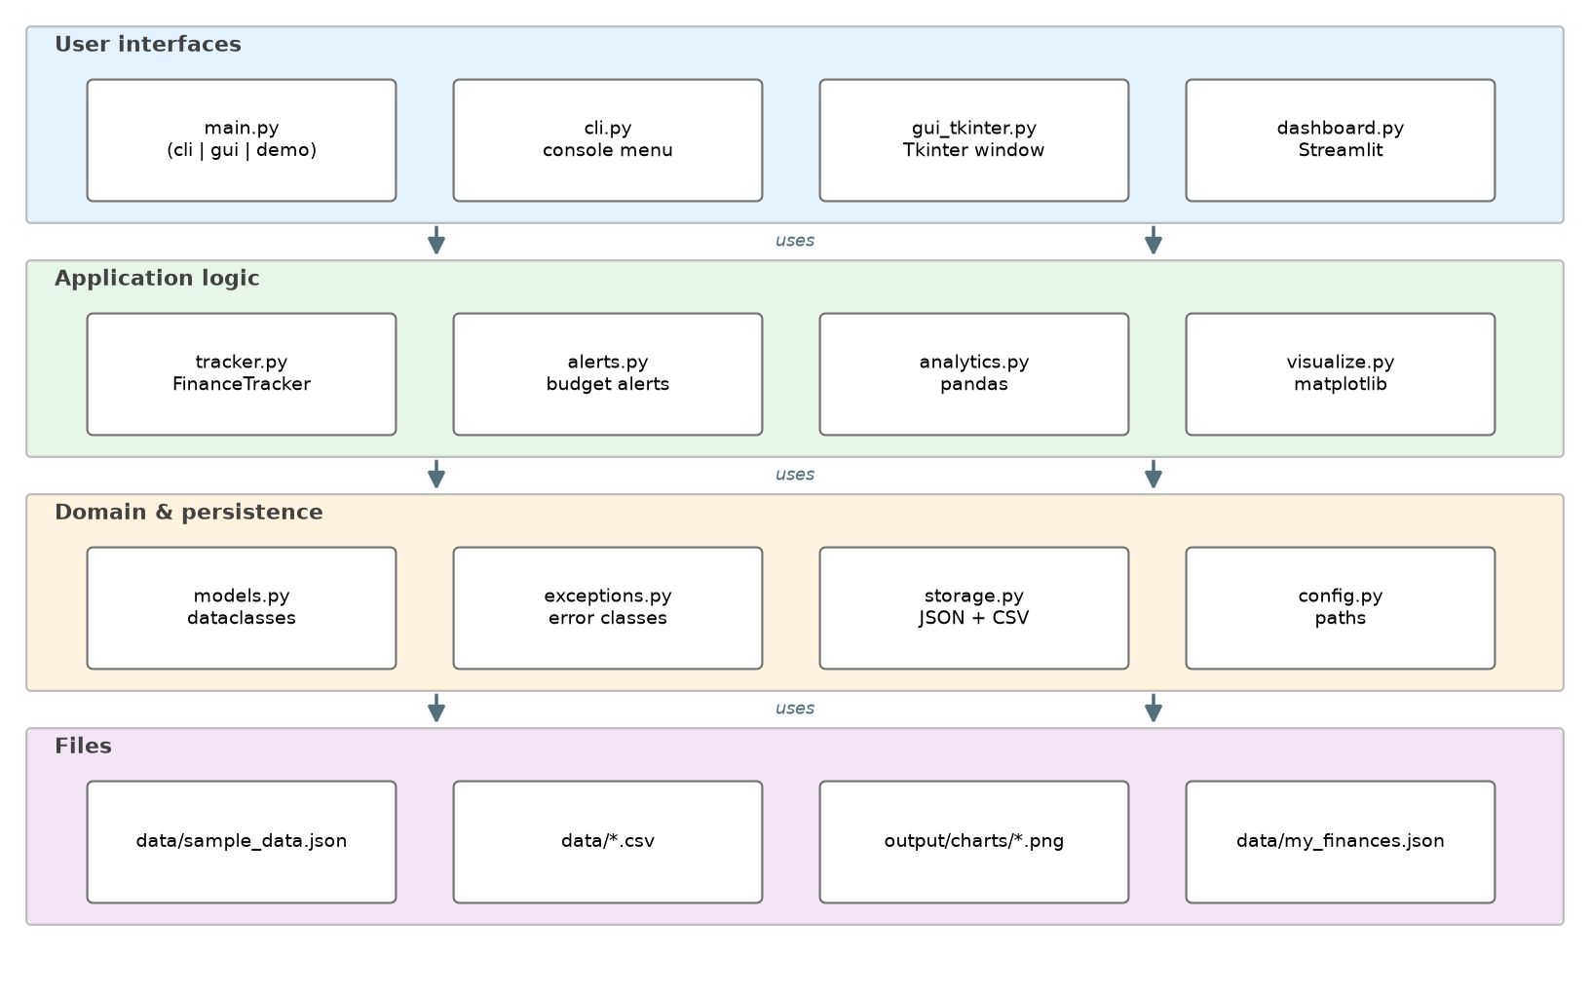
Figure 4 — Layered architecture: interfaces → application logic → domain & persistence → files.

5. Challenges and Solutions
These problems were met during development (see DEV_LOG.md for the full log).
Challenge | Solution
Our own StorageError (a subclass of OSError) was caught by a generic except OSError and re-wrapped, hiding the real message. | Added except StorageError: raise before the generic clause — handlers are checked in order.
Goal labels such as "$1,850 / $3,000" lost their dollar signs: matplotlib treats text between two $ as LaTeX math. The same happened in Streamlit's st.markdown. | Escaped the $ signs (\$) in both places and added regression tests.
CLI tests tried to read the real keyboard because input_func=input was a default argument, evaluated once when the function is defined. | Defaults changed to None, resolved at call time; tests inject a scripted input function.
On a HiDPI screen the Tkinter table rows overlapped and chart text was tiny: Tk scales fonts but not pixel sizes, and the canvas resets a figure's dpi. | Computed a scale factor from the real font height; added a dpi parameter to the charts.
First sample data had a negative savings rate and all goals "overdue" (data ended in 2025). | Re-tuned the generator (fixed seed 42) to Apr–Sep 2026 and added a test on the balance.
An independent review found that "0.004" passed the > 0 check before rounding, creating a $0.00 budget that later crashed with ZeroDivisionError. | Round first, then validate (at least 0.01); regression tests for budgets, goals and transactions.

6. Enhancements
- Tkinter GUI — four tabs (Transactions, Summary, Charts, Budgets & Goals), sortable Treeview, live search, embedded matplotlib charts, HiDPI support.
- JSON and CSV storage — JSON for the complete state, CSV for spreadsheets; both validated row by row, with missing-file and corrupted-file handling.
- Budget alerts — thresholds kept as constants (80 % / 100 %), sorted by severity, shown in every interface; goal milestones and missed deadlines are reported too.
- Streamlit dashboard — sidebar filters (source, dates, categories, kind), KPIs with month-over-month deltas, Plotly charts, heatmap, CSV upload and download.

7. Testing
The project has 173 automated pytest tests with 98 % line coverage of the finance_tracker package. The coverage scope excludes gui_tkinter.py (Tkinter) and dashboard.py (Streamlit): their event code is exercised by smoke tests instead. The tests cover normal use, invalid input (bad amounts, dates, kinds, empty names), missing and corrupted files, CSV files with missing columns or bad rows, every pandas calculation on a hand-checked dataset, and full CLI sessions driven by scripted answers. The GUI is built and clicked through on a real display, and the dashboard is rendered headlessly with Streamlit's AppTest. A standards test checks that every function has a Google-style docstring and type hints and that every course concept is tagged, and ruff enforces a consistent code style.

8. What I Learned
- Validating data once, at the boundary (__post_init__), keeps the rest of the code simple: everything after that point can trust its inputs.
- Choosing the right structure matters: a list keeps order, a dictionary gives fast lookup by name, and a set removes duplicates for free.
- pandas replaces dozens of lines of loops with one readable groupby or pivot_table, but empty data must be handled explicitly.
- Exception handlers are matched in order and by inheritance — a subtle source of bugs.
- Looking at the real output (screenshots, rendered charts) finds bugs that unit tests miss, such as the “$…$” math-text problem and the HiDPI layout issue.

9. Future Improvements
- Recurring transactions (rent, subscriptions) generated automatically each month.
- Import of real bank statements (OFX/QFX) with automatic category suggestions.
- A SQLite backend for larger histories and multi-user support.
- Spending forecasts (e.g. linear regression on monthly totals) in the dashboard.
- Packaging as an installable application with a pyproject.toml entry point.

