Snowflake and PowerBI Integration

Adding New Columns, New Measures and Making Reports Documentation

Create a Warehouse
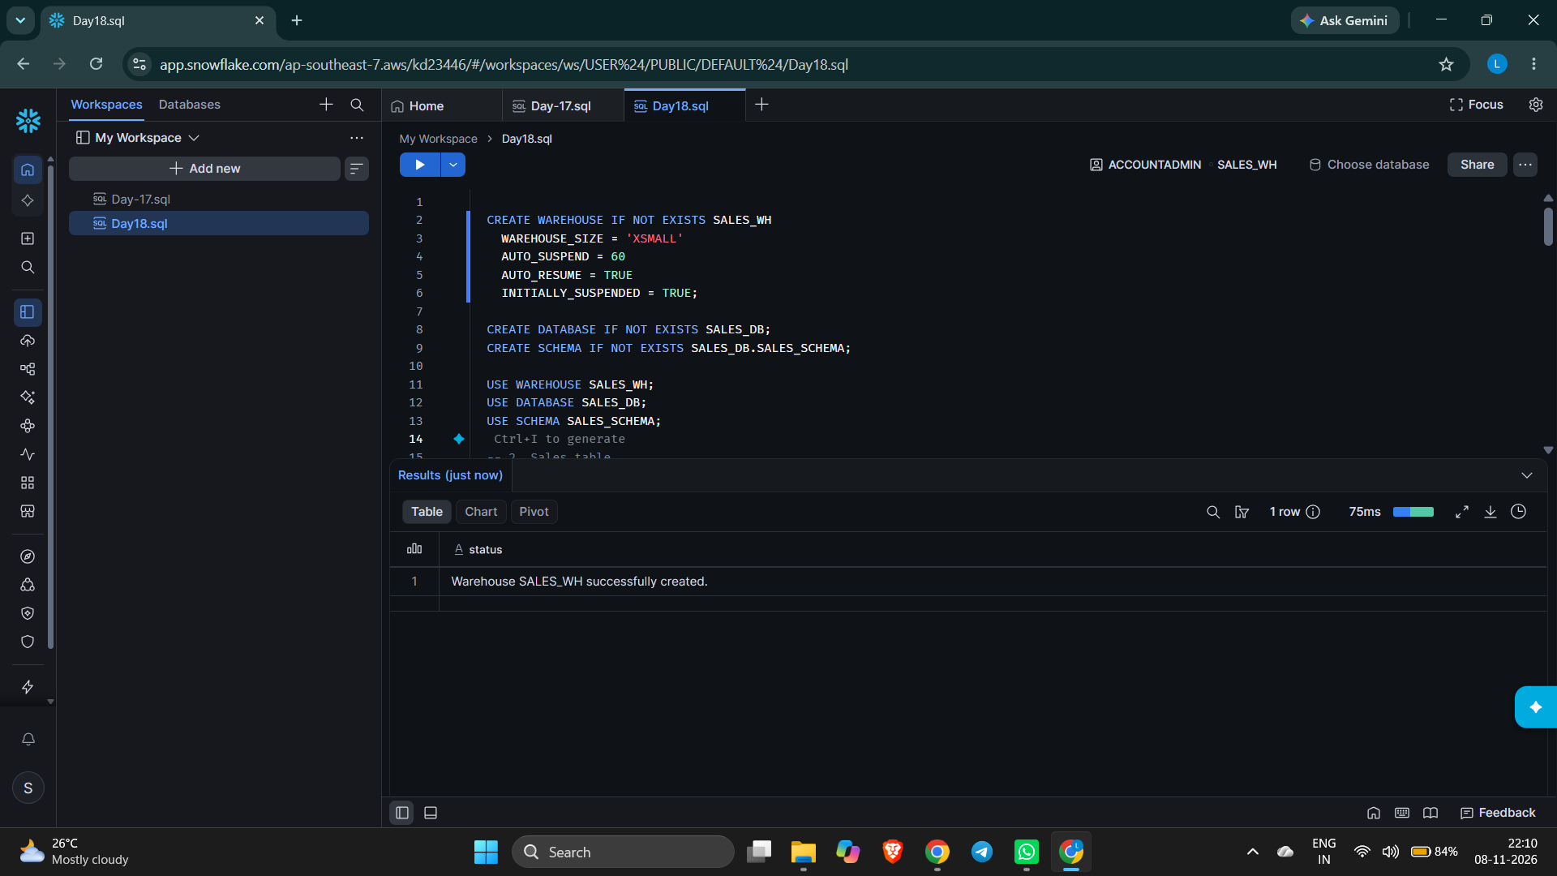
Create Database
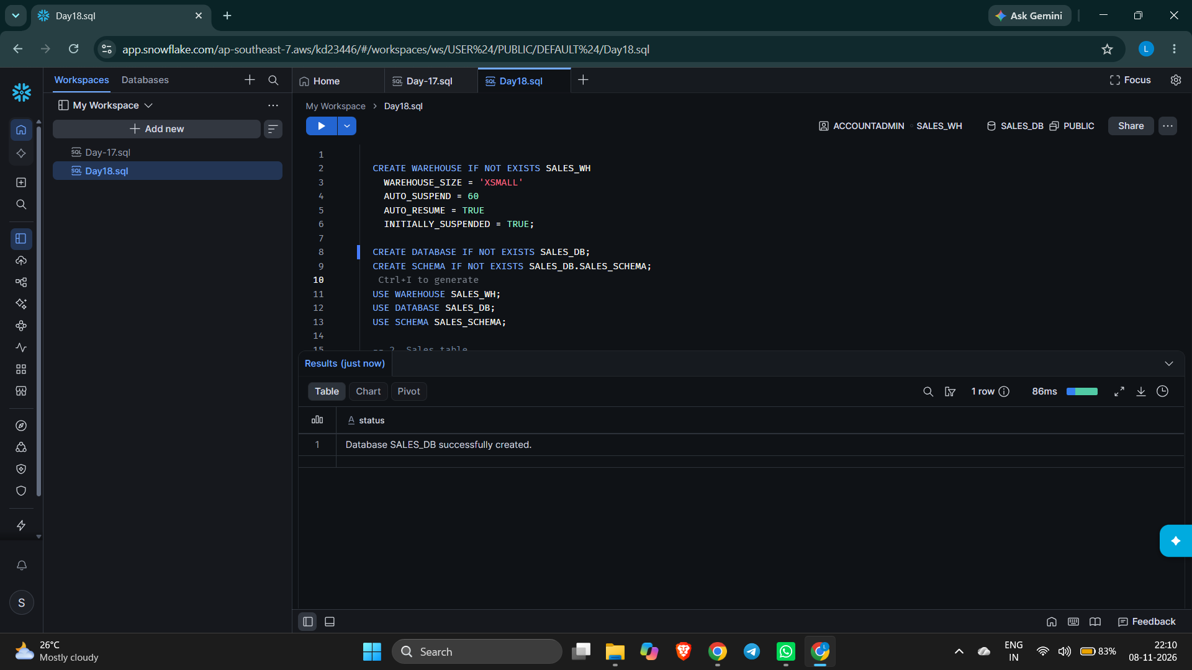

Create Schema
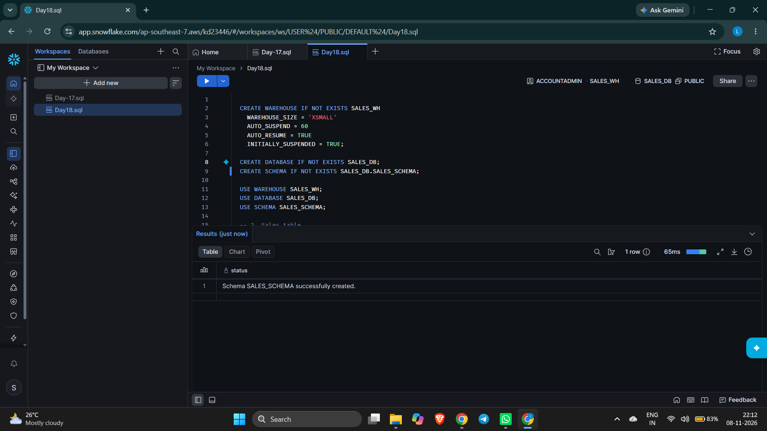
Create Table
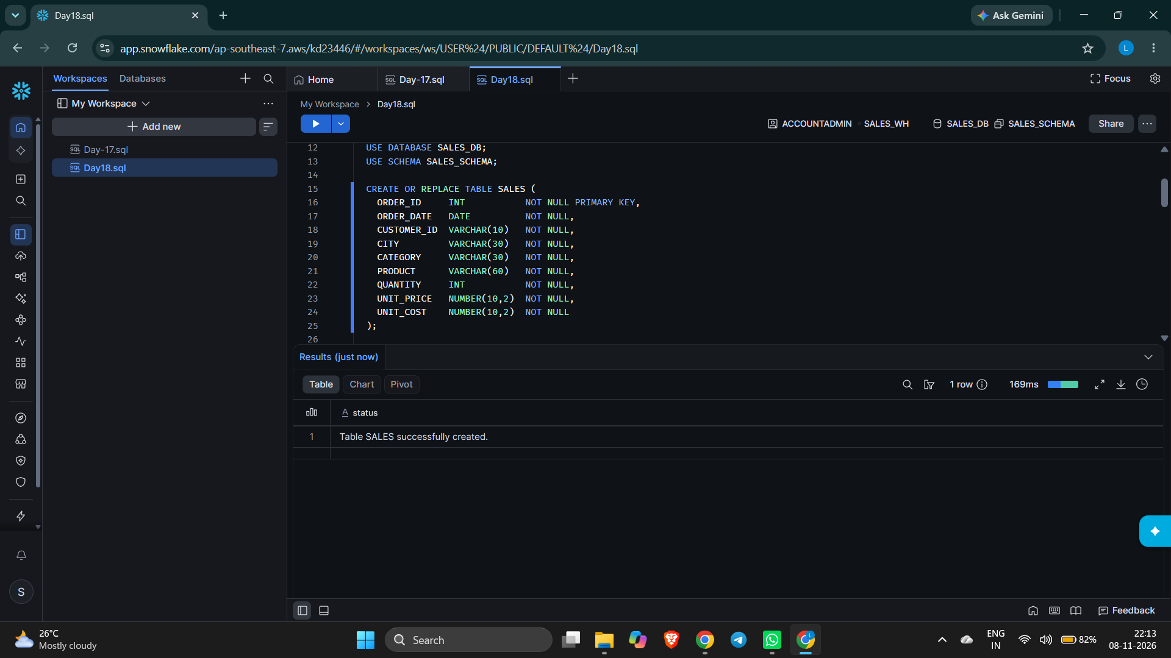

Insert 40 Records
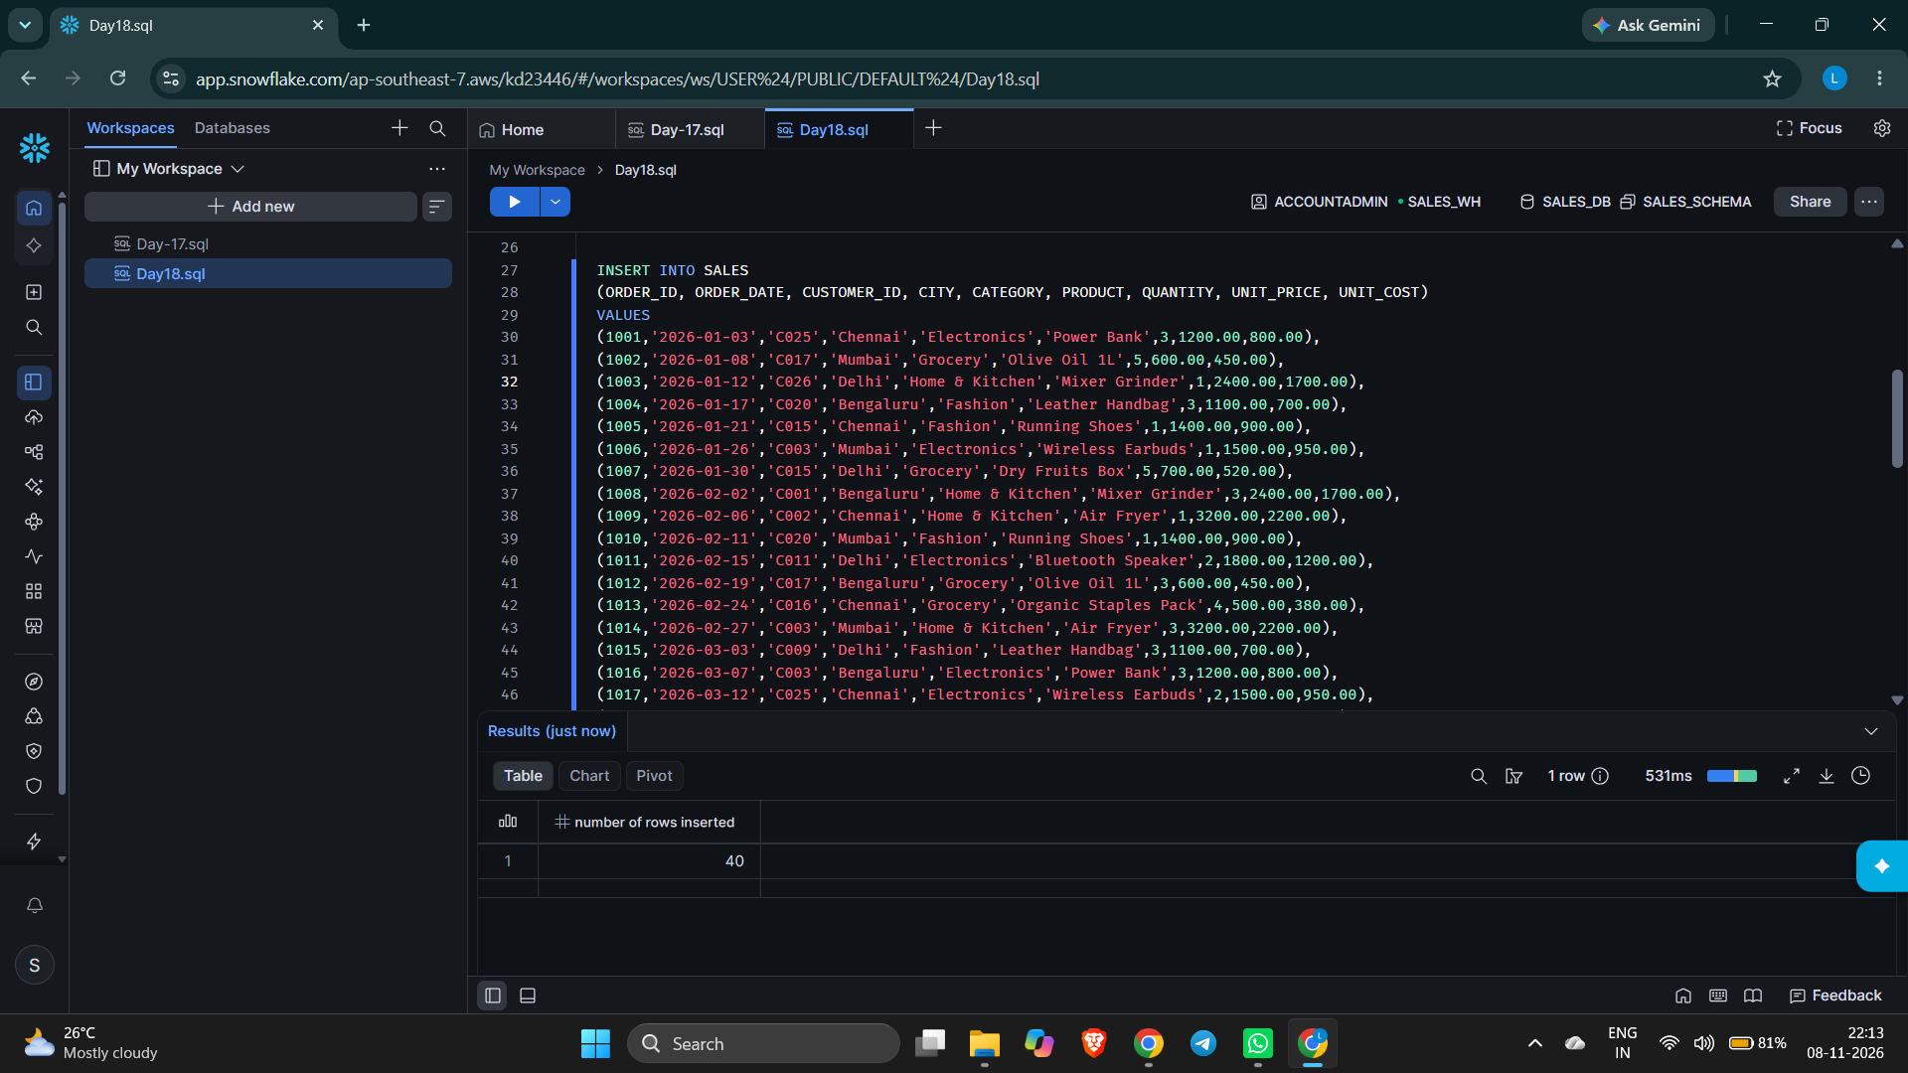
View All Records
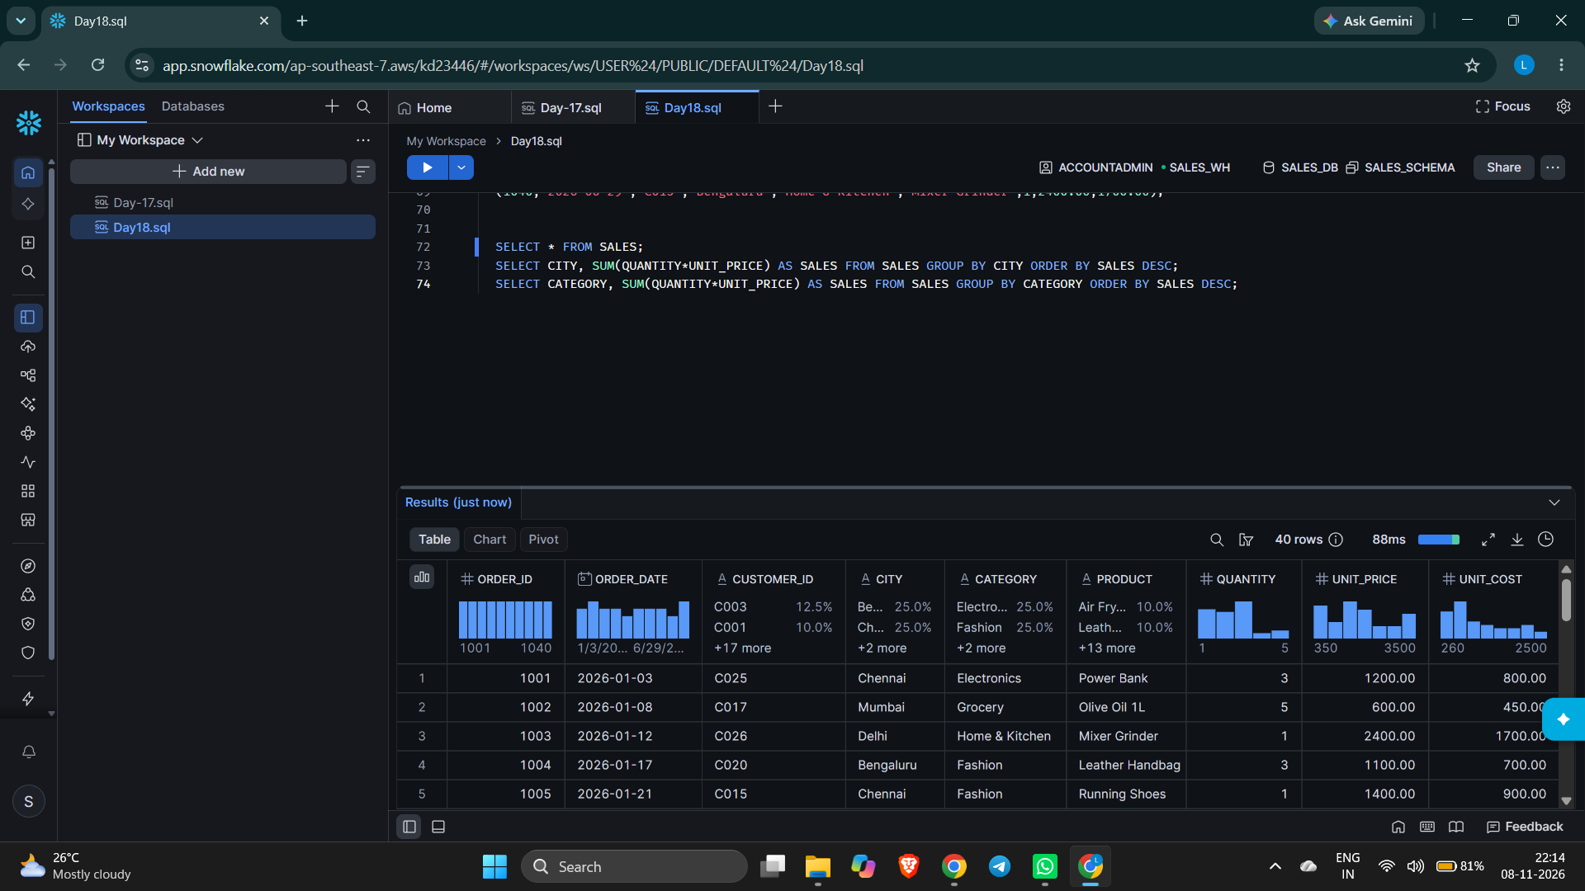

PowerBI Platform

Connecting Snowflake from PowerBI

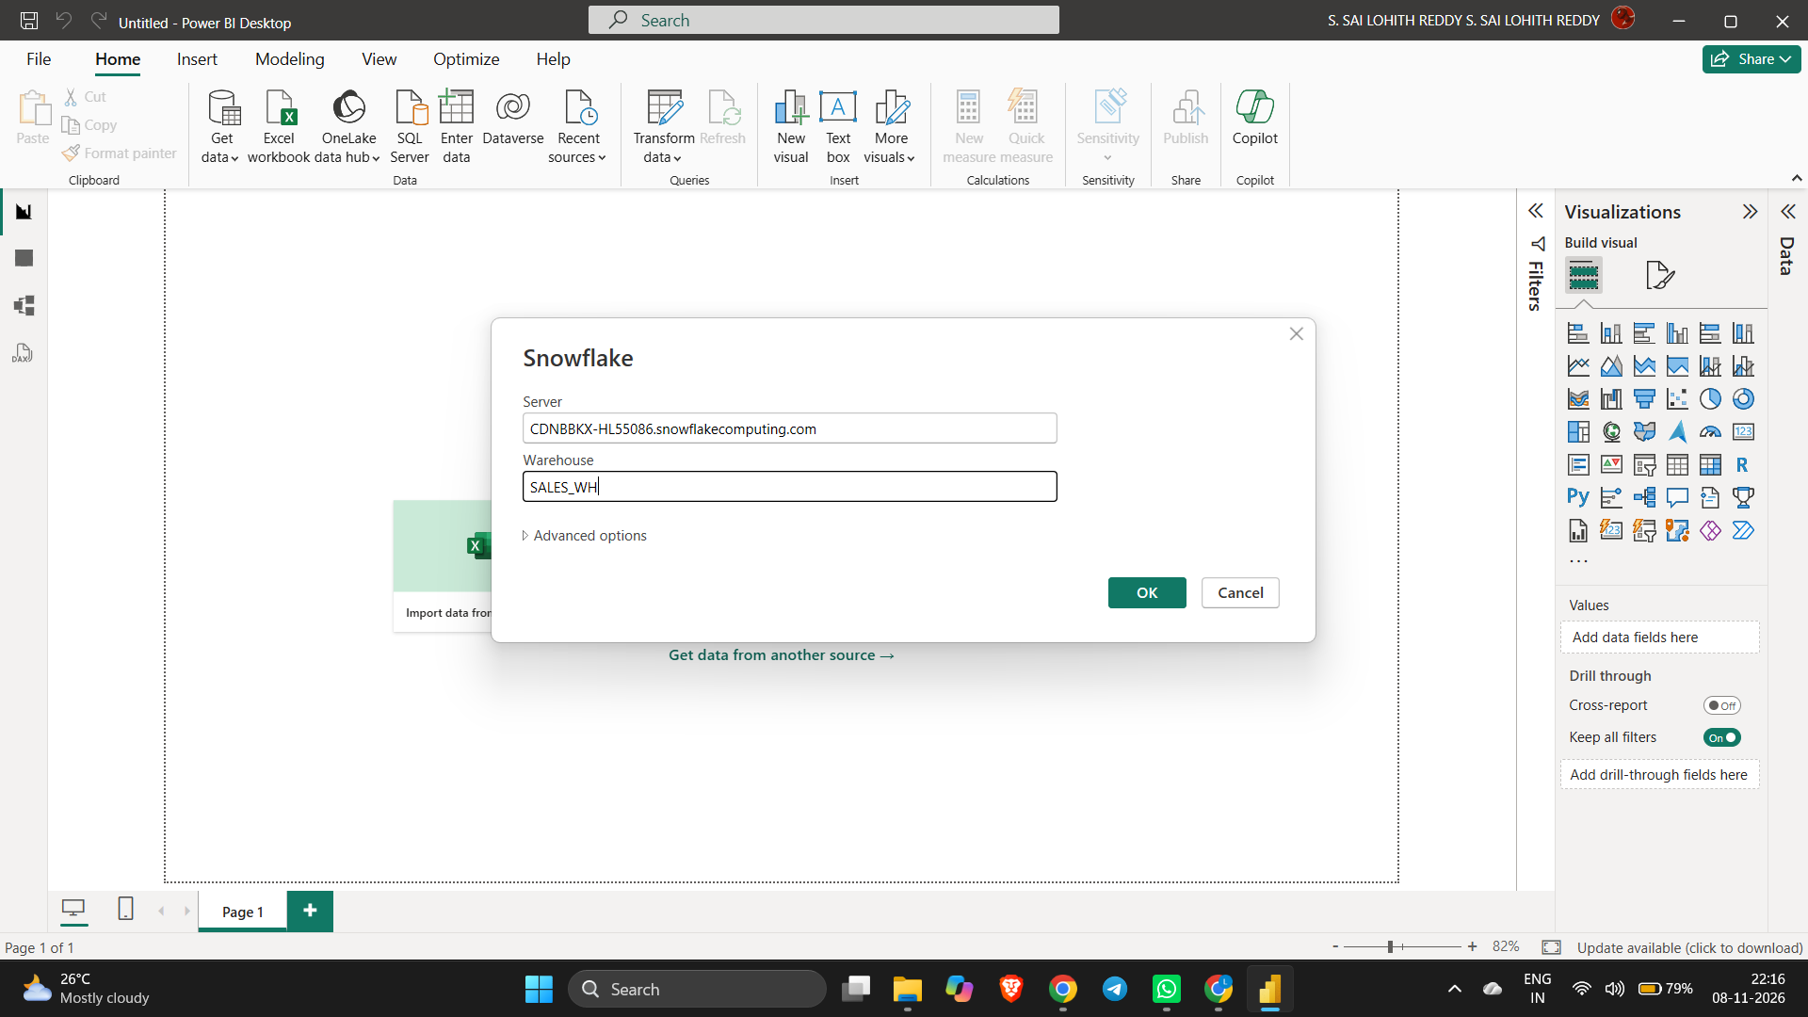
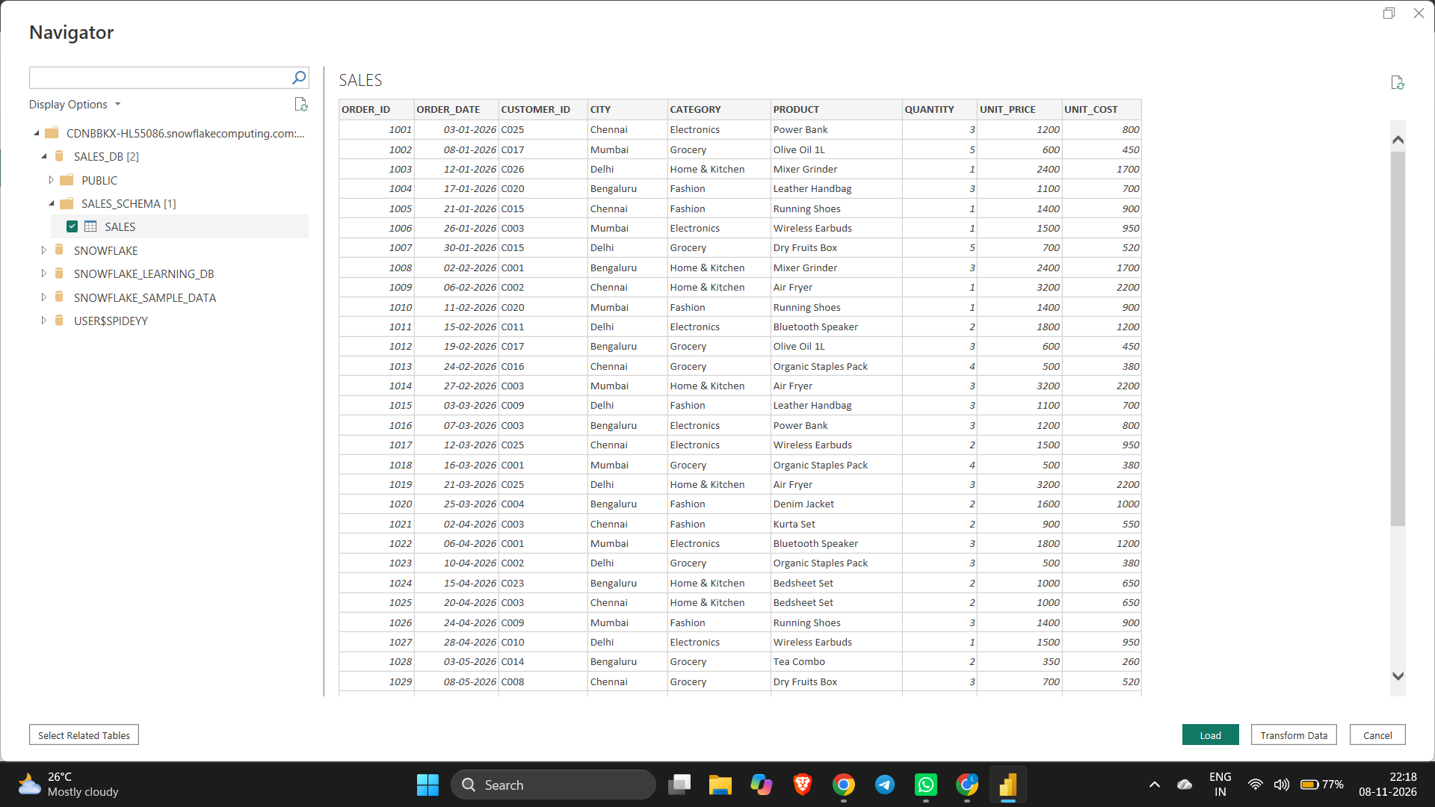
Before Adding New Colums
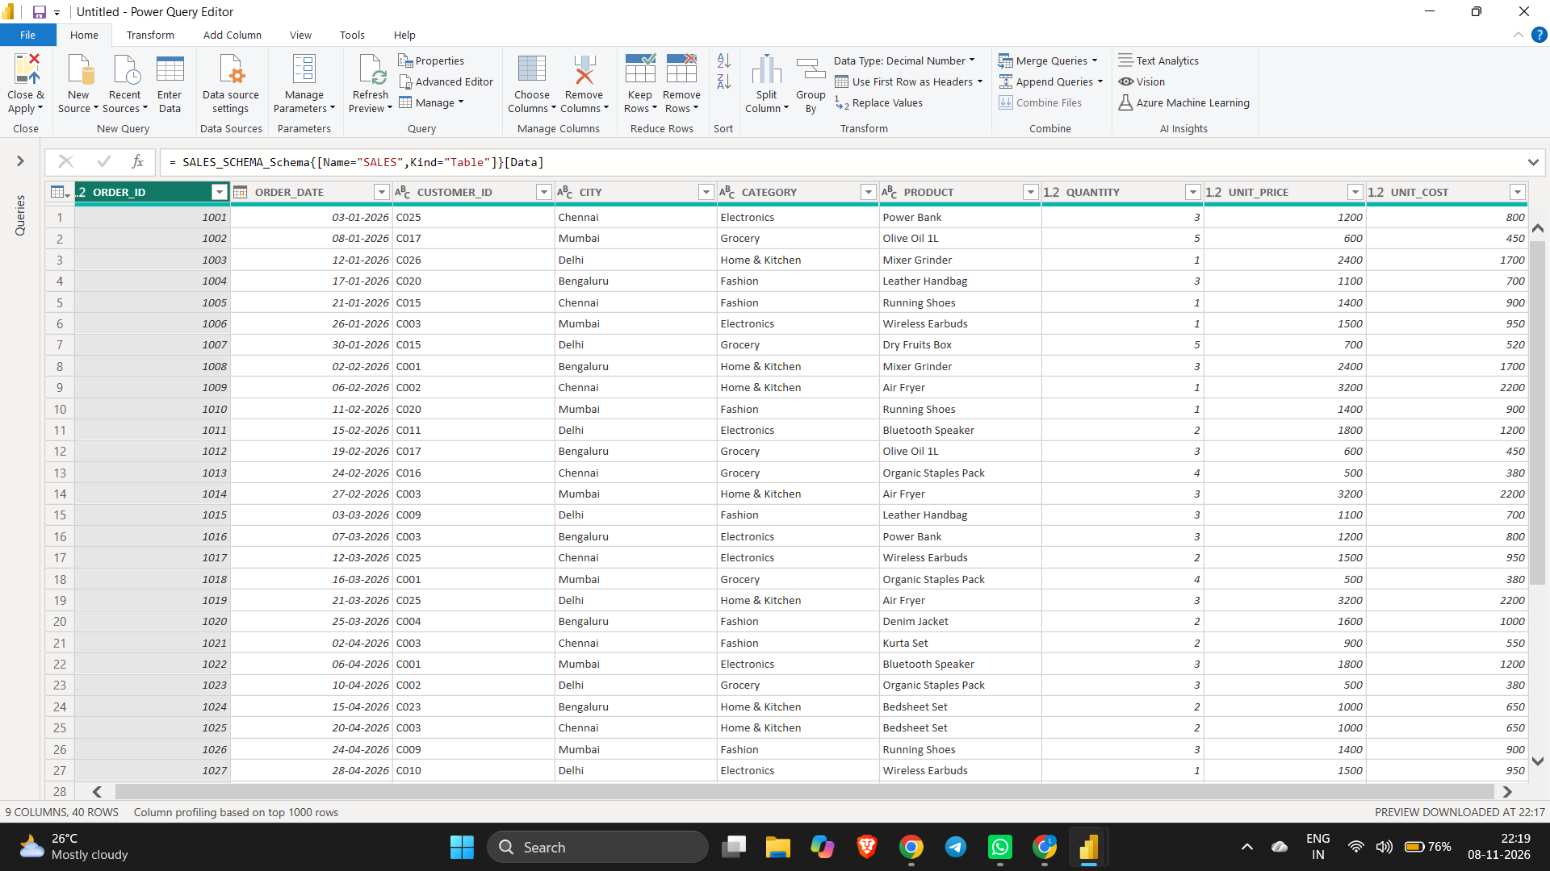

Adding New Columns
- Sales Amount
Column name: Sales Amount
Objective: To calculate the total sales value generated from each order.
Sales Amount = Sales[QUANTITY] * Sales[UNIT_PRICE]
- Total Cost
Column name: Total Cost
Objective: To calculate the estimated total cost of products sold. For Example, we assume that the product cost is 70% of its selling price.
Total Cost = Sales[Sales Amount] * 0.70
- Gross Profit
Column name: Gross Profit
Objective: To calculate the profit earned after deducting the product cost from the sales amount.
Gross Profit = Sales[Sales Amount] - Sales[Total Cost]
- Profit Category
Column name: Profit Category
Objective: To classify transactions based on their gross profit. We will use three categories:
- Higher Profit: Gross profit greater than or equal to ₹10,000.
- Medium Profit: Gross profit between ₹3,000 and ₹9,999.99.
- Lower Profit: Gross profit below ₹3,000.
Profit Category = SWITCH( TRUE(), Sales[Gross Profit] >= 10000, “Higher Profit”, Sales[Gross Profit] >= 3000, “Medium Profit”, “Lower Profit” )

New Measures

Total Sales using SUM()
Total Sales = SUM(Swiggy[FinalAmount])
This calculates the sum of all final sales amounts.

Average Sales using AVERAGE()
Average Sales = AVERAGE(Swiggy[FinalAmount])
This calculates the average sales amount per row.

Count Transactions using COUNTROWS()
Total Transactions = COUNTROWS(Swiggy)
This counts the number of rows in your sales table. If each order has one row, it represents the number of transactions.

Unique Customers using DISTINCTCOUNT()
Unique Customers = DISTINCTCOUNT(Swiggy[CUSTOMER_ID])
This counts each customer only once, even if they placed multiple orders.

Average Order Value using DIVIDE()
Average Order Value = DIVIDE([Total Sales], [Total Transactions], 0)
This divides total sales by total transactions. The 0 is returned if the denominator is zero.

Sales Target using IF()
Sales Target Status =
IF(
[Total Sales] >= 1000000,
"Target Achieved",
"Target Not Achieved"
)

Category-wise Sales using CALCULATE()
Biryani Sales =
CALCULATE(
[Total Sales],
Swiggy[CATEGORY] = "Biryani"
)

Revenue using SUMX()
Total Revenue SUMX =
SUMX(
Swiggy,
Swiggy[QUANTITY] * Swiggy[UNIT_PRICE]
)
Sales Classification using SWITCH()
Sales Performance =
SWITCH(
TRUE(),
[Total Sales] >= 500000, "HIGH",
[Total Sales] >= 250000, "MEDIUM",
"LOW"
)

Final Report


