
Alliance School of Advanced Computing

Course Name: GRAPH ANALYTICS
Course Code: E1ITC 302
Assignment No: 5

Name of the Student: Manoj K
Registration Number: 2411021060692

A. Title of The Problem:
University Course Registration System Using Neo4j
B. Problem Statement in details:
A university needs a system to represent and query information about students, faculty members, courses, and departments. In this project, Neo4j is used to model these entities as nodes and their connections as relationships. Students enrol in courses, faculty members teach courses, students belong to departments, and departments offer courses. Cypher queries are used to create the graph and retrieve connected academic information, including enrolments, teaching assignments, department membership, and course offerings.
C. HackerRank/LeetCode Link of the problem (If applicable):
Not applicable.
D. Student’s Github link of report and code upload, along with the readme file:
https://github.com/14mano2006/neo4j
E. Solution Steps/Algorithm:
1. Connect to the Neo4j AuraDB instance.
2. Create Student, Faculty, Course, and Department nodes with their properties.
3. Create ENROLLED_IN, TEACHES, BELONGS_TO, and OFFERS relationships.
4. Run Cypher queries to retrieve the required information.
5. Verify node counts, relationship types, and query results.
6. Use Neo4j graph visualization to inspect the connected university data.

F.1 Full Cypher code to create the complete database
Run these statements one at a time in Neo4j AuraDB, in the order shown. If you have already created the same data, do not run the CREATE statements again because duplicate nodes may be added.
1. Create uniqueness constraints
CREATE CONSTRAINT student_id_unique IF NOT EXISTS
FOR (s:Student) REQUIRE s.studentId IS UNIQUE;
CREATE CONSTRAINT faculty_id_unique IF NOT EXISTS
FOR (f:Faculty) REQUIRE f.facultyId IS UNIQUE;
CREATE CONSTRAINT course_code_unique IF NOT EXISTS
FOR (c:Course) REQUIRE c.courseCode IS UNIQUE;
CREATE CONSTRAINT department_id_unique IF NOT EXISTS
FOR (d:Department) REQUIRE d.departmentId IS UNIQUE;
2. Create departments
CREATE
(:Department {departmentId: 'D101', name: 'Computer Science', building: 'Block A'}),
(:Department {departmentId: 'D102', name: 'Information Technology', building: 'Block B'});
3. Create courses
CREATE
(:Course {courseCode: 'CS301', title: 'Graph Analytics', credits: 3, level: 'Advanced'}),
(:Course {courseCode: 'CS302', title: 'Database Management Systems', credits: 4, level: 'Advanced'}),
(:Course {courseCode: 'CS303', title: 'Data Mining', credits: 3, level: 'Intermediate'}),
(:Course {courseCode: 'CS304', title: 'Big Data Analytics', credits: 4, level: 'Advanced'}),
(:Course {courseCode: 'CS305', title: 'NoSQL Databases', credits: 3, level: 'Intermediate'});
4. Create faculty members
CREATE
(:Faculty {facultyId: 'F101', name: 'Dr. Meera Sen', designation: 'Associate Professor', specialization: 'Database Systems'}),
(:Faculty {facultyId: 'F102', name: 'Dr. Amit Roy', designation: 'Professor', specialization: 'Data Analytics'});
5. Create students
CREATE
(:Student {studentId: 'S101', name: 'Aarav Sharma', semester: 5, email: 'aarav@univ.edu'}),
(:Student {studentId: 'S102', name: 'Priya Das', semester: 5, email: 'priya@univ.edu'}),
(:Student {studentId: 'S103', name: 'Rahul Verma', semester: 3, email: 'rahul@univ.edu'}),
(:Student {studentId: 'S104', name: 'Sneha Roy', semester: 3, email: 'sneha@univ.edu'}),
(:Student {studentId: 'S105', name: 'Arjun Patel', semester: 5, email: 'arjun@univ.edu'});
6. Connect students to departments
MATCH (s:Student), (d:Department)
WHERE (s.name IN ['Aarav Sharma', 'Priya Das', 'Rahul Verma'] AND d.name = 'Computer Science')
OR (s.name IN ['Sneha Roy', 'Arjun Patel'] AND d.name = 'Information Technology')
MERGE (s)-[:BELONGS_TO]->(d);
7. Connect departments to courses
MATCH (d:Department), (c:Course)
WHERE (d.name = 'Computer Science' AND c.title IN
['Database Management Systems', 'Data Mining', 'NoSQL Databases'])
OR (d.name = 'Information Technology' AND c.title IN
['Graph Analytics', 'Big Data Analytics'])
MERGE (d)-[:OFFERS]->(c);
8. Connect faculty to courses
MATCH (f:Faculty), (c:Course)
WHERE (f.name = 'Dr. Meera Sen' AND c.title IN
['Database Management Systems', 'NoSQL Databases'])
OR (f.name = 'Dr. Amit Roy' AND c.title IN
['Graph Analytics', 'Data Mining', 'Big Data Analytics'])
MERGE (f)-[r:TEACHES]->(c)
SET r.academicYear = '2026-27';
9. Connect students to courses
MATCH (s:Student), (c:Course)
WHERE (s.name = 'Aarav Sharma' AND c.title IN
['Graph Analytics', 'Database Management Systems', 'NoSQL Databases'])
OR (s.name = 'Priya Das' AND c.title IN ['Graph Analytics', 'Data Mining'])
OR (s.name = 'Rahul Verma' AND c.title IN ['Database Management Systems', 'Big Data Analytics'])
OR (s.name = 'Sneha Roy' AND c.title IN ['Data Mining', 'NoSQL Databases'])
OR (s.name = 'Arjun Patel' AND c.title IN ['Big Data Analytics', 'Graph Analytics'])
MERGE (s)-[r:ENROLLED_IN]->(c)
SET r.semesterEnrolled = s.semester,
r.grade = 'Not Published';
10. Verify node counts
MATCH (n)
RETURN labels(n) AS Label, count(n) AS Total
ORDER BY Label;
11. Verify relationship counts
MATCH ()-[r]->()
RETURN type(r) AS Relationship, count(r) AS Total
ORDER BY Relationship;
12. Display the complete graph
MATCH (a)-[r]->(b)
RETURN a, r, b;
F. Code developed:
1. Display the complete graph
MATCH (a)-[r]->(b) RETURN a, r, b;
2. Count nodes by label
MATCH (n) RETURN labels(n) AS Label, count(n) AS Total;
3. Show relationship types and directions
MATCH (a)-[r]->(b) RETURN DISTINCT labels(a) AS Source, type(r) AS Relationship, labels(b) AS Target;
4. Find students in Semester 5
MATCH (s:Student) WHERE s.semester = 5 RETURN s.name AS Student, s.semester AS Semester;
5. Find courses with more than 3 credits
MATCH (c:Course) WHERE c.credits > 3 RETURN c.title AS Course, c.credits AS Credits;
6. Find courses taught by Dr. Meera Sen
MATCH (f:Faculty {name: 'Dr. Meera Sen'})-[:TEACHES]->(c:Course) RETURN c.title AS Course;
7. Find students enrolled in Graph Analytics
MATCH (s:Student)-[:ENROLLED_IN]->(c:Course {title: 'Graph Analytics'}) RETURN s.name AS Student;
8. Find students in Computer Science
MATCH (s:Student)-[:BELONGS_TO]->(d:Department {name: 'Computer Science'}) RETURN s.name AS Student;
9. Find courses offered by Information Technology
MATCH (d:Department {name: 'Information Technology'})-[:OFFERS]->(c:Course) RETURN c.title AS Course;
10. Find students enrolled in NoSQL Databases
MATCH (s:Student)-[r:ENROLLED_IN]->(c:Course {title: 'NoSQL Databases'}) RETURN s.name AS Student, s.semester AS Semester, r.grade AS Grade;
11. Show all student-course enrolments
MATCH (s:Student)-[r:ENROLLED_IN]->(c:Course) RETURN s.name AS Student, c.title AS Course, s.semester AS Semester, r.grade AS Grade;
12. Show faculty teaching assignments
MATCH (f:Faculty)-[r:TEACHES]->(c:Course) RETURN f.name AS Faculty, c.title AS Course, r.academicYear AS AcademicYear;
13. Show students and their departments
MATCH (s:Student)-[:BELONGS_TO]->(d:Department) RETURN s.name AS Student, d.name AS Department;
14. Find students enrolled in Graph Analytics and another course
MATCH (s:Student)-[:ENROLLED_IN]->(:Course {title: 'Graph Analytics'}), (s)-[:ENROLLED_IN]->(other:Course) WHERE other.title <> 'Graph Analytics' RETURN DISTINCT s.name AS Student, other.title AS OtherCourse;

G. Output screenshot (Mandatory):
Screenshots captured from the Neo4j Aura database are included below.

Output: Complete university course registration graph
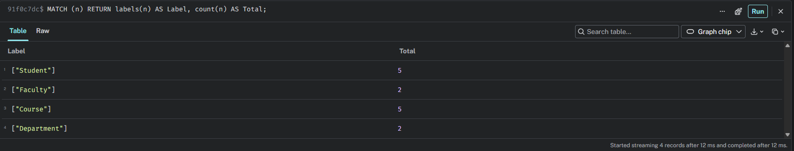
Output: Node counts by label
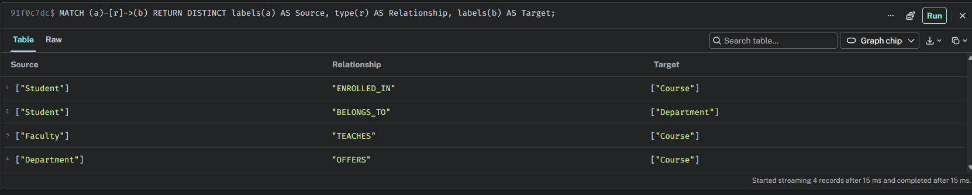
Output: Relationship types and directions
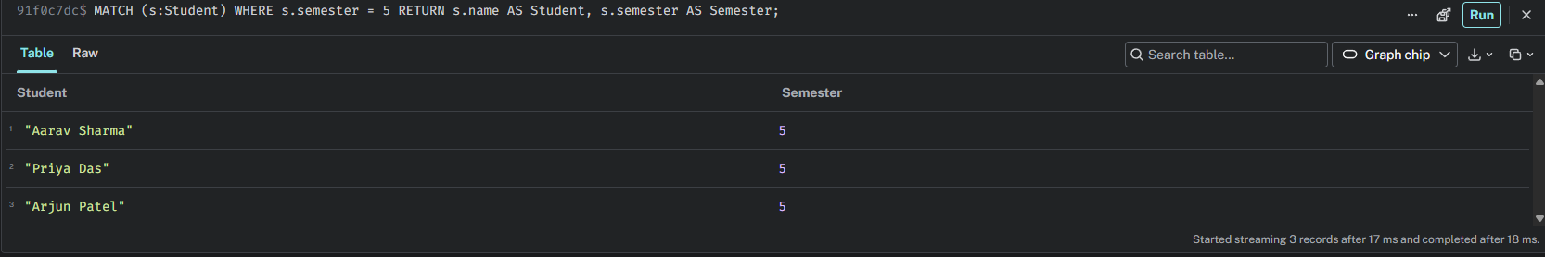
Output: Students in Semester 5
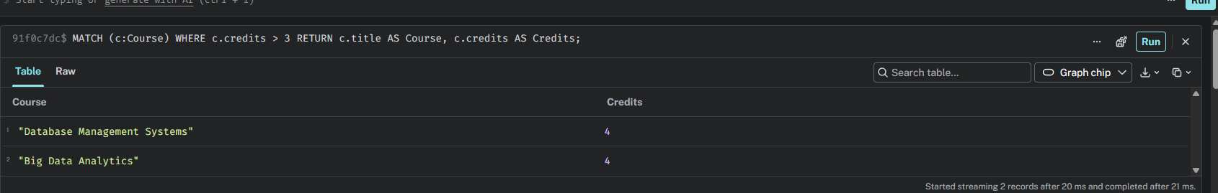
Output: Courses with more than 3 credits
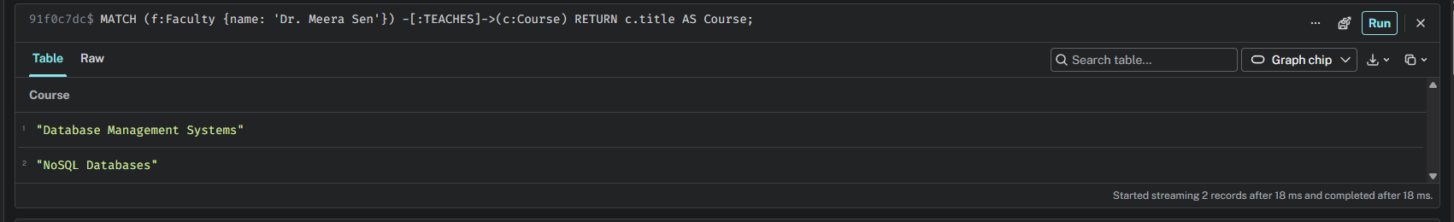
Output: Courses taught by Dr. Meera Sen
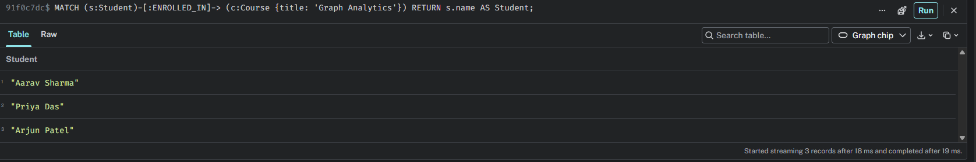
Output: Students enrolled in Graph Analytics
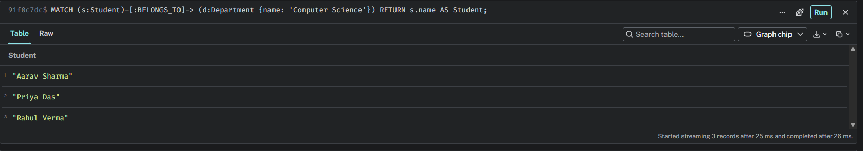
Output: Students in Computer Science
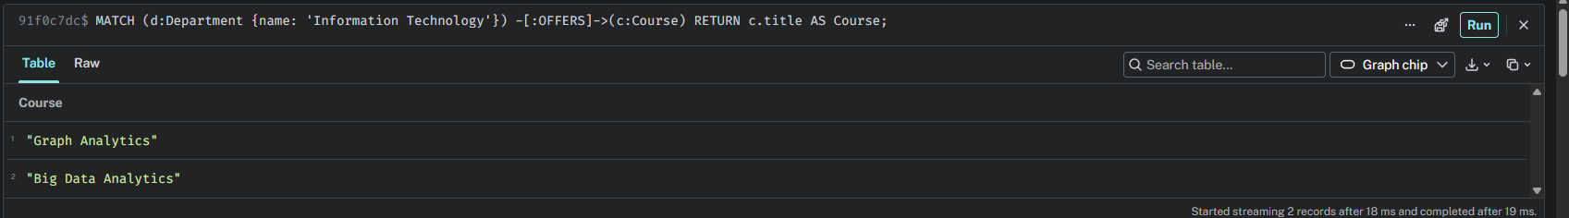
Output: Courses offered by Information Technology
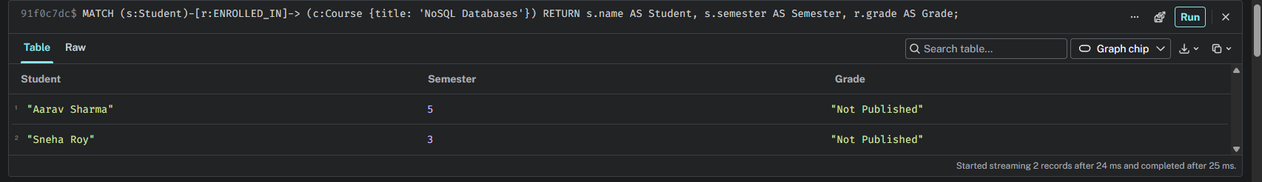
Output: Students enrolled in NoSQL Databases
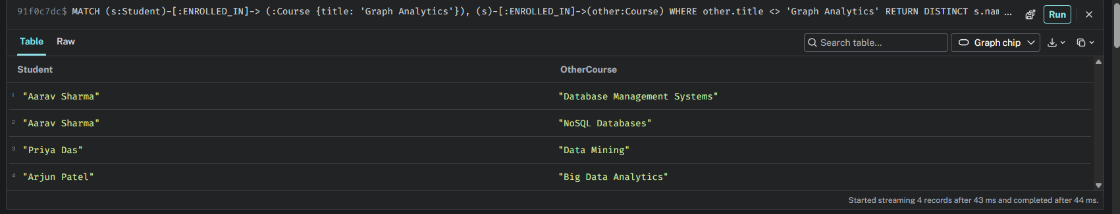
Output: Student-course enrolment records
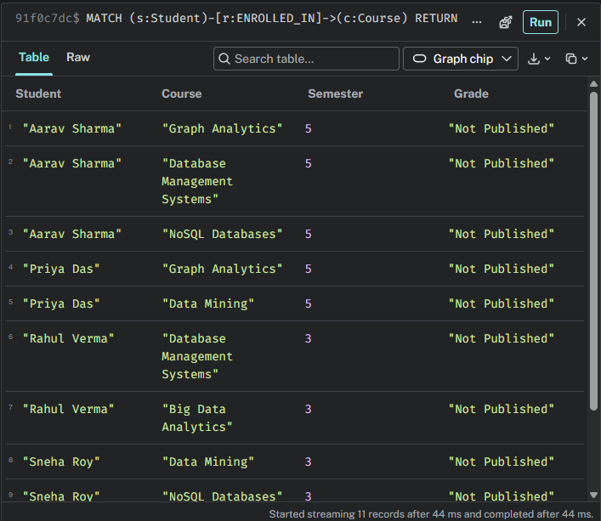
Output: Faculty teaching assignments
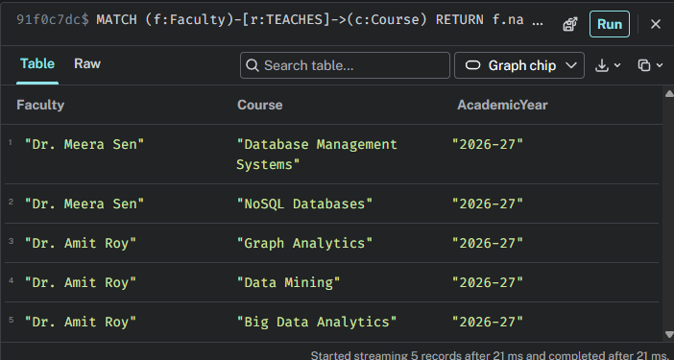
Output: Student department mapping
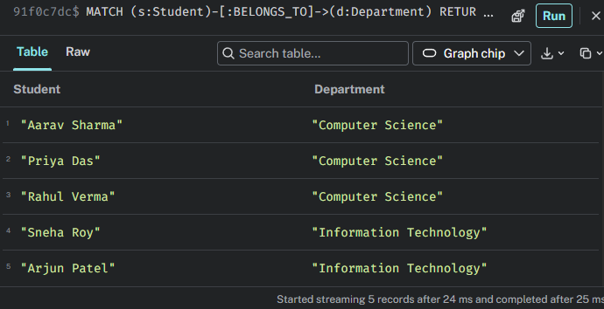
Output: Department course offerings
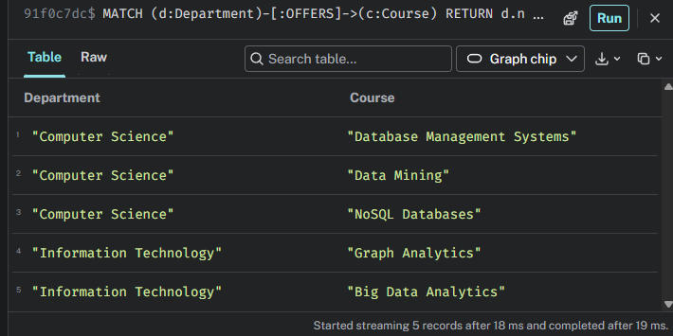
Output: Node count verification
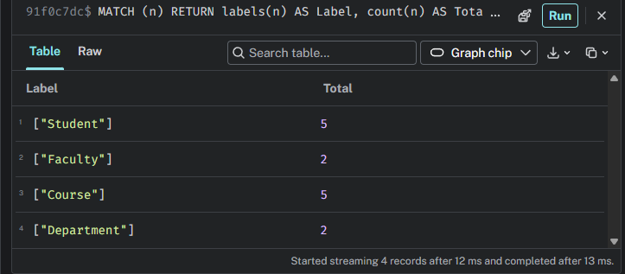
Output: Relationship graph view

Additional output: Student nodes

Additional output: Faculty nodes

Additional output: Course nodes

Additional output: Department nodes

H. Observation:
The graph contains 5 Student nodes, 2 Faculty nodes, 5 Course nodes, and 2 Department nodes. The relationships used are ENROLLED_IN, TEACHES, BELONGS_TO, and OFFERS. The queries successfully retrieve semester-wise students, courses with more than three credits, teaching assignments, student enrolments, department membership, and courses offered by departments.
Conclusion: Neo4j and Cypher provide a clear way to represent and query connected university information. The graph visualization helps inspect relationships between students, faculty, courses, and departments.

