# Luminosus (ETC Eos Edition) - MIDI to OSC Tool

Version 0.0.1.1.0.4  
May 25th, 2016

## Overview

Luminosus (ETC Eos Edition) is the project title for a “companion app” for consoles of the ETC Eos family. At the moment it can convert MIDI Note, Program and Control Change Messages to OSC commands. The goal is to eventually show useful information about Channel Attributes and Cue Lists and provide functions missing in the Eos software (i.e. a random fire effect).

It is designed for touch interaction and runs on Windows, Mac, Android and iOS.

## Software-Download

* The software can be downloaded for Windows and Mac from the following link:
  + TODO

## Installation

* Download and run the installer as mentioned above.
* If necessary, a previous installation will be removed, but the previous settings will be reused.

## User Interface

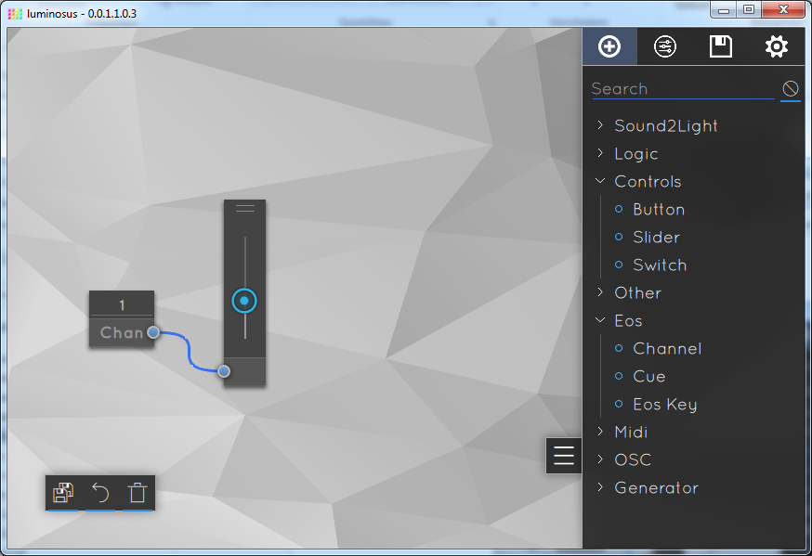

**Duplicate Block**

**Block**

**Drawer**

**Trash**

**Undo Delete**

**Open Drawer**

**Workspace**

## Blocks

Each “function” of the software is a *Block*. See *Block List* on how to add a block. The Blocks can be **moved** by clicking and dragging the light grey title area at the bottom of a Block. A Block can be **selected** with a single click on this light grey area (the shadow turns yellow). Only one Block can be selected at a time. To **delete** a block, select it and click on the trash symbol (or drag it into it). To configure a Block, select it and open the *Block Settings* (see below).

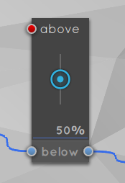

**Selected Node (red)**

**Output Node**

**Input Node**

Block Title

(Click and drag here to move Block)

## Nodes + Connections

Most of the blocks have at least one input or output *Node* (light blue circle). To **connect** two Nodes, click on one of them (it turns red) and then click on the other (a blue connecting line appears). To **disconnect** two Nodes, double-click on one of them. You can’t connect an input Node to another input Node or an output Node to another output Node.

The data “direction” is from right to left (on the right are the data “sources” and on the left the data “sinks”).

## Drawer

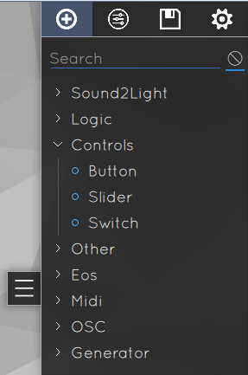

**1**

**2**

**3**

**4**

**5**

**6**

The drawer on the right can be opened by clicking on the button with the three horizontal lines (1).

It contains the Block List (2), the Block Settings (3), the Project List (4) and the Application Settings (5).

## Block List

The Block List in the first tab of the Drawer is a list of all available block types. A Block can be **added** by clicking on the name of it in the list (6), it will appear in the middle of the screen.

A Block can be directly connected and positioned next to an existing Block by first selecting a Node on that existing Block and then adding the new Block.

Not all Block types will be available on all platforms (for example because of missing MIDI support).

## Block Settings

The second tab of the Drawer contains the *Block Settings* and Block-specific help.

Some Blocks have settings that can be adjusted individual per Block instance. The settings of the currently selected Block will appear here.

Below that is a help text that contains some useful information about the selected Block.

## Project List

The third tab of the Drawer is the *Project List*.

A set-up of some connected Blocks can be saved as a Project. All Projects will appear in this list. To load a project simply click on it. To create a new Project, enter a name and then click on the plus-icon. A copy of the currently loaded Project can be saved by enter a new name and then click on copy-icon (right of the plus-icon). This can be useful to create backups of Projects. There is no save button, a Project will be saved whenever a different project is loaded and on a regular basis in the background.

The projects are JSON files and stored in the following directory:

Windows: *“C:/Users/<User>/AppData/Roaming/luminosus/projects”*

## Application Settings

The fourth tab of the Drawer contains the *Application Settings*. Those settings are global and not related to a specific project.

### OSC

In the OSC settings the target IP-address, the protocol and the ports to use can be specified.

### MIDI

The MIDI settings include the default input and output port. These can be overridden in the *Block Settings*.

MIDI message are always sent to all connected MIDI interfaces and the software listens on all MIDI interfaces for incoming messages at the same time.

### Debugging

The Settings under “Debugging” are only for developing purposes.

## Keyboard Shortcuts

|  |  |
| --- | --- |
| **Shortcut** | **Function** |
| Ctrl + C | Copy a Block to the internal Clipboard |
| Ctrl + V | Paste a Block from the internal Clipboard |
| Ctrl + Z | Undo the deletion of a Block |
| Ctrl + D | Duplicate the selected Block |
| Delete | Delete the selected Block |

## Example Use Case: Use Midi Notes to Control Eos Functions

An example use case would be to use Midi Notes, i.e. from a MIDI keyboard or controller, to trigger Eos functions, i.e. fire a cue.

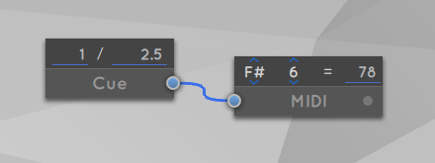To accomplish that, first add a *Midi Note In Block* from the *Block List*. Then add the desired Eos function, for example an *Eos Cue Block*. Click on the output Node (the blue circle on the left) of the Midi Note In Block and then click on the input Node of the Eos Cue Block. They should now be connected by a blue line. Change the Midi Note tone and octave by clicking on them and selecting a different value. Also adjust the Cue List Number and Cue Number in the Eos Cue Block. You can also adjust the Midi input channel in the application settings to match that of the Midi keyboard / controller.

Now if a Note On message with a velocity above 50% is received, the Cue will be fired.

## Known Bugs + Missing Features

At the moment this software is to be seen as a technology preview / proof of concept. Many features are missing and bugs are to be expected.

* Features to be added as part of the Bachelor Thesis:
  + More Eos specific Blocks (Subs, Playbacks etc.)
  + Showing information retrieved from the console (channel attributes, cue lists)
* Additional features that might be added:
  + More complete Sound2Light functionality
  + Table to directly map MIDI to OSC commands
  + Effects (for example random Fire effect)