Validate ListBox and DropDown List using Required Field Validator

*Posted By : Shailendra Chauhan, 17 Jun 2012*

*Updated On : 24 Jun 2014*

*Total Views : 9,162*

*Keywords : list box combo box dropdown list validation using required field,required field to validate list box combo box dropdown list, show message select a value in list box dropdown pdf*

In Asp.net, sometimes we need to validate ListBox and DropDown List using Required field validator. It is tricky and avoids the use of JavaScript function to validate ListBox and DropDown List. Here I am sharing the code.

Use **InitialValue = 0 for Dropdownlist**

Validate DropDown List and ListBox

1. **<form id="form1" runat="server">**
2. **<div>**
3. **<asp:ListBox ID="lstboxCity" runat="server" Width="200px" SelectionMode="Multiple">**
4. **<asp:ListItem Value="1">Delhi</asp:ListItem>**
5. **<asp:ListItem Value="2">Noida</asp:ListItem>**
6. **<asp:ListItem Value="3">Gurgaon</asp:ListItem>**
7. **<asp:ListItem Value="4">Mumbai</asp:ListItem>**
8. **<asp:ListItem Value="5">Pune</asp:ListItem>**
9. **<asp:ListItem Value="6">Banglore</asp:ListItem>**
10. **<asp:ListItem Value="7">Lucknow</asp:ListItem>**
11. **</asp:ListBox> <asp:RequiredFieldValidator ID="RequiredFieldValidator1" ControlToValidate="lstboxCity" InitialValue="" runat="server" ErrorMessage="Please select atleast one city"></asp:RequiredFieldValidator>**
12. **</div>**
13. **<br />**
14. **<div>**
15. **<asp:DropDownList ID="ddlCity" runat="server" Width="200px">**
16. **<asp:ListItem Value="0">--Select--</asp:ListItem>**
17. **<asp:ListItem Value="1">Delhi</asp:ListItem>**
18. **<asp:ListItem Value="2">Noida</asp:ListItem>**
19. **<asp:ListItem Value="3">Gurgaon</asp:ListItem>**
20. **<asp:ListItem Value="4">Mumbai</asp:ListItem>**
21. **<asp:ListItem Value="5">Pune</asp:ListItem>**
22. **<asp:ListItem Value="6">Banglore</asp:ListItem>**
23. **<asp:ListItem Value="7">Lucknow</asp:ListItem>**
24. **</asp:DropDownList>**
25. **<asp:RequiredFieldValidator ID="RequiredFieldValidator2" ControlToValidate="ddlCity" InitialValue="0" runat="server" ErrorMessage="Please select city"></asp:RequiredFieldValidator>**
26. **</div>**
27. **<br />**
28. **<asp:Button ID="btnSubmit" runat="server" Text="Submit" />**
29. **</form>**

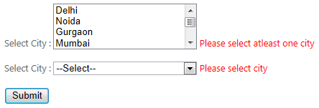 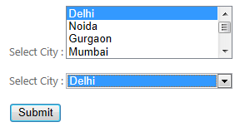

ASP.NET ValidationGroup Property

The ValidationGroup property specifies which group of controls is validated on validation.

This property is mostly used when there are several buttons in a form.

Syntax

<asp:ImageButton ValidationGroup="*group*" runat="server"*/>*

|  |  |
| --- | --- |
| **Attribute** | **Description** |
| group | The validation group to validate. |

Example

The following example validates the specific validation group:

<asp:textbox id="tb1" runat=Server />  
<asp:requiredfieldvalidator id="ReqField1" controltovalidate="tb1"  
validationgroup="valGroup1" errormessage="Required" runat=Server />  
  
<asp:ImageButton id="Button2" causesvalidation=true  
validationgroup="valGroup2" ImageUrl="img.gif" runat=Server />

ValidationGroup 1

Name:    
Age:    
  


ValidationGroup 2

City    
  
