SIMATS ENGINEERING (SAVEETHA SCHOOL OF ENGINEERING)
Department of Artificial Intelligence and Data Science
ASSESSMENT TOOL 3 – CODING CHALLENGE
Course Code: DSA03 Course Title: Natural Language Processing
CO Assessed: CO1 – Imitation (L1) Assessment: Assessment Tool 3 – Coding Challenge
Weightage: 30% of CIA
CO5 Statement: Analyse NLP models, regular expression patterns, finite state automata, morphological processing techniques and to interpret language processing. (BL-3)
Student Name: Prajiith K Reg. No.: 192324013
Section / Batch: C Date: 16/10/2026
Code of Conduct
I Prajiith K 192324013 certify that this submission is my original work and that I have adhered to the guidelines specified for this assessment. I understand that any violation of academic integrity rules will result in disciplinary action.
Signature of the Student: 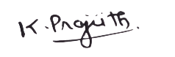
Instructions
- Develop a complete and modular Python program that meets all the functional requirements specified in the coding challenge using appropriate algorithms, data structures, and programming practices.
- Test the program using multiple valid and invalid test cases, and clearly display the input, processing, and output to verify the correctness of the implementation.
- Follow standard coding practices by using meaningful variable names, proper indentation, comments, exception handling (where applicable), and upload the source code, sample outputs, and README file to the designated GitHub repository.
- Duration: 40 minutes.

Section / Topic | Focus | Q Nos
Regular Expression Pattern Matching | Regular Expressions, Basic Regular Expression Patterns | 1
Finite State Automata Implementation | Finite State Automata, Models and Algorithms | 2
Advanced Regular Expression Search | Regular Expressions, Basic Regular Expression Patterns | 3

Annexure A – Coding Challenge
Section 1: Intelligent Email and Password Validator using Regular Expressions
1. Problem Statement:
A software company is developing a user registration system. Before creating an account, the system must validate user credentials based on predefined security policies.
Develop a Python application that validates:
Email Address
Password
Mobile Number
using Regular Expressions.
Validation Rules
Email
Must start with an alphabet.
May contain letters, digits, '.', '_' before '@'.
Domain should contain only alphabets.
Valid extensions: .com, .org, .edu, .net, .in
Password
Minimum 8 characters
At least one uppercase letter
At least one lowercase letter
At least one digit
At least one special character (@,#,$,%,&,!)
Mobile Number
Must contain exactly 10 digits.
First digit should be between 6–9.
Expected Output
Display:
Valid Email / Invalid Email
Strong Password / Weak Password
Valid Mobile Number / Invalid Mobile Number

Answer 1
"""
Section 1: Intelligent Email and Password Validator using Regular Expressions
Validates Email, Password and Mobile Number according to the given policies.
"""
import re
import sys

# ---------------------------------------------------------------- patterns
# Email: starts with an alphabet, letters/digits/'.'/'_' before '@',
# domain contains only alphabets, extension in (com, org, edu, net, in)
EMAIL_PATTERN = re.compile(r"^[A-Za-z][A-Za-z0-9._]*@[A-Za-z]+\.(com|org|edu|net|in)$")

# Password: min 8 chars, upper, lower, digit and special character (@#$%&!)
PASSWORD_PATTERN = re.compile(r"^(?=.*[A-Z])(?=.*[a-z])(?=.*\d)(?=.*[@#$%&!]).{8,}$")

# Mobile: exactly 10 digits, first digit between 6 and 9
MOBILE_PATTERN = re.compile(r"^[6-9]\d{9}$")

# --------------------------------------------------------------- validators
def validate_email(email: str) -> str:
return "Valid Email" if EMAIL_PATTERN.match(email) else "Invalid Email"

def validate_password(password: str) -> str:
return "Strong Password" if PASSWORD_PATTERN.match(password) else "Weak Password"

def validate_mobile(mobile: str) -> str:
return "Valid Mobile Number" if MOBILE_PATTERN.match(mobile) else "Invalid Mobile Number"

def run_test_cases() -> None:
"""Display input, processing (pattern used) and output for test cases."""
tests = [
("Email", validate_email, [
"john.doe@gmail.com", "alice_99@university.edu", "student@saveetha.in",
"1john@gmail.com", "john@gmail123.com", "john@gmail.xyz", "john@@gmail.com"]),
("Password", validate_password, [
"Secure@123", "Pass#word9", "password", "PASSWORD@1", "Pass@12", "NoSpecial123"]),
("Mobile", validate_mobile, [
"9876543210", "6123456789", "5876543210", "98765432", "98765432101", "98765abcde"]),
]
for name, func, cases in tests:
print(f"--- {name} Validation Test Cases ---")
for value in cases:
print(f"Input: {value:<26} -> {func(value)}")
print()

def read_input(prompt: str) -> str:
"""Read a line; echo it when input is piped so the run is self-explanatory."""
try:
value = input(prompt)
except EOFError:
value = ""
if not sys.stdin.isatty():
print(value)
return value.strip()

def main() -> None:
print("=" * 56)
print(" USER REGISTRATION - CREDENTIAL VALIDATOR")
print("=" * 56)
print()
run_test_cases()
print("--- Enter your own credentials ---")
email = read_input("Enter Email : ")
password = read_input("Enter Password : ")
mobile = read_input("Enter Mobile Number : ")
print()
print("Result")
print("Email :", validate_email(email))
print("Password :", validate_password(password))
print("Mobile :", validate_mobile(mobile))

if __name__ == "__main__":
main()
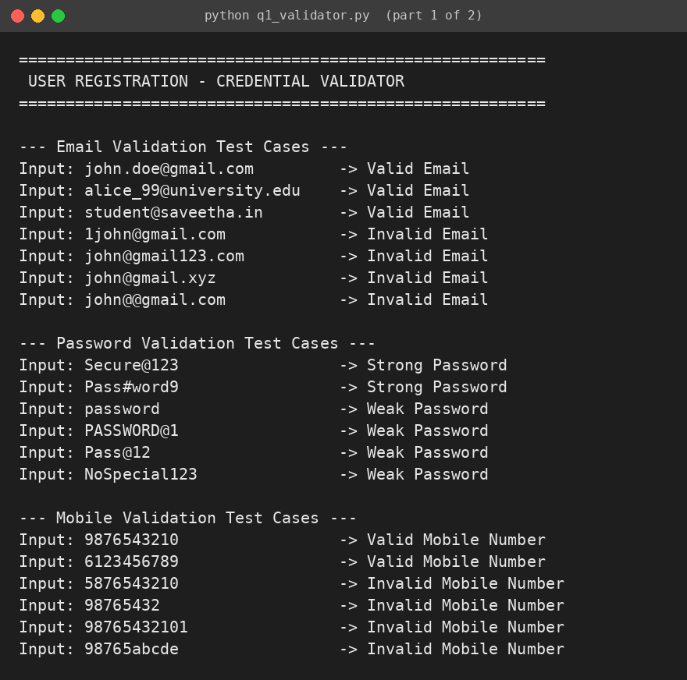
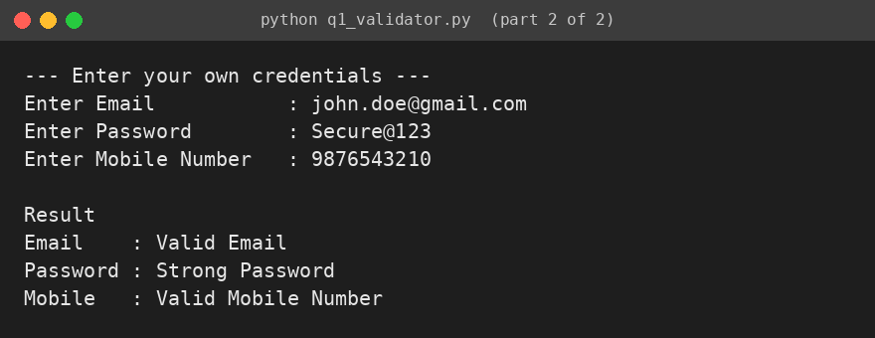

Section 2: Design a Finite State Automata (FSA) Simulator
2. Problem Statement
Develop a Python-based Deterministic Finite Automata (DFA) simulator.
The program should:
Accept the DFA description
States
Input alphabet
Transition table
Initial state
Final state(s)
Accept multiple input strings.
Simulate state transitions.
Display whether the string is Accepted or Rejected.
Example
Language:
Strings ending with "ab"
Input
abaab
Output
Transition Path:
q0 → q1 → q0 → q1 → q2
Accepted

Answer 2
"""
Section 2: Deterministic Finite Automata (DFA) Simulator
Accepts a DFA description (states, alphabet, transition table, initial state,
final states) and simulates any number of input strings.
"""
import sys

class DFA:
def __init__(self, states, alphabet, transitions, start, finals):
self.states = states
self.alphabet = alphabet
self.transitions = transitions # {(state, symbol): next_state}
self.start = start
self.finals = finals

def simulate(self, text: str):
"""Return (path, accepted, message)."""
state = self.start
path = [state]
for symbol in text:
if symbol not in self.alphabet:
return path, False, f"Symbol '{symbol}' is not in the input alphabet"
if (state, symbol) not in self.transitions:
return path, False, f"No transition from {state} on '{symbol}'"
state = self.transitions[(state, symbol)]
path.append(state)
return path, state in self.finals, ""

def read_input(prompt: str) -> str:
try:
value = input(prompt)
except EOFError:
value = "exit"
if not sys.stdin.isatty():
print(value)
return value.strip()

def read_dfa() -> DFA:
"""Read the DFA description from the user with validation."""
states = [s.strip() for s in read_input("Enter states (comma separated) : ").split(",") if s.strip()]
alphabet = [a.strip() for a in read_input("Enter input alphabet (comma separated): ").split(",") if a.strip()]
print("Enter transitions as 'state symbol next_state' (blank line to finish):")
transitions = {}
while True:
line = read_input(" > ")
if not line:
break
parts = line.split()
if len(parts) != 3:
print(" Invalid format, use: state symbol next_state")
continue
src, sym, dst = parts
if src not in states or dst not in states or sym not in alphabet:
print(" Unknown state or symbol, transition ignored")
continue
transitions[(src, sym)] = dst
start = read_input("Enter initial state : ")
finals = [f.strip() for f in read_input("Enter final state(s) (comma separated) : ").split(",") if f.strip()]
if start not in states or not set(finals) <= set(states):
raise ValueError("Initial/final state is not in the set of states")
return DFA(states, alphabet, transitions, start, finals)

def print_table(dfa: DFA) -> None:
print("\nTransition Table")
header = "State".ljust(8) + "".join(sym.ljust(8) for sym in dfa.alphabet)
print(header)
print("-" * len(header))
for s in dfa.states:
mark = ("->" if s == dfa.start else " ") + ("*" if s in dfa.finals else " ")
row = (mark + s).ljust(8) + "".join(dfa.transitions.get((s, a), "-").ljust(8) for a in dfa.alphabet)
print(row)
print("(-> initial state, * final state)\n")

def main() -> None:
print("=" * 56)
print(" DFA SIMULATOR (Language: strings ending with 'ab')")
print("=" * 56)
try:
dfa = read_dfa()
except ValueError as err:
print("Error:", err)
return
print_table(dfa)
print("Enter input strings to test (type 'exit' to stop)")
while True:
text = read_input("\nInput String : ")
if text.lower() == "exit":
break
path, accepted, message = dfa.simulate(text)
print("Transition Path:", " \u2192 ".join(path))
if message:
print("Note:", message)
print("Accepted" if accepted else "Rejected")

if __name__ == "__main__":
main()
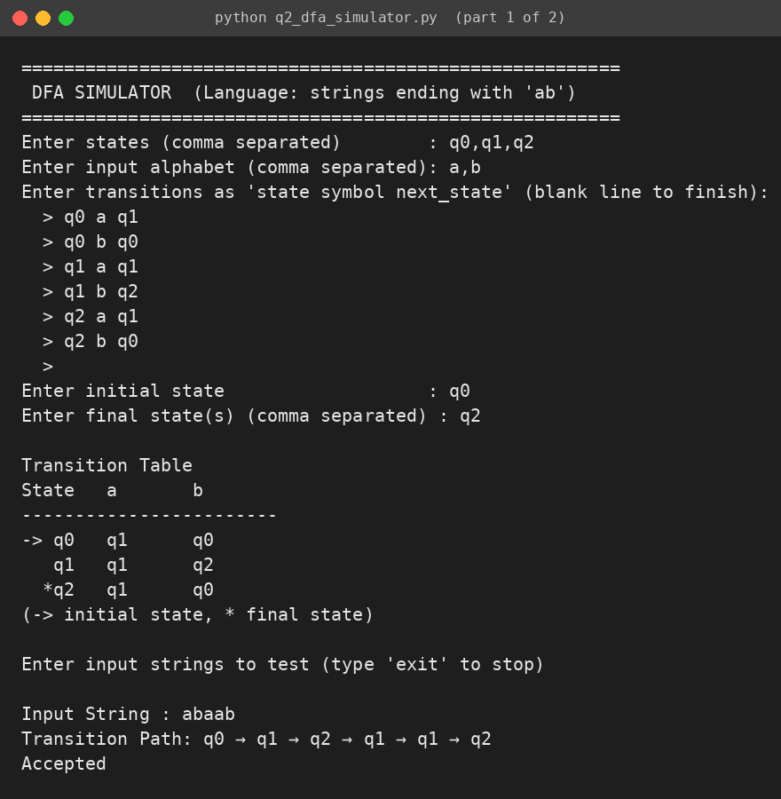
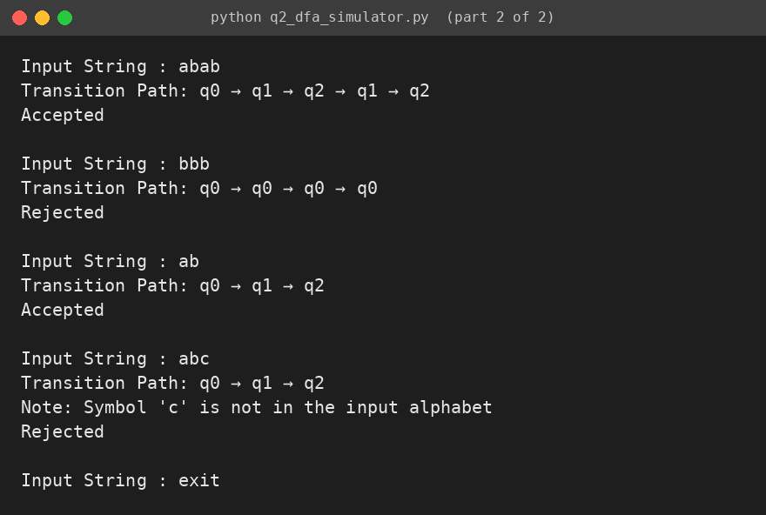

Section 3: Smart Pattern Matching Engine using Regular Expressions
3. Problem Statement
Develop a Python-based text search engine that performs pattern matching using Regular Expressions.
The system should support:
Word Search
Prefix Search
Suffix Search
Date Search
Phone Number Search
Hashtag Search
Mention (@username) Search
Example Input
Meeting on 12/09/2026
Call 9876543210
#NLP
@OpenAI
natural language processing
User Menu
1.Search Date
2.Search Phone Number
3.Search Hashtag
4.Search Mention
5.Search Prefix
6.Search Suffix
Expected Output
Display all matching patterns based on user selection.

Answer 3
"""
Section 3: Smart Pattern Matching Engine using Regular Expressions
Supports Word, Prefix, Suffix, Date, Phone Number, Hashtag and Mention search.
"""
import re
import sys

SAMPLE_TEXT = """Meeting on 12/09/2026
Call 9876543210
#NLP
@OpenAI
natural language processing"""

DATE_PATTERN = r"\b\d{1,2}/\d{1,2}/\d{4}\b"
PHONE_PATTERN = r"\b[6-9]\d{9}\b"
HASHTAG_PATTERN = r"#\w+"
MENTION_PATTERN = r"@\w+"

def search_pattern(pattern: str, text: str):
return re.findall(pattern, text, flags=re.IGNORECASE)

def search_word(word: str, text: str):
return re.findall(rf"\b{re.escape(word)}\b", text, flags=re.IGNORECASE)

def search_prefix(prefix: str, text: str):
return re.findall(rf"\b{re.escape(prefix)}\w*", text, flags=re.IGNORECASE)

def search_suffix(suffix: str, text: str):
return re.findall(rf"\b\w*{re.escape(suffix)}\b", text, flags=re.IGNORECASE)

def read_input(prompt: str) -> str:
try:
value = input(prompt)
except EOFError:
value = "0"
if not sys.stdin.isatty():
print(value)
return value.strip()

def show(title: str, matches) -> None:
if matches:
print(f"{title} found ({len(matches)}):")
for item in matches:
print(" ", item)
else:
print(f"No {title.lower()} found")

def menu() -> None:
print("\nUser Menu")
print("1.Search Date")
print("2.Search Phone Number")
print("3.Search Hashtag")
print("4.Search Mention")
print("5.Search Prefix")
print("6.Search Suffix")
print("7.Search Word")
print("0.Exit")

def main() -> None:
print("=" * 56)
print(" SMART PATTERN MATCHING ENGINE")
print("=" * 56)
print("Input Text:")
print(SAMPLE_TEXT)
text = SAMPLE_TEXT
while True:
menu()
choice = read_input("Enter your choice: ")
if choice == "1":
show("Date", search_pattern(DATE_PATTERN, text))
elif choice == "2":
show("Phone Number", search_pattern(PHONE_PATTERN, text))
elif choice == "3":
show("Hashtag", search_pattern(HASHTAG_PATTERN, text))
elif choice == "4":
show("Mention", search_pattern(MENTION_PATTERN, text))
elif choice == "5":
prefix = read_input("Enter prefix: ")
show("Prefix match", search_prefix(prefix, text)) if prefix else print("Prefix cannot be empty")
elif choice == "6":
suffix = read_input("Enter suffix: ")
show("Suffix match", search_suffix(suffix, text)) if suffix else print("Suffix cannot be empty")
elif choice == "7":
word = read_input("Enter word: ")
show("Word match", search_word(word, text)) if word else print("Word cannot be empty")
elif choice == "0":
print("Exiting...")
break
else:
print("Invalid choice, please select 0-7")

if __name__ == "__main__":
main()
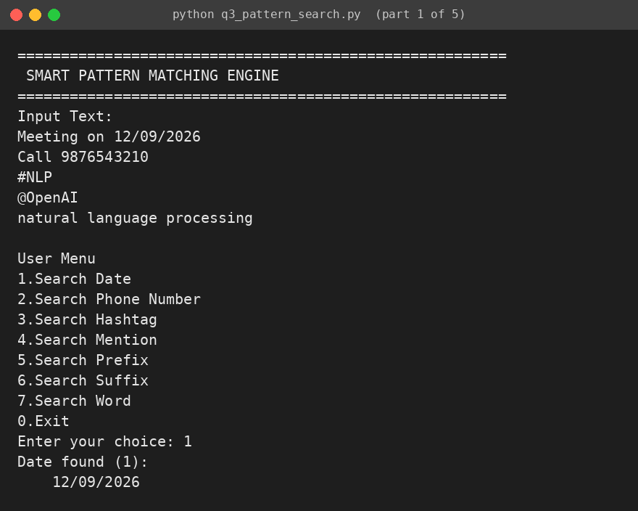
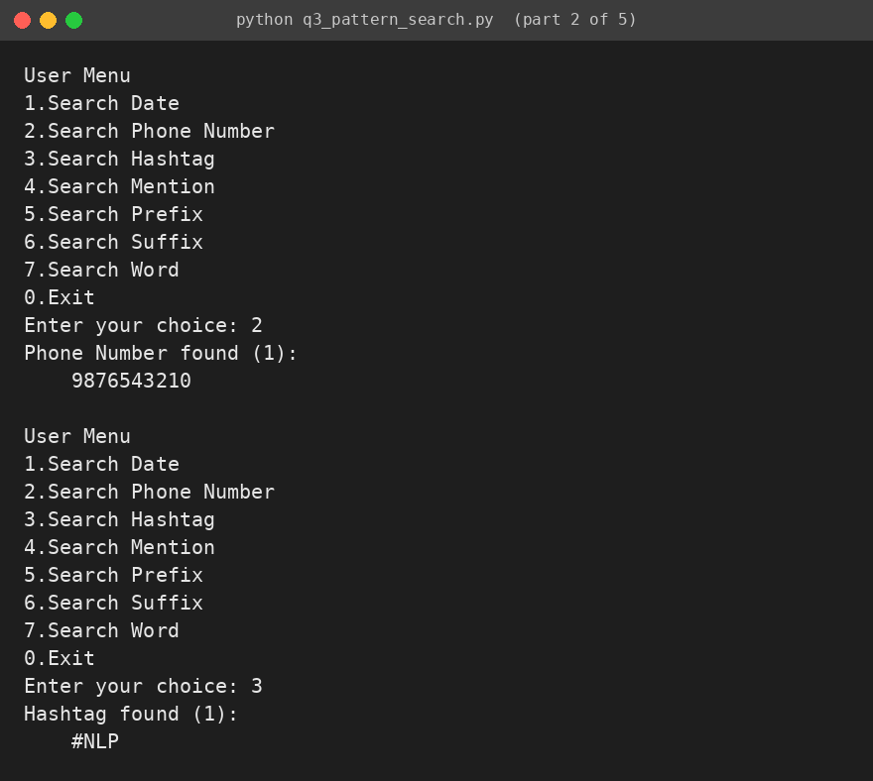
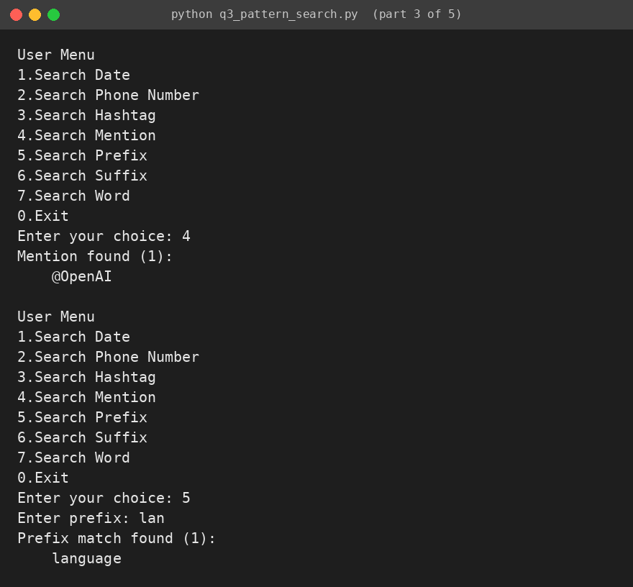
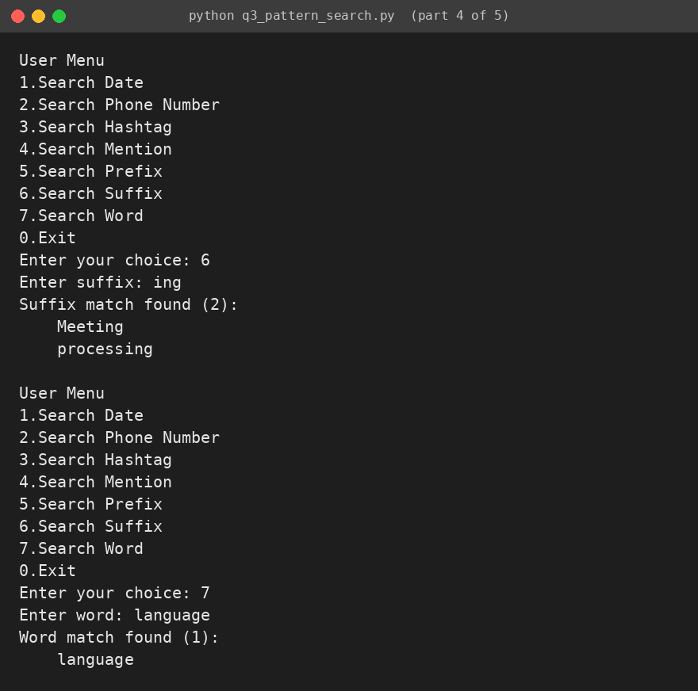
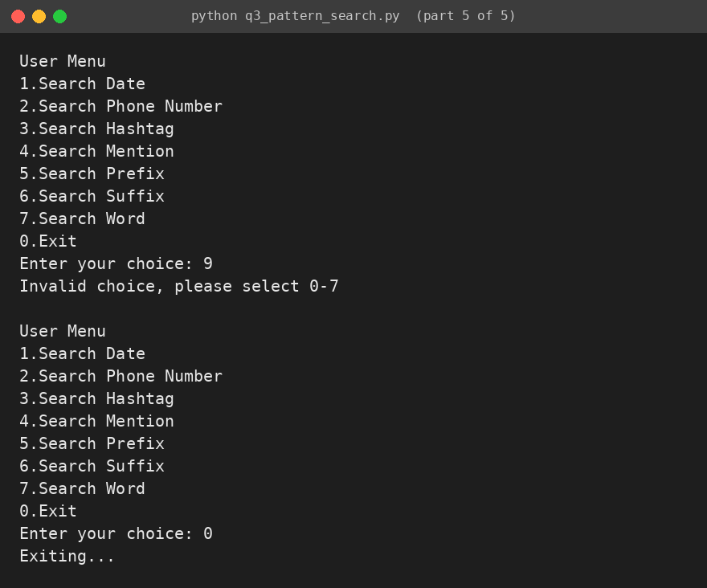

Rubrics for Calculation
Criteria | Weightage | Level 4 – Exemplary | Level 3 – Proficient | Level 2 – Developing | Level 1 – Beginning
Problem Understanding | 20% | Clearly understands problem constraints, edge cases, and competitive requirements | Understands problem with minor gaps in constraints | Partial understanding; misses key constraints | Misinterprets problem or constraints
Algorithm | 25% | Selects optimal algorithm with best time and space complexity for competitive constraints | Uses efficient algorithm with minor scope for improvement | Uses basic/inefficient approach | No clear algorithmic approach
Code Implementation | 20% | Writes correct, efficient, and clean code that passes all constraints | Code works with minor errors or inefficiencies | Partially correct code; fails for some cases | Code does not execute or gives incorrect results
Competitive Performance | 20% | Solves problem within time limits and handles large inputs effectively | Solves within acceptable time with minor delays | Struggles with time limits or larger inputs | Unable to solve within time constraints
Test Case Handling | 15% | Handles all test cases including edge and hidden cases | Handles most test cases | Misses important edge cases | Fails on multiple test cases

Q. No. / Criteria | Problem Understanding | Algorithm | Code Implementation | Competitive Performance | Test Case Handling | Sub. Total | Total %
1
2
3

Faculty In-charge  Signature: _______________  Date: ___________________ | Course Coordinator  Signature: _______________  Date: ___________________ | Program Director  Signature: _______________  Date: ___________________

