42028: Deep Learning and Convolutional Neural Network
Dataset details, GUI design, Implementation Plan

Project Title and number (Refer to Dashboard): Car parking detection availability system (No. 54)
Team Name: Parkivo
Team Members:
Student Name | Student ID | Email ID
Tien Dung Truong | 14519654 | Tien.D.Truong@student.uts.edu.au
Elijah Luu | 25473822 | Elijah.S.Luu@student.uts.edu.au
Tuan Hoang | 25505924 | Tuanhung.hoang@student.uts.edu.au

Dataset Details:
The dataset used in this project is the PKLot dataset, a publicly available dataset for detecting parking space occupancy. The dataset contains approximately 12,000 images of parking spaces collected from three different parking areas under varying weather and lighting conditions, such as sunny, cloudy, and rainy environments. This project will use the dataset for an image classification task. Each image represents a parking space and is labelled as "occupied" or "empty". Therefore, this is a binary classification problem.
The dataset will be split into training, validation, and test sets using a split ratio of 70%, 15%, and 15%. The training set will be used to train the models, the validation set will be used to fine-tune the model parameters, and the test set will be used to evaluate the model's final performance. This dataset is suitable for the project because it is a publicly available dataset, has enough images to train a CNN model, and represents real-world parking conditions.
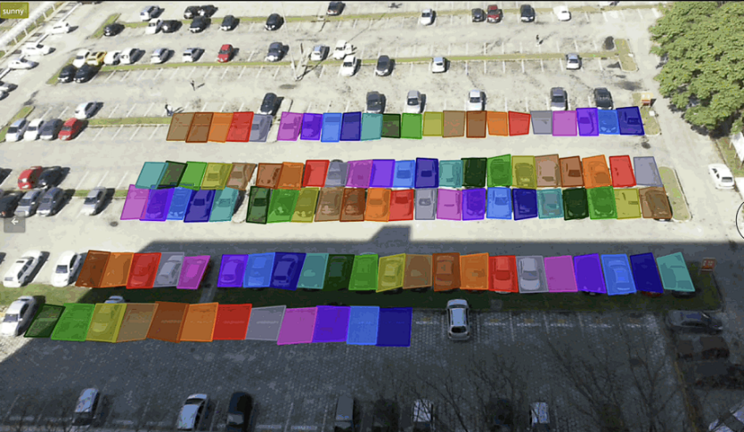
Figure 1:Preview of Dataset
Dataset link: https://huggingface.co/datasets/Voxel51/PKLot
GUI Design:
The planned GUI for this system is a display-based interface located at the entrance of the car park, supported by a simple web-based dashboard for system monitoring.
The main interface will be a large digital screen that shows parking recommendations to drivers as they enter. The screen will display clear and simple information such as the recommended parking location (e.g., “Row C, Spot 15”). Available parking spots will be highlighted in green, while occupied spots will be shown in red, making it easy for drivers to understand at a glance.
The design will be minimal and easy to read, using large text and simple colours to ensure visibility from a distance. The interface will automatically update in real time as cars enter and leave the car park.
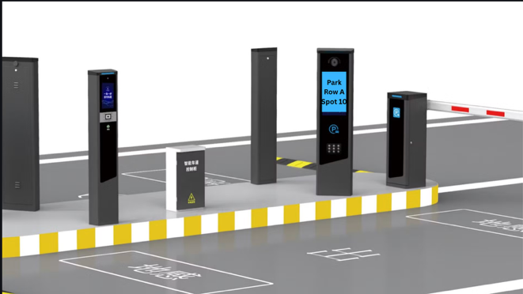
Figure 2: A online model of what the overall GUI design will look like

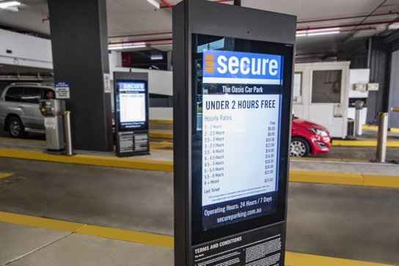
Figure 3: Real Life Example/Inspiration For GUI Design

Implementation plan:
This project will focus on building and evaluating an image classification system based on a convolutional neural network (CNN) to determine whether a parking space is occupied or empty. Our primary deep learning approach will be a custom CNN model trained from scratch on the PKLot dataset, ensuring that model development is always aligned with the learning objectives of this project.
For meaningful comparison, we also plan to implement traditional machine learning methods using HOG + SVM and LBP + SVM. This will allow us to compare manual feature generation methods with CNN-based feature learning and determine which method performs better for this task.
For training, the PKLot dataset will be pre-processed by resizing images to a consistent input size, normalizing pixel values, and splitting the data into training, validation, and test sets. The CNN model will be trained using the Adam optimizer and the binary cross-entropy loss function, as this is a binary classification problem.
The testing phase will evaluate the model's performance on untested test images using accuracy, precision, sensitivity, and F1 score. We expect the final CNN model to outperform traditional base models under normal parking conditions.
To minimize overfitting, we will use dropout, data enhancement, and early stopping. If underfitting occurs, we will improve the model by adjusting the number of layers, training epochs, or other hyperparameters. The proposed timeline is as follows: preprocessing the dataset and establishing the base model, followed by developing and training the CNN model, and then evaluating, comparing, and integrating the final graphical user interface (GUI).
The tentative timeline for the project is as follows:
- Before 24 April: Research, planning, and dataset preparation
- Checkpoint Part - C (24 April): Initial progress review and dataset readiness
- 24 April – 8 May: Model development and initial training
- Checkpoint Part - D (8 May): Demonstration of working model prototype
- 8 May – 25 May: Testing, evaluation, and system integration
- Checkpoint Part - E | Final Submission (25 May): Final system, improvements, and documentation submission

