**Exp.5 Experiment Tracking with MLflow**

**Objective:**

Set up and use MLflow to track machine learning experiments, compare model performances,

and manage experiment metadata.

**Results:**

Linear Regression:

Mean Squared Error: 0.7831576459188525

R-squared: 0.39911322580261044

MLflow Screenshots:

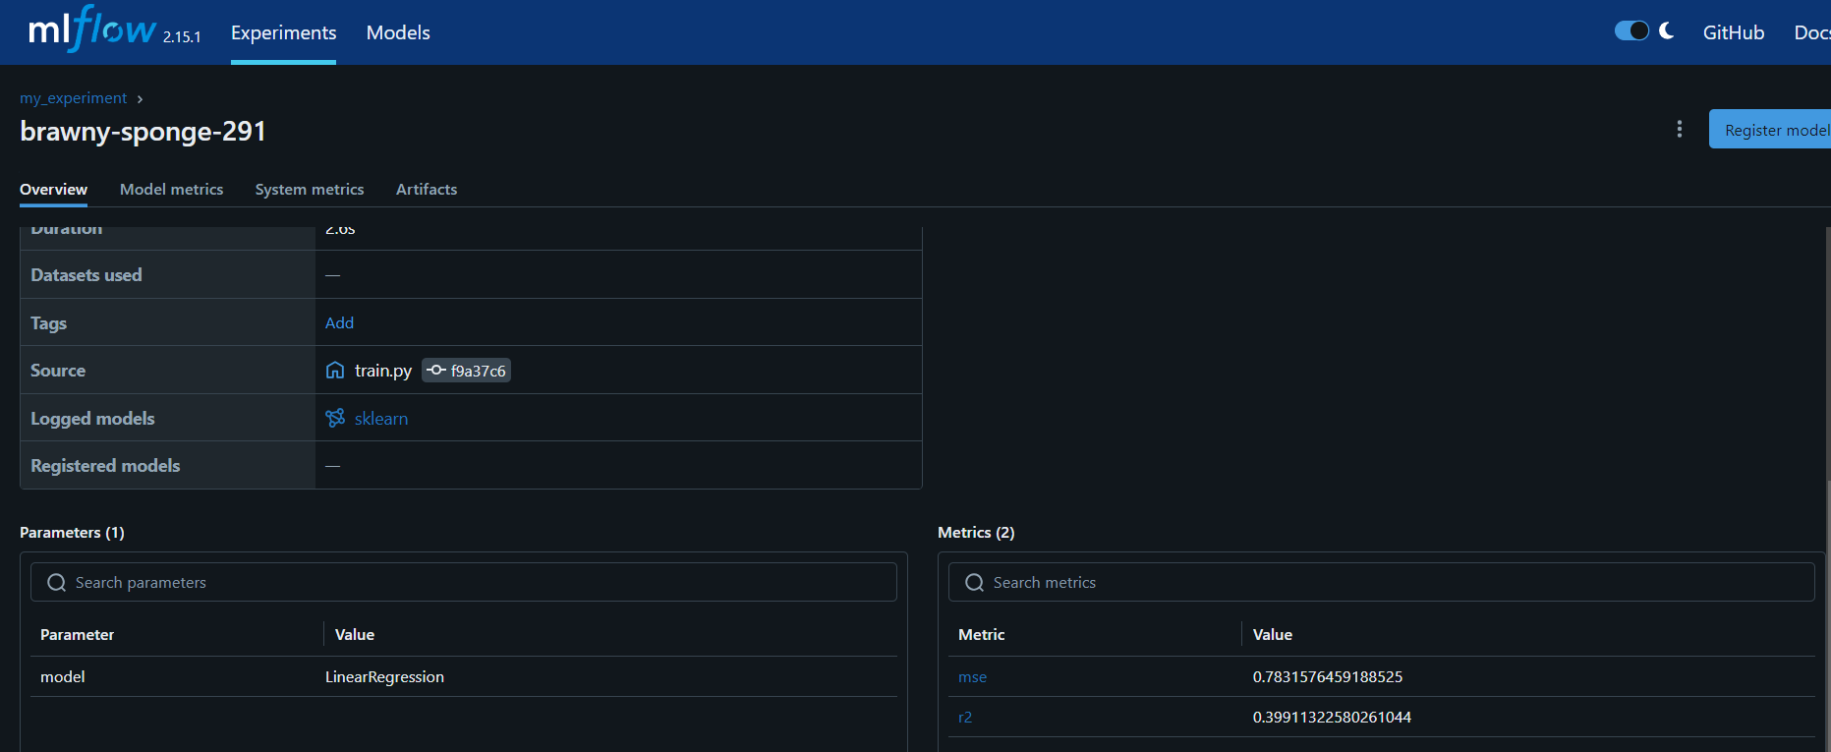

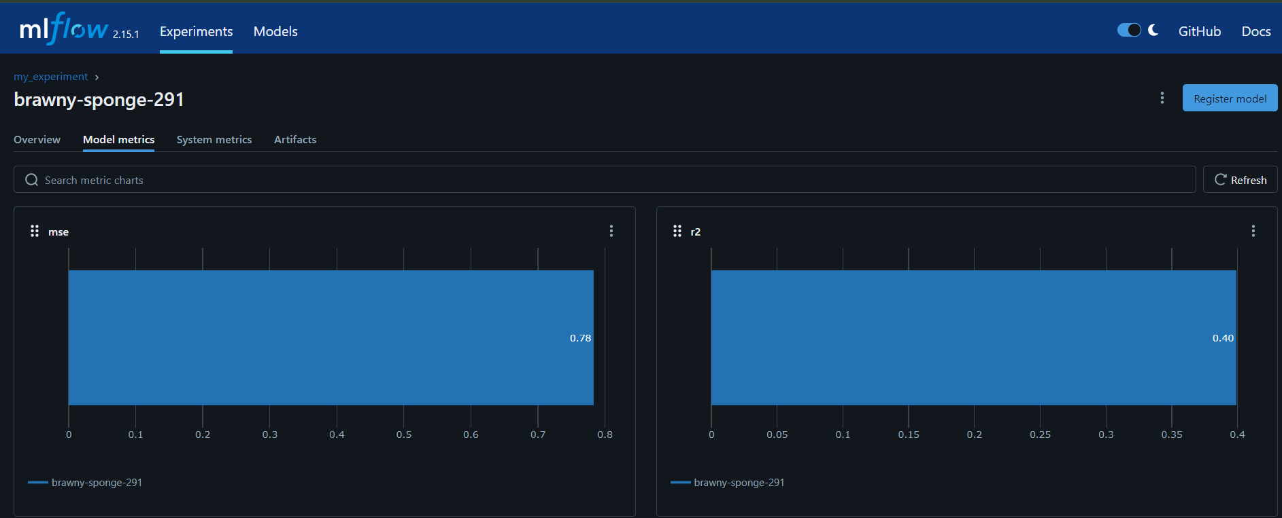

Random Forest Regressor:

Mean Squared Error: 0.7702153139615049

R-squared: 0.4090433798922357

MLflow Screenshots:

