So here is the simple userform

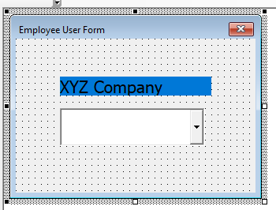

So as company name label I used XYZ Company in design time. So all the instance will have that if I don’t change them. Now Here is the code for the Create Function

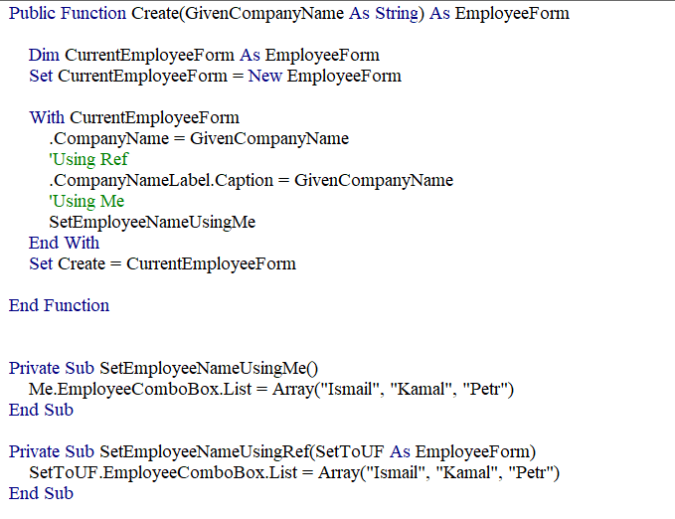

Look Carefully in the comments. So I am changing the caption for company using Ref(CurrentEmployeeForm) but in case of Employee Name list I am using Me keyword.

So As Userform PredeclaredId is set to true that’s why we have one global object and another is that new up (CurrentEmployeeForm). So Basically Me is referencing that Global object till the Create function is in the call stack.

Here is the driver code:

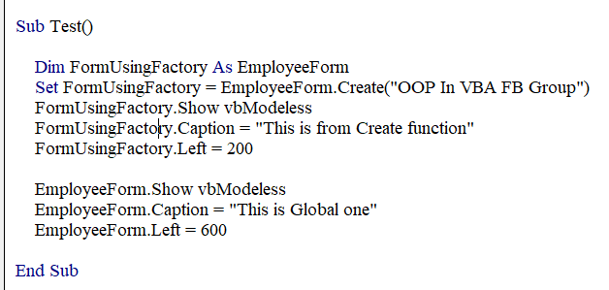

And the output:

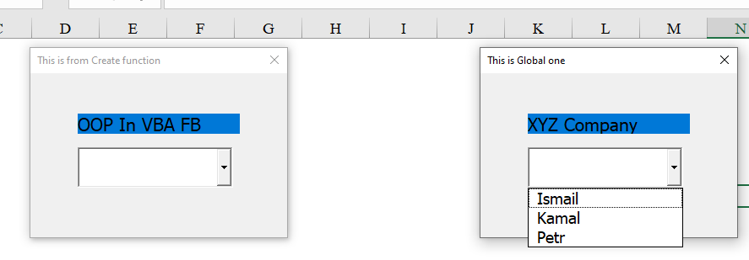See Caption and the combobox data. The one which is created from the Create function has set the Label properly but it doesn’t have the Employee list(Believe me or test it). But the Global one has the Employee List but it doesn’t have the updated Company name. So If you want to use Me keyword in this case then you have to be careful here. So If you are thinking that you are setting the list for the “CurrentEmployeeForm” using Me keyword then you are doing it wrong way. To set it properly you need to do something like this :

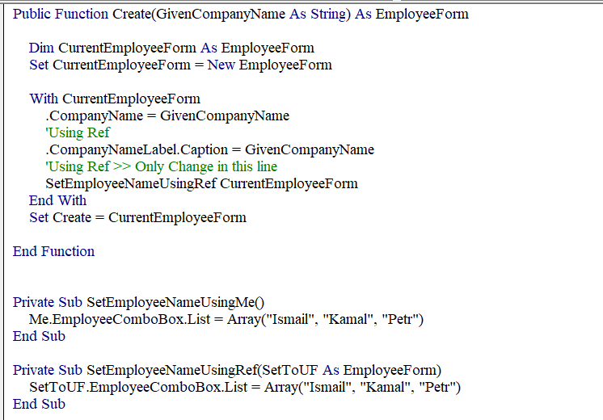

And Now the UF from Create Function has that list.

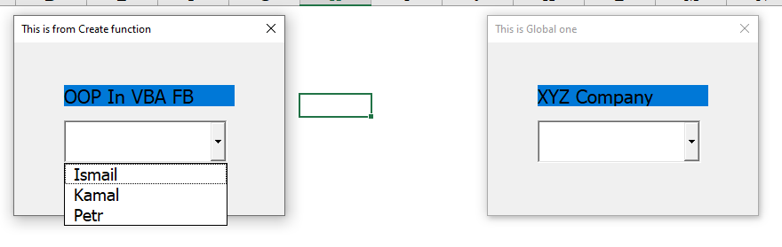

So If you want to use this way of coding then you have to remember that Me is different while Create is in the call stack.

Now I want you to focus in other way :

So If you want to change the code like this :

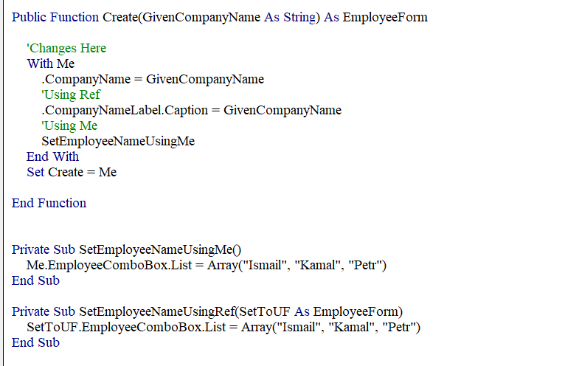

And This will be the output :

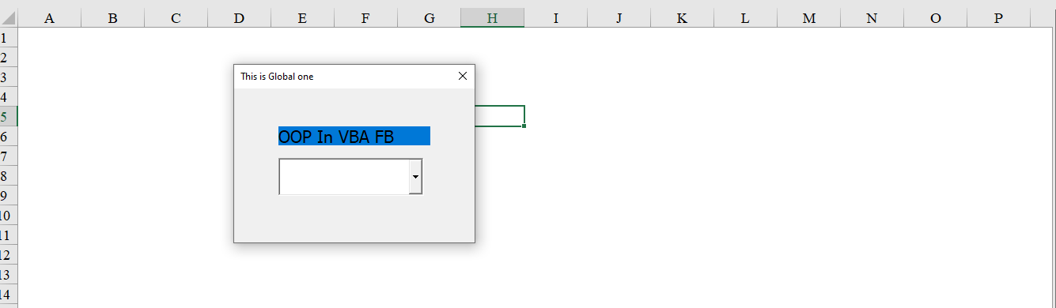

Check we only have one form. Why is that ? Because we are not creating any new object of that form type and it is editing in the original form no matter which variable you set that.

In case of Userform normally we don’t use multiple instance but in case of class it will be catastrophic. Let me add another class and example for clearly understand it.

So this is the Constructor code :

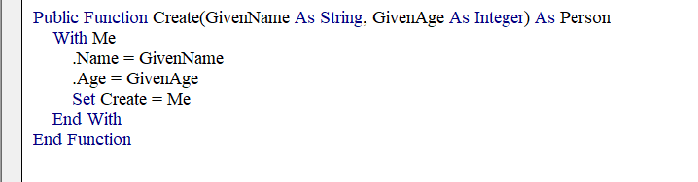

And here is the driver code and Output

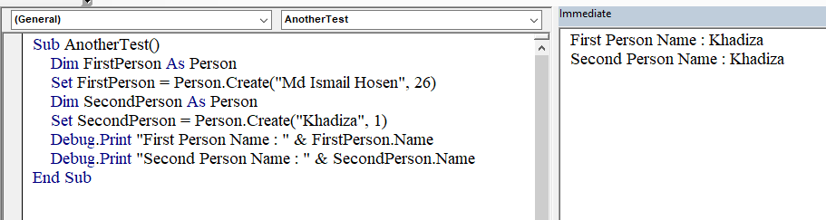

So both FirstPerson and SecondPerson refer to the same pointer and that’s why both are same thing.

I do have another version with “With New Person” way and in that case here is the code ;

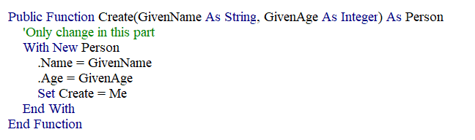

Although we are creating new Object but we are still setting to the Me(Global Instance here) and that’s why it is still the same object.

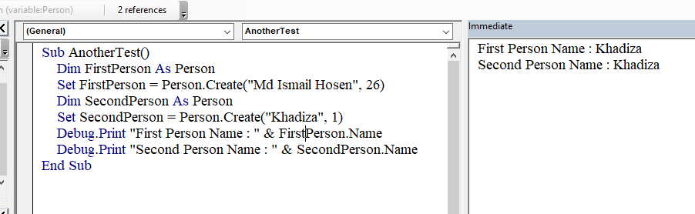

Now check this with the GetMe property added and being used :

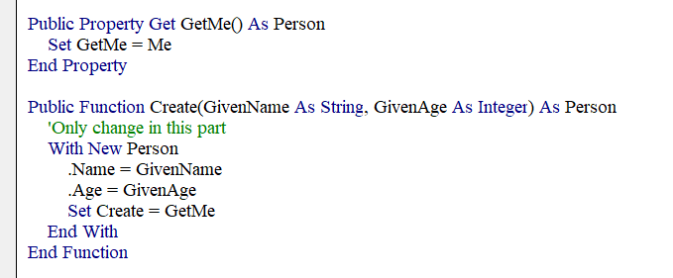

Now the output is

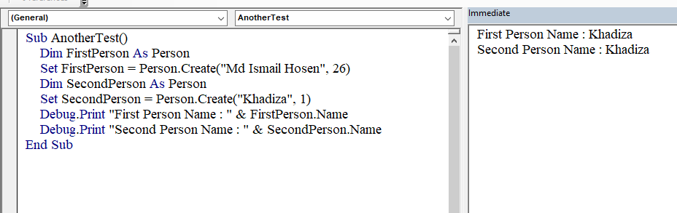

And Maybe You are thinkning what the hell again same output? Okay we did a small mistake here. We set Create = GetMe(This one is being called on the Global instance) and that’s why still it is being referred by two different variable her. But if you change that to Set Create = .GetMe then you will get different result. Let me show you.

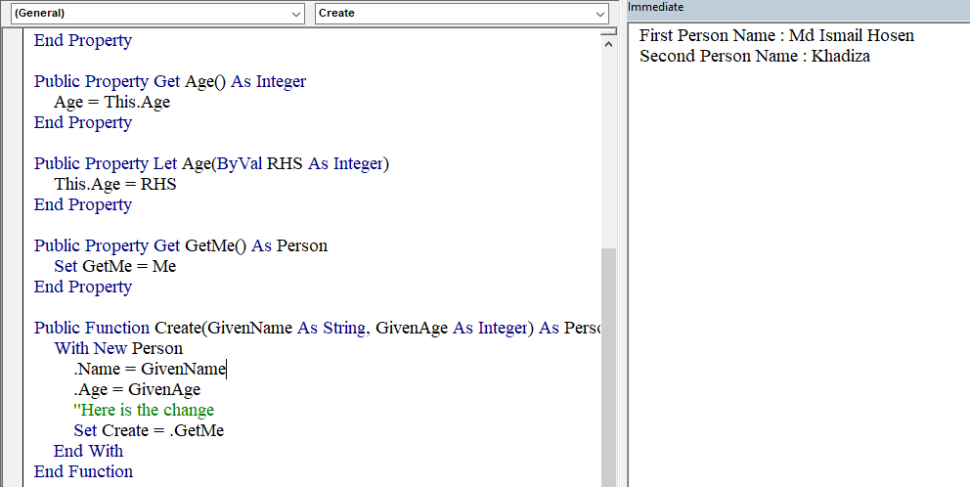

Here is the code and output. Now Probably you are thinking why the difference? It lies with the dot

When we are using .dot then we are calling GetMe property on the With New Person(On the fly object>> With is holding object reference but you can’t assign that to a variable except in this property way). So it is returning the new object instead of that Me Global Object.