Paper Report

Unknown

411410055 蕭子期

411410067 許世昕

411410073 洪子傑

411410091 葉暄鴻

Outline

1. Introduction……………………P.2 - P.4
2. Program Design……………………..P.5
3. Basic Part…………………….P.6 - P.17
4. Advance Part……………….P.18 - P.27
5. Demostration……………………….P.28

Introduction

Welcome to our library! In this library, it is divided into two parts, Administrator and Reader parts respectively. When executing, the user will choose which mode to enter , then need to sign up an account, below is a brief introduction for the mode.

● ADMINISTRATION MODE

* Book status(add, delete, lend).
* Check status(book, reader and admin information)
* Record borrowing history.
* Verify email account and password go by the rules.

● DATABASE

* Login account and Sign in account to administration and reader mode.
* Using struct type in Book and Manager, linked list type in Reader and
* Queue structure in storing borrowed history.

● USER-INTERFACE

* Using SDL resources to make buttons more aesthetic and functional.
* Using text boxes to provides a convenient, clear, and interactive way to input or display text.
* Incorporate prompts, error messages, and feedback to provide information to user
* System will clear the screen automatically to ensure a clean and readable interface for a better user experience

● READER MODE

* Check personal information.
* Reverse book from library.
* Search books information (name, author, call number, publisher, ISBN.)

This system is more visible and user-friendly than a normal library system, so we sincerely welcome to experience such an epoch-making system ! Hope you revel in our library !

Program Design



Starting the system, users need to choose two modes, which are reader and administration. Then sign up for the account when first entering in, the system will verify the format's user key in going by the rules. In reader mode, users can search all book’s information, reserve books, or check their personal information. In administration mode,users can check all the status of administrations, books, and readers.

Basic Part

● Three basic data types (int, float, char), and data created using structure

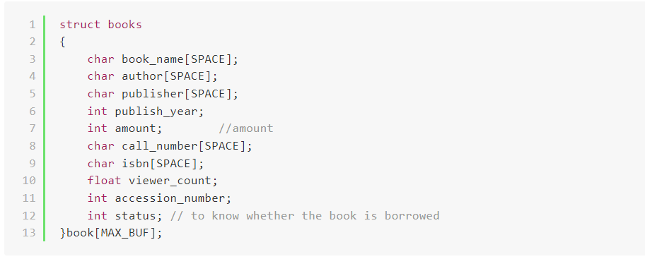

● String type

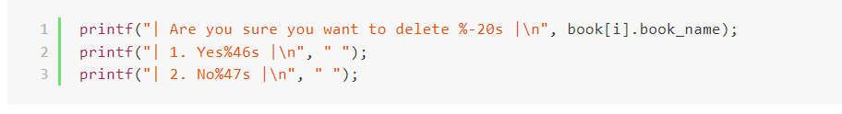

● Linked list

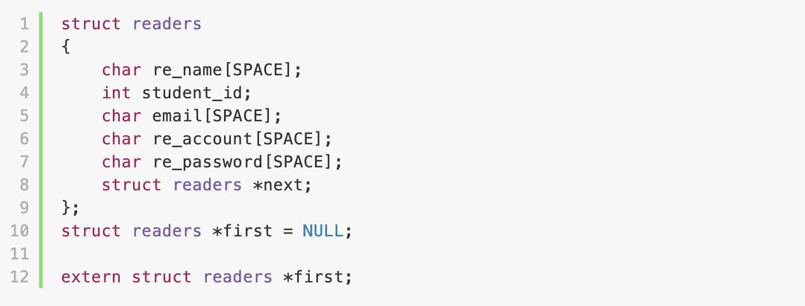

● Add

Administrator can add new book information, and the system will store it into the book database.

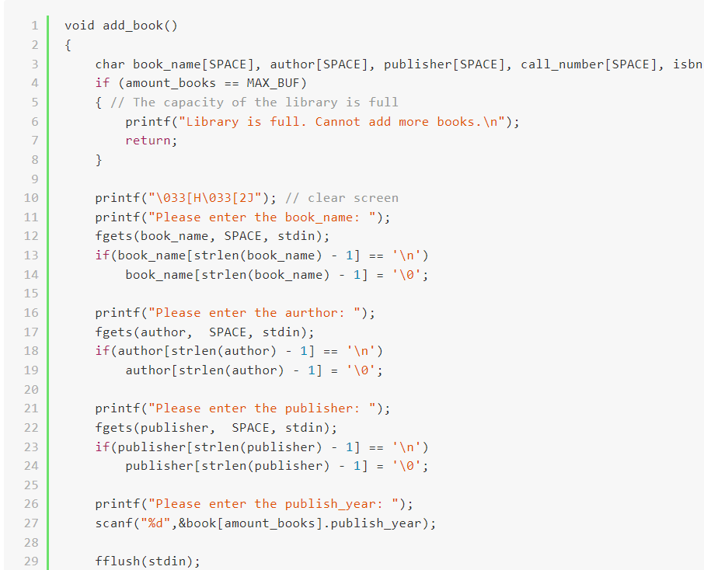

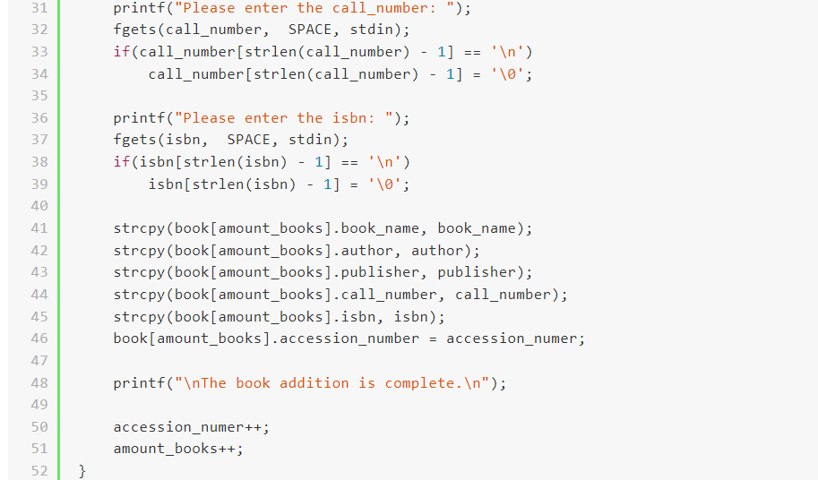

● Delete

Administrator can delete a book from the database.

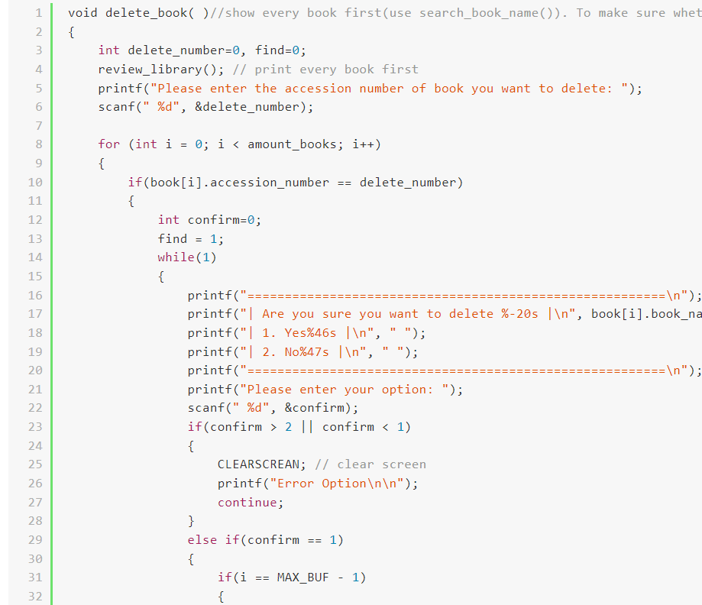

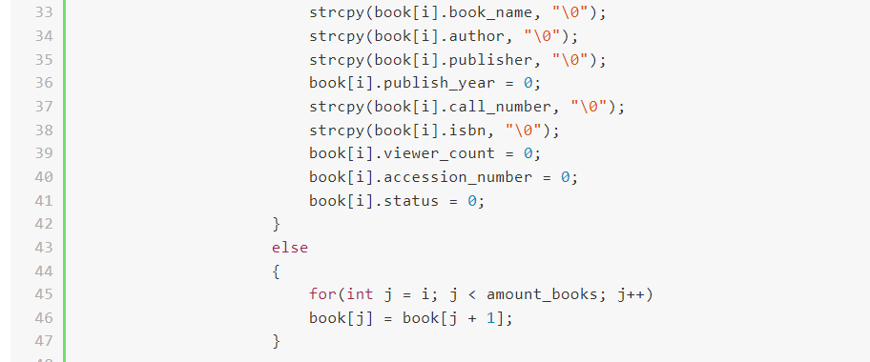

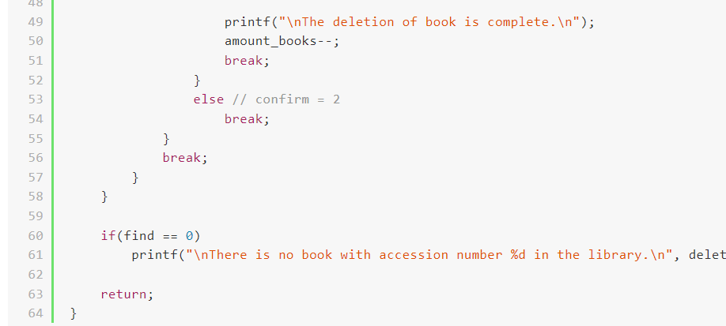

● Traverse

Print all the books listed in the library.

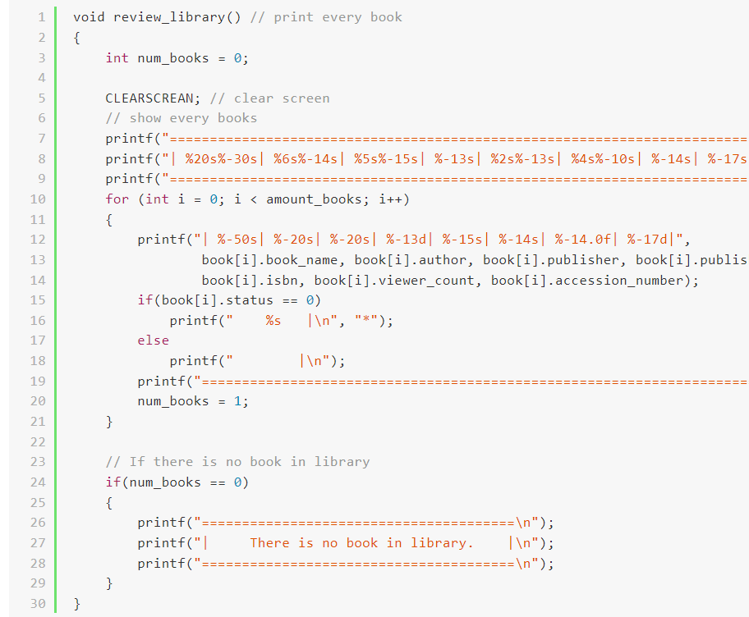

● Search

While readers enter the information of the book, the system will make all characters lower then compare by string function. Lastly, all the outcomes will print out on the screen.

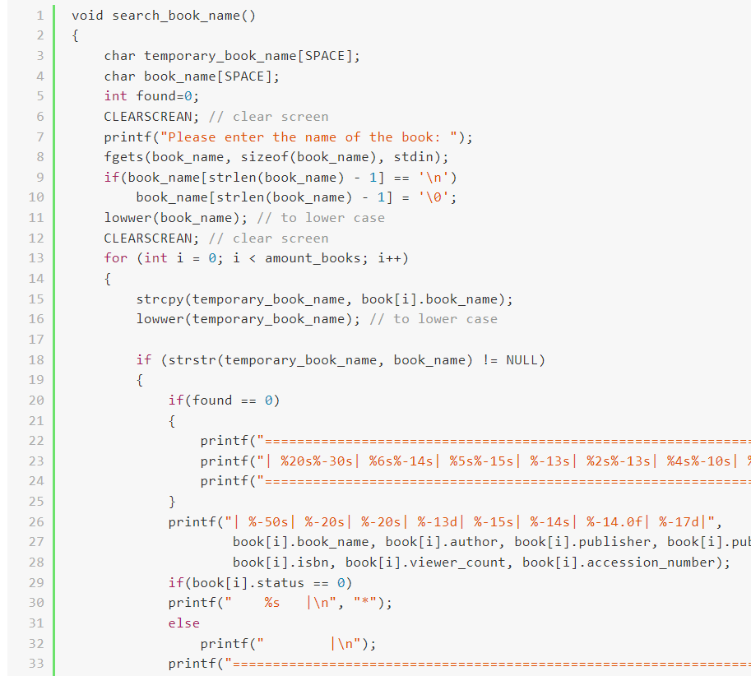

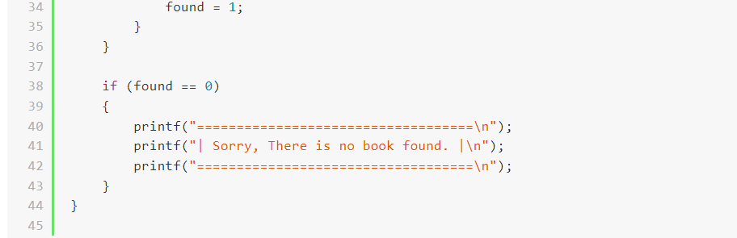

● Sort

* Lines 6 to 17, and lines 25 to 30 implement the bubble sort algorithm.

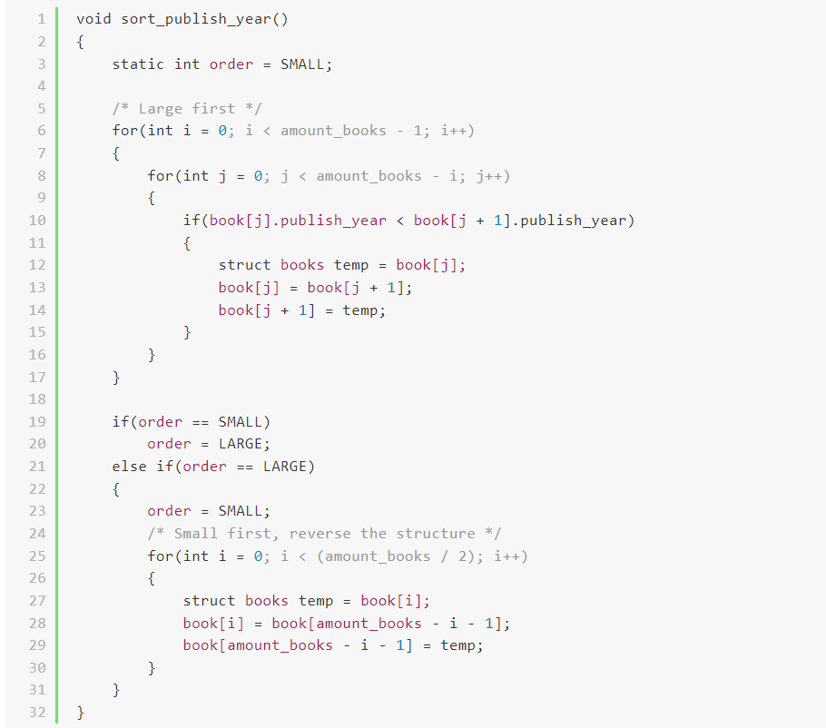

● File I/O

* While the process starts to execute. It will call input_file(). Which will read the information from the text files. Before the process stops. The process will call the output_file(). Which will write all the new data into the text files. To update the information.

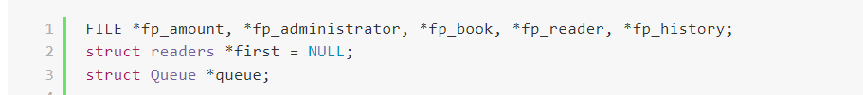

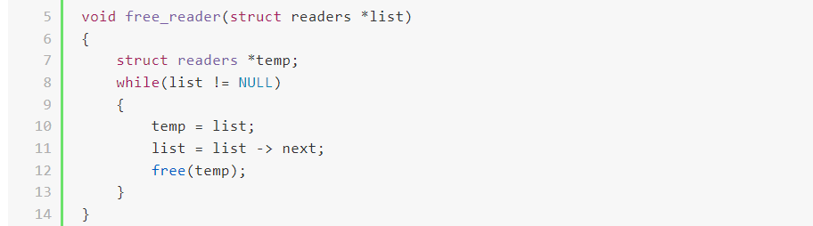

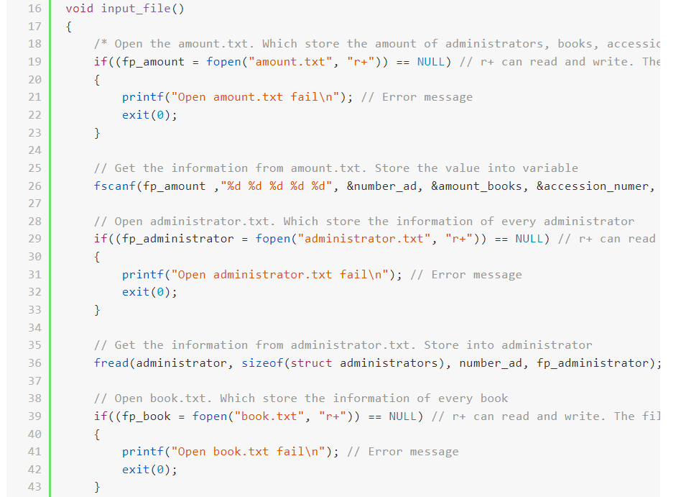

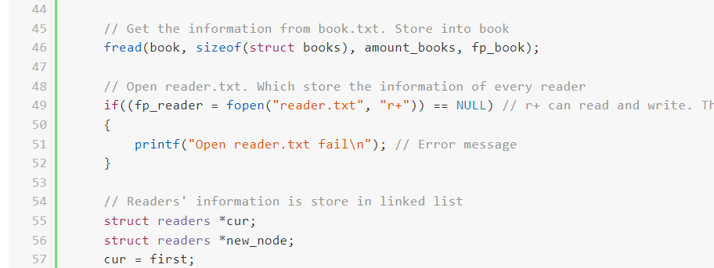

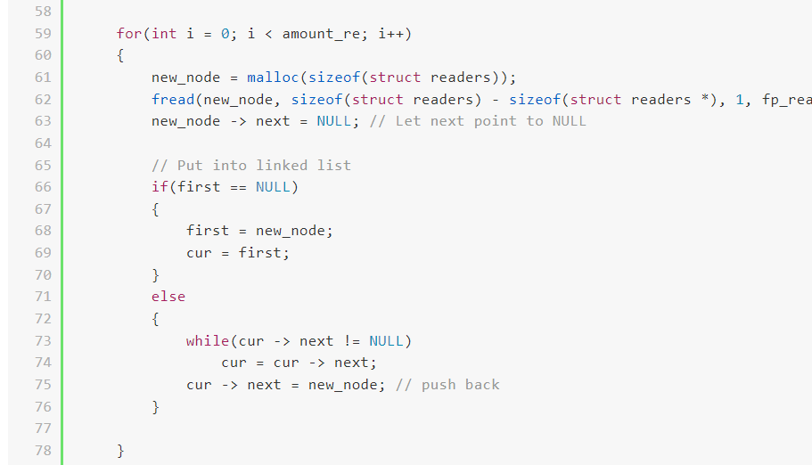

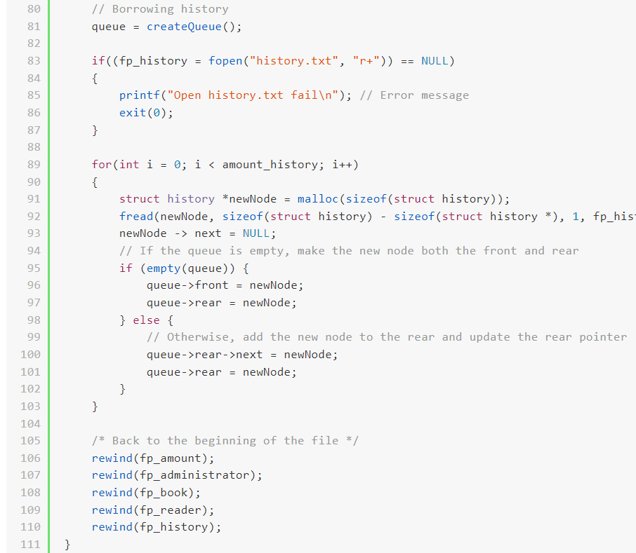

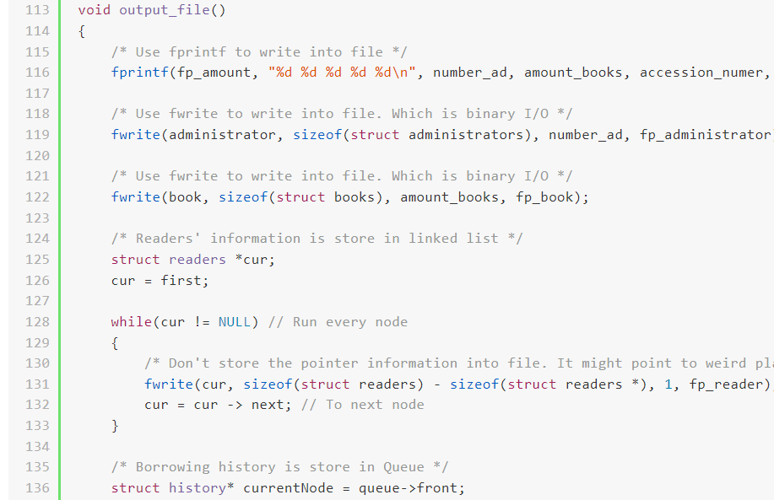

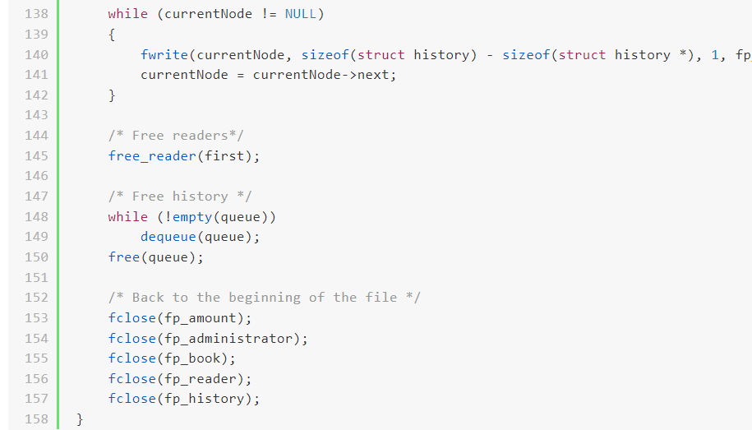

Advanced Part

● Good output format

* Output book data in a table, enclose information in boxes.

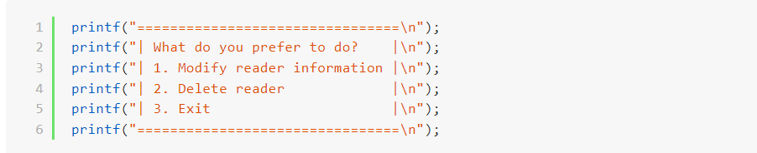

● Switch screens (by using clear screen method).

* Different commands are used to clear the screen based on different operating platforms.

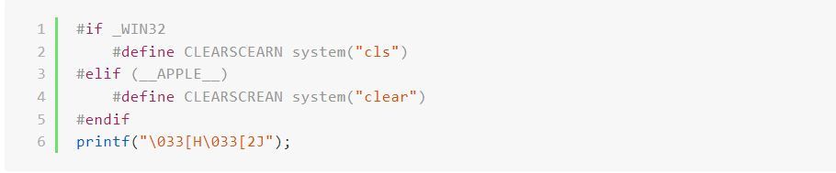

● Use SDL to create buttons for added convenience.

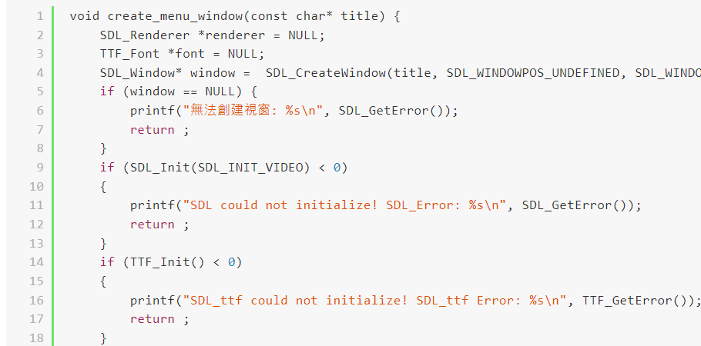

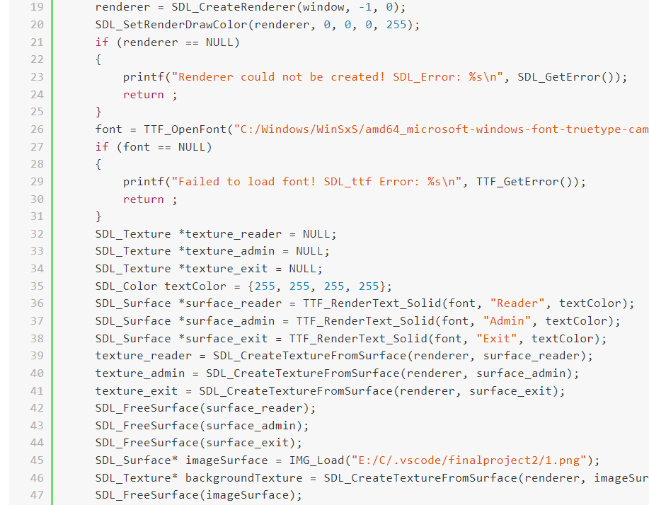

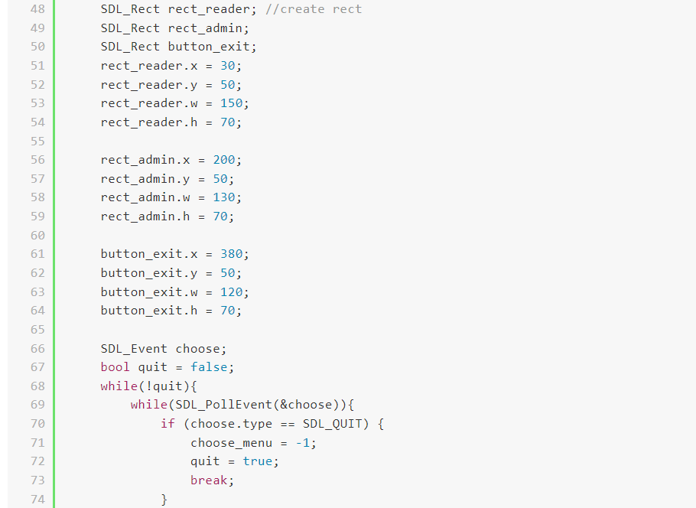

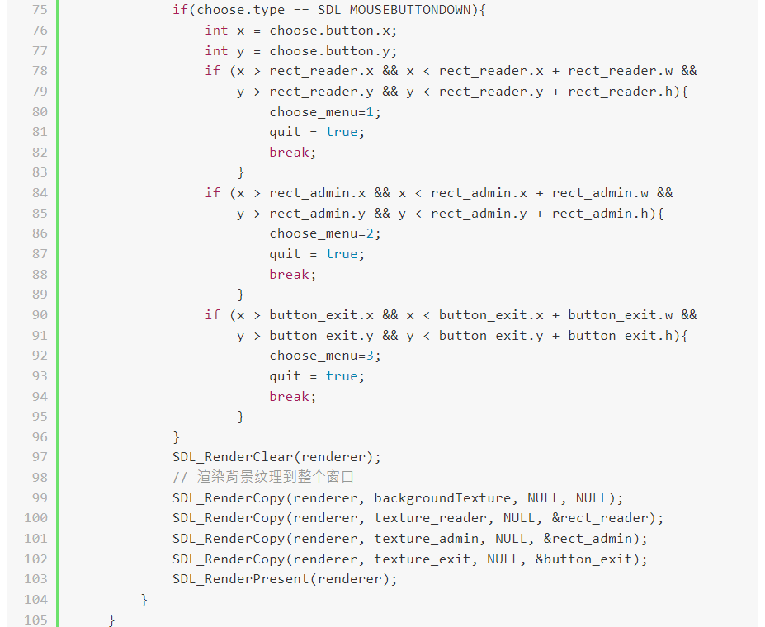

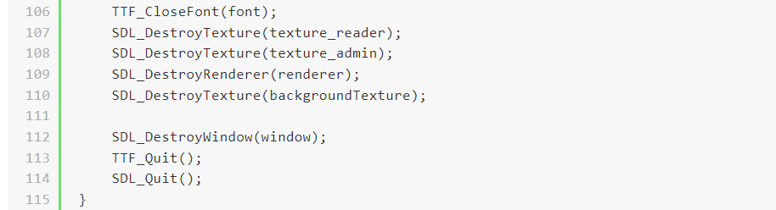

● Store and access data by queue.

* We use the characteristic of a queue to store the history of borrowing. We limit the data number. If the store of data reaches the limit, it will pop the oldest data. And add the newest data. The first function is to initialize the queue. Second one is checking whether the queue is empty. Then add a node of queue to store data. The last one is pop the oldest node of the queue.

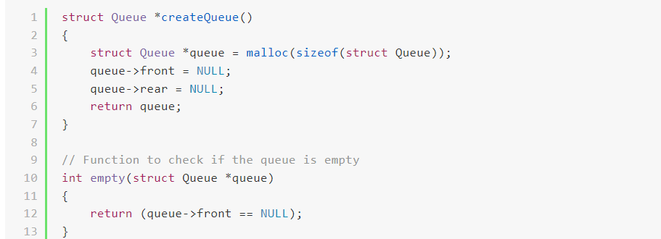

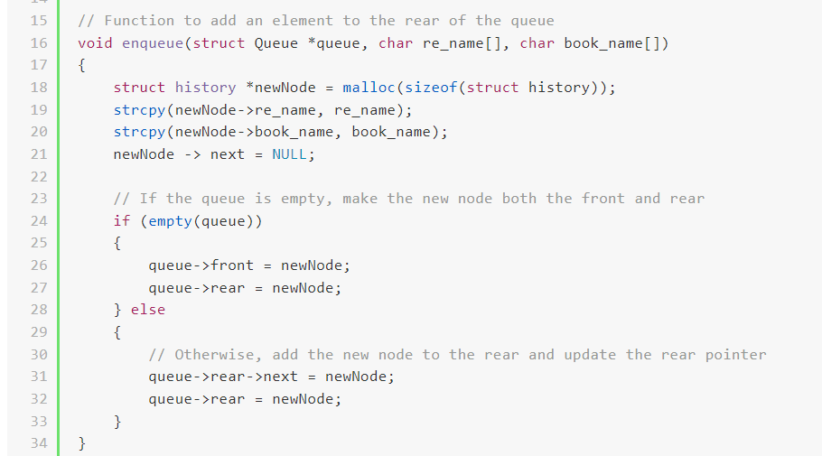

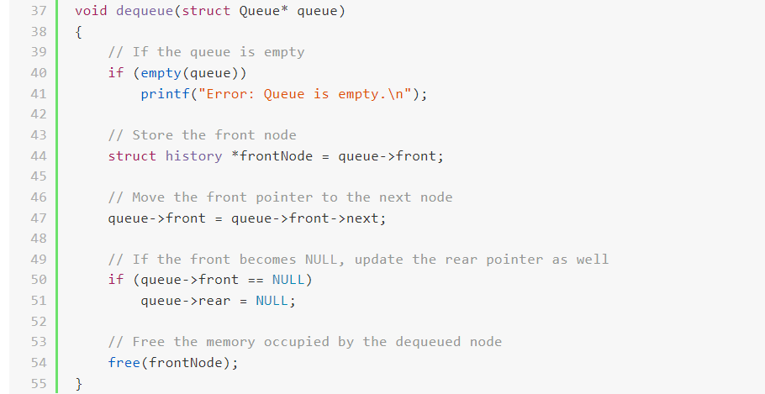

● Design an account and password login system.

* First we ask the user to input their account, and then use a function to check if the registered account is valid (function at line 12). After validating the account, we ask the user to input their password and use a function to check if the password is valid (function at line 26). This completes the registration process.

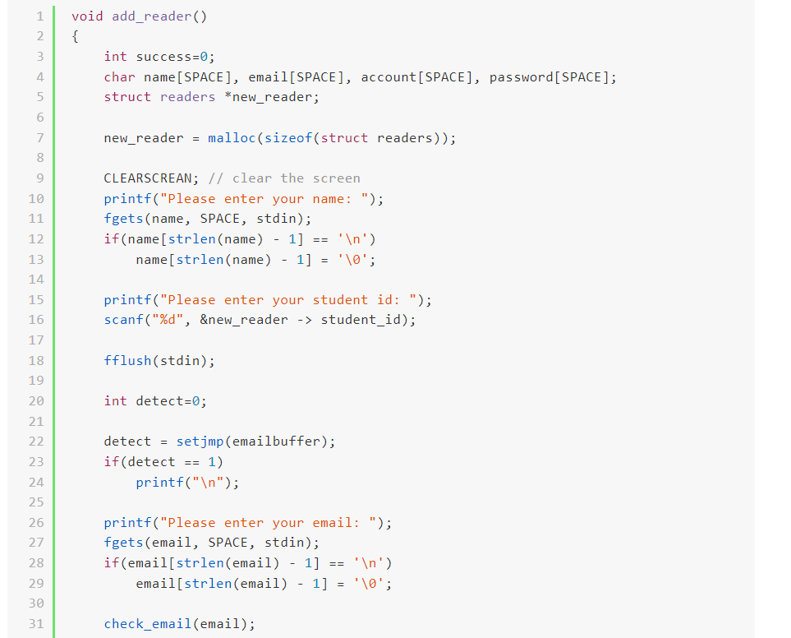

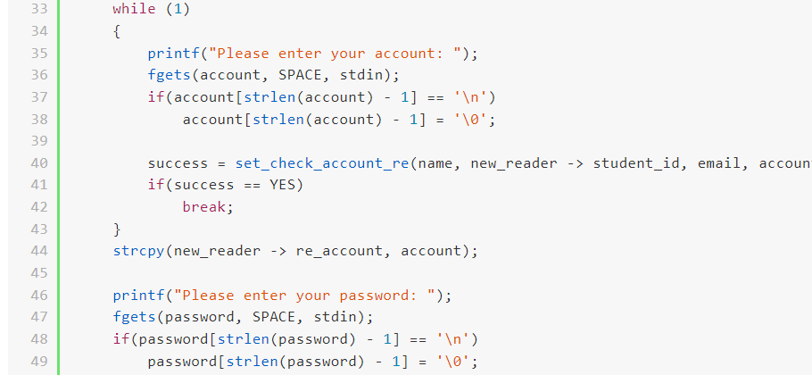

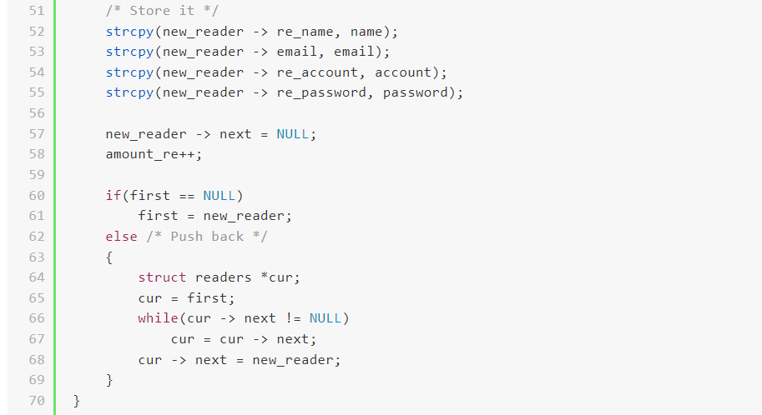

● Verify if the email format is correct.

* We write a simple function to check the format of email. First, there should be an ‘@’ in email. Second, there shouldn’t be more than one ‘@’. Next, there couldn’t exist ‘#’, ‘*’, ‘..’ in email. Last, there should be at least one ‘.’ behind ‘@’ .

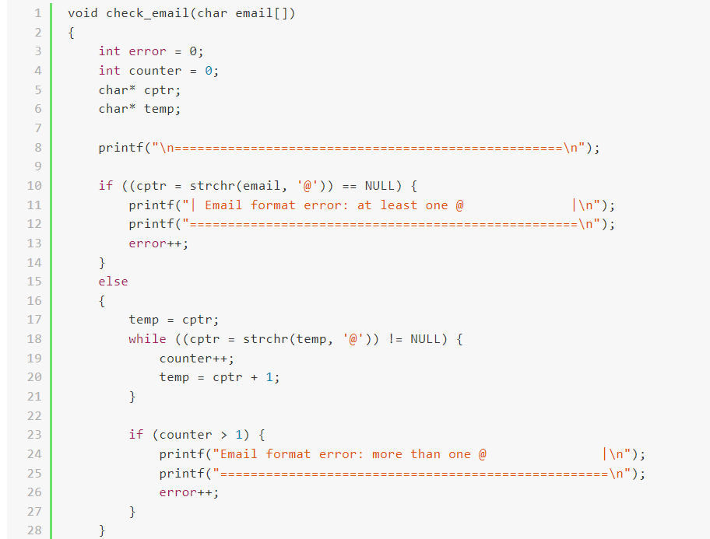

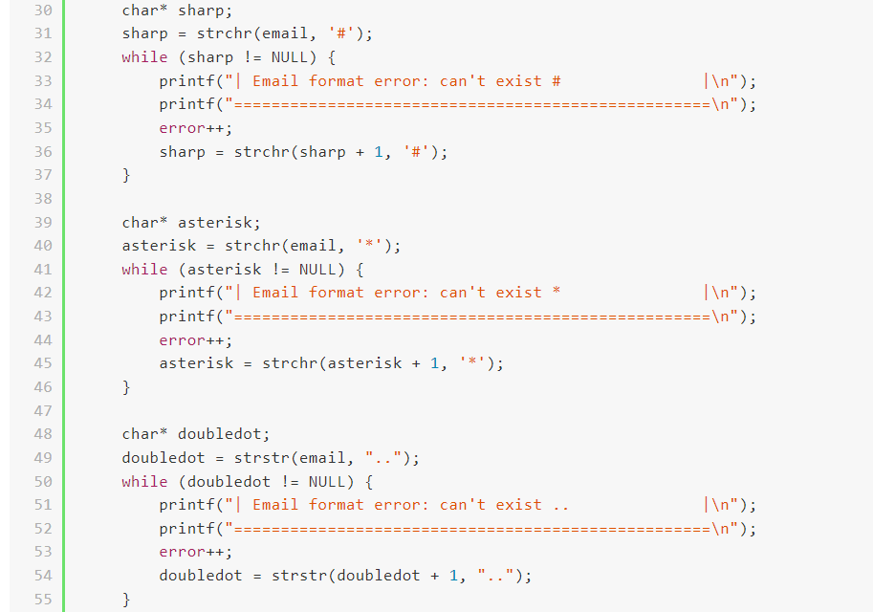

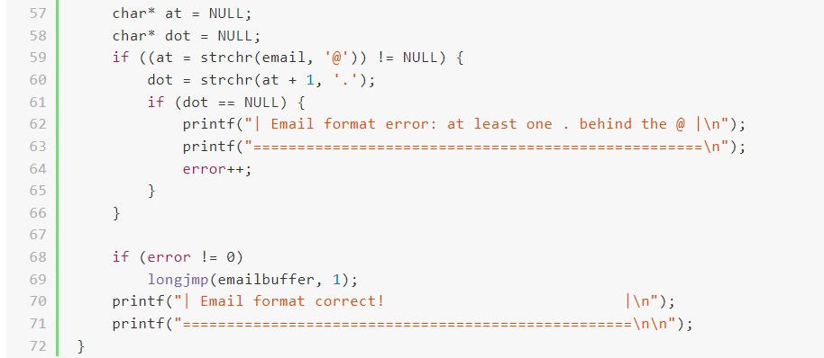

● When selecting to modify or delete data, all data will be displayed first for the user's convenience in confirmation.

* In the function "modify_ad_information", we call the function "check_ad_information" (line 16), to print all data before making any changes

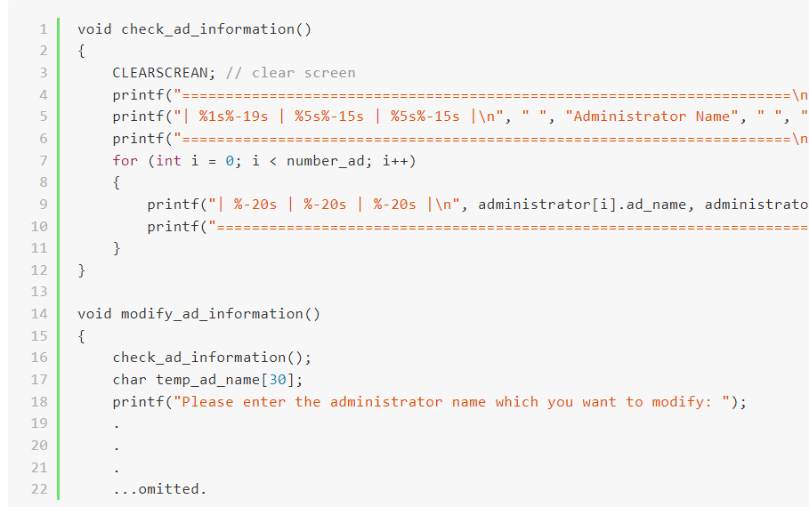

Demostration

Github repository link:

<https://github.com/1508leo/PD_Final_Project>

# 