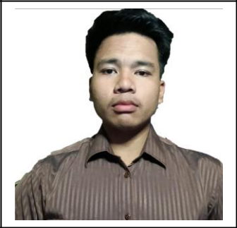**Franco Lewis P. Maturan**

12 Anahaw, Brgy. Pilar, Las Pinas City, Metro Manila

09308547312

Email Address: lewisfrancoleon@gmail.com

**OBJECTIVE:**

To contribute to the success of the company and obtain work experience in BPO industry that grant knowledge and enhance my communication skills, which provides career growth and development. Seeking challenges other than the program that I am pursuing at the college level.

**EDUCATION:**

* ***2010-2015: Elementary Graduates (3rd honorable mention award) Sampaloc Elementary School***
* ***2015-2019: High school Graduate (Graduated with honors) Sampaloc national High School***
* ***2019-2021: Senior High School Graduate ICT strand***

***STI College Las Pinas***

* ***2021-2023: 2nd year College***

***Bachelor of Science in Information Technology STI College Las Pinas***

**SKILLS:**

* *Computer skills*
* *Flexible*
* *Team Player*
* *Application programming*
* *System Administration*
* *Adaptability*

**References**

• Sean Natahnielle Pascasio STI Academic Center Las Pinas 09812576428