Hệ thống site map (27/05)

NOTE: This project is running on localhost:3000

1. **Guest:**
2. Home page (URL: /)

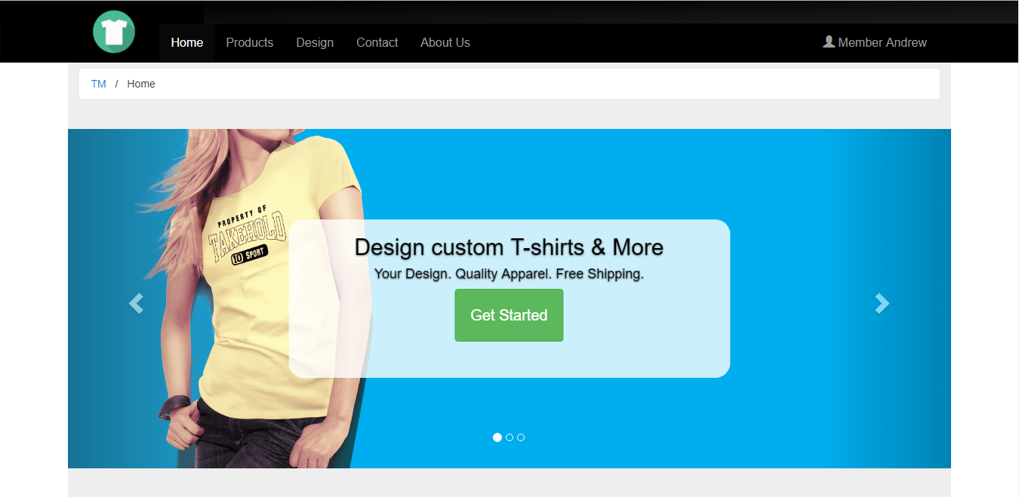

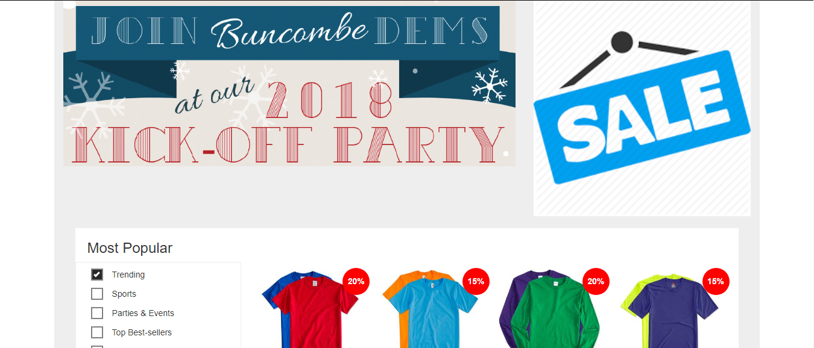

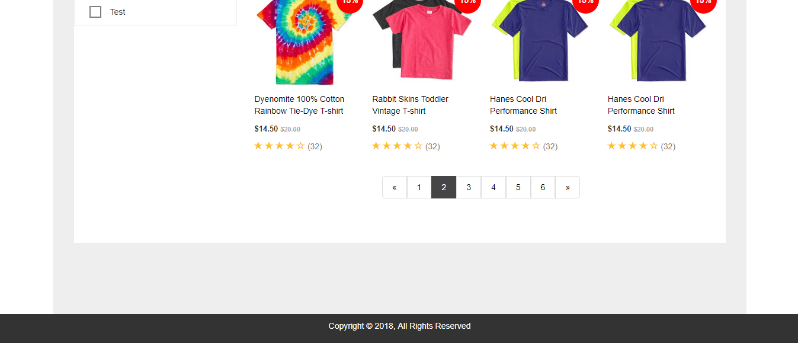

1. Products Page (URL: /products):

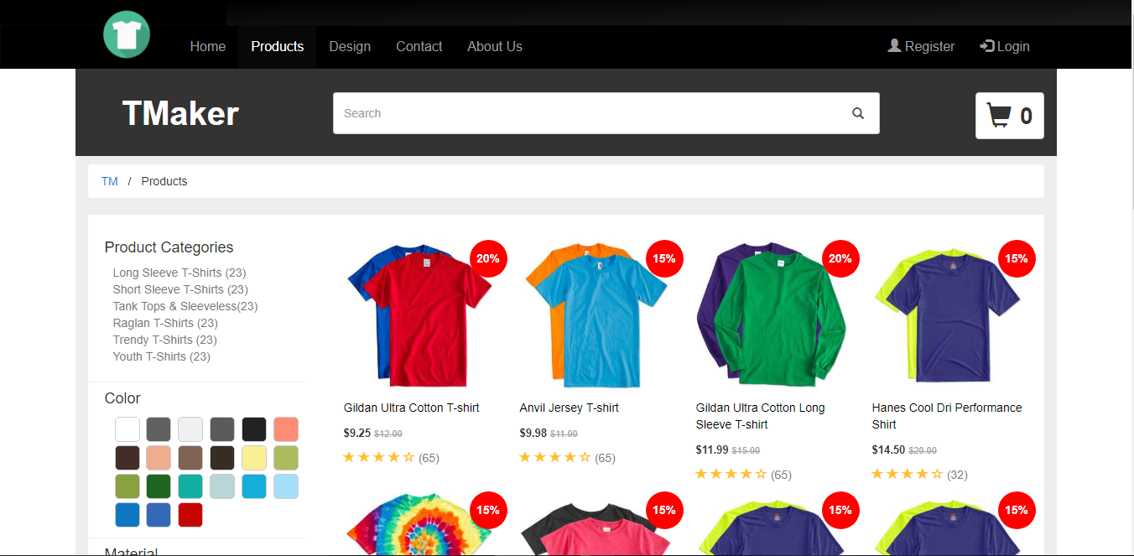

1. Product Detail (URL: /product-detail)

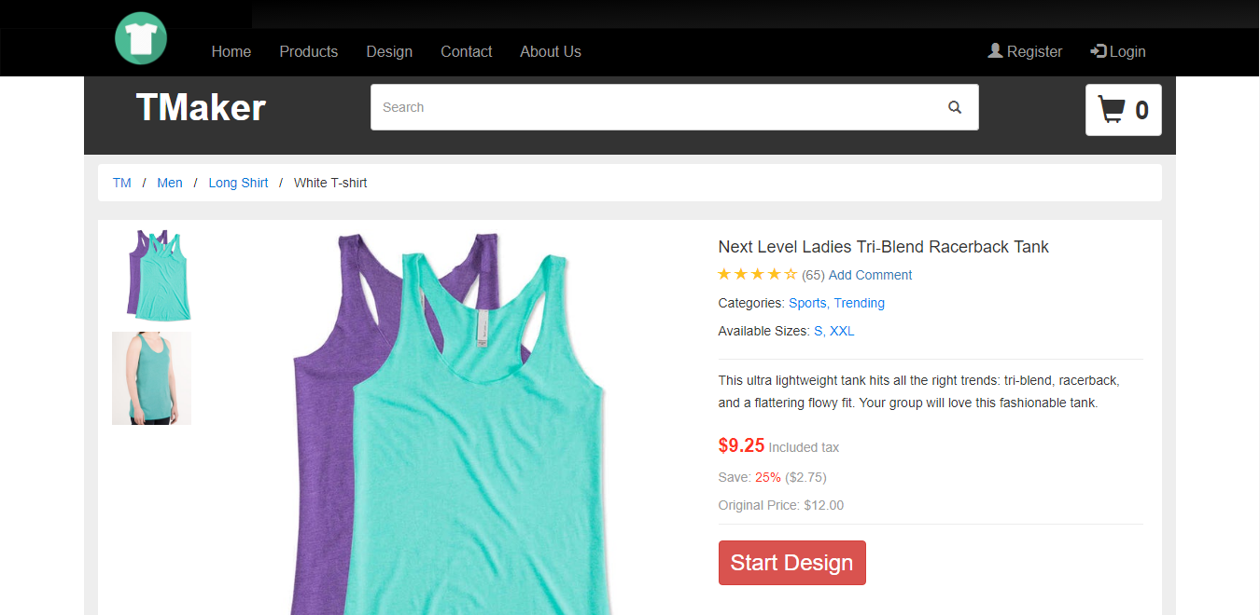

1. Design Page (URL: /design):

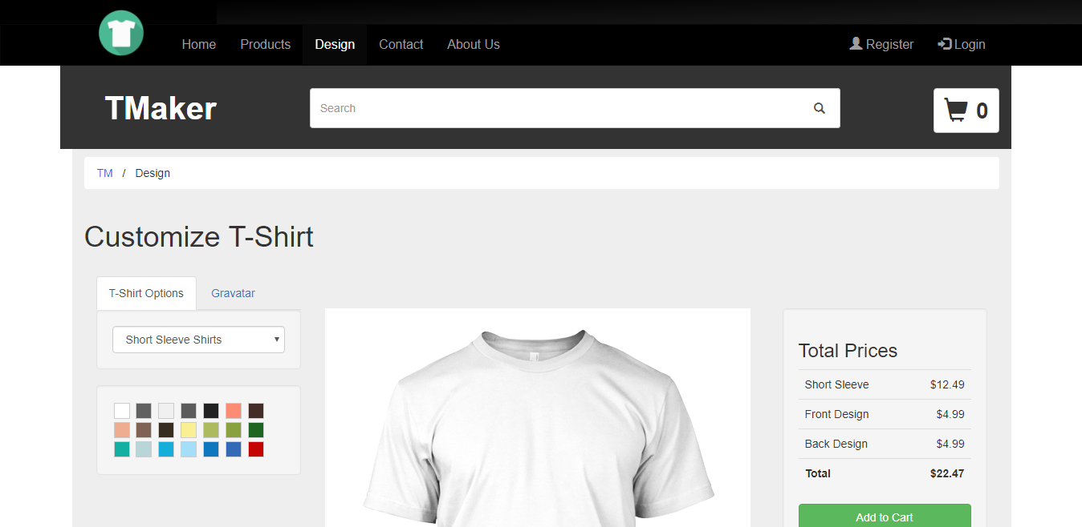

1. Contact (URL: /contact)

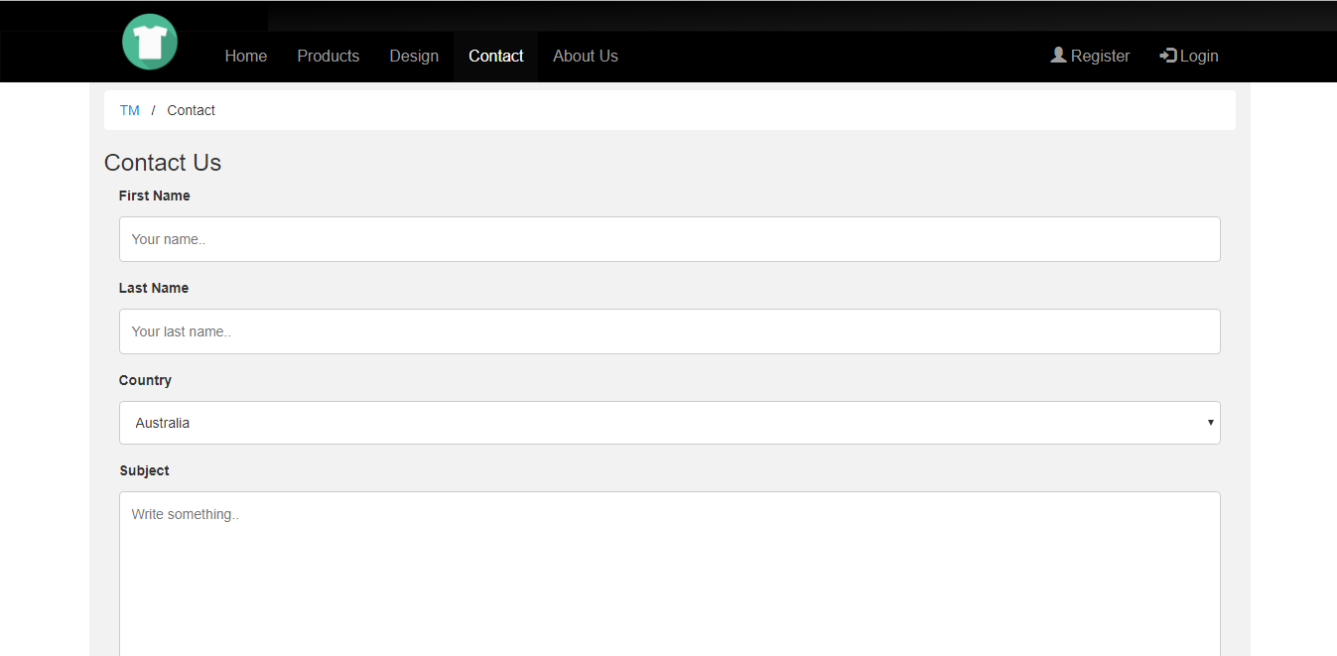

1. About Us (URL: /about-us)

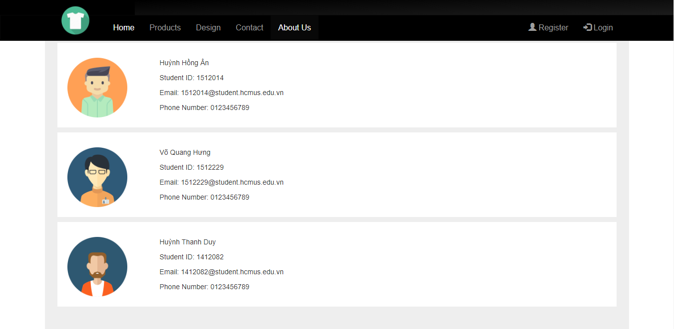

1. View Cart (URL: /view-cart)

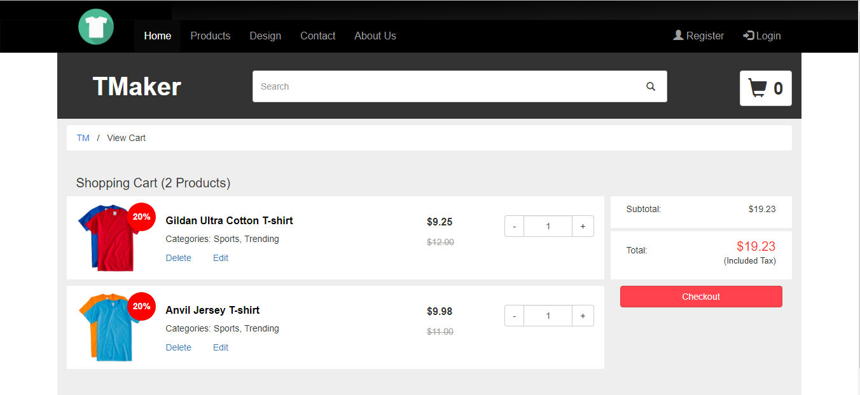

1. Checkout (URL: /checkout-step2)

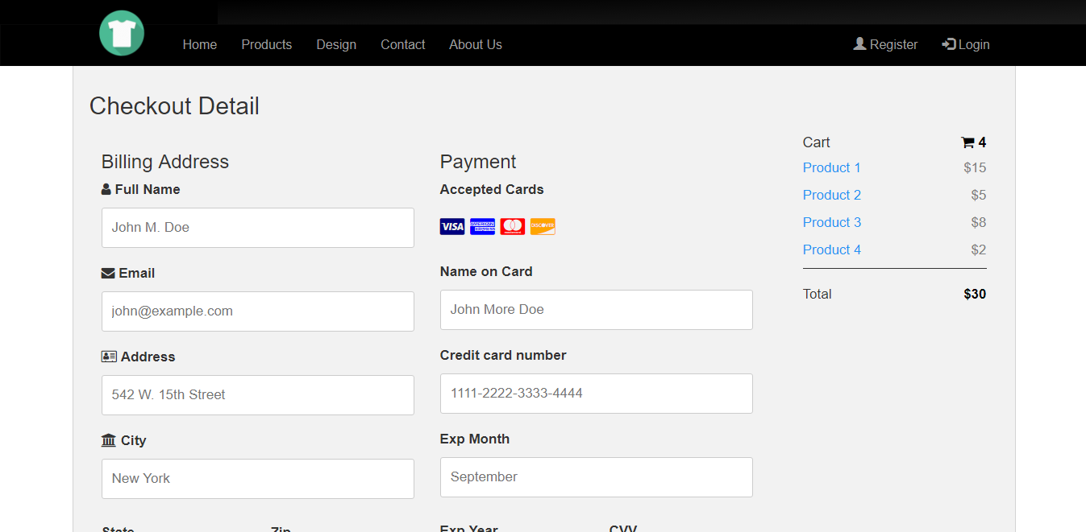

1. Confirm checkout (URL: /checkout-step3)

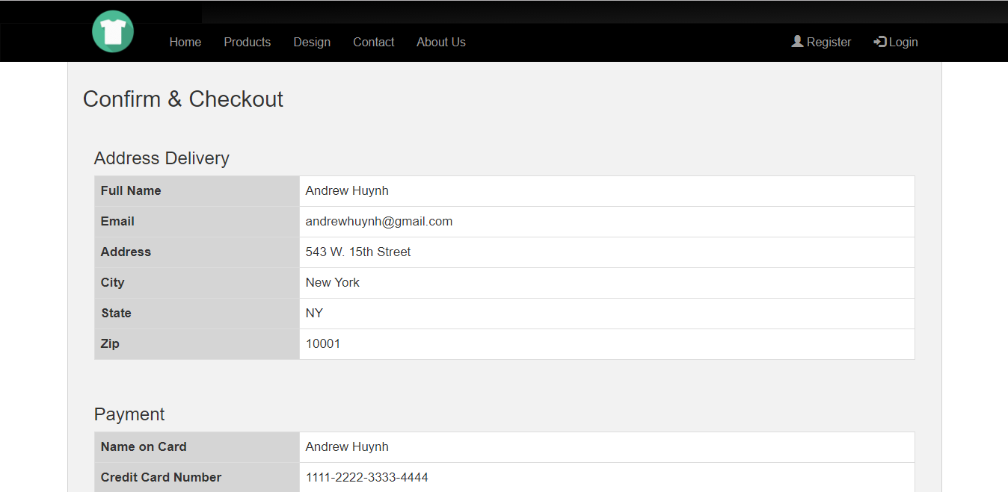

1. **Member:**
2. Login (URL: /login)

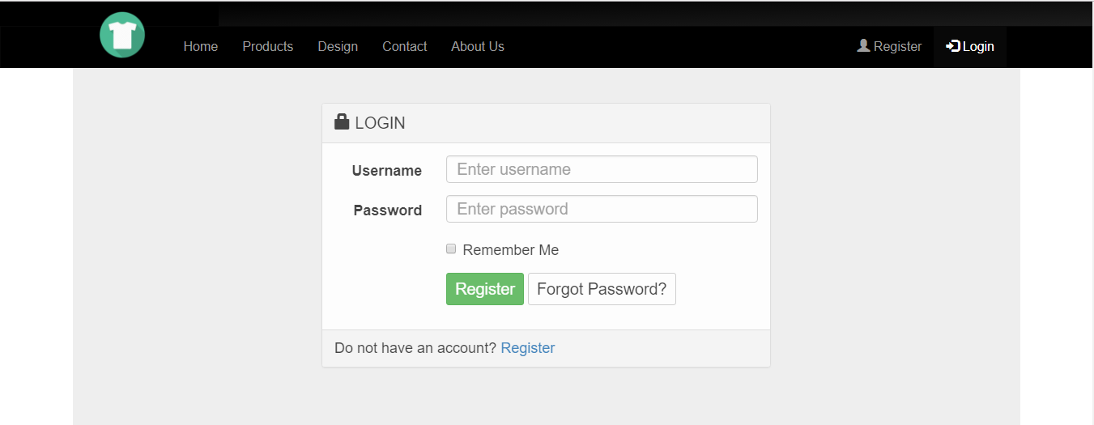

1. Register (URL: /register)

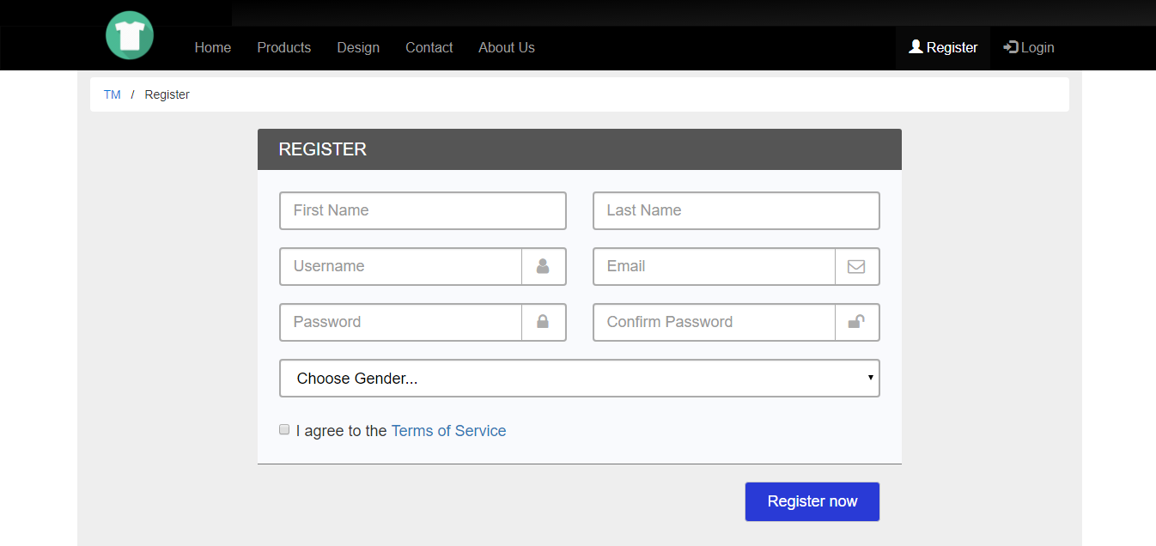

* After login, there will be a button to link to member page:

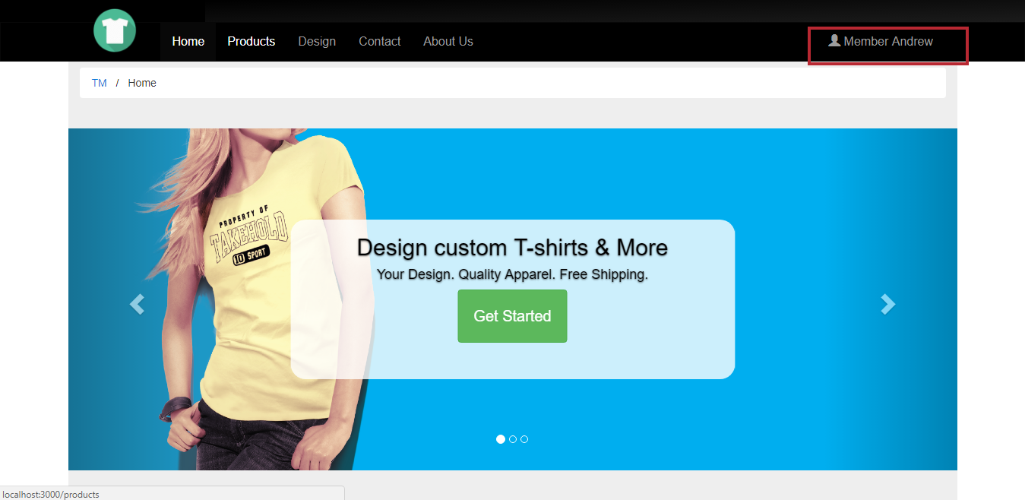

1. Member dashboard (URL: /member)

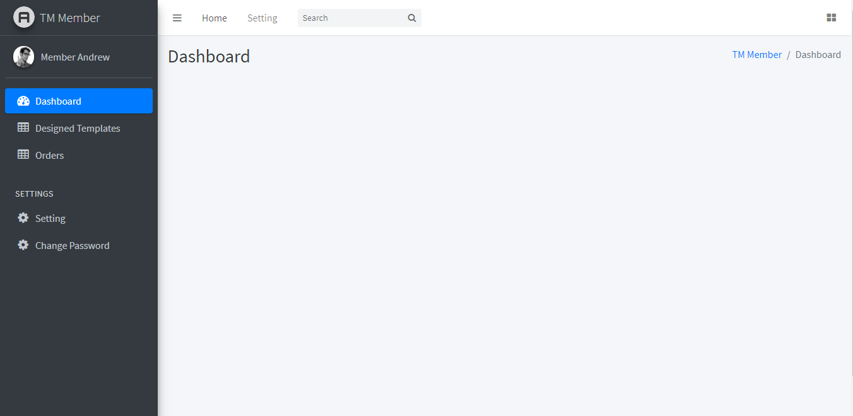

1. Member Designed Templates (URL: /member/template)

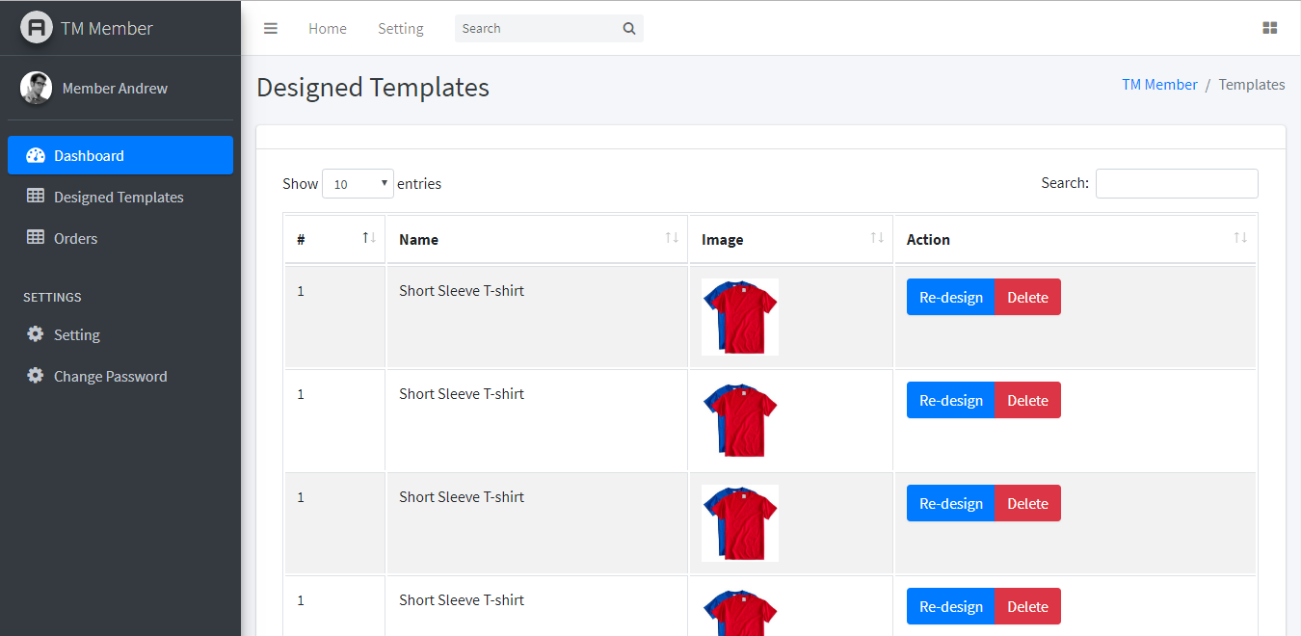

1. Member Booking Orders (URL: /member/orders)

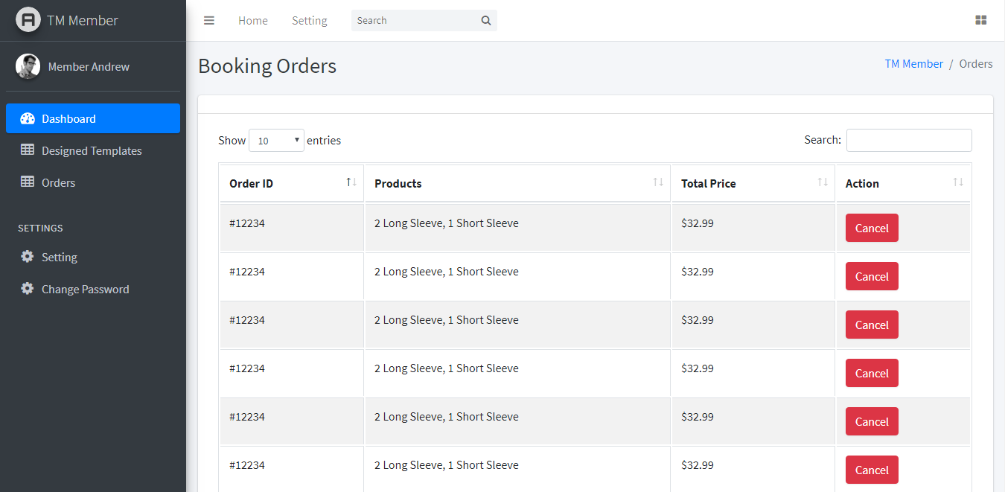

1. Member Change Password (URL: /member/change-password)

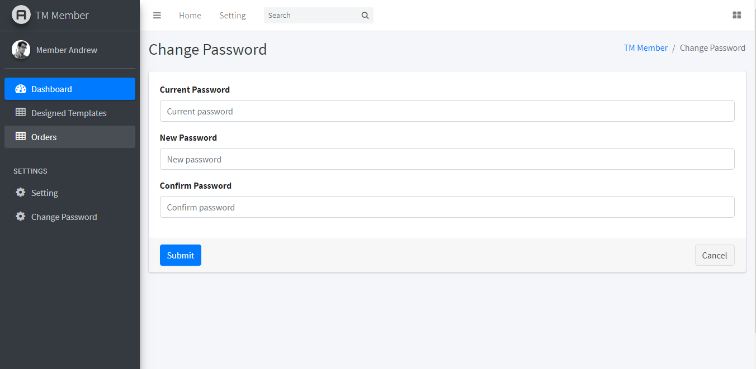

1. **Admin:**
2. Admin dashboard (URL: /admin)

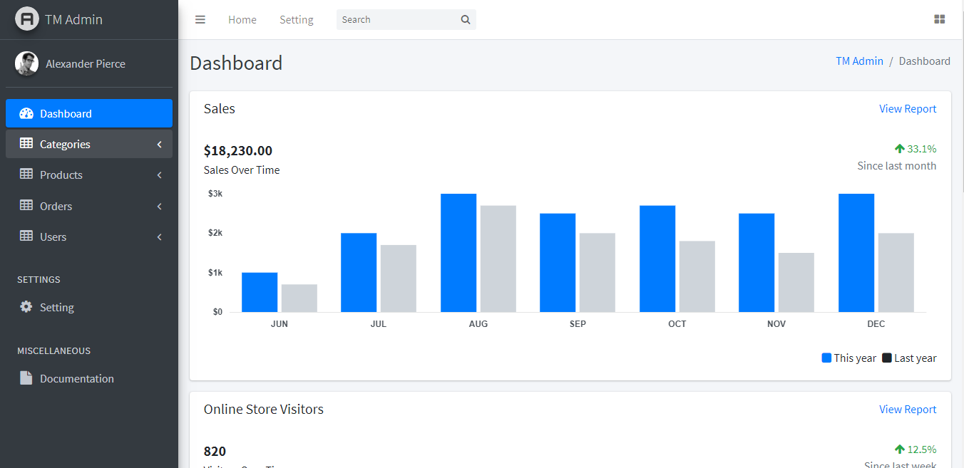

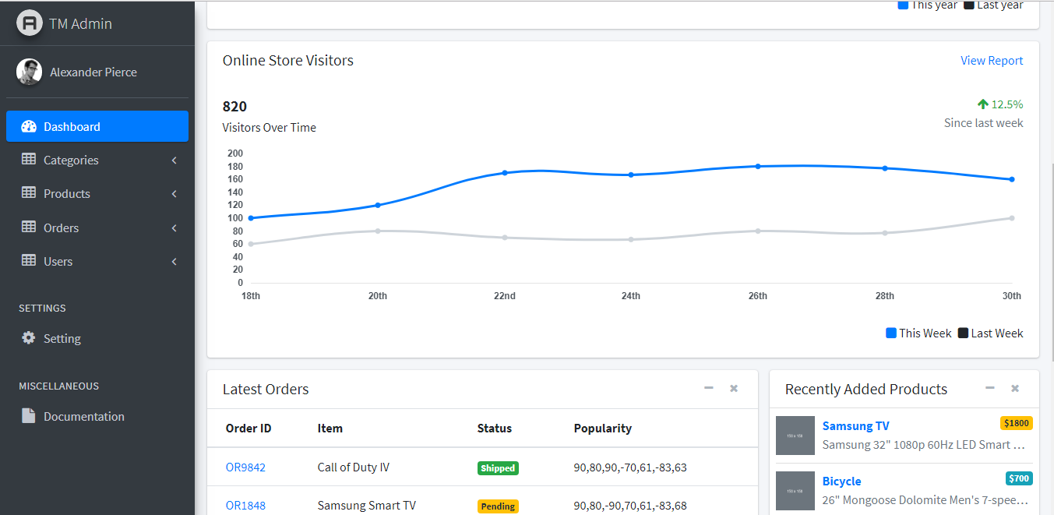

1. Admin Categories (URL: admin/categories/list)

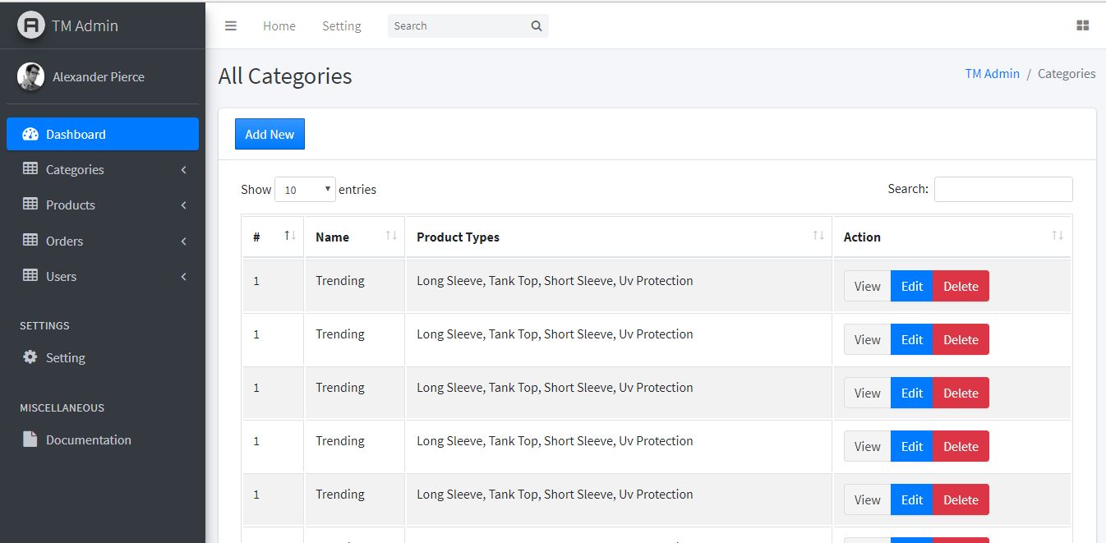

* New category (URL: admin/categories/new)

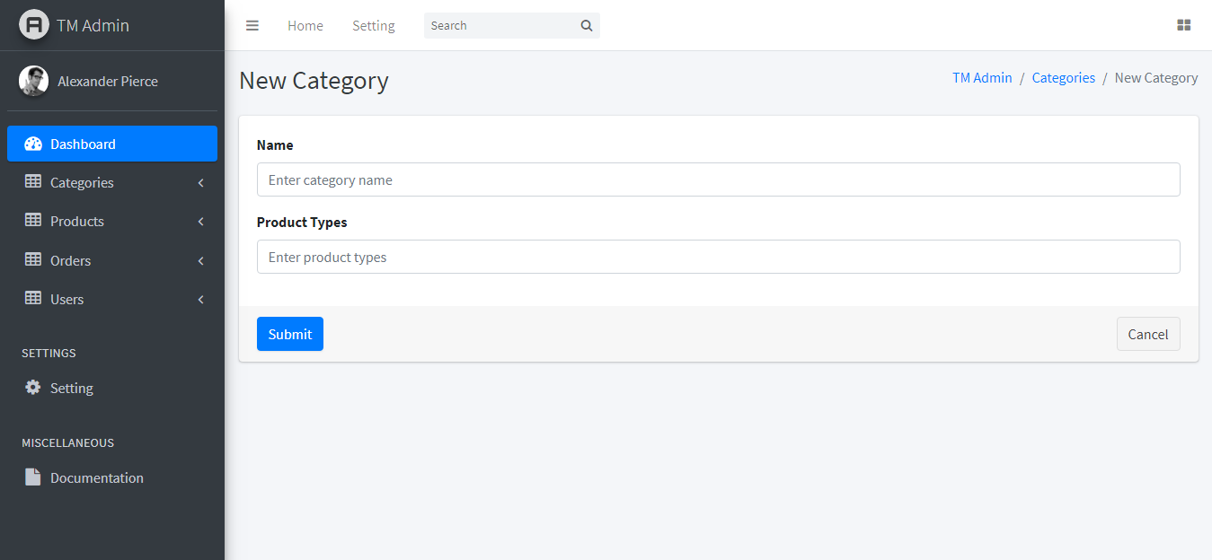

1. Admin Products (URL: admin/products/list)

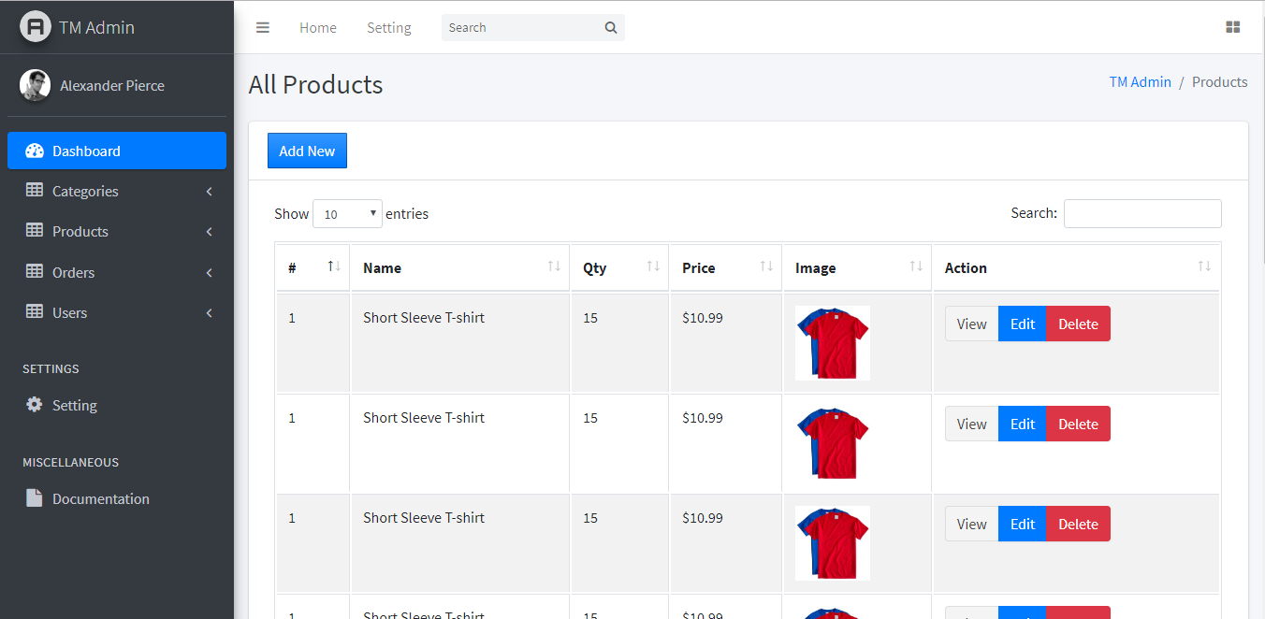

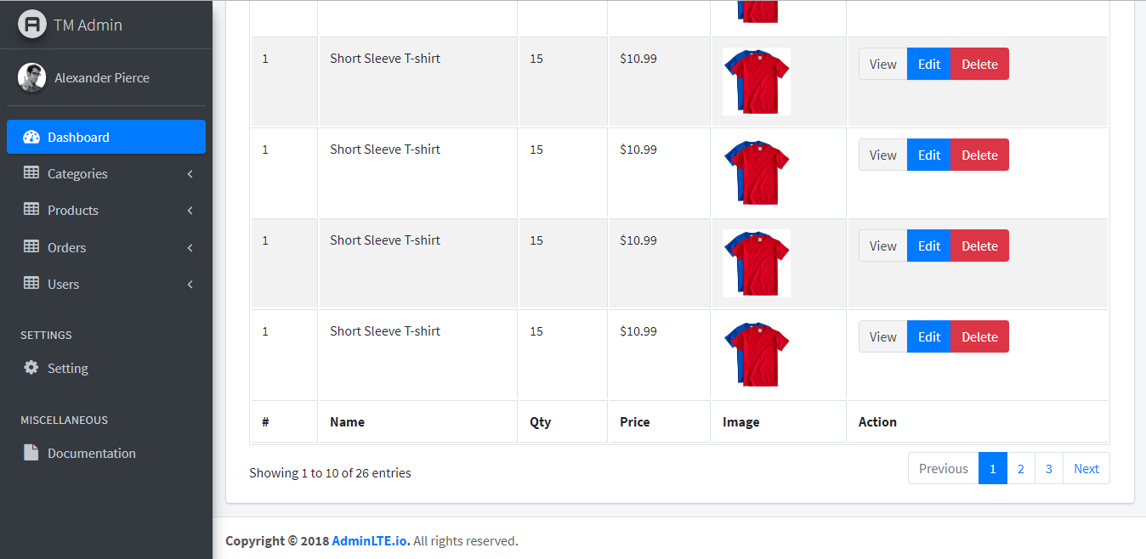

* New product (URL: admin/products/new)

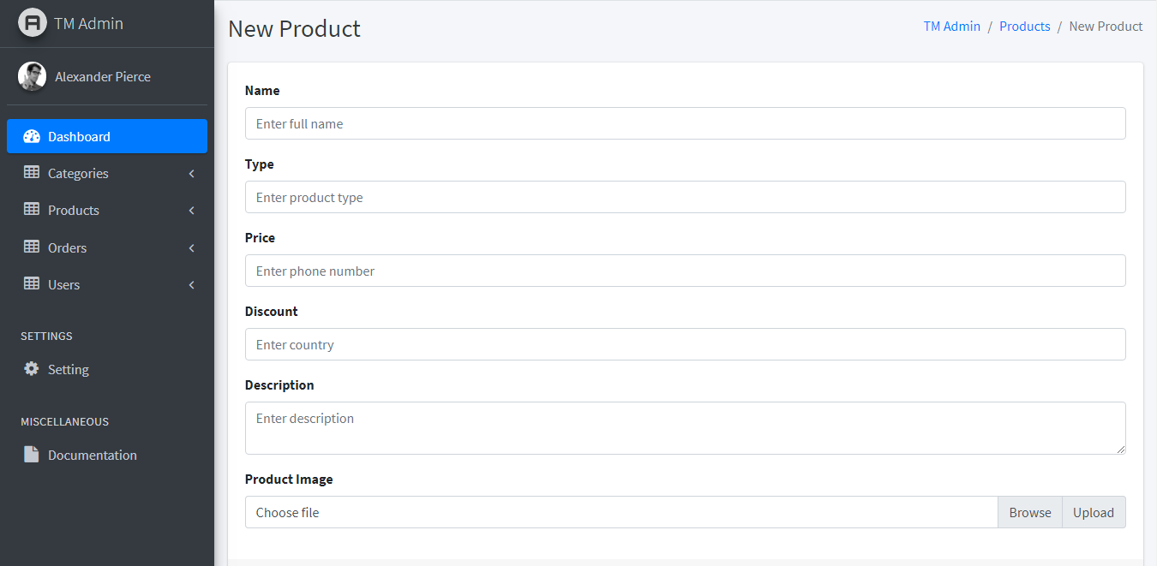

1. Admin Orders (URL: /admin/orders/list)

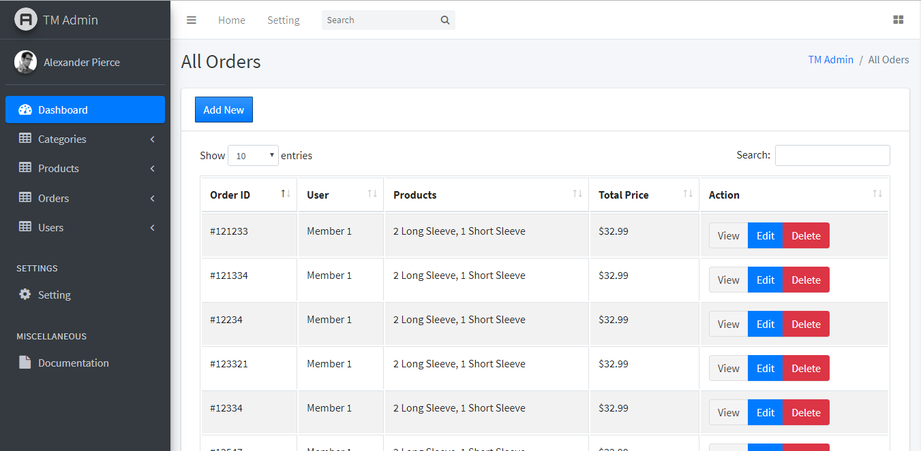

* New orders (URL: /admin/orders/new)

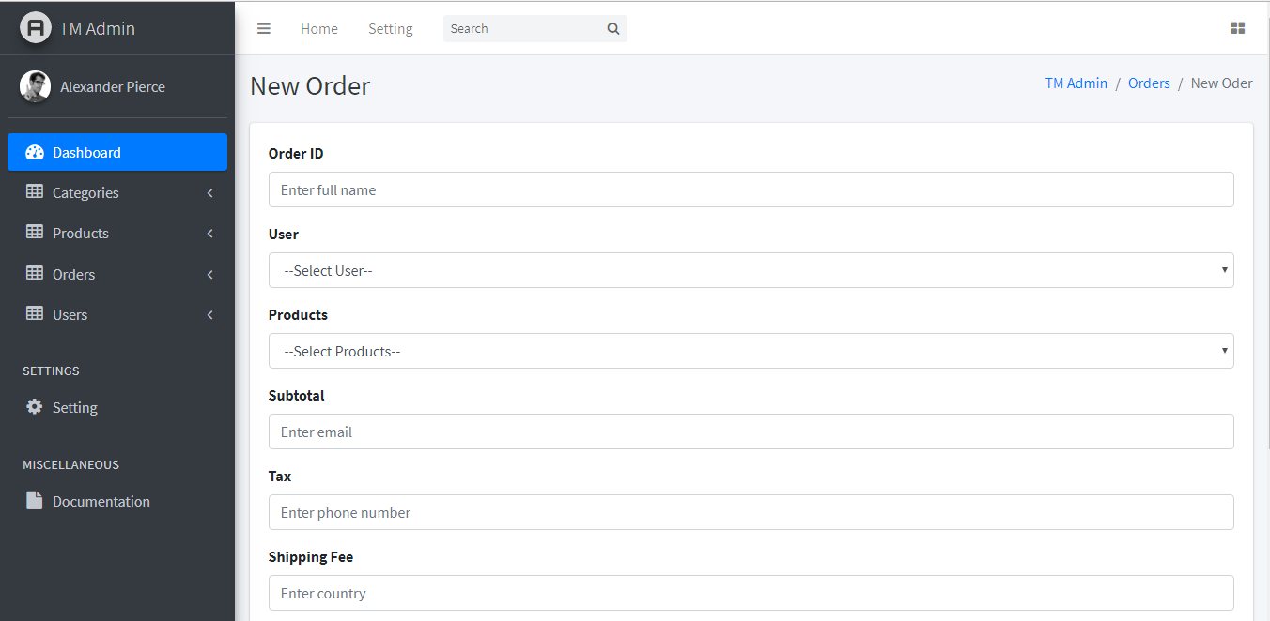

* Invoice (URL: /admin/orders/invoice)

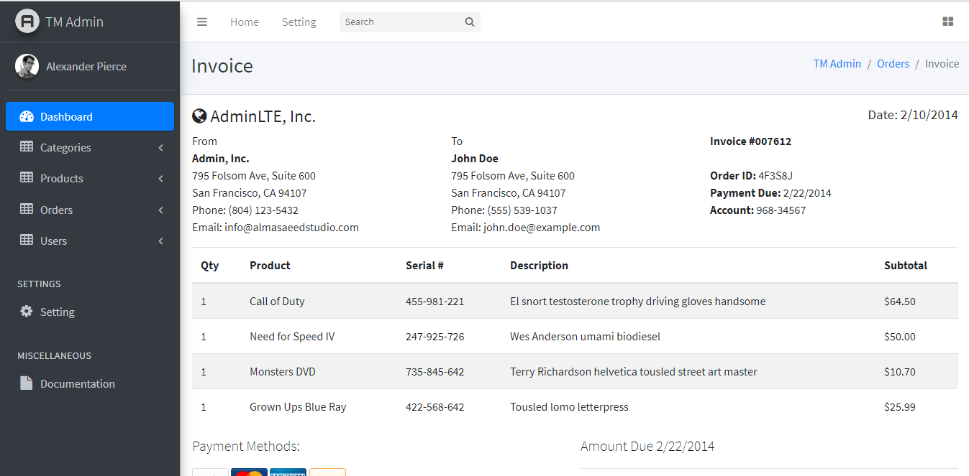

1. Admin Users (URL: /admin/users/list)

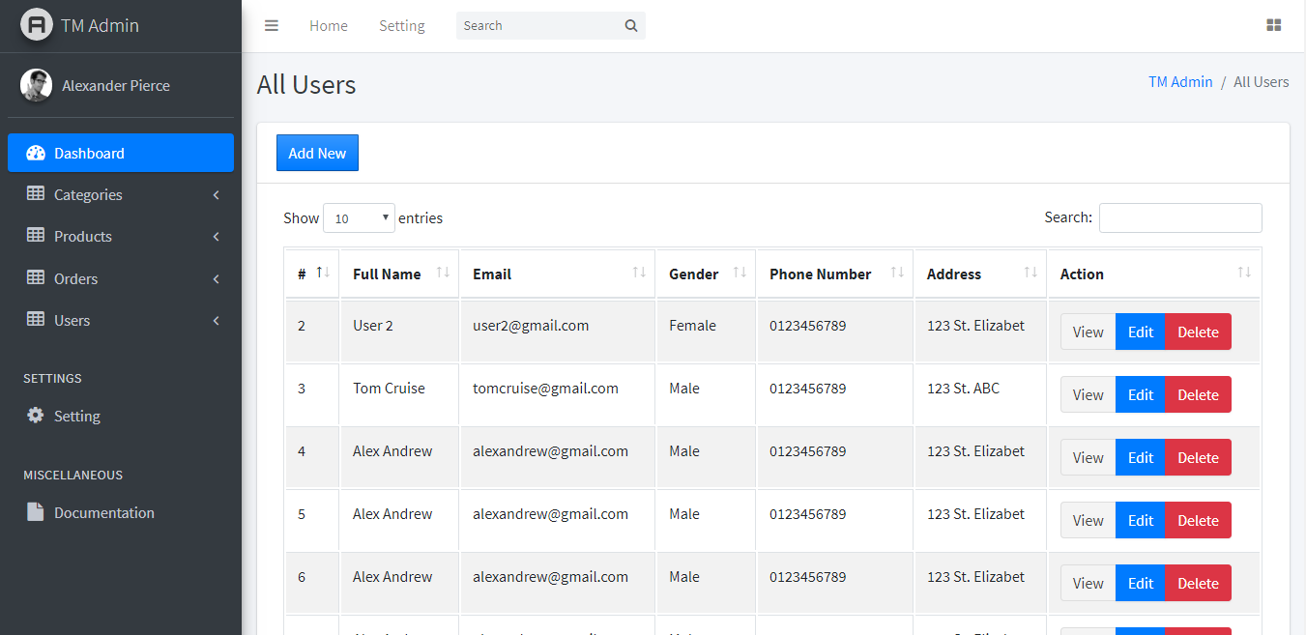

* New User (URL: /admin/users/new)

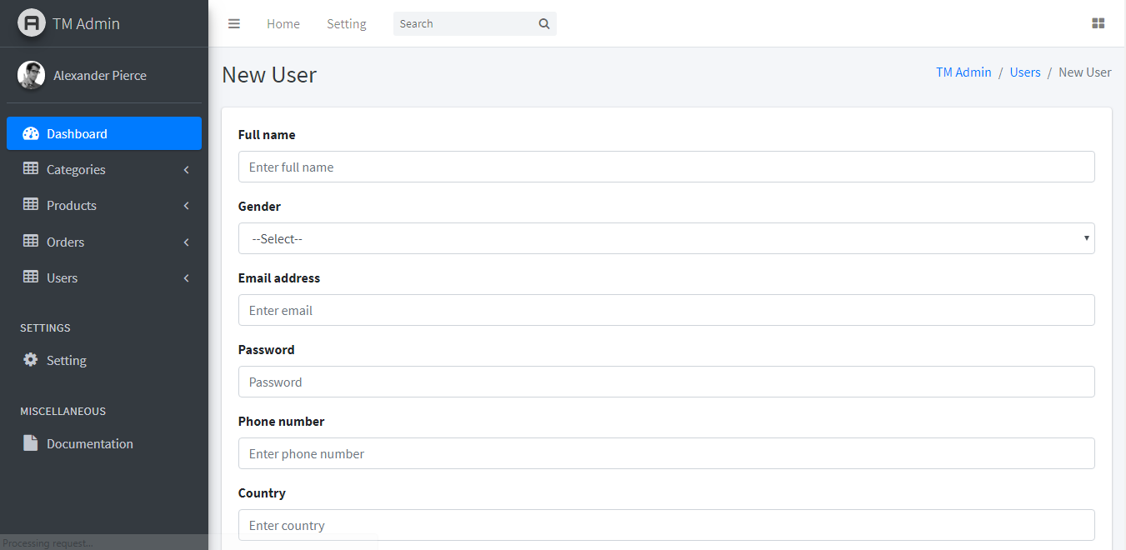

END