1.User posting information

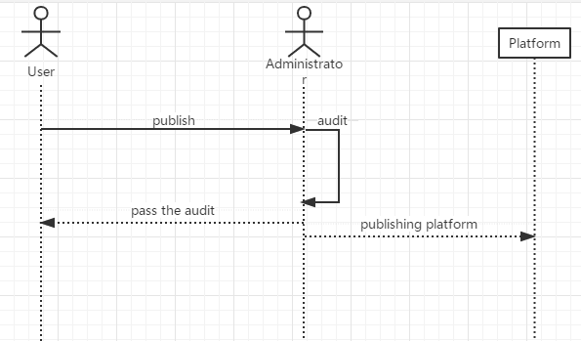

|  |  |
| --- | --- |
| Use Case UC-1： | User posting information |
| Related Requirements: | REQ1, REQ2 stated in Table 2-1 |
| Initiating Actor: | Any of: student, teacher, society |
| Actor’s Goal: | Enter the platform to publish service information |
| Participating Actors: | Wally |
| Preconditions: | • New users register through the login interface  • Old users can log in directly to enter the homepage |
| Post-conditions: | User-published information is subject to legal permission |
| Flow of Events for Main Success Scenario: | |
| → | 1.The user enters the main page through the account and password. |
| → | 2.Users can select the services they need on the home page or query the services they need and publish them to the platform. |
| ← | 3.Platform review passed and feedback to users. |

|  |  |
| --- | --- |
| Use Case UC-3： | User personal information input |
| Related Requirements: | REQ2，REQ3 stated in Table 2-1 |
| Initiating Actor: | Any of: student, teacher |
| Actor’s Goal: | Fill in your personal information after selecting the required service |
| Participating Actors: | Wally |
| Preconditions: | • User login into the interface  • The user has selected the required service |
| Post-conditions: | User-published information is subject to legal permission |
| Flow of Events for Main Success Scenario: | |
| → | 1.User enters personal information interface. |
| → | 2.The user enters the correct personal information on the personal information interface. |
| ← | 3.The platform has been approved and notified to the user. |