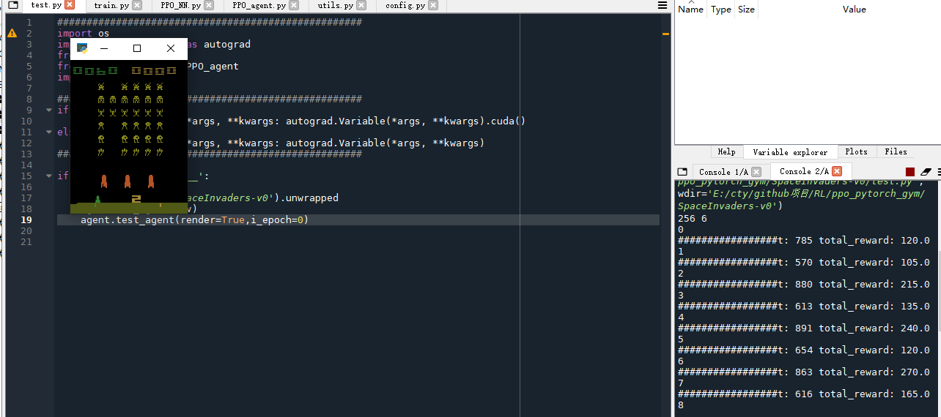

未经训练能生存500-1000steps，100-300分之间

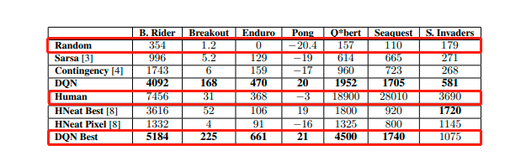

Playing Atari with Deep Reinforcement Learning