1. 交互时序图

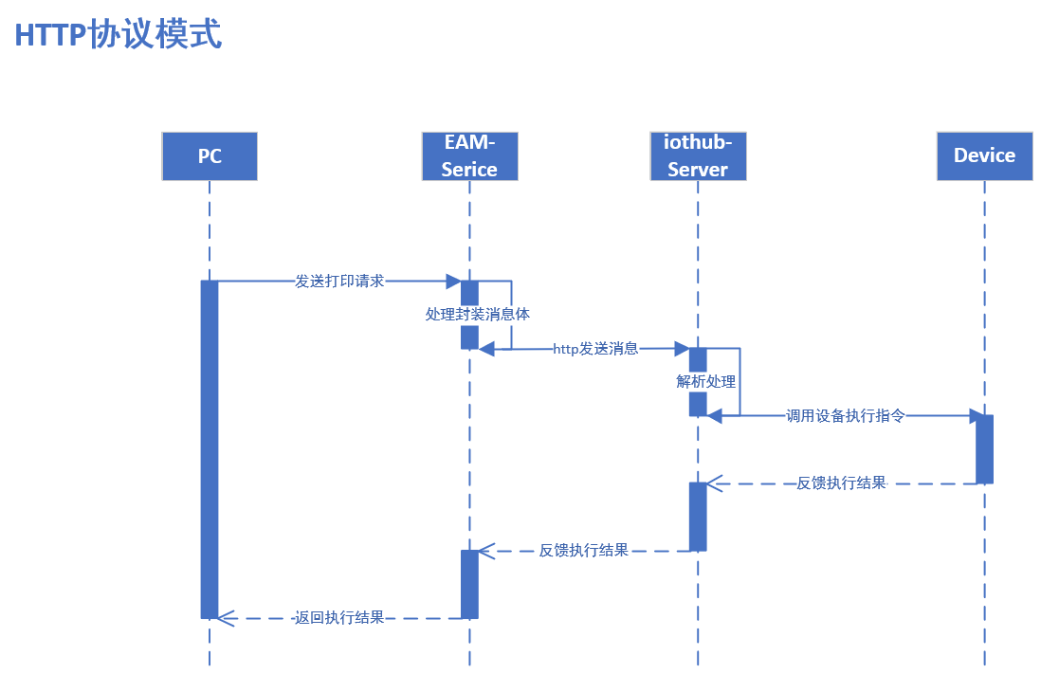

MQTT

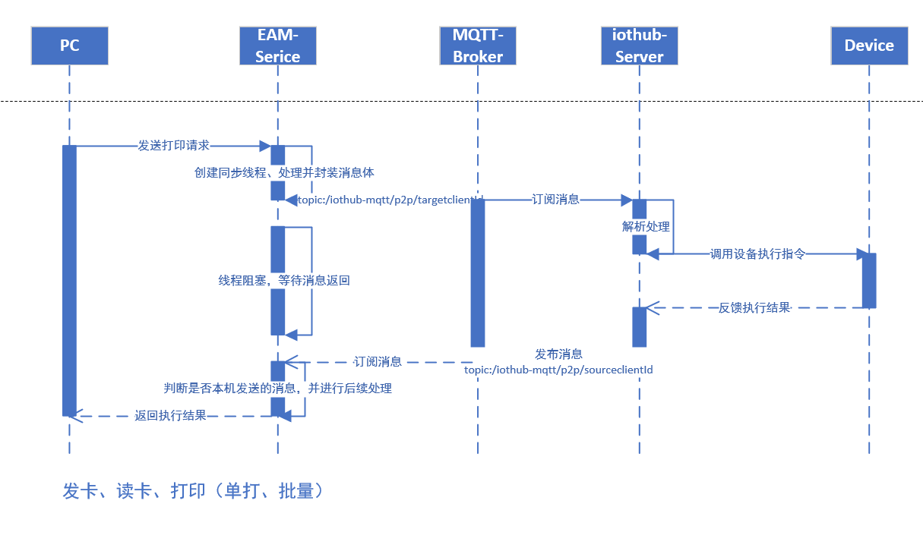

1. 请求协议规范
   1. HTTP接口
      1. 设备控制指令请求接口

|  |
| --- |
| **接口名称：**设备请求接口 |
| **接口描述：** |
| **请求方式：POST** |
| **URI:/iothub/api/action/execute** |
| **接口形式：restful** |
| **消息类型:application/json** |
| **输入参数：**  {      "actionInfo": {          "action": "PRINTER_PRINT",          "params": "[{\"PTK_ClearBuffer\":\"\"},{\"PTK_SetDarkness\":20},{},{\"PTK_SetDirection\":\"B\"},{\"PTK_SetLabelHeight\":\"900,24,0,false\"},{\"PTK_SetLabelWidth\":1200},{\"PTK_DrawRectangle\":\"23,5,4,817,204\"},{\"PTK_DrawLineOr\":\"24,51,791,4\"},{\"PTK_DrawLineOr\":\"25,87,791,4\"},{\"PTK_DrawLineOr\":\"24,126,791,4\"},{\"PTK_DrawLineOr\":\"24,163,359,4\"},{\"PTK_DrawLineOr\":\"381,51,4,151\"},{\"PTK_DrawLineOr\":\"573,52,4,77\"},{\"PTK_DrawLineOr\":\"171,53,4,150\"},{\"PTK_DrawText_TrueType\":\"286,6,44,0,Arial,1,400,0,0,0,资产管理中心\"},{\"PTK_DrawText_TrueType\":\"54,57,25,0,黑体,1,400,0,0,0,使用部门\"},{\"PTK_DrawText_TrueType\":\"227,57,25,0,黑体,1,400,0,0,0,财务部\"},{\"PTK_DrawText_TrueType\":\"54,94,25,0,黑体,1,400,0,0,0,资产编号\"},{\"PTK_DrawText_TrueType\":\"54,133,25,0,黑体,1,400,0,0,0,购买时间\"},{\"PTK_DrawText_TrueType\":\"54,168,25,0,黑体,1,400,0,0,0,启用时间\"},{\"PTK_DrawText_TrueType\":\"426,61,25,0,黑体,1,400,0,0,0,资产类型\"},{\"PTK_DrawText_TrueType\":\"217,97,25,0,黑体,1,400,0,0,0,A01252951\"},{\"PTK_DrawText_TrueType\":\"431,97,25,0,黑体,1,400,0,0,0,资产名称\"},{\"PTK_DrawText_TrueType\":\"624,95,25,0,黑体,1,400,0,0,0,彩色打印机\"},{\"PTK_DrawText_TrueType\":\"210,133,25,0,黑体,1,400,0,0,0,2021-07-22\"},{\"PTK_DrawText_TrueType\":\"210,170,25,0,黑体,1,400,0,0,0,2021-07-29\"},{\"PTK_DrawText_TrueType\":\"624,57,25,0,黑体,1,400,0,0,0,办公用品\"},{\"PTK_DrawText_TrueType\":\"429,148,25,0,黑体,1,400,0,0,0,使用人与保管人：王二\"}]"      },      "deviceInfo": {          "accessMode": "USB",          "clientId": "cscs",          "deviceMake": "POSTEK",          "deviceName": "博思得打印机",          "deviceType": "POSTEK",          "ip": "127.0.0.1",          "port": 888,          "serialPort": "255"      },      "messageId": "test_26a2ab4b2683",      "sourceClientId": "test_08fe277e0e7a"  } |
| **参数说明**：   |  |  |  |  |  | | --- | --- | --- | --- | --- | | 参数名称 | 类型 | 说明 | 示例值 | 是否必填 | | **messageId** | String | messageId可使用时间戳 | 123123123 | MQTT必填 | | **sourceClientId** | String | 来源客户端ID |  | MQTT必填 | | actionInfo  --action | String | 动作类型，打印、读卡、写卡  actionInfo为对象类型 | PRINTER_PRINT  RFID_READER_READ  RFID_READER_WRITE | 是 | | Actioninfo  --params | String | JsonStr 存放不同动作指令的参数  打印指令参考报文内容  如：写卡  params:"{\"epc\":\"2212312312312\",\"password\":\"12345678\"}" |  | 按需 | | DeviceInfo |  | 设备信息参数 | "deviceInfo":{  "deviceName":"设备名称",  "deviceType":"设备类型", //PRINTER、RFIDREADER、  "deviceMake":"POSTKET", //POSTKET、ZEBRA 、CYKEO  "accessMode":"NETWORK", //接入方式 NETWORK or USB  "ip":"192.1.1.1", //ip  "port":"9100", //port  "serialPort":"COM8:115200", //串口号 USB模式需填写  "clientId":"" //关联客户端id }, | 必须 | |  |  |  |  |  | |
| **输出结果:**  {  "success": false,  "code": 0,  "msg": "",  "messageId": "",  "data": {}  } |
| **结果说明：**  **success 请求结果 布尔值**  **code 0为成功非0 为失败，后续扩展定义多种code含义**  **msg为结果说明**  **messageId 对应MQTT模式下messageId 非必要**  **data为请求响应数据，不同设备的请求data内容不同** |
|  |

* + 1. 健康检查接口（electron客户端调用）

|  |
| --- |
| **接口名称：健康检查接口** |
| **接口描述：** |
| **请求方式：GET** |
| **URI:/iothub/api/health** |
| **接口形式：restful** |
| **消息类型:application/json** |
| **输入参数：** |
| **参数说明**： |
| **输出结果:**  **UP or DOWN** |
| **结果说明：** |

MQTT使用说明

1. 采用p2p的消息发送方式，接收方无需订阅，参考
   1. <https://help.aliyun.com/document_detail/96176.html>

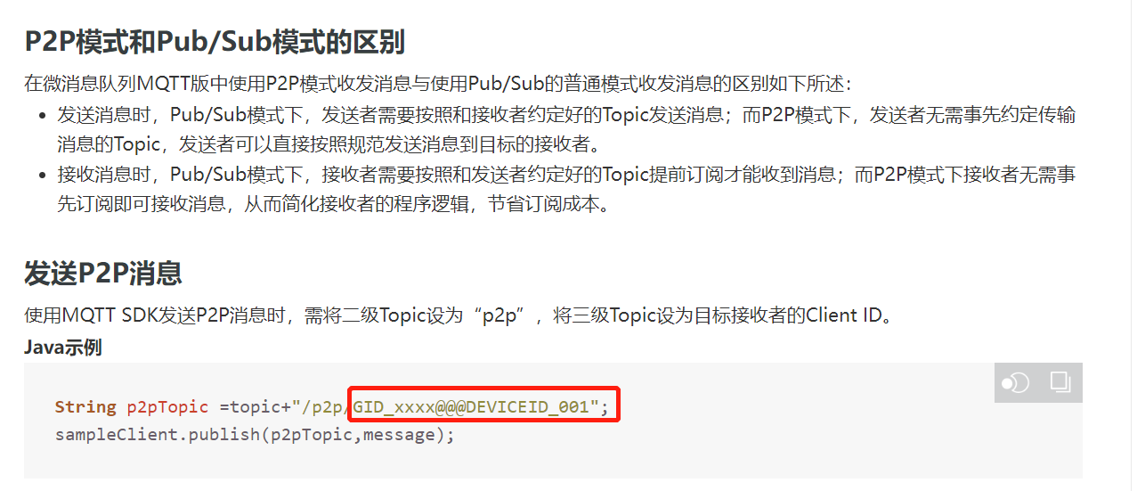

主题定义 topic在阿里云创建，固定值如： iothub-mqtt

Group在阿里云创建 区分测试和生产：如GID_EAM_PROD、GID_EAM_TEST

1. MQTT请求与相应消息报文格式与上述接口定义中http报文格式一致，实际开发过程中按需调整

|  |
| --- |
| **{**  **"messageId": "123123123",**  **"sourceClientId": "",**  **"actionInfo": {**  **"action": "",**  **"params": ""**  **},**  **"deviceInfo": {**  **"deviceName": "",**  **"deviceType": "",**  **"deviceMake": "",**  **"accessMode": "",**  **"ip": "",**  **"port": 0,**  **"serialPort": "",**  **"clientId": ""**  **}**  **}** |