Update files in cvs:

After installation of Putty run puttygen.exe

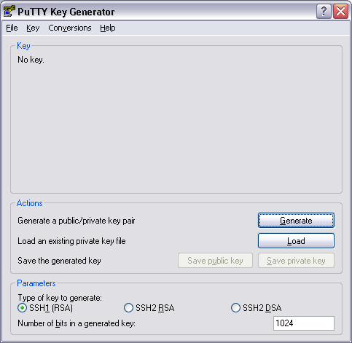

Press generate and Follow instructions

Save public and private keys.

Open pageant .exe
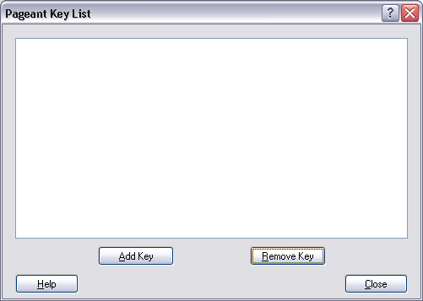

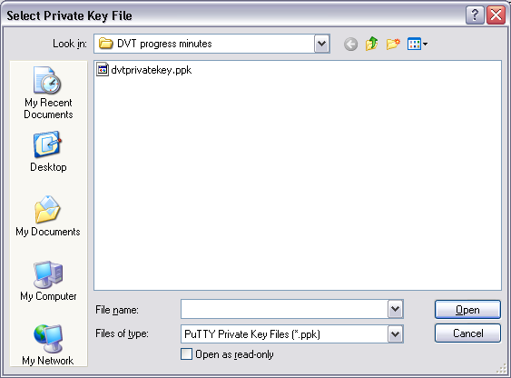

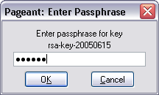

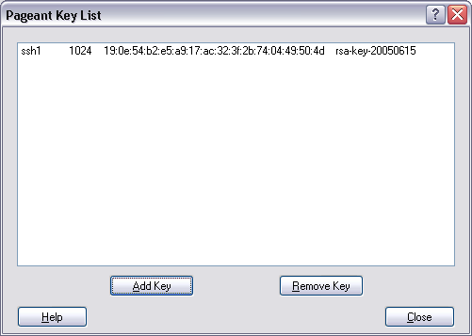

Goto SF site and to your personal page.

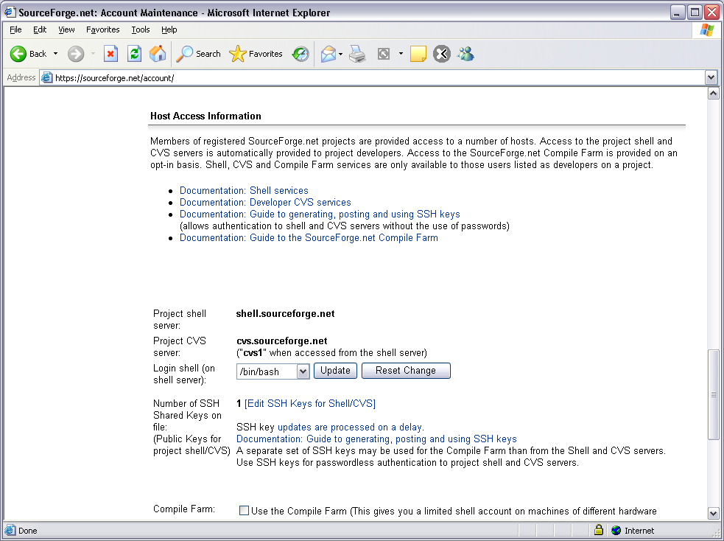

Press edit ssh keys for shell/cvs

Copy key form putty into memofield
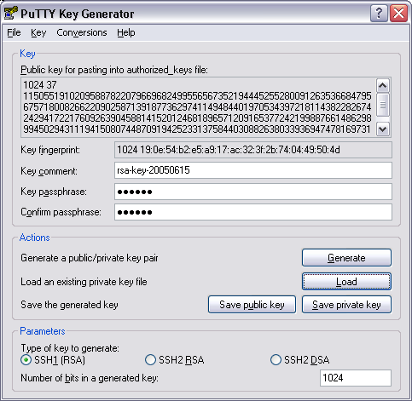
Close Page.

Wait for 10 minutes until you can use this.

