***EX NO :2***

***DATE :10/10/2020***

**AIM:**

To Write and run **Python function** **countX(lst, x)** to count the number x in a given list of numbers.

**PROGRAM:**

def countX(list,s):

c=0

for i in range(0,len(list)):

if(list[i]==s):

c+=1

print(c)

list=[]

x=int(input())

for i in range(0,x):

list.append(int(input()))

s=int(input())

countX(list,s)

**LINK:**

<http://103.53.53.18/mod/vpl/forms/edit.php?id=230&userid=1793>

**OUTPUT:**

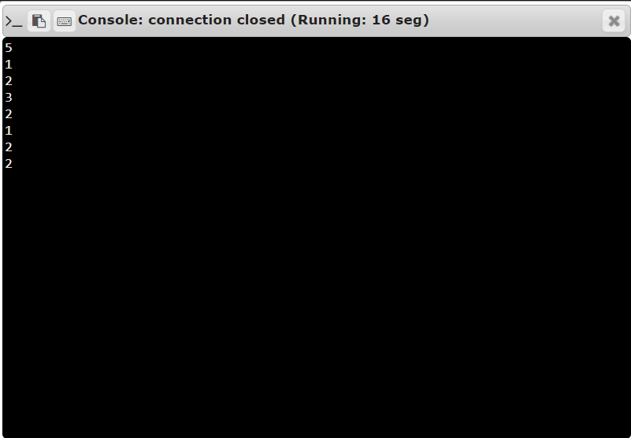

**RESULT:**

Thus, we run **Python function countX(lst, x)** to count the number x in a given list of numbers successfully.