***EX NO: 3***

***DATE: 10/10/2020***

**AIM:**

To write and run **Python program to remove and print every second number from a list of numbers until the list becomes empty**.

**PROGRAM:**

def remove3number(list):

temp=[]

p=1

s=0

for i in range(0,len(list)):

s=(p+s)%len(list)

el=list.pop(s)

temp.append(el)

return temp

n=int(input())

list=[]

for i in range(0,n):

list.append(int(input()))

p=remove3number(list)

print(p)

**LINK:**

<http://103.53.53.18/mod/vpl/forms/edit.php?id=231&userid=1793>

**OUTPUT:**

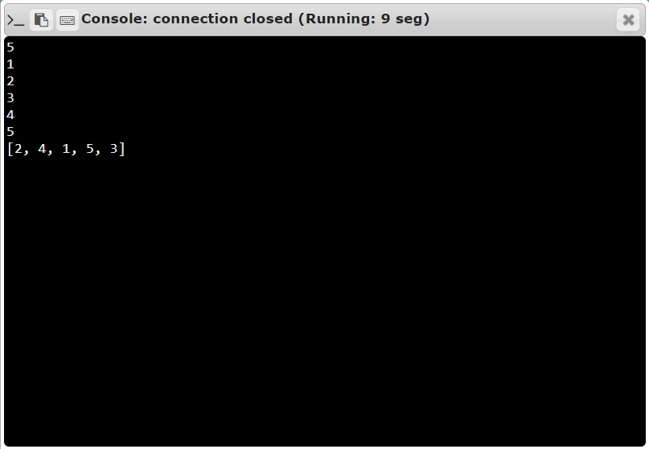

**RESULT:**

Thus, we executed Python program to remove and print every second number from a list of numbers until the list becomes empty successfully.