***EX NO: 5***

***DATE: 10/10/2020***

**AIM**:

We aim to make a string Pangram i.e., printing the missing alphabets from the given sentence.

**PROGRAM:**

a = input("enter the input sentence: ")

a = set(a.strip())

a.remove(chr(32))

b = "abcdefghijklmnopqrstuvwxyz"

b = set(b)

b = b.difference(a)

b = list(b)

b.sort()

print("".join(b))

**LINK:**

[http://103.53.53.18/mod/vpl/forms/edit.php?id=235&userid=1788#](http://103.53.53.18/mod/vpl/forms/edit.php?id=235&userid=1788)

**OUTPUT:**

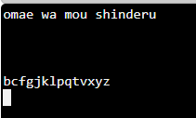

**RESULT:**

Thus, we run a Python program to make a string Pangram i.e., printing the missing alphabets from the given sentence Successfully.