Exploratory Data Analysis on Titanic Dataset
Dataset source: Titanic.csv
Number of records: 891
Objective
- To analyze the factors that influenced passenger survival during the Titanic .
- The goal is to identify key patterns, relationships, and insights that explain survival outcomes.

Table of Contents
1. Introduction
2. Data Loading & Preview
3. Missing Values & Cleaning
4. Feature Engineering
5. Univariate Analysis
6. Bivariate Analysis
7. Correlation Analysis
8. Insights & Conclusions
9. Code Appendix

1. Introduction
Objective: Explore the Titanic dataset to find patterns that affected passenger survival. The report includes data preview, cleaning steps, summary statistics, visualizations, and insights.

2. Data Loading & Preview
First 10 rows of the original dataset:
PassengerId | Survived | Pclass | Name | Sex | Age | SibSp | Parch | Ticket | Fare | Cabin | Embarked
1 | 0 | 3 | Braund, Mr. Owen Harris | male | 22.0 | 1 | 0 | A/5 21171 | 7.25 | nan | S
2 | 1 | 1 | Cumings, Mrs. John Bradley (Florence Briggs Thayer) | female | 38.0 | 1 | 0 | PC 17599 | 71.2833 | C85 | C
3 | 1 | 3 | Heikkinen, Miss. Laina | female | 26.0 | 0 | 0 | STON/O2. 3101282 | 7.925 | nan | S
4 | 1 | 1 | Futrelle, Mrs. Jacques Heath (Lily May Peel) | female | 35.0 | 1 | 0 | 113803 | 53.1 | C123 | S
5 | 0 | 3 | Allen, Mr. William Henry | male | 35.0 | 0 | 0 | 373450 | 8.05 | nan | S
6 | 0 | 3 | Moran, Mr. James | male | nan | 0 | 0 | 330877 | 8.4583 | nan | Q
7 | 0 | 1 | McCarthy, Mr. Timothy J | male | 54.0 | 0 | 0 | 17463 | 51.8625 | E46 | S
8 | 0 | 3 | Palsson, Master. Gosta Leonard | male | 2.0 | 3 | 1 | 349909 | 21.075 | nan | S
9 | 1 | 3 | Johnson, Mrs. Oscar W (Elisabeth Vilhelmina Berg) | female | 27.0 | 0 | 2 | 347742 | 11.1333 | nan | S
10 | 1 | 2 | Nasser, Mrs. Nicholas (Adele Achem) | female | 14.0 | 1 | 0 | 237736 | 30.0708 | nan | C

3. Missing Values & Cleaning
Missing values before cleaning:
Column | MissingCount | MissingPercent
PassengerId | 0 | 0.0
Survived | 0 | 0.0
Pclass | 0 | 0.0
Name | 0 | 0.0
Sex | 0 | 0.0
Age | 177 | 19.87
SibSp | 0 | 0.0
Parch | 0 | 0.0
Ticket | 0 | 0.0
Fare | 0 | 0.0
Cabin | 687 | 77.1
Embarked | 2 | 0.22
Cleaning steps applied:
- Filled Age with median.
- Filled Embarked with mode.
- Dropped Cabin column due to many missing values (if present).

4. Feature Engineering
Added a 'FamilySize' column (SibSp + Parch + 1) and a 'FamilyBucket' column (Alone / Small / Large).
Survival rate by family bucket:
FamilyBucket | SurvivalRate
Alone | 0.304
Large | 0.161
Small | 0.579

5. Univariate Analysis
Key univariate visuals: Survival counts and Age distribution.
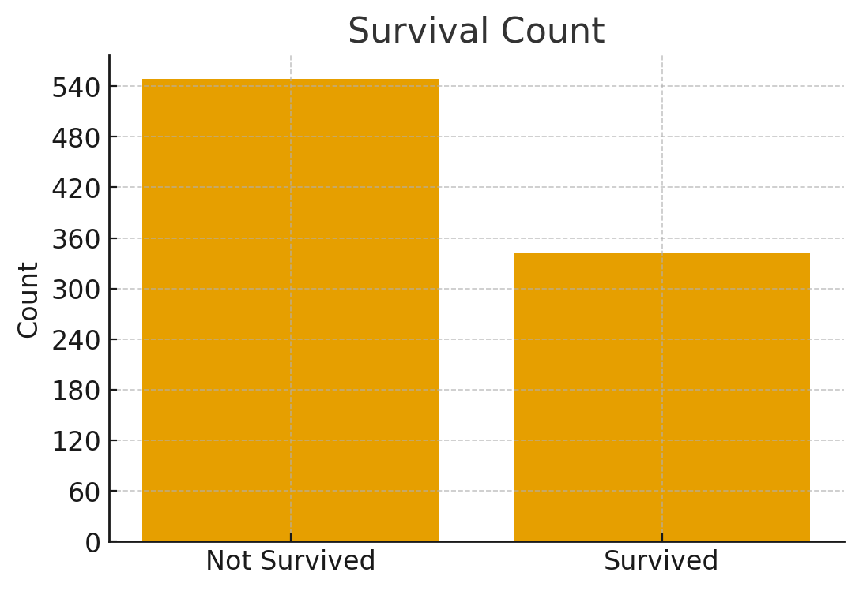

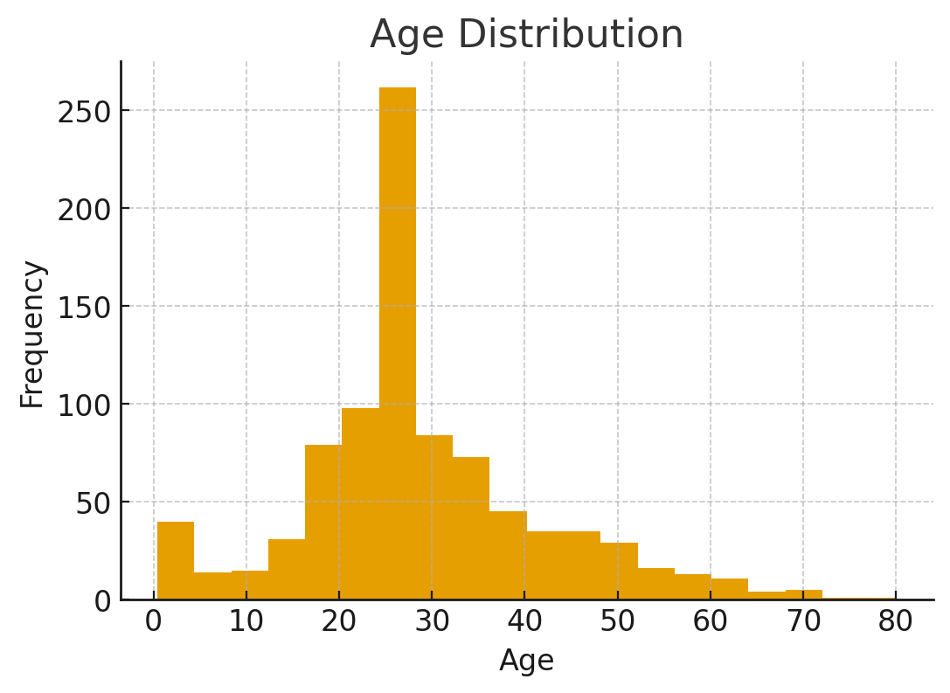

6. Bivariate Analysis
Survival rate by Sex and by Pclass, and Age distribution by survival.
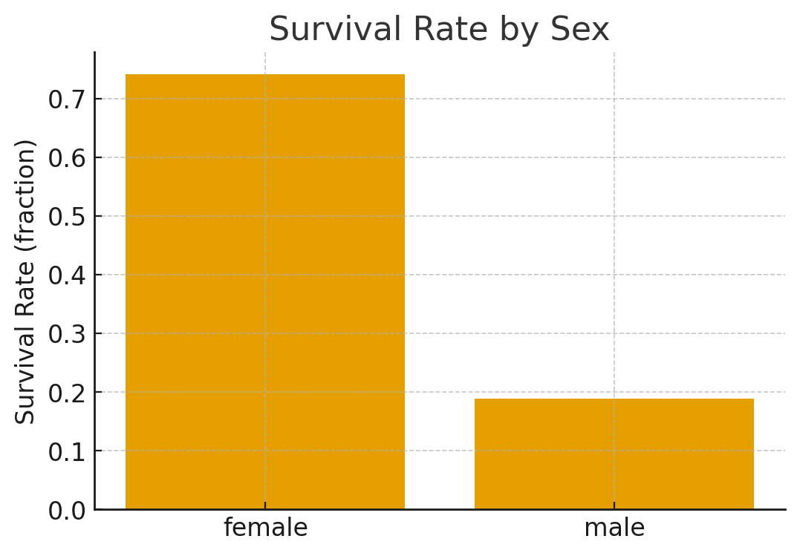

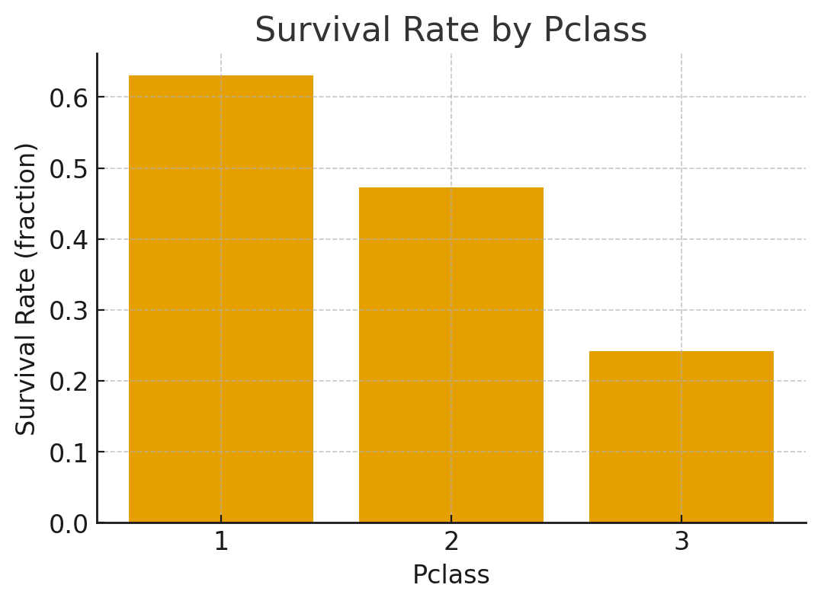

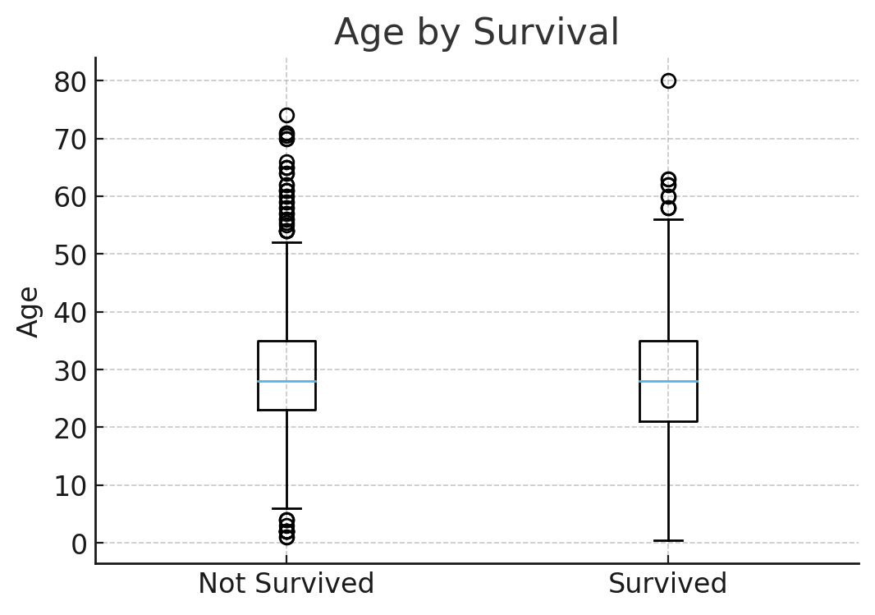

7. Correlation Analysis
Correlation matrix of numeric columns:
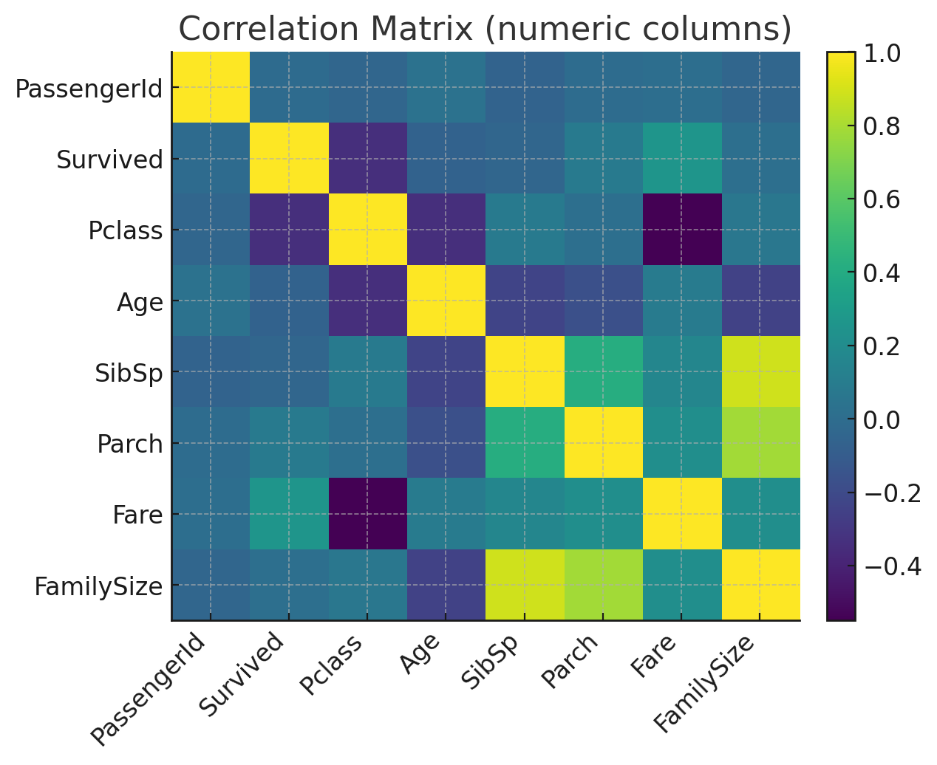
Correlation (numeric) summary:
 | PassengerId | Survived | Pclass | Age | SibSp | Parch | Fare | FamilySize
PassengerId | 1.000 | -0.005 | -0.035 | 0.034 | -0.058 | -0.002 | 0.013 | -0.040
Survived | -0.005 | 1.000 | -0.338 | -0.065 | -0.035 | 0.082 | 0.257 | 0.017
Pclass | -0.035 | -0.338 | 1.000 | -0.340 | 0.083 | 0.018 | -0.549 | 0.066
Age | 0.034 | -0.065 | -0.340 | 1.000 | -0.233 | -0.172 | 0.097 | -0.246
SibSp | -0.058 | -0.035 | 0.083 | -0.233 | 1.000 | 0.415 | 0.160 | 0.891
Parch | -0.002 | 0.082 | 0.018 | -0.172 | 0.415 | 1.000 | 0.216 | 0.783
Fare | 0.013 | 0.257 | -0.549 | 0.097 | 0.160 | 0.216 | 1.000 | 0.217
FamilySize | -0.040 | 0.017 | 0.066 | -0.246 | 0.891 | 0.783 | 0.217 | 1.000

8. Insights & Conclusions
Gender was the strongest survival predictor → Women had ~74% survival rate vs only ~19% for men (nearly 4x higher)
Passenger class had a massive impact on survival → 1st Class: ~63% survived 2nd Class: ~47% survived 3rd Class: ~24% survived → Clear evidence of "class privilege" during evacuation
Optimal family size dramatically increased survival odds → Passengers with small families (2–4 members) had the highest survival rate: 58% → Solo travelers: 30% | Large families (5+): only 16%
Children (especially young ones) and women in 1st/2nd class were prioritized → Supports the "Women and Children First" protocol
Higher fare strongly correlated with survival (r = 0.257) → Wealthier passengers (higher fare = better cabin location) had better access to lifeboats
Pclass was the most negatively correlated feature with survival (r = -0.338) → Lower class number (higher status) → much higher chance of survival
Port of Embarkation (Embarked) showed indirect impact → Passengers from Cherbourg (C) had higher survival (~55%) — likely because more 1st-class passengers boarded there more
Age had mild influence → Younger passengers (especially <10 years) survived more, but gender/class dominated

9. Code Appendix
Below are the main code snippets used to generate the analysis and visuals.
Loading & basic info
import pandas as pd
df = pd.read_csv("Titanic.csv")
df.info()
df.head()
Cleaning
df['Age'].fillna(df['Age'].median(), inplace=True)
df['Embarked'].fillna(df['Embarked'].mode()[0], inplace=True)
df.drop(columns=['Cabin'], inplace=True)
Feature engineering
df['FamilySize'] = df['SibSp'] + df['Parch'] + 1
def fam_bucket(n):
if n == 1:
return 'Alone'
elif 2 <= n <= 4:
return 'Small'
else:
return 'Large'
df['FamilyBucket'] = df['FamilySize'].apply(fam_bucket)
plot (survival count)
import matplotlib.pyplot as plt
counts = df['Survived'].value_counts().sort_index()
plt.bar(['Not Survived','Survived'], counts.values)
plt.title('Survival Count')
plt.ylabel('Count')
plt.show()

