**MyEclipse10仅7步成功破解激活(图解)**

2012-04-01 23:18:57|  分类： [Web Development](http://xly3000.blog.163.com/blog/#m=0&t=1&c=fks_084066085087089069080082080095085085083071086082081) |  标签：[myeclipse](http://xly3000.blog.163.com/blog/" \l "m=0&t=3&c=myeclipse)  [crack](http://xly3000.blog.163.com/blog/#m=0&t=3&c=crack)  |字号 订阅

* **准备文件**①JDK：[jdk-6u29-windows-i586.exe](http://www.oracle.com/technetwork/java/javase/downloads/jdk-6u29-download-513648.html" \t "_blank)   
  ②网盘MyEclipse10：[http://115.com/file/dpl3fjfc](http://115.com/file/dpl3fjfc" \o "http://115.com/file/dpl3fjfc" \t "_blank)   
     官网MyEclipse10：[http://downloads.myeclipseide.com/downloads/products/eworkbench/indigo/installers/myeclipse-10.0.2-offline-installer-windows.exe](http://downloads.myeclipseide.com/downloads/products/eworkbench/indigo/installers/myeclipse-10.0.2-offline-installer-windows.exe" \o "http://downloads.myeclipseide.com/downloads/products/eworkbench/indigo/installers/myeclipse-10.0.2-offline-installer-windows.exe" \t "_blank)   
  ③破解补丁文件：[Google检索后自己下载myeclipse10 Crack](http://www.google.com.hk/search?hl=zh-CN&as_q=myeclipse10+Crack&as_epq=&as_oq=&as_eq=&as_nlo=&as_nhi=&lr=&cr=&as_qdr=all&as_sitesearch=&as_occt=any&safe=active&tbs=&as_filetype=&as_rights=)
* **前提**①已经安装JDK。   
  ②已经安装MyEClipse10，并且安装完后没有启动过。   
  这里测试通过的是：myeclipse-10.0.2-offline-installer-windows.exe。   
  目前最新的版本还没有办法破解：myeclipse-10.1-offline-installer-windows.exe。
* **破解步骤**   
  **①**启动破解文件MyEclipse10crack1.0.exe(有些破解文件是先运行run.bat等等，用的都是同一个东西。)   
  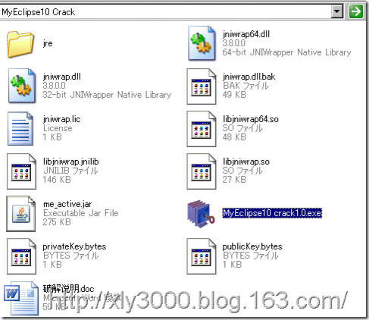   
  **②**Usercode输入任意值，选择版本，然后点击SystemId按钮，生成ID。   
  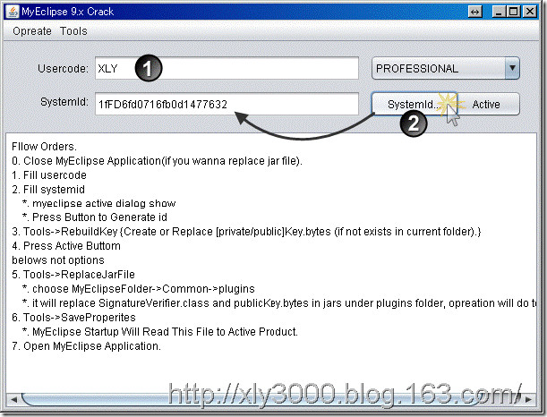   
  **③**点击菜单Tools→0.RebuildKey   
  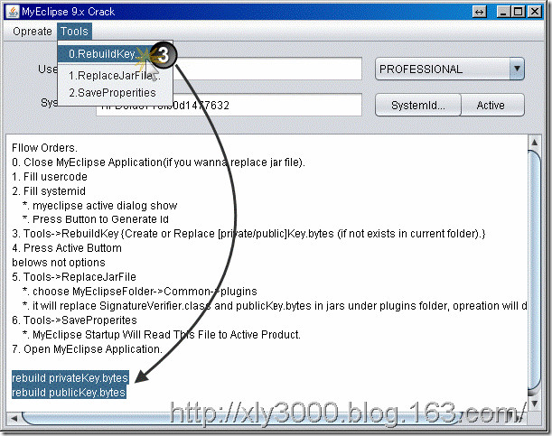   
  **④**点击Active按钮，生成LICENESS KEY。最好保存下。   
  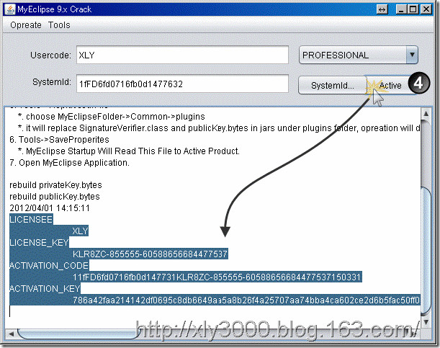   
  **⑤**点击菜单Tools→1.ReplaceJarFile→选择安装路径(plugins)→打开(会卡一会儿，成功后底下显示替换信息)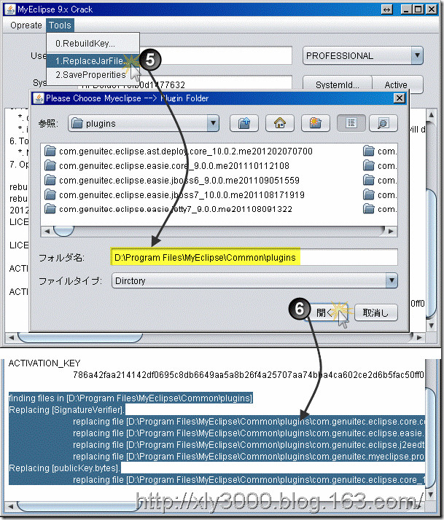   
  **⑥**点击菜单Tools→2.SaveProperities   
  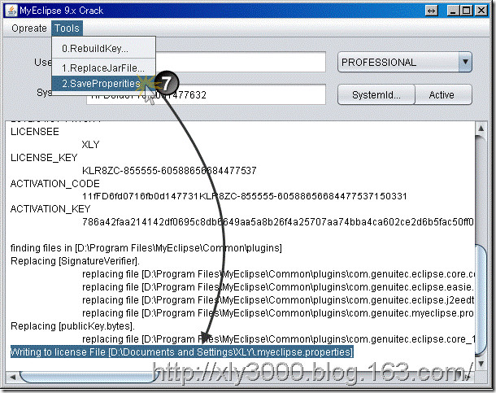   
  **⑦**启动MyEclipse10，然后在Subscription里面确认激活状态，这里激活后可以用3年。   
  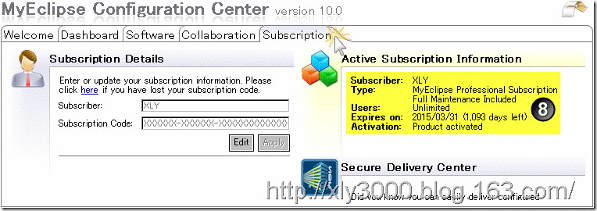   
  **⑧**如果启动还需要输入注册码，就把第**④**步里保存的信息复制过来一一输入就行。