1. 搜索框

<!DOCTYPE html>

<html lang="en">

<head>

<link type="text/css" rel="stylesheet" href="css/bootstrap.css">

</head>

<body>

<form class="well form-search">

<input type="text" class="span4-query" placeholder="搜索">

<button class="btn">搜索</button>

</form>

<script src="js/bootstrap.js"></script>

</body>

</html>

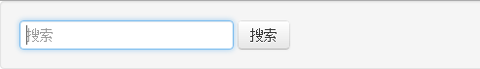

1. 登录界面

<form class="well form-inline">

<input type="text" class="span3" placeholder="Username..."/>

<input type="password" class="span3" placeholder="Password"/>

<button type="submit" class="btn btn-primary" >提交</button>

</form>

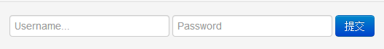

1. 下拉框

<ul class="nav nav-pills nav-stacked span3" >

<li><a href="#">Home</a><li>

<li class="active"><a href="#">About</a><li>

<li><a href="#">Products</a><li>

<li><a href="#">Services</a><li>

<li><a href="#">Contact</a><li>

</ul>

不同排布，有不同的效果，其中单单只用

<ul class=”nav nav-tabs”>



加上 左图是nav-statcked span3 右图就是上述代码

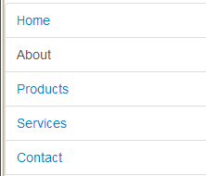 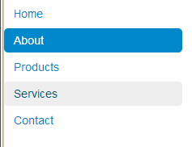

1. Button应用

<div class="well-small">

<button class="btn btn-danger"><i class="icon-trash

icon-white"></i> Delete</button>

<button class="btn btn-large"><i class="icon-comment icon-black"></i>Move comment</button>

<button class="btn btn-inverse"><i class="icon-refresh icon-black"></i>Refresh</button>

</div>

