

**Universidad Politécnica de Victoria**

**Ingeniería en tecnologías de la información**

Asignatura: Diseño de Interfaces

# Sistema Nelly’s Boutique

Erick Elizondo Rodríguez

1530061

# Table of Contents

Table of Contents........................................................................ 2

Version Information............................................................. 2

Introduction ................................................................................ 3

About this document ............................................................ 3

References.......................................................................... 3

Graphic treatment................................................................ 3

Structure and Navigation ............................................................. 4

Navigation........................................................................... 4

Page Descriptions ....................................................................... 6

1.1.2 Train Timetable .................................................................. 7

Description.......................................................................... 7

Navigation........................................................................... 7

Issues ................................................................................. 7

Elements .................................................................................... 8

## Version Information

Versión 1.0 Información y Diseño, Noviembre 2017

# Introduccion

Este documento describe la interfaz de usuario así como las interacciones de usuario en el proyecto Sistema Nelly’s Boutique, que fue desarrollado para gestionar la parte administrativa y financiera de la empresa Nelly’s Boutique, ubicada en Ciudad Victoria, Tamaulipas, teniendo así como un propósito adicional el proveer de una interfaz amigable y adecuada para el personal del establecimiento, para así lograr un incremento en la eficacia del negocio, el sistema además fue diseñado para que fuera alojado en una plataforma web utilizando software libre, lo que permite aun mas la flexibilidad de trabajo.

## Acerca de este documento

Lo que esta a continuacion en el document se divide en las siguientes secciones:

* *Estructura y Navegacion* describe la estructura de la aplicacion y las maneras en que esta puede ser negative para los usuarios.
* *Descripcion de las pantallas,* compone la parte principal del document, y contiene una descripcion detallada de cada interfaz asi como sus components.
* Los anexos contienen una lista complete de archivos que apoyen el documento.

## Referencias

*[Project] Design Brief*, dated February 8 2002.

*[Project] Preliminary Design Workshop report*, dated March 8 2002.

*[Project] Usability Walkthrough report*, dated March 24 2002.

## Tratamiento Grafico

No graphic treatment has been conducted. Therefore, the screen representations in this document should be considered as indicative of the elements to be contained within pages; rather than a representation of their appearance.

# Estructura y Navegacion

La estructura de navegación de la aplicación es simple, y se presenta como se muestra en el siguiente diagrama.

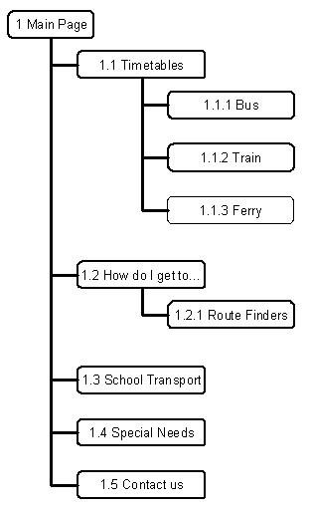

There are four primary elements in the site, and each of these may be accessed directly from the main page (in addition to the

‘Contact us’ information).

The structure is further broken down in the following diagrams.

[Diagrams]

## Navegacion

Within the pages, primary navigation is provided on the top of the screen, in a horizontal list of graphical links. Secondary navigation is provided on the left, in a vertical list of text links.

[Diagrams]

Pages are displayed in a single browser window, with the exception of indivdual timetables, which are shown in a pop-up. The pop-up contains no browser controls. Links are provided to Close and Print.

[Diagram]

# Page Descriptions

This major part of the document contains detailed descriptions of each screen in [Project name].

Unless otherwise noted, no graphic treatment has yet occurred.

# 1.1.2 Train Timetable

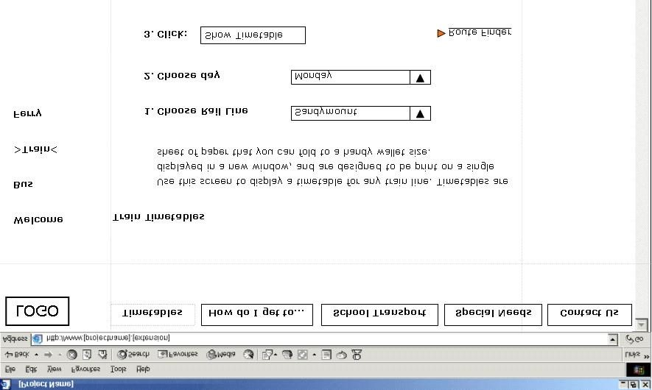

**Description**

The Train Timetable screen enables the user to specify a rail line and day of week.

On submitting, the [project name] displays the requested timetable in the popup window.

## Navigation

[A brief description of how this page or screen is accessed.]

Navigation to the screen is by clicking the ‘Train’ link in the secondary navigation area.

Note that this page is also reached from multiple external sites.

## Issues

[List any unresolved issues or special conditions or considerations.]

1. The list of rail lines does not specify direction of travel (for example, Northbound). Further exploration is recommended.

1. The URL of this page should be kept stable because of the number of external links.

# Elements

The following is a list of all elements in this screen.

[Some sample elements included here. Use a pro-forma to ensure consistent treatment for all elements in any set.]

## ‘Rail Line’

|  |  |
| --- | --- |
| **Type:** | Dropdown list box |
| **Label:** | ‘Rail Line’ |
| **Content:** | List of all rail lines, sorted alphabetically, preceded by the default. |
| **Default:** | ‘Choose from this list’ if the user has accessed the page from an external link, or without previously choosing a rail line.  A specific rail line if the user has chosen one on a previous screen. |
| **Behaviour:** | Standard. |
| **Comment:**    **[Option button set]** | None. |
| **Type:** | Option (‘radio’) button set. |
| **Label:** |  |
| **Default:** | . |
| **Behaviour:** |  |
| **Comment:**    **[Field]** |  |
| **Type:** | Field. |
| **Label:** |  |
| **Length:** |  |
| **Default:** | . |
| **Validation:** | [Describes valid entries.] |
| **Behaviour:** |  |
| **Comment:**    **[Text link]** |  |
| **Type:** | Text link. |
| **Behaviour:** | [Describes what happens when the link is clicked.] |
| **Comment:** |  |