Project Name |  | Confidentiality Level
Database Management System |  | For Recipients’ Reference Only
Project ID | Version | Document Code
BP | 1.0 | Project ID_SD_001

Database Management System Software System Design Specification



Copyright © Ruankosoft Technologies(Shenzhen), Co., Ltd.
. All Rights Reserved
Revision Record
Date | Revision Version | CR ID /Defect ID | Sec No. | Change Description | Author

Content
1 Introduction 5
1.1 Purpose 5
1.2 Scope 5
1.2.1 Name 5
1.2.2 Functions 5
1.2.3 Applications 5
2 Level 0 Design Description 5
2.1 Software System Context Definition 5
2.2 Design Considerations 5
2.2.1 Design Alternatives 5
2.2.2 Design Constraints 5
2.2.3 Other Design Considerations 6
3 Level 1 Design Description 6
3.1 System Architecture 6
3.1.1 Description of the Architecture 6
3.1.2 Representation of the Business Flow 6
3.2 Decomposition Description 6
3.2.1 Module/Subsystem 1 Description 6
3.2.2 Module/Subsystem 2 Description 6
3.3 Dependency Description 6
4 Level 2 Design Description (Optional) 6
4.1 Module Name 1 7
4.1.1 Design Description 7
4.1.2 Function Illustration 7
4.2 Module Name 2 7
4.2.1 Design Description 7
4.2.2 Function Illustration 7
5 Data Structure/Database Design 7
6 UI Design 7
7 Detailed Design of Module 8
7.1 Class1 Design 8
7.1.1 Overview 8
7.1.2 Class Diagram 8
7.1.3 Attributes 8
7.1.4 Methods 8
7.2 Class2 Design 9

Keywords:
Abstract:
List of abbreviations: Describe abbreviations in this document, full spelling of the abbreviation and Chinese explanation should be provided.>
Abbreviations | Full spelling | Chinese explanation
SDI | Single Document Interface | 单文档界面
MFC | Microsoft Foundation Classes | 微软基础类库
DBMS | Database Management System | 数据库管理系统
RDBMS | Relational Database Management System | 关系型数据库管理系统
C/S | Client/Server | 客户/服务器模式
MVC | Model View Controller | 模型（model）一视图（view）一控制器（controller）

- Introduction

Purpose
This document describes the Database Management System’s design process, including general
design and detailed design to conduct project team to implement coding and unit testing.

Scope
    - Name
Database Management System
    - Functions
This part refer to the requirement specification document.
    - Applications
Just for study.
- Level 0 Design Description

Software System Context Definition
Application
Request
Database
Management
Table
Management
Field
Management
Data
Management
Index
Management
Transaction
Management
Integrity
Management
Security
Management
Operate
System
data
Application Formatted
Message

Request Message

System call Message

Binary File Binary File

Design Considerations
    - Design Alternatives
Analyze several alternatives of system design scheme, and specify the scheme that shall be used.
    - Design Constraints
      - Standards compliance
Could expand the specification that do not exist in the following requirements, but it cannot contrary to the standard.
      - Technology Limitations
The minimum configuration of the hardware:
CPU:1GHZ
RMA:128MB
To ensure that the game can run smoothly, the configuration best meet the following requirement:
CPU:1.8GHZ
RAM:1G
    - Other Design Considerations
Describe other design considerations of the software system.
- Level 1 Design Description

System Architecture
    - Description of the Architecture
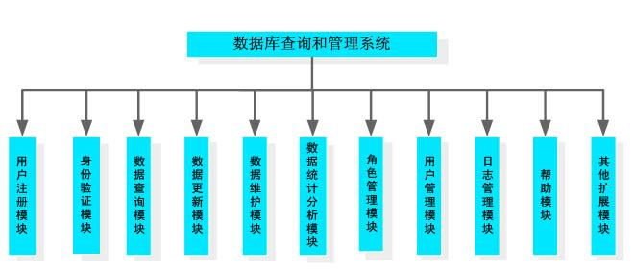
    - Representation of the Business Flow
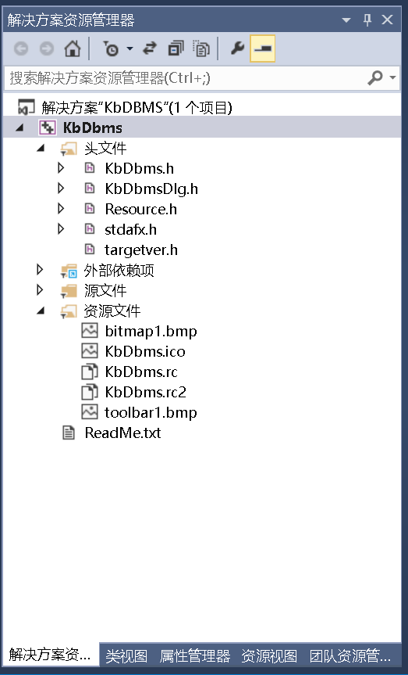

Decomposition Description
This section describes the packages, sub-systems, modules in the system.

    - Module/Subsystem 1 Description
- Overview view
Create and delete the database. Implement database definition file creation, modification and query.

- Functions make it convenient for the user to make some operation
Module Name | Function Name | Function Description
Database Management | Create Database | Implement the function of creation.  Corresponding SQL statement:CREATE DATABASE<database name>
Database Management | Drop Database | Implement the function of deletion .  Corresponding SQL statement:DROP DATABASE<database name>

    - Module/Subsystem 2 Description

Dependency Description
This project is a Windows window program and depends on the operation system. The data storage depends on the file management system of the operating system. The communication between the server and client depends on TCP/IP network communication protocol.
- Level 2 Design Description (Optional)
Each module that is defined in L1 and identified for further description shall be stated by separate sub-sections as mentioned below. More sub-section levels could be added optionally, and finally all specific classes corresponding to each final minimal module, including its public attributes and pubic methods, should be defined.
This will be repeated for each package/module as follows.

Module Name 1
Don't actually write "Module name (1)". Specify the name of the module in few words.
    - Design Description
Depict the decomposition of the modules e.g. the functionality of each sub modules. The design classes should be defined here, class diagrams could be used to describe the design classes and the relationships among these classes, and the design pattern(s) should also be interpreted.
This will be repeated for each class as follows.
      - Class name1
Should be replaced by a true design class name.
Specific classes corresponding to each final minimal module should be defined as below.
(1) Overview
Overview of its responsibilities.

(2) Definition (Optional)
Class diagrams or pseudo codes could be used to depict the class definitions in detail，if it is not described previously. All the public attributes and methods should be defined specifically.
      - Class name2
(1) Overview
(2) Definition (Optional)

    - Function Illustration
Sequence diagrams or collaboration diagrams, etc. could be used to represent the relationships among the design classes and how the design classes implement their typical responsibilities.

Module Name 2
    - Design Description
      - Class name1
      - Class name2
    - Function Illustration

- Data Structure/Database Design
Basic Data Type
INTERGER | Description | Size | Progress Type
INTEGER | Integer | 4 bytes | int
BOOL | Boolean type | 1 byte | bool
DOUBLE | Floating point number | 2 bytes | double
VARCHAR | String type, maximum length is 255, ended with “\0” to mark the end of a string. | 256 bytes | Char[n]
DATETIME | Date time type | 16 bytes | SYSTEMTIME

File design
Type | File | Name | Remark
Data definition file | Database description file | ruanko.db | Save the database information
 | Table description | *.tb | Save the table information
 | Table definition file | *.tdf | Save the field information
 | Integrity description file | *.tic | Save the integrity constraints
 | Index description file | *.tid | Save the definition of the index
Data File | Record File | *.trd
 | Index data file | *.ix
 | Log file | *.log
File Structure

- UI Design
Main Interface

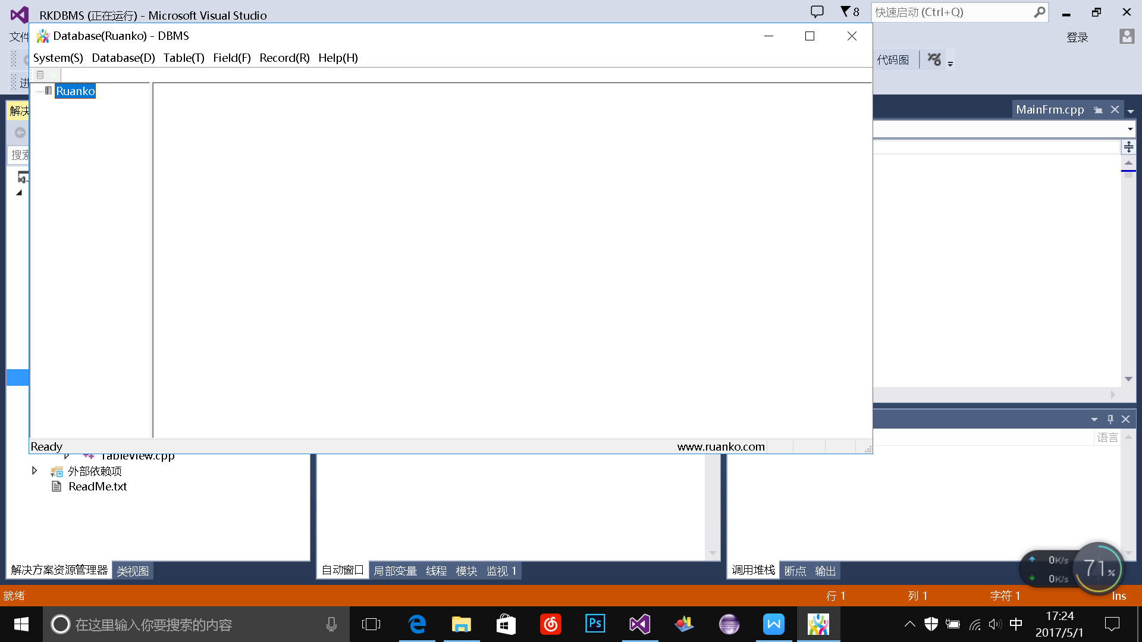

Show Table Interface
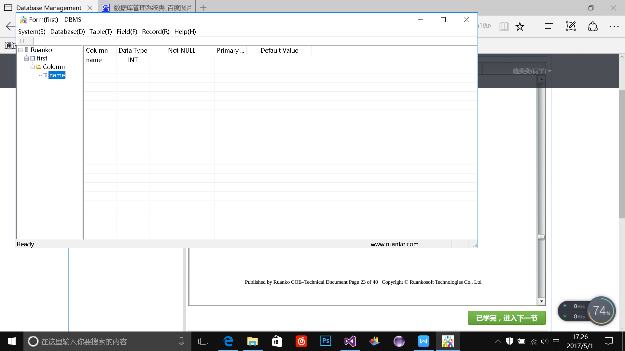
Create Table Interface
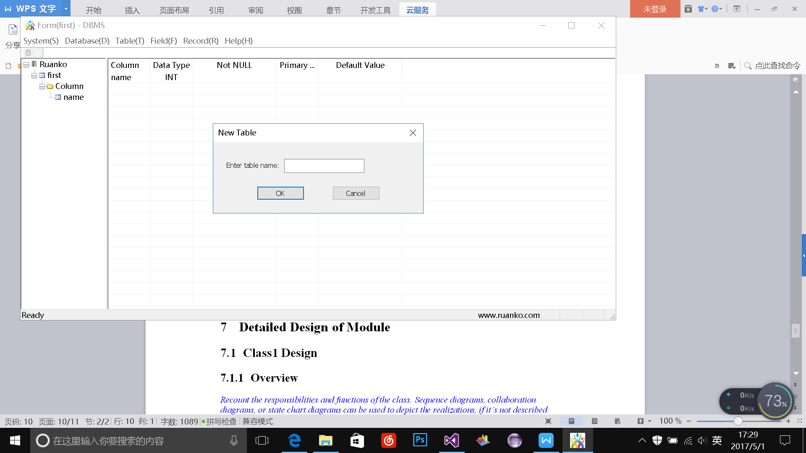
Add Field Interface

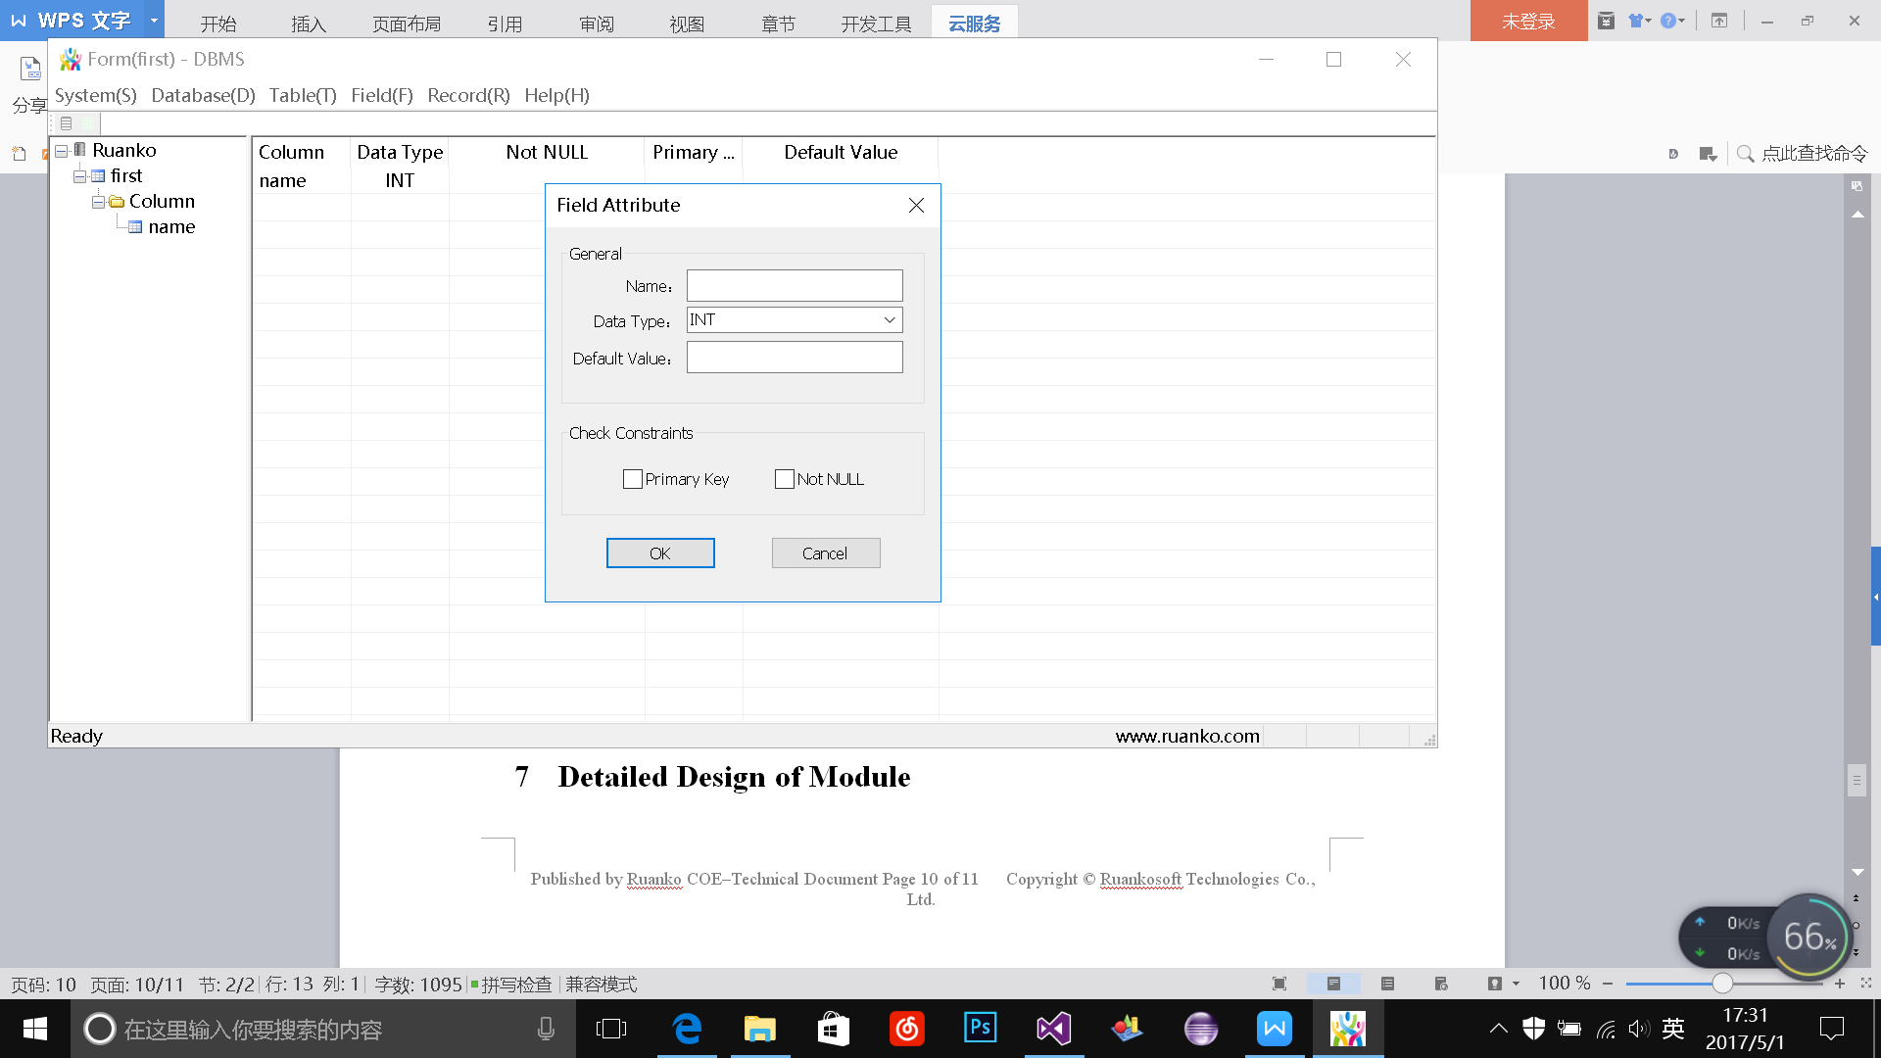
Insert Record Interface
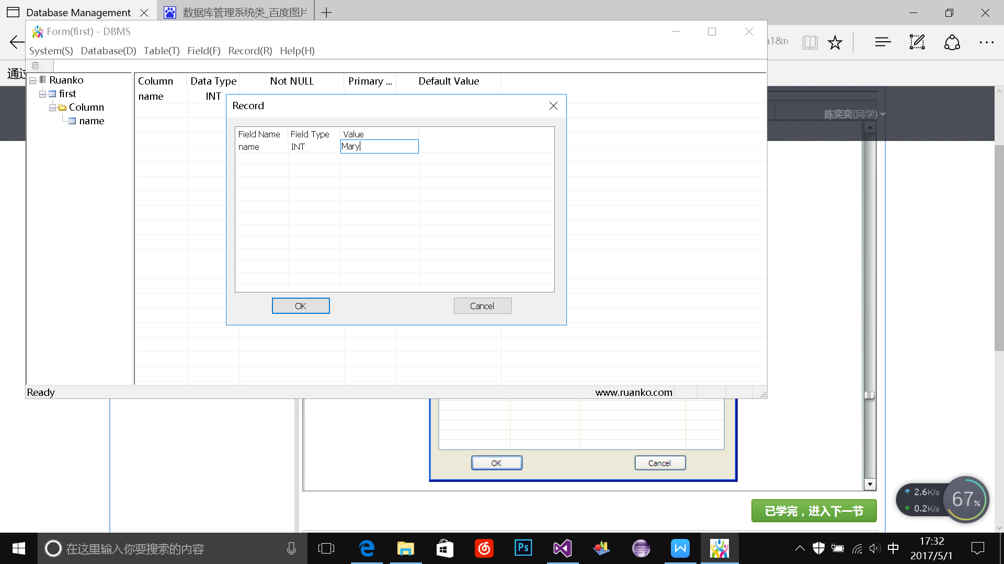
- Detailed Design of Module

Class1 Design
    - Overview
Define the data type of the database management system.
    - Class Diagram
Class diagram, if not described in HLD.
    - Attributes
The common data structure should be described here.
Visibility | Name | Type | Brief descriptions
    - Methods
Every method should be described.
      - Method1
(1) Method Descriptions
Prototype
Description
Calls
Called By
Input
Output
Return
Exception

(2) Implementation Descriptions
Pseudo codes could be used to depict the method definitions. This is the most important part of LLD.
      - Method2

Class2 Design

