**本通知面向复旦大学在校在读本科生和非在职在读硕士研究生（直升本校研究生的学生申请时须同时提交直升本校研究生的证明，请注意因学制这部分同学参加暑期项目无法予以考虑补助）。**

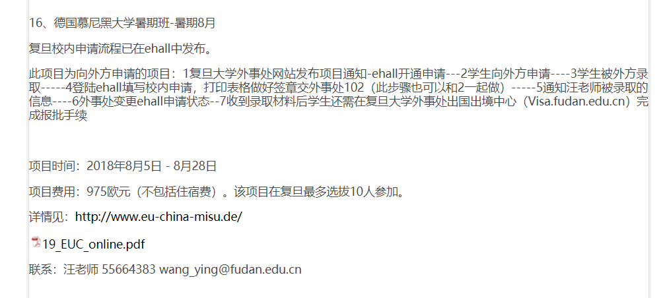

**LMU 德国慕尼黑大学 （在复旦最多招10个人）**

We aim to offer both to our guest students from Chinese partner universities: a profound introduction to European integration and specialization on key aspects of the European Union. Therefore we invite interested to students to apply for one of the four specialized modules on: The Member States of the European Union; The EU in International Affairs; European Economic Affairs; The EU's Area of Freedom, Security and Justice.

**分为四个module**

**欧盟的成员国**

**欧盟在国际事务中的作用**

**欧洲经济事件**

**欧盟区域的自由、安全与正义**

Lectures, presentations and examinations will be held in English. Knowledge of German is not a required.

# Grades

The Academic Board of the LMU Munich defines the requirements and contact hours* for successful completion of the courses as follows:

* regular attendance (6 lessons max. absence)
* preparation for and active participation in seminars
* attendance and contribution to lectures
* participation in and contribution to class excursions
* self-study and homework assignments
* written assignments
* presentations

# Fees & Payment

The total price for each student is 1.535,00 € (approx. 10.100 RMB):

* € 250,00   MISU registration fee
* € 725,00   Tuition
* € 410,00   Housing fee Munich (student dorm, single room, food is not included)
* € 150,00   Transfer and housing fee Vienna (student dorm, double room)

### **Deadlines**

* April 1, 2019: Online Application deadline
* May 15, 2019: Final payment of MISU registration, housing fee and tuition.

Note: Application is based on a first come first serve basis. Early application and payment is recommended. Only with our confirmation it is possible to apply for visa.

毕业典礼在6.21号之前结束

研究生8.31报到

