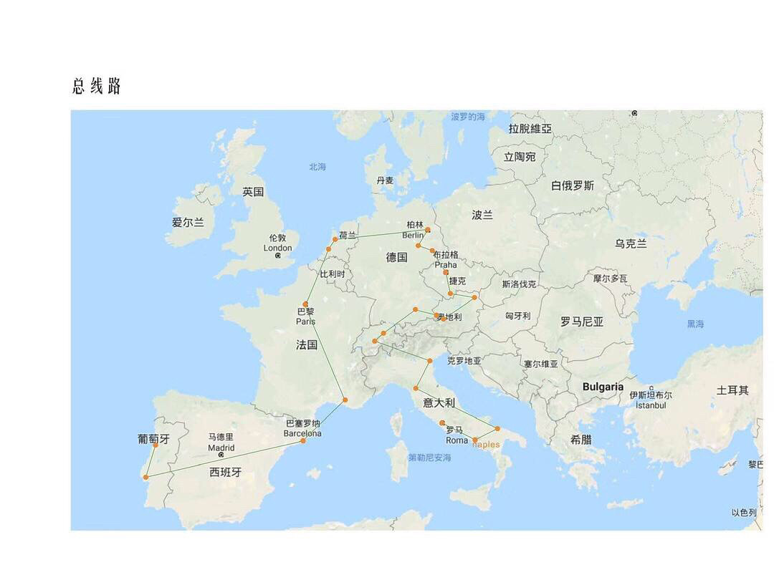

In higher education, the term 'contact hours' is used very broadly, to refer to the amount of time that you spend learning in contact with teaching or associated staff, when studying for a particular course. This time provides you with support in developing your subject knowledge and skills, and opportunities to develop and reflect on your own, independent learning. Contact time can take a wide variety of forms depending on your subject, as well as where and how you are studying. Some of the most common examples are: • lectures • seminars • tutorials • project supervisions • demonstrations • practical classes and workshops • supervised time in a studio/workshop • fieldwork • external visits • work-based learning (including placements)

应该是松耦合，而不是事事时时依赖于别人

遇到让自己不开心的队友，尽量及早分开行动。旅途中的开心才最重要。

