|  |
| --- |
| I’m an associate professor of computer science at Fudan University since Nov 2017. Prior to this, I was a postdoc at Institut TELECOM SudParis from 2009 to 2010, a lecturer at University of Technology Sydney (UTS) from 2011 to 2013, and a senior research scientist of machine learning at CSIRO’s Data61 (formerly NICTA) from 2013 to 2017. I received my PhD degree in computer science from Fudan University in 2009.  My research interests lie in machine learning, Bayesian nonparametrics and computational cognitive science, particularly in complex data (e.g., relational, structured, and streaming) representation, modeling and inference. I’m also interested in “AI & Visual Arts”. |

2017 复旦 青年研究员

苏丹电信研究所 博士后 2009-2010

悉尼大学 客座教授 2011-2013

2009 获得复旦的博士学位

Also interested in “艺术设计”

**2019**

Xuhui Fan, **Bin Li**, Scott A. Sisson, The Binary Space Partitioning Forest, Proceedings of the 22nd International Conference on Artificial Intelligence and Statistics (**AISTATS-19**), accepted.

Jinyang Yuan*, **Bin Li**, Xiangyang Xue, Spatial Mixture Models with Learnable Deep Priors for Perceptual Grouping, Proceedings of the 33rd AAAI Conference on Artifi cial Intelligence (**AAAI-19**), accepted.

Wei Wu*, **Bin Li**, Ling Chen, Chengqi Zhang, Philip S. Yu, Improved Consistent Weighted Sampling Revisited, IEEE Transactions on Knowledge and Data Engineering (**IEEE TKDE**), in press.

Dingqi Yang, **Bin Li**, Laura Rettig, Philippe Cudré-Mauroux, D2HistoSketch: Discriminative and Dynamic Similarity-Preserving Sketching of Streaming Histograms, IEEE Transactions on Knowledge and Data Engineering (**IEEE TKDE**), in press.

**2018**

Xuhui Fan*, **Bin Li**, Scott A. Sisson, Rectangular Bounding Process, Proceedings of the 32nd Conference on Neural Information Processing Systems (**NIPS-18**), pp.7631-7641, 2018.

Wei Wu*, **Bin Li**, Ling Chen, Chengqi Zhang, Efficient Attributed Network Embedding via Recursive Randomized Hashing, Proceedings of the 27th International Joint Conference on Artificial Intelligence (**IJCAI-18**), pp.2861-2867, 2018.

Jianjia Zhang, **Bin Li**, Xuhui Fan, Yang Wang, Fang Chen, Corrosion Prediction on Sewer Networks with Sparse Monitoring Sites: A Case Study, Proceedings of the 22nd Pacific-Asia Conference on Knowledge Discovery and Data Mining (PAKDD-18), pp.223-235, 2018.

Xuhui Fan*, **Bin Li**, Scott A. Sisson, The Binary Space Partitioning-Tree Process, Proceedings of the 21st International Conference on Artificial Intelligence and Statistics (**AISTATS-18**), pp.1859-1867, 2018.

Wei Wu*, **Bin Li**, Ling Chen, Xingquan Zhu, Chengqi Zhang, $K$-Ary Tree Hashing for Fast Graph Classification, IEEE Transactions on Knowledge and Data Engineering (**IEEE TKDE**), 30(5):936-949, 2018.

Lianhua Chi*, **Bin Li**, Xingquan Zhu, Shirui Pan, Ling Chen, Hashing for Adaptive Real-time Graph Stream Classifi cation with Concept Drifts, IEEE Transactions on Cybernetics (**IEEE TCYB**), 48(5):1591-1604, 2018.

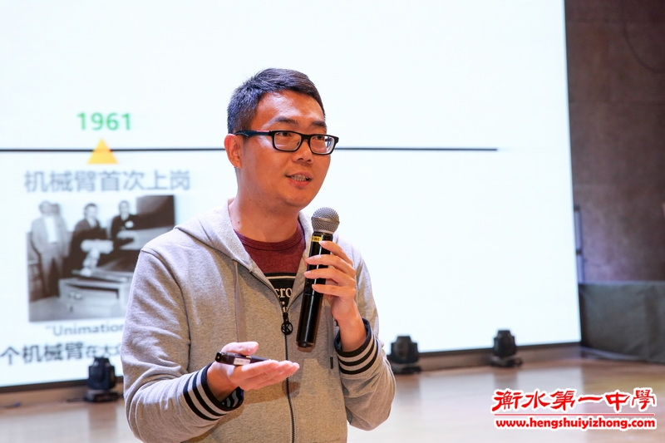

薛向阳

自1989年6月至1995年3月，在[西安电子科技大学](https://baike.baidu.com/item/%E8%A5%BF%E5%AE%89%E7%94%B5%E5%AD%90%E7%A7%91%E6%8A%80%E5%A4%A7%E5%AD%A6" \t "https://baike.baidu.com/item/%E8%96%9B%E5%90%91%E9%98%B3/_blank)通信工程专业攻读学士、硕士和博士学位。

1989年6月至1995年3月，在西安电子科技大学通信工程专业攻读学士、硕士和博士学位。

1995年5月，进复旦大学计算机科学与技术博士后流动站；

1996年12月，留复旦大学计算机科学系工作。27 岁获得博士学位， 29 岁评为副教授， 32 岁破格晋升为教授， 33 岁评为博士生导师。

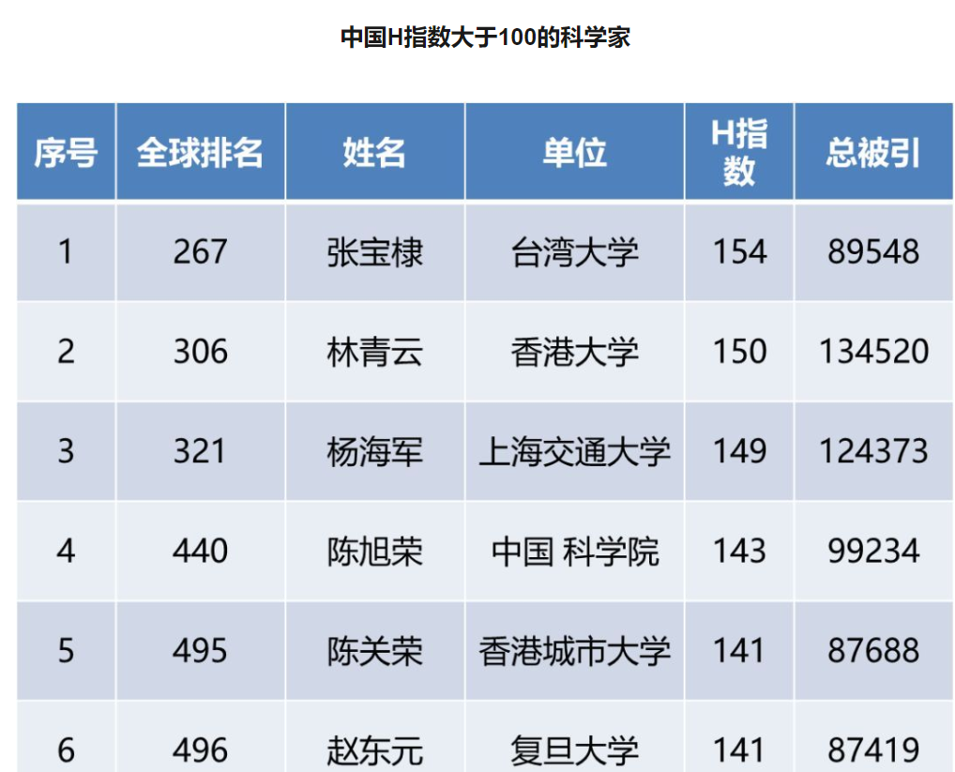

第三，在当今学术官僚化、教育产业化和高校大跃进的情况下，博士点授予权和博士生导师的遴选和“权”、“钱”紧密相连，存在着太多的非学术因素，在这些因素的干扰下，实际上不具备博士点授予权资格的单位有可能“打造”成博士点获得单位，不具备博士资格的教授也可能获得博士生导师资格。同时为了确保博士点授予权，在教授职称缺位的情况下，当然也可能“突破”不是教授不能当博士生导师的传统模式，武汉大学是否属于这类情况不得而知，但是不排除有些单位为“争”博士点而出奇招。

1、有硕士点和博士点学校就可以培养对应专业的硕士和博士，才能授予硕士与博士学位。  
2、没有硕士点与博士点无法培养对应专业的硕士和博士，需要挂靠到别的学校或者专业下培养。  
3、必须要有硕士点,博士点才能招收[硕士研究生](https://www.baidu.com/s?wd=%E7%A1%95%E5%A3%AB%E7%A0%94%E7%A9%B6%E7%94%9F&tn=SE_PcZhidaonwhc_ngpagmjz&rsv_dl=gh_pc_zhidao" \t "https://zhidao.baidu.com/question/_blank)和博士研究生。一个学校的硕士点,博士点的多少可以大致说明一个学校的学术水平。