# 并发请求验证

## 环境准备

/study-gateway/src/main/java/com/bage/gateway/user/controller/UserController.java

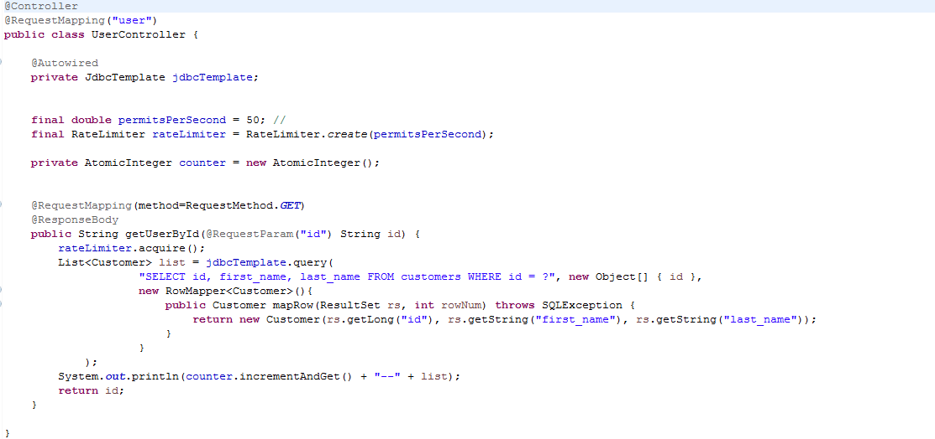

## 验证方式

#### 线程池模拟

/study-gateway/src/main/java/com/bage/gateway/user/controller/UserController.java

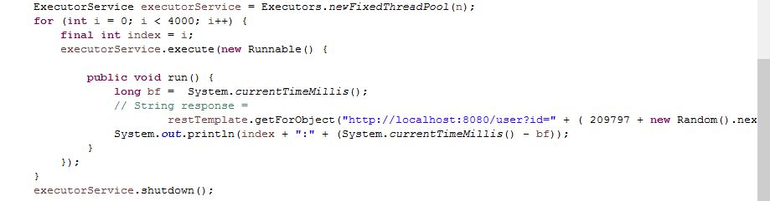

#### Linux 请求模拟

ab -n4000 -c100 http://192.168.0.184:8080/user?id= 209797

参考链接：<https://blog.csdn.net/qq_27517377/article/details/78794409>

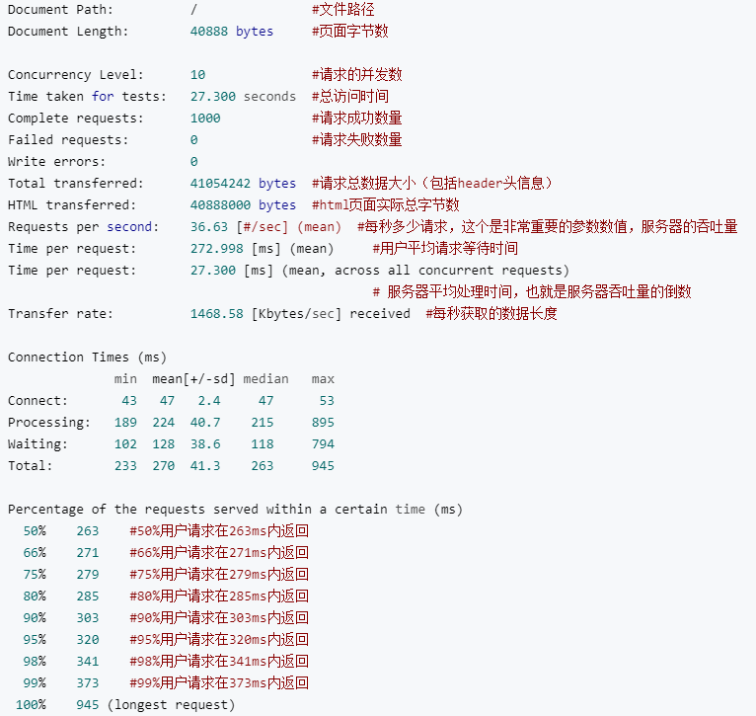

## 验证效果

