1. create table Student_2018091613023 (

StudentID CHAR(13) not null,

StudentName VARCHAR(20) null,

Sex VARCHAR(10) null,

constraint PK_STUDENT_2018091613023 primary key (StudentID)

);

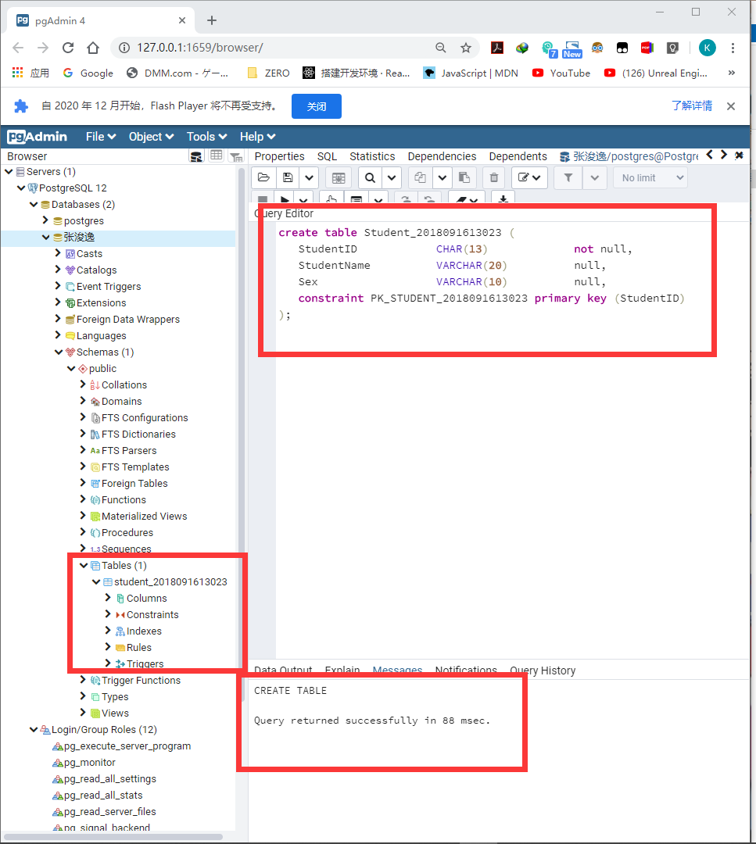

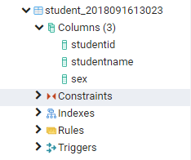

2. create table Teacher_2018091613023 (

TeacherID CHAR(4) not null,

TeacherName VARCHAR(20) null,

College VARCHAR(40) null,

Email VARCHAR(40) null,

constraint PK_TEACHER_2018091613023 primary key (TeacherID)

);

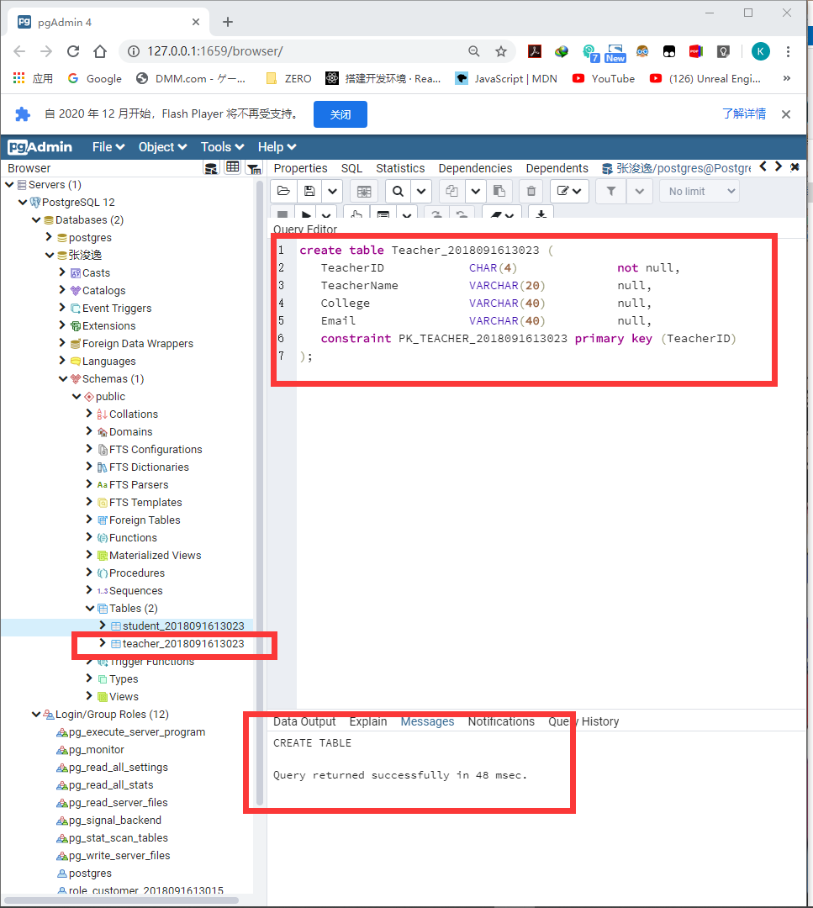

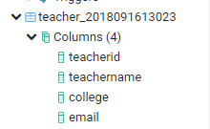

3. create table Course_2018091613023 (

CourseID CHAR(4) not null,

CourseName VARCHAR(20) null,

TeacherID CHAR(4) null,

constraint PK_COURSE_2018091613023 primary key (CourseID)

);

alter table Course_2018091613023

add constraint FK_COURSE_2_REFERENCE_TEACHER_ foreign key (TeacherID)

references Teacher_2018091613023 (TeacherID)

on delete restrict on update restrict;

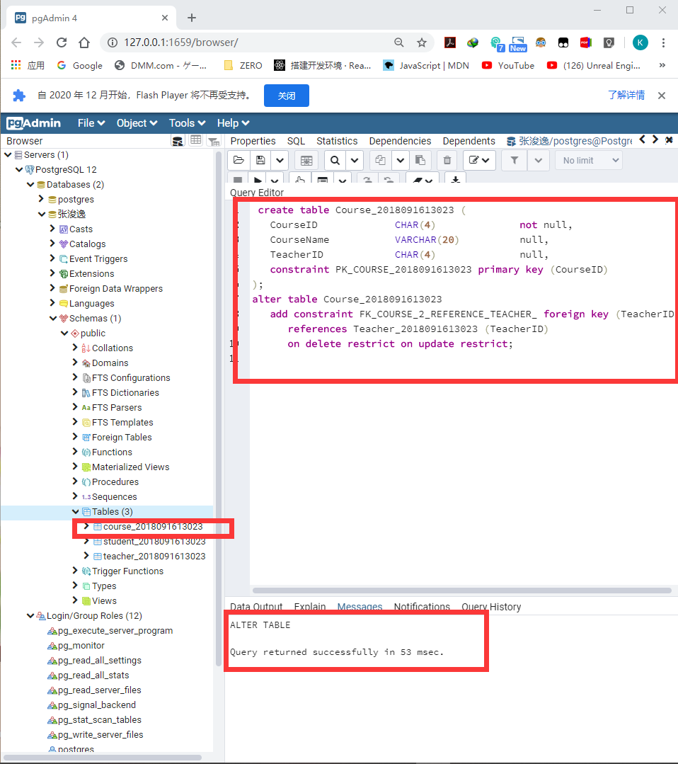

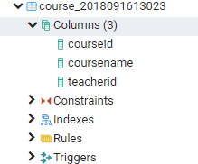

4. create table Register_2018091613023 (

StudentID CHAR(13) not null,

CourseID CHAR(4) not null,

RegDate DATE null,

constraint PK_REGISTER_2018091613023 primary key (StudentID, CourseID)

);

alter table Register_2018091613023

add constraint FK_REGISTER_REFERENCE_STUDENT_ foreign key (StudentID)

references Student_2018091613023 (StudentID)

on delete restrict on update restrict;

alter table Register_2018091613023

add constraint FK_REGISTER_REFERENCE_COURSE_2 foreign key (CourseID)

references Course_2018091613023 (CourseID)

on delete restrict on update restrict;

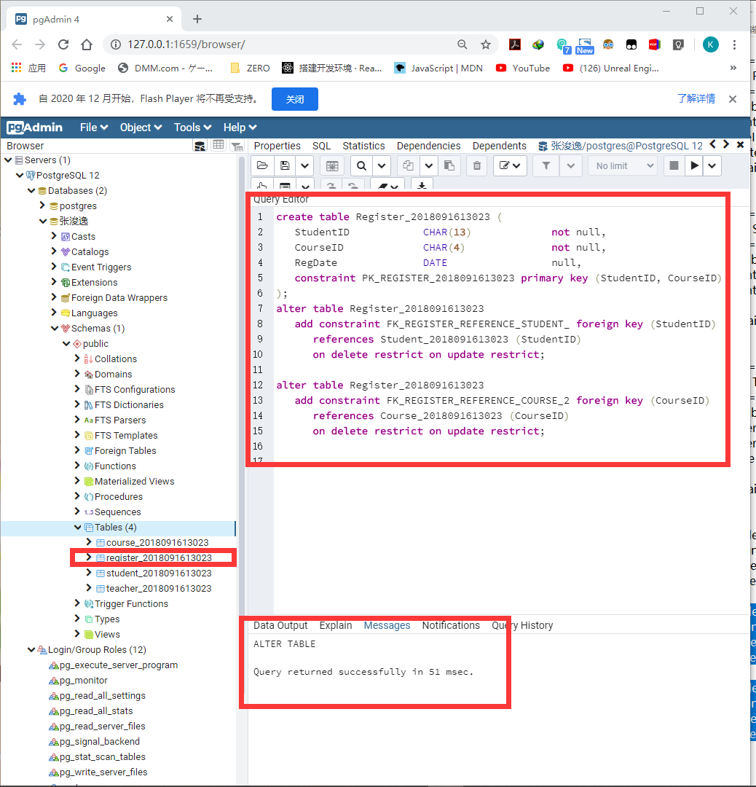

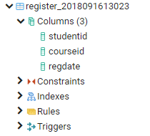

5. INSERT INTO STUDENT_2018091613023 values('2018091613023','张浚逸','男');

INSERT INTO STUDENT_2018091613023 values('2017431001101','赵燕','女');

INSERT INTO STUDENT_2018091613023 values('2017431001102','刘建','男');

INSERT INTO STUDENT_2018091613023 values('2017431001103','郝杰','男');

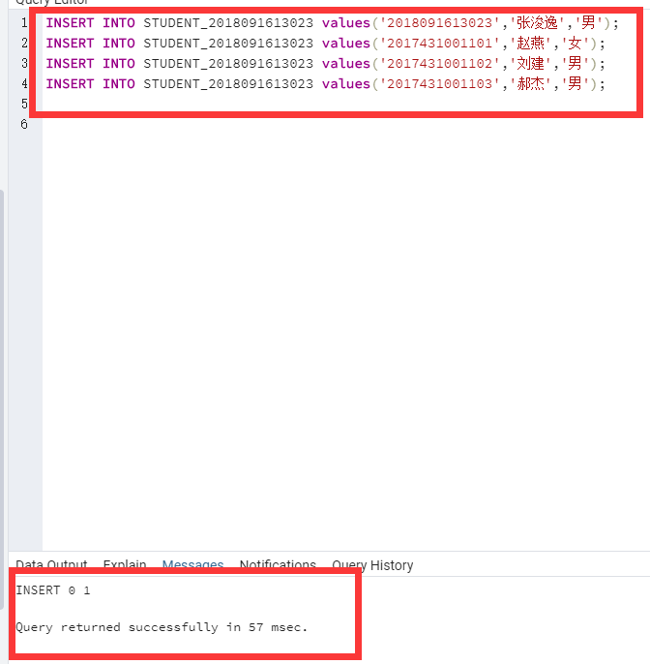

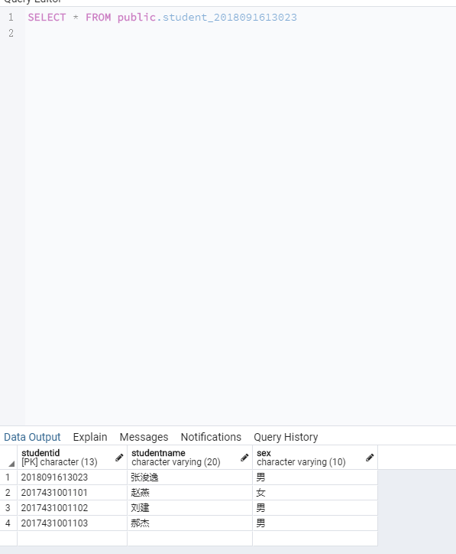

6. INSERT INTO TEACHER_2018091613023 values('T001','张老师','软件学院','Zhang@uestc.edu.cn');

INSERT INTO TEACHER_2018091613023 values('T002','王老师','软件学院','Wang@uestc.edu.cn');

INSERT INTO TEACHER_2018091613023 values('T003','张浚逸','软件学院','2018091613023@uestc.edu.cn');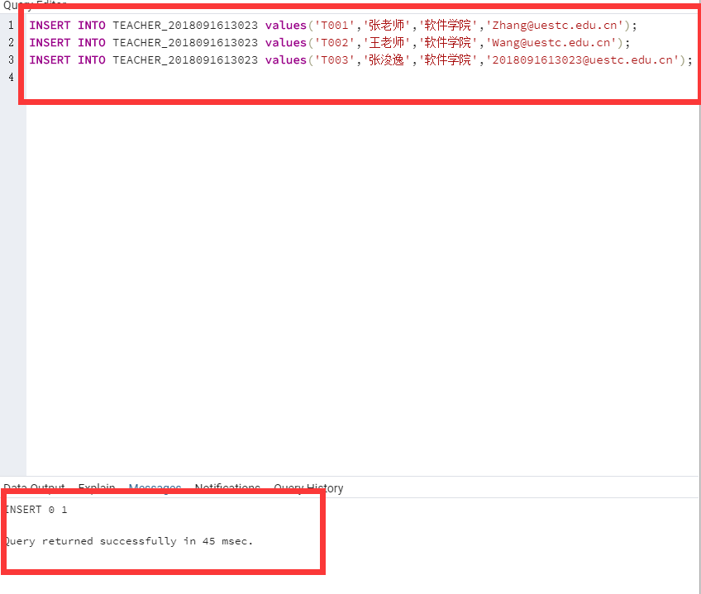

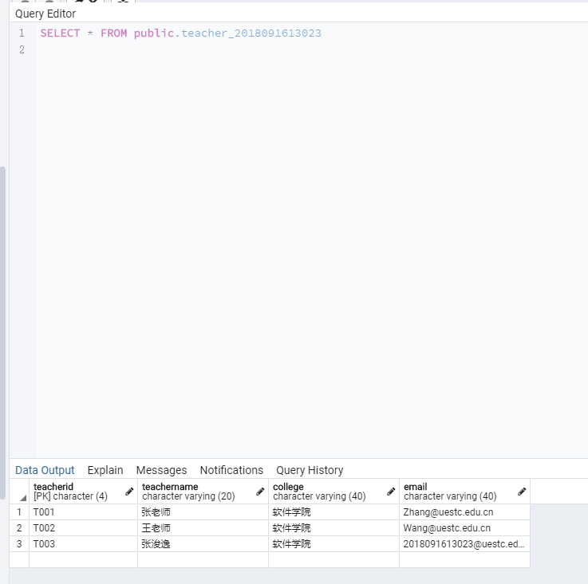

7. INSERT INTO Course_2018091613023 values('C001','软件测试','T001');

INSERT INTO Course_2018091613023 values('C002','程序设计','T002');

INSERT INTO Course_2018091613023 values('C003','综合设计-2018091613023','T003');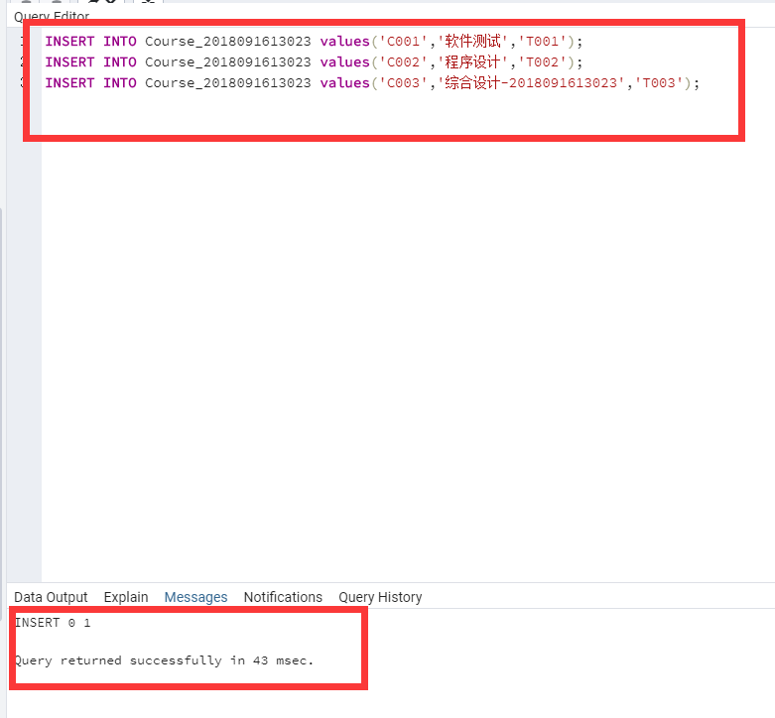

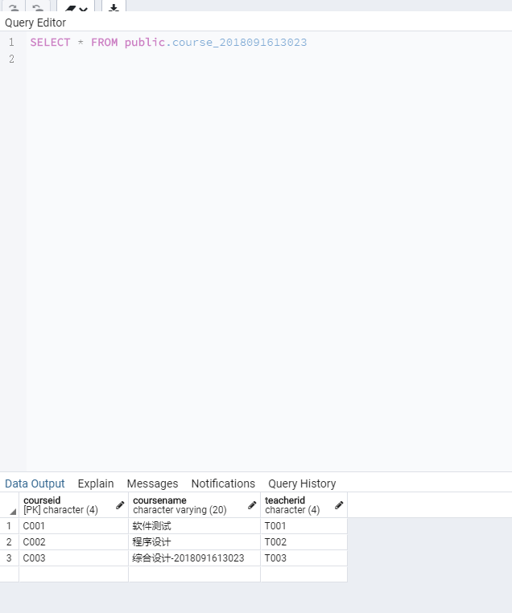

8. INSERT INTO REGISTER_2018091613023 values('2017431001101','C001','2019-06-15');

INSERT INTO REGISTER_2018091613023 values('2017431001102','C002','2019-06-18');

INSERT INTO REGISTER_2018091613023 values('2017431001103','C002','2019-06-18');

INSERT INTO REGISTER_2018091613023 values('2018091613023','C001','2019-06-20');

INSERT INTO REGISTER_2018091613023 values('2018091613023','C002','2019-06-20');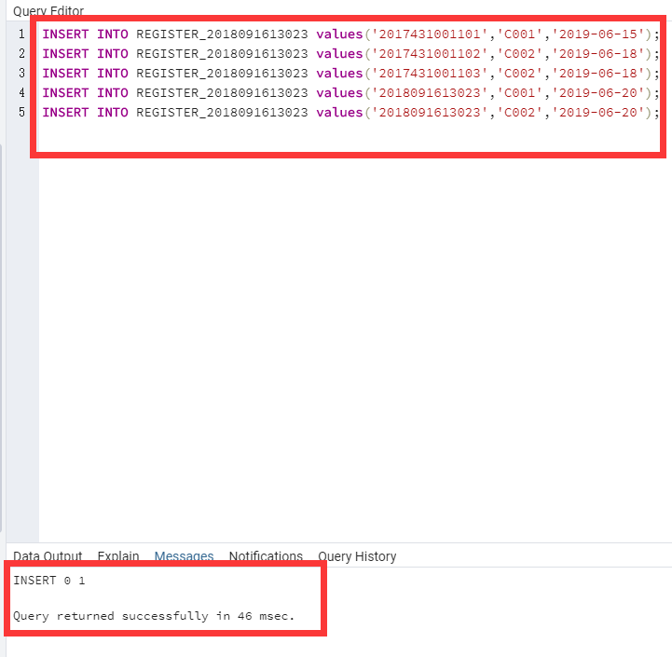

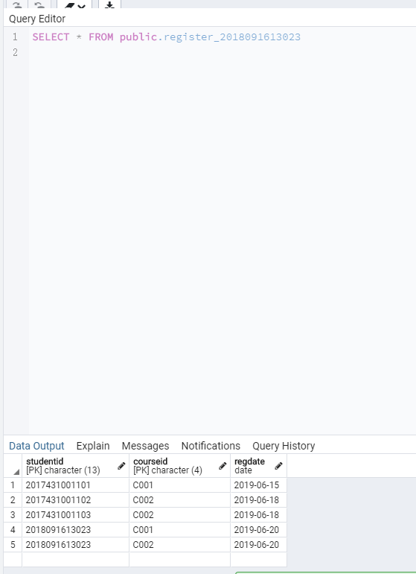

9. SELECT StudentID AS 学号,StudentName AS 学生姓名,CourseName AS 课程名称,Regdate AS 注册日期

FROM (REGISTER_2018091613023

NATURAL JOIN Student_2018091613023

NATURAL JOIN Course_2018091613023)

WHERE StudentID = '2018091613023'; 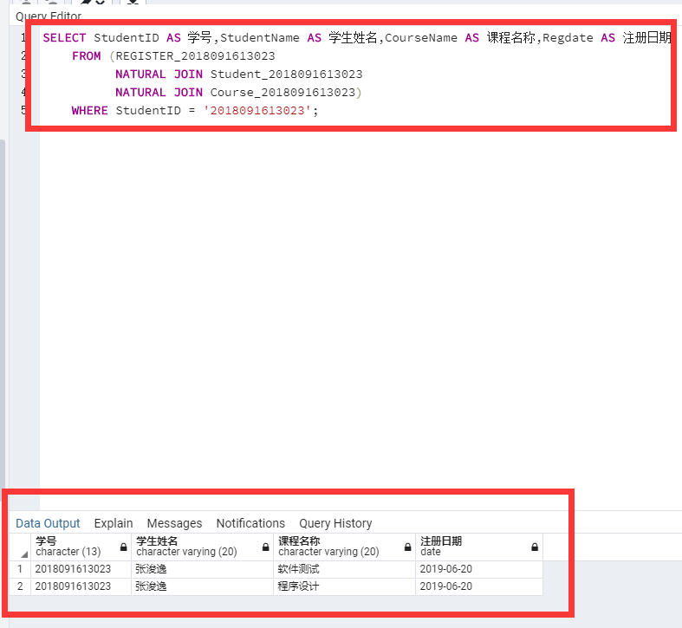

10. Create view View_Reg_2018091613023 as

SELECT C.CourseID AS 课程编号,C.CourseName AS 课程名称,COUNT(*) AS 选课人数

FROM Course_2018091613023 AS C

JOIN REGISTER_2018091613023 AS R ON R.CourseID=C.CourseID

GROUP BY C.CourseID;

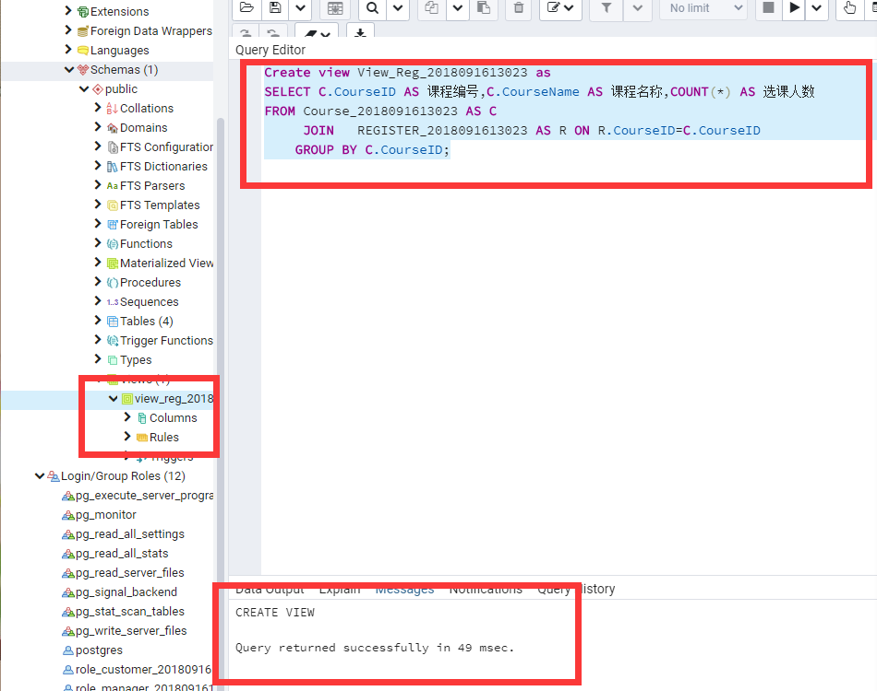

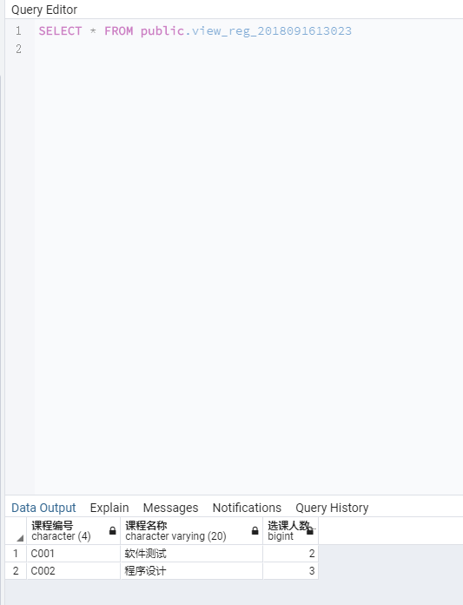

11. CREATE ROLE Role_Student_2018091613023 WITH

LOGIN

INHERIT

CONNECTION LIMIT -1;

CREATE ROLE Role_Teacher_2018091613023 WITH

LOGIN

INHERIT

CONNECTION LIMIT -1;

CREATE ROLE Role_TAadmin_2018091613023 WITH

LOGIN

INHERIT

CONNECTION LIMIT -1;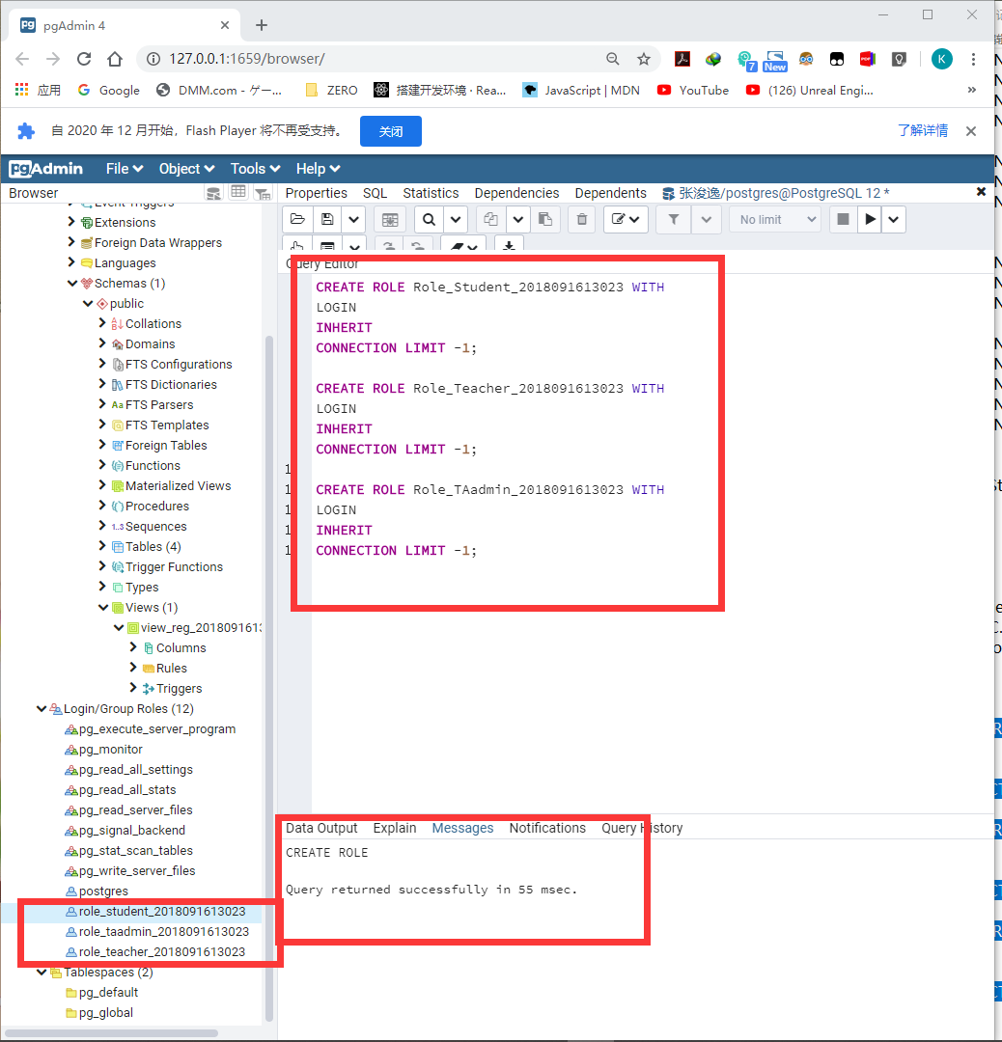

12.

GRANT SELECT,UPDATE ON STUDENT_2018091613023 TO Role_Student_2018091613023;

GRANT SELECT ON STUDENT_2018091613023 TO Role_Teacher_2018091613023;

GRANT SELECT ON STUDENT_2018091613023 TO Role_TAadmin_2018091613023;

GRANT SELECT ON TEACHER_2018091613023 TO Role_Student_2018091613023;

GRANT SELECT,UPDATE ON TEACHER_2018091613023 TO Role_Teacher_2018091613023;

GRANT SELECT ON TEACHER_2018091613023 TO Role_TAadmin_2018091613023;

GRANT SELECT ON Course_2018091613023 TO Role_Student_2018091613023;

GRANT SELECT ON Course_2018091613023 TO Role_Teacher_2018091613023;

GRANT SELECT,INSERT,UPDATE,DELETE ON Course_2018091613023 TO Role_TAadmin_2018091613023;

GRANT SELECT,UPDATE ON REGISTER_2018091613023 TO Role_Student_2018091613023;

GRANT SELECT ON REGISTER_2018091613023 TO Role_Teacher_2018091613023;

GRANT SELECT,INSERT,UPDATE,DELETE ON REGISTER_2018091613023 TO Role_TAadmin_2018091613023;

