|  |  |
| --- | --- |
| Wireshark Lab:  DNS v8.0  **SOLUTIONS**  Supplement to *Computer Networking: A Top-Down Approach, 8th ed.,* J.F. Kurose and K.W. Ross  *“Tell me and I forget. Show me and I remember. Involve me and I understand.”* Chinese proverb  © 2005-2020, J.F Kurose and K.W. Ross, All Rights Reserved |  |

1. Run *nslookup* to obtain the IP address of a Web server in Asia. What is its IP address? ***ANSWER:*** *I performed nslookup fo*[*r www.rediff.com*](http://www.rediff.com/)*. Its IP address is 208.184.138.70*

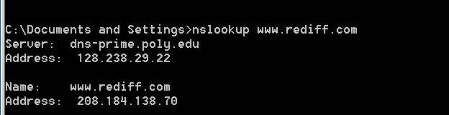

Screenshot taken for question 1

2. Run *nslookup* to determine the authoritative DNS servers for a university in Europe. What is its IP address. ***ANSWER****: I performed nslookup for a European University in Ioannina Greece. Its IP address is 128.238.29.22*

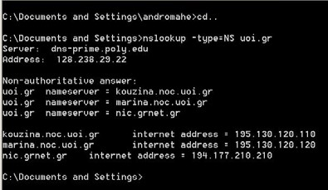

Screenshot taken for question 2

3. Run *nslookup* so that one of the DNS servers obtained in Question 2 is queried for the mail servers for Yahoo! mail. What is its IP address? ***ANSWER:*** *the IP address of the mail server(s) is 18.72.0.3.*

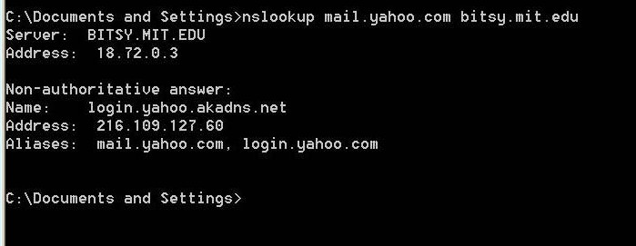

Screenshot taken for question 3

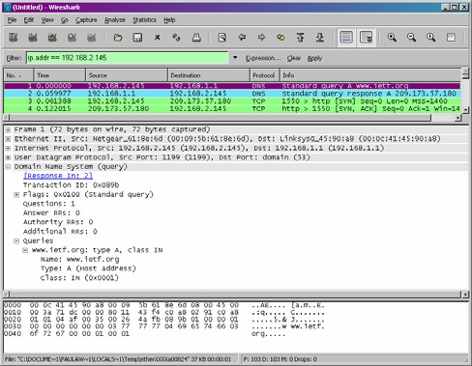

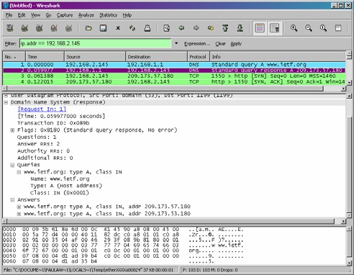*Screenshot for DNS query Screenshot for DNS response*

4. Locate the DNS query and response messages. Are then sent over UDP or TCP? ***ANSWER:*** *They are sent over UDP*

5. What is the destination port for the DNS query message? What is the source port of DNS response message? ***ANSWER:*** *The destination port for the DNS query is 53 and the source port of the DNS response is 53.*

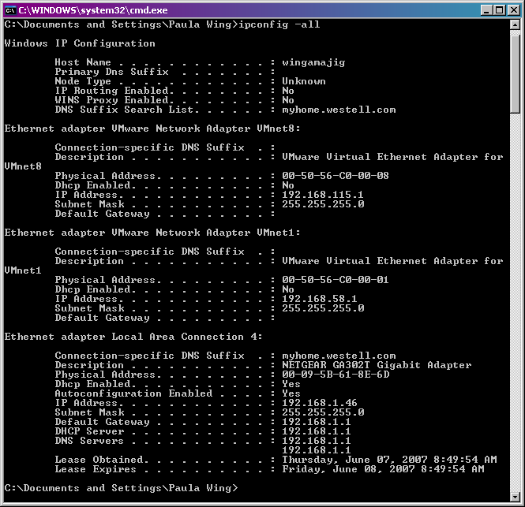

*Screenshot for ipconfig –all*

6. To what IP address is the DNS query message sent? Use ipconfig to determine the IP address of your local DNS server. Are these two IP addresses the same? ***ANSWER:*** *It’s sent to 192.168.1.1, which is the IP address of one of my local DNS servers.*

7. Examine the DNS query message. What “Type” of DNS query is it? Does the query message contain any “answers”? ***ANSWER:*** *It’s a type A Standard Query and it doesn’t contain any answers.*

8. Examine the DNS response message. How many “answers” are provided? What do each of these answers contain? ***ANSWER:*** *There were 2 answers containing information about the name of the host, the type of address, class, the TTL, the data length and the IP address.*

Answers

[www.ietf.org:](http://www.ietf.org/) type A, class IN, addr 209.173.57.180

Name: [www.ietf.org](http://www.ietf.org/) Type: A (Host address) Class: IN (0x0001)

Time to live: 30 minutes

Data length: 4

Addr: 209.173.57.180

[www.ietf.org:](http://www.ietf.org/) type A, class IN, addr 209.173.53.180

Name: [www.ietf.org](http://www.ietf.org/) Type: A (Host address) Class: IN (0x0001)

Time to live: 30 minutes

Data length: 4

Addr: 209.173.53.180

9. Consider the subsequent TCP SYN packet sent by your host. Does the destination IP address of the SYN packet correspond to any of the IP addresses provided in the DNS response message? ***ANSWER:*** *The first SYN packet was sent to 209.173.57.180 which corresponds to the first IP address provided in the* *DNS response message.*

10. This web page contains images. Before retrieving each image, does your host issue new DNS queries? ***ANSWER:*** *No*

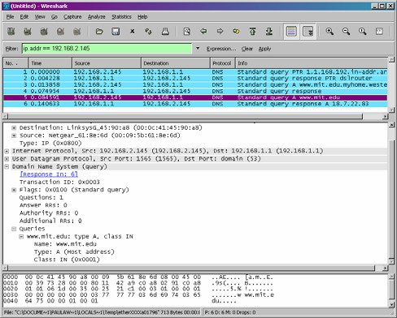

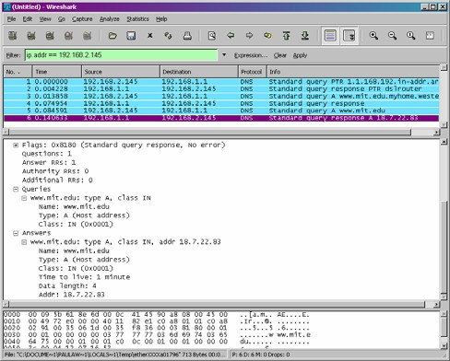*Screenshot for DNS query Screenshot for DNS response*

11. What is the destination port for the DNS query message? What is the source port of DNS response message? ***ANSWER:*** *The destination port of the DNS query is 53 and the source port of the DNS response is 53.*

12. To what IP address is the DNS query message sent? Is this the IP address of your default local DNS server? ***ANSWER:*** *It’s sent to 192.168.1.1 which as we can see from the ipconfig –all screenshot, is the default local DNS server.*

13. Examine the DNS query message. What “Type” of DNS query is it? Does the query message contain any “answers”? ***ANSWER****: The query is of type A and it doesn’t contain any answers.*

14. Examine the DNS response message. How many “answers” are provided? What do each of these answers contain? ***ANSWER:*** *The response DNS message contains one answer containing the name of the host, the type of address, the class, and the IP address.*

Answers

[www.mit.edu:](http://www.mit.edu/) type A, class IN, addr 18.7.22.83

Name: [www.mit.edu](http://www.mit.edu/)

Type: A (Host address) Class: IN (0x0001)

Time to live: 1 minute

Data length: 4

Addr: 18.7.22.83

15. Provide a screenshot.

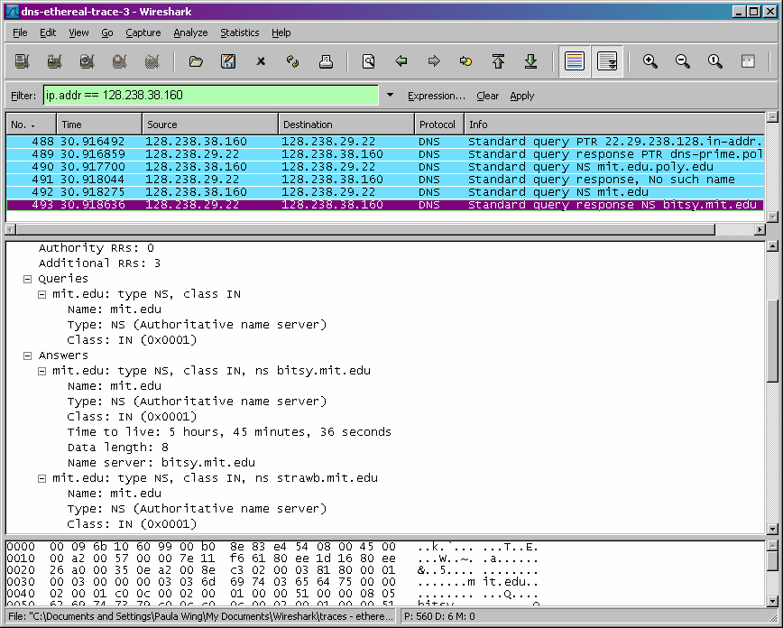

Screenshot for DNS response

16. To what IP address is the DNS query message sent? Is this the IP address of your default local DNS server? ***ANSWER:*** *It was sent to 128.238.29.22 which is my default DNS server.*

17. Examine the DNS query message. What “Type” of DNS query is it? Does the query message contain any “answers”? ***ANSWER:*** *It’s a type NS DNS query that doesn’t contain any answers.*

18. Examine the DNS response message. What MIT nameservers does the response message provide? Does this response message also provide the IP addresses of the MIT nameservers? ***ANSWER:*** *The nameservers are bitsy, strawb and w20ns. We can find their IP addresses if we expand the Additional records field in Wireshark as seen below.*

Answers

mit.edu: type NS, class inet, ns bitsy.mit.edu mit.edu: type NS, class inet, ns strawb.mit.edu mit.edu: type NS, class inet, ns w20ns.mit.edu

Additional records

bitsy.mit.edu: type A, class inet, addr 18.72.0.3 strawb.mit.edu: type A, class inet, addr 18.71.0.151 w20ns.mit.edu: type A, class inet, addr 18.70.0.160

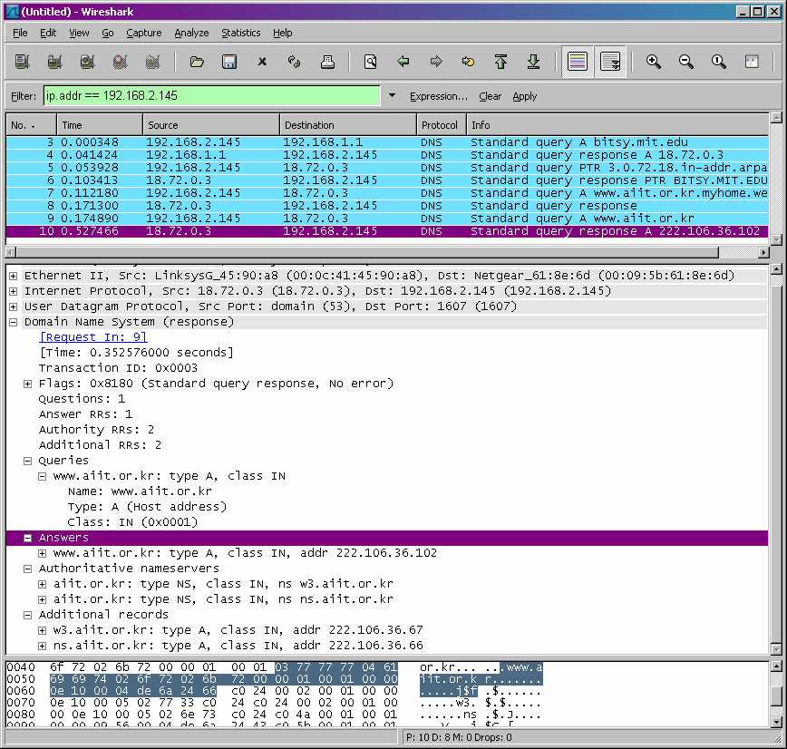

Screenshot for DNS response

20. To what IP address is the DNS query message sent? Is this the IP address of your default local DNS server? If not, what does the IP address correspond to? ***ANSWER:*** *The query is sent to 18.72.0.3 which corresponds to bitsy.mit.edu.*

21. Examine the DNS query message. What “Type” of DNS query is it? Does the query message contain any “answers”? ***ANSWER*** *It’s a standard type A query that doesn’t contain any answers.*

22. Examine the DNS response message. How many “answers” are provided? What does each of these answers contain? ***ANSWER:*** *One answer is provided in the DNS response message. It contains the following:*

Answers

[www.aiit.or.kr:](http://www.aiit.or.kr/) type A, class inet, addr 222.106.36.102

Name: [www.aiit.or.kr](http://www.aiit.or.kr/) Type: Host address Class: inet

Time to live: 1 hour

Data length: 4

Addr: 222.106.36.102