Chapter 1:

P2:

the time of first one is N*L/R.the packets after the first one just spent L/R time.So for p packets need (N+P-1)*(L/R).

P9：

a.1 when it is 1Mbps link,N = 10;when it is 1Gbps link,N = 10000

b. every user is busy generating data only with probability p = 0.1,more than N users are busy generating data with the probability: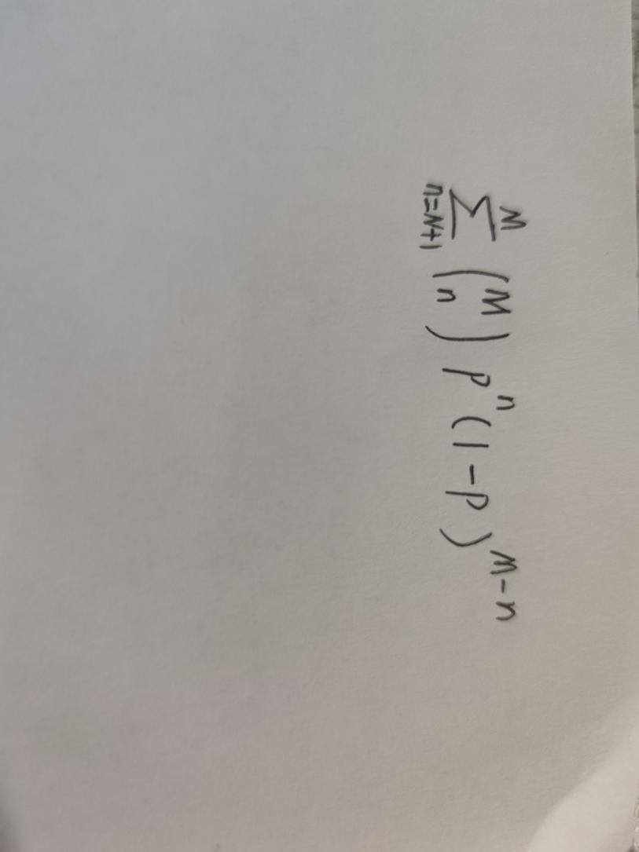

P10:

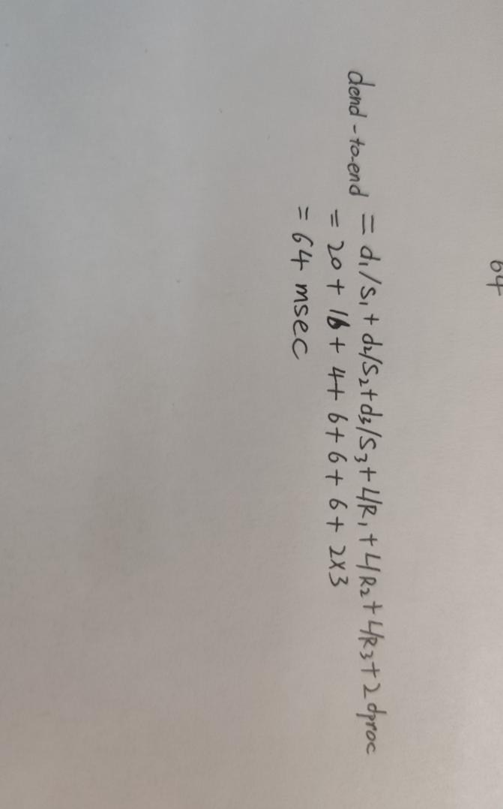

Chapter2:

P6:

1. Client and server both can use connection header with "close" label to close the persistent connection .
2. HTTP doesn’t provide encryption services.
3. Can’t
4. Yes.It is possible that a client has started to send a new request while the server has decided to close the “idle” connection.

P12:

TCPServer.py

from socket import*

serverPort=12000

serverSocket=socket(AF_INET,SOCK_STREAM)

serverSocket.bind((‘ ‘,serverPort))

serverSocket.listen(1)

connectionSocket,addr=serverSocket.accept()

while 1:

sentence=connectionSocket.recv(1024)

print (sentence.decode())

connectSocket.close()