# Homework of week1

P2:

the time of first one is N*L/R.the packets after the first one just spent L/R time.So for p packets need (N+P-1)*(L/R).

P9：

a.1 when it is 1Mbps link,N = 10;when it is 1Gbps link,N = 10000

b. every user is busy generating data only with probability p = 0.1,more than N users are busy generating data with the probability: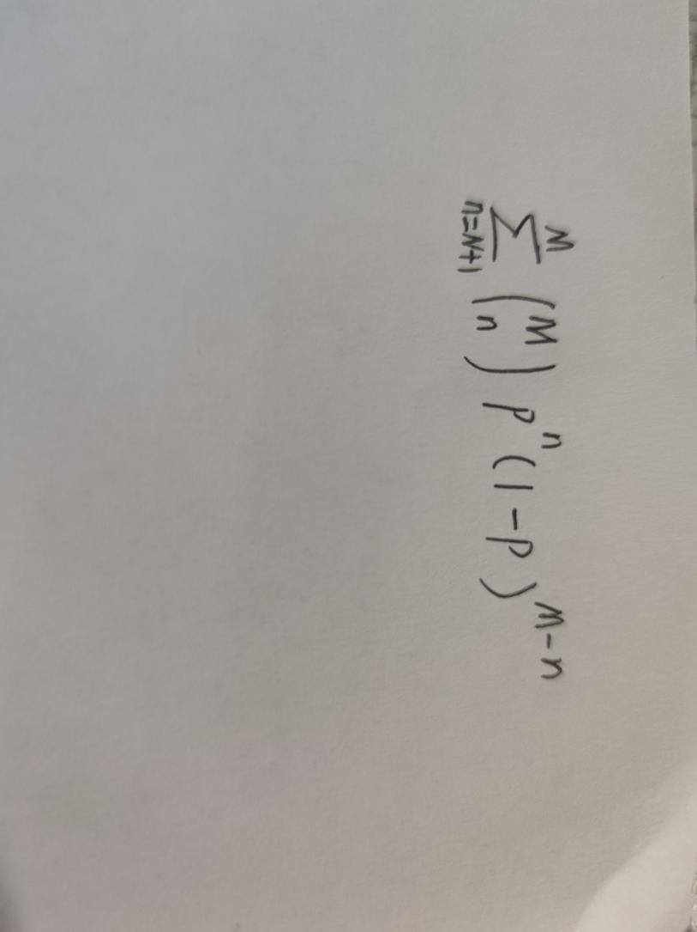

P10:

