**SP3 Team 5 :**Chuan Guang Zhe (152104G)  
Teo Jia Hao (155209G)  
Zhang Jia Bao, Jason (155212W)  
Sri Sham Haran S/O R Raja (155129R)

SP3 Team 5 TDD

Phantom Hunter

**Table of Content**

**Project Overview** 1

**Game Concept** 1

**System Requirements** 1

**Third Party Library** 1

**Game Play** 1

**Projectiles** 1

**Collision** 1

**Player actions** 1

**Victory conditions** 1

**Enemy state** 1

**User Interface** 1

**Game Menus** 1

**In-Game Controls** 1

**Movement** 1

**Looking around / Aiming** 1

**Weapon control** 1

**Shop** 1

**Interacting with objects** 1

**Graphics** 1

**Features** 1

**Formats** 1

**Audio** 1

**Features** 1

**Formats** 1

**Task List** 1

**Appendices** 1

**OBJ** 1

**Texture** 1

**Sound files** 1

# **Project Overview**

## **Game Concept**

The game will be a 3D Horror-themed Adventure FPS game. Its progression with be linear with transitions between each level. There is a main hub that players can visit to shop for items.  
  
In each level there is wandering ghosts that the player can catch. The player will have limited inventory space to keep the captured ghost. The spaces can be increase by purchasing upgrades in the shop. Ghosts can be turned into ectoplasm (money) at the main hub, each ghost worth different value. Players can only capture weaken ghosts.  
  
There will be a boss at the last level.

The player will not have HP, but instead will have a “Fear” factor. As fear rises, the player will have decreased vision and if it rises too high the player will faint and be teleported back to the main hub.

## **System Requirements**

OS: Windows 7/8/10  
Minimum Hardware:

* 1050 MHz Processor
* 256MB RAM
* 32MB onboard video ram
* 100MB Hard-Drive space available.

Recommended Hardware:

* 1.8 GHz Processor
* 512MB RAM
* 96MB onboard video ram
* 100MB Hard-Drive space available.

## **Third Party Library**

The game will use external libraries such as **irrklang** to use as a sound engine

# **Game Play**

## **Projectiles**

There only projectile in the game is the player’s bullets. These will not be affected by physics and will simply travel along a straight line until they collide with something.

## **Collision**

Types of Collision

* AABB
* Barycentric Terrain collision

## **Player actions**

The player will take on the body of a Ghost Hunter from the Church of Harambe. And the Ghost Hunter is capable of the following actions:

* Walking around in a 3D world
* Looking around his environment
* Sprinting at the cost of stamina
* Interact with NPC
* Use weapons (Shoot and reload)
* Capture ghosts
* Access and check inventory
* Use items

## **Victory conditions**

The player wins the game when the Ghost Boss is defeated. You can only access which level once, except level 3 which is repeatable

## **Enemy state**

Normal ghost:

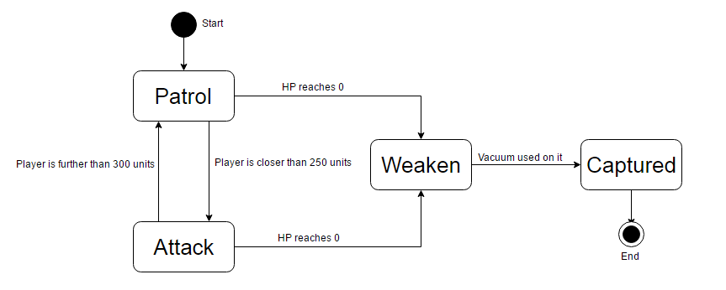

Boss:

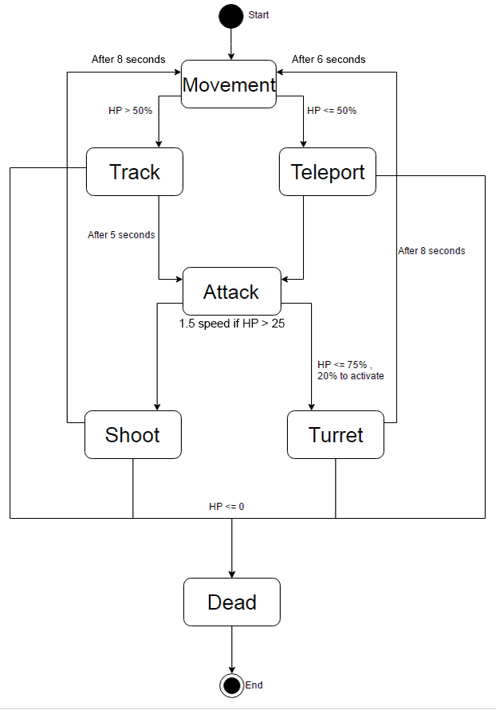

# **User Interface**

## **Game Menus**

The startup menu will consist of a 2D menu with the following choices:

* “Start Game” – This starts up the game.
* “Instructions” – This opens up the instruction screen.
* “Options” – This opens up the options screen
* “Quit” – This closes the game and application.

## **In-Game Controls**

### **Movement**

Movement will take place with a standard 4-command strafing setup. One command will walk forward, another backwards, one of strafing left, and the last will strafe right. These commands are bounded to:

* W / S / A / D
* UPARROW / DOWNARROW / LEFTARROW / RIGHTARROW

### **Looking around / Aiming**

Looking around and aiming with the weapon uses the mouse. Moving the mouse with pan the camera in the corresponding direction:

* Moving up the mouse will pan the camera upwards.
* Moving down the mouse will pan the camera downwards.
* Moving left with the mouse will pan the camera towards the left.
* Moving right with the mouse will pan the camera towards the right.

### **Weapon control**

The firing / shooting of the weapon will be controlled by the mouse’s left click while the reloading of the weapon will be bind to ‘R’.

### **Shop**

Navigation of the shop and purchasing of items will all be controlled by the mouse.  
Left clicking an item / weapon will select it while left clicking buttons will trigger the action stated on the buttons.

### **Interacting with objects**

Interactions with other objects will be bind to ‘E’.

# **Graphics**

OpenGL 3.0 introduced a deprecation mechanism to simplify future revisions of the API. Certain features, marked as deprecated, could be completely disabled by requesting a forward-compatible context from the windowing system.

## **Features**

Shaders are added and edited to allow the following features:

* Shadows
* Reflections
* Terrain generation
* Fog
* Billboarding
* Cel shading
* Obj loading
* Texture mapping

## **Formats**

* Object file (*.obj)
* TARGA File (*.tga)

# **Audio**

irrKlang is a powerful high level API for playing back sound in 3D and 2D applications like games, scientific visualizations and multimedia applications. irrKlang is free for non-commercial use.

## **Features**

The following features are available through the API:

* 2D/3D sound effects
* 2D music with support for compressed file formats
* Control of volume
* Multiple sound effects simultaneously

## **Formats**

irrKlang supports these following formats:

* RIFF WAVE (*.wav)
* Ogg Vorbis (*.ogg)
* MPEG-1 Audio Layer 3(*.mp3)
* Free Lossless Audio Codec (*.flac)
* Amiga Modules (*.mod)
* Impulse Tracker (*.it)
* Scream Tracker 3 (*.s3d)
* Fast Tracker 2 (*.xm)

# **Task List**

**MAIN FEATURES**

|  |  |
| --- | --- |
| FEATURE | DONE BY |
| SIMPLE AI [STATIC, STATE MACHINE] | GUANG ZHE |
| RADAR | GUANG ZHE |
| SHOOTING GHOST | JASON |
| CAPTURING GHOST (vacuum) | JASON |
| 3D SOUND (BGM, SFX) | JIAHAO |
| GUI & INVENTORY | JIAHAO |
| TERRAIN COLLISION | SRI SHAM |
| AABB COLLISION | SRI SHAM |
| SPATIAL PARTITIONING | SRI SHAM |

**SIDE FEATURES**

|  |  |
| --- | --- |
| FEATURE | DONE BY |
| Load text file | GUANG ZHE |
| SHADOWS (SOFT SHADOW) | GUANG ZHE |
| REFLECTIONS | GUANG ZHE |
| CEL SHADING | GUANG ZHE |
| OPTIONS SCREEN | JASON |
| DIFFERENT WEAPONS | JASON |
| MAIN MENU | JIAHAO |
| INVENTORY INTERFACE | JIAHAO |
| PAUSE SCREEN | SRI SHAM |
| NIGHT VISION | SRI SHAM |

**Level layout**

|  |  |
| --- | --- |
| LEVEL | DONE BY |
| LEVEL 1 – INDOORS | JASON |
| LEVEL 2 – OUTDOORS | JIAHAO |
| LEVEL 3 – JUNGLE/FOREST | GUANG ZHE |
| LEVEL 4 - GRAVEYARD | SRI SHAM |

# **Appendices**

The following lists contains the names of all object, textures and sound files used.

## **OBJ**

* Weapon (Folder)
  + pistol.obj
  + rifle.obj
  + vacuum.obj
* Indoor (Folder)
  + barricade.obj
  + bed.obj
  + chair.obj
  + chandelier.obj
  + door.obj
  + gate.obj
  + hammer.obj
  + indoorGate.obj
  + Level01.obj
  + Stairs.obj
  + table.obj
  + toilet.obj
* Outdoor (Folder)
  + bench.obj
  + fountain.obj
  + hedge.obj
  + house.obj
  + house2.obj
  + key.obj
  + metalFence.obj
  + pot.obj
* Forest (Folder)
  + Bridge.obj
  + Logs.obj
* Graveyard (Folder)
  + Tombstone.obj
  + tree.obj
  + wooden_fence.obj
* Boss.obj

## **Texture**

* Ghosts (Folder)
  + Ghost_1.tga
  + Ghost_2.tga
  + Ghost_3.tga
  + Boss.tga
  + Wisp.tga
* HUD (Folder)
  + Boss_icon.tga
  + Ghost_1_icon.tga
  + Ghost_2_icon.tga
  + Ghost_3_icon.tga
  + HP.tga
  + Inventory_Hover.tga
  + Radar.tga
  + nightVision.tga
* Screen (Folder)
  + Load_Screen01.tga
  + Load_Screen02.tga
  + Load_Screen03.tga
  + Load_Screen04.tga
  + title.tga
  + play.tga
  + instruction.tga
  + option.tga
  + credits.tga
  + exit.tga
* Terrain (Folder)
  + Terrain_Level01.raw
  + Terrain_Level03.raw
  + Terrain_Level04.raw
* Weapon (Folder)
  + pistol.tga
  + rifle.tga
  + vacuum.tga
* Indoor (Folder)
  + bed.tga
  + ceilingRoom.tga
  + chair.tga
  + chandelier.tga
  + door.tga
  + floor.tga
  + hammer.tga
  + indoorCeiling.tga
  + indoorFloor.tga
  + indoorGate.tga
  + stairs.tga
  + Table.tga
  + toilet.tga
  + walltex.tga
* Outdoor (Folder)
  + bench.tga
  + coconutTree.tga
  + fountain.tga
  + hedge.tga
  + house3.tga
  + houseTex.tga
  + houseTex2.tga
  + key.tga
  + level4_ground.tga
  + metalFence.tga
  + pot.tga
  + rust.tga
  + water.tga
* Forest (Folder)
  + Bridge.tga
  + Bush.tga
  + Dead_Leaves.tga
  + Dead_Tree.tga
  + Grass.tga
  + Logs.tga
  + sea.tga
  + sea2.tga
  + Tree_1.tga
  + Tree_2.tga
* Graveyard (Folder)
  + deadTree.tga
  + Tombstone.tga
  + wood_1.tga
* Sky.tga
* calibri.tga

## **Sound files**

* Boss_Hurt.mp3
* Boss_Shoot.mp3
* doorClose.mp3
* doorOpen.mp3
* fountain.mp3
* gateOpen.mp3
* Ghost_3_SFX.mp3
* menu.mp3
* shoot.mp3
* spray.mp3
* vaccum.mp3

## **Text files**

* Ghost_Amount.csv