|  |
| --- |
| **Assignment 1 : Project Planning** |

Admission No: 155129R

Name: Sri Sham Haran s/o R Raja

1. **Project Overview**
   1. Goals and objectives

*\* Describe the goals and objectives of your project.*

*\* Mostly, goals are given by the company management so you can rewrite the goals in your term.*

The primary goal of the project is to create a viral mobile application that will stand in the top 200 in the US AppStore / GooglePlay within 3 months after its launch. The game is to be completed in 6 months and should have its prototype made within its first 2 months of production. The game will be targeted for both iOS and Android devices.

* 1. Unique selling point

*\* Identify and short description of the unique selling point.*

* Refreshing, revolutionary mechanisms, rarely introduced to any Match3 game.
* Customizable Characters and playboards.
* Custom Levels

1. **Game**
   1. Game play

*\* Short description of how can we play your game and how the game works.*

It is a Match 3 game where players can match 3 planets of the same colour and type to gain points and defeat enemies. Power-ups can be gained by playing the game or by purchasing the items through micro-transactions. Player can progress through the story and its different stages. Players can create their own levels and stories and share with their friends and the public.

* 1. Features and functions

*\* The main features of your game related with your unique selling point. Do not describe entire features and functions of your game here but please try to list up the important items.*

* In-Game Store
* Custom level editor
* Power-up system
* Playboard style editor
* Interactive combat system
  1. Team roles and responsibilities.

*\* Describe the roles and responsibilities of each team members. This is defining your human resources for assign the tasks.*

* 2 programmers – Work on base game and features
* 2 Artists – Create concept art and art assets for the game
* 1 Project Manager – Manage tasks and ensure schedule is met efficiently

1. **Project Plan**
   1. Deliverable features and functions of the game

*\* List up the deliverables features and functions. This list should include more details from ‘2.2 Features and Functions’.*

* In-Game Store
  + Store for players to purchase power-ups, cosmetics and player icons.
* Custom level editor
  + Allows players to create and edit levels and add their own storylines which can be shared with friends and the public
* Power-up system
  + Allow player to use power-ups (if they have acquired power-up) whilst in game
* Playboard style editor
  + Allow player to change looks of the game layout (colours and patterns; only if they have purchased respective cosmetic items from In-Game store)
* Combat systems
  + Battle animations
  + Stat calculations
  + Adaptive Difficulty
* Base match 3 mechanics
  + Match 3 planets to carry out attacks
  + Change board according to changes
  + Allow for board reshuffle (max 3 per battle)
  1. Work breakdown structure and estimates with task list

*\* The task list of your project.*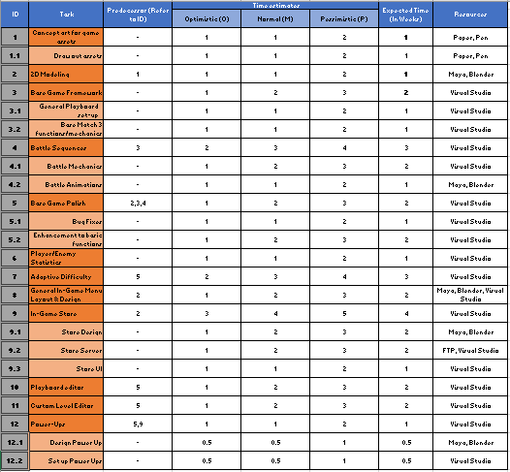

Refer to Task Breakdown.xlsx

* 1. Resources assignment

*\* The list of resource assignments with tasks. You can merge the task list and resource assignment into one table if you can.*

Refer to 3.2

* 1. The PERT Charts with critical path identified

*\* Pick up two major features from ‘2.2 Features and Functions’ and build a two different PERT charts for each features.*

*\* The tasks for each feature should be more than 10.*

*\* Link each tasks into the members in the team (regarding from ‘2.3 Team roles and responsibilities) and make it work on parallel. So your PERT chart should have more than 2 branches.*

*\* Identify the critical path, forward path time calculation, backward path time calculation and slack time calculation.*

* In-Game Store
  + - Create UI (Task A)
  + - Design UI (Task B)
  + - Gather Item Data (Task C)
  + - Create Items based on data (Task D)
  + - Create Item behaviour (Task E)
  + - Design Items (Task F)
  + - Get Hosting for server (Task G)
  + - Set up Server (Task H)
  + - Set up connection and collaboration between game and server (Task I)
  + - Set up Credit payment service (Task J)
  + - Item Balancing (Task K)
  + - Add Items to server (Task L)
  + - Test store (Task M)
  + - Bug Fix (Task N)
* Interactive combat system
  + Set Up battle area (Task A1)
  + Design graphical representation for stats (Task B1)
  + Set up attacks (Task C1)
  + Design Battle animations (Task D1)
  + Code Damage Multiplier Functions (Task E1)
  + Integrate Power-Ups (Task F1)
  + Computation of stats (Task G1)
  + Design themed battle scenes (Task H1)
  + Character States (Task I1)
  + Adaptive Difficulty (Task J1)
  + Test Battle (Task K1)
  + Bug Fix (Task L1)
  1. Milestone & Schedule Estimation

*\* Table or list of milestone to make an estimation of your schedule.*

*\* All the items in ‘3.1 Deliverable features and functions’ should be shown in this table (or list).*

1. **Remark (optional)**

*\* This part is optional for the assignment. If you want to make more note and details you can add any remarks here.*

*\* Examples in below;*

* 1. *Challenges and Risks*
  2. *Remarkable Issues*