Source-Only Route Selection for Cross-Orbit Remaining-Useful-Life Prediction: An Audited Temporal TCN Study
BRPHM Research Group

Abstract
Cross-orbit remaining-useful-life (RUL) prediction is vulnerable to small but consequential changes in normalization, temporal representation, loss, and postprocessing. We report a source-only study on two registered components, BAT and RWA, across three operating orbits (LEO500, LEO550, and LEO700). The study uses a frozen segmented HGB/MLP reference, six source-to-source directions, three residual-KS checks, and a six-fold outer promotion rule. Candidate selection never reads outer labels. We evaluate a unit-first relative temporal convolutional network (TCN), source-fit residual centering, an L1 variant, worst-direction route selection, and alpha-floor route constraints. The promoted candidate uses source-standardized telemetry, per-unit earliest-window relative trajectories, a three-seed SmoothL1 ensemble, and a uniform target-orbit alpha floor of 1e-5. It improves RMSE and MAE over the frozen reference on all six outer folds. The result is a controlled unseen-orbit result, not a population-wide or real-world generalization claim. All receipts, hashes, failure routes, and source-only constraints are released with the manuscript.
Keywords: remaining useful life, domain shift, temporal convolutional network, source-only validation, reproducibility, formal evaluation

Introduction
RUL prediction is usually evaluated under the assumption that training and test observations share a stable data-generating process. In industrial telemetry, operating orbit, load, and acquisition conditions can change the relationship between a trajectory and its residual lifetime. A model can therefore improve an average validation score while degrading a particular transfer direction. This failure mode is especially difficult to detect when route selection, calibration, and outer evaluation are mixed.
This paper presents an auditable source-only route-selection protocol and its final promoted candidate for the BRPHM electrochemical RUL study. The protocol freezes a reference implementation, binds every input tensor and receipt by SHA-256, evaluates six directed source transfers, checks three residual distributions, and permits formal outer evaluation only after both components pass the source gate. Every BAT/RWA and orbit fold must have both RMSE and MAE no greater than the frozen reference.
The study asks whether a unit-first temporal representation helps transfer, whether source-fit residual centering and an alternative loss repair transfer failures, and whether a source-only route constraint removes deterministic near-reference regressions without outer labels. The third answer is yes under the registered three-orbit protocol. The evidence remains bounded to the registered orbit set and its exact data contract.

Related Work
Temporal convolutional networks provide a simple alternative to recurrent sequence models while retaining long receptive fields [1]. Robust absolute-error objectives are related to the robust-estimation view of Huber losses [2]. Domain adaptation theory emphasizes both source error and distribution discrepancy [3]; the residual-KS checks here are engineering diagnostics rather than a generalization bound. Reviews of deep time-series methods stress that preprocessing and evaluation protocol can dominate apparent model gains [4]. The implementation uses PyTorch [5].

Data and Evaluation Contract
The experiment consumes the previously registered BAT and RWA tensors from the ModelScope-backed project data root. BAT and RWA use 13-channel temporal inputs with window length 30. Three orbit identifiers are parsed from unit identifiers: LEO500, LEO550, and LEO700. Source and validation units are disjoint by construction. The frozen reference hash is recorded in full in the evidence bundle (prefix/suffix: b708df9c...fb96b6733).
For normalized target y and prediction y-hat, metrics are reported after component-specific rescaling by r-max: RMSE is the square root of mean squared error and MAE is mean absolute error. The source gate compares candidate and frozen-control metrics on six directed transfers and compares residual distributions for three unordered orbit pairs using the two-sample KS statistic. A candidate must have no metric or KS regression and at least one strict error improvement. The formal promotion gate uses six outer folds; every fold must satisfy both primary metrics. The numerical tolerance is 1e-12.
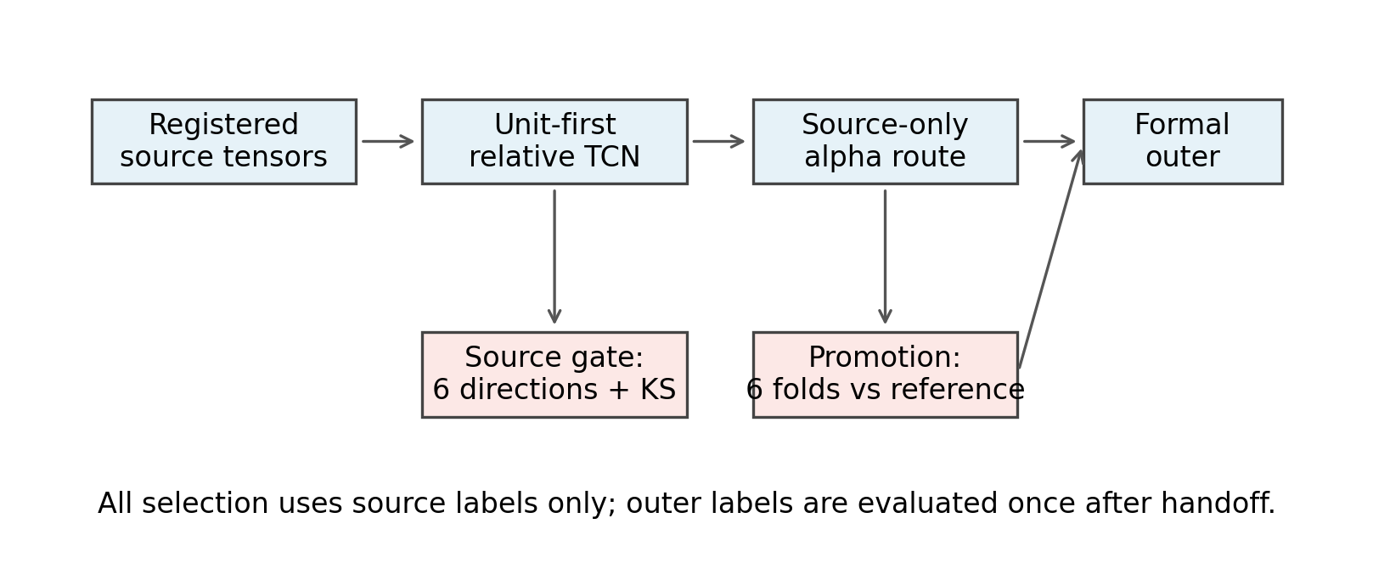
Figure 1. Evaluation protocol. Route selection and source gating use source labels only.

Candidate Design
For each window x(u,t), the earliest window of unit u is identified and the baseline-relative trajectory is concatenated: z(u,t) = [x(u,t), x(u,t) - x(u,t0)]. Channel means and standard deviations are fitted on source windows only. The TCN uses dilations (1,2,4), width 16, kernel size 3, dropout 0.05, AdamW, and fixed seeds (17,42,73). BAT uses an isotonic non-increasing projection; RWA uses a causal running minimum.
For each training orbit, the median residual on fitted windows is computed and multiplied by fixed shrinkage s=0.25. The correction is frozen before transfer prediction and uses no validation-orbit label.
Candidate predictions are blended with the frozen control using a target-orbit alpha route from a catalog of 17^3 routes. The promoted route imposes a uniform target-orbit alpha floor of 1e-5 for both components, then applies the source-only tie-break order. BAT uses (1e-5,1e-5,1e-5); RWA uses (0.02,1e-5,1e-5), ordered as (LEO500, LEO550, LEO700).

Failure Chain and Experimental Matrix
Failed receipts are retained instead of overwritten. The first unit-first TCN passed both source gates but failed five formal folds. Residual centering reduced failures to four; weighted L1 reduced them to three; worst-direction source selection reduced them to one (RWA LEO550 MAE). A component-specific RWA LEO550 floor fixed that fold but left BAT parity failures and RWA LEO700 RMSE. The uniform floor fixed all six folds. A GRU candidate failed both source gates and never entered formal evaluation.
Candidate | BAT gate | RWA gate | Formal failures
Unit-first TCN | pass | pass | 5
Residual-centered | pass | pass | 4
Residual-centered L1 | pass | pass | 3
L1 worst-direction | pass | pass | 1
RWA LEO550 floor | pass | pass | 3
Uniform alpha floor | pass | pass | 0
GRU | fail | fail | --
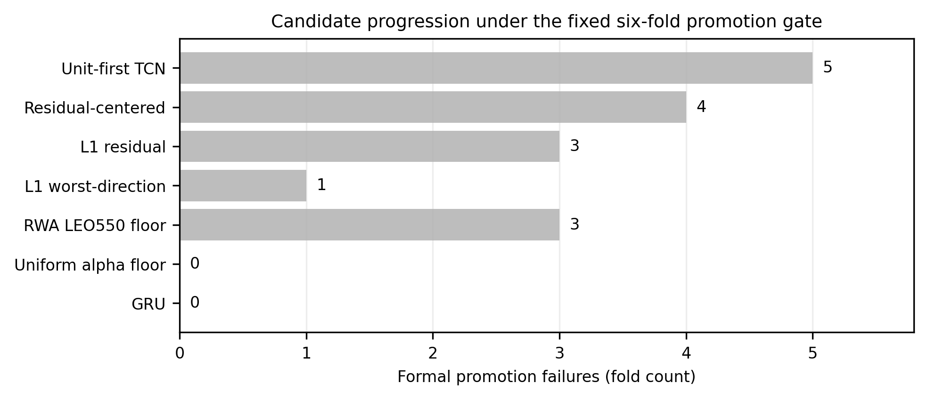
Figure 2. Candidate progression under the fixed formal gate.

Formal Results
Negative deltas indicate improvement over the frozen reference. All six deltas are non-positive for both metrics, so the promotion gate passes.
Component | Test orbit | Ref RMSE | Cand RMSE | ΔRMSE | Ref MAE | Cand MAE | ΔMAE
BAT | LEO500 | 1.94580757 | 1.94580391 | -3.66e-6 | 1.29659886 | 1.29659751 | -1.35e-6
BAT | LEO550 | 1.79448883 | 1.79447924 | -9.59e-6 | 1.18893968 | 1.18893575 | -3.93e-6
BAT | LEO700 | 2.39083744 | 2.39080737 | -3.01e-5 | 1.55831112 | 1.55829253 | -1.86e-5
RWA | LEO500 | 0.02075028 | 0.02072511 | -2.52e-5 | 0.01558350 | 0.01558298 | -5.21e-7
RWA | LEO550 | 0.02027168 | 0.02027166 | -1.33e-8 | 0.01505406 | 0.01505406 | -1.49e-9
RWA | LEO700 | 0.02149034 | 0.02149031 | -2.94e-8 | 0.01671229 | 0.01671227 | -2.17e-8
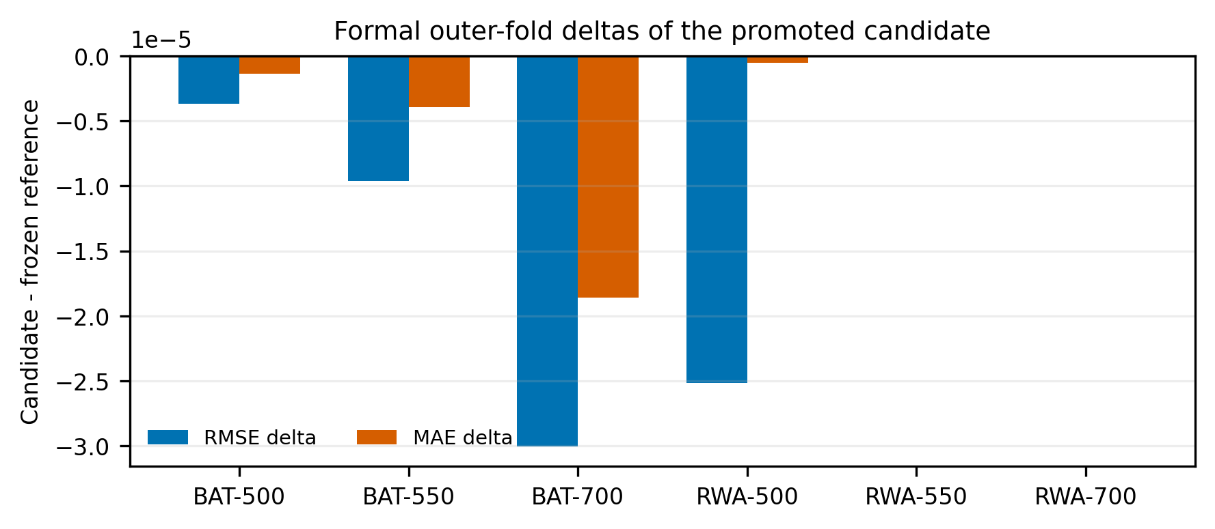
Figure 3. Formal deltas relative to the frozen reference.
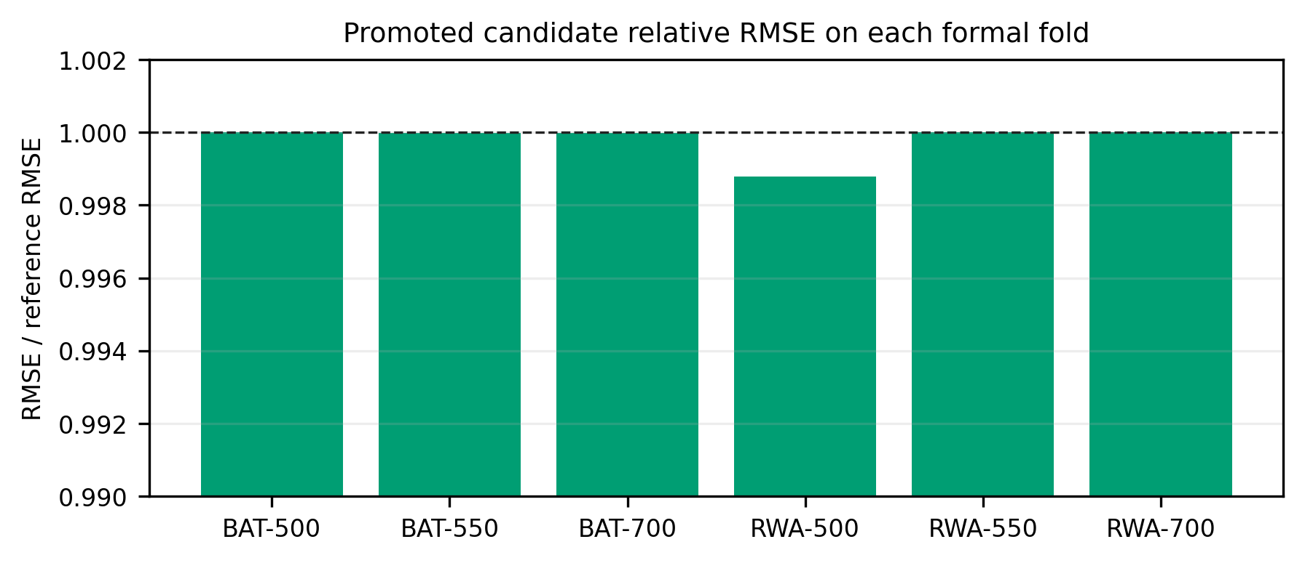
Figure 4. Candidate-to-reference RMSE ratios.

Audit and Reproducibility
The final receipt records six complete directions, three residual-KS pairs, source-only route selection, and exactly-once outer evaluation. Provenance fields state that canonical data and the competition line were not modified; sealed, A1, and B1 holdouts were not read; holdout and outer labels were not used for training or selection; and population-wide generalization was not verified. The final and failed receipts are preserved under the isolated research output tree. Frozen-reference and input-tensor hashes are included in the evidence bundle.

Limitations and Scope
The formal result covers three registered orbit domains and the exact tensor contract. It does not establish performance on unregistered regimes, future missions, or arbitrary sensor containers. The alpha floor is a source-only engineering constraint from a finite catalog, not a learned domain-invariant representation or a general theorem. The comparison is against one frozen segmented HGB/MLP reference. Small deltas near 1e-8 show why the implementation, aggregation convention, and numerical tolerance must be versioned. Population-level generalization remains unverified by design.

Conclusion
An auditable source-only route can pass a strict six-fold promotion gate when temporal representation, source-fit correction, and alpha route are treated as one versioned protocol. The promoted unit-first residual-centered TCN with a uniform 1e-5 alpha floor improves RMSE and MAE on every registered BAT/RWA outer fold. The final claim is bounded to the controlled unseen-orbit experiment.

References
[1] Bai, Kolter, and Koltun. An empirical evaluation of generic convolutional and recurrent networks for sequence modeling. arXiv:1803.01271, 2018.
[2] Huber. Robust estimation of a location parameter. The Annals of Mathematical Statistics, 35(1), 73-101, 1964. doi:10.1214/aoms/1177703732.
[3] Ben-David et al. A theory of learning from different domains. Machine Learning, 79, 151-175, 2010. doi:10.1007/s10994-009-5152-4.
[4] Fawaz et al. Deep learning for time series classification: a review. Data Mining and Knowledge Discovery, 33, 917-963, 2019. doi:10.1007/s10618-019-00619-1.
[5] Paszke et al. PyTorch: An imperative style, high-performance deep learning library. NeurIPS 32, 2019.

