**#include <iostream.h>**

**class person**

**{**

**char * name;**

**int age;**

**int tel;**

**public:**

**person()**

**{**

**cout<<"this is person class!\n";**

**}**

**~person()**

**{**

**cout<<"the destructor of class person!\n";**

**}**

**};**

**class student:public person**

**{**

**char * department;**

**int score;**

**public:**

**student()**

**{**

**cout<<"this is a student class!\n";**

**}**

**~student()**

**{**

**cout<<"the destructor of student class!\n";**

**}**

**};**

**class teacher:public person**

**{**

**char * name;**

**char * style;**

**int * salary;**

**public:**

**teacher()**

**{**

**cout<<"this is a teacher class!\n";**

**}**

**~teacher()**

**{**

**cout<<"the destructor of teacher class!\n";**

**}**

**};**

**void main()**

**{**

**student a3;**

**teacher b2;**

**}**

**运行结果：**

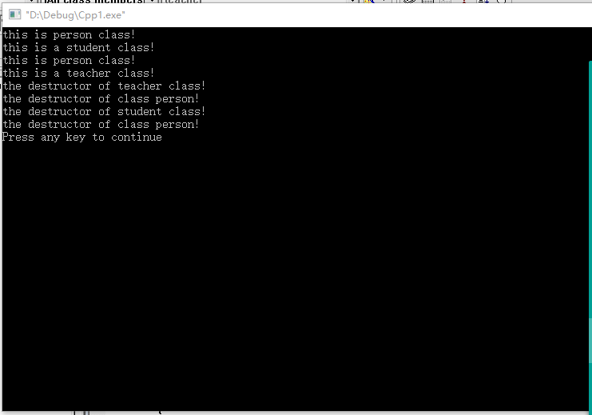

**所以由程序的运行结果可以知道，在C++共有继承当中先调用基类的公有成员函数，在调用派生类，然后进行析构函数的顺序刚刚好相反，先析取子类，后析取父类。**