 O-RAN.WG1.O-RAN-Architecture-Description-v04.00

Technical Specification

O-RAN Architecture Description

Copyright © 2021 by O-RAN ALLIANCE e.V.

By using, accessing or downloading any part of this O-RAN specification document, including by copying, saving, distributing, displaying or preparing derivatives of, you agree to be and are bound to the terms of the O-RAN Adopter License Agreement contained in the Annex ZZZ of this specification. All other rights reserved.

O-RAN ALLIANCE e.V.

Buschkauler Weg 27, 53347 Alfter, Germany

Register of Associations, Bonn VR 11238

VAT ID DE321720189

[**www.o-ran.org**](https://protect2.fireeye.com/v1/url?k=c80e048c-97953da1-c80e4417-8692dc8284cb-7f635c8d2a14e888&q=1&e=e2721732-7bea-412d-9f83-3380a433d6ca&u=http%3A%2F%2Fwww.o-ran.org%2F)

# Revision History

|  |  |  |  |
| --- | --- | --- | --- |
| **Date** | **Revision** | **Editor(s)** | **Description** |
| 2019.09.06 | 00.01 | Haseeb Akhtar (Ericsson) | * First draft of O-RAN Architecture Description Document. |
| 2019.10.12 | 00.02 | Haseeb Akhtar (Ericsson) | * Added the contact names of sponsoring organizations. * Figure 4‑3 to show the UEs clustered together. * Added a description of Non-RT RIC (Section 4.3.1). |
| 2019.10.14 | 00.03 | Haseeb Akhtar (Ericsson) | * Added DT as one of the co-sponsors. * Revised the description of Non-RT RIC (Section 4.3.1). * Added a description of Near-RT RIC (Section 4.3.2). * Updated the versioning format as per O-RAN guidance. |
| 2019.10.16 | 00.04 | Haseeb Akhtar (Ericsson) | * Revised the description of Non-RT RIC (Section 4.3.1). * Minor editorial corrections. |
| 2019.10.17 | 00.05 | Cagatay Buyukkoc (AT&T) | * Added Orange as one of the co-sponsors. |
| 2020.01.16 | 01.00 | Paul Smith (AT&T)  Jinri Huang (CMCC)  Chai Li (CMCC)  Haseeb Akhtar (Ericsson) | * Added the CR on ‘v1.0 work items of Architecture Description’ (PA19). |
| 2020.03.25 | 02.00.01 | Haseeb Akhtar (Ericsson) | * Added the CR on ‘O-RAN Network Function implementation options’ (v02). |
| 2020.05.18 | 02.00.02 | Haseeb Akhtar (Ericsson) | * Added the CR on ‘revised defintions’ (v03). * Added the CR on ‘revised text for multiple LLS options’ (v02). |
| 2020.05.28 | 02.00.03 | Haseeb Akhtar (Ericsson) | * Added the CR on ‘architecture principle in chapter 3’ (v02). |
| 2020.06.11 | 02.00.04 | Haseeb Akhtar (Ericsson) | * Added the revised CR on ‘text for multiple LLS options’ (v3). The multiple LLS option text was moved from the descriptions of O-DU and O-RU (Sections 4.3.5 and 4.3.6) to ‘Overall Architecture of O-RAN’ (Section 4.1). |
| 2020.07.13 | 02.00.05 | Haseeb Akhtar (Ericsson) | * Editorial changes based on the comments from Vikas Dixit (JIO) and Changlan Tsai (ITRI) during WG1 vote. |
| 2020.07.15 | 02.00.06 | Haseeb Akhtar (Ericsson) | * Removed all track changes from the document for TSC review. |
| 2020.07.24 | 02.00.07 | Haseeb Akhtar (Ericsson) | * Removed ‘-0’ from the name since the Architecture Description does not have any ‘branch’ document. |
| 2020.10.30 | 0.2.00 | Haseeb Akhtar (Ericsson) | * Removed the extension ‘.07’ from the name. * Updated copyright statement in the title page. |
| 2020.09.27 | 03.00.01 | Haseeb Akhtar (Ericsson) | * Added the CR on ‘description of Uu interface’ (v02). |
| 2020.10.20 | 03.00.02 | Haseeb Akhtar (Ericsson) | * Added the CR on ‘Arhitecture Description editorial changes’ (v02). |
| 2020.10.29 | 03.00.03 | Haseeb Akhtar (Ericsson) | * Added the CR on ‘FHM and FHGW implementation options’ (v07). * Added the CR on ‘Architecture Description updates for V5 WG4 M-Plane’ (v04). * Added the CR on ‘Managed Application defintion’ (v02). * Added the CR on ‘SMO description’ (v02). |
| 2020.10.30 | 03.00.04 | Haseeb Akhtar (Ericsson) | * Added the CR on ‘O-RAN Architecture Description Document Updates for R1 Interface Changes’ (v09). * Addressed comments from Vikas Dixit (JIO) on correcting the references. * Made minor editorial changes in ‘References’ section. |
| 2020.11.02 | 03.00.05 | Haseeb Akhtar (Ericsson) | * Added the CR on ‘Adding Legend to Architecture Figures’ (v02). * Replaced ‘Near RT RIC’ with ‘Near-RT RIC’ in Figure 4.3-1. * Added ‘xNF’ in the ‘Abbreviations’ section. |
| 2020.11.05 | 03.00.06 | Haseeb Akhtar (Ericsson) | * Addressed comment from Linda Horn (Nokia) on correcting the text as per the CR on ‘SMO description’ (v02). * Added 'E-UTRA', 'E-UTRAN', 'FFT', 'iFFT', 'O-Cloud', 'PRACH', 'RF', 'RRC', 'RRH' and 'TRP' in the ‘Abbreviations’ section. * Replaced ‘Other RAN xNF’ with ‘Other O-RAN xNF’ in Figure 4.3-1. |
| 2020.11.12 | 03.00.07 | Haseeb Akhtar (Ericsson) | * Addressed comment from Anil Umesh (DCM) to remove the sentence 'FHM function may be implemented as part of O-DU or as part of O-RU or as an independent network element between O-DU and O-RU' from the document (Section A2). |
| 2020.11.21 | 03.00.08 | Haseeb Akhtar (Ericsson) | * Addressed comment from Vishwanath Ramamurthi (Verizon) to remove the words ‘Optionally, and only’ from the sentence ‘Optionally, and only in the hybrid model, Open Fronthaul M-plane interface between SMO and O-RU for FCAPS support’ (Section 4.3.1). |
| 2020.11.25 | 03.00 | Haseeb Akhtar (Ericsson) | * Changed the year in copyright message to ‘2021’. * Removed the last two digits of the version for external publication. |
| 2021.03.02 | 04.00.01 | Haseeb Akhtar (Ericsson) | * Added the CR on ‘Control Loop Timing Clarifications’ (rev 6). * Added the CR on ‘SMO to O-RU OAM Link’ (v02). * Added the CR on ‘Architecture Description Editorial Changes’ (v02). |
| 2021.03.03 | 04.00.02 | Haseeb Akhtar (Ericsson) | * Addressed comment from Jinri Huang (CMCC) to change ‘use cases involving the Non-RT RIC control loop’ to ‘use cases involving the Non-RT control loops’ (Section 4.2). * Made editorial changes in ‘O-RAN Control Loops’ (Section 4.2) to the text consistent with this document. * Added RT (Real Time) in the ‘Abbreviations’ section. |
| 2021.03.05 | 04.00.03 | Haseeb Akhtar (Ericsson) | * Created a clean version for WG1 voting. |
| 2021.03.09 | 04.00.04 | Haseeb Akhtar (Ericsson) | * Added TR (Technical Report), TS (Technical Specification) and UE (User Equipment) in ‘Abbreviations’ section. |
| 2021.03.18 | 04.00.05 | Haseeb Akhtar (Ericsson) | * Addressed a comment from Vikas Dixit (JIO) on correcting the version format from x.y.z to xx.yy.zz (Section 1.1). |
| 2021.03.18 | 04.00 | Haseeb Akhtar (Ericsson) | * Created a clean version for the approvals of TSC and EC/Board. * Removed the last two digits of the version for external publication. |

Contents

Revision History 2

Chapter 1. Introductory Material 7

1.1 Scope 7

1.2 References 7

1.3 Definitions and Abbreviations 8

1.3.1 Definitions 8

1.3.2 Abbreviations 9

Chapter 2. O-RAN Overview 12

2.1 Scope and Objectives 12

Chapter 3. General O-RAN Architecture Principles 13

Chapter 4. O-RAN Architecture 14

4.1 Overall Architecture of O-RAN 14

4.2 O-RAN Control Loops 16

4.3 Description of O-RAN Functions 16

4.3.1 Service Management and Orchestration (SMO) 16

4.3.2 Near-RT RIC 19

4.3.3 O-CU-CP 19

4.3.4 O-CU-UP 19

4.3.5 O-DU 19

4.3.6 O-RU 20

4.3.7 O-eNB 20

4.3.8 O-Cloud 20

4.4 Relevant Interfaces in O-RAN Architecture 20

4.4.1 A1 Interface 21

4.4.2 O1 Interface 21

4.4.3 O2 Interface 21

4.4.4 E2 Interface 21

4.4.5 Open Fronthaul Interface 21

4.4.6 E1 Interface 21

4.4.7 F1-c Interface 22

4.4.8 F1-u Interface 22

4.4.9 NG-c Interface 22

4.4.10 NG-u Interface 22

4.4.11 X2-c Interface 22

4.4.12 X2-u Interface 22

4.4.13 Xn-c Interface 22

4.4.14 Xn-u Interface 22

4.4.15 Uu Interface 22

Chapter 5. O-RAN Information Model (IM) Principles 23

Annex A (Informative): Implementation Options of O-RAN Functions and Network Elements 24

A.1 Shared Cell 24

A.2 FHGW Function 25

A.3 Near-RT RIC 26

A.4 Near-RT RIC, O-CU-CP, O-CU-UP, O-DU and O-RU 26

Annex ZZZ : O-RAN Adopter License Agreement 31

Section 1: DEFINITIONS 31

Section 2: COPYRIGHT LICENSE 31

Section 3: FRAND LICENSE 31

Section 4: TERM AND TERMINATION 32

Section 5: CONFIDENTIALITY 32

Section 6: INDEMNIFICATION 32

Section 7: LIMITATIONS ON LIABILITY; NO WARRANTY 32

Section 8: ASSIGNMENT 33

Section 9: THIRD-PARTY BENEFICIARY RIGHTS 33

Section 10: BINDING ON AFFILIATES 33

Section 11: GENERAL 33

# Introductory Material

## Scope

This Technical Specification has been produced by the O-RAN Alliance.

The contents of the present document are subject to continuing work within O-RAN WG1 and may change following formal O-RAN approval. Should the O-RAN Alliance modify the contents of the present document, it will be re-released by O-RAN Alliance with an identifying change of release date and an increase in version number as follows:

Release xx.yy

where:

xx the first digit is incremented for all changes of substance, i.e., technical enhancements, corrections, updates, etc. (the initial approved document will have xx=01).

yy the second digit is incremented when editorial only changes have been incorporated in the document.

zz the third digit included only in working versions of the document indicating incremental changes during the editing process.

For the very first draft version of this document, the version shall be 00.00.01, followed by working versions 00.00.02, 00.00.03, etc. until an approved version is agreed for publication, which shall be numbered 01.00. After the first version is published, the next working version shall be 01.00.01, followed by 01.00.02, 01.00.03 and so on until the next published version is approved, which (if a minor revision with editorial changes only) shall be numbered 01.01 or (if a major revision) shall be numbered 02.00. No published version of this document shall include three digit-groups.

The present document defines the O-RAN architecture and interfaces.

## References

The following documents contain provisions which, through reference in this text, constitute provisions of the present document.

- References are either specific (identified by date of publication, edition number, version number, etc.) or non‑specific.

- For a specific reference, subsequent revisions do not apply.

- For a non-specific reference, the latest version applies. In the case of a reference to a 3GPP document (including a GSM document), a non-specific reference implicitly refers to the latest version of that document.

1. 3GPP TR 21.905: “Vocabulary for 3GPP Specifications”.
2. 3GPP TR 38.801: “Study on new radio access technology: Radio access architecture and interfaces (Release 14)”.
3. 3GPP TS 23.501: “System Architecture for the 5G System (5GS); Stage 2”.
4. 3GPP TS 28.622: " Generic Network Resource Model (NRM); Stage 2".
5. 3GPP TS 32.101: “Technical Specification Group Services and System Aspects; Telecommunication management; Principles and high level requirements (Release 15)”.
6. 3GPP TS 36.401: “ Evolved Universal Terrestrial Radio Access Network (E-UTRAN); Architecture Description”.
7. 3GPP TS 36.420: “Evolved Universal Terrestrial Radio Access Network (E-UTRAN); X2 general aspects and principles”.
8. 3GPP TS 38.300 “NR; NR and NG-RAN Overall Description; Stage 2”.
9. 3GPP TS 38.401: "NG-RAN; Architecture description".
10. 3GPP TS 38.420: “NG-RAN; Xn general aspects and principles”.
11. 3GPP TS 38.460: "NG-RAN; E1 general aspects and principles".
12. 3GPP TS 38.470: "NG-RAN; F1 general aspects and principles".
13. O-RAN White Paper: “O-RAN: Towards an Open and Smart RAN”, October 2018.
14. O-RAN-WG1.OAM-Architecture-v04.00: “O-RAN WG1 Operations and Maintenance Architecture v04.00”.
15. O-RAN-WG1.O1-Interface-v04.00: “O-RAN Operations and Maintenance Interface Specification v04.00”.
16. O-RAN.WG1.Use-Cases-Analysis-Report-v05.00: “O-RAN Working Group 1; Use Cases Analysis Report v05.00”.
17. O-RAN.WG1.Use-Cases-Detailed-Specification-v05.00: “O-RAN Working Group 1; Use Cases Detailed Specification v05.00”.
18. O-RAN-WG2.A1GAP-v02.02: “O-RAN Working Group 2; A1 interface: General Aspects and Principles v02.02”.
19. O-RAN.WG2.Non-RT-RIC-ARCH-v01.01: “O-RAN Working Group 2; Non-RT RIC Functional Architecture v01.01”.
20. ORAN-WG3.E2GAP.0-v01.01: “O-RAN Working Group 3; Near-Real-time RAN Intelligent Controller Architecture & E2 General Aspects and Principles v01.01”.
21. ORAN-WG3.E2SM-v01.01: “O-RAN Working Group 3; Near-Real-time RAN Intelligent Controller E2 Service Model (E2SM) v01.01”.
22. O-RAN-WG4.MP.0-v06.00: “O-RAN Alliance Working Group 4; Management Plane Specification v06.00”.
23. O-RAN-WG4.CUS.0-v06.00: “O-RAN Fronthaul Working Group; Control, User and Synchronization Plane Specification v06.00”.
24. O-RAN-WG6.CAD-v02.01: “Cloud Architecture and Deployment Scenarios for O-RAN Virtualized RAN v02.01”.
25. ORAN.WG7.IPC-HRD-Opt8.0-v02.00: “O-RAN WG7; Hardware Reference Design Specification for Indoor Picocell FR1 with Split Architecture Option 8 v02.00”.

## Definitions and Abbreviations

### Definitions

For the purposes of the present document, the terms and definitions given in 3GPP TR 21.905 [1] and the following apply. A term defined in the present document takes precedence over the definition of the same term, if any, in 3GPP TR 21.905 [1].

**E2 Node:** A logical node terminating E2 interface. In this version of the specification, O-RAN nodes terminating E2 interface are:

* for NR access: O-CU-CP, O-CU-UP, O-DU or any combination as defined in [20],
* for E-UTRA access: O-eNB as defined in Section 4.3.7.

**Managed Application:** The definition of Managed Application is given in O-RAN Operations and Maintenance Architecture [14].

**Managed Element:** The definition of a Managed Element (ME) is given in 3GPP TS 28.622 [4], Section 4.3.3.

**Managed Function:** The definition of a Managed Function (MF) is given in 3GPP TS 28.622 [4], Section 4.3.4.

**Near-RT RIC:** O-RAN Near-Real-Time RAN Intelligent Controller: A logical function that enables near-real-time control and optimization of RAN elements and resources via fine-grained data collection and actions over E2 interface. It may include AI/ML workflow including model training, inference and updates. Please refer to [20] for more information

**Non-RT RIC:** O-RAN Non-Real-Time RAN Intelligent Controller: A logical function within SMO that drives the content carried across the A1 interface. It is comprised of the Non-RT RIC Framework and the Non-RT RIC Applications (rApps) whose functions are defined below. Please refer to [18] for more information.

**Non-RT RIC Applications (rApps):** Modular applications that leverage the functionality exposed via the Non-RT RIC Framework’s R1 interface to provide added value services relative to RAN operation, such as driving the A1 interface, recommending values and actions that may be subsequently applied over the O1/O2 interface and generating “enrichment information” for the use of other rApps. The rApp functionality within the Non-RT RIC enables non-real-time control and optimization of RAN elements and resources and policy-based guidance to the applications/features in Near-RT RIC. Please refer to [19] for more information.

**Non-RT RIC Framework:** That functionality internal to the SMO that logically terminates the A1 interface to the Near-RT RIC and exposes to rApps, via its R1 interface, the set of internal SMO services needed for their runtime processing. The Non-RT RIC Framework functionality within the Non-RT RIC provides AI/ML workflow including model training, inference and updates needed for rApps. Please refer to [19] for more information.

**NMS:** A Network Management System for the O-RU as specified in [22] to support legacy Open Fronthaul M-Plane deployments (prior to version 5 of [22]).

**O-Cloud:** O-Cloud is a cloud computing platform comprising a collection of physical infrastructure nodes that meet O-RAN requirements to host the relevant O-RAN functions (such as Near-RT RIC, O-CU-CP, O-CU-UP, and O-DU), the supporting software components (such as Operating System, Virtual Machine Monitor, Container Runtime, etc.) and the appropriate management and orchestration functions. Please refer to [24] for more information.

**O-CU-CP**: O-RAN Central Unit – Control Plane: a logical node hosting the RRC and the control plane part of the PDCP protocol. Please refer to Section 4.3.3 for more information.

**O-CU-UP**: O-RAN Central Unit – User Plane: a logical node hosting the user plane part of the PDCP protocol and the SDAP protocol. Please refer to Section 4.3.4 for more information.

**O-DU**: O-RAN Distributed Unit: a logical node hosting RLC/MAC/High-PHY layers based on a lower layer functional split. Please refer to Section 4.3.5 for more information.

**O-eNB:** An eNB [6] or ng-eNB [8] that supports E2 interface. Please refer to Section 4.3.7 for more information.

**O-RU**: O-RAN Radio Unit: a logical node hosting Low-PHY layer and RF processing based on a lower layer functional split. This is similar to 3GPP’s “TRP” or “RRH” but more specific in including the Low-PHY layer (FFT/iFFT, PRACH extraction). Please refer to Section 4.3.6 for more information.

**O1**: Interface between SMO framework as specified in Section 4.3.1 and O-RAN managed elements, for operation and management, by which FCAPS management, PNF (Physical Network Function) software management, File management shall be achieved.

**O2**: Interface between SMO framework as specified in Section 4.3.1 and the O-Cloud for supporting O-RAN virtual network functions. Please refer to [24] for more information.

**Open FH M-Plane**: Management interface controlling the O-RU, generally driven from the O-DU but in the case of the hybrid topology also driven from the SMO. Please refer to [22] for more details.

**SMO:** A Service Management and Orchestration system as described in Section 4.3.1**.**

**xApp**: An application designed to run on the near-RT RIC. Such an application is likely to consist of one or more microservices and at the point of on-boarding will identify which data it consumes and which data it provides. The application is independent of the near-RT RIC and may be provided by any third party. The E2 enables a direct association between the xApp and the RAN functionality [20].

### Abbreviations

For the purposes of the present document, the abbreviations given in 3GPP TR 21.905 [1] and the following apply. An abbreviation defined in the present document takes precedence over the definition of the same abbreviation, if any, in 3GPP TR 21.905 [1].

3GPP 3rd Generation Partnership Project

5GC 5G Core

5GS 5G System

AAL Accelerator Abstraction Layer

API Application Programing Interface

AI Artificial Intelligence

AMF Access and Mobility Functions

CM Configuration Management

E-UTRA Evolved Universal Terrestrial Radio Access

E-UTRAN Evolved Universal Terrestrial Radio Access Network

EN-DC E-UTRAN New Radio – Dual Connectivity

eNB evolved Node B

FCAPS Fault, Configuration, Accounting, Performance, Security

FFT Fast Fourier Transform

FHGW Fronthaul Gateway

FHM Fronthaul Multiplexer

FM Fault Management

gNB next generation Node B

gNB-CU gNB Central Unit

gNB-DU gNB Distributed Unit

iFFT inverse Fast Fourier Transform

LLS Lower Layer Split

LTE Long Term Evolution

MA Managed Application

MAC Media Access Control

ME Managed Element

MF Managed Function

ML Machine Learning

Near-RT RIC Near-Real-Time RAN Intelligent Controller

NFV Network Function Virtualization

NG-RAN Next Generation RAN

NMS Network Management System

Non-RT RIC Non-Real-Time RAN Intelligent Controller

NR 5G New Radio

O-Cloud O-RAN Cloud

O-CU-CP O-RAN Central Unit – Control Plane.

O-CU-UP O-RAN Central Unit – User Plane

O-DU O-RAN Distributed Unit

O-eNB O-RAN eNB

O-RAN Open RAN

O-RU O-RAN Radio Unit

Open FH Open Fronthaul

PDCP Packet Data Convergence Protocol

PHY Physical layer

PM Performance Management

PNF Physical Network Function

PRACH Physical Random Access Channel

RAN Radio Access Network

rApp Non-RT RIC Application

RAT Radio Access Technology

RF Radio Frequency

RLC Radio Link Control

RRC Radio Resource Control

RRH Remote Radio Head

RRM Radio Resource Management

RRU Remote Radio Unit

RT Real Time

RU Radio Unit

SDAP Service Data Adaptation Protocol

SMO Service Management and Orchestration

TR Technical Report

TRP Transmission and Reception Point

TS Technical Specification

VNF Virtualized Network Function

UE User Equipment

WG Working Group

xApp Near-RT RIC Application

xNF Any Network Function

# O-RAN Overview

## Scope and Objectives

O-RAN activities are guided by the following objectives [13]:

* Leading the industry towards open, interoperable interfaces, RAN virtualization, and big data and AI enabled RAN intelligence.
* Maximizing the use of common-off-the-shelf hardware and merchant silicon and minimizing proprietary hardware
* Specifying APIs and interfaces, driving standards to adopt them as appropriate, and exploring open source where appropriate
* The O-RAN Architecture identifies the key functions and interfaces adopted in O-RAN.

# General O-RAN Architecture Principles

This section contains the general O-RAN architecture principles as described below.

* The O-RAN architecture and interface specifications shall be consistent with 3GPP architecture and interface specifications to the extent possible.
* This document shall represent the O-RAN architecture at the time of its publication and may evolve as deemed appropriate by the O-RAN community.

# O-RAN Architecture

## Overall Architecture of O-RAN

Figure 4.1‑1 below provides a high-level view of the O-RAN architecture. It shows that the four key interfaces – namely, A1, O1, Open Fronthaul M-plane and O2 – connect SMO (Service Management and Orchestration) framework to O-RAN network functions and O-Cloud. Figure 4.1‑1 below also illustrates that the O-RAN network functions can be VNFs (Virtualized Network Function), i.e., VMs or Containers, sitting above the O-Cloud and/or PNFs (Physical Network Function) utilizing customized hardware. All O-RAN network functions are expected to support the O1 interface when interfacing the SMO framework.

The Open Fronthaul M-plane interface, between SMO and O-RU, is to support the O-RU management in hybrid mode, as specified in [22]. The O-RU termination of the O1 interface towards the SMO as specified in [14] is under study. The management architecture of the flat mode [14] and its relation to O1 interface for the O-RU is a subject for future study.

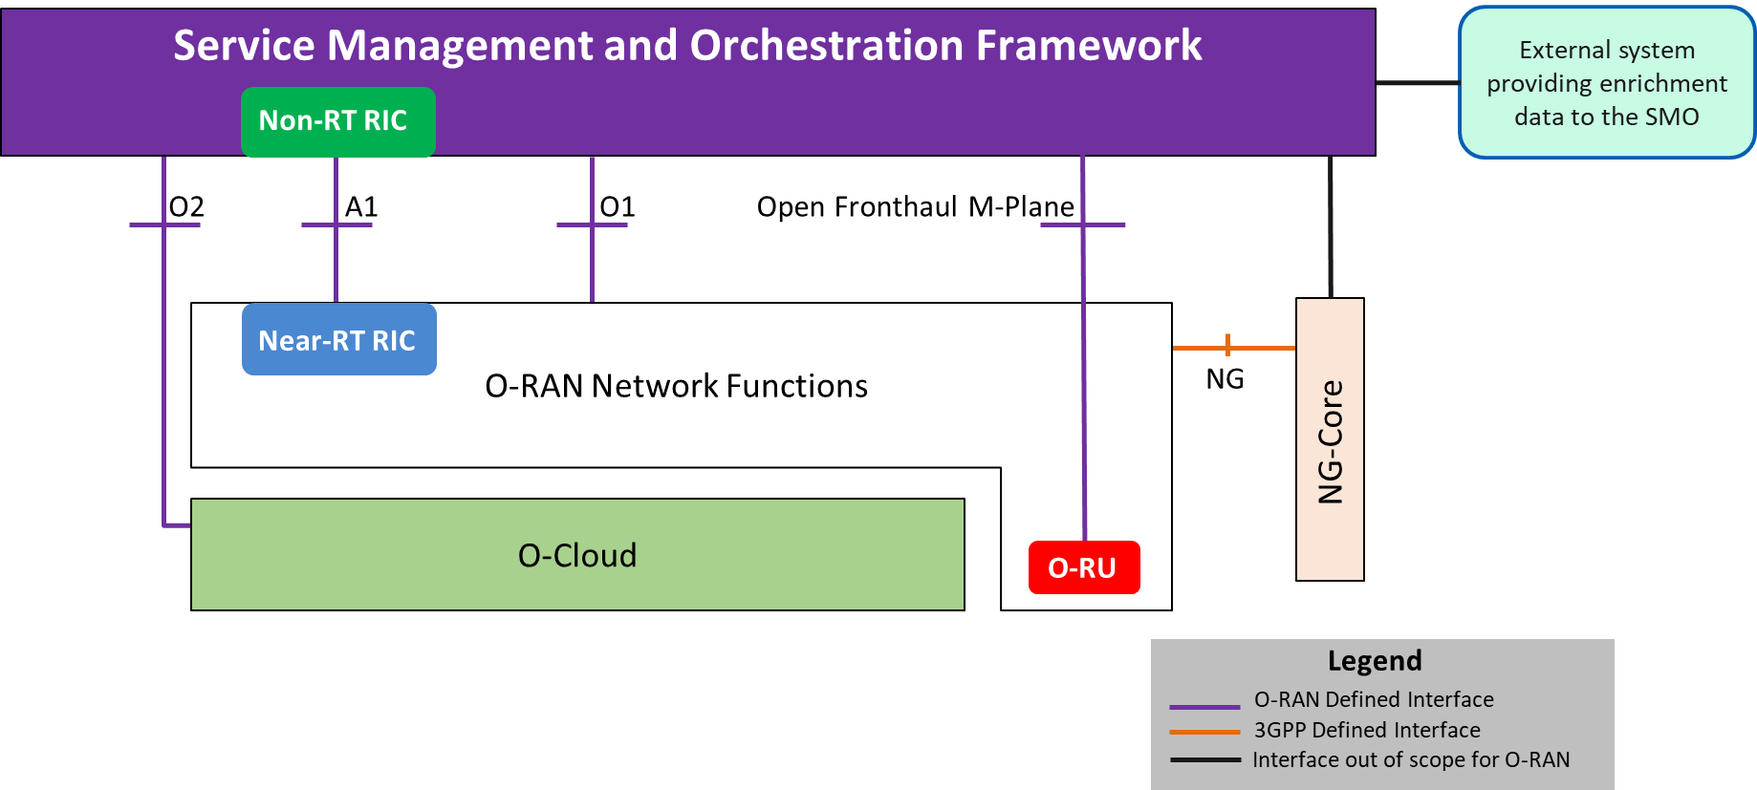

Figure ‑: High Level Architecture of O-RAN

Within the logical architecture of O-RAN, as shown in Figure 4.1‑2 below, the radio side includes Near-RT RIC, O-CU-CP, O-CU-UP, O-DU, and O-RU functions. The E2 interface connects O-eNB to Near-RT RIC. Although not shown in this figure, the O-eNB does support O-DU and O-RU functions with an Open Fronthaul interface between them.

As stated earlier, the management side includes SMO Framework containing a Non-RT-RIC function. The O-Cloud, on the other hand, is a cloud computing platform comprising a collection of physical infrastructure nodes that meet O-RAN requirements to host the relevant O-RAN functions (such as Near-RT RIC, O-CU-CP, O-CU-UP and O-DU etc.), the supporting software components (such as Operating System, Virtual Machine Monitor, Container Runtime, etc.) and the appropriate management and orchestration functions. The virtualization of O-RU is for future study.

As shown in this figure, the O-RU terminates the Open Fronthaul M-Plane interface towards the O-DU and SMO as specified in [22].

**Note:** The LLS (O-DU to O-RU interface) specified in Sections 4.3.5 and 4.3.6 (Split Option 7-2x) is the Open Fronthaul interface described in the O-RAN Open Fronthaul Specification [23]. Other LLS options [2] may be considered for reference designs when the relevant interfaces are described in specifications created by related open industry initiatives (e.g., the Small Cell Forum for Split Option 6) or in O-RAN white-box hardware specifications (e.g., Split Option 8).

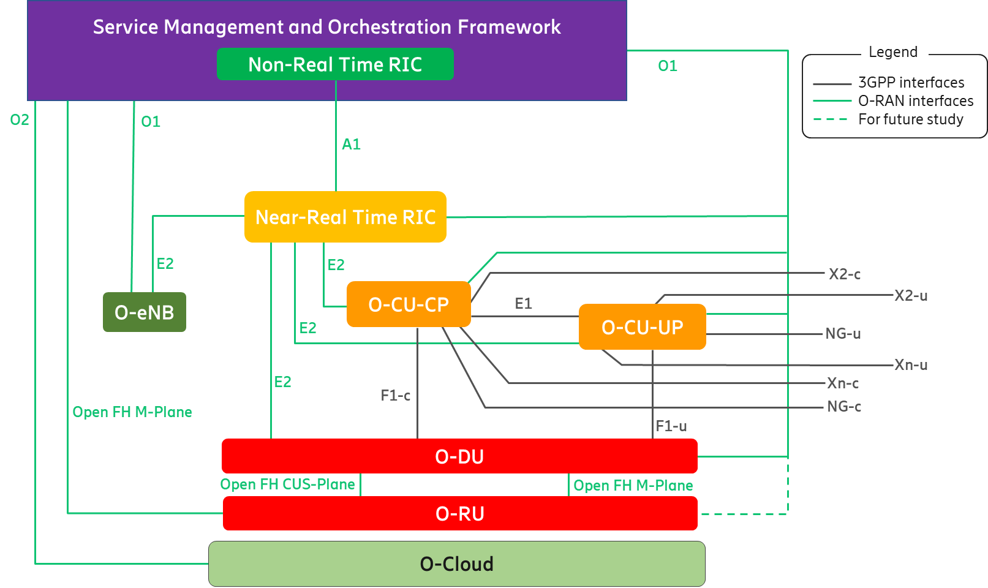

Figure ‑: Logical Architecture of O-RAN

The following figure shows the Uu interface between UE and O-RAN components as well as between UE and O-eNB. As shown in Figure 4.1‑3 below, the dotted box denotes all the O-RAN functions required to support the Uu interface for NR. The O-eNB, on the other hand, terminates the Uu interface for LTE. Please refer to Section 4.4.15 for more details.

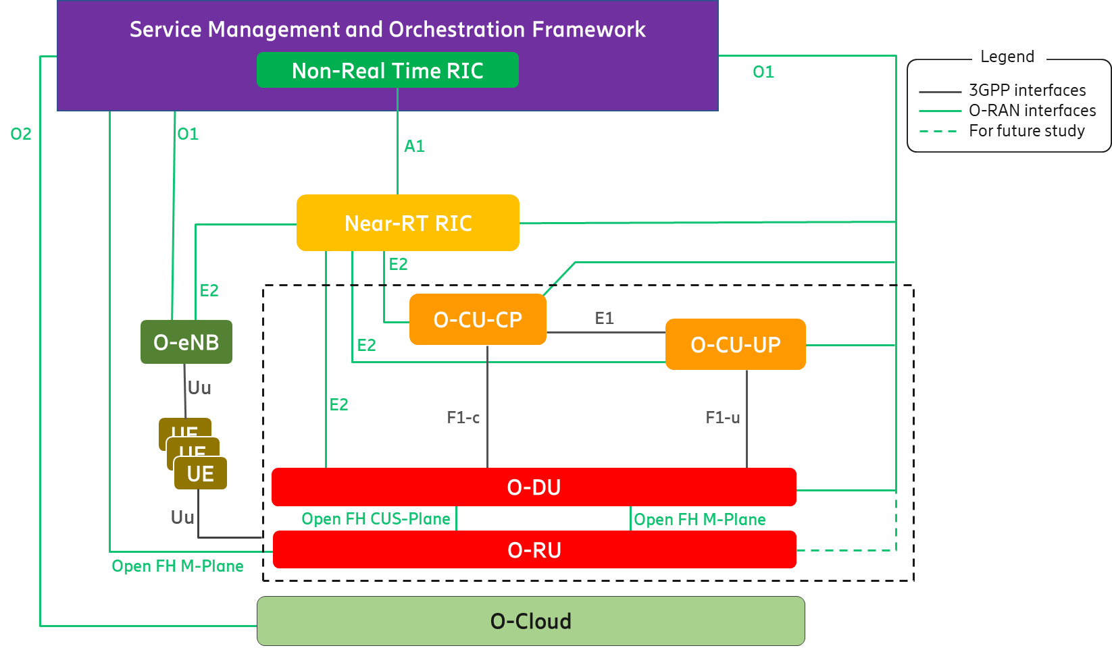

Figure ‑: Uu interface for O-RAN components and O-eNB

## O-RAN Control Loops

The O-RAN architecture supports at least the following control loops involving different O-RAN functions:

* Non-RT (Non-Real Time) control loops
* Near-RT (Near-Real Time) control loops
* RT (Real Time) control loops

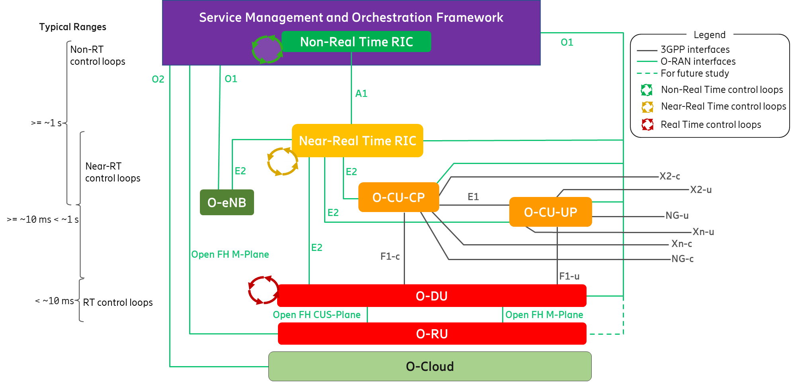

Figure ‑: O-RAN Control Loops

As shown in Figure 4.2‑1 above, the control loops are defined based on the controlling entity and the architecture shows the other logical nodes with which the control loop host interacts.

Control loops exist at various levels and run simultaneously. Depending on the use case, they may or may not interact with each other. The use cases for the Non-RT and Near-RT control loops and the interaction between the RICs for these use cases are fully defined by O-RAN Use Cases Analysis Report [16]. This report [16] also defines relevant interaction for the O-CU-CP and O-DU control loops, responsible for call control and mobility, radio scheduling, HARQ, beamforming etc. along with slower mechanisms involving SMO management interfaces.   
The timing of these control loops is use case dependent. Typical execution time for use cases involving the Non-RT control loops are 1 second or more; Near-RT control loops are in the order of 10 milliseconds or more; control loops in the E2 Nodes can operate below 10 milliseconds. (e.g., O-DU radio scheduling).

For any specific use case, however, a stable solution would require the loop time in the non-RT RIC and/or SMO management plane processes to be significantly longer than the loop time for the same use case in the control entities stated above.

## Description of O-RAN Functions

### Service Management and Orchestration (SMO)

This section describes the functionality provided by the SMO in O-RAN. In a Service Provider’s Network, there can be many management domains such as RAN management, Core Management, Transport Management, End to End Slice Management etc. In the O-RAN architecture, SMO is responsible for RAN domain management. The SMO description in this architecture document is focused on the SMO services that support the RAN. The key capabilities of the SMO that provide RAN support in O-RAN are:

* FCAPS interface to O-RAN Network Functions
* Non-RT RIC for RAN optimization
* O-Cloud Management, Orchestration and Workflow Management

The SMO performs these services through four key interfaces to the O-RAN Elements.

* A1 Interface between the Non-RT RIC in the SMO and the Near-RT RIC for RAN Optimization.
* O1 Interface between the SMO and the O-RAN Network Functions for FCAPS support.
* In the hybrid model, Open Fronthaul M-plane interface between SMO and O-RU for FCAPS support.
* O2 Interface between the SMO and the O-Cloud to provide platform resources and workload management.

SMO, at this time, does not define any formal interface towards the Non-RT RIC. An SMO implementation, therefore, may make its own design choice for creating a boundary towards the Non-RT RIC Framework, or choose not to implement a clear boundary at all.

The following defines the full complement functionality of the SMO:

* Inherent Non-RT RIC Framework Functionality – This functionality is definitively associated with the Non-RT RIC itself. Examples include the two interfaces “owned” by the Non-RT RIC: the A1 and R1 interfaces (see Section 4.3.1.2).
* Inherent O-RAN SMO Framework Functionality – This functionality is definitively not associated with the Non-RT RIC. Examples include the O1 and O2 interfaces.
* Implementation Variable Functionality – This functionality may or may not be associated with the Non-RT RIC. An SMO provider is free to include this functionality in or exclude this functionality from a Non-RT RIC implementation.

These terms and the relationships between the functions are illustrated in Figure 4.3‑1 below.

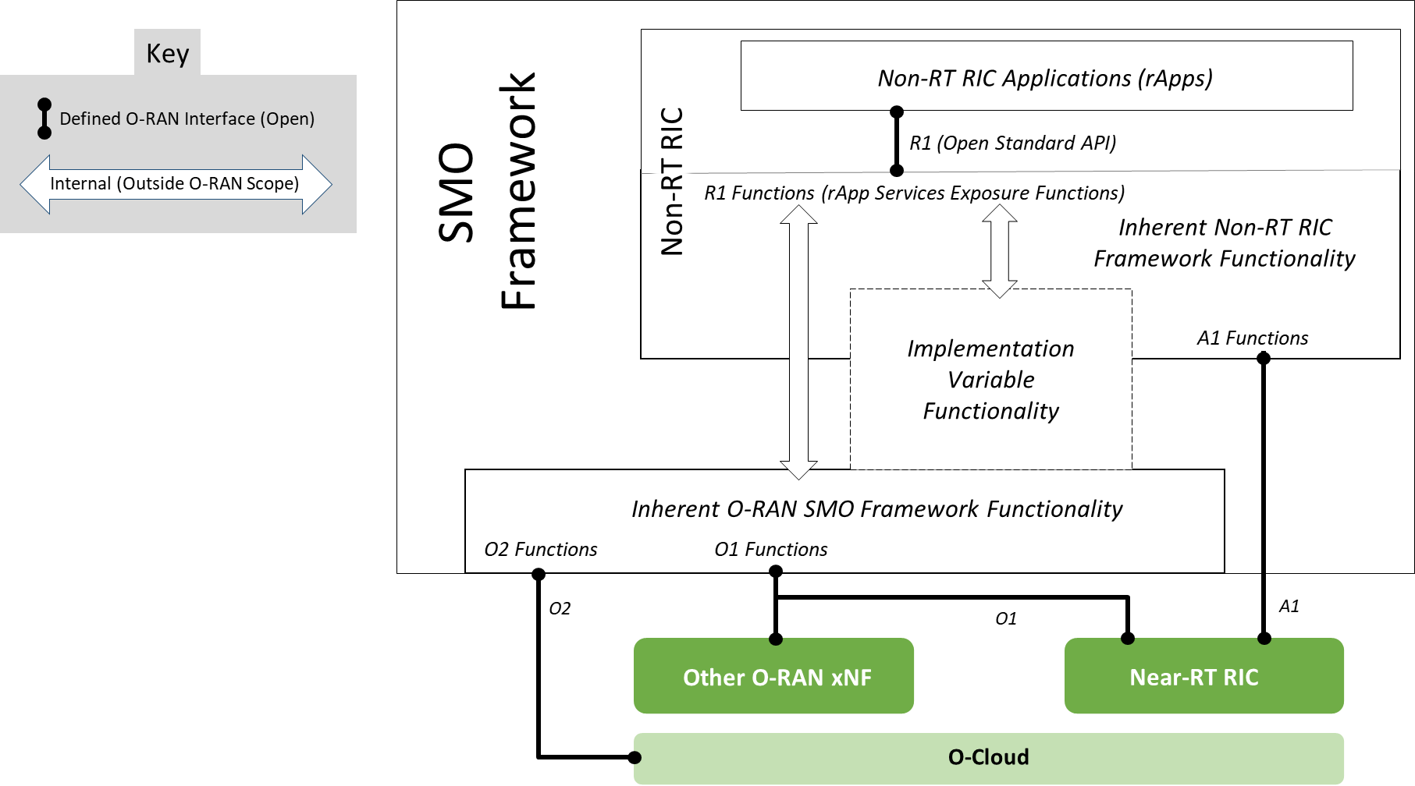

Figure ‑: Exposure of SMO Framework Services to rApps

Please refer to [19] for more details.

#### SMO support for FCAPS to O-RAN Network Functions

The SMO provides support for O-RAN network function FCAPS via the O1 Interface. The O1 Interface is defined in [15]. The O1 interface is aligned to the degree possible with the 3GPP specifications for RAN element management. In its role of supporting the FCAPs capabilities of O-RAN Network Functions, the SMO is providing support as described in [5]. The following FCAPS functions defined in the O1 Specification are examples of the functionality across the O1 interface. See [15] for a fully defined list.

* Performance Management (PM)
* Configuration Management (CM)
* Fault Management (FM)
* File Management
* Communications Surveillance (Heartbeat)
* Trace
* Physical Network Function (PNF) Discovery
* PNF Software Management.

The Open Fronthaul M-plane interface, as defined in [22], is specific for supporting FCAPS to the O-RU. The following FCAPS functions, as defined in [22], are examples of capabilities supported across this Open Fronthaul M-plane interface.

* “Start-up” installation
* SW management
* Configuration management
* Performance management
* Fault Management
* File Management

#### Non-RT RIC

Non-Real Time RAN Intelligent Controller (Non-RT RIC) is the functionality internal to the SMO in O-RAN architecture that provides the A1 interface to the Near-Real Time RIC.

The primary goal of Non-RT RIC is to support intelligent RAN optimization by providing policy-based guidance, ML model management and enrichment information to the near-RT RIC function so that the RAN can optimize, e.g., RRM under certain conditions [18]. It can also perform intelligent radio resource management function in non-real-time interval (i.e., greater than 1 second).

Non-RT RIC can use data analytics and AI/ML training/inference to determine the RAN optimization actions for which it can leverage SMO services such as data collection and provisioning services of the O-RAN nodes.

The Non-RT RIC is comprised of two sub-functions:

* Non-RT RIC Framework – Functionality internal to the SMO Framework that logically terminates the A1 interface and exposes the required services to rApps through its R1 interface.
* Non-RT RIC Applications (rApps) – Modular applications that leverage the functionality exposed by the Non-RT RIC Framework to perform RAN optimization and other functions via the A1, O1, O2 and R1 interfaces.

The Non-RT RIC Framework is responsible for exposing all required functionality to the rApps, whether “inherent” to the Non-RT RIC Framework, “inherent” to the SMO Framework, or “implementation variable” functionality.

For more information, please refer to [19].

#### O-Cloud Management, Orchestration and Workflow Management

The SMO provides the capability of managing the O-Clouds as well as providing support for the orchestration of platform and application elements and workflow management. The SMO utilizes the O2 interface to the O-Cloud to provide these capabilities. The O2 interface supports the management of the cloud infrastructure and the use of the cloud resources allocated to the RAN. The O2 interface will be fully specified in the O2 interface specification by Working Group 6. The example functionalities should be supported but are not limited to the following:

* Discovery and administration of O-Cloud Resources
* Scale-In, Scale-Out for O-Cloud
* FCAPS (PM, CM, FM, Communication Surveillance) of O-Cloud
* Software Management of Cloud Platform
* Create, Delete Deployments and Associated Allocated O-Cloud Resources
* Scale-In, Scale-Out Deployments and Allocated O-Cloud Resources
* FCAPS (PM, FM) of Deployments and Allocated O-Cloud Resources
* Software Management of Deployments

### Near-RT RIC

It is a logical function that enables near real-time control and optimization of E2 Nodes functions and resources via fine-grained data collection and actions over the E2 interface with control loops in the order of 10 ms-1s. The Near-RT RIC hosts one or more xApps that use E2 interface to collect near real-time information (e.g. on a UE basis or a Cell basis) and provide value added services. The Near-RT RIC control over the E2 Nodes is steered via the policies and the enrichment data provided via A1 from the Non-RT RIC.

The RRM functional allocation between the Near-RT RIC and the E2 Node is subject to the capability of the E2 Node exposed over the E2 interface by means of the E2 Service Model [21], in order to support the use cases described in [17]. The E2 service model describes the functions in the E2 Node which may be controlled by the Near-RT RIC and the related procedures, thus defining a function-specific RRM split between the E2 Node and the Near-RT RIC. For a function exposed in the E2 Service Model [21], the near RT RIC may e.g. monitor, suspend/stop, override or control via policies the behavior of E2 Node.

In the event of a Near-RT RIC failure, the E2 Node will be able to provide services but there may be an outage for certain value-added services that may only be provided using the Near-RT RIC.

### O-CU-CP

The O-CU-CP terminates the NG-c, X2-c, Xn-c, F1-c and E1 interfaces as well as the RRC and PDCP (for SRB) protocols towards the UE as specified in [9].

The O-CU-CP terminates E2 interface to Near-RT RIC as specified in [20].

The O-CU-CP terminates O1 interface towards the SMO as specified in [14].

The O-CU-CP terminates NG-c interface to 5GC as specified in [8].

The O-CU-CP terminates X2-c interface to eNB or to en-gNB in EN-DC as specified in [7] [8].

The O-CU-CP terminates Xn-c to gNB or ng-eNB as specified in [8] [10].

### O-CU-UP

The O-CU-UP terminates the NG-u, X2-u, S1-u, Xn-u, F1-u and E1 interfaces as well as the PDCP and SDAP protocols towards the UE as specified in [9].

The O-CU-UP terminates E2 interface to Near-RT RIC as specified in [20].

The O-CU-UP terminates O1 interface towards the SMO as specified in [14].

The O-CU-UP terminates NG-u interface to 5GC as specified in [8].

The O-CU-UP terminates X2-u interface to eNB or to en-gNB in EN-DC as specified in [7] [8].

The O-CU-UP terminates Xn-u to gNB or ng-eNB as specified in [8] [10].

### O-DU

The O-DU terminates the E2 and the F1 interface (according to the principles described in Section 4.4.7), and the Open Fronthaul interface (also known as LLS interface [23]) as well as the RLC, MAC and High-PHY functions of the radio interface towards the UE.

The O-DU terminates the O1 interface towards the SMO as specified in [14].

The O-DU terminates the Open Fronthaul M-Plane interface, towards the O-RU, to support O-RU management either in hierarchical model or hybrid model, as specified in [22].

### O-RU

The O-RU terminates the Open Fronthaul interface (also known as LLS interface [23]) as well as Low-PHY functions of the radio interface towards the UE. This is a physical node.

The O-RU terminates the Open Fronthaul M-Plane interface towards the O-DU and SMO as specified in [22].

The O-RU termination of the O1 interface towards the SMO as specified in [14] is under study.

### O-eNB

The O-eNB terminates:

* the S1, X2 and E2 interfaces as well as the RRC, PDCP, RLC, MAC and PHY layers of the LTE-Uu radio interface towards the UE in case O-eNB is an eNB as defined in [6].
* the NG, Xn and E2 interfaces as well as the RRC, SDAP, NR PDCP, RLC, MAC and PHY layers of the LTE-Uu radio interface towards the UE in case O-eNB is an ng-eNB as defined in [8].

The O-eNB supports O-DU and O-RU functions with an Open Fronthaul interface between them as specified in [22]**Error! Reference source not found.** and [23].

### O-Cloud

O-Cloud is a cloud computing platform comprising a collection of physical infrastructure nodes that meet O-RAN requirements to host the relevant O-RAN functions (i.e., Near-RT RIC, O-CU-CP, O-CU-UP, and O-DU), the supporting software components (such as Operating System, Virtual Machine Monitor, Container Runtime, etc.) and the appropriate management and orchestration functions which satisfies the following criteria:

* Exports the O-RAN O2 interface for cloud and workload management to provide functions such as infrastructure discovery, registration, software lifecycle management, workload lifecycle management, fault management, performance management, and configuration management.
* Exports O-RAN Accelerator Abstraction Layer (AAL) API towards the hosted O-RAN workloads for hardware accelerator management.
* Satisfies one or more of the deployment scenarios and their associated requirements as outlined in the O-RAN Cloud Architecture and Deployment Scenarios specification [24] and subsequent detailed scenario specifications published by O-RAN.
* The virtualization of the O-RU is for future study.

## Relevant Interfaces in O-RAN Architecture

The following interfaces are defined and maintained by O-RAN:

* A1 interface
* O1 interface
* O2 interface
* E2 interface
* Open Fronthaul interface

The following interfaces are defined and maintained by 3GPP, but seen also as part of the O-RAN architecture:

* E1 interface
* F1-c interface
* F1-u interface
* NG-c interface
* NG-u interface
* X2-c interface
* X2-u interface
* Xn-c interface
* Xn-u interface
* Uu interface

Following sections describe the termination points of O-RAN defined interfaces and 3GPP interfaces adopted by O-RAN.

### A1 Interface

A1 interface is between Non-RT-RIC and the Near-RT RIC functions [18].

A1 is the interface between the Non-RT RIC function in SMO and the Near-RT RIC function. A1 interface supports three types of services as defined in [18]:

* Policy Management Service
* Enrichment Information Service
* ML Model Management Service

A1 policies have the following characteristics compared to persistent configuration [17] [18]. A1 policies,

* are not critical to traffic;
* have temporary validity;
* may handle individual UE or dynamically defined groups of UEs;
* act within and take precedence over the configuration;
* are non-persistent, i.e., do not survive a restart of the near-RT RIC.

### O1 Interface

The O1 interface is between O-RAN Managed Element and the management entity as defined in [14].

### O2 Interface

The O2 interface is between the SMO and O-Cloud as introduced in [24].

### E2 Interface

E2 is a logical interface connecting the near-RT RIC with an E2 Node as defined in [20].

* An E2 Node is connected to only one near-RT RIC.
* A near-RT RIC can be connected to multiple E2 Nodes.

The protocols over E2 interface are based exclusively on Control Plane protocols. The E2 functions are grouped into the following categories:

* Near-RT RIC Services (REPORT, INSERT, CONTROL and POLICY, as described in [20]).
* Near-RT RIC support functions, which include, e.g., E2 Interface Management (E2 Setup, E2 Reset, Reporting of General Error Situations etc.) and Near-RT RIC Service Update (capability exchange related to the list of E2 Node functions exposed over E2 etc.).

### Open Fronthaul Interface

The Open FH (Fronthaul) Interface is between O-DU and O-RU functions [22] [23]. The Open FH Interface includes the CUS (Control User Synchronization) Plane and M (Management) Plane. In hybrid mode, the Open FH M-Plane interface connects the O-RU to the SMO for FCAPS functionality.

### E1 Interface

The E1 interface, as defined by 3GPP, is between the gNB-CU-CP and gNB-CU-UP logical nodes [9] [11]. In O-RAN, it reuses the principles and protocol stack defined by 3GPP but is adopted between the O-CU-CP and the O-CU-UP functions.

### F1-c Interface

The F1-c interface, as defined by 3GPP, is between the gNB-CU-CP and gNB-DU logical nodes [9] [12]. In O-RAN, it reuses the principles and protocol stack defined by 3GPP but is adopted between the O-CU-CP and the O-DU functions, as well as for the definition of interoperability profile specifications.

### F1-u Interface

The F1-u interface, as defined by 3GPP, is between the gNB-CU-UP and gNB-DU logical nodes [9] [12]. In O-RAN, it reuses the principles and protocol stack defined by 3GPP but is adopted between the O-CU-UP and the O-DU functions, as well as for the definition of interoperability profile specifications.

### NG-c Interface

The NG-c interface, as defined by 3GPP, is between the gNB-CU-CP and the AMF in the 5GC [8]. It is also referred as N2 in [8]. In O-RAN, it reuses the principles and protocol stack defined by 3GPP but is adopted between the O-CU-CP and the 5GC.

### NG-u Interface

The NG-u interface, as defined by 3GPP, is between the gNB-CU-UP and the UPF in the 5GC [8]. It is also referred as N3 in [8]. In O-RAN, it reuses the principles and protocol stack defined by 3GPP but is adopted between the O-CU-UP and the 5GC.

### X2-c Interface

The X2-c interface is defined in 3GPP for transmitting control plane information between eNBs or between eNB and en-gNB in EN-DC as specified in [7] [8]. In O-RAN, it reuses the principles and protocol stack defined by 3GPP but is adopted for the definition of interoperability profile specifications.

### X2-u Interface

The X2-u interface is defined in 3GPP for transmitting user plane information between eNBs or between eNB and en-gNB in EN-DC as specified in [7] [8]. In O-RAN, it reuses the principles and protocol stack defined by 3GPP but is adopted for the definition of interoperability profile specifications.

### Xn-c Interface

The Xn-c interface is defined in 3GPP for transmitting control plane information between gNBs, ng-eNBs or between ng-eNB and gNB as specified in [8] [10]. In O-RAN, it reuses the principles and protocol stack defined by 3GPP but is adopted for the definition of interoperability profile specifications.

### Xn-u Interface

The Xn-u interface is defined in 3GPP for transmitting user plane information between gNBs, ng-eNBs or between ng-eNB and gNB as specified in [8] [10]. In O-RAN, it reuses the principles and protocol stack defined by 3GPP but is adopted for the definition of interoperability profile specifications.

### Uu Interface

The UE to e/gNB interface in 3GPP is denoted as the Uu interface. The Uu is a complete protocol stack from L1 to L3 and as such, seen as a whole, it terminates in the NG-RAN. If the NG-RAN is decomposed, different protocols terminate at different reference points and none of them has been defined by O-RAN. Since the Uu messages still flow from the UE to the intended e/gNB managed function, it is not shown in the O-RAN architecture as a separate interface to a specific managed function. For more information on the Uu interface between the UE and the NG-RAN, please refer to chapters 5.2 and 5.3 of [9].

# O-RAN Information Model (IM) Principles

O-RAN shall align its Information Model (IM) with 3GPP to the extent possible. The additional O-RAN extensions to its IM are described in (IM specification will be published by Working Group 1).

Annex A (Informative): Implementation Options of O-RAN Functions and Network Elements

1. Shared Cell

Shared cell [23] is defined as the operation for the same cell by several O-RUs with one or multiple component carriers. It can be deployed in either FHM (Fronthaul Multiplexer) or Cascade mode as described below.

In FHM mode, the shared cell may be realized by placing an FHM function between an O-DU and several O-RUs that may have one or multiple component carriers from these O-RUs. FHM function may be modelled as an O-RU with LLS Fronthaul support (same as normal O-RU) along with the copy and combine function (additional to normal O-RU), but without radio transmission/reception capability. The Figure A.1-1 below shows how each O-RU can be used for either operating in the same cell (Single Cell Scenario) or in different cells (Multiple Cells Scenario) by configuring the FHM function.

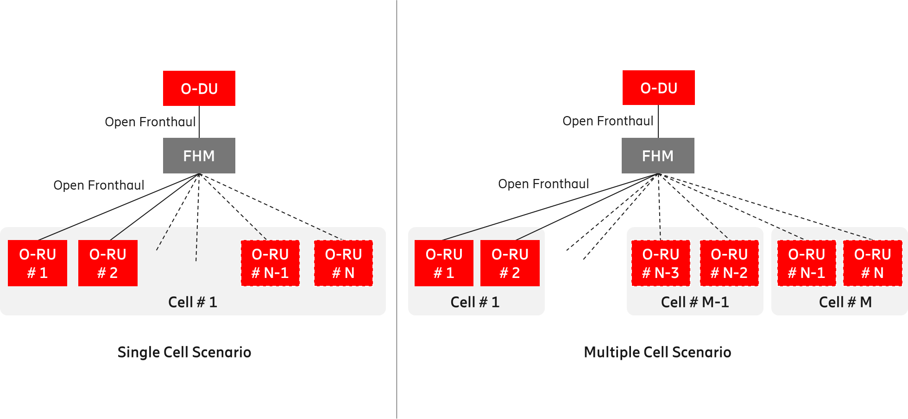

Figure A.1-: Shared cell deployment using FHM mode

In Cascade mode, the shared cell is realized by several O-RUs cascaded in chain. In this case, one or more O-RUs are inserted between the O-DU and the O-RU. The O-RUs in the cascaded chain except for the last O-RU shall support Copy and Combine function. Figure A.1-2 below shows an implementation of Cascade mode shared cell.

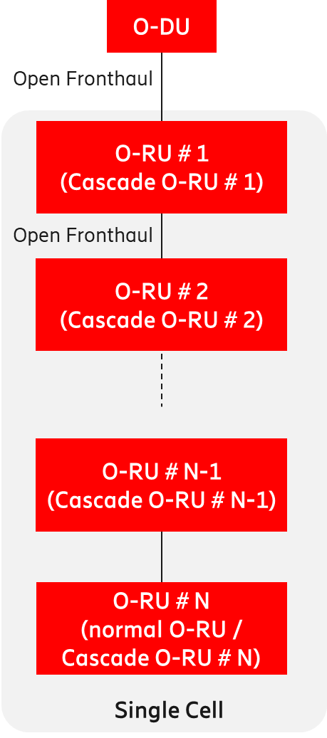

Figure A.1-: Shared cell deployment using Cascade mode

The Cascade mode, as described above, is implemented within the O-RU.

Please refer to [23] for additional information.

1. FHGW Function

The FHGW (Fronthaul Gateway) function may be placed between the O-DU and RU/RRU (Radio Unit / Remote Radio Unit) with the following O-RAN specified interfaces:

* The interface between O-DU and FHGW function is Open Fronthaul (Option 7-2x).
* The interface between FHGW function and RU/RRU is subject to reference implementation developed by any relevant O-RAN WG (e.g., WG7). An example of such reference implementation is described in [25]. The exact specification of this interface (i.e., between FHGW function and RU/RRU) is for future study.
* The interface between FHGW function and RU/RRU shall not support Open Fronthaul (Option 7-2x).
* The FHGW function may be packaged with other functions (such as Ethernet switching) in a physical product, as considered within WG7.

The Figure A.2-1 below depicts the deployment of the FHGW function using O-RAN specified interfaces.

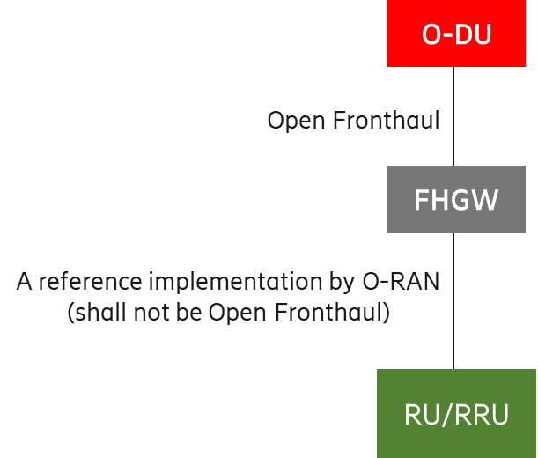

Figure A.2-: Deployment of O-DU and RU/RRU using FHGW function

1. Near-RT RIC

The Near-RT RIC can control multiple E2 Nodes or can control a single E2 Node. The following figures show two implementation options of Near-RT RIC.

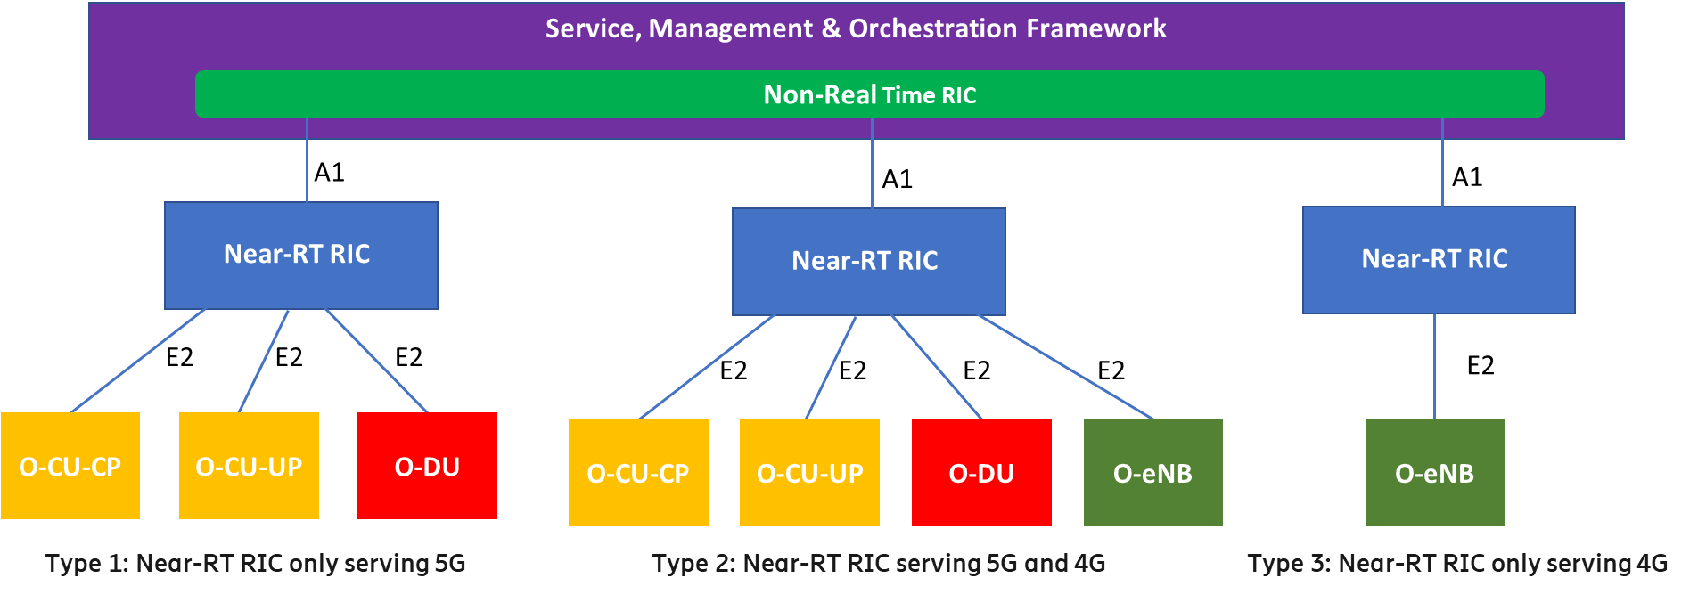

Figure A.3-: Centralized Near-RT RIC Serving 4G and 5G Simultaneously

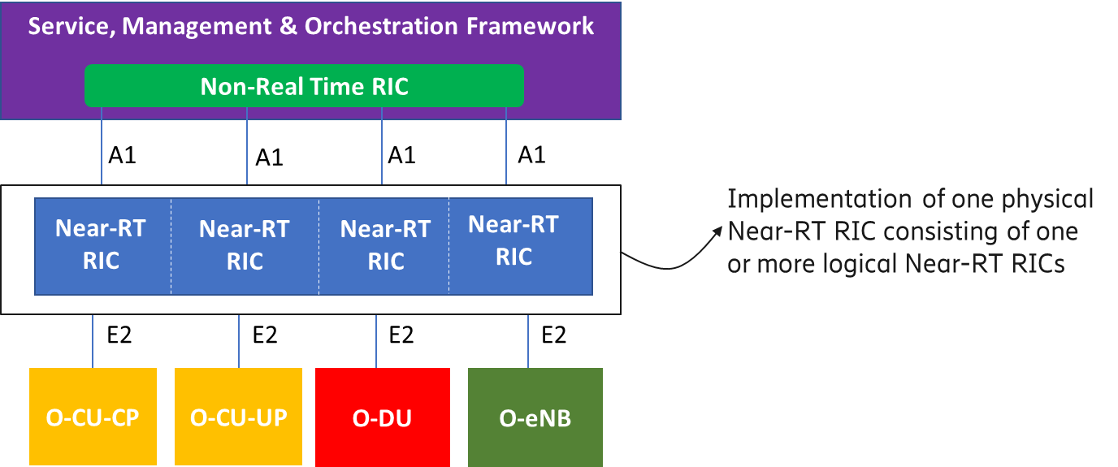

Figure A.3-: Distributed Near-RT RIC

1. Near-RT RIC, O-CU-CP, O-CU-UP, O-DU and O-RU

Although the O-RAN architecture specify the O-RAN nodes Near-RT RIC, O-CU-CP, O-CU-UP, O-DU and O-RU as separate entities, it is possible in the implementation to bundle some or all of these O-RAN nodes, and thus collapsing some of the internal interfaces such as F1-c, F1-u, E1 and E2. At least the following implementation options are possible:

* Disaggregated network functions as per O-RAN architecture
* Bundle the O-CU-CP and O-CU-UP
* Bundle the O-CU-CP, O-CU-UP and O-DU
* Bundle the Near-RT RIC, O-CU-CP and O-CU-UP
* Bundle the O-CU-CP, O-CU-UP, O-DU and O-RU
* Bundle the O-DU and O-RU
* Bundle the Near-RT RIC, O-CU-CP, O-CU-UP, O-DU and O-RU

Bundling of O-RAN nodes is supported by the O-RAN specified interfaces O1 and E2. For the O1 interface, the bundled functions will be managed as separate Managed Functions belonging to a single Managed Element as specified in [14]. For the E2 interface the bundled functions can be exposed as part of the E2 Service Model towards the Near-RT RIC (see Annex A in [20]).

**Note:** In the implementation options where the Near-RT RIC function is bundled with other O-RAN functions it may only control E2 Nodes of the same RAT (Radio Access Technology) type (e.g., a bundled near-RT RIC and O-CU-CP may only control E2 Nodes O-CU-UP and O-DU) which are not bundled with Near-RT RIC.

**Note:** Bundling multiple instances of the same type of O-RAN function is supported.

Please see the figures (i.e., Figure A.4-1 through Figure A.4-7) below.



Figure A.4-: Disaggregated Network Functions

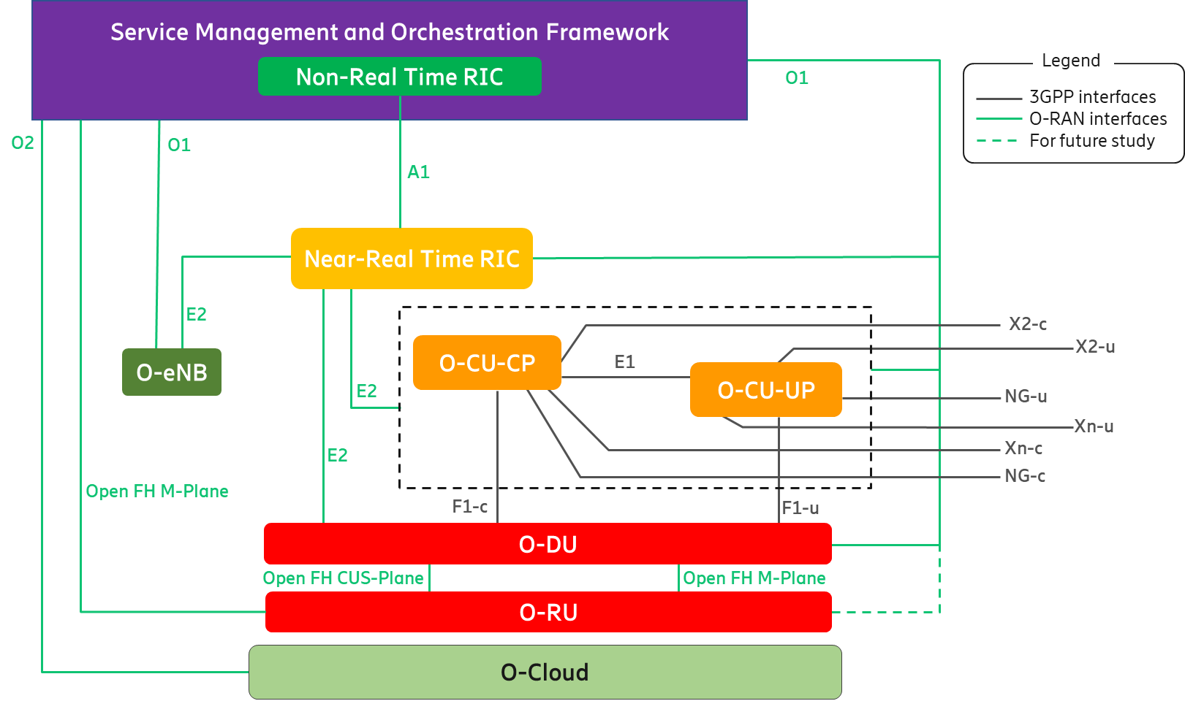

Figure A.4-: Aggregated O-CU-CP and O-CU-UP

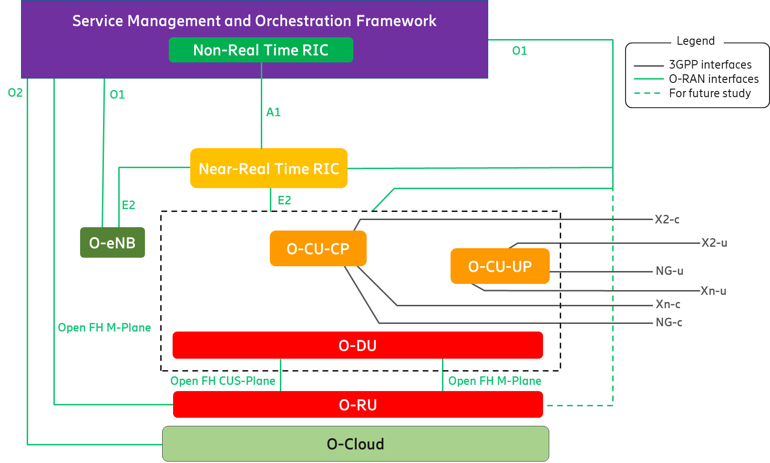

Figure A.4-: Aggregated O-CU-CP, O-CU-UP and O-DU

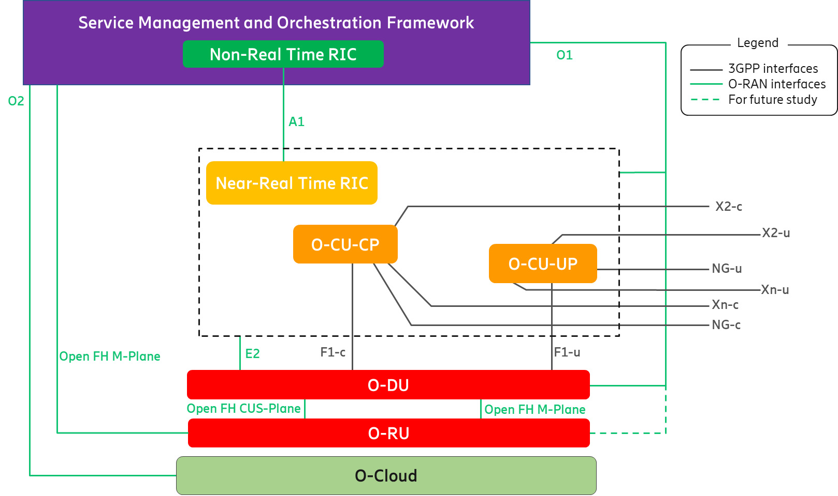

Figure A.4-: Aggregated Near-RT RIC, O-CU-CP and O-CU-UP

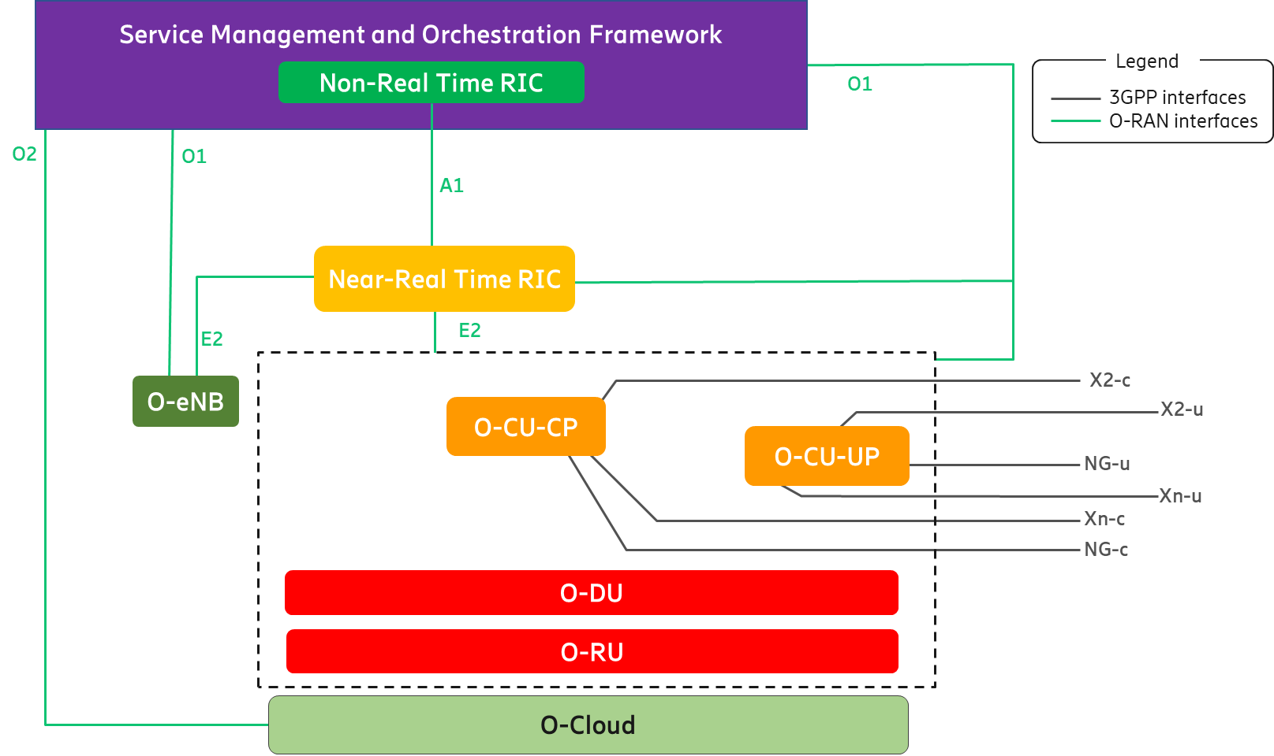

Figure A.4-: Aggregated O-CU-CP, O-CU-UP, O-DU and O-RU

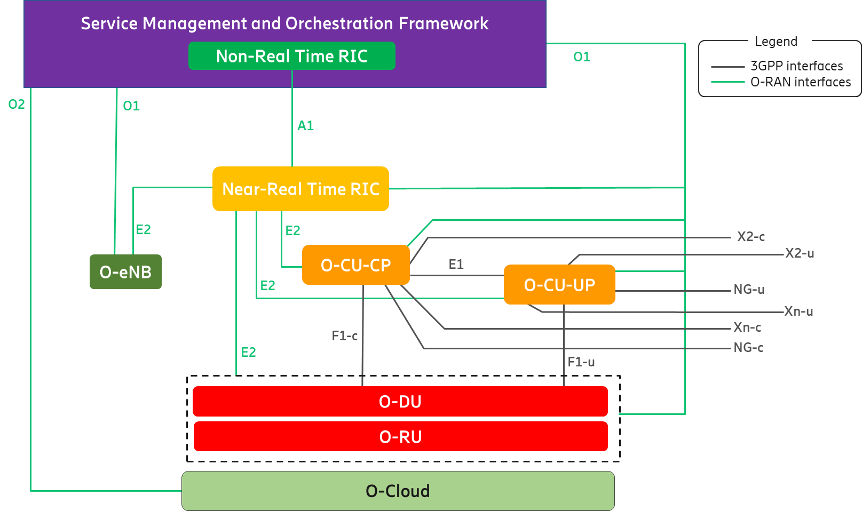

Figure A.4-: Aggregated O-DU and O-RU

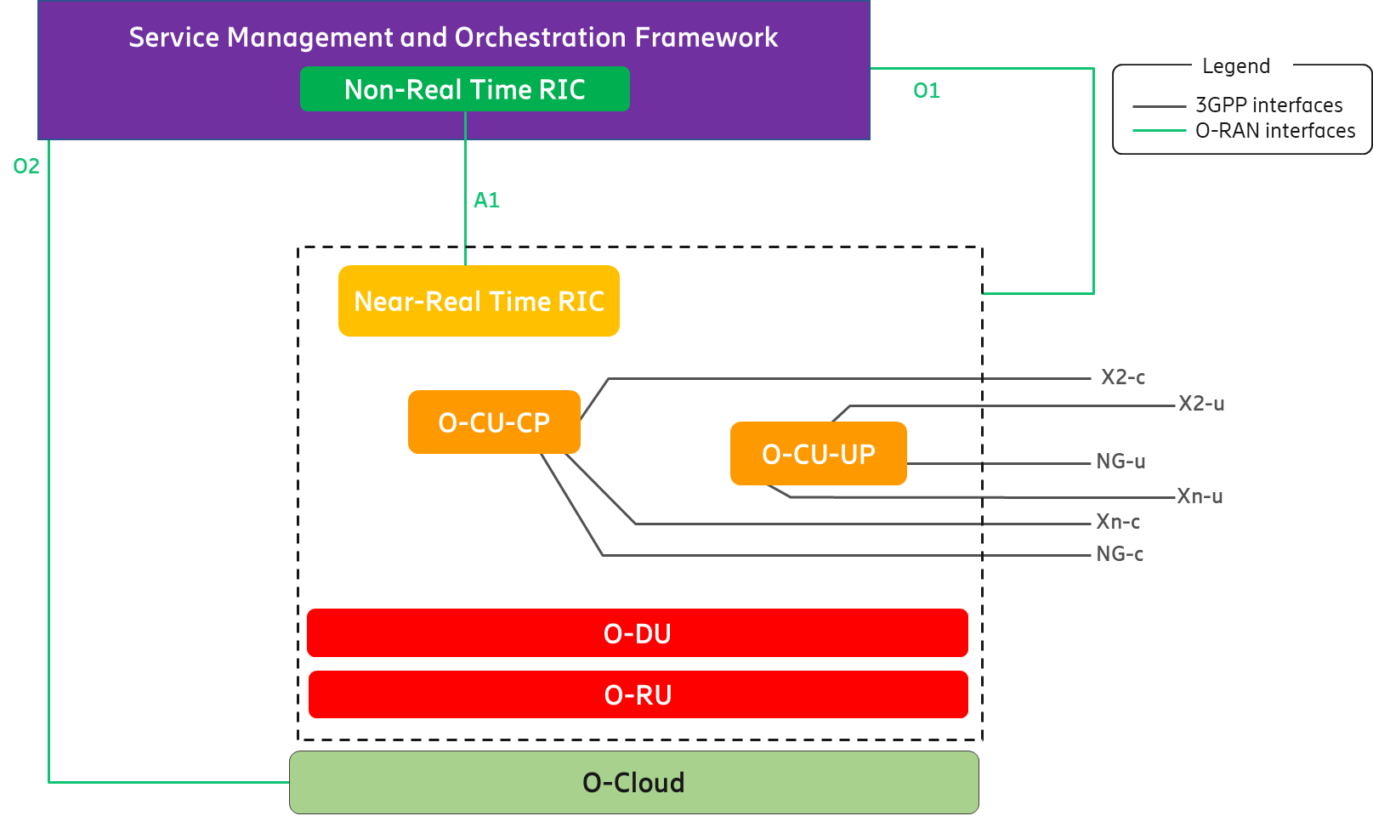

Figure A.4-: Aggregated Near-RT RIC, O-CU-CP, O-CU-UP, O-DU and O-RU

Annex ZZZ : O-RAN Adopter License Agreement

BY DOWNLOADING, USING OR OTHERWISE ACCESSING ANY O-RAN SPECIFICATION, ADOPTER AGREES TO THE TERMS OF THIS AGREEMENT.

This O-RAN Adopter License Agreement (the “Agreement”) is made by and between the O-RAN Alliance and the entity that downloads, uses or otherwise accesses any O-RAN Specification, including its Affiliates (the “Adopter”).

This is a license agreement for entities who wish to adopt any O-RAN Specification.

## Section 1: DEFINITIONS

1.1 “Affiliate” means an entity that directly or indirectly controls, is controlled by, or is under common control with another entity, so long as such control exists. For the purpose of this Section, “Control” means beneficial ownership of fifty (50%) percent or more of the voting stock or equity in an entity.

1.2 “Compliant Implementation” means any system, device, method or operation (whether implemented in hardware, software or combinations thereof) that fully conforms to a Final Specification.

1.3 “Adopter(s)” means all entities, who are not Members, Contributors or Academic Contributors, including their Affiliates, who wish to download, use or otherwise access O-RAN Specifications.

1.4 “Minor Update” means an update or revision to an O-RAN Specification published by O-RAN Alliance that does not add any significant new features or functionality and remains interoperable with the prior version of an O-RAN Specification. The term “O-RAN Specifications” includes Minor Updates.

1.5 “Necessary Claims” means those claims of all present and future patents and patent applications, other than design patents and design registrations, throughout the world, which (i) are owned or otherwise licensable by a Member, Contributor or Academic Contributor during the term of its Member, Contributor or Academic Contributorship; (ii) such Member, Contributor or Academic Contributor has the right to grant a license without the payment of consideration to a third party; and (iii) are necessarily infringed by a Compliant Implementation (without considering any Contributions not included in the Final Specification). A claim is necessarily infringed only when it is not possible on technical (but not commercial) grounds, taking into account normal technical practice and the state of the art generally available at the date any Final Specification was published by the O-RAN Alliance or the date the patent claim first came into existence, whichever last occurred, to make, sell, lease, otherwise dispose of, repair, use or operate a Compliant Implementation without infringing that claim. For the avoidance of doubt in exceptional cases where a Final Specification can only be implemented by technical solutions, all of which infringe patent claims, all such patent claims shall be considered Necessary Claims.

1.6 “Defensive Suspension” means for the purposes of any license grant pursuant to Section 3, Member, Contributor, Academic Contributor, Adopter, or any of their Affiliates, may have the discretion to include in their license a term allowing the licensor to suspend the license against a licensee who brings a patent infringement suit against the licensing Member, Contributor, Academic Contributor, Adopter, or any of their Affiliates.

## Section 2: COPYRIGHT LICENSE

2.1 Subject to the terms and conditions of this Agreement, O-RAN Alliance hereby grants to Adopter a nonexclusive, nontransferable, irrevocable, non-sublicensable, worldwide copyright license to obtain, use and modify O-RAN Specifications, but not to further distribute such O-RAN Specification in any modified or unmodified way, solely in furtherance of implementations of an O-RAN

Specification.

2.2 Adopter shall not use O-RAN Specifications except as expressly set forth in this Agreement or in a separate written agreement with O-RAN Alliance.

## Section 3: FRAND LICENSE

3.1 Members, Contributors and Academic Contributors and their Affiliates are prepared to grant based on a separate Patent License Agreement to each Adopter under Fair Reasonable And Non- Discriminatory (FRAND) terms and conditions with or without compensation (royalties) a nonexclusive, non-transferable, irrevocable (but subject to Defensive Suspension), non-sublicensable, worldwide patent license under their Necessary Claims to make, have made, use, import, offer to sell, lease, sell and otherwise distribute Compliant Implementations; provided, however, that such license shall not extend: (a) to any part or function of a product in which a Compliant Implementation is incorporated that is not itself part of the Compliant Implementation; or (b) to any Adopter if that Adopter is not making a reciprocal grant to Members, Contributors and Academic Contributors, as set forth in Section 3.3. For the avoidance of doubt, the foregoing licensing commitment includes the distribution by the Adopter’s distributors and the use by the Adopter’s customers of such licensed Compliant Implementations.

3.2 Notwithstanding the above, if any Member, Contributor or Academic Contributor, Adopter or their Affiliates has reserved the right to charge a FRAND royalty or other fee for its license of Necessary Claims to Adopter, then Adopter is entitled to charge a FRAND royalty or other fee to such Member, Contributor or Academic Contributor, Adopter and its Affiliates for its license of Necessary Claims to its licensees.

3.3 Adopter, on behalf of itself and its Affiliates, shall be prepared to grant based on a separate Patent License Agreement to each Members, Contributors, Academic Contributors, Adopters and their Affiliates under Fair Reasonable And Non-Discriminatory (FRAND) terms and conditions with or without compensation (royalties) a nonexclusive, non-transferable, irrevocable (but subject to Defensive Suspension), non-sublicensable, worldwide patent license under their Necessary Claims to make, have made, use, import, offer to sell, lease, sell and otherwise distribute Compliant Implementations; provided, however, that such license will not extend: (a) to any part or function of a product in which a Compliant Implementation is incorporated that is not itself part of the Compliant Implementation; or (b) to any Members, Contributors, Academic Contributors, Adopters and their Affiliates that is not making a reciprocal grant to Adopter, as set forth in Section 3.1. For the avoidance of doubt, the foregoing licensing commitment includes the distribution by the Members’, Contributors’, Academic Contributors’, Adopters’ and their Affiliates’ distributors and the use by the Members’, Contributors’, Academic Contributors’, Adopters’ and their Affiliates’ customers of such licensed Compliant Implementations.

## Section 4: TERM AND TERMINATION

4.1 This Agreement shall remain in force, unless early terminated according to this Section 4.

4.2 O-RAN Alliance on behalf of its Members, Contributors and Academic Contributors may terminate this Agreement if Adopter materially breaches this Agreement and does not cure or is not capable of curing such breach within thirty (30) days after being given notice specifying the breach.

4.3 Sections 1, 3, 5 - 11 of this Agreement shall survive any termination of this Agreement. Under surviving Section 3, after termination of this Agreement, Adopter will continue to grant licenses (a) to entities who become Adopters after the date of termination; and (b) for future versions of O-RAN Specifications that are backwards compatible with the version that was current as of the date of termination.

## Section 5: CONFIDENTIALITY

Adopter will use the same care and discretion to avoid disclosure, publication, and dissemination of O-RAN Specifications to third parties, as Adopter employs with its own confidential information, but no less than reasonable care. Any disclosure by Adopter to its Affiliates, contractors and consultants should be subject to an obligation of confidentiality at least as restrictive as those contained in this Section. The foregoing obligation shall not apply to any information which is: (1) rightfully known by Adopter without any limitation on use or disclosure prior to disclosure; (2) publicly available through no fault of Adopter; (3) rightfully received without a duty of confidentiality; (4) disclosed by O-RAN Alliance or a Member, Contributor or Academic Contributor to a third party without a duty of confidentiality on such third party; (5) independently developed by Adopter; (6) disclosed pursuant to the order of a court or other authorized governmental body, or as required by law, provided that Adopter provides reasonable prior written notice to O-RAN Alliance, and cooperates with O-RAN Alliance and/or the applicable Member, Contributor or Academic Contributor to have the opportunity to oppose any such order; or (7) disclosed by Adopter with O-RAN Alliance’s prior written approval.

## Section 6: INDEMNIFICATION

Adopter shall indemnify, defend, and hold harmless the O-RAN Alliance, its Members, Contributors or Academic Contributors, and their employees, and agents and their respective successors, heirs and assigns (the “Indemnitees”), against any liability, damage, loss, or expense (including reasonable attorneys’ fees and expenses) incurred by or imposed upon any of the Indemnitees in connection with any claims, suits, investigations, actions, demands or judgments arising out of Adopter’s use of the licensed O-RAN Specifications or Adopter’s commercialization of products that comply with O-RAN Specifications.

## Section 7: LIMITATIONS ON LIABILITY; NO WARRANTY

EXCEPT FOR BREACH OF CONFIDENTIALITY, ADOPTER’S BREACH OF SECTION 3, AND ADOPTER’S INDEMNIFICATION OBLIGATIONS, IN NO EVENT SHALL ANY PARTY BE LIABLE TO ANY OTHER PARTY OR THIRD PARTY FOR ANY INDIRECT, SPECIAL, INCIDENTAL, PUNITIVE OR CONSEQUENTIAL DAMAGES RESULTING FROM ITS PERFORMANCE OR NON-PERFORMANCE UNDER THIS AGREEMENT, IN EACH CASE WHETHER UNDER CONTRACT, TORT, WARRANTY, OR OTHERWISE, AND WHETHER OR NOT SUCH PARTY HAD ADVANCE NOTICE OF THE POSSIBILITY OF SUCH DAMAGES. O-RAN SPECIFICATIONS ARE PROVIDED “AS IS” WITH NO WARRANTIES OR CONDITIONS WHATSOEVER, WHETHER EXPRESS, IMPLIED, STATUTORY, OR OTHERWISE. THE O-RAN ALLIANCE AND THE MEMBERS, CONTRIBUTORS OR ACADEMIC CONTRIBUTORS EXPRESSLY DISCLAIM ANY WARRANTY OR CONDITION OF MERCHANTABILITY, SECURITY, SATISFACTORY QUALITY, NONINFRINGEMENT, FITNESS FOR ANY PARTICULAR PURPOSE, ERROR-FREE OPERATION, OR ANY WARRANTY OR CONDITION FOR O-RAN SPECIFICATIONS.

## Section 8: ASSIGNMENT

Adopter may not assign the Agreement or any of its rights or obligations under this Agreement or make any grants or other sublicenses to this Agreement, except as expressly authorized hereunder, without having first received the prior, written consent of the O-RAN Alliance, which consent may be withheld in O-RAN Alliance’s sole discretion. O-RAN Alliance may freely assign this Agreement.

## Section 9: THIRD-PARTY BENEFICIARY RIGHTS

Adopter acknowledges and agrees that Members, Contributors and Academic Contributors (including future Members, Contributors and Academic Contributors) are entitled to rights as a third-party beneficiary under this Agreement, including as licensees under Section 3.

## Section 10: BINDING ON AFFILIATES

Execution of this Agreement by Adopter in its capacity as a legal entity or association constitutes that legal entity’s or association’s agreement that its Affiliates are likewise bound to the obligations that are applicable to Adopter hereunder and are also entitled to the benefits of the rights of Adopter hereunder.

## Section 11: GENERAL

This Agreement is governed by the laws of Germany without regard to its conflict or choice of law provisions.

This Agreement constitutes the entire agreement between the parties as to its express subject matter and expressly supersedes and replaces any prior or contemporaneous agreements between the parties, whether written or oral, relating to the subject matter of this Agreement.

Adopter, on behalf of itself and its Affiliates, agrees to comply at all times with all applicable laws, rules and regulations with respect to its and its Affiliates’ performance under this Agreement, including without limitation, export control and antitrust laws. Without limiting the generality of the foregoing, Adopter acknowledges that this Agreement prohibits any communication that would violate the antitrust laws.

By execution hereof, no form of any partnership, joint venture or other special relationship is created between Adopter, or O-RAN Alliance or its Members, Contributors or Academic Contributors. Except as expressly set forth in this Agreement, no party is authorized to make any commitment on behalf of Adopter, or O-RAN Alliance or its Members, Contributors or Academic Contributors.

In the event that any provision of this Agreement conflicts with governing law or if any provision is held to be null, void or otherwise ineffective or invalid by a court of competent jurisdiction, (i) such provisions will be deemed stricken from the contract, and (ii) the remaining terms, provisions, covenants and restrictions of this Agreement will remain in full force and effect.

Any failure by a party or third party beneficiary to insist upon or enforce performance by another party of any of the provisions of this Agreement or to exercise any rights or remedies under this Agreement or otherwise by law shall not be construed as a waiver or relinquishment to any extent of the other parties’ or third party beneficiary’s right to assert or rely upon any such provision, right or remedy in that or any other instance; rather the same shall be and remain in full force and effect.