 O-RAN.WG3.E2GAP-v01.01

\\

Technical Specification

O-RAN Working Group 3   
Near-Real-time RAN Intelligent Controller

Architecture &   
E2 General Aspects and Principles

Prepared by the O-RAN Alliance e.V. Copyright © 2020 by the O-RAN Alliance e.V.

By using, accessing or downloading any part of this O-RAN specification document, including by copying, saving, distributing, displaying or preparing derivatives of, you agree to be and are bound to the terms of the O-RAN Adopter License Agreement contained in the Annex ZZZ of this specification. All other rights reserved.

Copyright © 2020 by the O-RAN Alliance e.V. Your use is subject to the terms of the O-RAN Adopter License Agreement in the Annex ZZZ. 1

# Revision History

|  |  |  |  |
| --- | --- | --- | --- |
| **Date** | **Revision** | **Author** | **Description** |
| 2020.02.06 | 01.00.00 | C. Coletti (DT) | Updated Text based on outcome of SCTP Port ID application process |
| 2020.03.11 | 01.00.01 | C. Coletti (DT) | Implementing CRs (for maintenance) agreed in Virtual F2F February 2020. |
| 2020.03.11 | 01.00.02 | C. Coletti (DT) | Small editorial on Section 4. |
| 2020.07.08 | 01.00.03 | A. Urie (Nokia) | Alignment with published v01.00.00 version (copyright statement)  Inclusion of approved CRs from meeting #60 and co-chair editorial changes |
| 2020.07.15 | v01.01 | P. Stephens (Nokia) | Minor typographical corrections provided during voting stage Version incremented for publication to v01.01 |

"© 2020. 3GPP™ TSs and TRs are the property of ARIB, ATIS, CCSA, ETSI, TSDSI, TTA and TTC who jointly own the copyright in them. They are subject to further modifications and are therefore provided to you "as is" for information purposes only. Further use is strictly prohibited."

Contents

Revision History 2

1 Introductory Material 5

1.1 Scope 5

2 References 5

3 Definitions and Abbreviations 6

3.1 Definitions 6

3.2 Abbreviations 7

4 Near-RT RIC Architecture 7

4.1 General Architecture Principles 7

4.2 Near-RT RIC Architecture Overview 8

4.3 Near-RT RIC Requirements 9

4.4 Near-RT RIC functional architecture 9

4.4.1 General 9

4.4.2 RRM Functional Allocation 10

5 E2 Interface 10

5.1 E2 interface general principles 10

5.2 E2 interface specification objectives 11

5.3 Functions of the E2 Interface 12

5.3.1 General 12

5.3.2 RIC services and related procedures 12

5.3.3 Combining RIC services within a common Subscription 20

5.3.4 Combining RIC services as a sequence of RIC services 20

5.4 RAN Function E2 Service Model 21

5.5 Near-RT RIC support functions 21

5.5.1 General 21

5.5.2 E2 Setup procedure 21

5.5.3 E2 Reset procedure 23

5.5.4 Near-RT RIC Service Update procedure 26

5.5.5 E2 Node Configuration Update procedure 26

6 Services expected from signalling transport 27

6.1 E2 Control Plane Protocol (E2AP) 27

6.2 Multiple TNLAs over E2 28

7 Security Requirements 31

7.1 General 31

7.2 Requirements for the E2 interfaces 31

8 Other E2 interface specifications 31

8.1 O-RAN E2 interface: E2 Application Protocol (E2AP) (ORAN-WG3.E2AP) 31

8.2 O-RAN E2 interface: E2 Service Model (E2SM) specifications 31

Annex A Deployment considerations 32

A.1 Deployment use cases 32

Annex ZZZ : O-RAN Adopter License Agreement 34

Section 1: DEFINITIONS 34

Section 2: COPYRIGHT LICENSE 34

Section 3: FRAND LICENSE 34

Section 4: TERM AND TERMINATION 35

Section 5: CONFIDENTIALITY 35

Section 6: INDEMNIFICATION 35

Section 7: LIMITATIONS ON LIABILITY; NO WARRANTY 36

Section 8: ASSIGNMENT 36

Section 9: THIRD-PARTY BENEFICIARY RIGHTS 36

Section 10: BINDING ON AFFILIATES 36

Section 11: GENERAL 36

# 1 Introductory Material

## 1.1 Scope

This Technical Specification has been produced by the O-RAN Alliance.

The contents of the present document are subject to continuing work within O-RAN and may change following formal O-RAN approval. Should the O-RAN Alliance modify the contents of the present document, it will be re-released by O-RAN with an identifying change of release date and an increase in version number as follows:

Release x.y.z

where:

x the first digit is incremented for all changes of substance, i.e. technical enhancements, corrections, updates, etc. (the initial approved document will have x=01).

y the second digit is incremented when editorial only changes have been incorporated in the document.

z the third digit included only in working versions of the document indicating incremental changes during the editing process.

The present document describes the overall architecture of the Near-RT-RIC (RAN Intelligent Controller) and the general aspects and principles of the E2 interface, including the interaction with applications hosted in the Near-RT RIC.

# 2 References

The following documents contain provisions which, through reference in this text, constitute provisions of the present document.

- References are either specific (identified by date of publication, edition number, version number, etc.) or non‑specific.

- For a specific reference, subsequent revisions do not apply.

- For a non-specific reference, the latest version applies. In the case of a reference to a 3GPP document (including a GSM document), a non-specific reference implicitly refers to the latest version of that document *in the same Release as the present document*.

[1] 3GPP TR 21.905: "Vocabulary for 3GPP Specifications".

[2] ORAN-WG3.E2AP, “O-RAN Working Group 3, Near-Real-time RAN Intelligent Controller, E2 Application Protocol (E2AP)”.

[3] ORAN-WG2.A1.GA&P, “O-RAN Working Group 2, A1 interface: General Aspects and Principles”.

[4] O-RAN-WG1.O1-Interface, “O-RAN Operations and Maintenance Interface Specification”.

[5] 3GPP TS 36.401: "Evolved Universal Terrestrial Radio Access Network (E-UTRAN); Architecture Description".

[6] 3GPP TS 38.401: "NG-RAN; Architecture description".

[7] 3GPP TS 36.423: “Evolved Universal Terrestrial Radio Access Network (E-UTRAN); X2 application protocol (X2AP)”.

[8] O-RAN-WG1.OAM Architecture, “O-RAN Operations and Maintenance Architecture”.

[9] 3GPP TS 38.410 “NG general aspects and principles”.

[10] 3GPP TS 38.420 “Xn general aspects and principles”.

[11] 3GPP TS 38.470 “F1 general aspects and principles”.

[12] IETF RFC 4960 (2007-09): “Stream Control Transmission Protocol”.

[13] 3GPP TS 33.401 “3GPP System Architecture Evolution (SAE); Security architecture”.

[14] 3GPP TS 33.501 “Security architecture and procedures for 5G System”.

[15] O-RAN.WG2.UCR-v02.00 "O-RAN Working Group 2 Use Cases and Requirements v02.00".

[16] 3GPP TS 38.300 NR; “NR and NG-RAN Overall Description; Stage 2”.

[17] ORAN-WG3.E2SM; “O-RAN Working Group 3, Near-Real-time RAN Intelligent Controller, ”.

[18] O-RAN-WG1-O-RAN Architecture Description - v01.00.00; “O-RAN Architecture Description”.

[19] O-RAN.WG3.RICARCH, “O-RAN Working Group 3, Near-Real-time RAN Intelligent Controller, Near-RT RIC Architecture”

# 3 Definitions and Abbreviations

## 3.1 Definitions

For the purposes of the present document, the terms and definitions given in TR 21.905 [1] and the following apply.   
A term defined in the present document takes precedence over the definition of the same term, if any, in TR 21.905 [1].

**O-CU** (O-RAN Central Unit): a logical node hosting RRC, SDAP and PDCP protocols

**O-CU-CP** (O-RAN Central Unit – Control Plane): a logical node hosting the RRC and the control plane part of the PDCP protocol

**O-CU-UP** (O-RAN Central Unit – User Plane): a logical node hosting the user plane part of the PDCP protocol and the SDAP protocol

**O-DU** (O-RAN Distributed Unit): a logical node hosting RLC/MAC/High-PHY layers based on a lower layer functional split.

**O-eNB** (O-RAN eNB):an eNB [5] or ng-eNB [16] that supports E2 interface.

**O-RU** (O-RAN Radio Unit): a logical node hosting Low-PHY layer and RF processing based on a lower layer functional split.  This is similar to 3GPP’s “TRP” or “RRH” but more specific in including the Low-PHY layer (FFT/iFFT, PRACH extraction).

**Non-RT RIC**(O-RAN non-real-time RAN Intelligent Controller):a logical function that enables non-real-time control and optimization of RAN elements and resources, AI/ML workflow including model training and updates, and policy-based guidance of applications/features in Near-RT RIC.

**Near-RT RIC (**O-RAN near-real-time RAN Intelligent Controller): a logical function that enables near-real-time control and optimization of RAN elements and resources via fine-grained (e.g. UE basis, Cell basis) data collection and actions over E2 interface.

**O1**: Interface between orchestration & management entities (Orchestration/NMS) and O-RAN managed elements, for operation and management, by which FCAPS management, Software management, File management and other similar functions shall be achieved.

**A1**: Interface between Non-RT RIC and Near-RT RIC to enable policy-driven guidance of Near-RT RIC applications/functions, and support AI/ML workflow.

**E2**: Interface connecting the Near-RT RIC and one or more O-CU-CPs, one or more O-CU-UPs, one or more O-DUs, and one or more O-eNBs.

**E2 Node**: a logical node terminating E2 interface. In this version of the specification, ORAN nodes terminating E2 interface are:

- for NR access: O-CU-CP, O-CU-UP, O-DU or any combination as defined in [8];

- for E-UTRA access: O-eNB.

**RAN Function**: A specific Function in a E2 Node; examples include X2AP, F1AP, E1AP, S1AP, NGAP interfaces and RAN internal functions handling UEs, Cells, etc.

**xApp:** An application designed to run on the Near-RT RIC. Such an application is likely to consist of one or more microservices and at the point of on-boarding will identify which data it consumes and which data it provides. The application is independent of the Near-RT RIC and may be provided by any third party. The E2 enables a direct association between the xApp and the RAN functionality.

**RIC Service:** A Service provided on an E2 Node to provide access to messages and measurements and / or enable control of the E2 Node from the Near-RT RIC.

## 3.2 Abbreviations

For the purposes of the present document, the following abbreviations apply.

O-CU O-RAN Central Unit

O-CU-CP O-RAN Central Unit – Control Plane

O-CU-UP O-RAN Central Unit – User Plane

O-DU O-RAN Distributed Unit

O-eNB O-RAN eNB

O-RU O-RAN Radio Unit

Non-RT RIC non-real-time RAN Intelligent Controller:

Near-RT RICNear-real-time RAN Intelligent Controller

RAT Radio Access Technology

# 4 Near-RT RIC Architecture

## 4.1 General Architecture Principles

The general principles guiding the definition of Near-RT RIC architecture as well as the interfaces between Near-RT RIC, E2 Nodes and Service Management & Orchestration are the following:

- Near-RT RIC and E2 Node functions are fully separated from transport functions. Addressing scheme used in Near-RT RIC and the E2 Nodes shall not be tied to the addressing schemes of transport functions.

- The E2 Nodes support all protocol layers and interfaces defined within 3GPP radio access networks that include eNB for E-UTRAN [5] and gNB/ ng-eNB for NG-RAN [16].

- Near-RT RIC and hosted “xApp” applications shall use a set of services exposed by an E2 Node that is described by a series of RAN function and Radio Access Technology (RAT) dependent “E2 Service Models”.

- The Near-RT RIC interfaces are defined along the following principles:

- The functional division across the interfaces have as few options as possible.

- Interfaces are based on a logical model of the entity controlled through this interface.

- One physical network element can implement multiple logical nodes.

## 4.2 Near-RT RIC Architecture Overview

The Near-RT RIC is a logical network node placed between the Service Management & Orchestration layer [8], which hosts the Non-RT RIC, and the E2 Nodes.

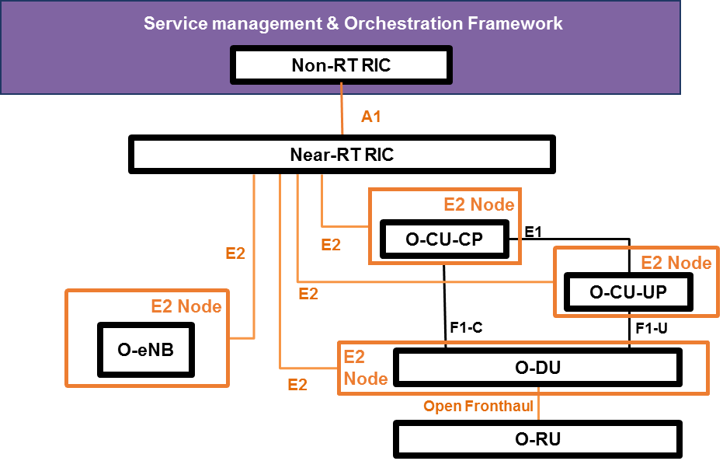

Figure 4.2-1: O-RAN Architecture Overview showing Near-RT RIC interfaces

The Near-RT-RIC logical architecture and related interfaces are shown in Figure 4.2-1:

- The Near-RT RIC is connected to the Non-RT RIC through the A1 interface [3];

- A Near-RT RIC is connected to only one Non-RT RIC;

- E2 is a logical interface connecting the Near-RT RIC with an E2 Node;

- The Near-RT RIC is connected to the O-CU-CP;

- The Near-RT RIC is connected to the O-CU-UP;

- The Near-RT RIC is connected to the O-DU;

- The Near-RT RIC is connected to the O-eNB;

- An E2 Node is connected to only one Near-RT RIC;

- A Near-RT RIC can be connected to multiple E2 Nodes, i.e. multiple O-CU-CPs, O-CU-UPs, O-DUs and O-eNBs.

- F1 (F1-C, F1-U) and E1 are logical 3GPP interfaces, whose protocols, termination points and cardinalities are specified in [6].

In addition, the near-RT RIC and other RAN nodes have O1 interfaces as defined in [8][18].

The Near-RT RIC hosts one or more xApps that use E2 interface to collect near real-time information (e.g. UE basis, Cell basis) and provide value added services.

The Near-RT RIC may receive declarative Policies and obtain Data Enrichment information over the A1 interface [3].

The protocols over E2 interface are based exclusively on Control plane protocols and are defined in [2].

On E2 or Near-RT RIC failure, the E2 Node will be able to provide services but there may be an outage for certain value-added services that may only be provided using the Near-RT RIC.

## 4.3 Near-RT RIC Requirements

The Near-RT RIC architecture shall support the following requirements:

- The Near-RT RIC shall use a dedicated E2 connection that uniquely identifies each E2 Node configured to directly provide RIC Services to the Near-RT RIC.

- A given Near-RT RIC may support E2 connections from multiple E2 Nodes, each supporting a specific RAT type.

- The Near-RT RIC shall obtain from the E2 Nodes a list of functions supporting RIC Services and the corresponding E2 Service Model.

- The Near-RT RIC shall host a set of applications, known as xApps. Individual xApp in Near-RT RIC may address specific RAN Functions in a specific E2 Node.

- The Near-RT RIC shall, as per any other network element, provide an O1 interface towards the Service Management & Orchestration layer for element management and configuration

- The Near-RT RIC shall provide an A1 interface [3] towards the Non-RT RIC. The A1 interface is used to provide Policies to the Near-RT RIC which may be used to modify Near-RT RIC and Near-RT RIC hosted xApp behavior and hence modify E2 Node behavior.

- The E2 node shall be able to function independently of the Near-RT RIC when and if the E2 interface and/or Near-RT RIC fails.

- The Near-RT RIC shall support latency requirements for near-real-time optimization, i.e. from 10 milliseconds up to 1 second [8].

## 4.4 Near-RT RIC functional architecture

### 4.4.1 General

The Near-RT RIC supports the following functions:

- A1 interface termination

- Terminates the A1 interface from the Non-RT RIC and forwards A1 messages.

- O1 interface termination

- Terminates the O1 interface from Service Management & Orchestration layer and forwards management messages to the Near-RT RIC management function;

- E2 interface termination

- Terminates the E2 interface from an E2 Node;

- Routes xApp-related messages to the target xApp;

- Routes non xApp-related messages to the E2 Manager;

- Hosted xApps

- allow RRM control functionalities to be executed at the Near-RT RIC and enforced in the E2 Nodes via E2 interface, as described in Section 4.4.2;

- Initiates xApp-related transactions over E2 interface;

- Handles xApp-related responses from the E2 interface;

Near-RT RIC Architecture is described in detail in [19]

### 4.4.2 RRM Functional Allocation

The RRM functional allocation between the Near-RT RIC and the E2 Node is subject to the capability of the E2 node exposed over the E2 interface by means of the E2 Service Model, in order to support the use cases such as in [15].

The E2 service model describes the functions in the E2 Node which may be controlled by the Near RT RIC and the related procedures, thus defining a function-specific RRM split between the E2 node and the Near RT RIC.

For a function exposed in the E2 service model, the Near-RT RIC may e.g. monitor, suspend/stop, override or control via policies the behavior of E2 node.

# 5 E2 Interface

## 5.1 E2 interface general principles

The general principles for the specification of the E2 interface are as follows:

- the E2 interface is open;

- the E2 interface supports the exchange of control signaling information between the endpoints;

- from a logical standpoint, the E2 is a point-to-point interface between the endpoints;

- E2 should reuse interface management procedures, as already defined for existing 3GPP RAN interfaces such as 3GPP X2 [7].

- Near-RT RIC shall provide flexibility by separating the O-RAN data collection (e.g. network measurements, context information, etc.) from the supported use cases.

- E2 should provide the capability to send predefined information towards the Near-RT RIC based on a pre-configured trigger event

- E2 should support the ability to provide UE ID information towards the Near-RT RIC based on a pre-configured trigger event.

- E2 should enable the Near-RT-RIC to direct the E2 Node to suspend an RRM procedure by interrupting the E2 Node local process and forwarding the relevant information to the Near-RT RIC for processing.

- E2 should support the ability to send control messages (e.g. UE basis, Cell basis) to the E2 Node.

- E2 should support the ability to provide the E2 Node with a set of policies to use when defined events occur.

- E2 should support the ability for E2 Node to notify the Near-RT RIC of what functionality it supports.

With respect to the E2 interface, the E2 Node consists of:

- E2 Agent used to terminate the E2 interface and to forward/receive E2 messages.

- One or more RAN functions that are controlled by the Near-RT RIC, i.e. supporting Near-RT RIC Services.

- Other RAN functions that do not support Near-RT RIC Services.

With respect to the E2 interface, the Near-RT RIC consists of:

- Database holding data from xApp applications and E2 Node and providing data to xApp applications

- E2 Termination function

- One or more xApp applications



Figure 5.1-1: Relationship between Near-RT RIC and E2 Node

## 5.2 E2 interface specification objectives

The E2 interface specifications shall facilitate the following:

Connectivity between Near-RT RIC and E2 Node supplied by different vendors;

- Exposure of selected E2 Node data (e.g. configuration information (cell configuration, supported slices, PLMNs, etc.), network measurements, context information, etc.) towards the Near-RT RIC

- Enables the Near-RT RIC to control selected functions on the E2 Node

## 5.3 Functions of the E2 Interface

### 5.3.1 General

The E2 functions are grouped into the following categories:

NEAR-RT RIC services:

* Near-RT RIC Services (**REPORT**, **INSERT**, **CONTROL** and **POLICY**, as described in Section 5.3.2).

NEAR-RT RIC support functions:

* Interface Management (E2 Setup, E2 Reset, E2 Node Configuration Update, Reporting of General Error Situations)
* Near-RT RIC Service Update, i.e. a E2 Node initiated procedure to inform Near-RT RIC of changes to list of supported Near-RT RIC services and mapping of services to functions.

### 5.3.2 RIC services and related procedures

Near-RT RIC may use the following RIC services provided by an E2 node:

- **REPORT**: Near-RT RIC uses a RIC Subscription procedure to request that E2 Node sends a **REPORT** message to Near-RT RIC and the associated procedure continues in E2 Node after each occurrence of a defined RIC Subscription procedure Event Trigger.

The **REPORT** service involves following steps:

1. Near-RT RIC configures a RIC Subscription procedure in the E2 Node with information used to configure an Indication (Report) that is to be performed by E2 Node with each occurrence of RIC trigger event condition

2. During normal functioning of an associated procedure in the E2 Node, a RIC Event Trigger is detected.

3. E2 Node sends Indication procedure to Near-RT RIC containing requested **REPORT** information along with originating Request ID.

4. Associated procedure instance continues in the E2 Node.

@startuml

skinparam ParticipantPadding 5

skinparam BoxPadding 10

skinparam lifelineStrategy solid

participant “Near-RT RIC” as near

participant “E2 Node” as ran

ran<->near: RIC SUBSCRIPTION PROCEDURE (RIC Event Trigger, Action=REPORT)

...

note over ran #white: E2 Node detects \nRIC Event Trigger

ran->near: RIC INDICATION(REPORT)

note over ran #lime: Associated procedure \ninstance **continues**

@enduml

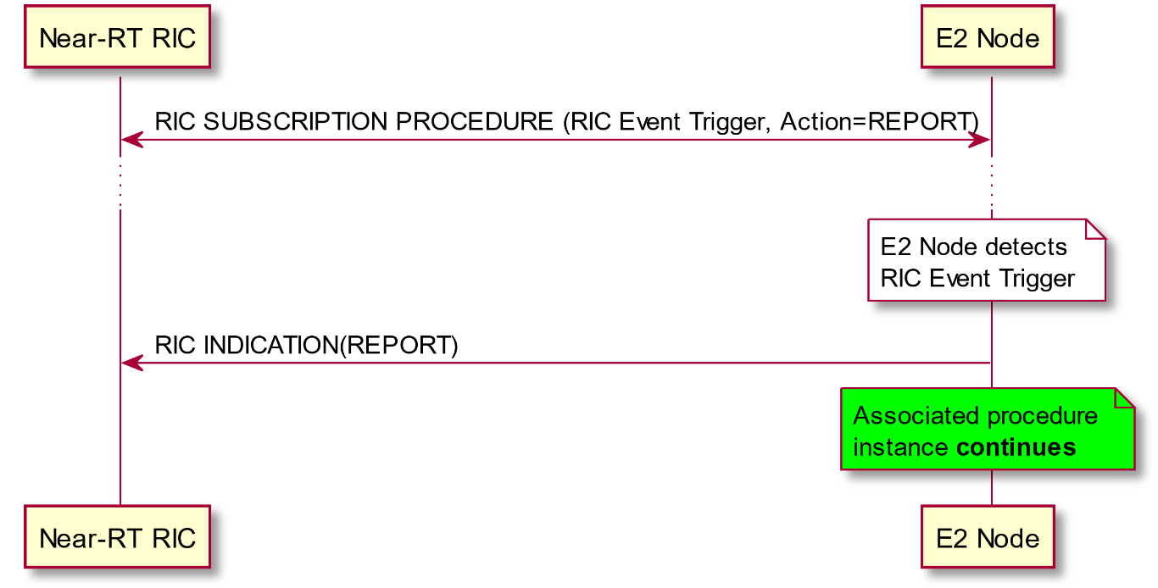

Figure 5.3.2-1: Near-RT RIC REPORT Service

- **INSERT**: Near-RT RIC uses a RIC Subscription to request that E2 Node sends an **INSERT** message to Near-RT RIC and suspends the associated procedure in E2 Node after each occurrence of a defined RIC Subscription procedure Event Trigger.

The **INSERT** service involves following steps:

1. Near-RT RIC configures a RIC Subscription in the E2 Node with information used to configure an Indication(Insert) along with a wait timer that is to be performed by E2 Node with each occurrence of Event

2. During normal functioning of an associated procedure instance in the E2 Node, a trigger event is detected.

3. E2 Node suspends associated procedure instance for up to a defined Wait Period (wait period may be set to zero)

4. E2 Node sends Indication procedure to Near-RT RIC containing requested **INSERT** information along with originating Request ID and information used to identify the suspended associated procedure instance.

According to the timer state, arrival of RIC Control procedure and Subsequent Action parameter in RIC Subscription, the E2 Node may then:

a) Resume associated procedure instance using information received from a RIC Control procedure sent by Near-RT RIC

b) Continue the original associated procedure instance if and when the associated Wait timer expires and Subsequent Action set to Continue. A subsequent RIC Control procedure sent by Near-RT RIC shall be ignored.

c) Halt the original associated procedure instance if and when the associated Wait timer expires and Subsequent Action set to Halt. A subsequent RIC Control procedure sent by Near-RT RIC shall be ignored.

@startuml

skinparam ParticipantPadding 5

skinparam BoxPadding 10

skinparam lifelineStrategy solid

participant “Near-RT RIC” as near

participant “E2 Node” as ran

ran<->near: RIC SUBSCRIPTION PROCEDURE (RIC Event Trigger, Action=INSERT)

...

note over ran #white: E2 Node detects \nRIC Event Trigger

note over ran #pink: Associated procedure \ninstance **suspended**

note over ran #aqua: Start Wait Timer

ran->near: RIC INDICATION(INSERT)

alt a) Near-RT RIC __responds__

note over near #white: Near-RT RIC \nperforms action

near->ran: RIC CONTROL REQUEST

note over ran #aqua: Cancel Wait Timer

note over ran #lime: Associated procedure \ninstance **resumes**

ran-->near: RIC CONTROL ACKNOWLEDGE

else b) Timer Expires and Subsequent Action = __Continue__

note over ran #aqua: Timer expires

note over ran #lime: Associated procedure \ninstance **resumes**

near<-->ran: RIC CONTROL PROCEDURE with outcome = Failure (expired)

else c) Timer Expires and Subsequent Action = __Halt__

note over ran #aqua: Timer expires

note over ran #red: Associated procedure \ninstance **halted**

near<-->ran: RIC CONTROL PROCEDURE with outcome = Failure (expired)

end

@enduml

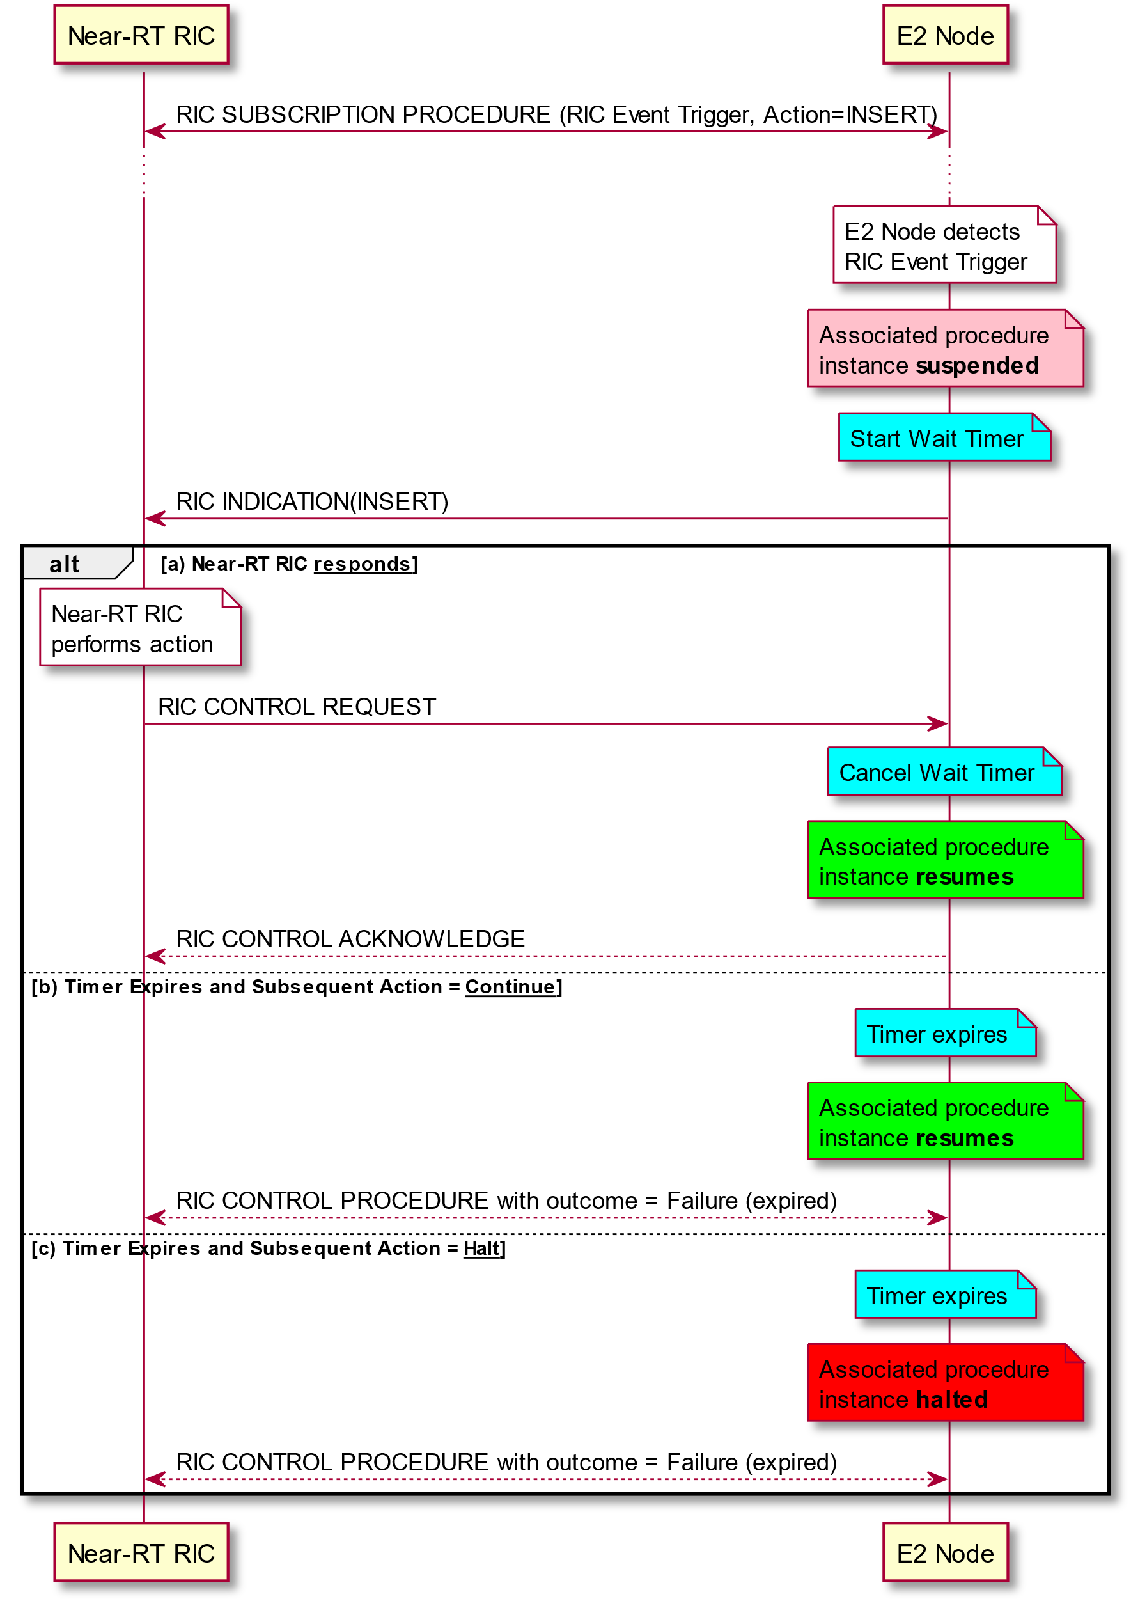

Figure 5.3.2-2: Near-RT RIC INSERT Service with three possible outcomes

- **CONTROL**: Near-RT RIC sends a Control message to E2 Node to initiate a new associated procedure or resume a previously suspended associated procedure in the E2 Node.

The **CONTROL** service involves following steps:

Near-RT RIC detects an event trigger. This step may be triggered by either:

a) a previous RIC INDICATION sent by E2 Node

b) internal to Near-RT RIC

1. Near-RT RIC performs an action

2. Near-RT RIC sends RIC CONTROL REQUEST to E2 Node. This step may contain an information used to identify a previous suspended associated procedure instance and may request acknowledgement

3. E2 Node initiates or resumes associated procedure

4. If requested, E2 Node sends a RIC CONTROL ACKNOWLEDGE

@startuml

skinparam ParticipantPadding 5

skinparam BoxPadding 10

skinparam lifelineStrategy solid

participant “Near-RT RIC” as near

participant “E2 Node” as ran

ran<->near: RIC SUBSCRIPTION PROCEDURE (RIC Event Trigger, Action=INSERT)

...

note over ran #white: E2 Node detects \nRIC Event Trigger

note over ran #pink: Associated procedure \ninstance **suspended**

ran->near: RIC INDICATION(INSERT)

note over near #white: Near-RT RIC \nperforms action

near->ran: RIC CONTROL REQUEST

alt a) Request received before wait timer expiry

note over ran #lime: Associated procedure \ninstance initiated \nor resumed

ran-->near: RIC CONTROL ACKNOWLEDGE (Success)

else b) Request received after Expiry with subsequent Action= Halt or Continue

note over ran #pink: Associated procedure instance \npreviously Halted or Continued

ran-->near: RIC CONTROL FAILURE (Expired)

else c) Request received with invalid Call Process ID set or request rejected

note over ran #pink: Associated procedure instance \nHalted or Continued

ran-->near: RIC CONTROL FAILURE

end

@enduml

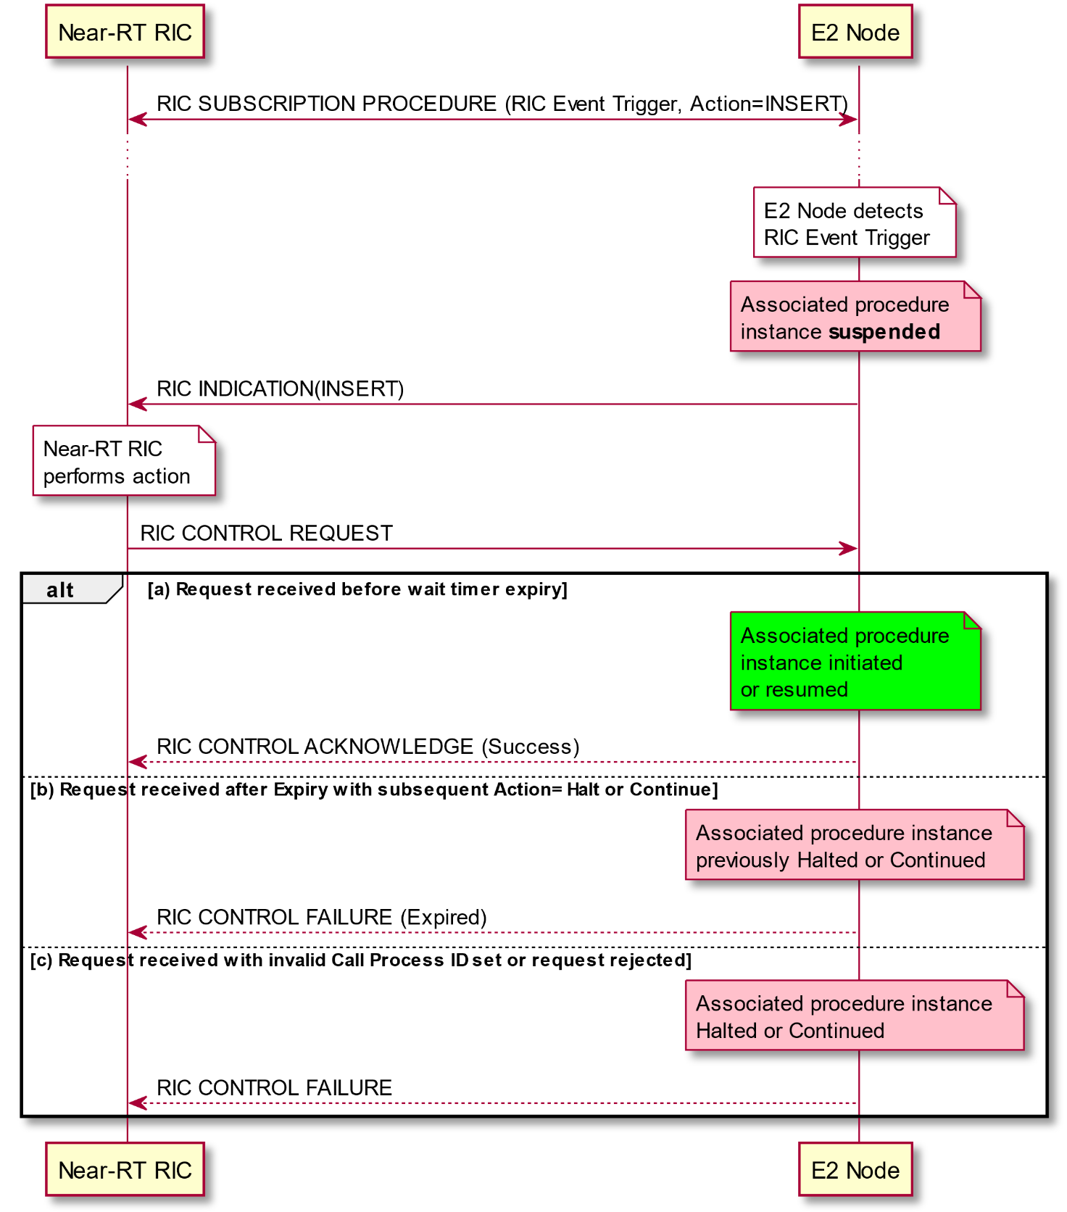

Figure 5.3.2-3A: Near-RT RIC CONTROL Service as response to Near-RT RIC Insert Service

@startuml

skinparam ParticipantPadding 5

skinparam BoxPadding 10

skinparam lifelineStrategy solid

participant “Near-RT RIC” as near

participant “E2 Node” as ran

note over near #white: RIC internal event

note over near #white: Near-RT RIC detects \nevent trigger

note over near #white: Near-RT RIC \nperforms action

near->ran: RIC CONTROL REQUEST

alt a) Request received without Call Process ID set and accepted by E2 Node

note over ran #lime: Associated procedure \ninstance initiated

ran-->near: RIC CONTROL ACKNOWLEDGE (Success)

else b) Request received without Call Process ID set and not accepted by E2 Node

note over ran #pink: Ignore Control request

ran-->near: RIC CONTROL FAILURE

end

@enduml

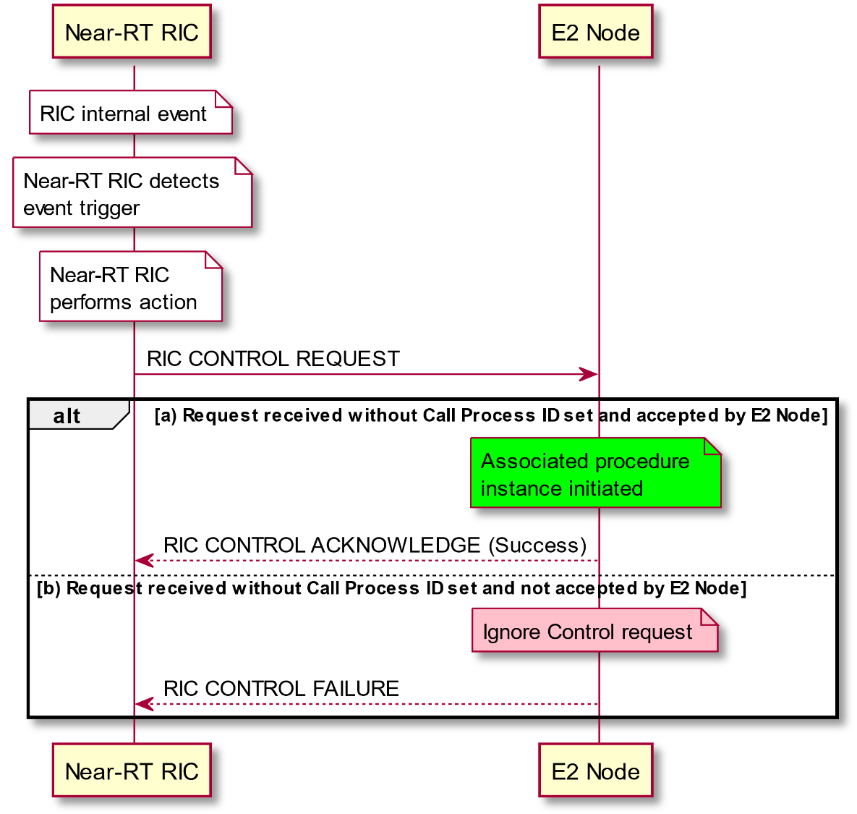

Figure 5.3.2-3B: Near-RT RIC CONTROL Service initiated by NEAR-RT RIC

- **POLICY:** Near-RT RIC requests that E2 Node executes a specific POLICY during functioning of the E2 Node after each occurrence of a defined RIC Subscription procedure Event Trigger.

The **POLICY** service involves following steps:

1. Near-RT RIC configures a RIC Subscription in the E2 Node with information used to configure a **POLICY** that is to be performed by E2 Node with each occurrence of trigger event

2. During normal functioning of the E2 Node, a trigger event is detected.

3. E2 Node modifies ongoing call process according to information contained in the **POLICY** description statement

4. Associated procedure instance continues in the E2 Node.

@startuml

skinparam ParticipantPadding 5

skinparam BoxPadding 10

participant “Near-RT RIC” as near

participant “E2 Node” as ran

ran<->near: RIC SUBSCRIPTION PROCEDURE (RIC Event Trigger, Action=POLICY)

...

note over ran #white: E2 Node detects \nRIC Event Trigger

note over ran #white: E2 Node modifies \nongoing process \naccording to policy

note over ran #lime: Associated procedure \ninstance **continues**

@enduml

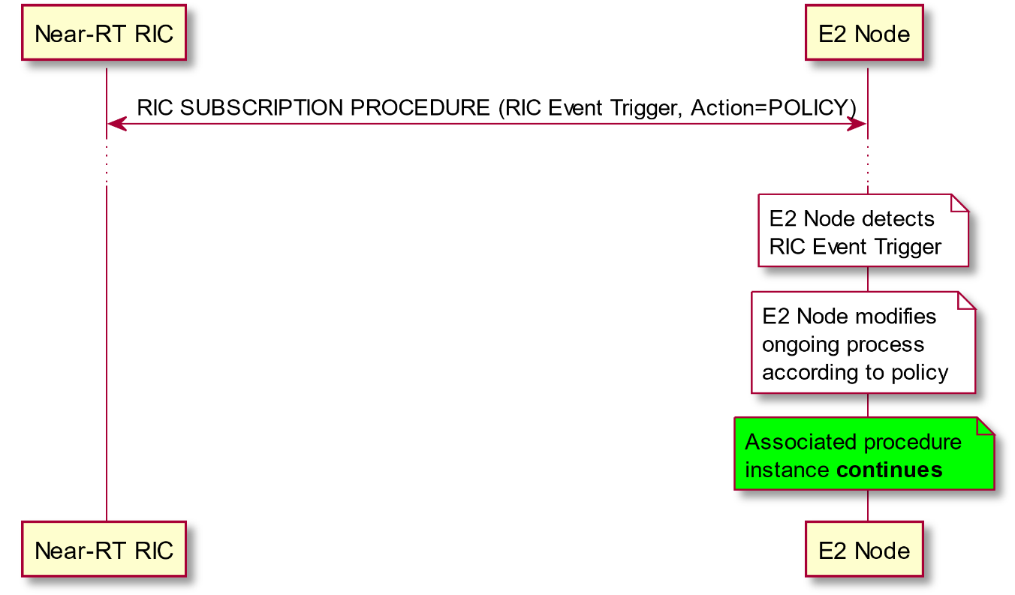

Figure 5.3.2-4: Near-RT RIC POLICY Service

The RIC Services may be realized using the following E2AP procedures:

E2AP RIC Subscription procedure

- Used to install Event Trigger and Actions corresponding to RIC services **REPORT**, **INSERT** and/or **POLICY**

E2AP RIC Indication procedure

- Used to carry outcome of RIC services **REPORT** and **INSERT**

E2AP RIC Control procedure

- Used to initiate RIC service **CONTROL**

Table 5.3.2-1: Relationship between RIC Services and E2AP Procedures

|  |  |  |  |
| --- | --- | --- | --- |
|  | **E2AP Procedure** | | |
| **RIC Service** | **E2AP RIC SUBSCRIPTION** | **E2AP RIC INDICATION** | **E2AP RIC CONTROL** |
| **REPORT** | Installs RIC Service | Carries outcome of RIC Service | - |
| **INSERT** | Installs RIC Service | Carries outcome of RIC Service | - |
| **CONTROL** | - | - | Initiates or modifies RIC Service |
| **POLICY** | Installs RIC Service | - | - |

### 5.3.3 Combining RIC services within a common Subscription

RIC services defined in 5.3.2 may be combined within a common Subscription with each RIC Service implemented a part of a sequence of Actions.

Where appropriate in these cases, successive **REPORT** or **INSERT** messages sent to Near-RT RIC would indicate a common Subscription Request identifier, a common sequence number and a unique Action identifier.

Examples include:

**- POLICY** then **REPORT**. In this case, at each occurrence of the defined Event Trigger, the E2 Node would be instructed to first execute a defined POLICY and then send a defined REPORT message

**- REPORT** then **REPORT**. In this case, at each occurrence of the defined Event Trigger, the E2 Node would be instructed to first send a defined REPORT message to be followed by a second defined REPORT message containing normally different information.

### 5.3.4 Combining RIC services as a sequence of RIC services

RIC services defined in 5.3.2 may be combined using a sequence of different RIC services implemented using a procedure executed within the Near-RT RIC.

Examples include:

**- REPORT** followed by **POLICY.** In this case, at each occurrence of the defined Event Trigger, the E2 Node would be instructed to send a defined **REPORT** message. The Near-RT RIC would use the information from one or more successive **REPORT** messages as input to a procedure that may result in a change or establishment of a RIC **POLICY** service.

**- INSERT** followed by **CONTROL.** In this case, at each occurrence of the defined Event Trigger, the E2 Node would be instructed to send a defined **INSERT** message containing information used to identify the suspended associated procedure instance and then the Near-RT RIC would send a corresponding **CONTROL** message containing information used to identify a previous suspended associated procedure instance.

**- REPORT** followed by **CONTROL.** In this case, at each occurrence of the defined Event Trigger, the E2 Node would be instructed to send a defined **REPORT** message. The Near-RT RIC would use the information from one or more successive REPORT messages as input to a procedure that may result in a RIC **CONTROL** service message being sent to initiate an associated procedure instance in the E2 Node.

## 5.4 RAN Function E2 Service Model

As described in section 5.1 the E2 interface is used to carry messages between a given RAN Function and Near-RT RIC. These messages are RAN Function specific and are described in the corresponding RAN Function specific E2 Service Model.

Each RAN Function is described in the following terms:

- *RAN Function definition*. Defines the RAN Function Name and describes the E2 services that the specific RAN Function is currently configured to present over the E2 interface.

- *RIC Event Trigger Definition* approach. Describes the approach to be used in Near-RT RIC Subscription messages to set Near-RT RIC Event Trigger Definition in the RAN Function.

- *RIC Action Definition* approach. Describes the approach to be used in subsequent Near-RT RIC Subscription messages to set required sequence of Near-RT RIC Action in the RAN Function.

- *RIC Indication header* and *RIC Indication message* approach. Describes the approach to be used by RAN when composing Indication messages for Near-RT RIC **REPORT** and **INSERT** services.

- *RIC Control header* and *RIC Control message* approach. Describes the approach to be used by Near-RT RIC when composing **CONTROL** messages.

- RAN Function Policies. Describes the set of policies that the RAN Function is configured to support and the corresponding Parameters that may be used to configure the policy using Near-RT RIC **POLICY** services

## 5.5 Near-RT RIC support functions

### 5.5.1 General

The Near-RT RIC support functions facilitate the following:

* E2 Setup
* E2 Reset
* Near-RT RIC Service Update
* E2 Node Configuration Update
* Reporting of General Error Situations

The E2 Setup, E2 Reset, Near-RT RIC Service Update and E2 Node Configuration Update procedures are described in further details below.

### 5.5.2 E2 Setup procedure

The E2 Setup procedure is used to establish the E2 interface between the Near-RT RIC and an E2 Node. During this procedure the E2 Node provides:

* List of supported Near-RT RIC services and mapping of services to functions within the E2 Node. This information is specific to each RAN Function in the E2 node and is defined by a specific E2 Service Model as described in section 5.4
* List of E2 Node configuration information. This information is specific to the E2 Node type (see section 4.2) and defined by the E2 Node system specifications

If the E2 Setup procedure fails, the Near-RT RIC may provide an alternative Transport Layer Information for the E2 Node to use when reinitiating the E2 Setup procedure.

@startuml

skinparam ParticipantPadding 5

skinparam BoxPadding 10

skinparam lifelineStrategy solid

participant “Near-RT RIC” as near

participant “E2 Node” as ran

note over ran #white

E2 Node preconfigured with

Near-RT RIC address

and RIC service information

and E2 node configuration

end note

ran<-->near: SCTP connection establishment

ran->near: E2 SETUP REQUEST \n(RIC service and E2 Node configuration information)

note over near #white

Near-RT RIC extracts list of

supported Near-RT RIC Services

and mapping of services to

functions and stores information

end note

note over near #white

Near-RT RIC extracts list of

E2 Node configuration

information and stores information

end note

ran<-near: E2 SETUP RESPONSE \n(RIC Service and E2 Node configuration Ack)

@enduml

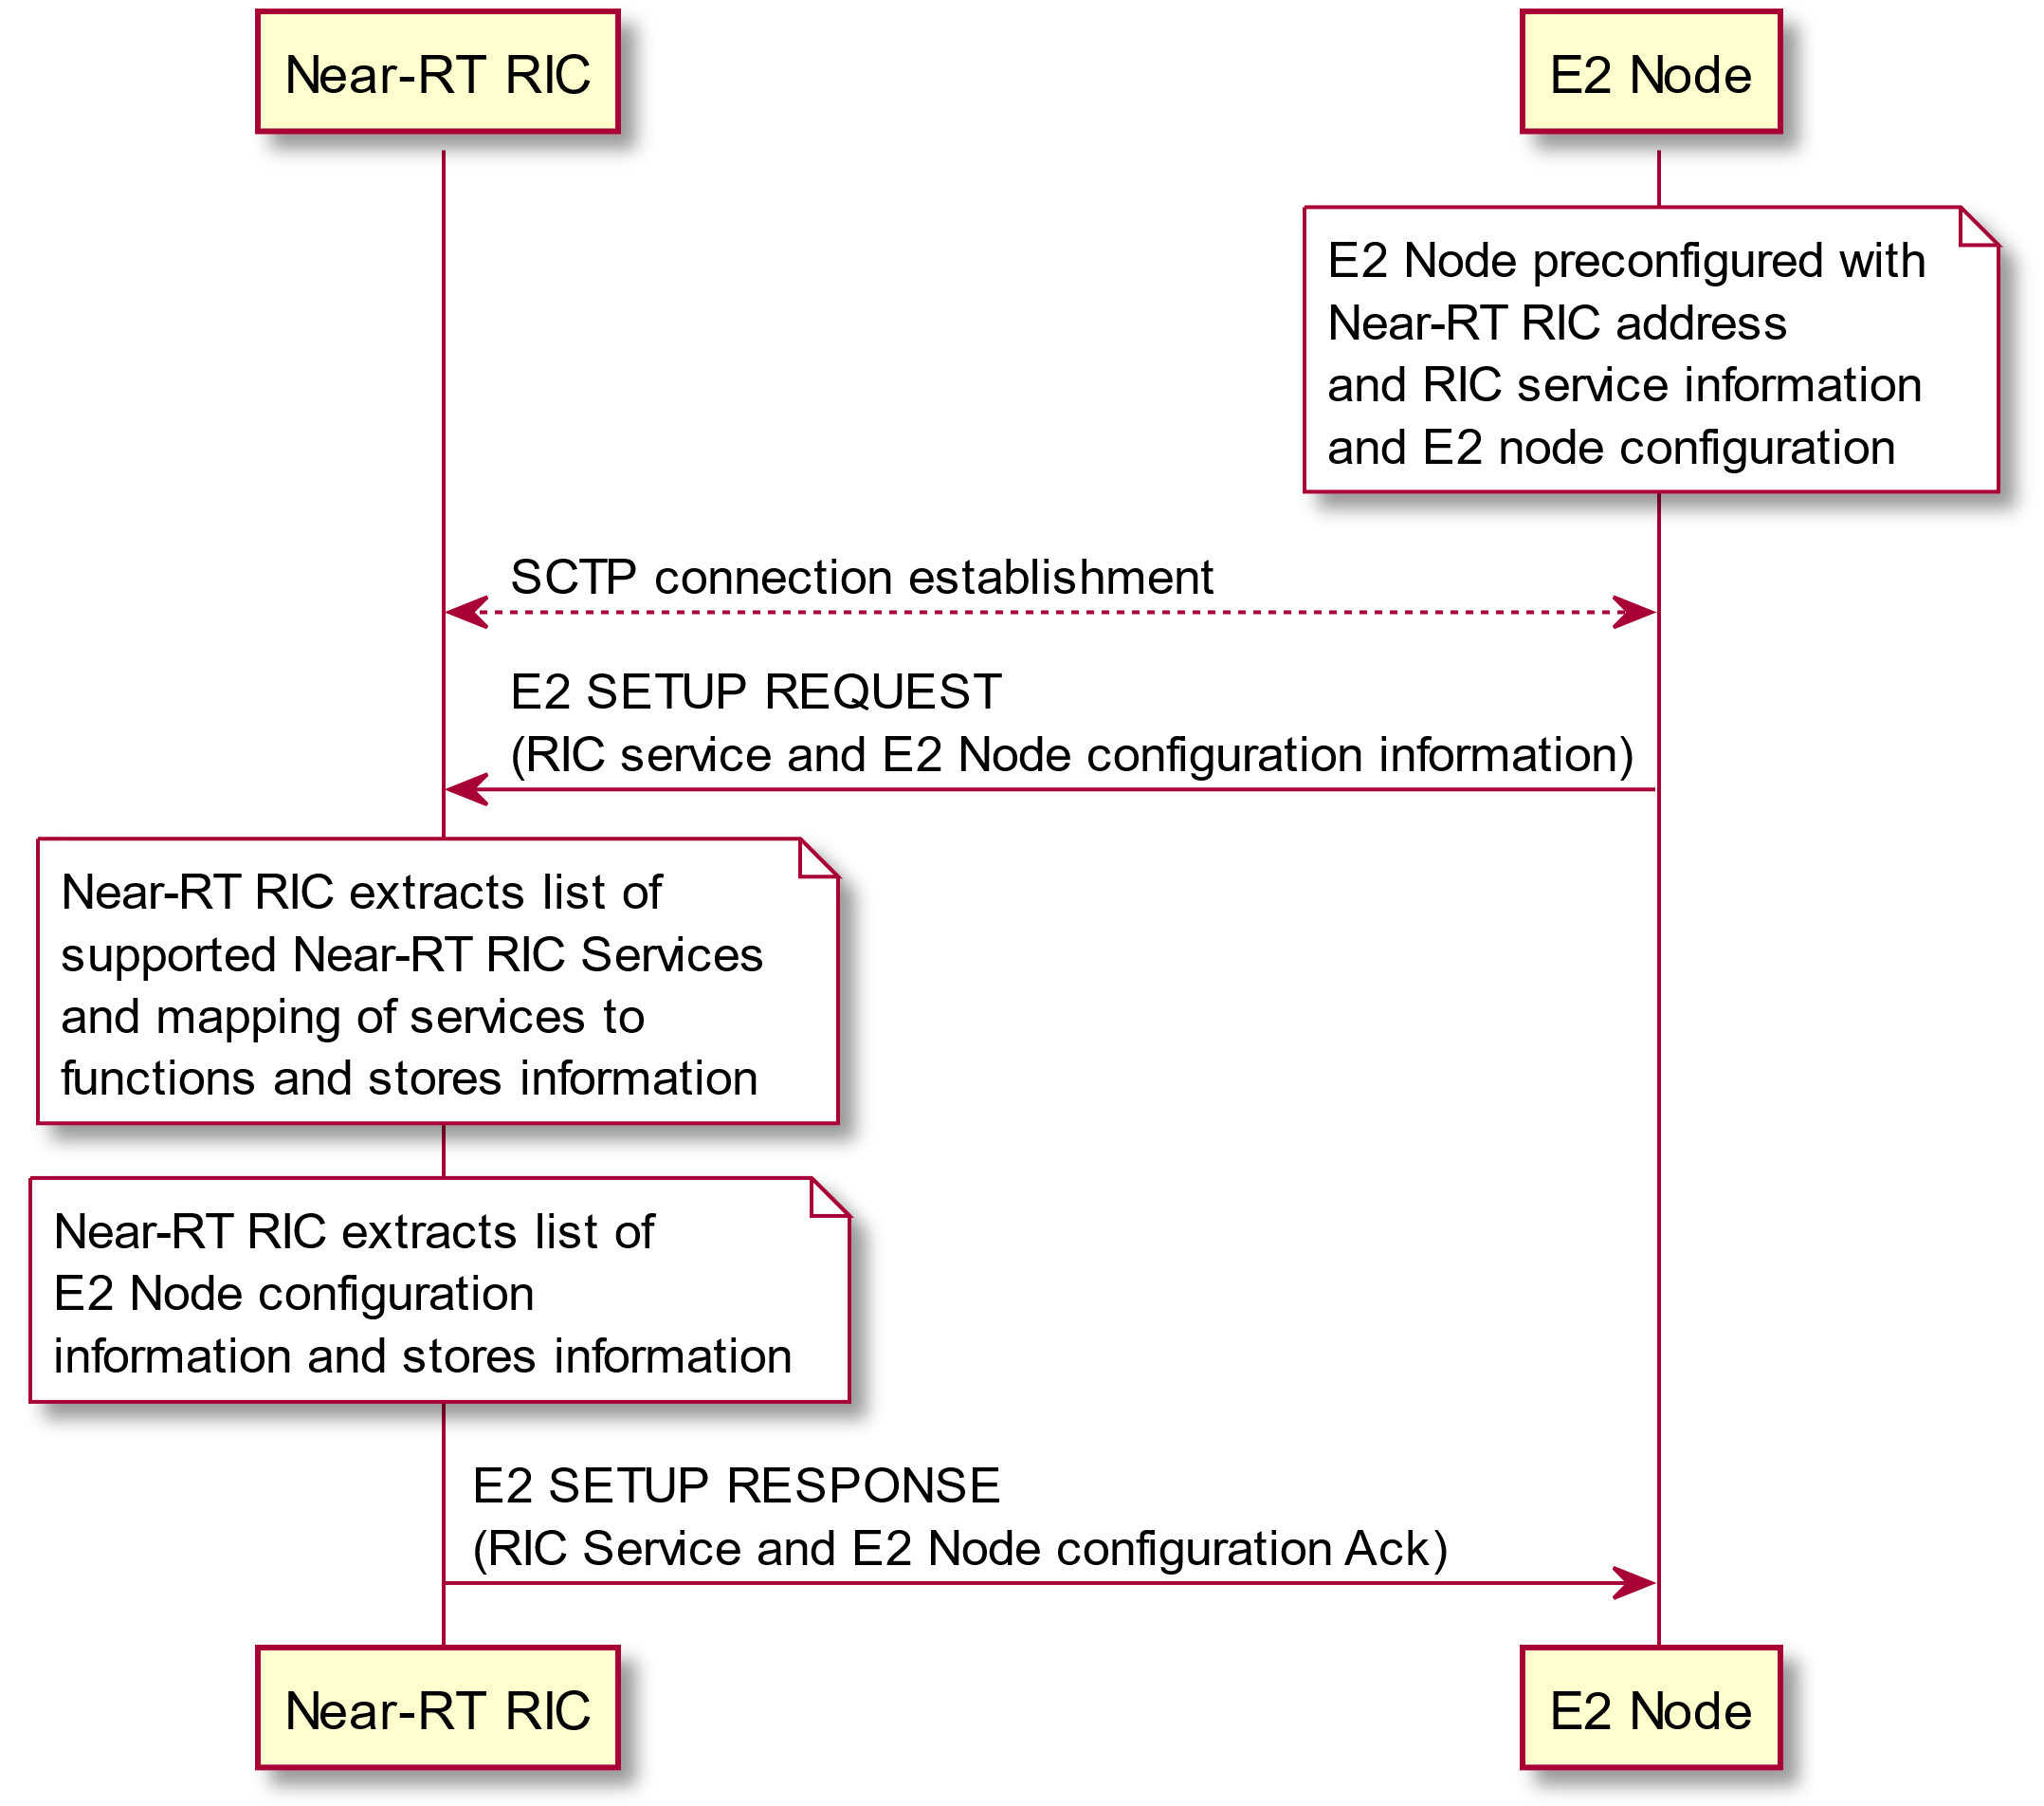

Figure 5.5.2-1: E2 Setup procedure

### 5.5.3 E2 Reset procedure

The E2 Reset procedure is used by either the E2 Node or Near-RT RIC to reset the E2 interface.

Information previous exchanged during E2 Setup, E2 Node Configuration Update and RIC Service Update procedures shall be maintained however the outcome of all previous RIC Subscription shall be deleted from the E2 Node and E2 Node gracefully terminates any ongoing Near-RT RIC call processes.

The Near-RT RIC may then proceed to re-establish any RIC Subscriptions as required.

@startuml

skinparam ParticipantPadding 100

skinparam BoxPadding 10

skinparam lifelineStrategy solid

participant “Near-RT RIC” as near

participant “E2 Node” as ran

note over ran #white

E2 Node detects abnormal failure

end note

ran->near: RESET REQUEST (Cause)

note over near #white

Near-RT RIC informs xApps of

RESET from E2 Node

end note

note over ran #white

E2 Node deletes any

pre-established RIC

Subscriptions

end note

note over ran #white

E2 Node gracefully

terminates any ongoing

Near-RT RIC call processes

end note

ran<-near: RESET RESPONSE

note over near #white

Near-RT RIC may re-establish

RIC Subscriptions

end note

@enduml

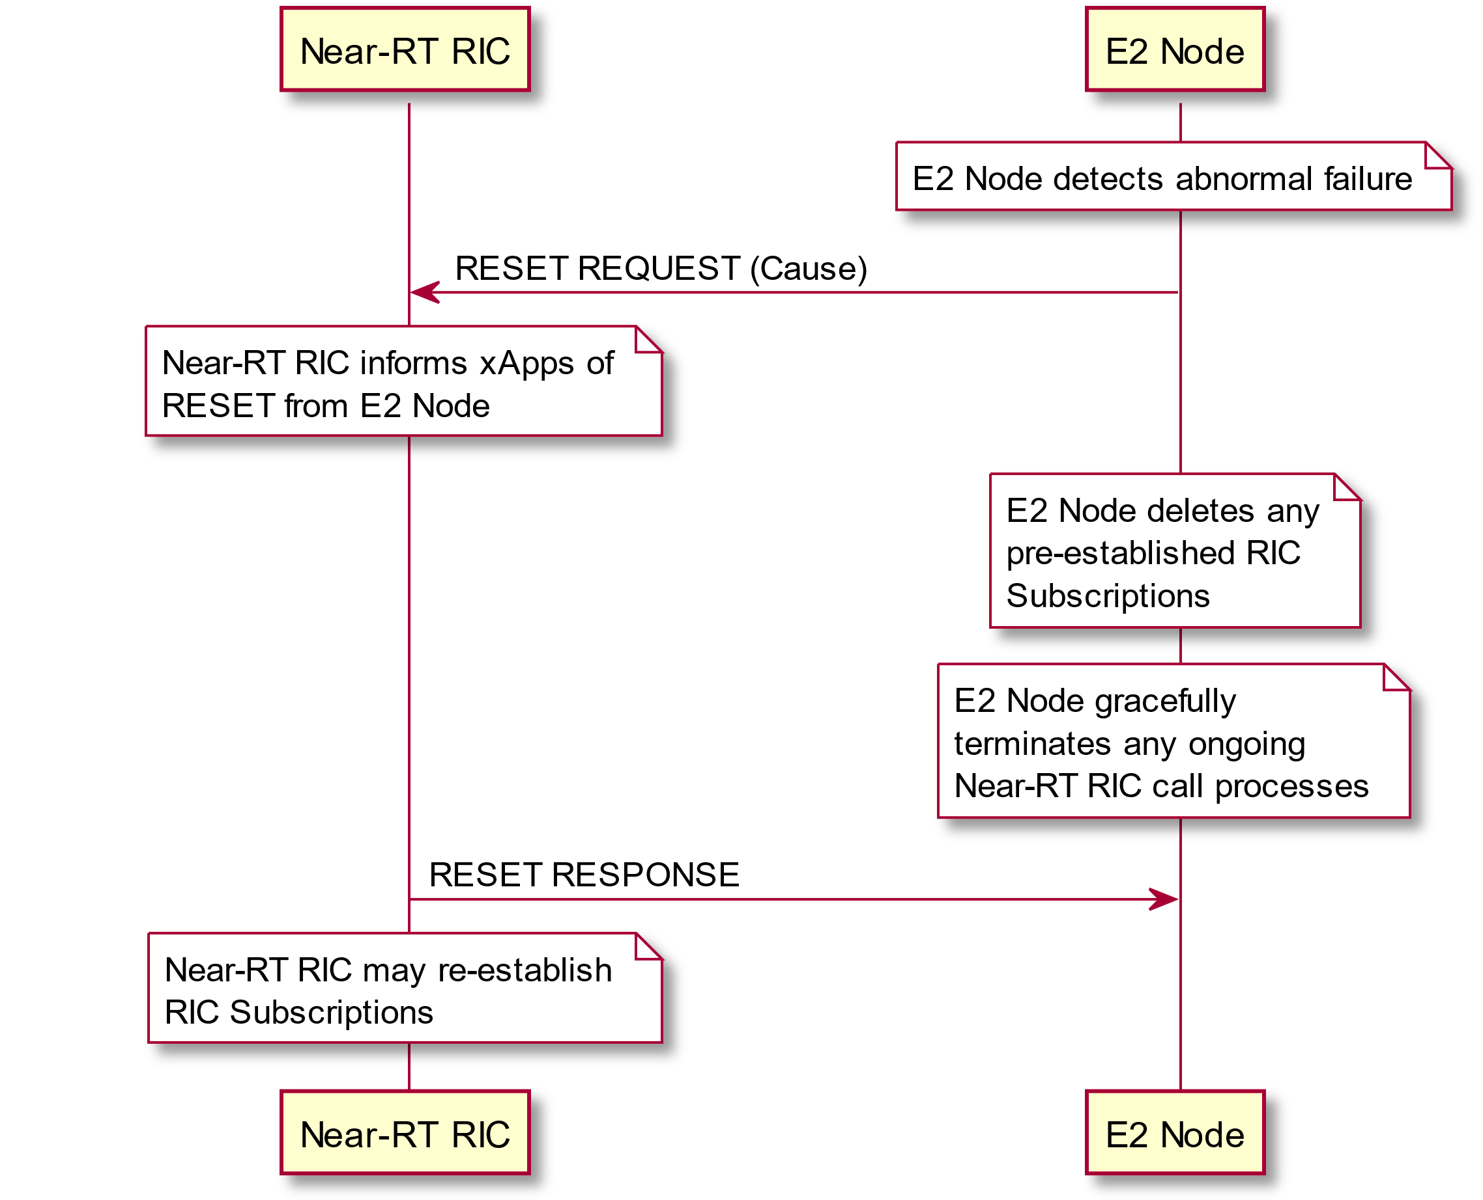

Figure 5.5.3-1: E2 Reset procedure (E2 Node initiated)

@startuml

skinparam ParticipantPadding 100

skinparam BoxPadding 10

skinparam lifelineStrategy solid

participant “Near-RT RIC” as near

participant “E2 Node” as ran

note over near #white

Near-RT RIC detects abnormal failure

end note

ran<-near: RESET REQUEST (Cause)

note over ran #white

E2 Node deletes any

pre-established RIC

Subscriptions

end note

note over ran #white

E2 Node gracefully

terminates any ongoing

Near-RT RIC call processes

end noteran->near: RESET RESPONSE

note over near #white

Near-RT RIC informs xApps of

RESET from E2 Node

end note

note over near #white

Near-RT RIC may re-establish

RIC Subscriptions

end note

@enduml

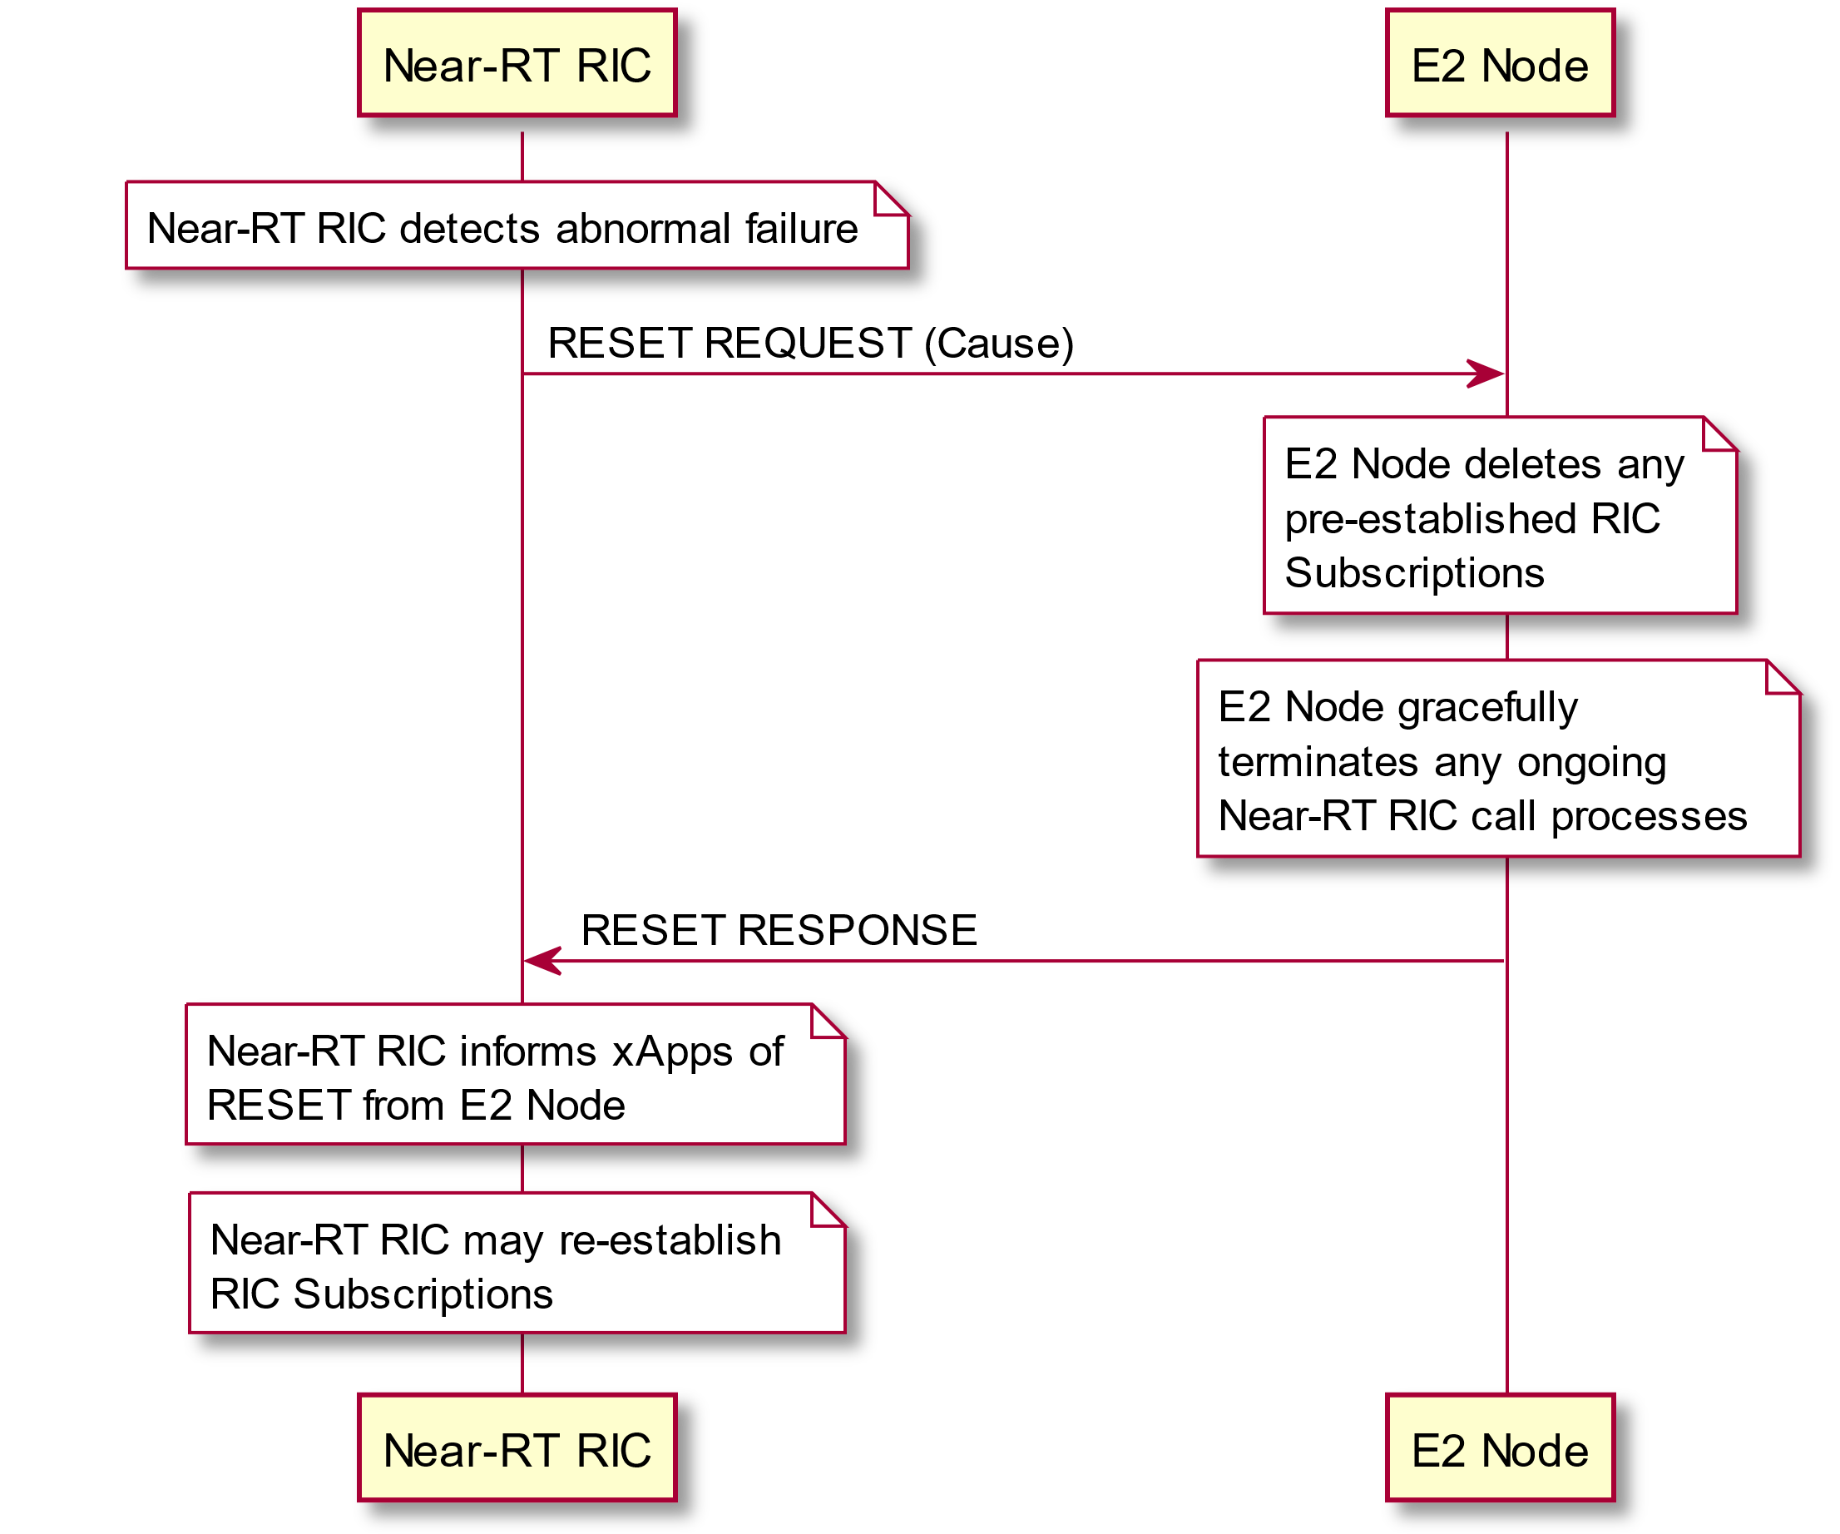

Figure 5.5.3-2: E2 Reset procedure (Near-RT RIC initiated)

### 5.5.4 Near-RT RIC Service Update procedure

The Near-RT RIC Service Update procedure is used by the E2 Node to inform the Near-RT RIC of any change to the list of supported Near-RT RIC services and mapping of services to functions within the E2 Node. This information is specific to each RAN Function in the E2 node and is defined by a specific E2 Service Model as described in section 5.4

This procedure may also be initiated by the Near-RT RIC sending a RIC SERVICE QUERY message.

@startuml

skinparam ParticipantPadding 5

skinparam BoxPadding 10

skinparam lifelineStrategy solid

participant “Near-RT RIC” as near

participant “E2 Node” as ran

note over near #white: Near-RT RIC decides to query E2 Node

near-->ran: RIC SERVICE QUERY

note over ran #white: Change to RIC service configuration on E2 Noderan->near: RIC SERVICE UPDATE (RIC service information)

note over near #white: Near-RT RIC extracts list of changes \nto supported Near-RT RIC Services \nand mapping of services to functions \nand updates stored information

ran<-near: RIC SERVICE UPDATE ACKNOWLEDGE (RIC Service Ack)

@enduml

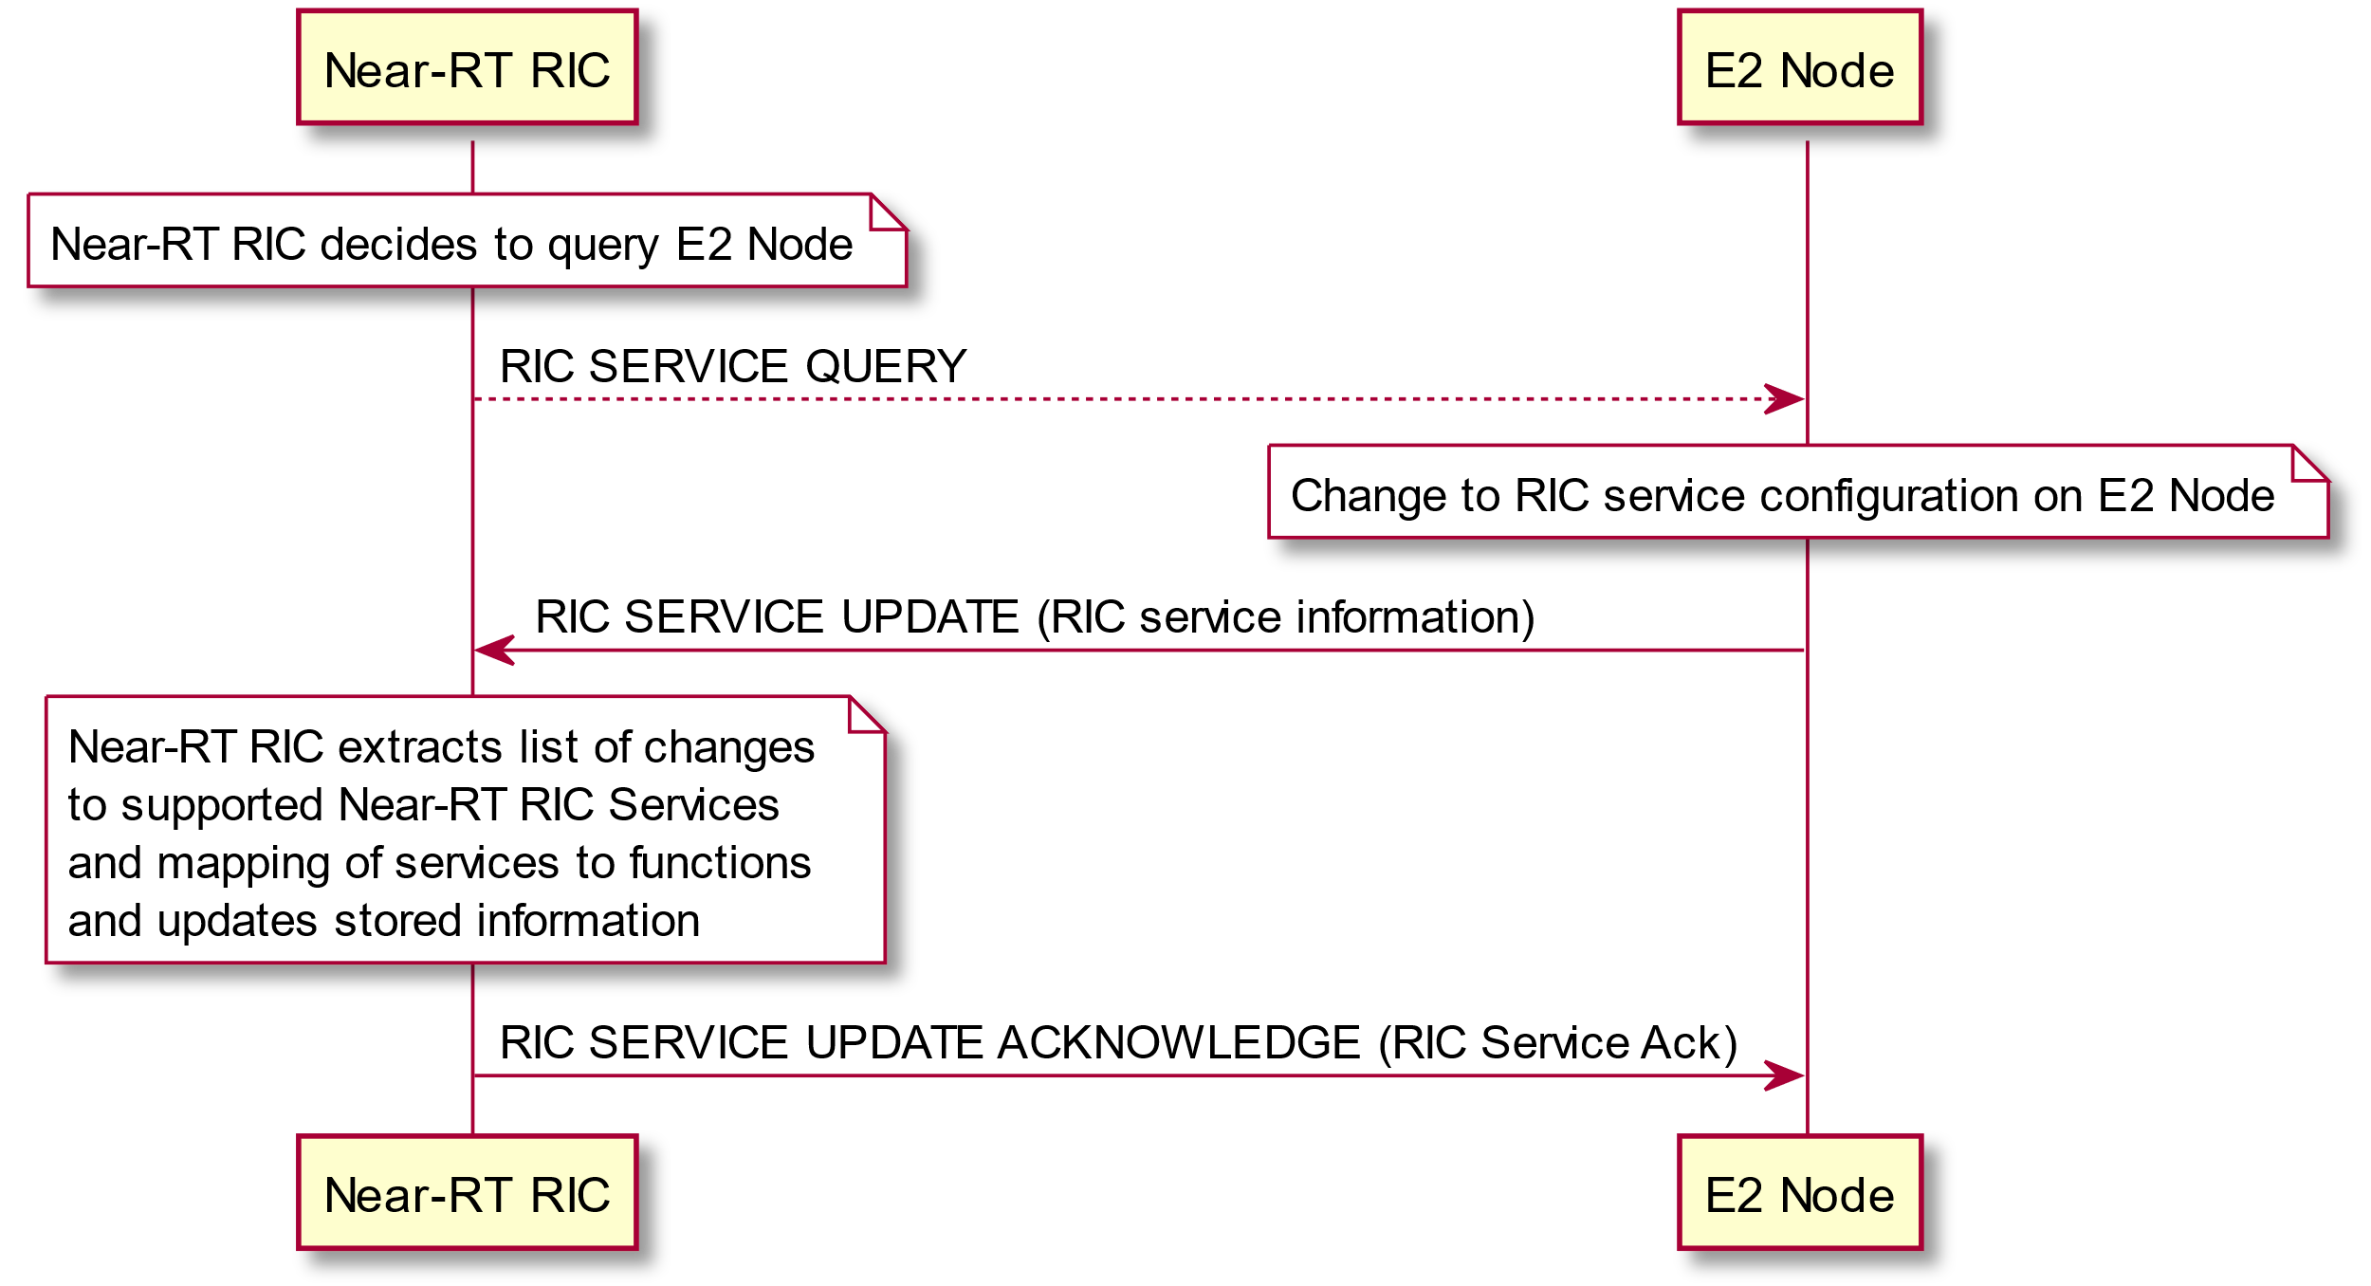

Figure 5.5.4-1: RIC Service update procedure

### 5.5.5 E2 Node Configuration Update procedure

The E2 Node Configuration Update procedure is used by the E2 Node to inform the Near-RT RIC of any change to the configuration of the E2 Node. This information is specific to the E2 Node type and defined by the E2 Node system specifications as described in section 4.2.

@startuml

skinparam ParticipantPadding 5

skinparam BoxPadding 10

skinparam lifelineStrategy solid

participant “Near-RT RIC” as near

participant “E2 Node” as ran

note over ran #white: Change to E2 node system configuration

ran->near: E2 NODE CONFIGURATION UPDATE \n(E2 node configuration information)

note over near #white: Near-RT RIC extracts list of changes \nto E2 Node configuration information \nand updates stored information

ran<-near: E2 NODE CONFIGURATION UPDATE ACKNOWLEDGE \n(E2 node configuration ack)

@enduml

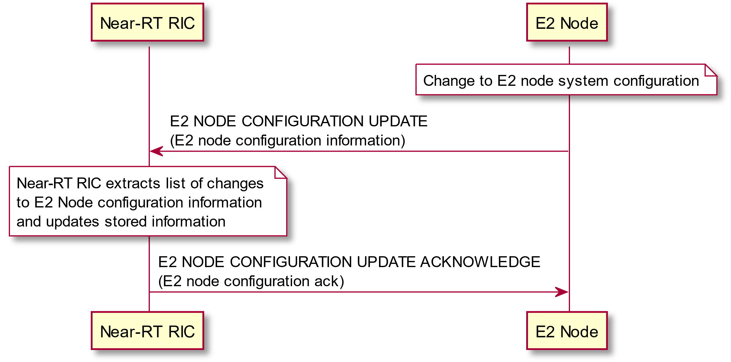

Figure 5.5.5-1: E2 Node configuration update procedure

# 6 Services expected from signalling transport

## 6.1 E2 Control Plane Protocol (E2AP)

The control plane protocol stack of the E2AP interface is shown on Figure 6.1-1. The transport network layer is built on IP transport. For the reliable transport of signaling messages, SCTP [12] is added on top of IP. When configurations with multiple SCTP associations are supported, the Near-RT RIC may request to dynamically add/remove SCTP associations between the E2 Node/Near-RT RIC pair. Within the set of SCTP associations established between one Near-RT RIC and E2 node pair, the Near-RT RIC may request the E2 Node to restrict the usage of SCTP association for certain types of E2 signaling. If no restriction information is provided for an SCTP association, any type of E2 signaling is allowed via the SCTP association. The application layer signaling protocol is referred to as E2AP (E2 Application Protocol). The Payload Protocol Identifier assigned by IANA to be used by SCTP for the application layer protocol E2AP is 70. This value is to be used for all deployment configurations described in this specification. Payload Protocol Identifiers 71 and 72, also assigned by IANA for E2, are reserved for future use.

No SCTP Destination Port number value was assigned by IANA for the E2AP protocol and so networks shall rely on E2 node and Near-RT RIC configuration to select a suitable port number.

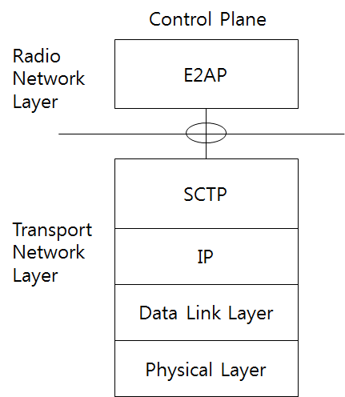

Figure 6.1-1: E2AP protocol stack

Note: The E2AP messages are transported over the E2 interfaces

## 6.2 Multiple TNLAs over E2

The Near-RT RIC supports multiple TNL Associations over E2 interface.

An initial TNL Association is established during E2 SETUP procedure. At this point the single TNL association is configured to be used for both RIC Services and E2 Support functions.

TNL Associations may then be added, modified or removed during subsequent E2 CONNECTION UPDATE procedures.

@startuml

skinparam ParticipantPadding 5

skinparam BoxPadding 10

skinparam lifelineStrategy solid

participant “Near-RT RIC” as near

participant “E2 Node” as ran

note over ran #white

E2 Node obtains Near-RT RIC

IP address and Port number

end note

ran<-->near : SCTP connection (TNLA1)

ran->near: E2 SETUP REQUEST

near->ran: E2 SETUP RESPONSE

note over near, ran #yellow: E2 interface using TNLA1

...

near->ran: E2 CONNECTION UPDATE (TNLA2 addition)

ran<-->near : SCTP connection (TNLA2)

ran->near: E2 CONNECTION UPDATE ACKNOWLEDGE (Status TNLA1, TNLA2)

note over near, ran #yellow: E2 interface using TNLA1 and TNLA2

...

near->ran: E2 CONNECTION UPDATE (TNLA1 and TNLA2 modification)

note over ran #white: Modify usage assignments \nfor TNLA1 and TNLA2

ran->near: E2 CONNECTION UPDATE ACKNOWLEDGE (Status TNLA1, TNLA2)

note over near, ran #yellow: E2 interface using TNLA1 and TNLA2 with modified usage

...

near->ran: E2 CONNECTION UPDATE (TNLA1 removal)

ran<-->near : SCTP connection removal (TNLA1)

ran->near: E2 CONNECTION UPDATE ACKNOWLEDGE (Status TNLA2)

note over near, ran #yellow: E2 interface using TNLA2

@enduml

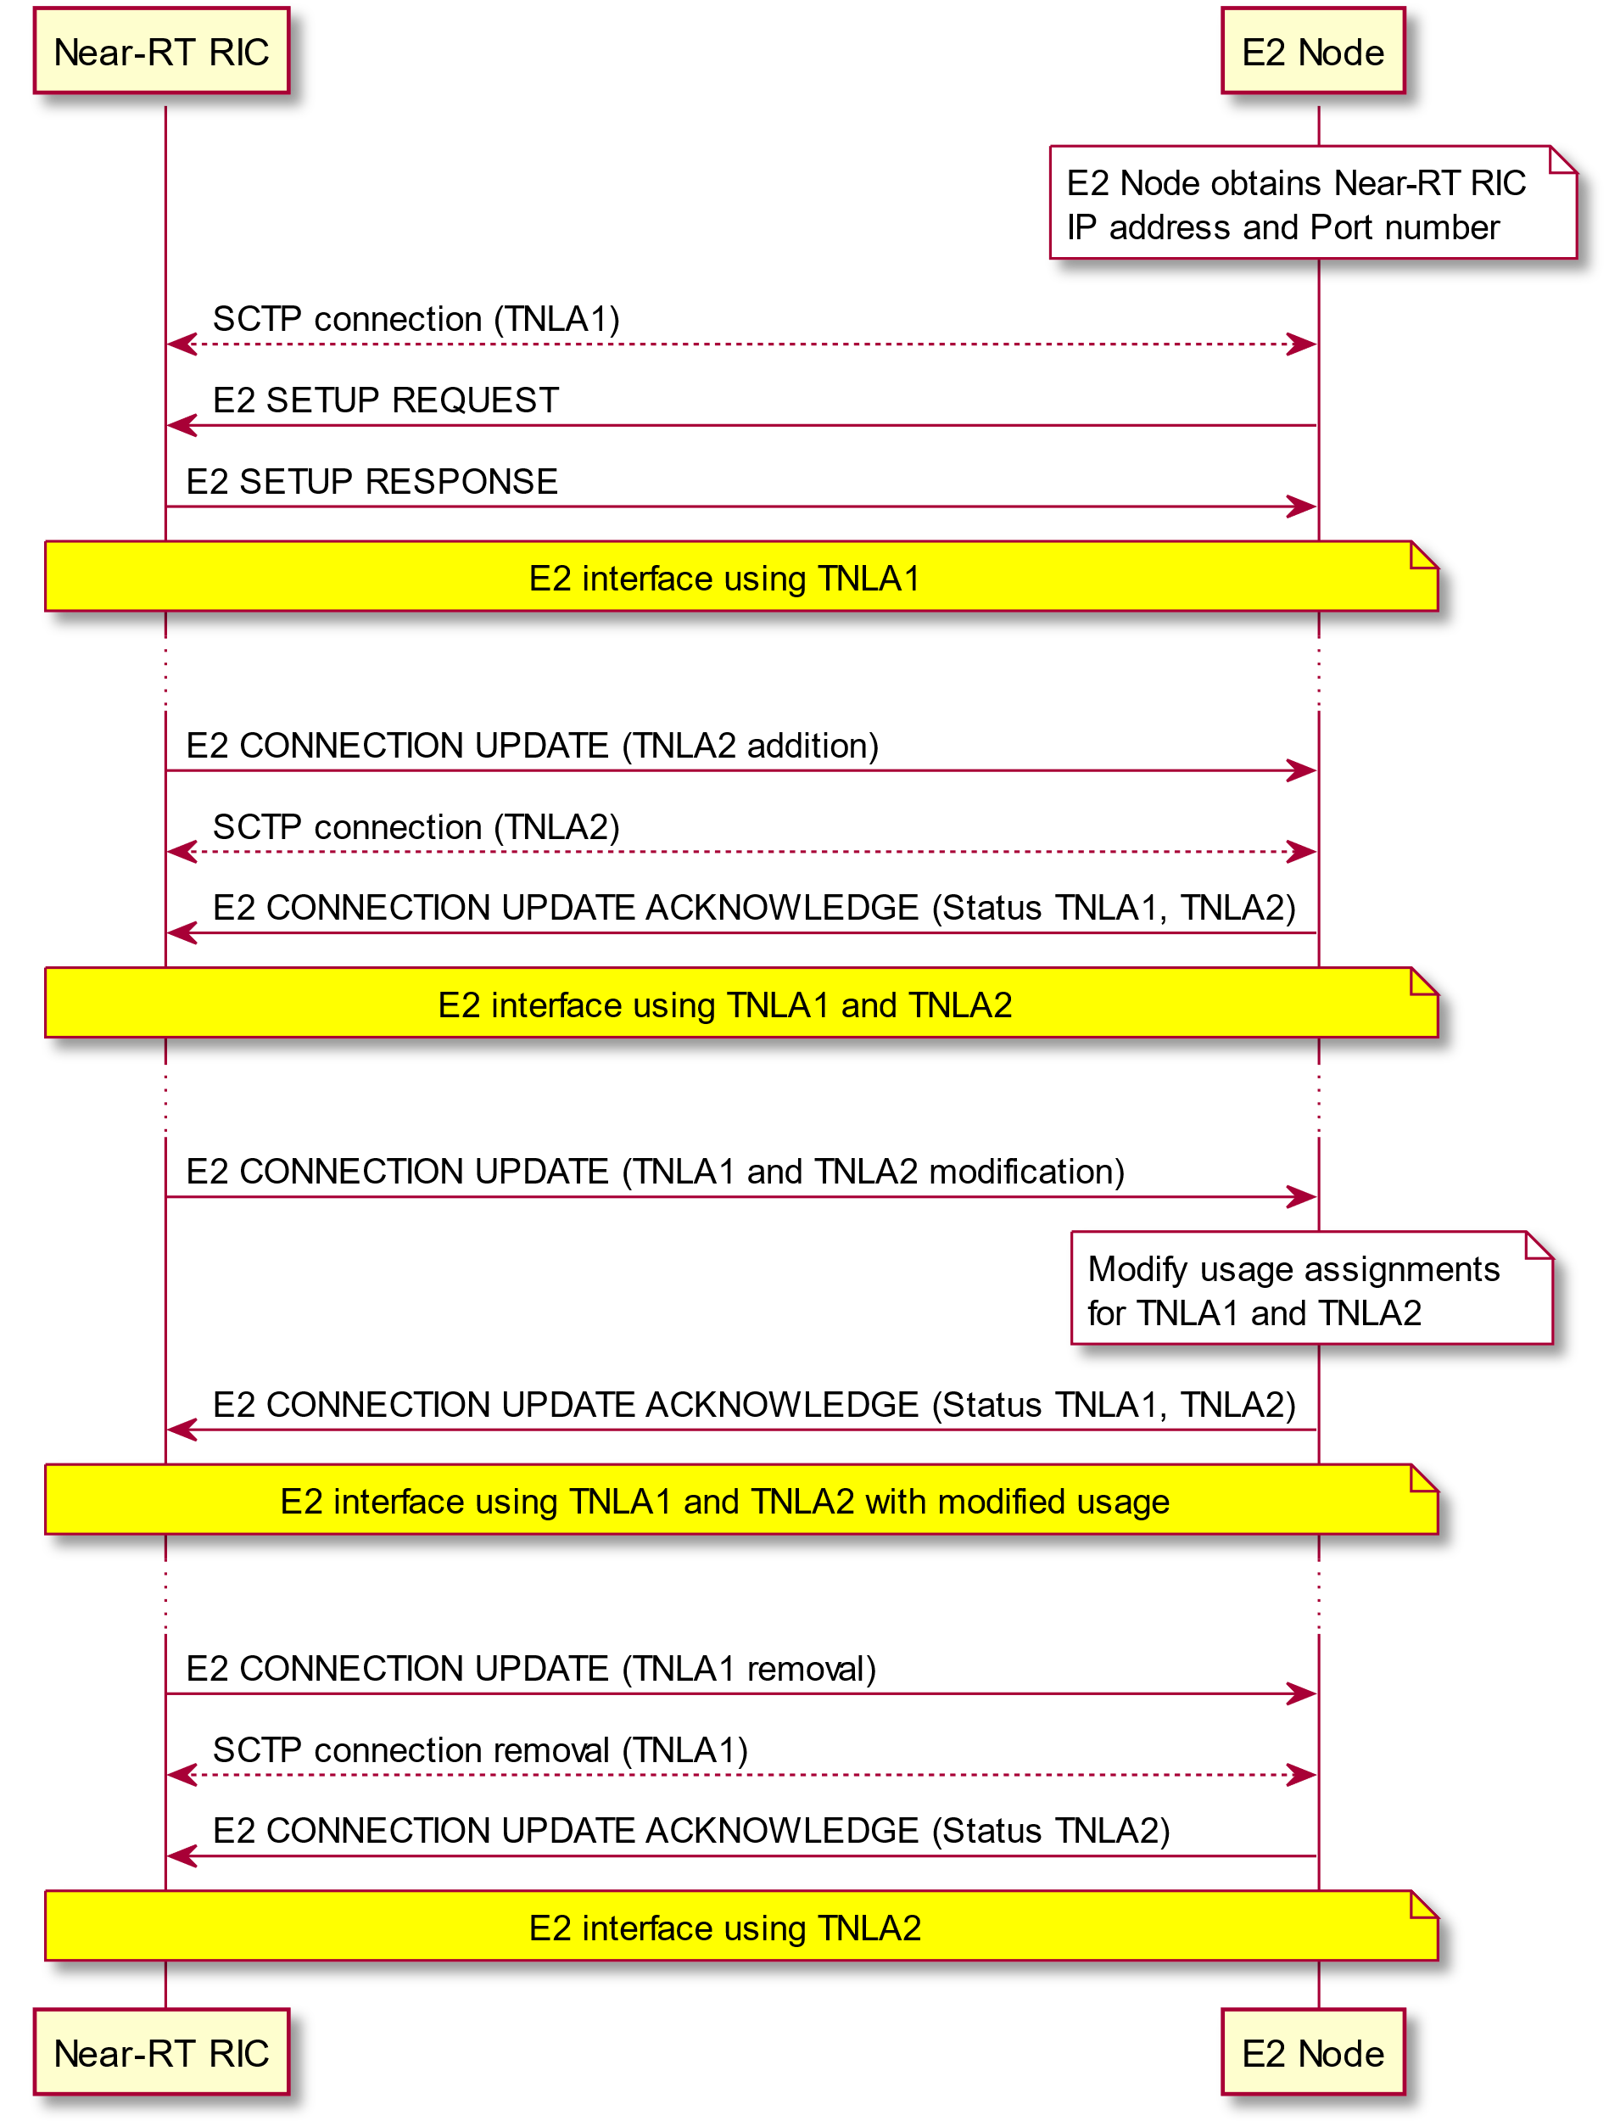

Figure 6.2-1: TNL management examples

# 7 Security Requirements

## 7.1 General

The security requirements given in this section only apply to the E2 interface. The security requirements for the 3GPP LTE eNB is defined in [13] and for the 5G NR gNB in [14].

## 7.2 Requirements for the E2 interfaces

The requirements given below apply to E2 interface defined in this document:

* E2 interface shall support confidentiality, integrity and replay protection.

# 8 Other E2 interface specifications

## 8.1 O-RAN E2 interface: E2 Application Protocol (E2AP) (ORAN-WG3.E2AP)

The technical specification ORAN-WG3.E2AP [2] specifies the signaling protocol between the Near-RT RIC and the E2 Node over the E2 interface.

## 8.2 O-RAN E2 interface: E2 Service Model (E2SM) specifications

The technical specification ORAN-WG3.E2SM [17] provides the list of the supported RAN Function-specific E2 Service Models supported over the E2 interface and presents a recommended layout for additional E2SM specifications.

# Annex A Deployment considerations

## A.1 Deployment use cases

The Near-RT RIC may be connected to range of different RAN configurations similar to the list of cases described in [8] for O&M architecture. Examples include:

- Standalone O-CU-CP connected to one or more standalone O-CU-UP and one or more standalone O-DU. Each logical node is considered as an E2 Node that presents an E2 interface to the Near-RT RIC.

- Combined O-CU-CP and O-CU-UP connected to one or more standalone O-DU. The combined O-CU-CP/O-CU-UP may present either a common E2 interface or individual E2 interfaces corresponding to the individual O-RAN components

- Combined O-CU-CP, O-CU-UP and O-DU. The combined node may present either a common E2 interface or individual E2 interfaces corresponding to the individual O-RAN components

In all cases the different RAN components may initiate either independent E2 connections to the Near-RT RIC for each logical O-RAN component or may present a shared E2 interface and hence present the combined RAN components as a common E2 Node supporting services appropriate to more than one logical O-RAN component.

In all cases each E2 Node shall present a single E2 interface to the Near-RT RIC and shall announce which E2 Services supports for each logical O-RAN component.

Example deployment use case are presented in figure A.1-1 and figure A.1-2. Note that in addition, the near-RT RIC and other RAN nodes have O1 interfaces as described in [8].

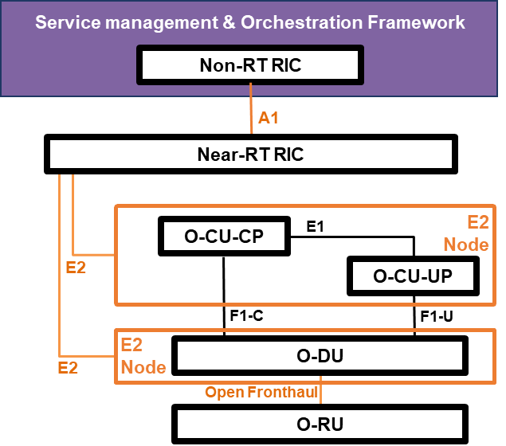

Figure A.1-1: Example deployment use case with single E2 Node supporting both O-CU-CP and O-CU-UP roles

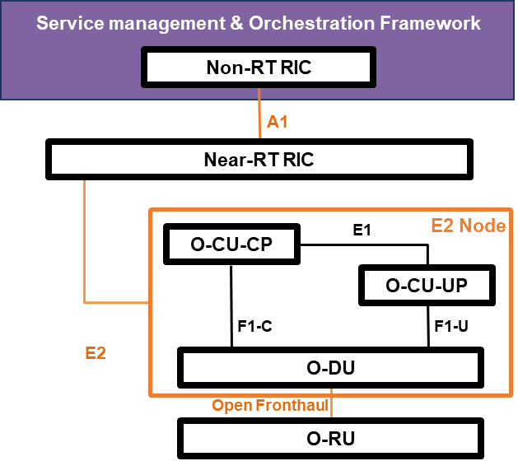

Figure A.1-2: Example deployment use case with single E2 Node supporting O-CU-CP, O-CU-UP and O-DU roles

Annex ZZZ : O-RAN Adopter License Agreement

BY DOWNLOADING, USING OR OTHERWISE ACCESSING ANY O-RAN SPECIFICATION, ADOPTER AGREES TO THE TERMS OF THIS AGREEMENT.

This O-RAN Adopter License Agreement (the “Agreement”) is made by and between the O-RAN Alliance and the entity that downloads, uses or otherwise accesses any O-RAN Specification, including its Affiliates (the “Adopter”).

This is a license agreement for entities who wish to adopt any O-RAN Specification.

## Section 1: DEFINITIONS

1.1 “Affiliate” means an entity that directly or indirectly controls, is controlled by, or is under common control with another entity, so long as such control exists. For the purpose of this Section, “Control” means beneficial ownership of fifty (50%) percent or more of the voting stock or equity in an entity.

1.2 “Compliant Implementation” means any system, device, method or operation (whether implemented in hardware, software or combinations thereof) that fully conforms to a Final Specification.

1.3 “Adopter(s)” means all entities, who are not Members, Contributors or Academic Contributors, including their Affiliates, who wish to download, use or otherwise access O-RAN Specifications.

1.4 “Minor Update” means an update or revision to an O-RAN Specification published by O-RAN Alliance that does not add any significant new features or functionality and remains interoperable with the prior version of an O-RAN Specification. The term “O-RAN Specifications” includes Minor Updates.

1.5 “Necessary Claims” means those claims of all present and future patents and patent applications, other than design patents and design registrations, throughout the world, which (i) are owned or otherwise licensable by a Member, Contributor or Academic Contributor during the term of its Member, Contributor or Academic Contributorship; (ii) such Member, Contributor or Academic Contributor has the right to grant a license without the payment of consideration to a third party; and (iii) are necessarily infringed by a Compliant Implementation (without considering any Contributions not included in the Final Specification). A claim is necessarily infringed only when it is not possible on technical (but not commercial) grounds, taking into account normal technical practice and the state of the art generally available at the date any Final Specification was published by the O-RAN Alliance or the date the patent claim first came into existence, whichever last occurred, to make, sell, lease, otherwise dispose of, repair, use or operate a Compliant Implementation without infringing that claim. For the avoidance of doubt in exceptional cases where a Final Specification can only be implemented by technical solutions, all of which infringe patent claims, all such patent claims shall be considered Necessary Claims.

1.6 “Defensive Suspension” means for the purposes of any license grant pursuant to Section 3, Member, Contributor, Academic Contributor, Adopter, or any of their Affiliates, may have the discretion to include in their license a term allowing the licensor to suspend the license against a licensee who brings a patent infringement suit against the licensing Member, Contributor, Academic Contributor, Adopter, or any of their Affiliates.

## Section 2: COPYRIGHT LICENSE

2.1 Subject to the terms and conditions of this Agreement, O-RAN Alliance hereby grants to Adopter a nonexclusive, nontransferable, irrevocable, non-sublicensable, worldwide copyright license to obtain, use and modify O-RAN Specifications, but not to further distribute such O-RAN Specification in any modified or unmodified way, solely in furtherance of implementations of an O-RAN

Specification.

2.2 Adopter shall not use O-RAN Specifications except as expressly set forth in this Agreement or in a separate written agreement with O-RAN Alliance.

## Section 3: FRAND LICENSE

3.1 Members, Contributors and Academic Contributors and their Affiliates are prepared to grant based on a separate Patent License Agreement to each Adopter under Fair Reasonable And Non- Discriminatory (FRAND) terms and conditions with or without compensation (royalties) a nonexclusive, non-transferable, irrevocable (but subject to Defensive Suspension), non-sublicensable, worldwide patent license under their Necessary Claims to make, have made, use, import, offer to sell, lease, sell and otherwise distribute Compliant Implementations; provided, however, that such license shall not extend: (a) to any part or function of a product in which a Compliant Implementation is incorporated that is not itself part of the Compliant Implementation; or (b) to any Adopter if that Adopter is not making a reciprocal grant to Members, Contributors and Academic Contributors, as set forth in Section 3.3. For the avoidance of doubt, the foregoing licensing commitment includes the distribution by the Adopter’s distributors and the use by the Adopter’s customers of such licensed Compliant Implementations.

3.2 Notwithstanding the above, if any Member, Contributor or Academic Contributor, Adopter or their Affiliates has reserved the right to charge a FRAND royalty or other fee for its license of Necessary Claims to Adopter, then Adopter is entitled to charge a FRAND royalty or other fee to such Member, Contributor or Academic Contributor, Adopter and its Affiliates for its license of Necessary Claims to its licensees.

3.3 Adopter, on behalf of itself and its Affiliates, shall be prepared to grant based on a separate Patent License Agreement to each Members, Contributors, Academic Contributors, Adopters and their Affiliates under Fair Reasonable And Non-Discriminatory (FRAND) terms and conditions with or without compensation (royalties) a nonexclusive, non-transferable, irrevocable (but subject to Defensive Suspension), non-sublicensable, worldwide patent license under their Necessary Claims to make, have made, use, import, offer to sell, lease, sell and otherwise distribute Compliant Implementations; provided, however, that such license will not extend: (a) to any part or function of a product in which a Compliant Implementation is incorporated that is not itself part of the Compliant Implementation; or (b) to any Members, Contributors, Academic Contributors, Adopters and their Affiliates that is not making a reciprocal grant to Adopter, as set forth in Section 3.1. For the avoidance of doubt, the foregoing licensing commitment includes the distribution by the Members’, Contributors’, Academic Contributors’, Adopters’ and their Affiliates’ distributors and the use by the Members’, Contributors’, Academic Contributors’, Adopters’ and their Affiliates’ customers of such licensed Compliant Implementations.

## Section 4: TERM AND TERMINATION

4.1 This Agreement shall remain in force, unless early terminated according to this Section 4.

4.2 O-RAN Alliance on behalf of its Members, Contributors and Academic Contributors may terminate this Agreement if Adopter materially breaches this Agreement and does not cure or is not capable of curing such breach within thirty (30) days after being given notice specifying the breach.

4.3 Sections 1, 3, 5 - 11 of this Agreement shall survive any termination of this Agreement. Under surviving Section 3, after termination of this Agreement, Adopter will continue to grant licenses (a) to entities who become Adopters after the date of termination; and (b) for future versions of O-RAN Specifications that are backwards compatible with the version that was current as of the date of termination.

## Section 5: CONFIDENTIALITY

Adopter will use the same care and discretion to avoid disclosure, publication, and dissemination of O-RAN Specifications to third parties, as Adopter employs with its own confidential information, but no less than reasonable care. Any disclosure by Adopter to its Affiliates, contractors and consultants should be subject to an obligation of confidentiality at least as restrictive as those contained in this Section. The foregoing obligation shall not apply to any information which is: (1) rightfully known by Adopter without any limitation on use or disclosure prior to disclosure; (2) publicly available through no fault of Adopter; (3) rightfully received without a duty of confidentiality; (4) disclosed by O-RAN Alliance or a Member, Contributor or Academic Contributor to a third party without a duty of confidentiality on such third party; (5) independently developed by Adopter; (6) disclosed pursuant to the order of a court or other authorized governmental body, or as required by law, provided that Adopter provides reasonable prior written notice to O-RAN Alliance, and cooperates with O-RAN Alliance and/or the applicable Member, Contributor or Academic Contributor to have the opportunity to oppose any such order; or (7) disclosed by Adopter with O-RAN Alliance’s prior written approval.

## Section 6: INDEMNIFICATION

Adopter shall indemnify, defend, and hold harmless the O-RAN Alliance, its Members, Contributors or Academic Contributors, and their employees, and agents and their respective successors, heirs and assigns (the “Indemnitees”), against any liability, damage, loss, or expense (including reasonable attorneys’ fees and expenses) incurred by or imposed upon any of the Indemnitees in connection with any claims, suits, investigations, actions, demands or judgments arising out of Adopter’s use of the licensed O-RAN Specifications or Adopter’s commercialization of products that comply with O-RAN Specifications.

## Section 7: LIMITATIONS ON LIABILITY; NO WARRANTY

EXCEPT FOR BREACH OF CONFIDENTIALITY, ADOPTER’S BREACH OF SECTION 3, AND ADOPTER’S INDEMNIFICATION OBLIGATIONS, IN NO EVENT SHALL ANY PARTY BE LIABLE TO ANY OTHER PARTY OR THIRD PARTY FOR ANY INDIRECT, SPECIAL, INCIDENTAL, PUNITIVE OR CONSEQUENTIAL DAMAGES RESULTING FROM ITS PERFORMANCE OR NON-PERFORMANCE UNDER THIS AGREEMENT, IN EACH CASE WHETHER UNDER CONTRACT, TORT, WARRANTY, OR OTHERWISE, AND WHETHER OR NOT SUCH PARTY HAD ADVANCE NOTICE OF THE POSSIBILITY OF SUCH DAMAGES. O-RAN SPECIFICATIONS ARE PROVIDED “AS IS” WITH NO WARRANTIES OR CONDITIONS WHATSOEVER, WHETHER EXPRESS, IMPLIED, STATUTORY, OR OTHERWISE. THE O-RAN ALLIANCE AND THE MEMBERS, CONTRIBUTORS OR ACADEMIC CONTRIBUTORS EXPRESSLY DISCLAIM ANY WARRANTY OR CONDITION OF MERCHANTABILITY, SECURITY, SATISFACTORY QUALITY, NONINFRINGEMENT, FITNESS FOR ANY PARTICULAR PURPOSE, ERROR-FREE OPERATION, OR ANY WARRANTY OR CONDITION FOR O-RAN SPECIFICATIONS.

## Section 8: ASSIGNMENT

Adopter may not assign the Agreement or any of its rights or obligations under this Agreement or make any grants or other sublicenses to this Agreement, except as expressly authorized hereunder, without having first received the prior, written consent of the O-RAN Alliance, which consent may be withheld in O-RAN Alliance’s sole discretion. O-RAN Alliance may freely assign this Agreement.

## Section 9: THIRD-PARTY BENEFICIARY RIGHTS

Adopter acknowledges and agrees that Members, Contributors and Academic Contributors (including future Members, Contributors and Academic Contributors) are entitled to rights as a third-party beneficiary under this Agreement, including as licensees under Section 3.

## Section 10: BINDING ON AFFILIATES

Execution of this Agreement by Adopter in its capacity as a legal entity or association constitutes that legal entity’s or association’s agreement that its Affiliates are likewise bound to the obligations that are applicable to Adopter hereunder and are also entitled to the benefits of the rights of Adopter hereunder.

## Section 11: GENERAL

This Agreement is governed by the laws of Germany without regard to its conflict or choice of law provisions.

This Agreement constitutes the entire agreement between the parties as to its express subject matter and expressly supersedes and replaces any prior or contemporaneous agreements between the parties, whether written or oral, relating to the subject matter of this Agreement.

Adopter, on behalf of itself and its Affiliates, agrees to comply at all times with all applicable laws, rules and regulations with respect to its and its Affiliates’ performance under this Agreement, including without limitation, export control and antitrust laws. Without limiting the generality of the foregoing, Adopter acknowledges that this Agreement prohibits any communication that would violate the antitrust laws.

By execution hereof, no form of any partnership, joint venture or other special relationship is created between Adopter, or O-RAN Alliance or its Members, Contributors or Academic Contributors. Except as expressly set forth in this Agreement, no party is authorized to make any commitment on behalf of Adopter, or O-RAN Alliance or its Members, Contributors or Academic Contributors.

In the event that any provision of this Agreement conflicts with governing law or if any provision is held to be null, void or otherwise ineffective or invalid by a court of competent jurisdiction, (i) such provisions will be deemed stricken from the contract, and (ii) the remaining terms, provisions, covenants and restrictions of this Agreement will remain in full force and effect.

Any failure by a party or third party beneficiary to insist upon or enforce performance by another party of any of the provisions of this Agreement or to exercise any rights or remedies under this Agreement or otherwise by law shall not be construed as a waiver or relinquishment to any extent of the other parties’ or third party beneficiary’s right to assert or rely upon any such provision, right or remedy in that or any other instance; rather the same shall be and remain in full force and effect.